Report 18/10/2022

During this session, I began the modeling of the protection of the brushless motor. It took me all my time because of the measure, my little mistake like the TAR of the caliper. Or even the choice of my plan for some sketch.

I inspired myself from the following picture from the site :

<https://howtomechatronics.com/projects/diy-arduino-based-rc-hovercraft/>

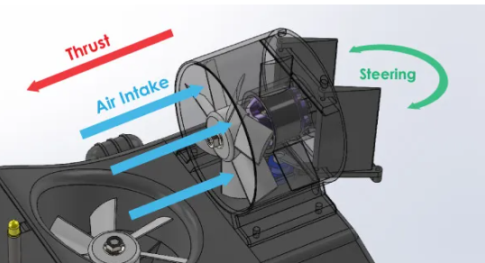

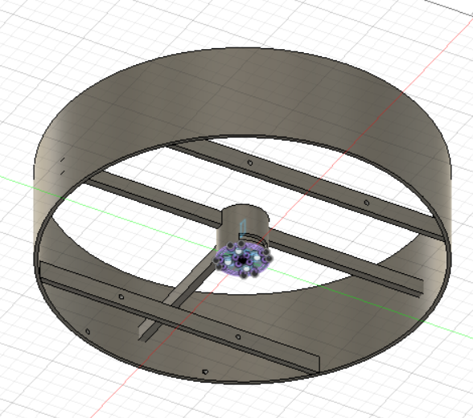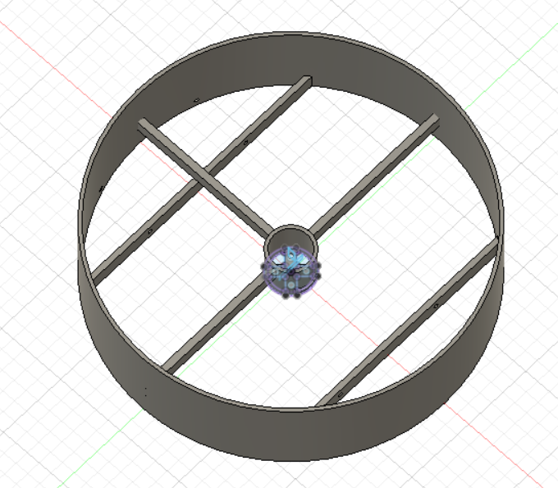I finally succeed in created my coverage, it has a support for the motor and also a protection for the propeller.

The three links connected to the center allow the motor coverage to not move.

The two others strengthen the whole protection and they will also support the rudders that will follow.

I also add holes for the two metallic stems that will hold the rudders and allow me to connect them together.