Report 15/11/2022

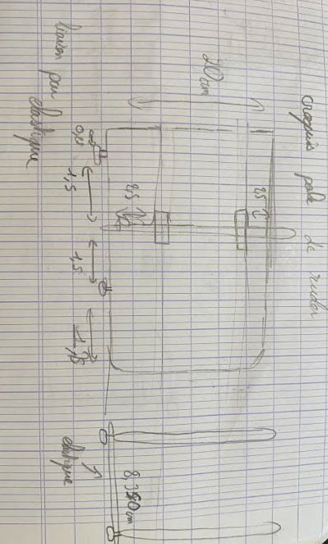This time around, I began by correcting the sketch of my rudders. There were a lot of problem with the number of piece, there were differentiation between the pieces, however we want it with only one body. I took me some time and I couldn’t end it, I tried to modify the type of extrusion and for most of my problem, it resolve it but for one piece, it didn’t work. I’ll asked some help to M.Lebreton next time because he was in meeting.   
After that, we discuss a lot with my colleague, Nino, to find how we’ll create the back of the rudder, the part which must hold on despite the wind and allow the rotation of the boat. We made a few sketch to determine the form, but also the link between the two palms.

The first one was in one piece and both of them were link by an elastic to the servomotor.

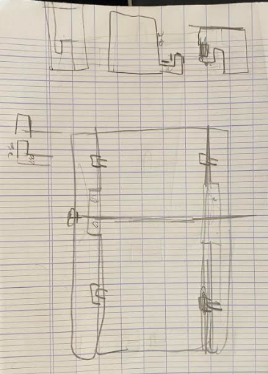The second one was separate in three par to make it easier to connect and place it. Because there are some support in the model.

Support

We thought that the second one corresponded better to what we need, and we think about the method to fix the different part together without destroying the aerodynamic to much, and it will be connecting by a system of hook.

After that, I also add some fillet to the part that we be against the wind to reduce the strength that the piece will face.