Report 25/11/2022

I started this lesson by resolving my issue with the two bodies in my design. To do so, I just take and review every step that I took in the creation to find the issue. Fortunately, I could correct the bug, which was due by the software. The link in one of the extrusion has been neglected by Fusion.

As said in the last report, then I begin the creation of the rear of the rudder. To create the pale, I divided it in three part, to ease the assembly. I began by the general form and when those form will be finished, I will add the detail and the assembly system.

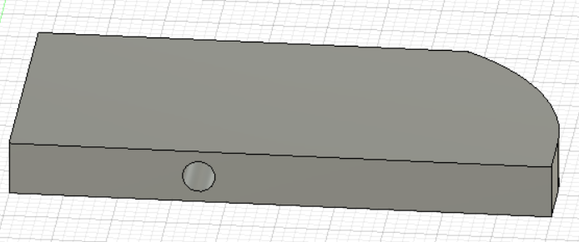

After beginning, a little issue happened, I need to think about the margin to allow the rotation of the pale. We thought about just add a new cut but after some thinking, we decided to use the chamfer.

It would allow a rotation from -45° to 45° and meet the support at those limits.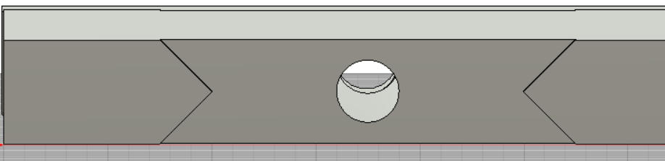

For the bottom part, I just need to copy the top part and add the part that will connect both of the pale. After the test I saw that it won’t work, because went I modified the copy, the original also undergo it.

So I just recreate the last part.

To start adding the link between the different parts, I think about a method to do it. It will be two “U” that will be insert in both parts. The “U” will be another piece. 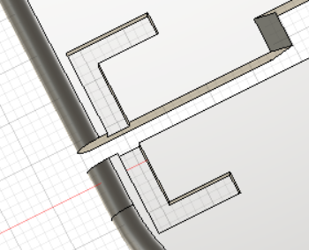

It will be the same “U” that will be print 8 times (4 for each), and the second pale will be created by using a symmetry.