Report 06/12/2022

This time around, I continue what I was doing. I had a hard time because of my laptop, he would not allow me to run fusion and even when I can run it, I couldn’t not work due to the delay. After restarting my computer three time, I could finally work normally.

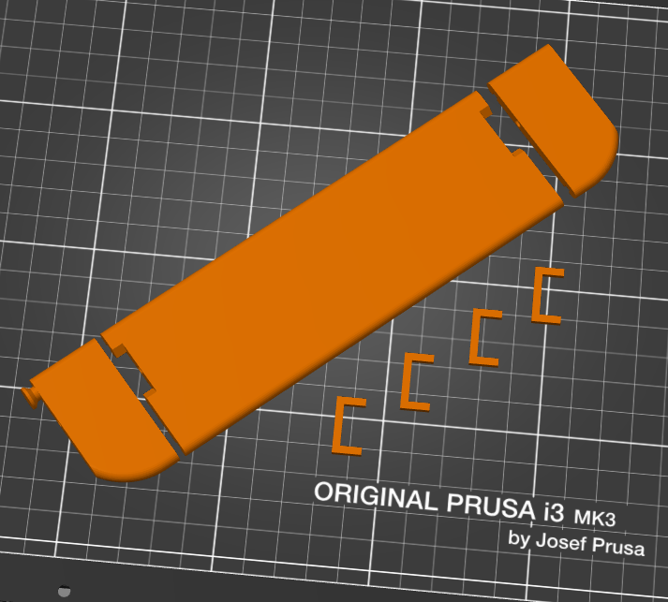I finished my rudder and went to print it, however by two time it failed, After trying to find the issues and asking help, I finally manage to correct them. It was due to the position of a support on our piece that was larger than the remaining part, in addition it was also probably because I print it without support.

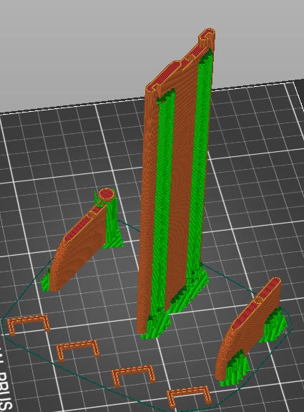So I correct my G-code by splitting each part of the peace and modifying their position.

For ending the lesson, I remove some of the support on my protection for the motor, On part wasn’t easy because I needed to be attentive to the weak part around.

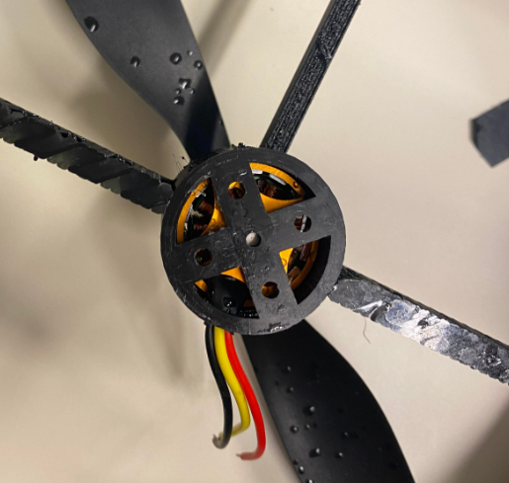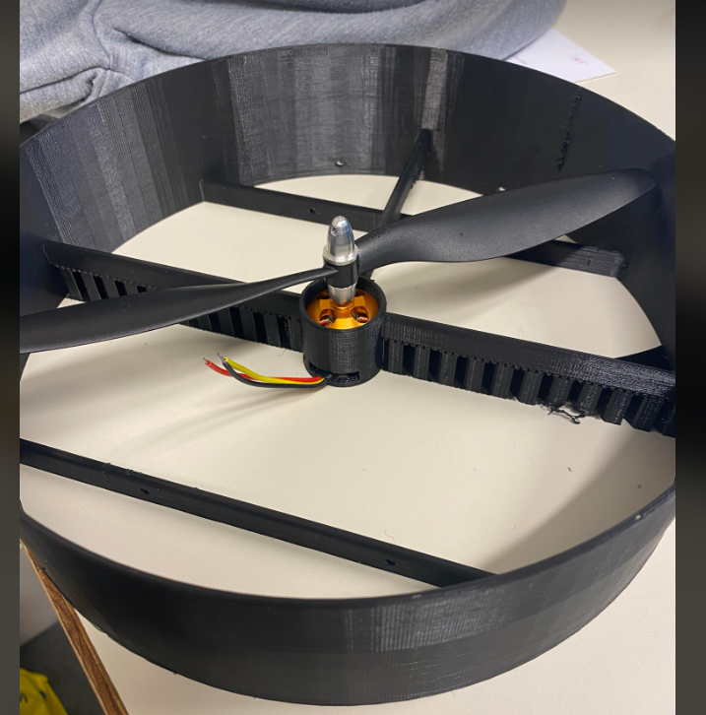It was pleasant when I finally could put my motor in it. The next time I will need to do some welding to connect it to the esc. The protection is a bit too short for the pale, it can fit in it but cannot turn. For this problem, I think I will cut a part of the pale.