Report 13/12/2022

After trying to use the brushless motor in the support, I saw that it was too thigh and couldn’t rotate. So I designed it again. The correction almost took me all the session, because it was some precise detail. Those detail are the placement of the hole for the screw but also the width of the piece in the center.

I also choose to strengthen the inside of the cover.

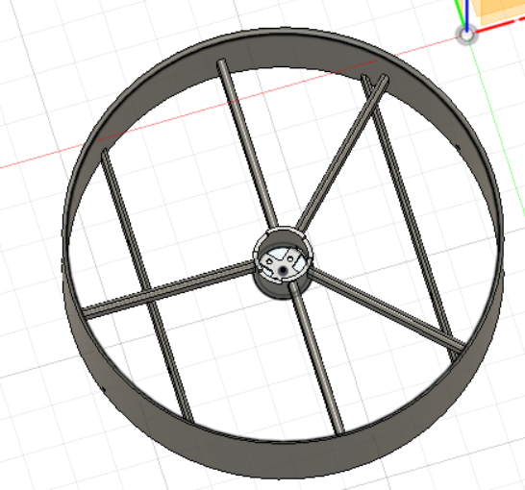

I choose to strengthen the inside so that the outline won’t deform itself to much

With my friend, we choose to create a cover for the front of the motor, It will be a part between the propeller and the rotor

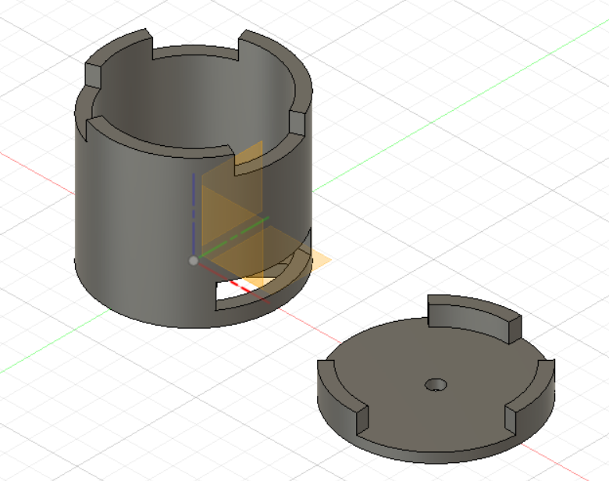

I also separate this part to use less PETG in the printing. At the end of the session I only print the center of the piece that I separate from the support. I couldn’t try the rudder because I forgot to take it, I will work on it the next time, with the study of the motor