Session 1 - 2021-05-06 22:24-22:58

Δίκτυα Υπολογιστών Ι

Ρόντος Έκτορας – Θωμάς

ΑΕΜ: 9477

## G1 – Echo Packet Response Test (2021-05-06 22:24)

### Started at: 2021-05-06 22:24:24:0 Finished at: 2021-05-06 22:29:24:4 Echo request code: E1065 Modem Speed: 1000kbps Students online: 4 Total packets received: 354

Δίκτυα Υπολογιστών Ι  
Ρόντος Έκτορας – Θωμάς  
ΑΕΜ: 9477

## G1’ – Echo Packet Response Test 2 (2021-05-06 22:37)

### Started at: 2021-05-06 22:37:29:5 Finished at: 2021-05-06 22:41:29:9 Echo request code: E1065 Modem Speed: 2000kbps Students online: 3 Total packets received: 403

Δίκτυα Υπολογιστών Ι  
Ρόντος Έκτορας – Θωμάς  
ΑΕΜ: 9477

## G2 – ARQ Response Test (2021-05-06 22:52)

### Started at: 2021-05-06 22:52:10:7 Finished at: 2021-05-06 22:57:10:8 ACK result code: Q0185 NACK result code: R5258 Modem Speed: 1000kbps Students online: 3 Total packets received correctly: 356 Total packets received incorrectly: 89

Δίκτυα Υπολογιστών Ι  
Ρόντος Έκτορας – Θωμάς  
ΑΕΜ: 9477

## G2’ – ARQ Response Test 2 (2021-05-06 22:58)

### Started at: 2021-05-06 22:58:16:2 Finished at: 2021-05-06 23:03:16:3 ACK result code: Q0185 NACK result code: R5258 Modem Speed: 2000kbps Students online: 3 Total packets received correctly: 665 Total packets received incorrectly: 189

Δίκτυα Υπολογιστών Ι  
Ρόντος Έκτορας – Θωμάς  
ΑΕΜ: 9477

## G3 – Retransmissions probability distribution (2021-05-06 22:52)

### Started at: 2021-05-06 22:52:10:7 Finished at: 2021-05-06 22:57:10:8 ACK result code: Q0185 NACK result code: R5258 Modem Speed: 1000kbps Students online: 3 Total packets received correctly: 356 Total packets received incorrectly: 89

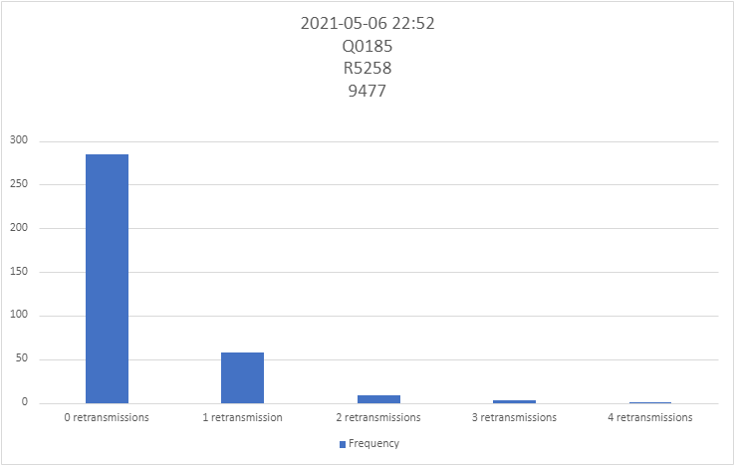

Δίκτυα Υπολογιστών Ι  
Ρόντος Έκτορας – Θωμάς  
ΑΕΜ: 9477

## G3’ – Retransmissions probability distribution 2 (2021-05-06 22:58)

### Started at: 2021-05-06 22:58:16:2 Finished at: 2021-05-06 23:03:16:3 ACK result code: Q0185 NACK result code: R5258 Modem Speed: 2000kbps Students online: 3 Total packets received correctly: 665 Total packets received incorrectly: 189

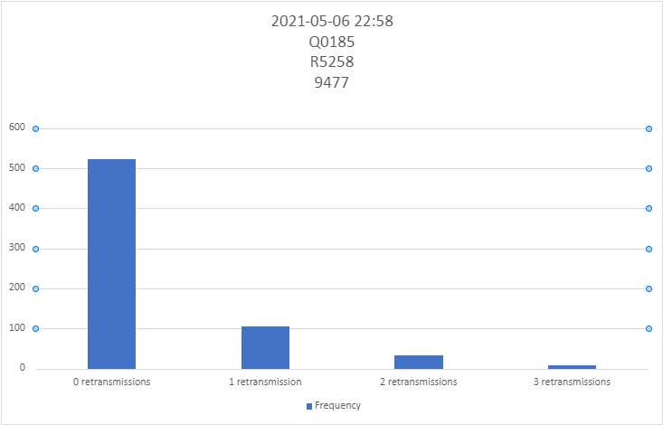

Δίκτυα Υπολογιστών Ι  
Ρόντος Έκτορας – Θωμάς  
ΑΕΜ: 9477

## E1 – Image without errors (2021-05-06 22:43)

### Started at: 2021-05-06 22:43:37:8 Finished at: 2021-05-06 22:43:52:5 Image request code: M7185

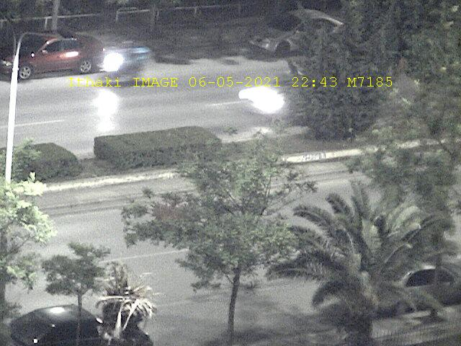

Δίκτυα Υπολογιστών Ι  
Ρόντος Έκτορας – Θωμάς  
ΑΕΜ: 9477

## E2 – Image with errors (2021-05-06 22:44)

### Started at: 2021-05-06 22:44:56:1 Finished at: 2021-05-06 22:45:13:1 Image request code: G6708

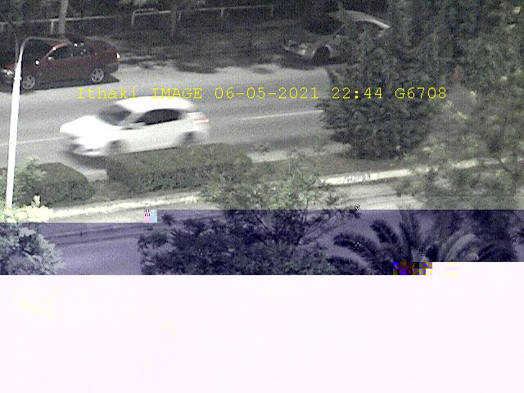

Δίκτυα Υπολογιστών Ι  
Ρόντος Έκτορας – Θωμάς  
ΑΕΜ: 9477

## M1 – GPS traces (2021-05-06 22:47)

### Started at: 2021-05-06 22:47:47:7 Finished at: 2021-05-06 22:48:12:1 GPS request code: P2360 Follow-up code: R=1000099 Time between traces: 20s

Δίκτυα Υπολογιστών Ι  
Ρόντος Έκτορας – Θωμάς  
ΑΕΜ: 9477

## M1’ – GPS traces 2 (2021-05-06 22:49)

### Started at: 2021-05-06 22:49:59:1 Finished at: 2021-05-06 22:50:24:2 GPS request code: P2360 Follow-up code: R=1050099 Time between traces: 20s

## Υπολογισμοί BER

Θα χρησιμοποιήσω τον τύπο: P = (1 - BER)^L, όπου P = ack /(ack + nack) και L το μήκος του μηνύματος σε bits.

G2,G3: BER = 1 - ( 356/(356+89) )^(1/128) = 1.7417x10^(-3)

G2’,G3’: BER’ = 1 - ( 665/(665+189) )^(1/128) = 1.3743x10^(-3)