Session 2 - 2021-05-09 00:55-01:30

Δίκτυα Υπολογιστών Ι

Ρόντος Έκτορας – Θωμάς

ΑΕΜ: 9477

## G1 – Echo Packet Response Test (2021-05-09 00:55)

### Started at: 2021-05-09 00:55:12:4 Finished at: 2021-05-09 01:00:12:6 Echo request code: E1862 Modem Speed: 2000kbps Students online: 2 Total packets received: 1150

Δίκτυα Υπολογιστών Ι  
Ρόντος Έκτορας – Θωμάς  
ΑΕΜ: 9477

## G1’ – Echo Packet Response Test 2 (2021-05-09 01:00)

### Started at: 2021-05-09 01:00:51:8 Finished at: 2021-05-09 01:05:51:8 Echo request code: E1862 Modem Speed: 8000kbps Students online: 2 Total packets received: 2943

Δίκτυα Υπολογιστών Ι  
Ρόντος Έκτορας – Θωμάς  
ΑΕΜ: 9477

## G2 – ARQ Response Test (2021-05-09 01:19)

### Started at: 2021-05-09 01:19:33:3 Finished at: 2021-05-09 01:24:33:5 ACK result code: Q7699 NACK result code: R4600 Modem Speed: 2000kbps Students online: 2 Total packets received correctly: 628 Total packets received incorrectly: 130

Δίκτυα Υπολογιστών Ι  
Ρόντος Έκτορας – Θωμάς  
ΑΕΜ: 9477

## G2’ – ARQ Response Test 2 (2021-05-09 01:25)

### Started at: 2021-05-09 01:25:24:6 Finished at: 2021-05-09 01:30:24:8 ACK result code: Q7699 NACK result code: R4600 Modem Speed: 8000kbps Students online: 2 Total packets received correctly: 1541 Total packets received incorrectly: 746

Δίκτυα Υπολογιστών Ι  
Ρόντος Έκτορας – Θωμάς  
ΑΕΜ: 9477

## G3 – Retransmissions probability distribution (2021-05-09 01:19)

### Started at: 2021-05-09 01:19:33:3 Finished at: 2021-05-09 01:24:33:5 ACK result code: Q7699 NACK result code: R4600 Modem Speed: 2000kbps Students online: 2 Total packets received correctly: 628 Total packets received incorrectly: 130

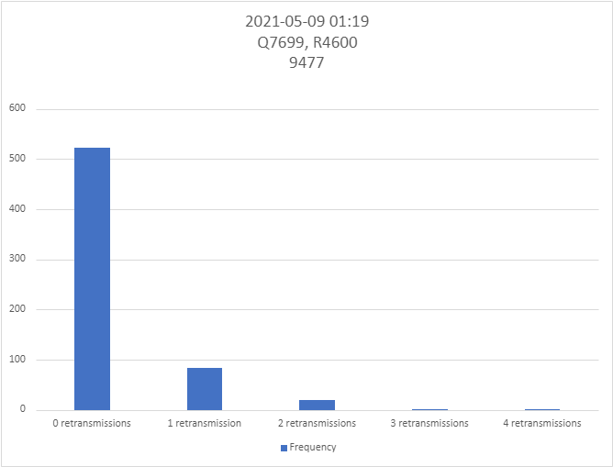

Δίκτυα Υπολογιστών Ι  
Ρόντος Έκτορας – Θωμάς  
ΑΕΜ: 9477

## G3’ – Retransmissions probability distribution 2 (2021-05-09 01:25)

### Started at: 2021-05-09 01:25:24:6 Finished at: 2021-05-09 01:30:24:8 ACK result code: Q7699 NACK result code: R4600 Modem Speed: 8000kbps Students online: 2 Total packets received correctly: 1541 Total packets received incorrectly: 746

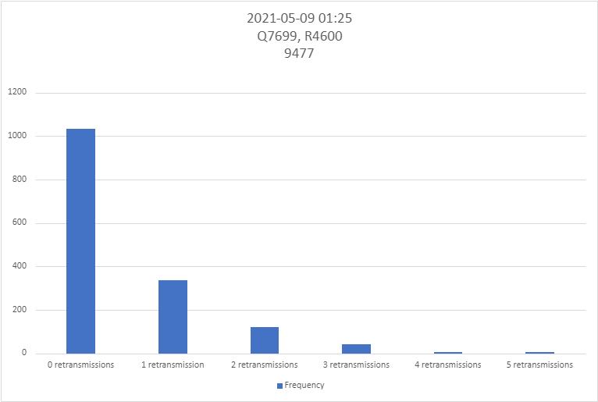

Δίκτυα Υπολογιστών Ι  
Ρόντος Έκτορας – Θωμάς  
ΑΕΜ: 9477

## E1 – Image without errors (2021-05-09 01:07)

### Started at: 2021-05-09 01:07:51:6 Finished at: 2021-05-09 01:08:07:1 Image request code: M3200

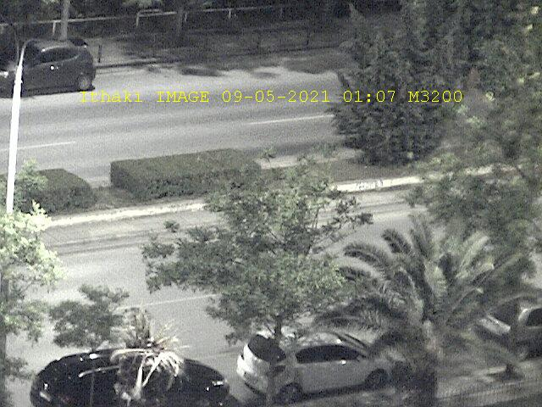

Δίκτυα Υπολογιστών Ι  
Ρόντος Έκτορας – Θωμάς  
ΑΕΜ: 9477

## E2 – Image with errors (2021-05-09 01:08)

### Started at: 2021-05-09 01:08:48:9 Finished at: 2021-05-09 01:09:04:2 Image request code: G0158

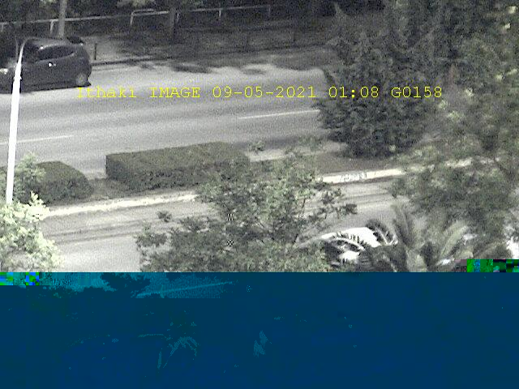

Δίκτυα Υπολογιστών Ι  
Ρόντος Έκτορας – Θωμάς  
ΑΕΜ: 9477

## M1 – GPS traces (2021-05-09 01:14)

### Started at: 2021-05-09 01:14:21:3 Finished at: 2021-05-09 01:14:46:7 GPS request code: P4772 Follow-up code: R=1006999 Time between traces: 20s

Δίκτυα Υπολογιστών Ι  
Ρόντος Έκτορας – Θωμάς  
ΑΕΜ: 9477

## M1’ – GPS traces 2 (2021-05-09 01:17)

### Started at: 2021-05-09 01:17:02:7 Finished at: 2021-05-09 01:17:27:7 GPS request code: P4772 Follow-up code: R=1020099 Time between traces: 20s

## Υπολογισμοί BER

Θα χρησιμοποιήσω τον τύπο: P = (1 - BER)^L, όπου P = ack /(ack + nack) και L το μήκος του μηνύματος σε bits.

G2,G3: BER = 1 - ( 628/(628+130) )^(1/128) = 1.4687x10^(-3)

G2’,G3’: BER’ = 1 - ( 1541/(1541+749) )^(1/128) = 3.0899x10^(-3)