# Team members report by 09.06.2013

Conditional section: should be hidden should be shown

## Table view

|  |  |
| --- | --- |
| Name | Role |
| John | Tester |
| Total | 1 members |

## List view

1. John, Tester

## Nested list view

1. Tester
   1. John

## List inside table

|  |  |  |
| --- | --- | --- |
| Name | Role | Projects |
| John | Tester | 1. Proj |

## Table inside list

1. Proj

|  |  |
| --- | --- |
| Name | Role |
| John | Tester |

## Several blocks

|  |  |
| --- | --- |
| Name | John |
| Role | Tester |
| Statistics | |
| Tester | Count |

## Merged rows

|  |  |  |  |
| --- | --- | --- | --- |
| Name | John | Role | Tester |
| Age | 32 |
| Gender | Male |

## Merged columns

|  |  |  |
| --- | --- | --- |
| Name | Role | Age |
| John | Tester | 32 |
| Projects | proj | |

## Image

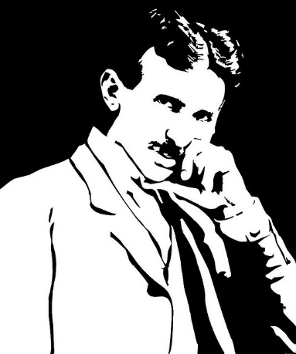

## Images inside a table

|  |  |  |  |
| --- | --- | --- | --- |
|  | Name | Born | Born |
| Info | Info |

## Images inside a list

* 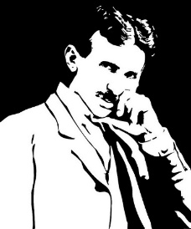 Name (dates of life)
* Info

## Repeats

 Name (dates of life)

* Info

## Hide

 Name (dates of life)

* Info