**Memory Game**

Memory game is a game where you have to memorize the locations of image pairs and match them after they are flipped.

The game provides dynamic number of pairs, a solve button and a timer. Image locations are randomly generated and images are randomly chosen in the table where you have to match the images. A timer starts whenever a game is started and ends when the user successfully matches all the pairs or presses the solve button.

**Work:**

A flexbox accommodates the game UI including the solve button, start/size and the game itself. The game itself is made up of a table(grid) that has its <td></td> placed with a dynamic number using javascript according to the size chosen by the user.

The webpage works on all browsers/devices as most of the text and images fit according to size of the display. When the size is too small the flexbox orients vertically meaning the solve button becomes above the grid of the game instead of to its left.

Game prevents most of improper input including but not limited to clicking on multiple images at once or clicking on the images before they are flipped.

**Design:**

A dark theme is mainly used:

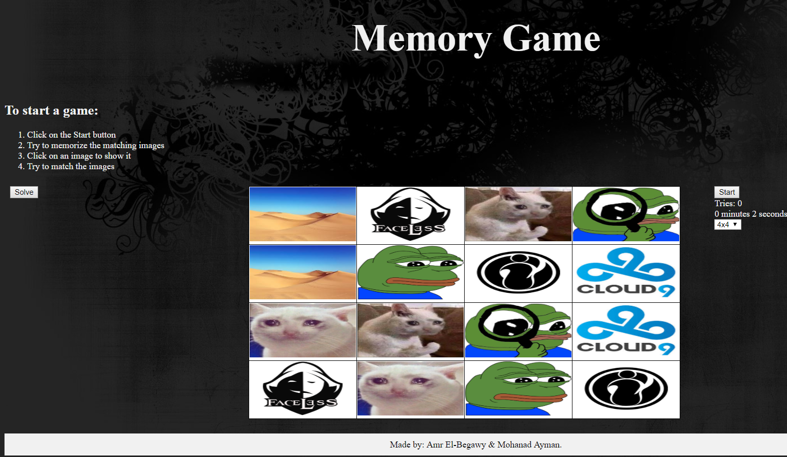

**User Manual:**

1. Choose the desired grid size using the dropdown box.
2. Press start and try to memorize the image locations in the 2 seconds window.
3. Click on an image to reveal it and attempt to click on the matching image.
4. If you’re stuck, you may use the solve button to instantly end the game and reveal all images.