|  |  |  |
| --- | --- | --- |
|  | IMO-logo-rgb | ***E*** |

|  |  |
| --- | --- |
| MARITIME SAFETY COMMITTEE  103rd session  Agenda item 5 | MSC 103/5/x  16 March 2021  Original: ENGLISH  Pre-session public release: |

**REGULATORY SCOPING EXERCISE FOR THE USE OF**

**MARITIME AUTONOMOUS SURFACE SHIPS (MASS)**

**Comments on document MSC 102/5/29**

**Submitted by the Russian Federation**

|  |  |
| --- | --- |
| **SUMMARY** | |
| *Executive summary:* | This document provides comments regaring the interim results of the Autonomous and Remote Navigation Trial Project carried out in the Russian Federation and outlined in document MSC 102/5/29 |
| *Strategic direction, if applicable:* | 2 |
| *Output:* | 2.7 |
| *Action to be taken:* | Paragraph 18 |
| *Related documents:* | MSC 102/5/29, MSC 102/INF.8 |

**Introduction**

1 This document is submitted under the provisions of paragraph 6.12.5 of the *Organization and method of work of the Maritime Safety Committee and the Marine Environment Protection Committee and their subsidiary bodies* (MSC-MEPC.1/Circ.5/Rev.1) and comments on document.

**Background**

2 As from 2019 the Autonomous and Remote Navigation Trial Project is being implemented in Russia as part of the MARINET roadmap of the National Technology Initiative, supported by the Ministry of Industry of Trade of the Russian Federation, with the participation of the Ministry of Transport of the Russian Federation and the Russian Maritime Register of Shipping (RS). Information about the project was presented by the Russian Federation to the Committee in MSC 102/5/29.

3 The goal of the project – to develop and test the standard set of technologies of automated remote navigation (a-Navigation) and methods of implementation on various merchant ships having different automation level and under various operation conditions. General task of the project – to create opportunity for shipping companies for broad prototype testing of MASS under the flag of the Russian Federation in accordance with the relevant national legislation under development.

4 By means of the present document the Russian Federation informs the Committee on interim results of the project as prepared by the Centre for promotion of autonomous shipping technologies «MARINET RUT» created by the Russian University of Transport together with Sector-specific Centre MARINET in accordance with the Order of the Ministry of Transport of the Russian Federation. More detailed information on the project developments is available at website www.a-nav.org

**Comments regarding the outcome of the project**

5 The timeframe of the project outlined in MSC 102/5/29 has been extended to 6 months due to COVID-19 pandemic and related limitations for experts involved. As an example of the impact: as of 12th of March 2021 on one of the ships involved (m/v «Mikhail Ulyanov») the connection of a-Navigation systems to the actuators of the ship has not been completed due to limitations related to visit of foreign engineer of company manufacturer of on board systems. At the moment the timeframe of the project is as follows:

.1 Development of basic solutions and linkage with the national legislation (March 2019 – May 2020);

.2 Preliminary tests of systems on shore using dedicated simulators (June – August 2020);

.3 Manufacturing of experimental equipment and installation on board four ships (May - September 2020);

.4 Collection of field data from ships and analysis of systems operation without possibility to control the ships (from September 2020);

.5 Tests of automated and remote operation of ships under control of the crew and additional control by shipping company (from February 2021);

.6 Demonstrational voyages with the participation of Russian government officials and representatives of international organizations (planned for April – June 2021).

6 By now stages 1-3 of the project have been successfully completed. From September 2020 data on systems performance during actual commercial operation of all ships is being collected and analysed (without a possibility to influence the work of operational devices). In February 2021 the trials continued with the phase of immediate control by a-Navigation systems of actuators on board under supervision of the persons in change in the shipping companies and the crew – when the autonomous regime is being activated during agreed timeframe.

7 A set of experimental systems is installed on board of m/v «Pola Anfisa», a bulk carrier by “Pola Rise” shipping company, m/v «Mikhail Ulyanov», tanker by “SCF” shipping company and m/v «Rabochaya», a self-propelled barge by “Rosmorport” enterprise. Experimental remote control stations (RCS) are installed in the office of “Pola Rise” (connected to m/v «Pola Anfisa»), “SCF” (connected to m/v «Mikhail Ulyanov») and on board of dredger “Redut” (connected to m/v «Rabochaya»). Additional monitoring systems are installed in the offices of “Rosmorport” enterprise, company “Kronshtadt Technologies” (systems operator) and in the Ministry of Industry and Trade of the Russian Federation The relevant structure is in the picture below.

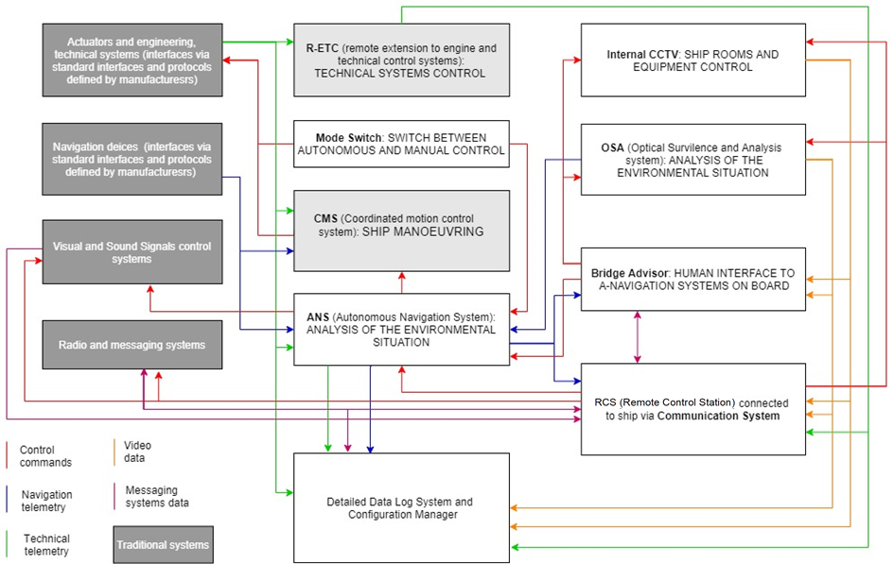

8 Experimental hardware on board has been developed and installed in accordance with the project documentation agreed by RS, surveyed by RS after installation and does not create safety risks or influence to other on board systems of ships. The connection to existing on board systems was agreed with the systems manufacturers and shipowners, whilst the mechanical Mode Switch was installed on the connection line to actuators which provide physical link with ship bridge. In addition a constant indication is available on board and in RCS regarding the status of mode switch and availability of a-Navigation systems.

9 With the participation of the Central Research Institute “KURS” in 2019 a risk analysis was performed related to the functioning of new systems and arrangement of trials, which was taken into account as part of systems requirements and trial programme. The trial programme provides full and constant control by ship’s master during tests of automated and remote operation, immediate switch to normal operation in case of any errors or limitations: critical deterioration of weather conditions, intense shipping traffic, malfunctions on board etc.

10 On the basis of developed requirements to systems, results of preliminary on-shore tests and analysis of systems operation on board in December 2020 the Russian Maritime Register of Shipping issued the Approval in Principle for systems of a-Navigation.

11 On the basis of our experience, when conducting MASS trials it is considered necessary to use simulators, as outlined in document MSC 102/INF.8 (Annex 4.1). That allows not only to reduce risks to safety of navigation but also to broaden the conditions of trials to include those which are not typical for real operational conditions. Thus in accordance with the Recommendations on application of COLREG-72 to autonomous ships, issued by the Federal Agency for Maritime and River Transport of the Russian Federation, Collision Avoidance Module contains 50 typical scenarios of passing, 15 of those did actually happen during real trials on three different ships throughout six months.

12 The simulator used in the project includes the simulation of navigational conditions, on board systems and RCS that allow to create various conditions and scenarios. At the same time an open platform of virtual modelling of autonomous navigation is being developed within MARINET, we plan to offer it to all interested parties in 2022 for development, testing and certification of a-Navigation tools.

13 We also use and consider it feasible to use the simulation technologies to build virtual models reflecting the situation on RCS as an additional instrument to increase situational awareness of remote operator. The use of virtual models on RCS on the basis of telemetric data specified particularly in guidelines on MASS by classification societies the Russian Maritime Register of Shipping and DNV would allow to ensure equivalent level of oversight of situation around in bad visibility or limited capacity of communication channel between the MASS and RCS, for example in the Arctic with both possible bad visibility and unstable satellite communication.

14 Despite the fact that the priority of our systems is automated mode (both in terms of autonomous navigation system and optical analysis system), our approach provides permanent control by RSC operator with possibility to engage in operation or call crew to come to the bridge. The capacity and stability of communication channels between the MASS and RCS is of critical importance. Current technical arrangements imply:

.1 Allocated bandwidth of 256 kbit/s for two-way transmission of telemetric data including navigation and technical data;

.2 Additional bandwidth of up to 256 kbit/s for voice and radio communication of remote operator;

.3 Additional bandwidth of not less than 1 mbit/s for transmission of visual data from ship to RCS.

Depending on the conditions and available speed of communication channel the operator may be able to choose one of three modes on display: high resolution with discrete frame transmission, streaming video of low quality or virtual model.

The need to provide remote servicing of a-Navigation systems by IT experts should be taken into account, i.a. remote access and software update are intensive in terms of channel capacity.

15 To achieve the required level of accuracy of a-Navigation systems a substantial amount of field data is require to tune and teach the systems. After 6 months of testing on board three ships the existing level of automatic recognition by optic system of analysis (OSA) has allowed to identify 7 types of objects on water, including ships (with accuracy up to 90%) and navigation lights (low accuracy so far). In a similar manner the autonomous navigation system (ANS) does not perform correctly in all cases the automatic assessment of navigational situation and calculation of collision avoidance manoeuvres. Systems are being updated consistently on the basis of data received during trials.

16 We did not manage to implement in OSA the automatic identification of distance using the laser rangers: acceptable results could be achieved with substantial increase of cost of the system which would not be affordable to majority of shipping companies. That is why we are now elaborating the technology of using physical stereoscopic pairs together with smart recognition of objects.

17 Sound and visual signals by the MASS is not only a statutory requirement but also one of the means of interaction of the MASS with traditional ships. In order to ensure timely signalling the ANS should be connected to the means of control of sound and visual signals of the MASS. While manoeuvring autonomously the ANS should make signals in accordance with COLREG-72, while in remote controlled mode it should allow the remote operator to do that via the RCS interface.

**Action requested of the Committee**

18 The Committee is invited to take note of the information regarding MASS trials in the Russian Federation for the benefit of MASS trials worldwide.