|  |  |  |
| --- | --- | --- |
|  | IMO-logo-rgb | ***E*** |

|  |  |
| --- | --- |
| MARITIME SAFETY COMMITTEE  103rd session  Agenda item 5 | MSC 103/5/x  16 March 2021  Original: ENGLISH  Pre-session public release: |

**REGULATORY SCOPING EXERCISE FOR THE USE OF**

**MARITIME AUTONOMOUS SURFACE SHIPS (MASS)**

**Comments on documents MSC 102/5/1, MSC 102/5/3, MSC 102/5/4**

**Submitted by the Russian Federation**

|  |  |
| --- | --- |
| **SUMMARY** | |
| *Executive summary:* | The document provides comments on remote control stations referred to in documents MSC 102/5/1, MSC 102/5/3, MSC 102/5/4 |
| *Strategic direction, if applicable:* | 2 |
| *Output:* | 2.7 |
| *Action to be taken:* | Paragraph 11 |
| *Related documents:* | MSC 102/5/1, MSC 102/5/3, MSC 102/5/4, MSC 102/5/29 |

**Introduction**

1 This document is submitted under the provisions of paragraph 6.12.5 of the *Organization and method of work of the Maritime Safety Committee and the Marine Environment Protection Committee and their subsidiary bodies* (MSC-MEPC.1/Circ.5/Rev.1) and comments on document.

**Background**

2 Since 2020, in Russia, within the MARINET project of the National Technology Initiative, a-navigation means have been tested in the real operational conditions on board ships “Mikhail Ulyanov”, “Pola Anfisa”, “Rabochaya” and “Redut”, the information thereon is set out in document MSC 102/5/29.

3 The practical experience of design, installation and use of a-navigation means in interaction with various shipping companies and Russian Maritime Register of Shipping makes it possible to provide substantial comments on a number of matters concerning remote control stations referred to in documents MSC 102/5/1, MSC 102/5/3 and MSC 102/5/4.

4 The Russian Federation, through this document, shares its views based on the accumulated practical experience. The review was done by MARINET RUT, the Centre for Promotion of Technologies of Autonomous Shipping, established by the Russian University of Transport together with the MARINET Departmental Centre under the order of the Minister of Transport of the Russian Federation.

**Comments**

5 It is our basic principle that MASS remote control should comply with the existing regulatory standards including those pertaining to the situation awareness and radio communication. In this light we suggest a remote control station (RSC) should be considered equivalent to a navigation bridge and central control station under the relevant SOLAS provisions, but RCS is located outside the autonomous ship and has a high degree of control automation.

6 RCS is designed to simultaneously display to operator various data, those equivalent to the information on the ship’s navigation bridge (Figure 1.):

.1 Navigation systems interface including ECDIS equivalent, autonomous navigation system and control interfaces of ship onboard radars;

.2 Video information display interfaces on the ambient surroundings and control of the optical surveillance and analysis system;

.3 Interfaces of the remote engine and technical monitoring system allowing surveillance and control of the unattended engine room;

.4. Interfaces of video information display and internal ship’s CCTV control;

.5 Interfaces of the ship motion control (joystick system);

.6 Radio interaction terminals for a RCS operator to interact with the onboard radio equipment (VHF and MF-HF radio stations, MF-HF radiotelex, Inmarsat station, Navtex receiver and public address system) connected to the corresponding devices onboard;

.7 Microphones and speakers for interaction with the public address system and receiving audio signals and video communication with the crew onboard;

.8 Indicators and interfaces of the a-navigation settings and diagnostics system.

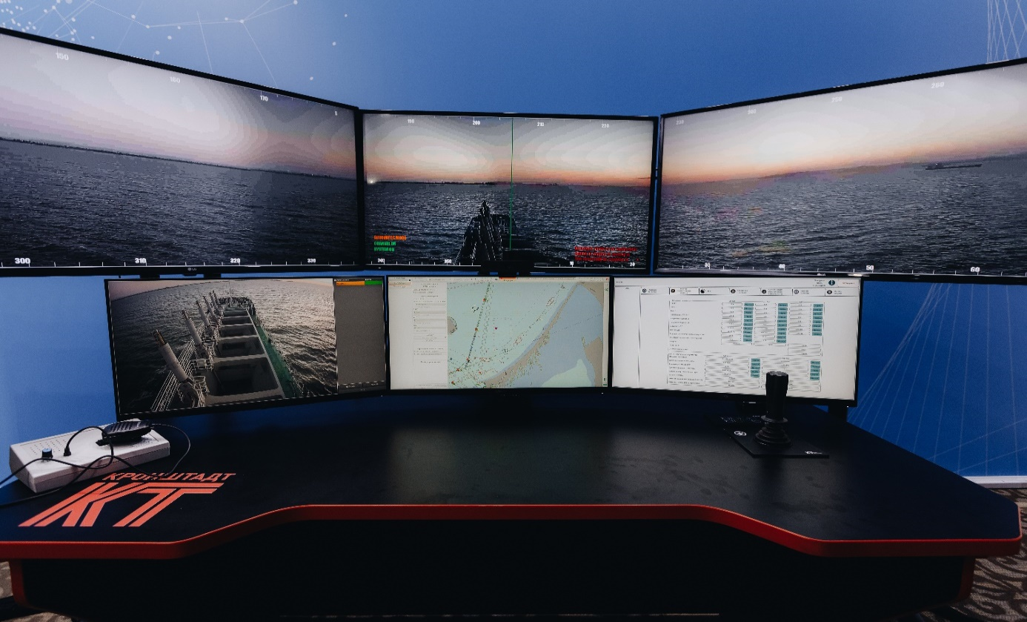

7 In displaying video information on the ambient surroundings, we think it preferable to keep the real angular positions and sizes of objects, for which purpose, in our case, video information display zone is a 5 display arc of 180 degrees, equivalent to the real 180-degree viewing arc as seen by the navigator on the bridge. Operator can rotate the view in horizontal plane (equivalent to a navigator’s switching to a different view angle), amplify the chosen view zone (binocular equivalent), switch to the infra-red band and to the virtual view model.

8 We consider it is appropriate to have on MASS onboard radars remotely controlled to be through RCS by a remote operator.

9 RCS is similar to navigation bridge and qualified navigators will be familiarized with its use with no need for any significant further training.

10 RCS can be located either ashore or onboard another ship: convoy navigation is part of the on-going tests, where RSC for monitoring and control of the hopper barge is installed onboard dredger, the head-ship of the dredging convoy.

**Action requested of the Committee**

11 The Committee is invited to take note of the information on MASS trials carried out in the Russian Federation for the purpose of further MASS trials worldwide and to comment as it may deem appropriate.