**Kathmandu University**

**Department of Computer Science and Engineering**

**Dhulikhel, Kavre**



**A Project Proposal**

**on**

**“El. Mars”**

**[ENGG - 102]**

**(For partial fulfillment of First Year/Second Semester in Computer Science/Engineering)**

**Submitted By:**

**Nirjal Bhurtel (Roll No.12)**

**Dipen Khatri (Roll No.23)**

**Roshan Sahani(Roll No.42)**

**Asim Shrestha (Roll No.48)**

**Submitted To:**

**Manish Joshi**

**Department of Computer Science and Engineering**

**Date: 5th January 202**

Cover Letter:

Align left

# Abstract

In a journey of humans to Mars, long-distance space explorations offer an inexhaustible amount of complexity. To reduce the complexity and live in metaverse, El. Mars will be an expo-civi game that would make each and every one visualizes Mars from their own device. The civilization simulation game will aim at building important aspects in establishing human settlements. It will be an interactive, and fun game that provides educational civilization knowledge that is suitable for all interested humans in Space travel. Our aim is to motivate all homo-sapiens to explore space and Mars and find a way to habitat. We hope that our project brings inspiration, curiosity and, ideas to bring the time of flight to Mars closer. In our game, the player serves to explore the mars, build a colony on Mars, visualize civilization and live in every child's dream of traveling to Mars one day.

To create a game, we will be using unreal game engine with TPP modules and use blender for 3d modeling and terrain design. We will be using information’s and resources from NASA’s research papers to design the terrain and way to live in mars environment.

**Keywords**:

Mars, Simulation, Exploration, Mars Habitant, Civilization

**Table of Contents**

Abstract i

List of Figures iii

Acronyms/Abbreviations iv

Chapter 1 Introduction 1

1.1 Background 1

1.2 Objectives 1

1.3 Motivation and Significance 2

Chapter 2: Related works 2

Chapter 3: Procedure and Methods: 3

3.1 Work Flow/ Road Map/ Flow chart: 3

Chapter 4 System Requirement Specification: 5

4.1 Software Specification 5

4.1.1 3D modeling and terrain design tool: 5

4.1.2 Game Engine 5

4.2 Hardware Specification 5

Chapter 5: Project Planning and Scheduling 5

Chapter 6: Expected Outcome 6

References 7

# List of Figures

Figure 1: Flow chart ………………………………………………………………4

Figure 2: Gantt Chart……………………………………………………………....6

# Acronyms/Abbreviations

1. Expo-Civi: Exploration and civilization
2. 3D: 3rd Dimensional
3. FPP: First Person Perspective
4. PC: Personal Computer
5. GB: Giga Byte

# Chapter 1 Introduction

## Background

The name homo sapiens were given to human because of their wise behavior. Humans are wise because of reason and reason is curiosity. So, every human once dreams to be on a space travel mission. But, only 12 people have stepped out of Earth to the Moon which is just 0.2 million miles away. Mars, on average, 140 million miles from Earth has many important habitability factors which include temperature, pressure, the variance of gravity, noise, and quantity of space. It is very essential to get the requisite food, sleep, and exercise needed to stay healthy and happy for space travelers. Even though space exploration is everyone's dream it is not possible and realistic. But there are always solutions to each problem. In finding the solution for space travel we have introduced the revolution of the gaming industry by thinking about our explorer El. Mars.

EL. Mars will be a civilization game along with explorations that would make each and every one visualizes Mars from their own device. The civilization simulation game will aim at building important aspects in establishing human settlements on Mars. In our game, the player will serve to build a colony on Mars, visualize civilization and live in the dream of every child's of traveling to Mars one day.

## 1.2 Objectives

The main objectives of our project is

***“TO GET STARTED WITH UNREAL ENGINE AND 3D MODELING IN BLENDER”***

The secondary objective is:

* To know more about game development and 3d terrain modeling.
* To get knowledge about space exploration and survival in mars.
* To create game in an exciting way that it challenges user to tackle all the concepts and discover a new way of building civilization with limited resources in an inhabitable environment.

## 1.3 Motivation and Significance

The concept of solving someone's dream is always a beautiful way to live. Thinking about the project that we are talking about has also provided a similar motivation. Even though it may sound over-ambitious and hard, we want to live in the present. Be in the movement. Apart from these, we want to enhance our skills in game development and 3d modeling. Also, tackling real-world problems might be the new way of living. The objective of our life is to deal with the challenges. That's what we want to enjoy and tackle problems that can come in our way while meeting the deadlines.

Continuing, the project is mainly knowledge-based and includes realism in the game. This portal of metaverse can be used to provide resources and materials to each and every one who loves science and space. With our game, users will be able to live on the mars that they once dreamed. They can follow their dreams and become a believer.

# Chapter 2: Related works

No web apps or games are similar to what we want. But there are some of them who we think share the same dream of the metaverse. The following are the games or apps that are as follows:

* Mars Walk

It is developed by Lockheed Martin. In this game users can walk along the surface of Mars and explore the landing sites of the mars. This (FPP) game also comes with the Dust storms at the Northern Crater and some information about the landing sites.

* Mars Rover Game

Mars Rover Game is a game developed by NASA. This game was released while Perseverance was sent to Mars. While playing this game we can control the rover in a small area and perform some work that perseverance can do.

* Surviving Mars

Surviving Mars is a game developed by Haemimont Games. Surviving Mars is a sci-fi city builder game. It is all about colonizing Mars and surviving the process. In this game the user has to cultivate his own food, mine minerals and do other things to survive in the new environment of mars.

# Chapter 3: Procedure and Methods:

Our purpose is to develop a civilization educational game that allows users to focus on keeping the avatar alive and healthy along with explorations of resources available based on real Martian data.

## Work Flow/ Road Map/ Flow chart:

Following is the proposed workflow for the project:

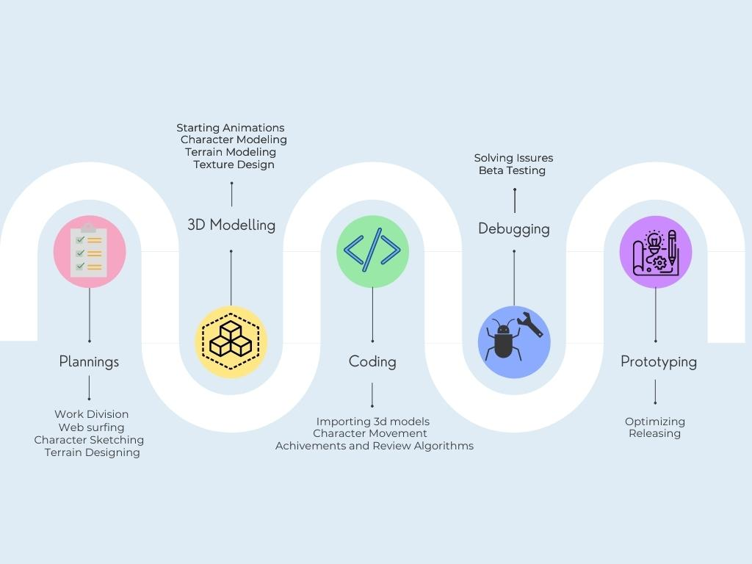

Figure 3.1: Flow Chart

#### **3.1.1. Planning**

We had a vision of how this game should look like and how an astronaut struggles millions of miles away from home with inhabitable environment. So, we started sketching our ideas and concepts before writing proposal. Then, after the starting of the project days we will be doing work divisions, web surfing, character sketching and terrain designing.

#### **3.1.2. 3D Modeling**

In [3D computer graphics](https://en.wikipedia.org/wiki/3D_computer_graphics)(“3D modeling”, 2021), 3D modeling is the process of developing a mathematical coordinate-based representation of any [surface](https://en.wikipedia.org/wiki/Surface_(mathematics)) of an object (inanimate or living) in [three dimensions](https://en.wikipedia.org/wiki/Three-dimensional_space) via [specialized software](https://en.wikipedia.org/wiki/3D_computer_graphics_software) by manipulating edges, vertices, and polygons in a simulated 3D space.

#### **3.1.3. Coding / Game Development**

Game Development (“Game Development”, 2021) is the art of creating games and describes the design, development and release of a game. It may involve concept generation, design, build, test and release. While you create a game, it is important to think about the game mechanics, rewards, player engagement and level design.

#### **3.1.4. Debugging**

(“Debugging”, 2021) In [computer programming](https://en.wikipedia.org/wiki/Computer_programming) and [software development](https://en.wikipedia.org/wiki/Software_development), debugging is the process of finding and resolving [*bugs*](https://en.wikipedia.org/wiki/Software_bug) (defects or problems that prevent correct operation) within [computer programs](https://en.wikipedia.org/wiki/Computer_program), [software](https://en.wikipedia.org/wiki/Software), or [systems](https://en.wikipedia.org/wiki/Software_system).

#### **3.1.5. Prototyping**

A prototype(“Prototyping”,2021) is an early sample, model, or release of a product built to test a concept or process. It is a term used in a variety of contexts, including [semantics](https://en.wikipedia.org/wiki/Semantics), [design](https://en.wikipedia.org/wiki/Design), [electronics](https://en.wikipedia.org/wiki/Electronics), and [software programming](https://en.wikipedia.org/wiki/Software_prototyping). A prototype is generally used to evaluate a new design to enhance precision by system analysts and users. Prototyping serves to provide specifications for a real, working system rather than a theoretical one. In some design workflow models, creating a prototype (a process sometimes called materialization) is the step between the [formalization](https://en.wikipedia.org/wiki/Formal_specification) and the [evaluation](https://en.wikipedia.org/wiki/Evaluation) of an idea.

# Chapter 4 System Requirement Specification:

## 4.1 Software Specification

### 4.1.1 3D modeling and terrain design tool:

**Blender**

Blender(“Blender”-2021) is a free and open-source 3D computer graphics software tools used for creating animated films, visual effects, art, 3D printed models, motion graphics, interactive 3D applications, virtual reality, and computer games.

## 4.1.2 Game Engine

**Unreal Engine**

Unreal Engine(“Unreal Engine”-2021) is a [game engine](https://en.wikipedia.org/wiki/Game_engine) developed by [Epic Games](https://en.wikipedia.org/wiki/Epic_Games), first showcased in the 1998 [first-person shooter](https://en.wikipedia.org/wiki/First-person_shooter) game [*Unreal*](https://en.wikipedia.org/wiki/Unreal_(1998_video_game)). Initially developed for [PC](https://en.wikipedia.org/wiki/Personal_computer) first-person shooters, it has since been used in a variety of genres of [three-dimensional](https://en.wikipedia.org/wiki/Three-dimensional_space) (3D) games and has seen adoption by other industries, most notably the film and television industry. Written in [C++](https://en.wikipedia.org/wiki/C%2B%2B), the Unreal Engine features a high degree of [portability](https://en.wikipedia.org/wiki/Software_portability), supporting a wide range of [desktop](https://en.wikipedia.org/wiki/Desktop_computer), [mobile](https://en.wikipedia.org/wiki/Mobile_phone), [console](https://en.wikipedia.org/wiki/Video_game_console) and [virtual reality](https://en.wikipedia.org/wiki/Virtual_reality) platforms.

## 4.2 Hardware Specification

Unreal Engine 4 is the most recent version of unreal engine. To import high graphics at least 2GB RAM and 2GB of free storage are recommended.

# Chapter 5: Project Planning and Scheduling

We want to make each and every moment memorable and enjoyable while working on this project. The routine is of 12 weeks but we would feel proud every second after the end of our project. We have divided our routine as follows: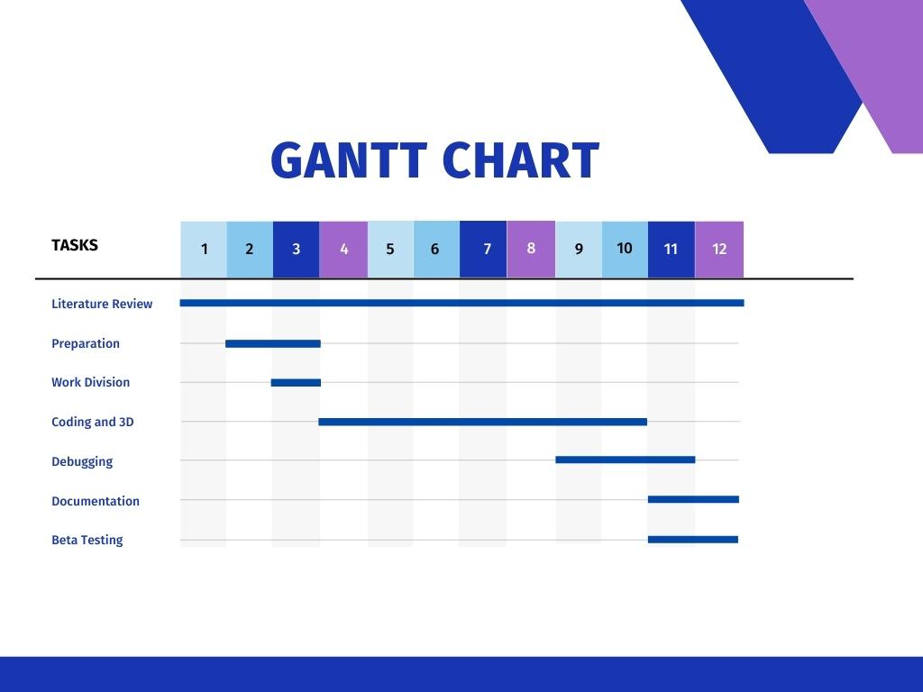

Figure 1: Gantt Chart 1

# Chapter 6: Expected Outcome

In this project we want to build the realistic model of mars and add perform scientific research based on real Martian data to survive and explore in Mars which might not get complete in 12 weeks. We will be upgrading and continuing this project in coming semesters. List of the targeted progress that we will be completing till the end of deadline:

* ‌Make the jetpack function that would be there for transportation of astronaut.
* ‌Make a small landing area where astronaut can explore.
* ‌Make an oxygen and food fill-up area.
* ‌Make a starting animation and story lines.

# References

1. Mars Walk – Mars walk Appstore (2021). Retrieved 4 January 2022, from

<https://apps.apple.com/us/app/mars-walk/id1192328042>

1. Mars Rover game - Mars Rover Game (2021). Retrieved 4 January 2022, from https://spaceplace.nasa.gov/explore-mars/en/
2. Surviving mars – Surviving Mars steam (2021). Retrieved 4 January 2022, from <https://store.steampowered.com/app/464920/Surviving_Mars/>
3. Character Movement – Unreal Engine (2021). Retrieved 5 January 2022, from

https://docs.unrealengine.com/4.27/en-US/InteractiveExperiences/HowTo/CharacterMovement/

1. Blender - Wikipedia. En.wikipedia.org. (2021). Retrieved 4

January 2022, from

<https://en.wikipedia.org/wiki/Blender_(software)>

1. Unreal Engine - Wikipedia. En.wikipedia.org. (2021). Retrieved 4

January 2022, from

<https://en.wikipedia.org/wiki/Unreal_Engine>

1. 3D Modeling - Wikipedia. En.wikipedia.org. (2021). Retrieved 5

January 2022, from

<https://en.wikipedia.org/wiki/3D_modeling>

1. Game Development – Free Code Camp. freecodecamp.org(2021). Retrieved 5 January 2022, from

<https://www.freecodecamp.org/news/what-is-game-development/>

1. Debugging - Wikipedia. En.wikipedia.org. (2021). Retrieved 5

January 2022, from

<https://en.wikipedia.org/wiki/Debugging>

1. Prototyping - Wikipedia. En.wikipedia.org. (2021). Retrieved 5

January 2022, from

https://en.wikipedia.org/wiki/Prototype