Code Structure & Functionality (1.py)
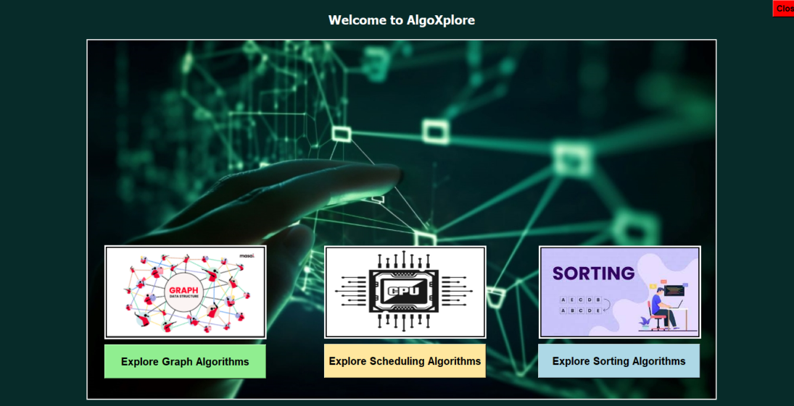
This is the main GUI file for AlgoXplore, responsible for launching the application and providing buttons to explore different algorithm categories.

1️ Overview of Functionality
- Tkinter GUI Creation
  - A fullscreen Tkinter window (root = tk.Tk()) with a dark greenish theme (#072B29).
  - A welcome label (tk.Label) at the top.
  - A main background image and three smaller images for buttons.
- Launching Different Algorithm Modules
  - Button 1: Opens graph.py (Graph Algorithms)
  - Button 2: Opens scheduling.py (Scheduling Algorithms)
  - Button 3: Opens sort.py (Sorting Algorithms)
  - Uses subprocess.Popen to run separate scripts for each section.
- Button & Image Layout
  - Uses Tkinter's pack() and place() methods for UI layout.
  - place(x, y) ensures precise placement of images and buttons.
  - Buttons are inside frames to keep the layout clean.
- Exit Button
  - A Close button (root.quit) is placed in the top-right corner using place(relx=1.0, rely=0.0, anchor="ne").

2️: Communication Between Files
The main file (1.py) does not directly call functions from graph.py, sorting.py, or scheduling.py.
Instead, it spawns new processes using:
subprocess.Popen(["python", "C:\\Users\\HP\\OneDrive\\Desktop\\algo_visualizer\\GUI\\graph.py"])
This means:
- Each module runs independently in a new window.
- No data is passed between 1.py and the other files.

3️) Tkinter Methods Used & Their Purpose
Tkinter Method | Usage in 1.py | Purpose
tk.Tk() | root = tk.Tk() | Creates the main GUI window.
root.configure(bg=color) | root.configure(bg="#072B29") | Sets the window background color.
root.attributes('-fullscreen', True) | Fullscreen mode.
tk.Label() | welcome_label = tk.Label(root, text="Welcome to AlgoXplore", ...) | Displays text/images.
label.pack() | welcome_label.pack(anchor=tk.N, padx=20, pady=20) | Automatically positions widgets (top in this case).
tk.Frame() | frame_buttons1 = tk.Frame(root, bg="black") | Container for buttons to organize layout.
tk.Button() | button1 = tk.Button(frame_buttons1, text="Explore Graph Algorithms", ...) | Creates a clickable button.
button.pack() | button1.pack() | Places the button inside the frame.
label.place(x, y) | label_small_image1.place(x=200, y=...) | Precise positioning of images and buttons.
root.quit() | command=root.quit | Exits the application when the close button is clicked.
root.mainloop() | root.mainloop() | Starts the Tkinter event loop, keeping the window open.
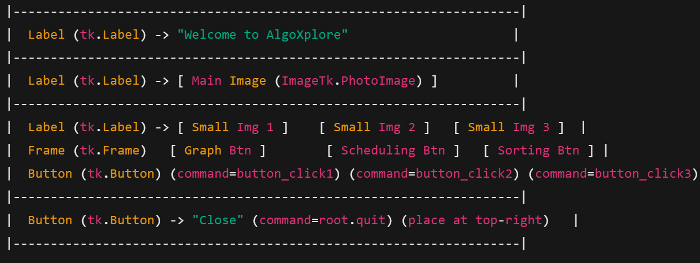

2) Graph.py

1.1. Main Components
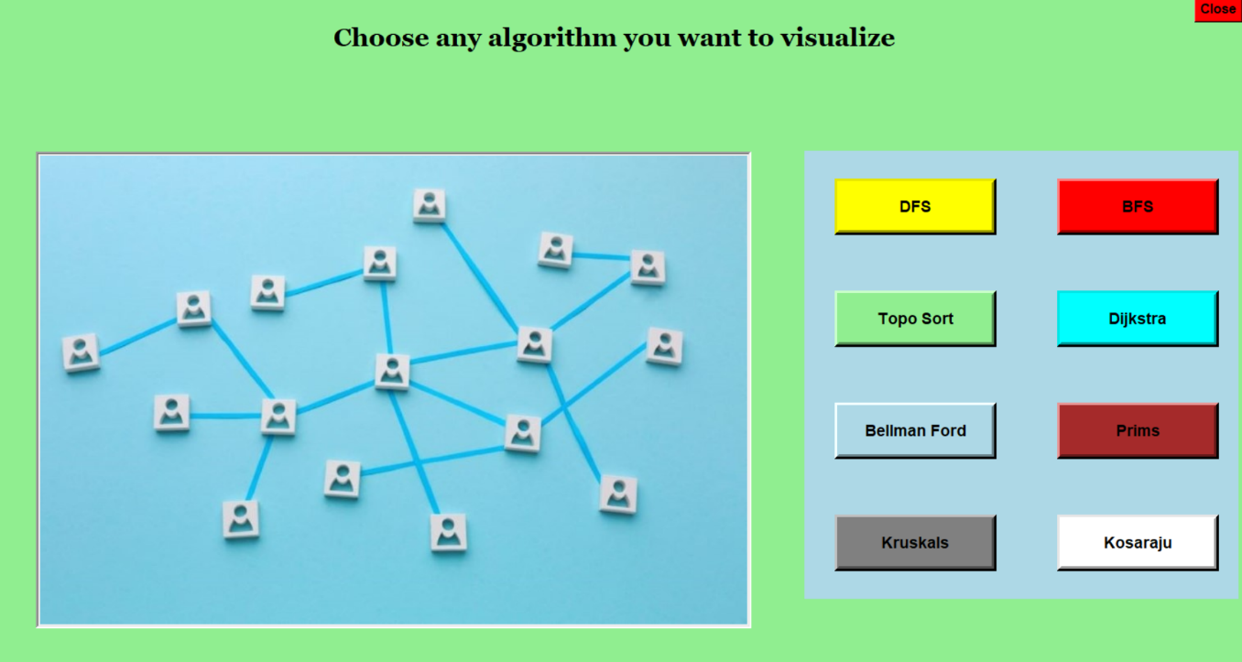
- Root Window (root):

  - The main window of the application.
  - Configured to be fullscreen with a lightgreen background.
  - Contains:
    - A title label ("Choose any algorithm you want to visualize").
    - An image displayed on the left side.
    - A frame (frame_buttons) on the right side containing buttons for each algorithm.
    - A close button at the top-right corner to exit the application.
- Algorithm Buttons:
  - Buttons for each algorithm (DFS, BFS, Dijkstra, etc.) are dynamically created in the frame_buttons frame.
  - Each button is associated with a script path and an algorithm name.
  - When clicked, the button triggers the open_initial_dialog function.
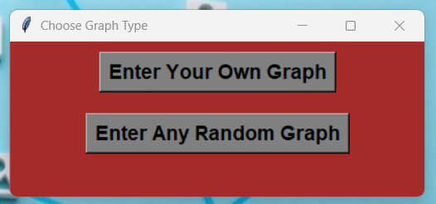
- Initial Dialog (open_initial_dialog):

  - A popup window that asks the user to choose between entering their own graph or using a random graph.
  - Contains two buttons:
    - "Enter Your Own Graph": Opens the input dialog for custom graph input; handle_own_graph().
    - "Enter Any Random Graph": Opens the input dialog for random graph input; handle_random_graph().
- Input Dialog (open_input_dialog):
  - A popup window where the user inputs graph details (e.g., vertices, edges, start/end nodes).
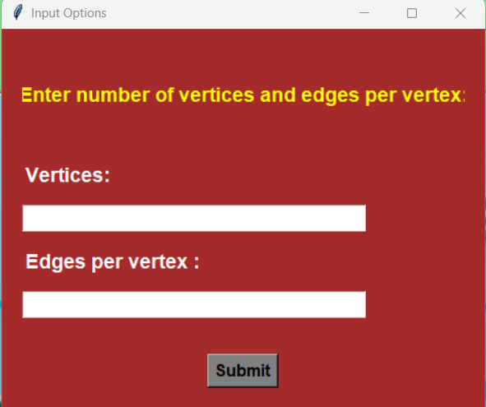
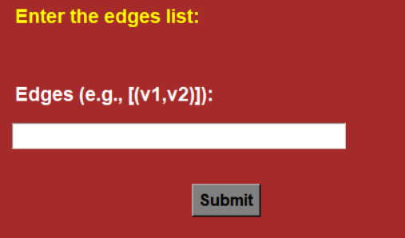
  - For own graph user enters the edge list [(v1,v2)] and for random graph user enter the number of vertices and edges per vertex.
  - For Dijkstra and Bellman ford we also enter the strt node and end node.
  - On submission, the submit function validates the input and calls execute_graph_algorithm.
- Algorithm Execution (execute_graph_algorithm):
  - Runs the selected algorithm's script using subprocess.Popen.
  - Passes the input parameters (edges, vertices, start/end nodes) as command-line arguments.
  - The argparse module in Python is used to handle command-line arguments. In your code, the execute_graph_algorithm function constructs a command to run an external Python script (the graph algorithm script) and passes input parameters (e.g., edges, vertices, start/end nodes) as command-line arguments. These arguments are then parsed in the external script using argparse.
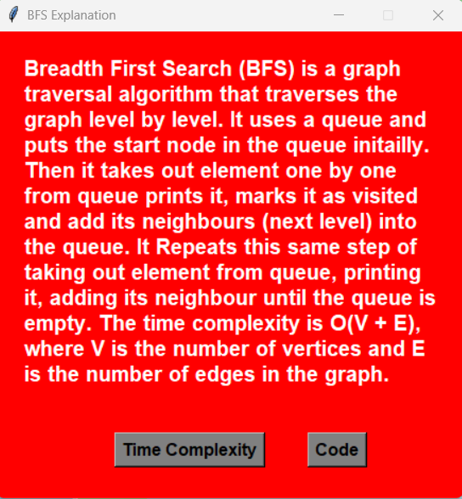
- Explanation Dialog (display_algorithm_explanation):

  - A popup window that displays a brief explanation of the selected algorithm.
  - Contains buttons to:
    - View the time complexity of the algorithm (display_algo_tc).
    - View the code of the algorithm (display_algorithm_code).
- Time Complexity and Code Display:
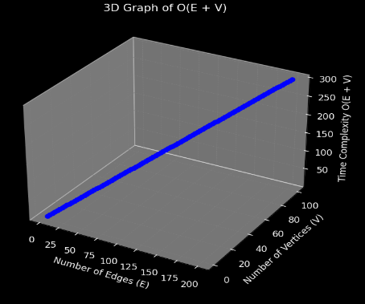
  - Time Complexity: Executes a script to display the tc of the algorithm.
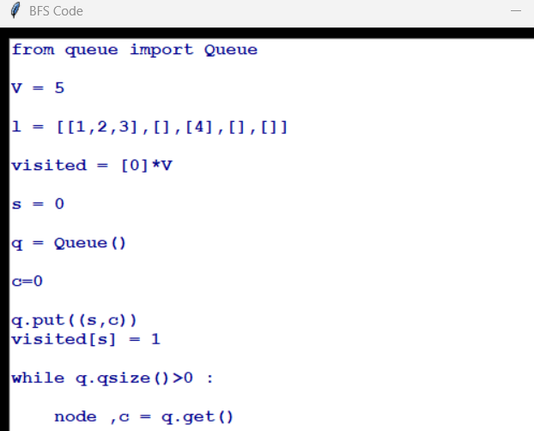
  - Code: Displays the Python code of the algorithm in a scrollable text widget.

2. Communication Between Components

- Button Click → Initial Dialog:
  - When an algorithm button is clicked, the open_initial_dialog function is called with the script path and algorithm name as arguments.
- Initial Dialog → Input Dialog:
  - Based on the user's choice (custom or random graph), the open_input_dialog function is called with the appropriate parameters.
- Input Dialog → Algorithm Execution:
  - The submit function in the input dialog validates the input and calls execute_graph_algorithm with the script path and input parameters.
- Algorithm Execution → Subprocess:
  - The execute_graph_algorithm function runs the algorithm script as a subprocess using subprocess.Popen.
- Explanation Dialog → Time Complexity and Code:
  - The explanation dialog provides buttons to view the time complexity and code of the algorithm, which are handled by display_algo_tc and display_algorithm_code, respectively.

3. Tkinter Methods and Their Usage
3.1. Main Window (root)
- tk.Tk(): Creates the main application window.
- root.configure(bg="lightgreen"): Sets the background color of the main window.
- root.attributes('-fullscreen', True): Makes the window fullscreen.
- root.mainloop(): Starts the Tkinter event loop.
3.2. Labels
- tk.Label(): Used to display text (e.g., title, instructions).
  - Example: title_label = tk.Label(root, text="Choose any algorithm...", font=("Georgia", 23, "bold"), fg="black", bg="lightgreen").
3.3. Buttons
- tk.Button(): Creates clickable buttons.
  - Example: button = tk.Button(frame_buttons, text="DFS", command=lambda: open_initial_dialog(script_path, "DFS")).
  - command: Specifies the function to call when the button is clicked.
3.4. Frames
- tk.Frame(): Used to group and organize widgets.
  - Example: frame_buttons = tk.Frame(root, bg="lightblue").
3.5. Popup Windows
- tk.Toplevel(): Creates a new window (e.g., initial dialog, input dialog, explanation dialog).
  - Example: initial_dialog = tk.Toplevel(root).
3.6. Entry Widgets
- tk.Entry(): Allows user input (e.g., vertices, edges, start/end nodes).
  - Example: edges_entry = tk.Entry(dialog, width=30).
3.7. Scrollable Text Widget
- scrolledtext.ScrolledText(): Displays scrollable text (used for showing algorithm code).
  - Example: code_text = scrolledtext.ScrolledText(code_dialog, wrap=tk.WORD, font=("Courier", 12)).
3.8. Message Boxes
- messagebox.showerror(): Displays error messages.
  - Example: messagebox.showerror("Invalid input", "Please enter valid numbers.").
3.9. Image Display
- ImageTk.PhotoImage(): Converts an image to a Tkinter-compatible format.
  - Example: image_tk = ImageTk.PhotoImage(image).
- tk.Label(): Displays the image.
  - Example: label_image = tk.Label(frame_image, image=image_tk).
3.10. Geometry Management
- pack(): Organizes widgets in blocks (e.g., title_label.pack(side=tk.TOP, pady=30)).
- grid(): Organizes widgets in a grid (e.g., button.grid(row=row, column=col, padx=37, pady=34)).
- place(): Places widgets at specific coordinates (e.g., button_close.place(relx=1.0, rely=0.0, anchor="ne")).
3.11. Event Handling
- protocol("WM_DELETE_WINDOW", callback): Specifies a function to call when the window is closed.
  - Example: explanation_dialog.protocol("WM_DELETE_WINDOW", close_dialogs).

3) Sorting.py and Scheduling.py: The structure is exactly same as above graph.py just there is change in function names like execute_graph_algorithms here become execute_sorting_algorithm or execute_scheduling_algorithm .

