GBA 5140 Statistics Essentials for Business Analytics

Problem Set 3

Probability Distribution

**Problem 1**

Automobile repair costs continue to rise with the average cost now at $367 per repair (U.S. News & World Report website, January 5, 2015). Assume that the cost for an automobile repair is normally distributed with a standard deviation of $88. Write R code to achieve the following tasks. ***Post your R code and RStudio output (console output) below each task.***

1. What is the probability that the cost will be more than $450?





1. What is the probability that the cost will be less than $250?
2. What is the probability that the cost will be between $250 and $450?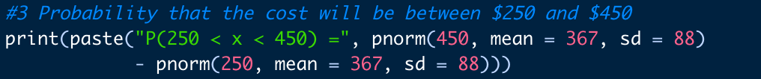Text

   Description automatically generated
3. If the cost of your car repair is in the lower 5% of automobile repair charges, what is your cost?