1. Introduction:
The purpose of this Project is to help people in selecting a good place of their new venue. It will help people making smart and efficient decision on selecting great neighborhood out of numbers of other neighborhoods in for their new business.
New York is a large city, and there is always a huge competition between all the venues, so selecting who are your competitors is a very important matter, this project is for helping people select who are their competitors.
This Project aim to create an analysis of features for people opening new venues in New York by searching for the best neighborhood for your new venue. The features include the average number of venues of the specified type in a neighborhood.
It will help people to get awareness of the area and neighborhood before opening their new venue to make people make better choices.

Data Section:
Data Link: https://data.cityofnewyork.us/City-Government/Neighborhood-Names-GIS/99bc-9p23
Will use data set of neighborhoods of New York, after manually removing some of the unneeded columns

Foursquare API Data:
We will need data about different venues in different neighborhoods. In order to gain that information we will use "Foursquare" API. Foursquare is a location data provider with information about all manner of venues and events within an area of interest. Such information includes venue names, locations, menus and even photos. As such, the foursquare location platform will be used as the sole data source since all the stated required information can be obtained through the API.
After finding the list of neighborhoods, we then connect to the Foursquare API to gather information about venues inside each and every neighborhood. For each neighborhood, we have chosen the radius to be 100 meter.
The data retrieved from Foursquare contained information of venues within a specified distance of the longitude and latitude of the postcodes. The information obtained per venue as follows:
1. Neighborhood
2. Neighborhood Latitude
3. Neighborhood Longitude
4. Venue
5. Name of the venue e.g. the name of a store or restaurant
6. Venue Latitude
7. Venue Longitude
8. Venue Category

3. Methodology Section
Using credentials of Foursquare API features of location of venues in each New York Neighborhood would be mined. Due to http request limitations the number of venues per neighborhood parameter would reasonably be set to 100 and the radius parameter would be set to 500.
After that we will choose the Borough with the least amount of the specified venue type and visualize it.

Results:

Lets say I wanted to open a restaurant in New York, These are the results i will get:

A map with all food related venues in New York marked
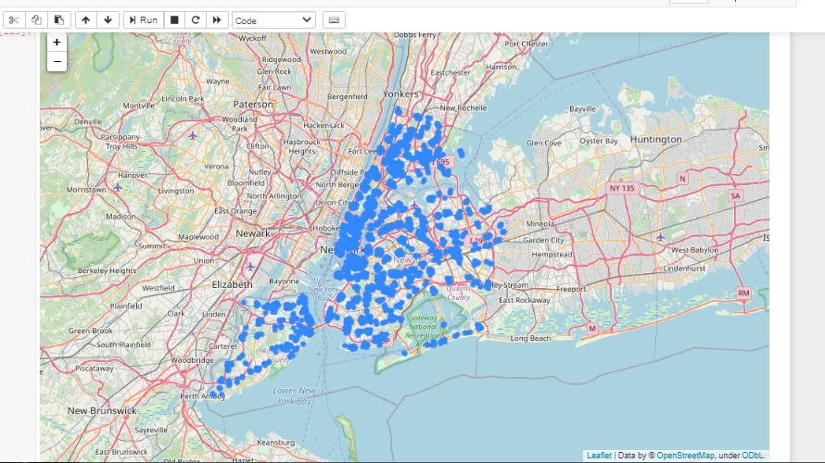

A Bar graph to visualize the number of venues in each Borough in New York
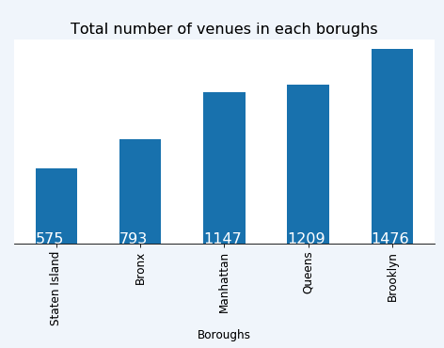

A Map to visualize the location of each venue in the Borough with the least amount of venues (Food Related in this Example)
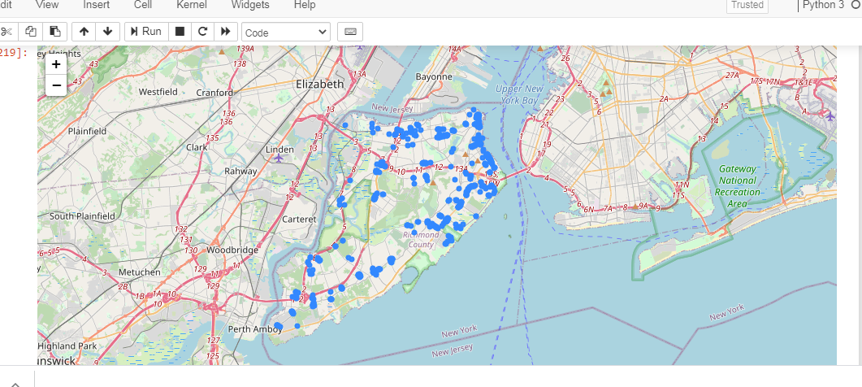

A Bar Graph to Visualize the number of venues in each neighborhood in the borough with the least amount of venues
