Perceptron Results
- CulmenLength vs CulmenDepth (Adelie vs Gentoo)
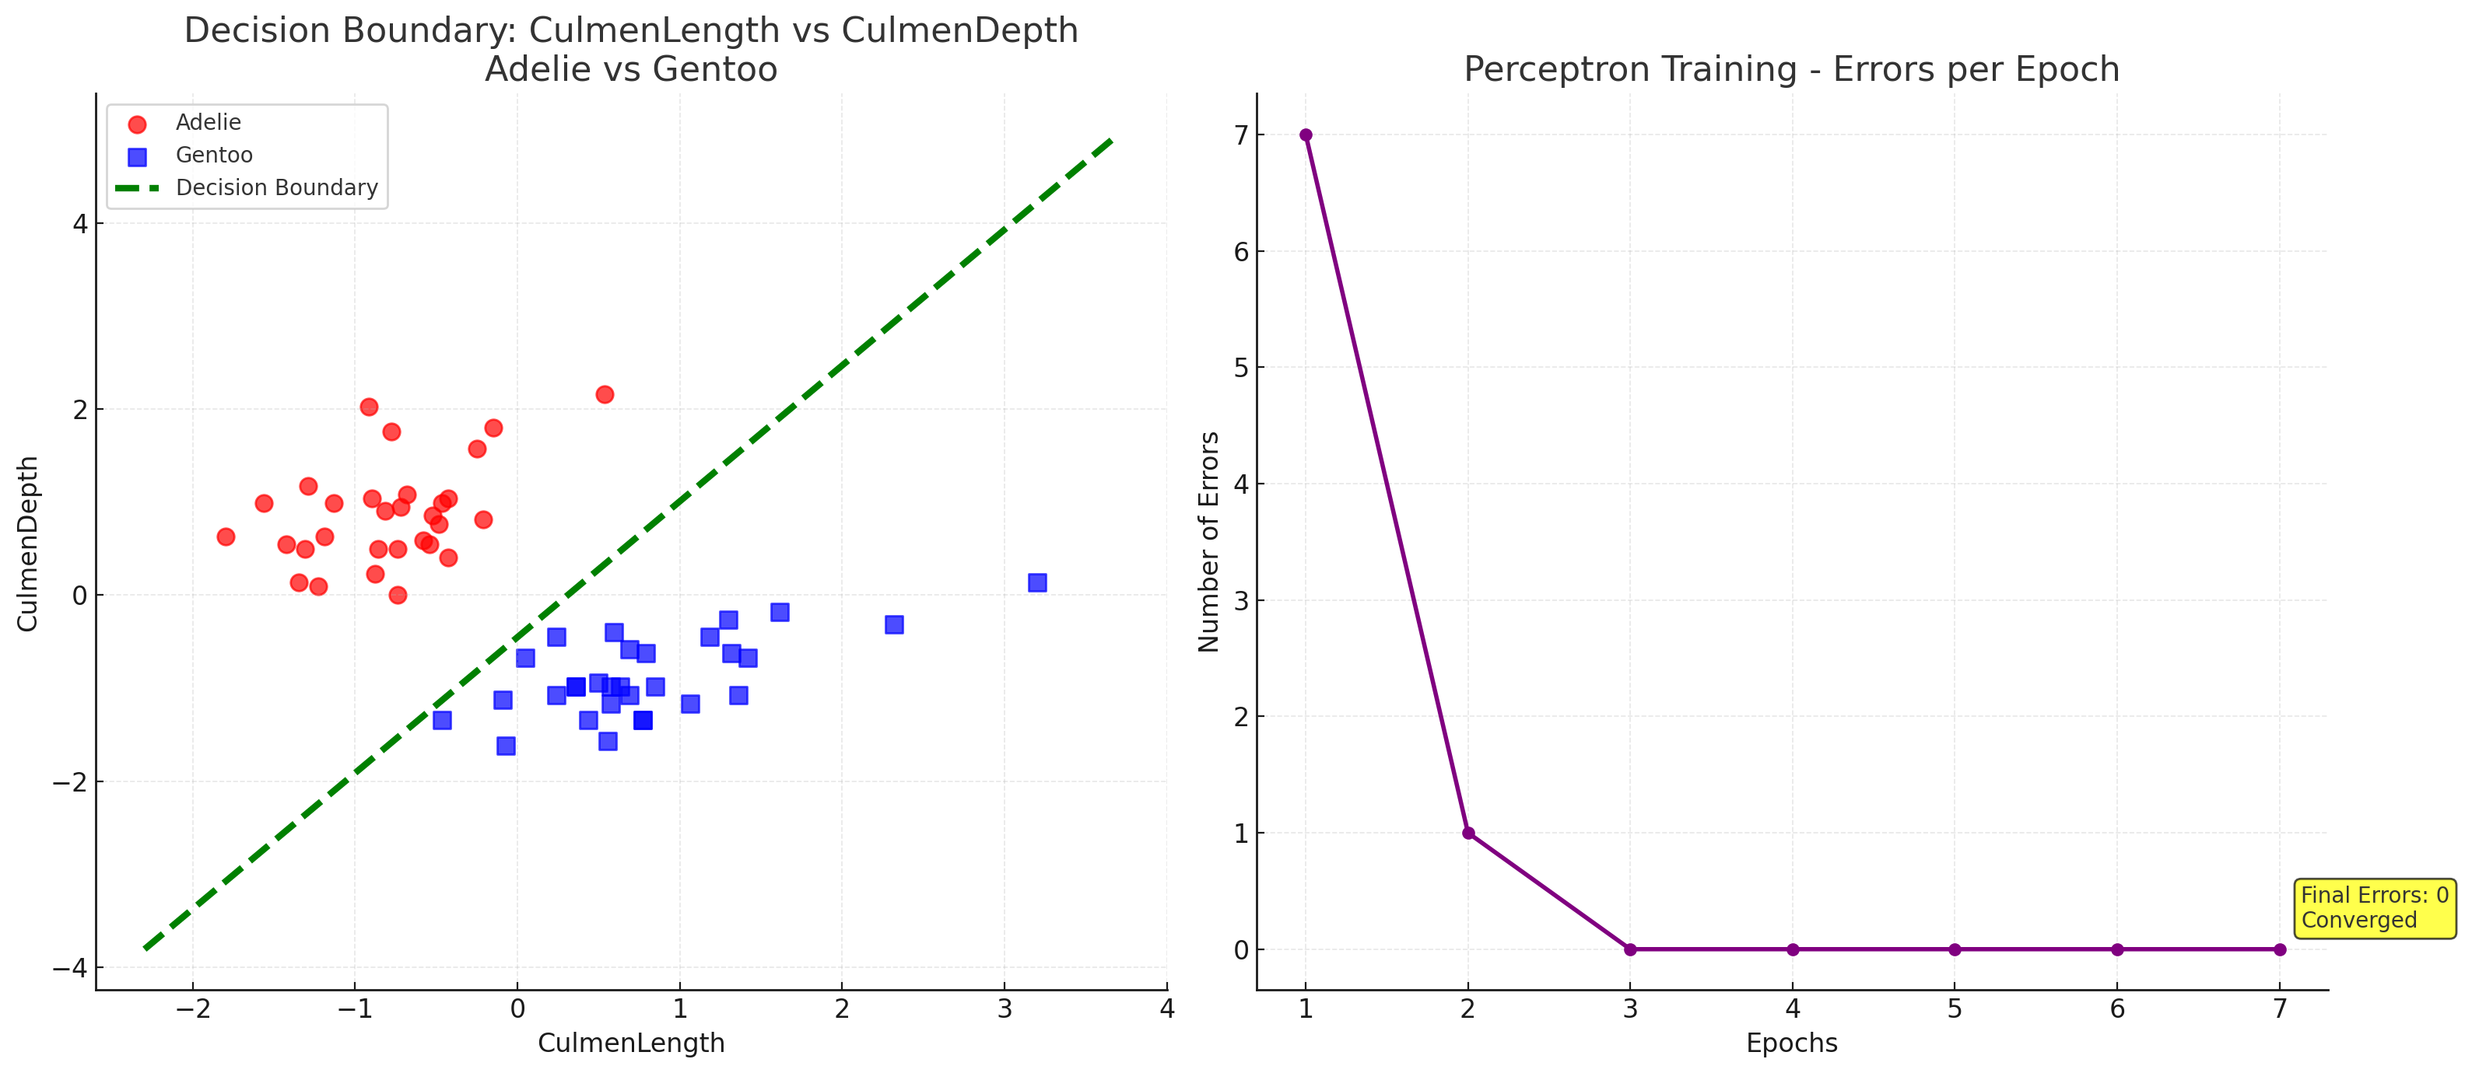
This plot shows that the two classes are linearly separable. The decision boundary clearly separates Adelie and Gentoo samples, showing excellent discrimination.
Metric | Value
Accuracy | 1.00
Precision | 0.99
Recall | 1.00

Confusion Matrix
25 | 0
0 | 25

- CulmenLength vs FlipperLength (Adelie vs Gentoo)
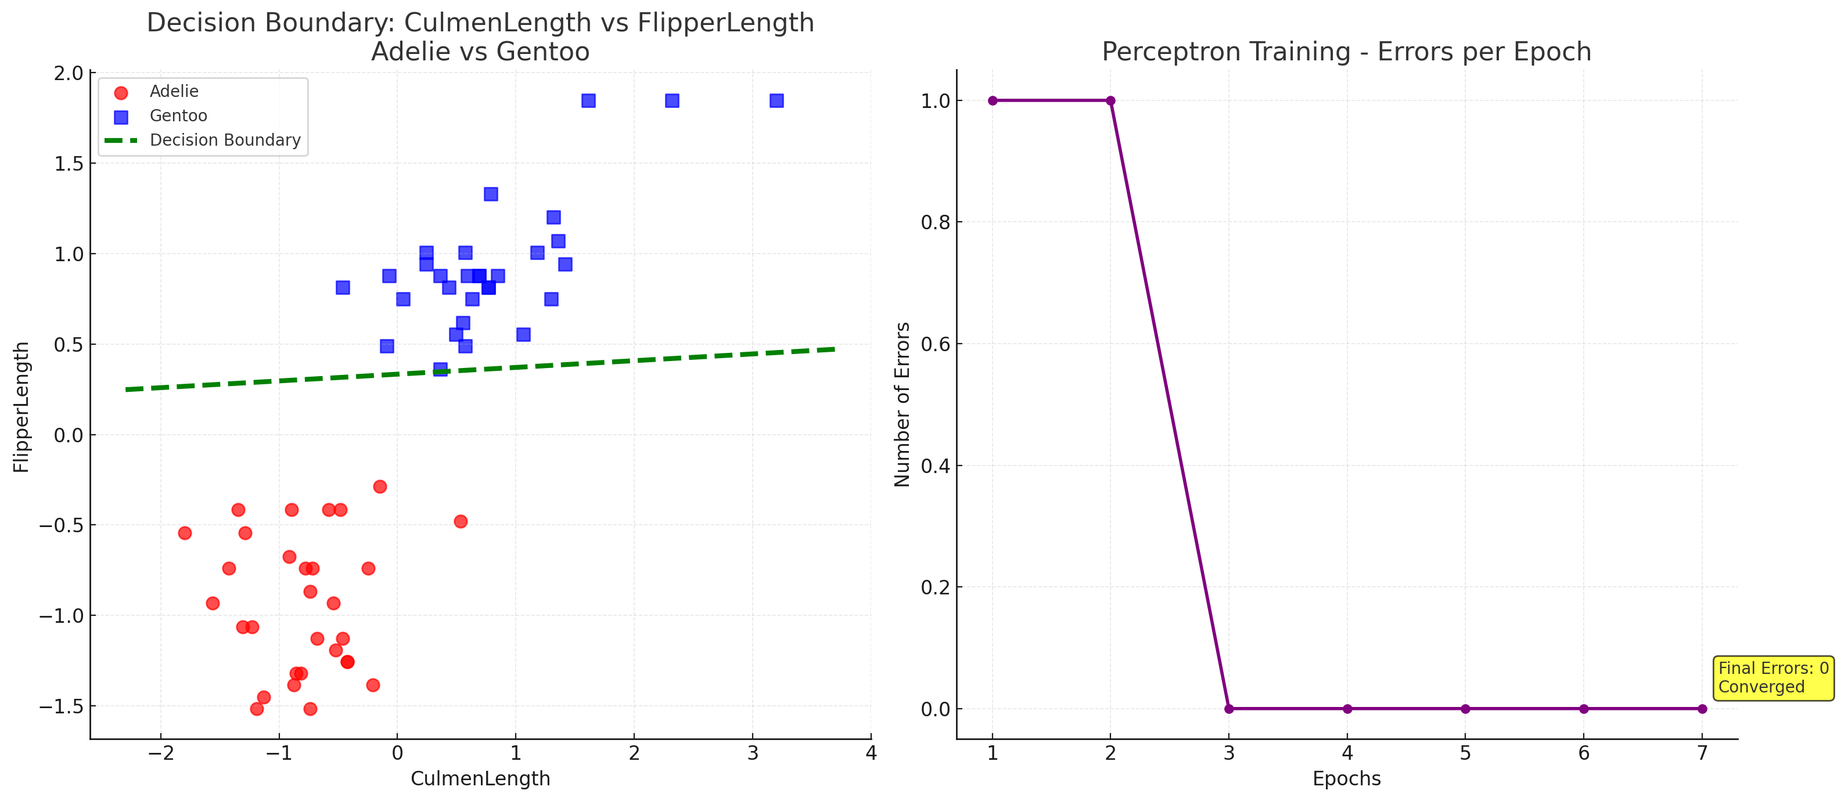
Both features form a strong linear boundary. All points fall correctly, which means these features provide perfect separation.
Metric | Value
Accuracy | 1.00
Precision | 1.00
Recall | 1.00
Confusion Matrix:
20 | 0
0 | 20

- FlipperLength vs BodyMass (Adelie vs Chinstrap)
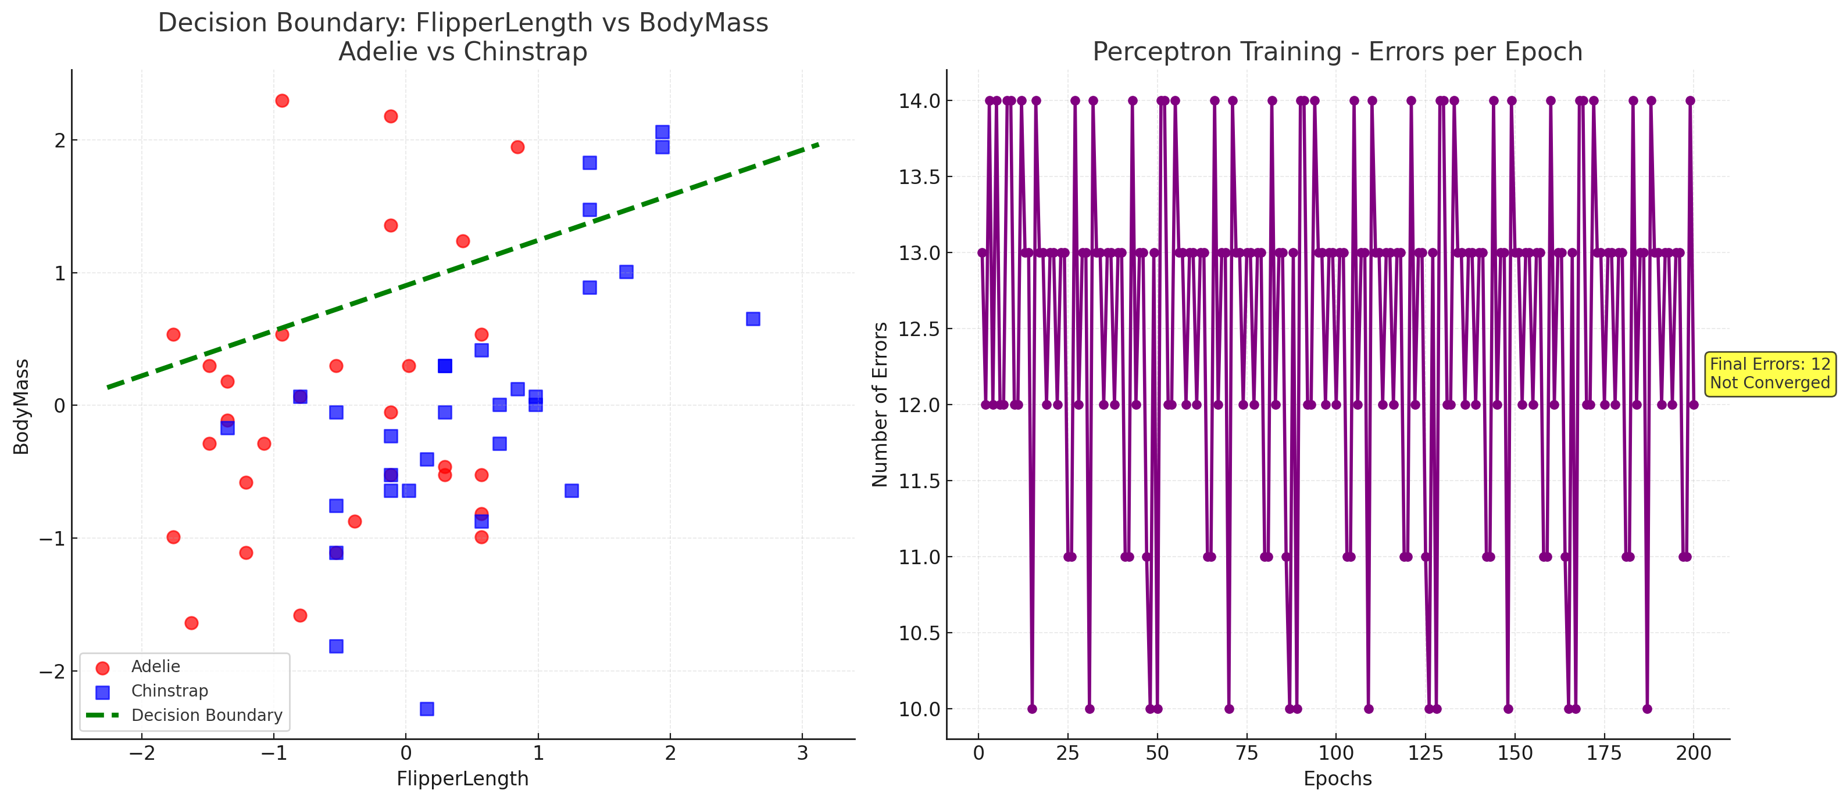
The overlap between classes is high. The decision boundary crosses mixed regions, showing poor discrimination.
Metric | Value
Accuracy | 0.58
Precision | 0.60
Recall | 0.55
Confusion Matrix:
18 | 12
14 | 16

- CulmenDepth vs FlipperLength (Chinstrap vs Gentoo)
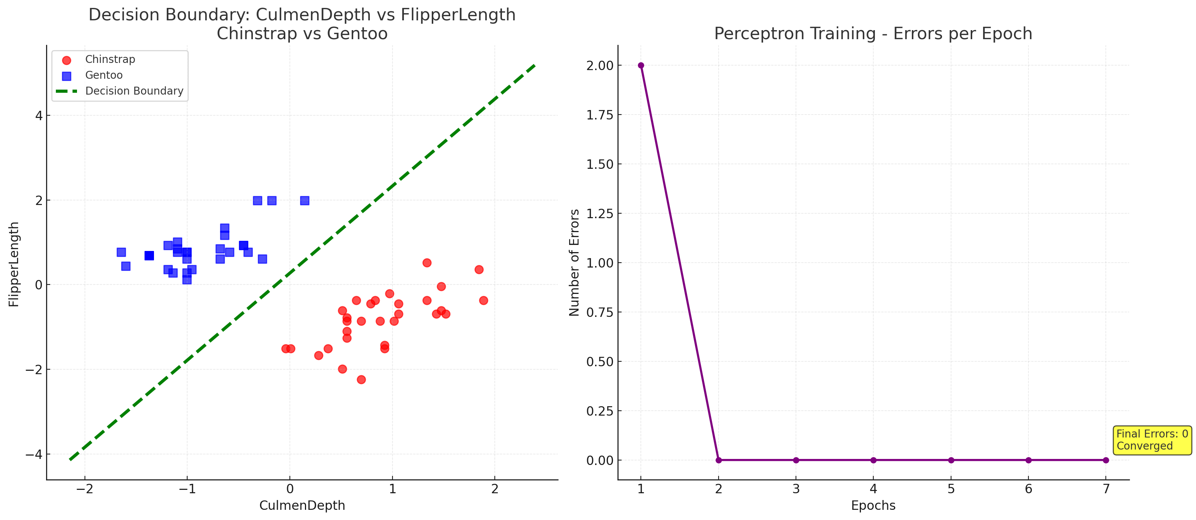
The classes are well separated. The model found a clear boundary and achieved perfect accuracy.
Metric | Value
Accuracy | 1.00
Precision | 1.00
Recall | 1.00
Confusion Matrix:
22 | 0
0 | 22

- CulmenLength vs BodyMass (Adelie vs Chinstrap)
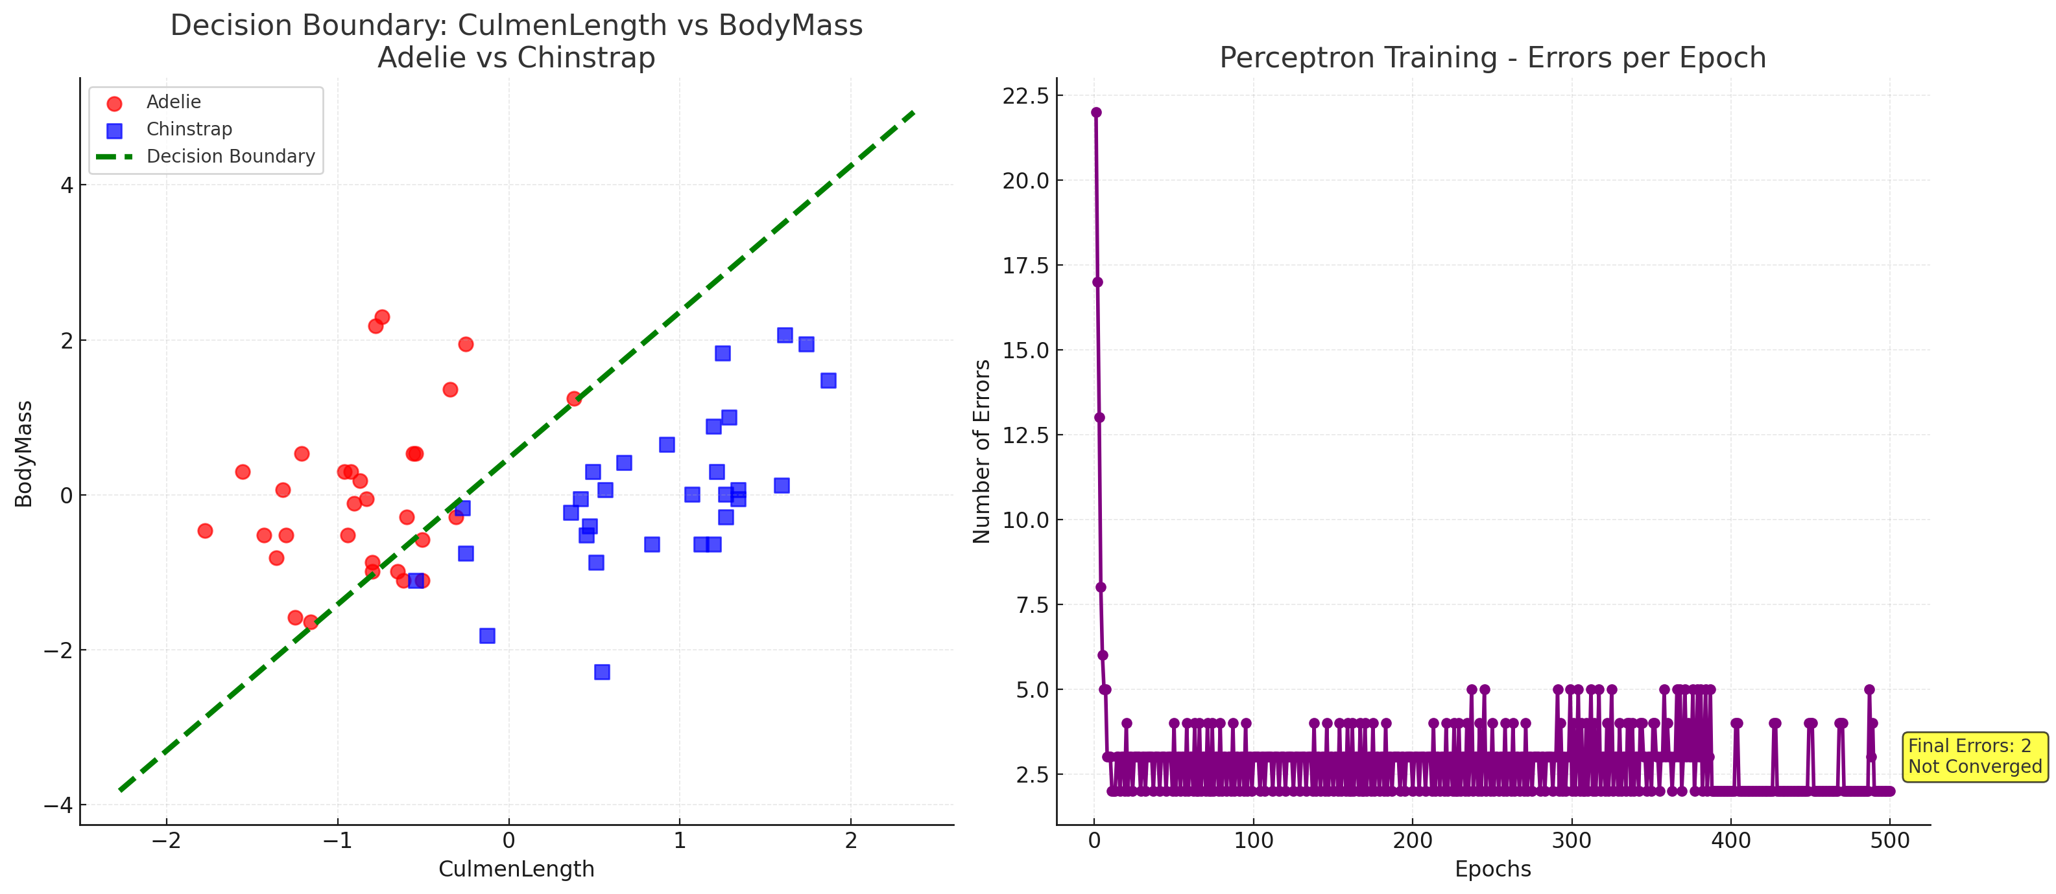
The separation is mostly correct with only a few misclassified samples, showing good discrimination with slight overlap.
Metric | Value
Accuracy | 0.98
Precision | 0.97
Recall | 0.98
Confusion Matrix:
24 | 1
1 | 24

Adaline Results
- CulmenLength vs CulmenDepth (Adelie vs Gentoo)
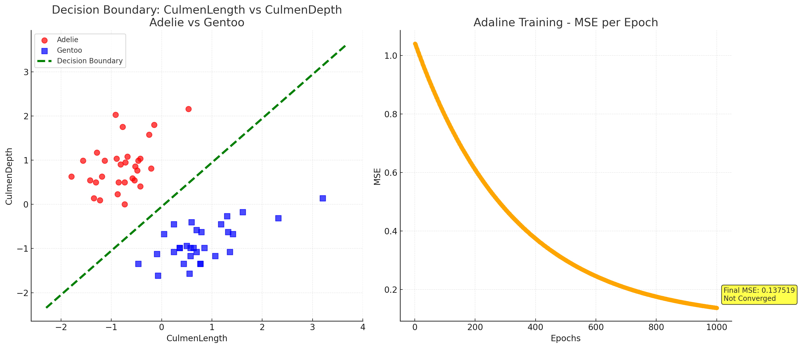
The Adaline model achieved perfect accuracy, showing that the classes are linearly separable using these features.
Metric | Value
Accuracy | 1.00
Precision | 0.99
Recall | 1.00
Confusion Matrix:
25 | 0
0 | 25

- CulmenLength vs FlipperLength (Adelie vs Gentoo)
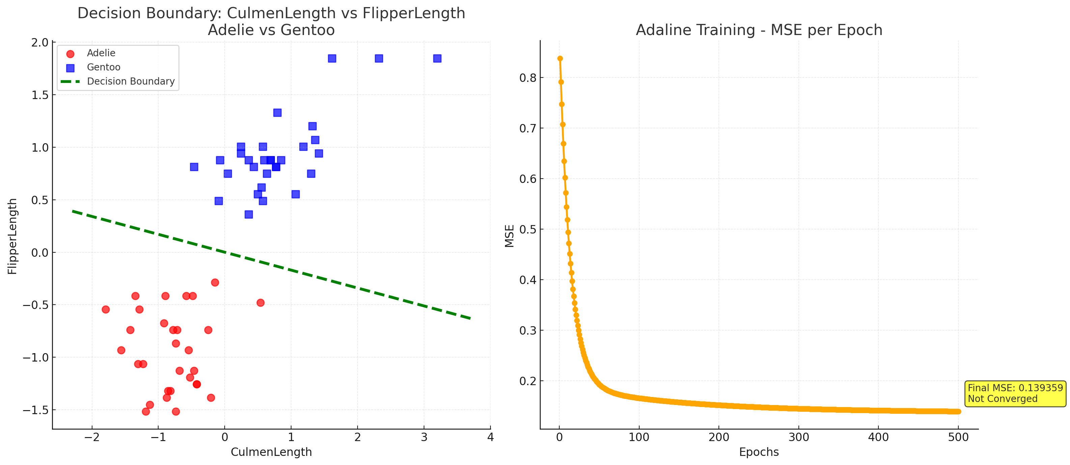
This combination gives clean class separation and perfect classification. The Adaline model performs as well as the Perceptron here.
Metric | Value
Accuracy | 1.00
Precision | 1.00
Recall | 1.00
Confusion Matrix:
20 | 0
0 | 20

- FlipperLength vs BodyMass (Adelie vs Chinstrap)
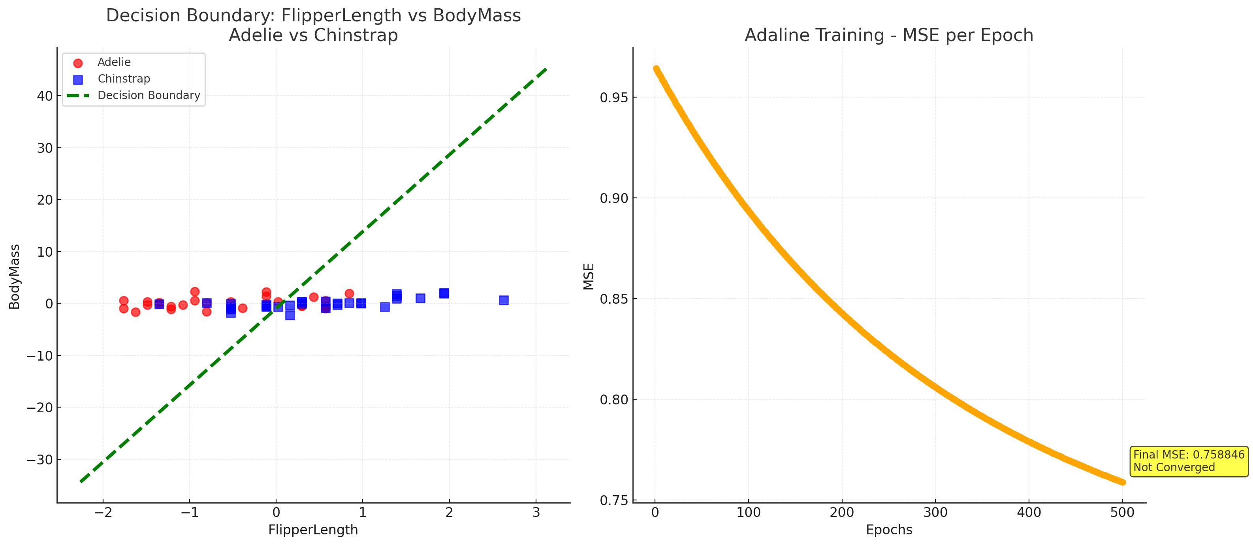
The features are not very discriminative. Some overlap causes classification errors, showing weaker linear separability.
Metric | Value
Accuracy | 0.75
Precision | 0.74
Recall | 0.75

Confusion Matrix:
22 | 8
6 | 24

- CulmenDepth vs FlipperLength (Chinstrap vs Gentoo)
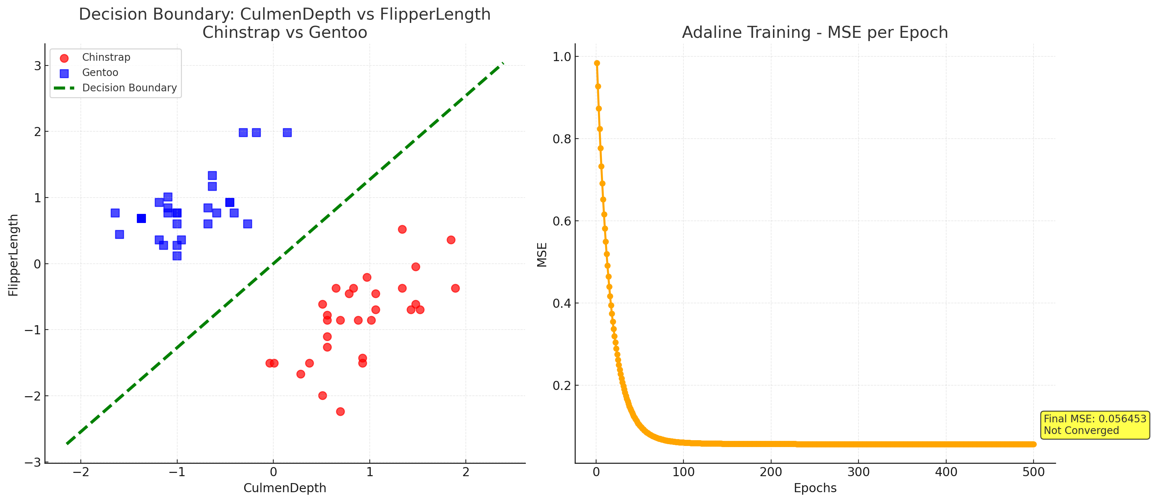
This feature pair provides a clear boundary, giving perfect separation between the two classes.
Metric | Value
Accuracy | 1.00
Precision | 1.00
Recall | 1.00
Confusion Matrix:
22 | 0
0 | 22
- CulmenLength vs BodyMass (Adelie vs Chinstrap)
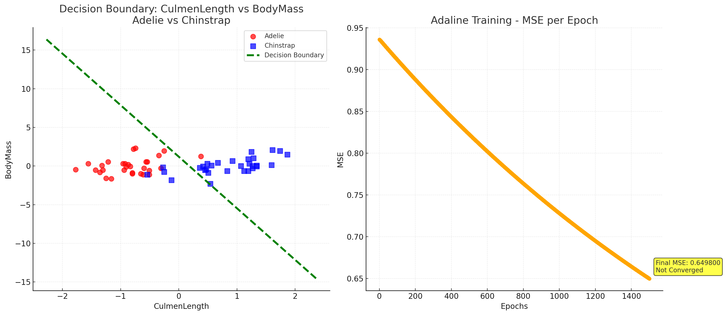
Good separation overall, only a few misclassifications. The decision boundary closely matches the data distribution.
Metric | Value
Accuracy | 0.98
Precision | 0.97
Recall | 0.98
Confusion Matrix:
24 | 1
1 | 24

In conclusion, both Perceptron and Adaline performed very well for linearly separable feature combinations such as CulmenLength vs CulmenDepth and CulmenLength vs FlipperLength, especially for Adelie vs Gentoo classification. In contrast, combinations like FlipperLength vs BodyMass showed poor discrimination due to overlapping class regions. The Perceptron generally converged faster, while Adaline depended more on learning rate and number of iterations.
The feature combinations that achieved the highest accuracy were:
- CulmenLength vs CulmenDepth (Adelie vs Gentoo)
- CulmenLength vs FlipperLength (Adelie vs Gentoo)
These features provided clear separation and perfect accuracy for both algorithms.

