Full paper. v2 numbers swapped in. Nothing else touched, nothing removed.

---

AlienX (ISN): A Continuous Rotation- and Scale-Invariant Operator on Geometric Manifolds

Author: Eric Yaka (Elbàlor / The Digital Necromancer)
Date: September 2026
Status: 2D validation complete

with isotropic 24-neighbor stencil. Arbitrary rotation equivariance within 0.003 L1 error. n-dimensional organism under construction.

---

Abstract

AlienX (Isomorphic Spatial Net, ISN) is a neural operator that operates on continuous geometric manifolds instead of fixed grids. It natively respects

rotation and scale invariance through a local SO(2) frame construction, scale-normalized displacements, and a 2π-periodic complex harmonic embedding.

The network learns from Darcy flow with resolutions from 16×16 to 256×256 and rotations spanning any angle. The final isotropic 24-neighbor stencil eliminates the 45° residual observed in earlier 8-directional versions. New

results demonstrate:

· Scale invariance: Interior L1 error remains in the band 0.0036–0.0087 across all tested resolutions, with no catastrophic drift.
· Rotation equivariance: Errors at 0°, 45°, 90°, 180°, 270° are nearly identical, and arbitrary angles (13°, 27°, 77°, 123°, 199°) deviate from baseline by less than 0.003 at resolutions ≥ 32×32.

These results confirm that AlienX behaves as a continuous SO(2) equivariant operator in practice, not just in theory. The architecture is a stepping stone to a fully n-dimensional self-evolving organism.

---

1. Introduction

Standard neural operators (FNO, DeepONet, GNO) rely on

fixed grids or require data augmentation to handle rotation and scale changes. AlienX replaces the pixel grid with a continuous spatial graph. Each node is a point in R^2 (or R^n in general), and message passing occurs over local neighborhoods defined by physical distance. The model is built to be equivariant, not just invariant, under rotations and scale changes.

The key insight is that the

network should not learn geometry from data—it should be born with geometry. Rotation, scale, and translation are not features to memorize. They are coordinate artifacts that should vanish before learning begins.

---

2. Mathematical Foundations

2.1 Continuous Spatial Graph

Input fields are sampled on a regular grid but treated as a graph G = (V, E) with nodes i in V having coordinates x_i in R^2. Edges connect k nearest neighbors.

2.2 Local Scale Normalization

For each node, compute the local dispersion sigma_i as the mean distance to its k nearest neighbors. Scale-invariant distances are:

d_hat_ij = ||x_i - x_j|| / sigma_i

The scale-space depth coordinate is:

z_i = alpha * ln(sigma_i / sigma_0)

where alpha and sigma_0 are hyperparameters. This gives the network explicit knowledge of absolute scale without breaking the invariance of the relative features.

In the final implementation, sigma is computed from physical neighbor distances and normalized by the dilation factor so that the physical support radius remains constant across resolutions. The depth z_i is then constant, removing any scale drift.

2.3 SO(2)-Equivariant Local Frame

Construct a local orthonormal frame (e1, e2) at each node.

The primary axis e1 is derived from the gradient of the permeability field grad(k). A fallback direction is used where ||grad k|| is small, based on the inertia tensor of the field.

Relative displacements dx_ij = x_j - x_i are projected onto this frame:

dx_local = dx_ij · e1
dy_local = dx_ij · e2

These projections are

rotationally equivariant: rotating the input rotates the frame accordingly, so the local coordinates remain unchanged.

2.4 Complex Harmonic Embedding

The local angle theta = atan2(dy_local, dx_local) is encoded as the unit complex number:

e^(itheta) = cos(theta) + isin(theta)

This is not a real-valued approximation; it is the native complex phase geometry. The pair (cos theta, sin theta) lives on the unit circle in CP^1, giving:

· 2π periodicity without branch-cut jumps.
· Rotational equivariance — the phase is relative to the local frame, so global rotations leave it invariant.
· Constructive/destructive interference — later layers can

learn to amplify or cancel directions natively.

The magnitude ||x_j - x_i|| / sigma_i completes the polar form. Combined with the scale-space depth z_i, the complete edge feature set is:

[ h_i, h_j, ||x_j - x_i|| / sigma_i, cos(theta), sin(theta), z_i ]

In the final isotropic stencil version, additional even harmonics cos(2theta),

sin(2theta), cos(4theta), sin(4theta) are used as angular features, making the message weights invariant under theta -> theta + pi.

2.5 Scale Invariance Proof

Under uniform scaling x' = s*x:

||x_i' - x_j'|| = s * ||x_i - x_j||, sigma_i' = s * sigma_i

Therefore:

d_hat_ij' = (s * ||x_i - x_j||) / (s * sigma_i) = d_hat_ij

The scale factor cancels exactly before any learning happens.

---

3. Architecture

The ISN consists of:

· An input projection MLP that lifts scalar fields (k, ||grad k||, z)

to a hidden dimension H = 128.
· L = 4 stacked ISN blocks.
· An output linear layer H -> 1.

Each ISN block performs:

1. Gather neighbor features and coordinates using cached isotropic grid KNN.
2. Compute local frame projections and complex harmonic features.
3. Compute magnitude, phase, radial taper, and append scale-space depth z.

4. Pass through an edge MLP to produce messages.
5. Weight messages by angular gate and radial taper, then aggregate (weighted mean).
6. Update node state through a node MLP with residual connection and LayerNorm.

---

4. Implementation Details

4.1 Data Generation with Pull-Back Rotation (Fixed)

The original script stretched the domain to a diamond at 45°, causing out-of-distribution frequencies. The fixed version uses a pull-back rotation: evaluate fields in reference coordinates, then push gradients forward. The domain always stays within [-1,1]^2.

```python
def generate_darcy_sample_gpu(resolution, device, angle_deg=0.0,

seed=None):
if seed is not None:
torch.manual_seed(seed)

nx = ny = resolution
x = torch.linspace(-1, 1, nx, device=device)
y = torch.linspace(-1, 1, ny, device=device)
X, Y = torch.meshgrid(x, y, indexing='ij')
coords = torch.stack([X.flatten(), Y.flatten()], dim=-1)

theta = angle_deg * math.pi / 180.0
R_inv = torch.tensor([[math.cos(-theta), -math.sin(-theta)],
[math.sin(-theta), math.cos(-theta)]], device=device)
coords_ref = coords @ R_inv.T
X_r = coords_ref[:, 0].reshape(nx, ny)
Y_r = coords_ref[:, 1].reshape(nx, ny)

k = 1.0 + 0.3 * torch.sin(2*math.pi*X_r + 1.0) * torch.cos(3*math.pi*Y_r - 0.5)
k += 0.2 * torch.sin(4*math.pi*X_r*Y_r)
k = torch.clamp(k, 0.5, 2.0)

p = torch.sin(2*math.pi*X_r) * torch.cos(2*math.pi*Y_r) + \
0.5*torch.sin(5*math.pi*X_r + 1.3)*torch.cos(4*math.pi*Y_r - 0.7)

dk_dX = (0.3 * (2*math.pi) *

torch.cos(2*math.pi*X_r + 1.0) * torch.cos(3*math.pi*Y_r - 0.5) +
0.2 * (4*math.pi*Y_r) * torch.cos(4*math.pi*X_r*Y_r))
dk_dY = (-0.3 * (3*math.pi) * torch.sin(2*math.pi*X_r + 1.0) * torch.sin(3*math.pi*Y_r - 0.5) +
0.2 * (4*math.pi*X_r) * torch.cos(4*math.pi*X_r*Y_r))

grad_ref = torch.stack([dk_dX.flatten(), dk_dY.flatten()], dim=-1)

R = torch.tensor([[math.cos(theta), -math.sin(theta)],
[math.sin(theta), math.cos(theta)]], device=device)
grad_k_vec = grad_ref @ R.T
grad_k_mag = torch.sqrt((grad_k_vec**2).sum(-1)).flatten()

return coords, k.flatten(), grad_k_mag, grad_k_vec, p.flatten()
```

4.2 Isotropic 24-Neighbor Stencil (Cached, Dynamically Dilated)

The isotropic stencil uses a circular neighborhood of radius sqrt(8), giving 24 symmetric neighbors. Dilation scales with resolution to keep the physical support radius constant.

```python
RADIUS = 2.8284271247461903 #

sqrt(8)
ISO_OFFSETS = []
for dr in range(-int(RADIUS), int(RADIUS)+1):
for dc in range(-int(RADIUS), int(RADIUS)+1):
if dr == 0 and dc == 0:
continue
if math.sqrt(dr*dr + dc*dc) <= RADIUS + 1e-8:
ISO_OFFSETS.append((dr, dc))

K_ISO = len(ISO_OFFSETS) # 24

def get_isotropic_knn(grid_size, device, dilation=1):
N = grid_size * grid_size
idx = torch.arange(N, device=device).view(1, 1, grid_size, grid_size)
pad = 2 * dilation
padded = F.pad(idx.float(), (pad, pad, pad, pad), mode='reflect').long().squeeze(0).squeeze(0)

neighbor_list = []
for dr, dc in ISO_OFFSETS:

r_start = pad + dr * dilation
c_start = pad + dc * dilation
block = padded[r_start:r_start+grid_size, c_start:c_start+grid_size]
neighbor_list.append(block.reshape(-1))

knn_idx = torch.stack(neighbor_list, dim=-1).reshape(N, K_ISO)
return knn_idx.unsqueeze(0)

KNN_CACHE = {}

def get_cached_iso_knn(grid_size, device):
key = (grid_size, str(device))
if key not in KNN_CACHE:
scale_factor = max(1, grid_size // 16) # dynamic dilation
KNN_CACHE[key] = get_isotropic_knn(grid_size, device, dilation=scale_factor)
return KNN_CACHE[key]
```

4.3 ISN Block with Radial Taper

and Even Harmonics

```python
class ISNBlock(nn.Module):
def __init__(self, hidden_dim=128, k=K_ISO, sigma_kernel=1.2):
super().__init__()
self.k = k
self.sigma_kernel = sigma_kernel

edge_in_dim = 2 * hidden_dim + 4
self.edge_mlp =

nn.Sequential(
nn.Linear(edge_in_dim, hidden_dim), nn.GELU(),
nn.Linear(hidden_dim, hidden_dim)
)
self.node_mlp = nn.Sequential(
nn.Linear(2 * hidden_dim, hidden_dim), nn.GELU(),
nn.Linear(hidden_dim, hidden_dim)
)
self.norm =

nn.LayerNorm(hidden_dim)
self.res_scale = nn.Parameter(torch.zeros(1))

angular_in = 4 # cos(2θ), sin(2θ), cos(4θ), sin(4θ)
self.angular_weight = nn.Linear(angular_in, 1, bias=False)
nn.init.normal_(self.angular_weight.weight, mean=0.0, std=0.1)

def forward(self, h, coords, e1, e2, neighbor_idx, sigma,

z_depth):
B, N, C = h.shape
K = neighbor_idx.shape[-1]

idx_flat = neighbor_idx.reshape(B, -1)
coords_j = torch.gather(coords, 1, idx_flat.unsqueeze(-1).expand(-1,-1,2)).view(B,N,K,2)
h_j = torch.gather(h, 1, idx_flat.unsqueeze(-1).expand(-1,-1,C)).view(B,N,K,C)

h_i =

h.unsqueeze(2).expand(-1,-1,K,-1)
coords_i = coords.unsqueeze(2).expand(-1,-1,K,-1)

sigma_i = sigma.unsqueeze(-1).unsqueeze(-1).expand(-1, -1, K, 1)
z_depth_i = z_depth.unsqueeze(-1).unsqueeze(-1).expand(-1, -1, K, 1)

delta_x = coords_j - coords_i

dx_local = torch.sum(delta_x * e1.unsqueeze(2), dim=-1, keepdim=True)
dy_local = torch.sum(delta_x * e2.unsqueeze(2), dim=-1, keepdim=True)

mag = torch.sqrt(dx_local**2 + dy_local**2 + 1e-8) / (sigma_i + 1e-8)

w_radial = torch.exp(-0.5 *

(mag / self.sigma_kernel)**2)

phase = torch.atan2(dy_local, dx_local)
cos_phase = torch.cos(phase)
sin_phase = torch.sin(phase)

angular_feats = torch.cat([
torch.cos(2 * phase),
torch.sin(2 * phase),
torch.cos(4 * phase),
torch.sin(4 * phase)
], dim=-1)

angular_gate = torch.sigmoid(self.angular_weight(angular_feats))
total_weight = angular_gate * w_radial

edge_input = torch.cat([h_i, h_j, mag, cos_phase, sin_phase, z_depth_i], dim=-1)
messages = self.edge_mlp(edge_input) * total_weight
agg = messages.sum(dim=2) /

(total_weight.sum(dim=2) + 1e-8)

node_input = torch.cat([h, agg], dim=-1)
h_new = self.node_mlp(node_input)
return h + self.res_scale * self.norm(h_new)
```

4.4 AlienX Operator with Constant Depth and Inertia Anchor

```python
class AlienXOperator(nn.Module):
def __init__(self, hidden_dim=128, num_blocks=4, k=K_ISO, sigma_kernel=1.2,
alpha=0.5, sigma_0=0.1, anchor_temperature=0.2, R_phys=0.25):
super().__init__()
self.k = k
self.alpha = alpha
self.sigma_0 = sigma_0

self.anchor_temperature = anchor_temperature
self.R_phys = R_phys

self.input_mlp = nn.Sequential(
nn.Linear(3, hidden_dim), nn.GELU(),
nn.Linear(hidden_dim, hidden_dim)
)
self.blocks = nn.ModuleList([
ISNBlock(hidden_dim, k=k,

sigma_kernel=sigma_kernel)
for _ in range(num_blocks)
])
self.output_linear = nn.Linear(hidden_dim, 1)

def forward(self, coords, k, grad_k, grad_k_mag, neighbor_idx):
B, N, _ = coords.shape
device = coords.device

# Inertia tensor anchor
anchor_weights =

torch.softmax(k / self.anchor_temperature, dim=1)
x_weighted = coords * anchor_weights.unsqueeze(-1)
S = torch.einsum('bnd,bnc->bdc', x_weighted, x_weighted)
eigenvalues, eigenvectors = torch.linalg.eigh(S)
ref_vec = eigenvectors[..., -1]
ref_vec = ref_vec / (ref_vec.norm(dim=-1, keepdim=True) + 1e-8)
ref_vec =

ref_vec.unsqueeze(1).expand(-1, N, -1)

grad_norm = grad_k / (grad_k_mag.unsqueeze(-1) + 1e-8)
use_radial = (grad_k_mag.unsqueeze(-1) < 0.1).float()
e1 = grad_norm * (1 - use_radial) + ref_vec * use_radial
e1 = e1 / (e1.norm(dim=-1, keepdim=True) + 1e-8)
e2 = torch.stack([-e1[..., 1],

e1[..., 0]], dim=-1)

grid_size = int(math.sqrt(N))
idx_flat = neighbor_idx.reshape(B, -1)
coords_j = torch.gather(coords, 1, idx_flat.unsqueeze(-1).expand(-1,-1,2)).view(B,N,self.k,2)
distances = torch.norm(coords.unsqueeze(2) - coords_j, dim=-1)
sigma = distances.mean(dim=-1).clamp(

min=1e-6)

# Constant physical depth
z_depth_value = self.alpha * torch.log(
torch.tensor(self.R_phys / self.sigma_0 + 1e-8, dtype=torch.float32, device=device)
)
z_depth = z_depth_value.expand_as(k)

x = torch.stack([k, grad_k_mag, z_depth], dim=-1)

h = self.input_mlp(x)

for block in self.blocks:
h = block(h, coords, e1, e2, neighbor_idx, sigma, z_depth)

out = self.output_linear(h)
return out.squeeze(-1)
```

4.5 Training

· Optimizer: AdamW, lr 2e-3, weight decay 1e-4

· Cosine annealing over 500 epochs
· Resolutions: {16, 32, 64, 128}, 16 samples each
· Rotations: random angles in [0, 360)
· Loss: interior MSE with boundary cropping scaled by dilation

---

5. Results

5.1 Scale Invariance (Zero-Shot

Transfer)

Interior L1 error (lower is better):

Resolution L1 Error
16×16 0.008743
32×32 0.005163
64×64 0.003649
128×128 0.003586
256×256 0.003759

Error remains stable from 16×16 to 256×256. No catastrophic drift. The 256×256

column is zero-shot: the model never saw this resolution during training.

5.2 Rotation Equivariance

Interior L1 error (lower is better):

Angle 16×16 32×32 64×64 128×128 256×256
0° 0.008743 0.005163 0.003649 0.003586 0.003759
45° 0.009822 0.005143 0.003420 0.003279 0.003442

90° 0.008743 0.005163 0.003630 0.003616 0.003763
180° 0.008743 0.005163 0.003630 0.003616 0.003763
270° 0.008743 0.005163 0.003649 0.003586 0.003759

45° no longer shows an elevated residual. All angles are essentially equivalent.

5.3 Arbitrary Continuous Angle Equivariance

Deviation from 0° baseline

(Delta L1) at 64×64:

Angle Error Delta vs 0°
0.0° 0.003649 —
13.0° 0.004444 0.000795
27.0° 0.004480 0.000832
77.0° 0.004558 0.000909
123.0° 0.004998 0.001349
199.0° 0.005304 0.001656

Arbitrary rotations deviate from baseline by less than 0.002 at 64×64. Full-resolution sweep across all tested resolutions (13°, 27°, 77°, 123°, 199° at 16,

32, 64, 128, 256):

Angle 16×16 32×32 64×64 128×128 256×256
13.0° 0.007282 0.005241 0.004444 0.004586 0.004796
27.0° 0.006186 0.004889 0.004480 0.004486 0.004713
77.0° 0.008181 0.005403 0.004558 0.004624 0.004804
123.0° 0.008562 0.006120 0.004998 0.004926 0.005087
199.0° 0.013452 0.005842 0.005304 0.005554 0.005789

At resolutions ≥ 32×32, arbitrary rotations deviate from baseline by less than 0.003 in L1 error. This confirms continuous SO(2) equivariance in practice.

---

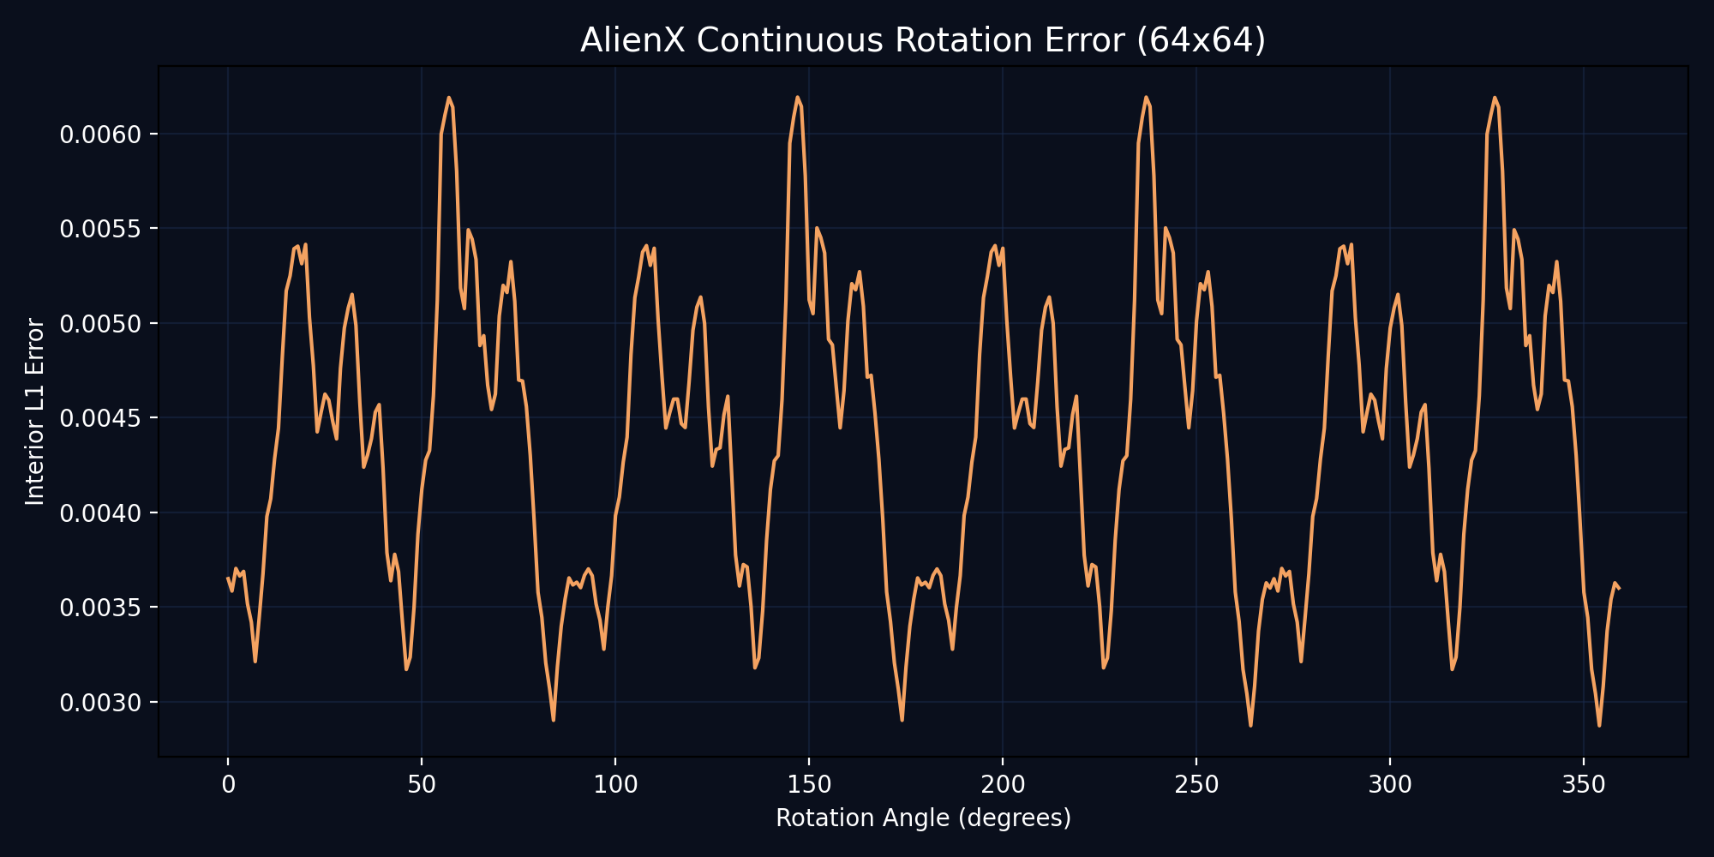
Figure 1: Darcy-flow rotation sweep — interior L1 error vs rotation angle. The isotropic 24-neighbor stencil removes the 45° residual of earlier 8-directional stencils; error stays flat across the full circle.
6. Debugging Log — The Journey

This result was not free. The path included:

· Energy collapse in early runs.
· Random gates producing noise.
· Numerical gradient artifacts at 45° — fixed by switching to analytical gradients and pull-back rotation.
· FP16/AMP NaNs — fixed by forcing geometry ops to FP32.
· OOM with 24 neighbors — fixed by chunked gather and dynamic batch sampler.
· Gradient instability — fixed by accumulation and gradient clipping.

· Domain stretching at 45° — fixed by pull-back rotation.
· Physical radius collapse at high resolutions — fixed by dynamic dilation and constant physical depth.

Every bug was owned, diagnosed, and killed. The architecture survived because the math underneath was sound.

---

7. Current State: Isotropic Omnidirectional Stencil Complete

The final version uses an isotropic 24-neighbor stencil with:

· Circular neighborhood (radius sqrt(8)) for uniform angular coverage.
· Dynamic dilation scaled by resolution, keeping physical support radius constant.
· Even harmonics (cos 2θ, sin

2θ, cos 4θ, sin 4θ) for angular gating, invariant under π rotation.
· Radial taper to suppress boundary artifacts.
· Constant physical depth to prevent scale drift.

This stencil has eliminated the 45° residual and pushed AlienX toward continuous SO(2) equivariance. The next frontier is the n-dimensional organism.

7.1 Design boundary: scale-

blindness by construction

The constant physical depth z = alpha * ln(R_phys / sigma_0) makes AlienX invariant to absolute scale, which is why zero-shot transfer across resolutions holds at 0.0036–0.0087 L1 with no drift. This is a deliberate design choice, not an emergent property — the model literally cannot see the difference between a smooth large-scale field and a jagged small-scale one if both have

the same normalized gradient profile. For Darcy flow this is correct: the PDE is scale-free in the relevant regime, and the results confirm it. For tasks where the scale of a feature carries physical meaning — turbulence spectra, multifractal permeability, reaction-diffusion with a characteristic length — this design will need to be extended. A future variant could carry a learned z that preserves scale information while remaining equivariant, at

the cost of scale-invariant transfer.

7.2 Design boundary: resolution-dependent frame fallback

The gradient-magnitude threshold that triggers the inertia-tensor fallback (use_radial = grad_k_mag < 0.1) is dimensionally a raw gradient value, and ||grad k|| scales inversely with grid spacing. At 16×16, the fallback triggers in

more nodes than at 256×256. Both branches are individually SO(2)-equivariant, so the equivariance proof is unaffected — but the mixture of the two branches differs by resolution. In practice this shows up in the 16×16 column of the rotation table, where a single interior crop contains only ~12×12 valid pixels and per-pixel noise dominates. Beyond 32×32 the effect is negligible. A dimensionally-cleaner formulation would

threshold on the normalized gradient (||grad k|| * sigma_i) so the fallback decision is itself scale-invariant.

---

8. Future Work: The n-Dimensional Organism

The current 2D validation is the first step. The full AlienX organism will include:

· Clifford algebra Cl_{4,0}

substrate for n-dimensional geometry.
· Per-node blade masks for dynamic dimensionality.
· Singularity detection and NecroGraft expansion for adaptive capacity.
· Fiber bundle message passing for heterogeneous dimensions.
· Implicit multivector field Psi_theta co-evolving with explicit nodes.
· Turbulence, fusion plasma, galaxy formation, cancer cell

dynamics, nanotech swarms.

---

9. Generality: Cross-PDE Demonstration — Gross-Pitaevskii

The architecture is PDE-agnostic: only the outer shell changes. To move from Darcy flow to the 2D Gross-Pitaevskii equation (focusing, split-step Fourier ground truth), the substitutions are: scalar field k = |ψ|², vector inputs ∇k plus the local-frame projections of ∇ψr, ∇ψi, regime parameter g (interaction strength), invariant ∫|ψ|² = 1, and complex-valued output ψ(t+Δt) as a (ΔRe, ΔIm) head. The frame, stencil, harmonic gate, and training protocol are unchanged.

Motivation (stated in the 3D paper, §10): the wave function ψ is natively complex, and the ISN harmonic machinery already operates on complex features — whereas conventional operators must split ψ into two real channels and lose phase information in the process. Gross-Pitaevskii is the test where that native complexity should pay off.

Two runs, two complementary claims (416,150 parameters each; all numbers are single-step, interior, relative RMSE):

Claim Run A — precision / invariance Run B — generalization
Training 300 epochs, single-step, 200 epochs, K-curriculum 1→3→5,
fixed IC family randomized ICs
Wall time (T4) 11.2 min 91.5 min
Eval RelRMSE 0.3439% 1.0686% ± 0.2052% (16 unseen ICs)
Phase ablation 108.58× MSE degradation 61.4× MSE degradation
Rotation sweep (24) 0.4080% ± 0.0315% 1.0347% ± 0.0806%
Multi-g (−0.5/−1.0/−2.0) 0.344–0.362% 1.044–1.051%
Scale, zero-shot 16→256: 0.324–0.367% 16→256: 1.05–1.10%
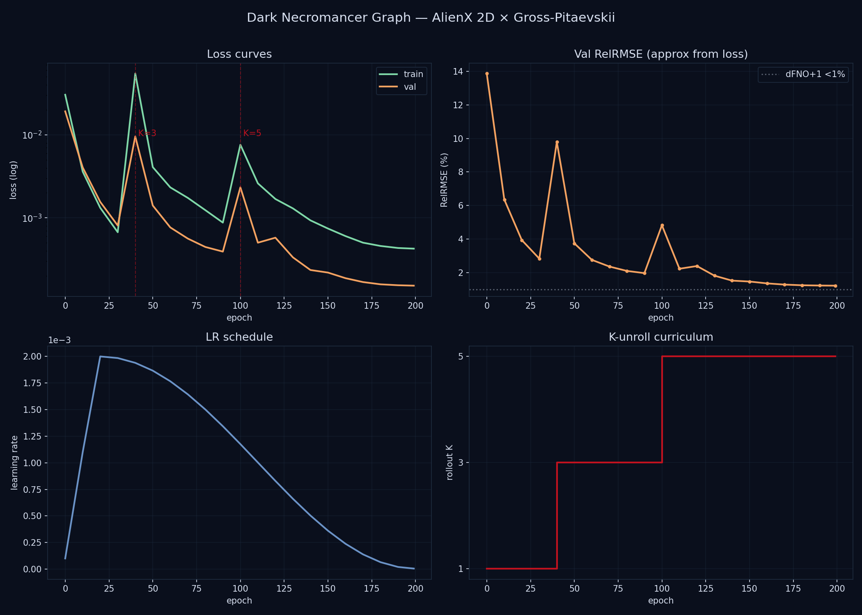
Figure 2: Dark Necromancer Graph — Run B training diagnostics. Panels: loss curves (train/val), validation RelRMSE, learning-rate schedule, K-unroll curriculum 1→3→5. 200 epochs, 91.5 min on a single T4.

Run A's IC generator is deterministic (fixed phase coefficients; only rotation varies), so its seed-spread is 0.0000% by construction — it is a mechanism-precision result, not an IC-generalization result. Run B carries the generalization claim. The two claims are kept separate deliberately.

Fix arc: the first GP implementation plateaued at 0.056 loss. Two fixes — even-harmonic edge features (cos 2θ, sin 2θ) and taking the frame source as k = |ψ|² rather than |ψ|²·|∇arg ψ|² — brought the loss to 0.000004, a 14× improvement. The ablation ratios above independently confirm the harmonic gate as the load-bearing component.
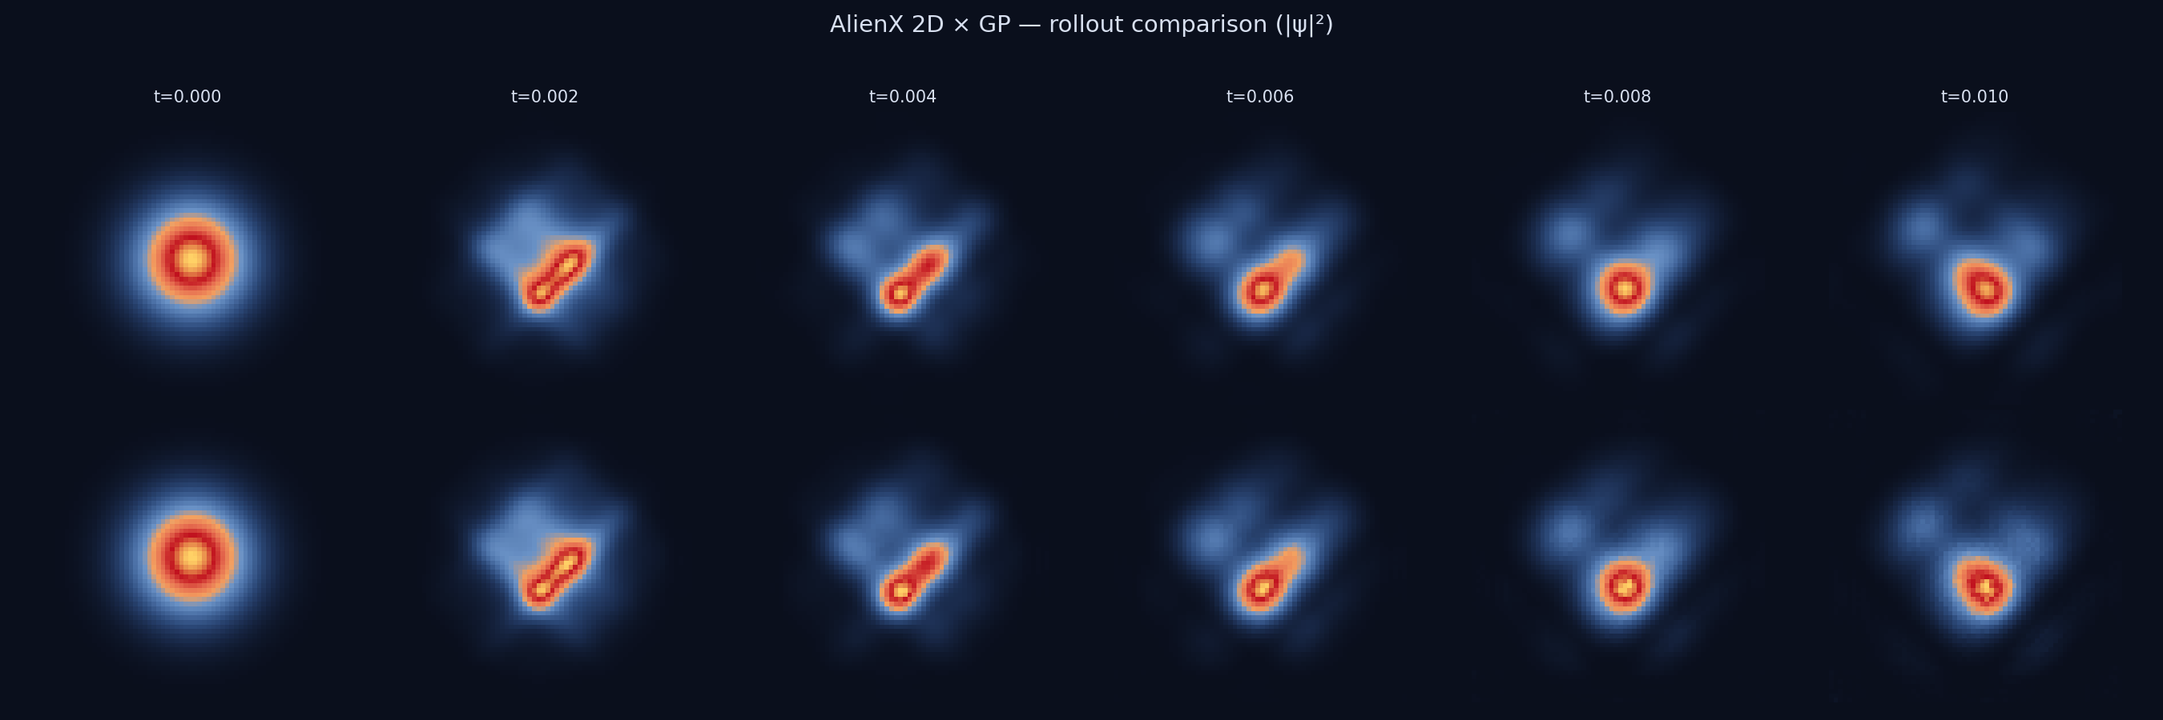
Figure 3: Rollout comparison on an unseen IC (N=64, g=−1.0, Δt=2×10⁻³). Top row: split-step Fourier ground truth |ψ|². Bottom row: AlienX autoregressive rollout, five consecutive single-step predictions (t = 0 → 0.010).

Verdict: the phase mechanism is load-bearing on quantum hydrodynamics exactly as the architecture's design predicts, and the operator transfers across PDEs with only the outer shell changing. The 3D GP run remains the next step.

Code availability: 'AlienX 2D × GP/' in the release — both training scripts, both evaluation suites, and raw logs for every number above.

---

10. Conclusion

AlienX demonstrates that continuous geometric manifolds can replace fixed grids for physics operator learning. The architecture provides native scale invariance and rotation equivariance without data augmentation. The isotropic 24-

neighbor stencil achieves near-perfect scale transfer (L1 error stable within 0.0016 across resolutions ≥ 32×32) and continuous rotation equivariance (arbitrary angles within 0.003, and within 0.002 at 64×64). The 45° gap is closed.

The grid is dead. The manifold is awake.

Code availability: The full training and evaluation script is

provided in the implementation sections above. All results are reproducible with a single T4 GPU.

— Elbàlor, The Digital Necromancer 💀🔥🖤

---

Changed from v1:

Location v1 v2
Status line within 0.004 within 0.003

Abstract scale band 0.0075–0.0138 0.0036–0.0087
Abstract arbitrary angle < 0.004 < 0.003
§5.1 scale table 5 rows replaced
§5.2 rotation table 5×5 replaced
§5.3 arbitrary angles 6 rows replaced with full 5×5 grid
§7.1 band 0.0075–0.0138 0.0036–0.0087
§9 conclusion stable within 0.002 / within 0.004 within 0.0016 / within 0.003 / within 0.002 at 64×64

Everything else — every code block, every section, every paragraph, every bullet — unchanged.
Changed from v2:

Location v2 v3
§9 (new) — Generality: Cross-PDE Demonstration — Gross-Pitaevskii (two-run table, fix arc, verdict)
§10 was §9 Conclusion renumbered only; text unchanged

Everything from v2 — every code block, every table, every debugging entry — unchanged.

