Prosper Loan Data

In this project I looked into the loan dataset. I was mostly looking into relationships between default loans and other variables to try to find a link. This could possibly help to reduce the default loans in the future.
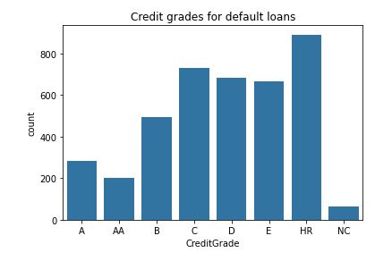
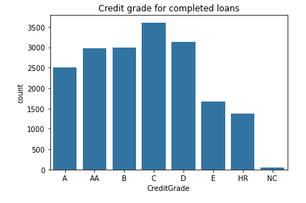
The credit grade system stopped being used so wasn't available for current loans. However, there was a clear link between high risk graded loans and the loan being defaulted.

As shown in the plots above and below, the distributions are different from the completed loans compared to the default loans. A bigger sample size will be needed for the default loans but there is a clear relationship between credit grades and whether the loan defaults or not.
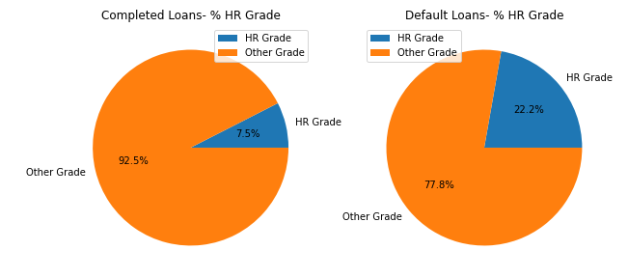
There was some relationships in APR but not enough to draw conclusions. A higher APR did indicate a higher chance of the loan being defaulted.
As credit grades are not used for the current loans, I looked at prosper scores yet to see if the current loans could be high risk. In terms on APR it didn't looked like they were high risk, as they were lower as a group. The prosper score did show that a large proportion of the current loans could be somewhat high risk.

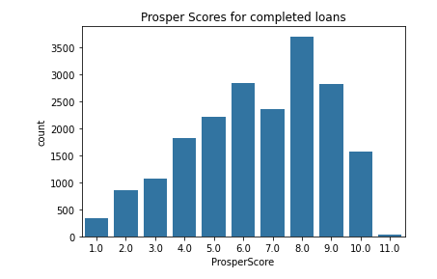

As seen in the plot above, you can see that prosper score could be a pretty good indication of whether the loan will be completed.
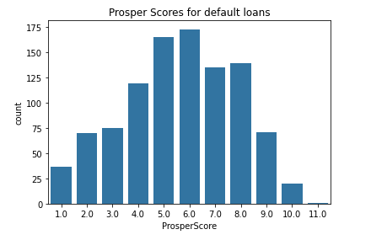
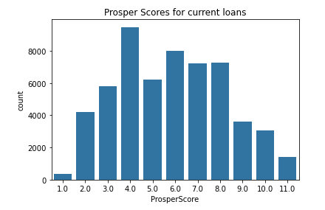
The above plots are for the scores from default loans and current loans. You can see that a large portion of the current loans are to people with a score of 6, so this could be potentially something to look at as the data suggests this is the score with the highest defaults. 17.2% of defaulted loans had a score of 6 and currently 14.1% (figures taken from code) had this score.

