## About Spacewalk

<https://www.unixmen.com/install-and-configure-spacewalk-in-centos-7/>

**Spacewalk** is a free, open source Linux management system. It is upstream community project for **Red Hat Satellite server**. Using Spacewalk, we can deploy, manage and update packages to Red Hat derived distributions like CentOS, Fedora, and Scientific Linux etc. It has a cool web interface that will help us to view the status of software updates in the clients and initiate update actions. Spacewalk provides provisioning capabilities that enables you to kickstart provision systems and manage and deploy configuration files. It also has virtualization capabilities to enable you to provision, control, manage, and monitor virtual KVM and Xen guests.

**Spacewalk Proxy**, the upstream version of **Red Hat Satellite Proxy** product, connects to your central Sapcewalk server and caches the contents from the Central server. Then, it distributes the contents to various geographical locations and reduces the load of the Central Spacewalk server. So, eventually, it reduces the downtime and increases the download speed for the client systems.

In this tutorial let us see how to install spacewalk and how to configure it in CentOS 7 64bit server. The same steps will work on Fedora and Scientific Linux distributions.

## Features

Using Spacewalk, you can:

* Inventory your systems (hardware and software information) ;
* Install and update software on your systems ;
* Collect and distribute your custom software packages into manageable groups ;
* Provision (kickstart) your systems ;
* Manage and deploy configuration files to your systems ;
* Provision and start/stop/configure virtual guests ;
* Distribute content across multiple geographical sites in an efficient manner ;
* And many.

## Install Spacewalk in CentOS 7

My testing machine details are given below:

* **Operating System** : CentOS 7 minimal installation ;
* **Hostname** : server1.unixmen.local ;
* **IP Address** : 192.168.1.150/24.

Before installing Spacewalk, we need to add some additional repositories that will help us to get some important dependencies which are not available in the Spacewalk official repository.

#### First, add EPEL repository:

Run the following command from your terminal to add and enable EPEL repository:

yum install epel-release

#### Add JPackage repository:

Run the following command from your Terminal to add JPackage repository:

cat > /etc/yum.repos.d/jpackage-generic.repo << EOF[jpackage-generic]name=JPackage generic#baseurl=http://mirrors.dotsrc.org/pub/jpackage/5.0/generic/free/mirrorlist=http://www.jpackage.org/mirrorlist.php?dist=generic&type=free&release=5.0enabled=1gpgcheck=1gpgkey=http://www.jpackage.org/jpackage.ascEOF

#### Add Spacewalk repository:

Add Spacewalk official repository as shown below depending upon the distribution you use. As of writing this tutorial, the latest Spacewalk version was **2.3**.

**On RHEL/CentOS/Scientific Linux 6:**

rpm -Uvh <http://yum.spacewalkproject.org/2.3/RHEL/6/x86_64/spacewalk-repo-2.3-4.el6.noarch.rpm>

**On RHEL/CentOS/Scientific Linux 7:**

rpm -Uvh <http://yum.spacewalkproject.org/2.3/RHEL/7/x86_64/spacewalk-repo-2.3-4.el7.noarch.rpm>

**Fedora 20:**

rpm -Uvh <http://yum.spacewalkproject.org/2.3/Fedora/20/x86_64/spacewalk-repo-2.3-4.fc20.noarch.rpm>

**Fedora 21:**

rpm -Uvh <http://yum.spacewalkproject.org/2.3/Fedora/21/x86_64/spacewalk-repo-2.3-4.fc21.noarch.rpm>

Since, I am using CentOS 7, I added the Spacewalk repository for CentOS 7.

Now, update the repository lists using command:

yum repolist && yum update

#### Install database server:

Spacewalk needs a database server to store it’s primary data. By default, Spacewalk uses an embedded PostgreSQL database. Also, you can use Oracle RDBMS (version 10g or higher) if you want.

We will go with defaults. Install postgreSQL database for Spacewalk using command:

yum install spacewalk-setup-postgresql

#### Install Spacewalk:

Now, install Spacewalk server using command:

yum install spacewalk-postgresql

#### Configure Firewall:

After installing Spacewalk, you need to allow few ports via your Firewall and router.

firewall-cmd --add-service=https --permanentfirewall-cmd --add-service=http --permanent

Also, add port **5222** if you want to push actions to client machines and **5269** for push actions to a Spacewalk Proxy, **69** udp if you want to use **tftp**.

Finally, restart firewall service using command:

firewall-cmd --reload

The installation part is over. Let us go and configure Spacewalk server.

## Configure Spacewalk server

Your Spacewalk server must have a valid FQDN like **server.example.com**. In case your server fails to resolve it’s hostname, edit **/etc/hosts** file and add Spacewalk server’s hostname and IP address manually.

Here is my **/etc/hosts** file output:

127.0.0.1 localhost localhost.localdomain localhost4 localhost4.localdomain4::1 localhost localhost.localdomain localhost6 localhost6.localdomain6**192.168.1.150 server1.unixmen.local server1**

Also, during Spacewalk configuration, you’ll be asked to enter a password for the Spacewalk database user. Please don’t use **‘#’** (number sign/pound/hash) and **‘@’** in your database password otherwise installation will fail.

Well, run the following command to configure the Spacewalk server:

spacewalk-setup --disconnected

**Sample output:**

* Setting up SELinux..** Database: Setting up database connection for PostgreSQL backend.** Database: Installing the database:** Database: This is a long process that is logged in:** Database: /var/log/rhn/install_db.log*** Progress: ###** Database: Installation complete.** Database: Populating database.*** Progress: ############################* Configuring tomcat.* Setting up users and groups.** GPG: Initializing GPG and importing key.** GPG: Creating /root/.gnupg directoryYou must enter an email address.Admin Email Address? [sk@unixmen.com](mailto:sk@unixmen.com) **## Enter your Email ##**\* Performing initial configuration.* Activating Spacewalk.** Loading Spacewalk Certificate.** Verifying certificate locally.** Activating Spacewalk.* Configuring apache SSL virtual host.Should setup configure apache's default ssl server for you (saves original ssl.conf) [Y]? **## Press Enter ##**\*\* /etc/httpd/conf.d/ssl.conf has been backed up to ssl.conf-swsave* Configuring jabberd.* Creating SSL certificates.CA certificate password? **## Enter certificate password ##**Re-enter CA certificate password? **## Re-enter theassword ##**Organization? Unixmen **## Enter your Organization ##**Organization Unit [server1.unixmen.local]? **## Verify your hostname and press Enter ##**Email Address [[sk@unixmen.com](mailto:sk@unixmen.com)]? **## Enter your Email Id ##**City? Erode **## Enter city ##**State? Tamilnadu **## Enter your state ##**Country code (Examples: "US", "JP", "IN", or type "?" to see a list)? IN **## Enter Country code ##**\*\* SSL: Generating CA certificate.** SSL: Deploying CA certificate.** SSL: Generating server certificate.** SSL: Storing SSL certificates.* Deploying configuration files.* Update configuration in database.* Setting up Cobbler..Cobbler requires tftp and xinetd services be turned on for PXE provisioning functionality. Enable these services [Y]? **## Press Enter ##**\* Restarting services.Installation complete.Visit [**https://server1.unixmen.local**](https://server1.unixmen.local) to create the Spacewalk administrator account.

Spacewalk server has been configured now. Now, let us go ahead and set up the password for the Spacewalk administrator account.

Open up your web browser and navigate to [**https://hostname/**](https://hostname/) or [**https://ip-address/**](https://ip-address/).

Enter the administrator account name, password, first name, last name and Email address etc. Then, click **Create Login** button.

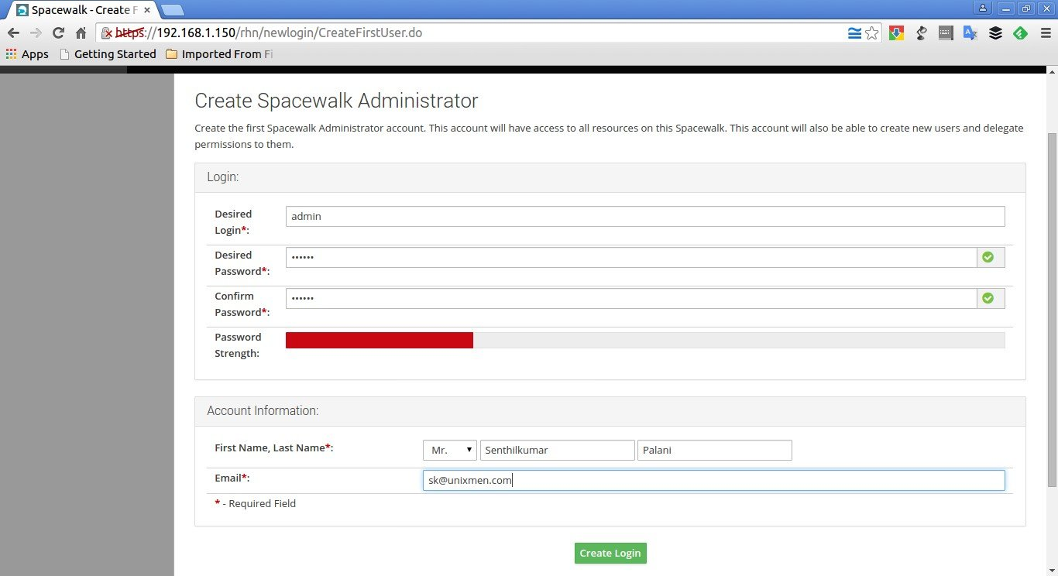

Now, you’ll be pleased with Spacewalk administrator dashboard.

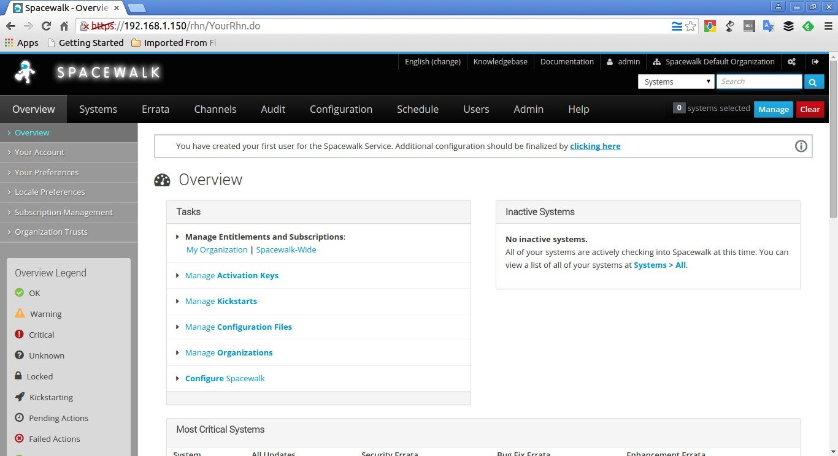

At this stage, you have successfully installed and configured Spacewalk server in CentOS 7. It is time to use Spacewalk server.

In our upcoming article, we’ll cover the basic usage, Spacewalk client configuration, and how to deploy packages from Spacewalk server.

Refer the following article to know how to manage Spacewalk Channels and Repositories.

* [**Manage Spacewalk Channels And Repositories**](http://www.unixmen.com/how-to-manage-spacewalk-channels-and-repositories/)

**Source and Reference:**

* [**Spacewalk homepage**](http://spacewalk.redhat.com/)
* [**Spacewalk Wiki**](https://fedorahosted.org/spacewalk/)