How to open a Genesis 3.8 Tunefile in TunerPro

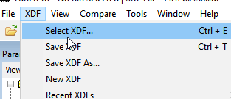

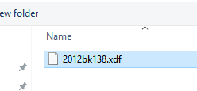
Select the option “Select XDF”

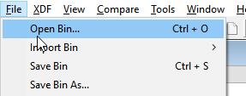
Select the 2012bk138.xdf file, this loads the definition to TunerPro

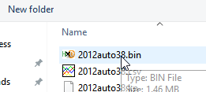

Repeat the process to open the bin, and you’re done!

