**A MODEL TO DETECT PLANT PEST AND DISEASE.**

**Introduction**

Agriculture accounts for about 28% of Ghana’s Gross Domestic product and employs more than half of the work force, mainly small landholders. About 7.8 Mha is under cultivation. The major starchy staples include maize, rice, cassava etc which occupy a total land area of 3.40Mha, representing about 43% of cultivated land.(yieldgap.org) Ghana and in most African countries agriculture plays a major role in the economy as this does not only feed the nation but provides jobs for a lot of citizens.

**PROBLEM**

Plant pests and diseases affect food crops, causing significant losses to farmers and threatening food security world.

A report on the Daily Graphic dated Oct 03, 2015, stated that Ghana loses 30% of crop yield to pest and disease, this was due to lack of plant health service as there are limited number of extension officers.

Low crop yield has an adverse effect on the economy of any nation whose economy depends on agriculture. When there is low crop yield, prices of crops go high due to scarcity of the produce, as this happens food which is a necessity becomes hard to afford, this results in hunger for most citizens due to high cost of foodstuff.

Also, when the quantity of food produced is lesser than the population of the country there is certain to be famine in the nation

**Purpose**

The purpose of this document is to present detailed description of a model to detect plant pest and Disease. It explains the purpose and features of the application itself, the Android interface through which farmers will be interacting with the app.

**Objective**

To offer farmers and gardeners the possibility to receive decision support directly on their smartphone.

There is therefore the need to get measures to alleviate this problem. This study seeks to address this problem by designing an AI model that gives accurate information on plant pest and diseases based on images of plants suffering from a particular disease or pest attack and offer recommendation to solving it. This will help farmers acquire help quickly and easily to improve and maximize crop yield, especially where there is lack of expert human diagnosis in the field.

The system will use image recognition from deep learning and neural networks, from a huge dataset in identifying pests of crops and diseases as well.

Recommendations of appropriate measures such as chemical, cultural and biological solutions will be offered based on the type of pest or disease found.

The system will also serve as a platform where appropriate pesticides can be acquired, contacts of extension services among others can be accessed.

One huge challenge that comes between the effective uses of this system is language barrier because the targets may face challenges with the English language. The system seeks to add an audio support which will help communicate easily findings from tests and solutions as well in local languages.

**Prototype of App Interface**

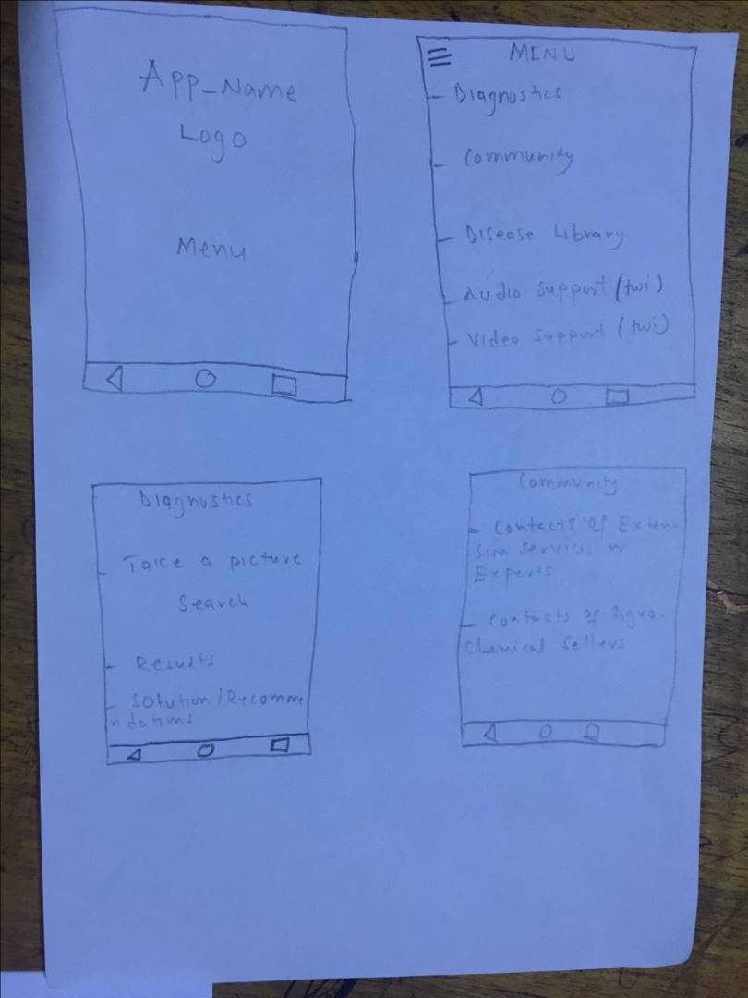

**Reference**

[*"Plantix - An easy plant disease diagnostic & monitoring tool"*](https://www.worldsummitawards.org/winner/plantix/). worldsummitawards.org. 2017*. Retrieved 22 March 2018*.

<http://www.fao.org/emergencies/emergency-types/plant-pests-and-diseases/en/>

<https://en.wikipedia.org/wiki/Plantix_(mobile_app)>

https://www.graphic.com.gh/news/general-news/ghana-loses-30-per-cent-of-crop-yields-to-pests-diseases.html

.