**AN ARTIFICIAL INTELLIGENCE MODEL TO DETECT PLANT PEST AND DISEASE**

**PRESENTED BY AKUGU GIDEON AND KUSI BENJAMIN**

**INTRODUCTION**

Agriculture accounts for about 28% of Ghana’s Gross Domestic product and employs more than half of the work force, mainly small landholders. About 7.8 Mha is under cultivation. The major starchy staples include maize, rice, cassava etc which occupy a total land area of 3.40Mha, representing about 43% of cultivated land.(yieldgap.org) Ghana and in most African countries agriculture plays a major role in the economy as this does not only feed the nation but provides jobs for a lot of citizens.

**DATA AND FEATURES**

Two datasets from the KAGGLE Machine Learning Repository  
were analyzed, it was divided into 2 (Testing dataset and Train dataset)

It features Cercospora_leaf_spot Gray_leaf_spot, corn maize common rust, corn maize healthy and Peach bacterial spot

**MODEL**

Deep learning is a class of machine learning algorithm that uses multiple layers to progressively extract higher level features from the raw input.

Artificial nueral networks may be used for predictive modeling, adaptive control and applications where they can be trained via a dataset.



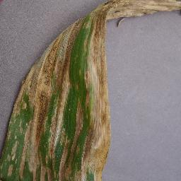

Unhealthy maize leave Healthy maize leave

The system will use image recognition from deep learning and neural networks, from a huge dataset in identifying pests of crops and diseases as well.

**Conclusion**

The system will use image recognition from deep learning and neural networks, from a huge dataset in identifying pests of crops and diseases as well.

Recommendations of appropriate measures such as chemical, cultural and biological solutions will be offered based on the type of pest or disease found.

**Future work**

Addition of more dataset of other crops to increase the accuracy and precision of pest and disease.

Addition of a system to detect plant nutrient deficiency

Addition of a system to detect rainfall pattern over a period of time.

**Reference**

"Plantix - An easy plant disease diagnostic & monitoring tool". worldsummitawards.org. 2017. Retrieved 22 March 2018.

http://www.fao.org/emergencies/emergency-types/plant-pests-and-diseases/en/

https://en.wikipedia.org/wiki/Plantix_(mobile_app)

https://www.graphic.com.gh/news/general-news/ghana-loses-30-per-cent-of-crop-yields-to-pests-diseases.html