Create a Quality control report for your MaxQuant output

## Requirements

Any Windows System

- no local R required if you followed the installation instructions at <https://github.com/cbielow/PTXQC>)

## Generating a quick QC report without asking questions!

1. open a Windows Explorer and find your MaxQuant txt-output folder
2. [optional – but highly recommended] copy the mqpar.xml which MaxQuant generated from the root directory into your txt folder,

e.g. c:\MQ_Diabetes_study\mqpar.xml 🡪 c:\MQ_Diabetes_study\combined\txt\mqpar.xml

This will enable PTXQC to extract some parameter settings and results in more accurate reports. Alternatively, you would have to set the parameters manually in the YAML file (see next section).

1. open **another** Windows Explorer window and navigate to the (network) folder where the QC software was copied to during installation, e.g. P:\Chris\Exchange\QC (where drive P could be some network share).
2. drag’n’drop the txt folder onto createQC_dragNdrop.bat

(you can also drag any file within the txt folder, e.g. evidence.txt)



1. A console will pop up and show stuff. Wait… if all went well, one of the last lines is “**Time elapsed: … min**” and a pdf report within your txt folder. It has a version and a folder name attached to it (e.g. report_v0.63_diabetes.pdf). The version number will increase every time there is an update in PTXQC (big change in version number means big change in functionality). The name is taken from the path where the txt is located in – it helps you to distinguish report files when they are open in a PDF viewer or copied somewhere else. The console window will stay up until you press a key.

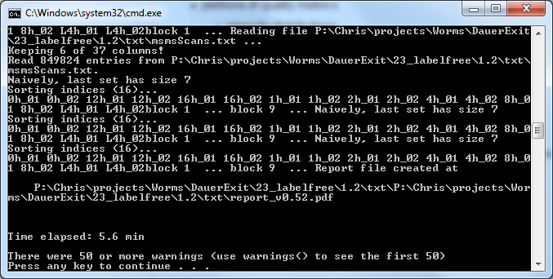

## Alternatively: Generating a QC report using a configuration file:

A configuration file allows you to enable/disable certain plots, and to modify most target thresholds used for the scoring metrics and within plots, e.g. the number of proteins you expect. This will differ by platform and instrument – so adapt it to your needs. The defaults are meant for a Thermo Orbitrap Velos, a 5h LC gradient for a complex matrix (e.g. human cells).

Disabling certain report sections will decrease report size and hide metrics which you may not need. The time required to create the report will also reduce, but usually this is not a bottleneck.

## Steps:

Just as before, but instead of using the createQC_dragNdrop.bat as target, use the createQC_dragNdrop_withYAML.bat. This bat file expects a YAML configuration file right next to the .bat file.

This file you need to provide. But no worries. One such file with default parameters is generated each time you invoke a QC report generation. Just look into the txt folder for something named report_v0.xyz.yaml.

Copy this YAML file next to the bat file, and name it config.yaml. You can also rename it if you want, but then you need to edit the bat file and correct the name.

Edit the YAML file as you desire using a text editor of your choice (e.g. Notepad++). Each YAML file has a leading comment section which will describe the basics of how YAML looks like and what you should/not change.

It's easy, just try it out.

**If you have suggestions on how to improve the report (other metrics/plots, axis labels etc), let me know.**