Inhaltsverzeichnis
Goal of the analysis: → sagt man das so O.o 1
data sources 1
OSM 1
rest 2
Center point: 2
Sources for the speed of trams, buses and travelling by foot 2
overcome issues: 2
room for improvement: 2
critique: 3

Goal of the analysis: → sagt man das so O.o
→ how fast can you reach the civic center of a city from any given point on it’s streets, first walking to the next station then by public transportation. → geht bestimmt irgendwie griffiger, aber so ungefähr :D. Ist genauer als der satz in der abschlusspräse.

data sources

OSM

Obtaining the relevant OSM data through Overpass turbo. Tram/Bus stops and lines, streets

eg. bus:
/*
This query looks for nodes, ways and relations
with the given key/value combination.
Choose your region and hit the Run button above!
*/
[out:json][timeout:25];
// gather results
(
// query part for: “route=bus”
node["route"="bus"]({{bbox}});
way["route"="bus"]({{bbox}});
relation["route"="bus"]({{bbox}});
);
// print results
out;
>;
out skel qt;

→ additional route tags → light_rail, tram, etc.

rest

Centre point:
manually created in QGIS based on what locals perceive as the centre point (works best if centre is also connected to a lot of public transportation

Sources for the speed of trams, buses and travelling by foot

tramspeed → 17,7 km/h, source :https://de.wikipedia.org/wiki/Stra%C3%9Fenbahn_Heidelberg , /60=295 meter/minute → very accurate for eppelheim and rohrbach, kirchheim is inaccurate because it was necessary to break the lines, but that means the tram doesn't take its actual route, but a shorter version across the montpellierbrücke

average speed by foot : 3-5km/h → 4 km/h/60 → 67 Meter/minute

Bus average speed →not available for heidelberg→ berlin 14km/h
→ the buses are very inaccurate because the net is more interconnected so breaking it means most of the buses take wrong routes

speed for a mixture of train and bus → tb speed → (233+295)/2=264

step by step code explanation

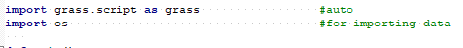

→ imports grass tools and library for importing data into python
→ this command deletes every existing vector file that was created in a previous iteration, usefull for debugging and making sure the script always runs from 0 to end
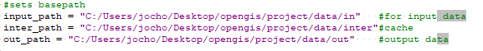
→ defines 3 different paths that are later used to load and store data → “cache” is later used for exporting then importing data to get unique ids. Data stored here is of no further interest.

1. importing and preparing data
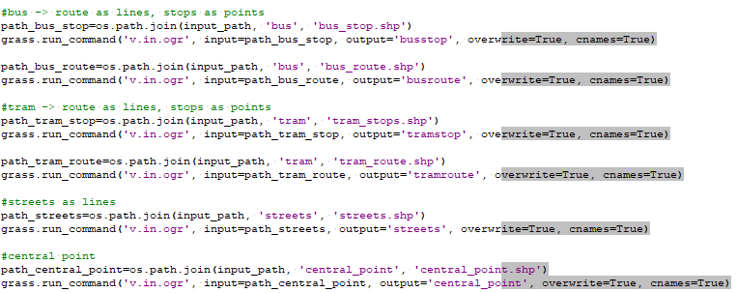
Jow sind halt alles importe ne..
stitching tram and bus together. This is later used to simulate changing between bus and tram (in a very bad way) and this net reaches places tram and bus alone cant reach.
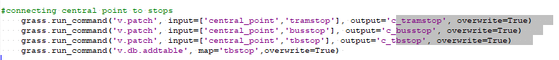
This adds the central point and each stop together. Prerequisition for network analysis (na) because 'v.net.iso' uses a range of points as centers from which the distance across the network is measured. If we add the center to the stops now the operator “connect” from “v-iso” draws lines to all the stops and the center point, which in turn later enables “v.distance” to always connect the correct time to each stop.
“v.db.addtable” is required to create a table for tbstop which is much later used to store the time to reach that stop from the center
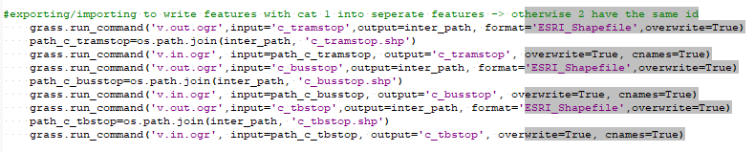
this part is necessary to assign each point an individual id. Because these layers are patched from 2 different layers (stops and centre) the id 1 overlaps. This would later cause an error because v.net.iso has “center_cats” =1 which then would be 2 different points.
This is important, because without “break”, only lines that go through our central point are drivable in the analysis. This would not be necessary if we had another implementation for changing lines. Since osm has each line mapped as 2 seperate lines (one for each direction) the intesections cause a lot of problems. This is overcome by using snap to eliminate lines that are parallel (or at least very similar) and are too close to each other. Rmdupl is used just in case if there are duplicates and rmdangle removes lines that are not connected to the net whatsoever (which would mean they are not reachable from the centre point by public transportation).

2. network 1 and preparation

→ first networks will be used to calculate the time it takes to reach each stop from the centre
This command creates a net layer from a line and a point layer → both end up as one layer even though they are different dimensions. ‘connect’ draws lines which connect the points to the closest point on the closest line
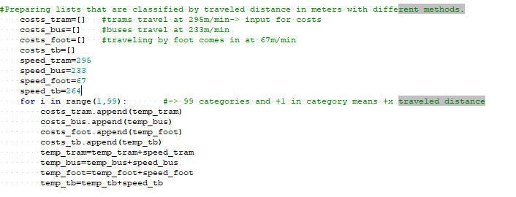
this whole part is a preparation for v.net.iso. v.net iso requires “costs” as an input which is measured in metres. Meaning if you input only “3, 5” it would split the whole net into lines that are under 3 metres away from the closest centre point (cat 1), lines that are between 3 and 5 metres away (cat 2) and lines that are further away than 5 metres (cat 3).
The code above creates lists that contain the numbers which are supposed to be the splitting points of the lines. Example: tram: trams in HD have an average speed of 295 meters per minute. This means that if the tram has to travel between 0 and 295 metres to the next stop it takes up to 1 minute. To travel another 295m it takes another. This means that if input a list that contains “295, (295+295)590, (295+295+295)885, …...)” it splits our net into x different categories (cat 1,2,3,4,...) which match the time it takes to reach this distance. If a point on the line has the cat 4 it takes 4 minutes to reach that point from the centre.
Executes the first network analysises (plural von analysis?) → centre to stops.
Center_cat 1 is our original “center_point” , costs are the lists we just created in the previous step.

3. extracting cats from network 1
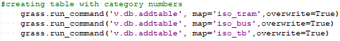

Preparation for v.distance
v.net.iso doesnt create a table. Thats why we need to do it manually. The new table is only filled with category numbers. This table is later used assign the category numbers of the network to the closest stops.

Here we add a column to the stops. This column will be filled with the cats from the closest line on the network.

4. network 2 and preparation
→ second network is used to calculate the time needed to travel from each point on any street to the closest station by foot
same as earlier, only this time creating a network from stops (only stops not c_stops!) and streets.

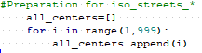

This part is used to create a list which is fed to v.net.iso for “center_cats”, which contains the numbers 1 to 999. Since the points in the current network are stops, this basically means that all stops are to be considered centres. This further means that this network cat which will be calculated in the next step now correctly depicts the time it takes from any point on any street to reach the closest stops.

Second network analysis → stops to each point on the streets

5. calculating the shortest time and preparation
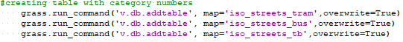
v.net.iso doesnt create a table. Thats why we need to do it manually. The new table is only filled with category numbers. Eventuell unnötig weil export import das selbe eh schon machen könnte. Zuhause ausprobieren (schreibe es dir dann Phillip ;P) .

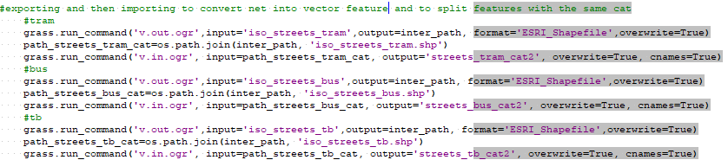
splits features that share the same cat number, and converts net into vector feature.
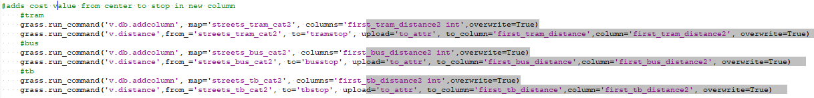
Creates a new column in the table of the feature that already contains the value of the time needed to get from the street to the next stop.
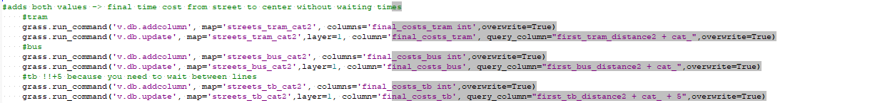
Adds another column and fills it with the sum of the time needed to get to the next stop plus the time needed to get from that stop to the center. For the net containing trams and buses (tb) “+5” is added, because in the next 2 steps we search for the net which has the fastest time to reach that point of the street. If tb is faster than both bus and tram alone, that means that you would need to change from bus to tram at least once. +5 stands for the waiting time needed to change. Obviously a very random number… most buses and trams at least in Heidelberg arrive every 10 minutes during daytime between monday and friday, that should mean, that the average waiting time is 5 minutes. This estimated average waiting time can change for each city, time of the day, weekday and line.
Adds the final values for the bus and tram net to the tb net as a preparation for the next step

calculates which of the 3 different final values is the lowest for each section on the streets. The resulting values should be a rough estimation how much time it takes to reach the centre from every point on every street in the city.

7. exporting final layers
Not a part of the actual analysis. This only enables us to use the data outside of grass gis. → e.g. for visualising the result in qgis

overcome unexpected issues:

→ before importing shapefiles into gis it was necessary to change attribute names in tables that are reserved key words in SQL. In this case “to” and “from”.

grass.run_command('v.distance',from_='tramstop', to='iso_tram', upload='cat', column='first_tram_distance', overwrite=True) → an error occurs because the tool uses a reserved keyword from sql (from). It works if you use a underscore eg. “from_” after the keyword.

Networks in grass don't work as individual features, that's why we needed to split the net. Worked by exporting the net into shapefile, then importing it
same solution if multiple features share the same id

room for improvement:
→ long time (4-15 mins) → probably not using the most efficient algorithms
→ no good implementation for switching lines → the bigger the city, and if the net gets increasingly intertwined, the worse the solutions get because “break” makes the algorithm always take the shortest path that might not actually be used by transportations.
→ tram/bus speed may be different in different cities → requires manual change
→ central point might not always be easy to pick
→ inclusion of actual timetables for stops instead of average speed (slower in centre)

critique:
- more interconnected lines mean worse results
- bigger cities may require additional public transportation such as trains
- “+x” minutes as a “brake” is never accurate and doesn’t depict changing times and the averaged travel speed in a realistic way

