**Name: Jesus Liriano**

**ID: 00316389**

**Course: CIS-245**

**Prof: Adrianna Holden-Gouveia**

**Date: 10/15/2023**

**1. Check your repositories that are included by default on both servers,**

**find out how you’d go about adding a repository, (both official and**

**PPA) and make sure you can install programs.**

To check this in CentOS 7 run, **yum repolist.**

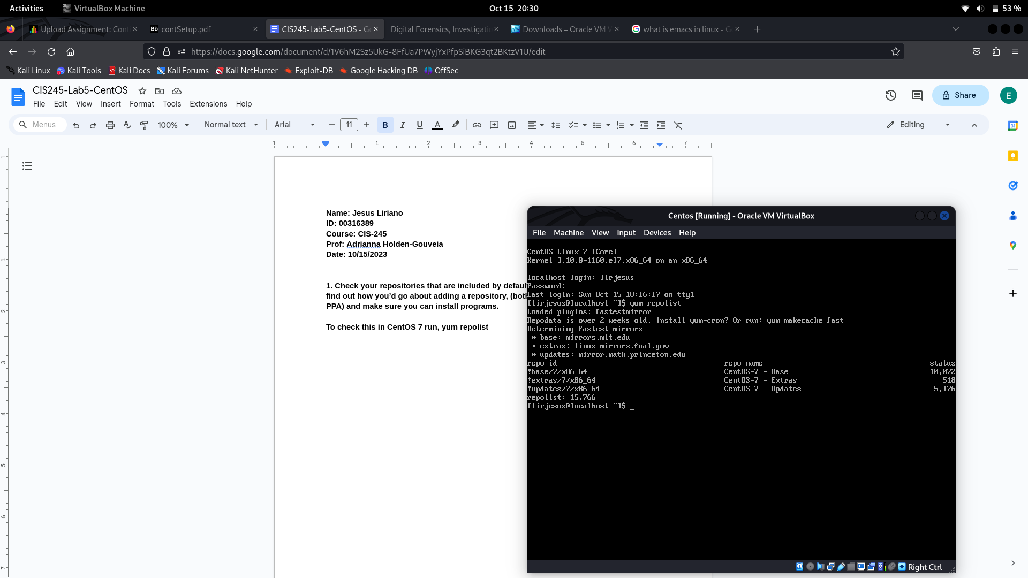

**2. Install Tmux, emacs, and Fail2Ban. Make sure you look through the**

**Fail2Ban settings as you do the install, and note anything that needs**

**to be changed or modified to get Fail2Ban up and working.**

**To install tmux run, sudo yum install -y tmux**

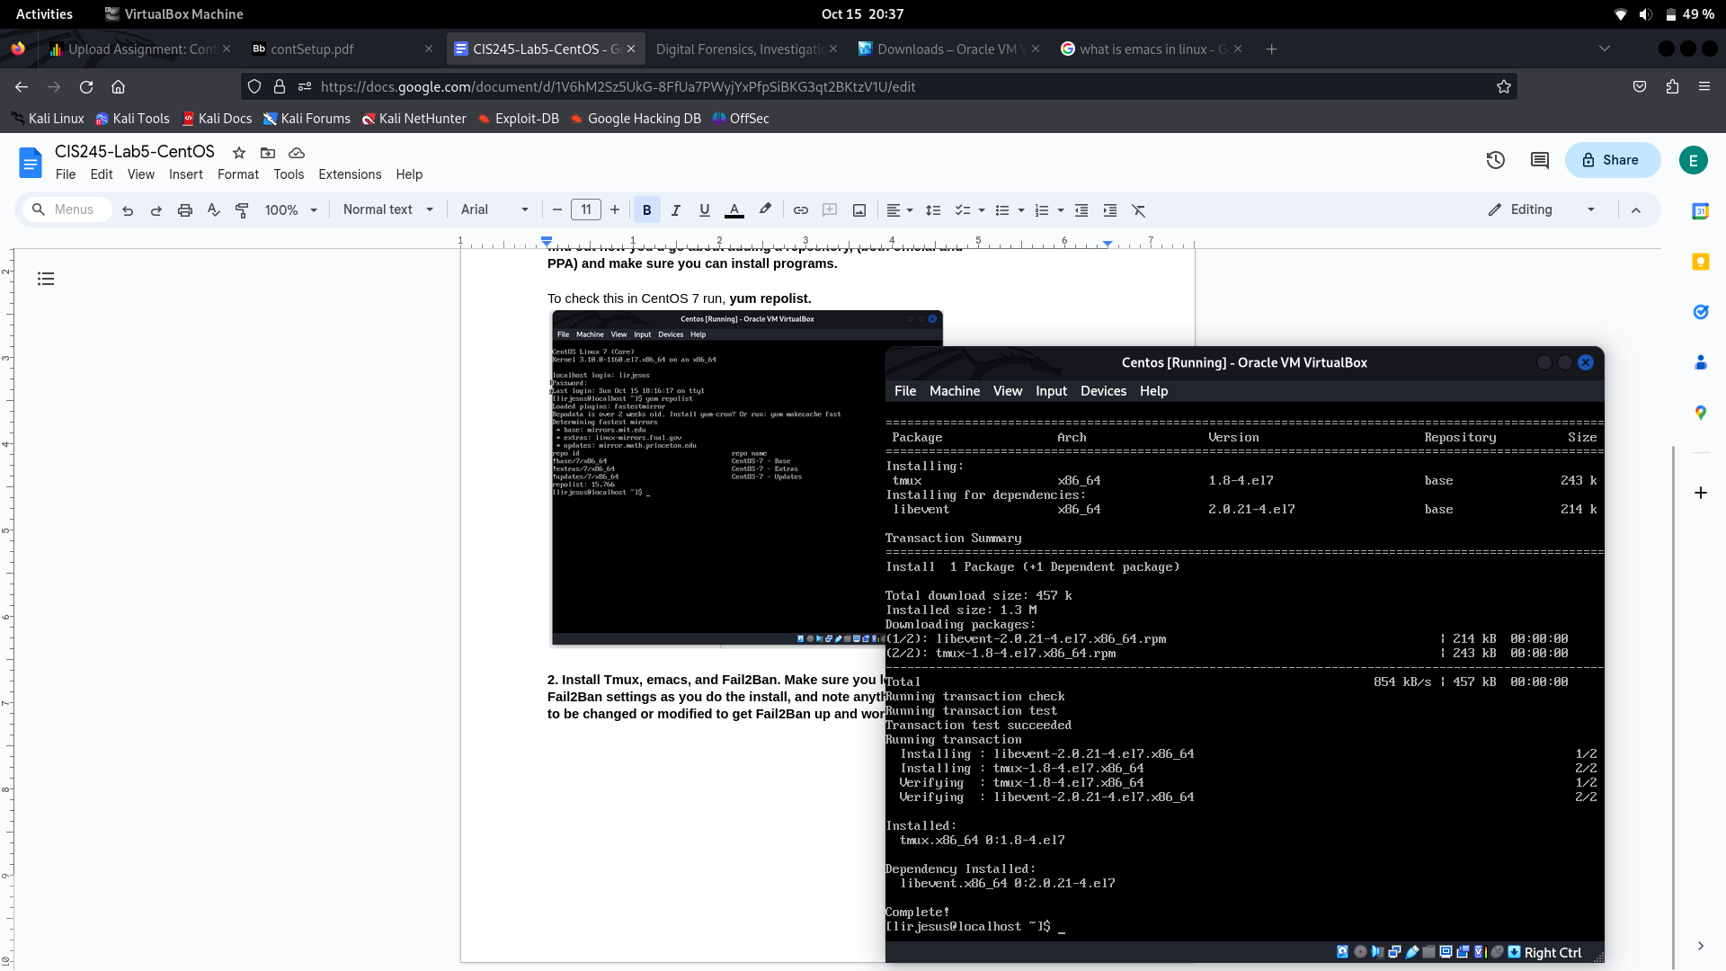

To install emacs run, **sudo yum install -y emacs**

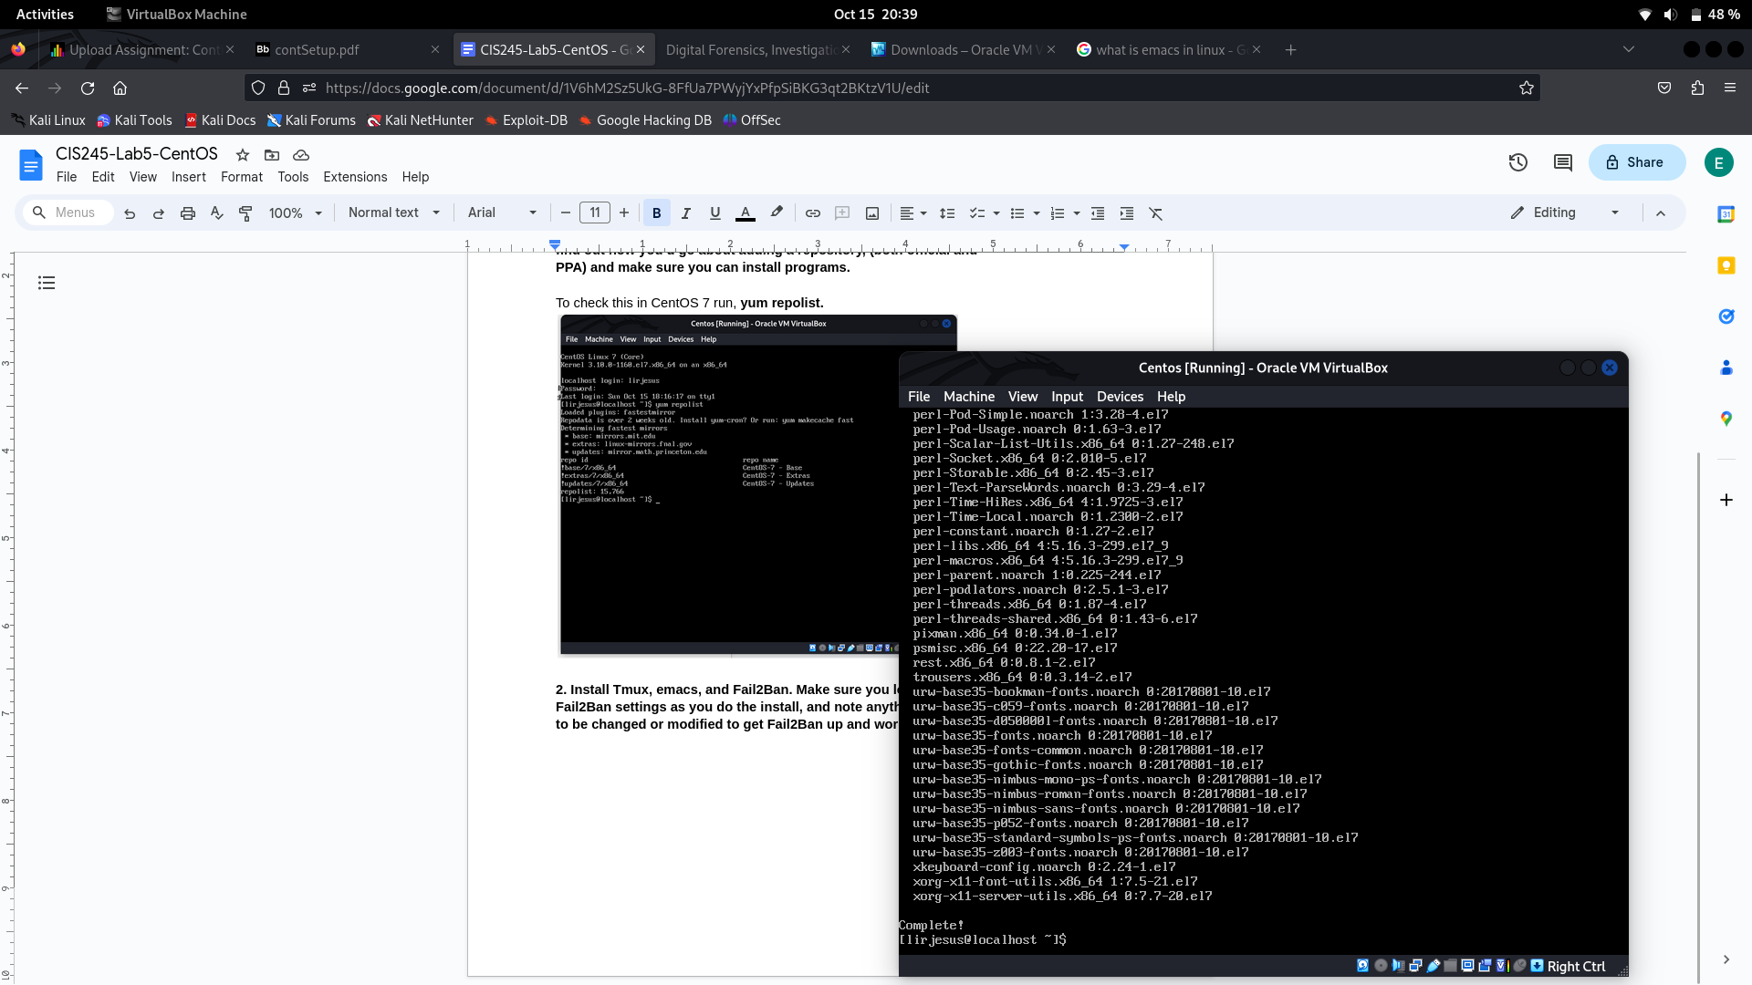

To install fail2ban I had to **install EPEl** which stands for **Extra Packages for Enterprise Linux,** since fail2ban in the regular repo for centos 7.The way to do this is **sudo yum install -y epel-release.** Then we proceed to install fail2ban normally by running **sudo yum -y install fail2ban**

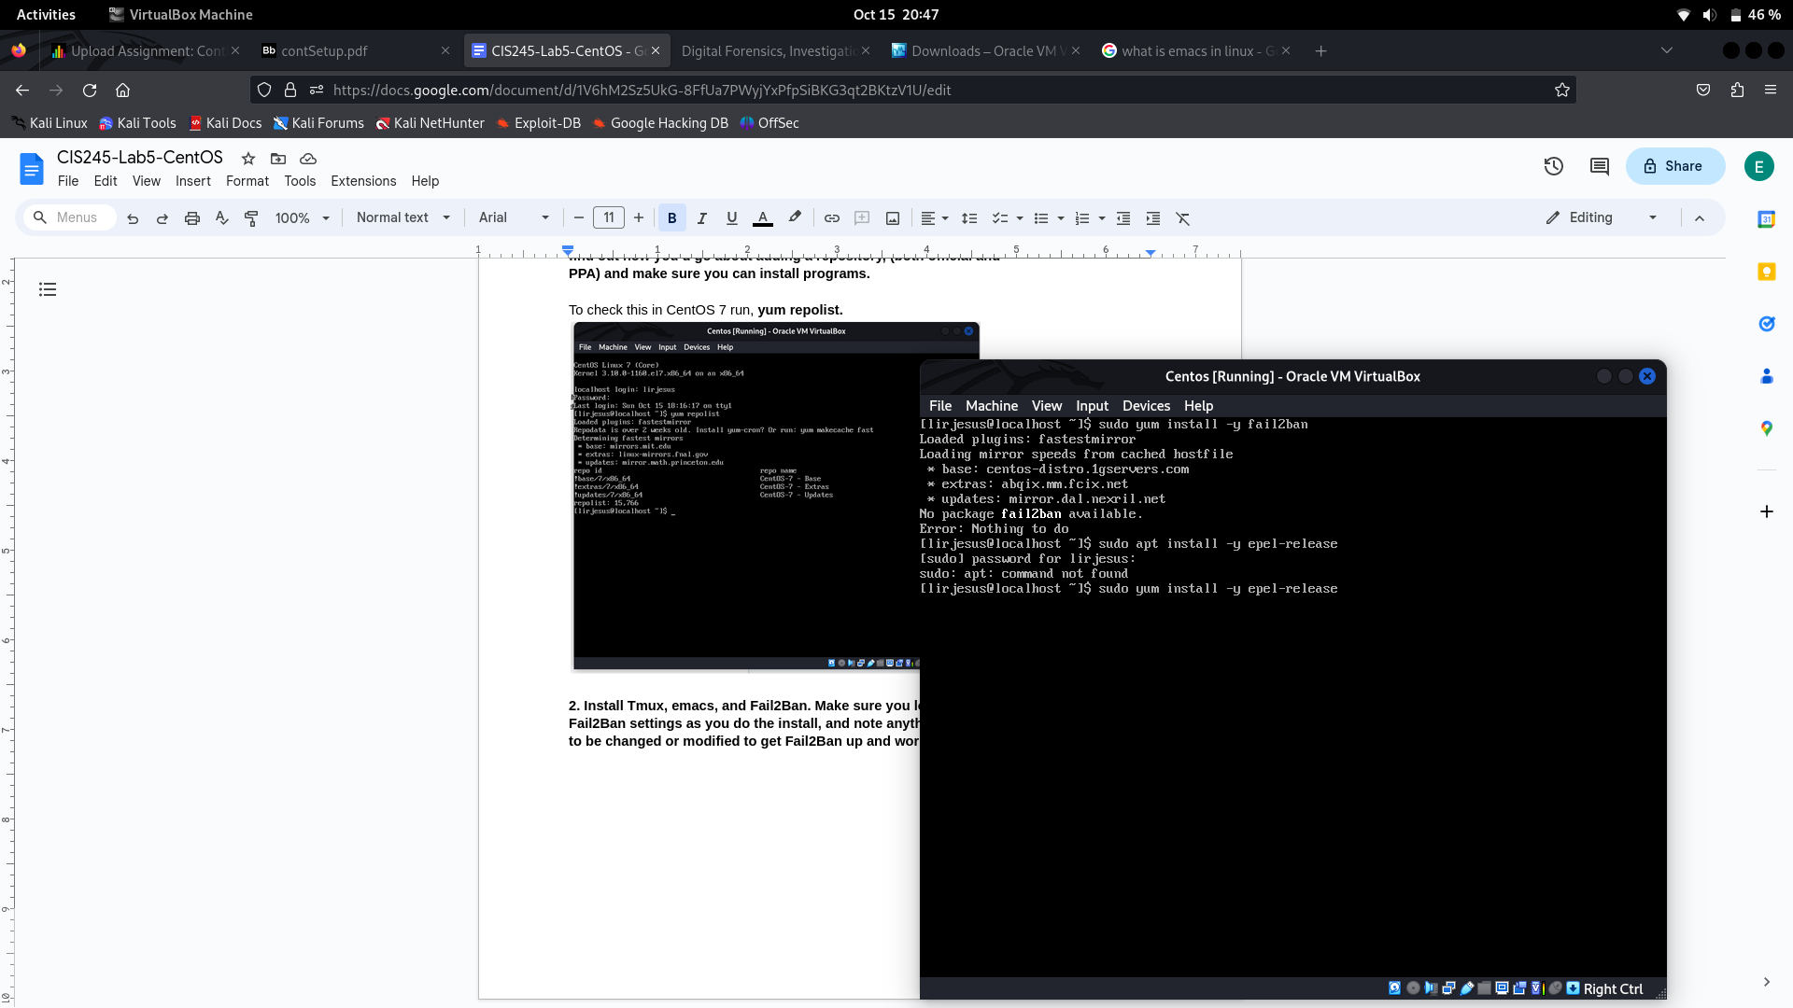

**3. Just for fun, install cowsay and lolcat. (Yes I know these are silly, the**

**point is that i know they aren’t there already.)**

**To install cowsay run, sudo yum install -y cowsay.**

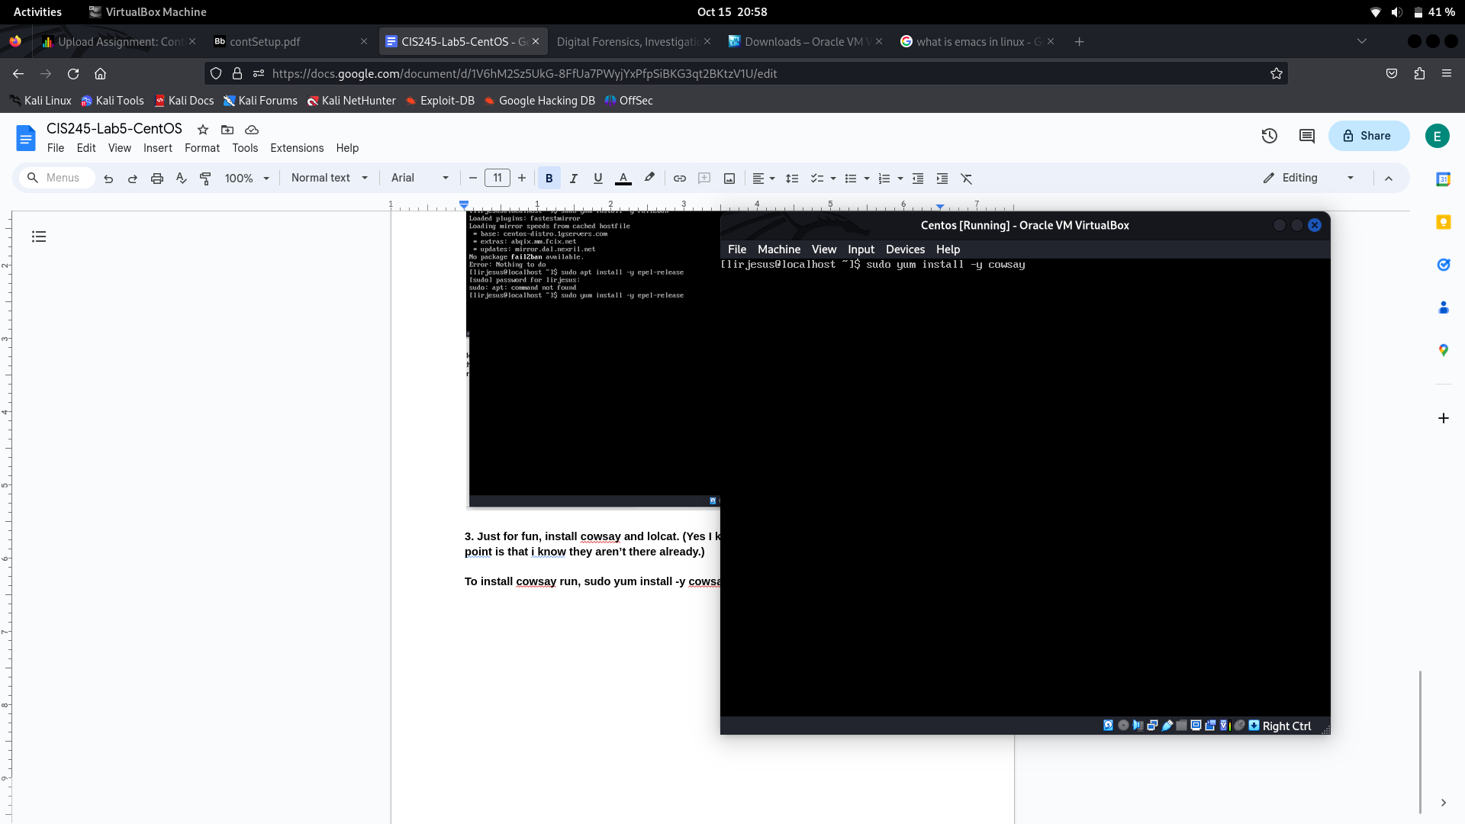

In Centos7 lolcat Is part of the programming language ruby so we are going to install ruby running **sudo yum install -y ruby.** Then we install lolcat by running **sudo gem install lolcat.**

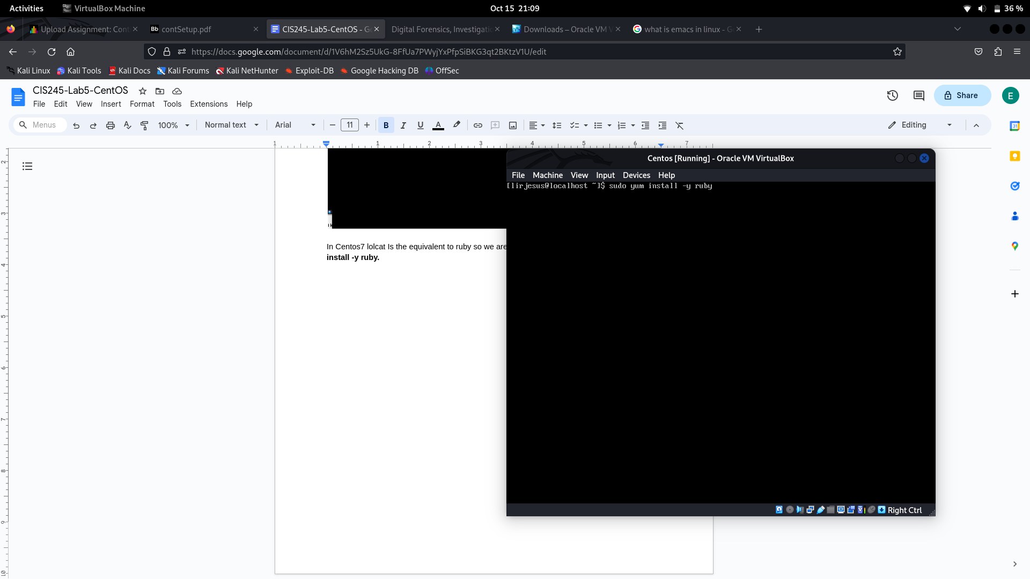

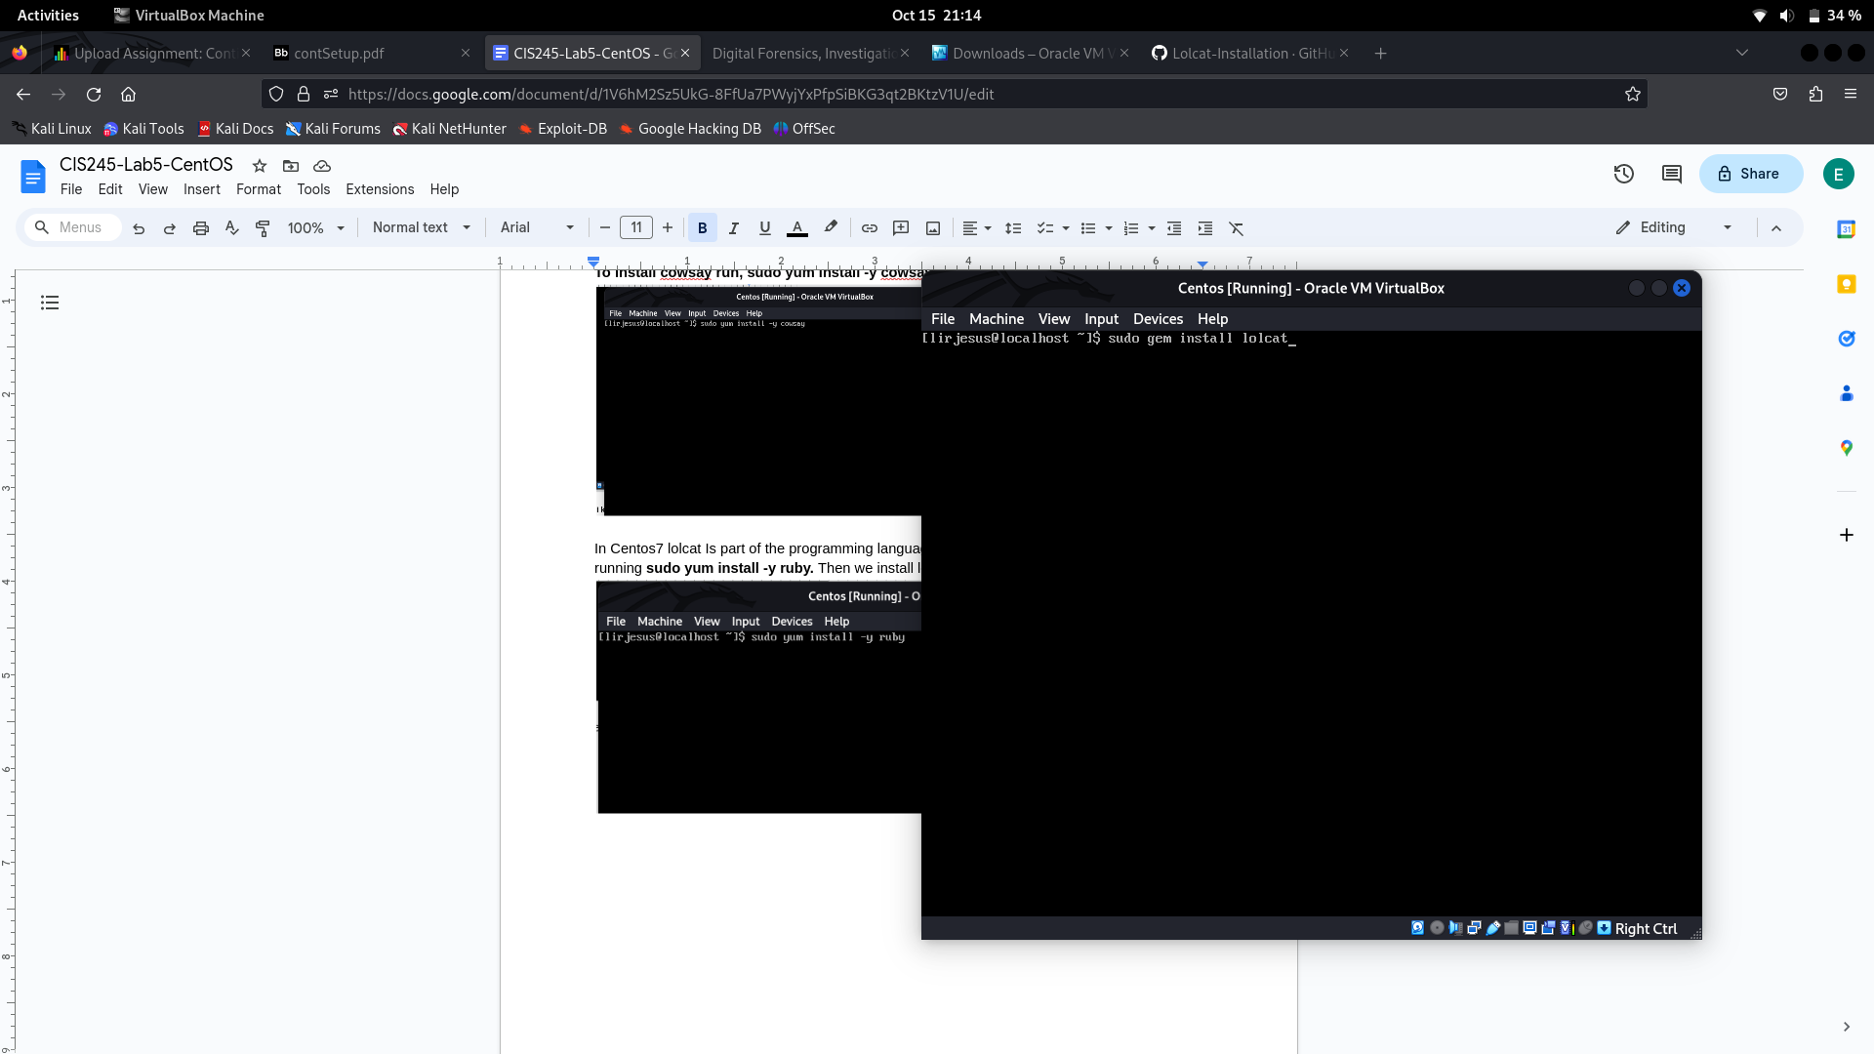

**4. Update VI to vim, update your servers if it’s needed**

To install vim we run, **sudo yum install -y vim.**

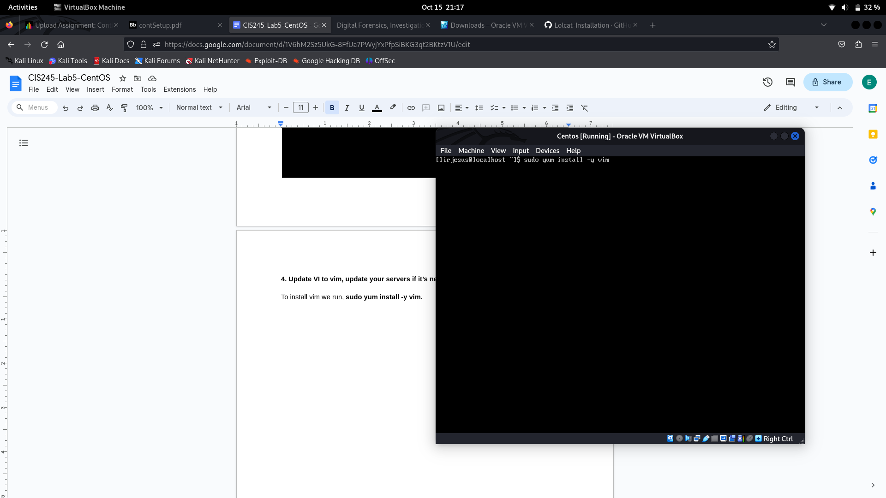

**5. Documentation should include locations of any files you’ve created or**

**need to reference. You should include any programs you’ve installed**

**or updated as well, with dates of when you’ve done those things. You also need to make sure to show how to open each program, what they**

**look like when open, how to use them, and how to close each program.**

To see all programs install we can run **sudo yum list installed** or **sudo yum list installed | less** for easier viewing. Or **grep** for more specific searching.

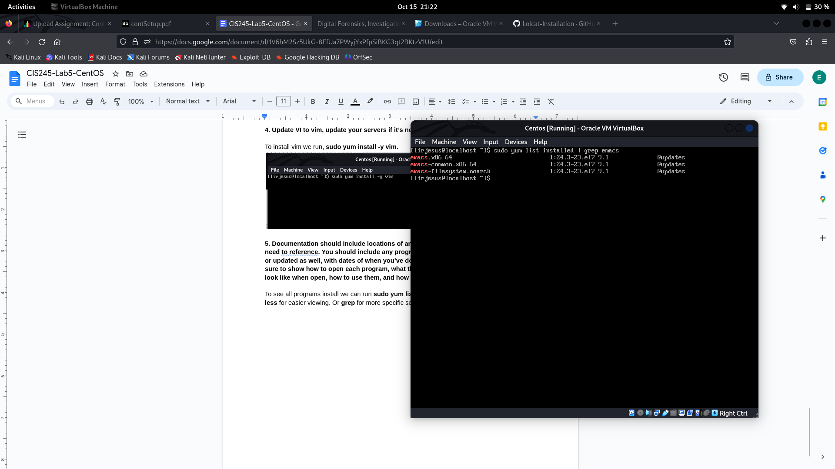

**Resources**

<https://gist.github.com/mtaziz/d5b2f9ef46b06f04fbbd>

<https://www.digitalocean.com/community/tutorials/how-to-protect-ssh-with-fail2ban-on-centos-7>