**Name: Jesus Liriano**

**ID: 00316389**

**Course: CIS-245**

**Prof: Adrianna Holden-Gouveia**

**Date: 10/15/2023**

**Go through both servers and complete the following**

**problems. Make sure your deliverables include docu-**

**ments for BOTH servers clearly labeled with what the**

**document is and which server it’s for**

**1. Check your repositories that are included by default on both servers,**

**find out how you’d go about adding a repository, (both official and**

**PPA) and make sure you can install programs.**

For Ubuntu 22.04, the packaging tool to install apps and repos is **“APT”**, Advanced Packaging Tool. The way we would add a repo is **“sudo add-apt-repository ppa:example/repository”** and you would replace the example with the URL of the repo you would want to add.

To check current repos you would type, **vi /etc/apt/sources.list**

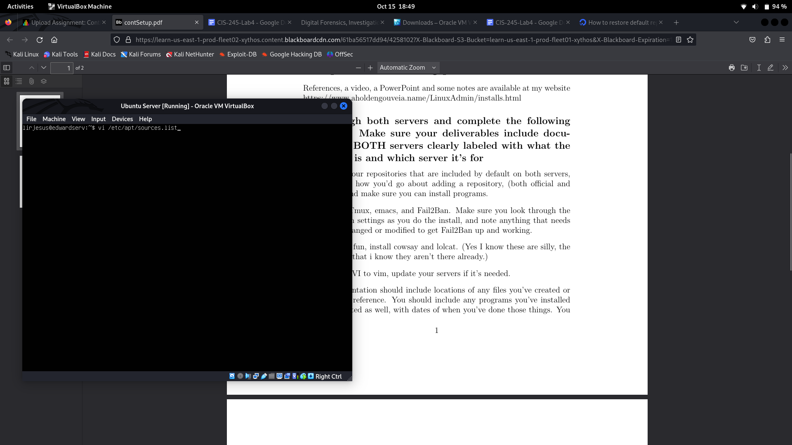

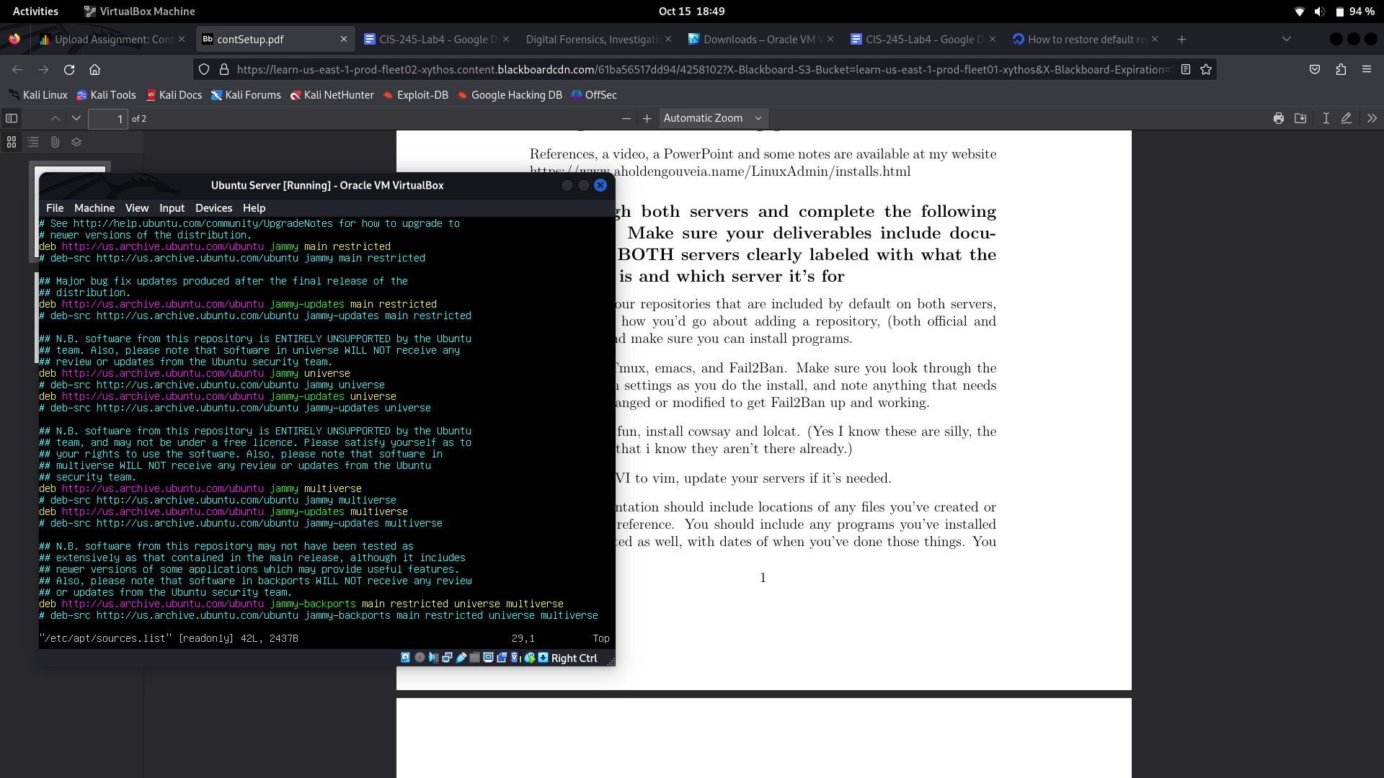

**2. Install Tmux, emacs, and Fail2Ban. Make sure you look through the**

**Fail2Ban settings as you do the install, and note anything that needs**

**to be changed or modified to get Fail2Ban up and working.**

To install Tmux, run, **sudo apt install -y (for yes option) tmux.** Tmux is a terminal multiplier, so basically it allows to create multiple terminal windows which would be useful to run multiple processes at the same time.

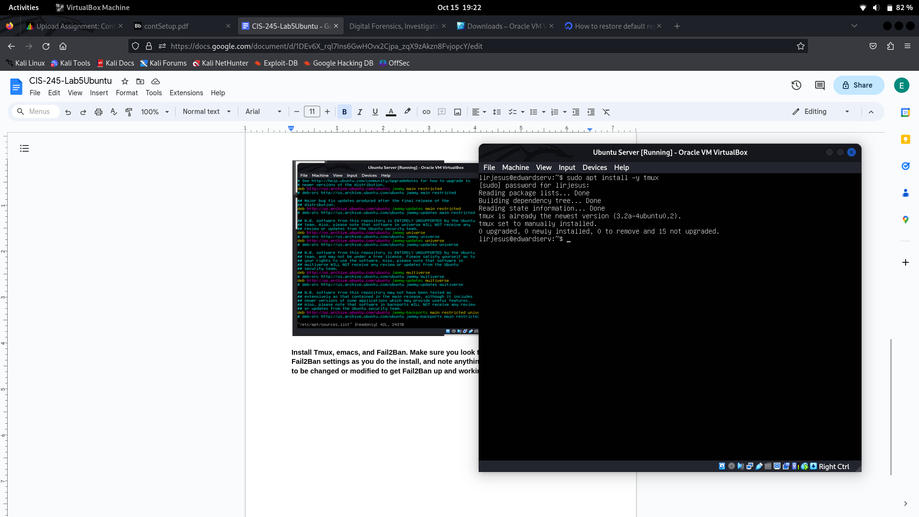

To install emacs run, **sudo apt install -y emacs.** Emacs is a text editing tool like vim that basically just offers more tools to navigate the editor.

**To launch type, emacs and enter**

**To open a file, press C-x C-f and then type the file path.**

**To save a file, press C-x C-s.**

**To exit Emacs, press C-x C-c. If you have unsaved changes, it will prompt you to save.**

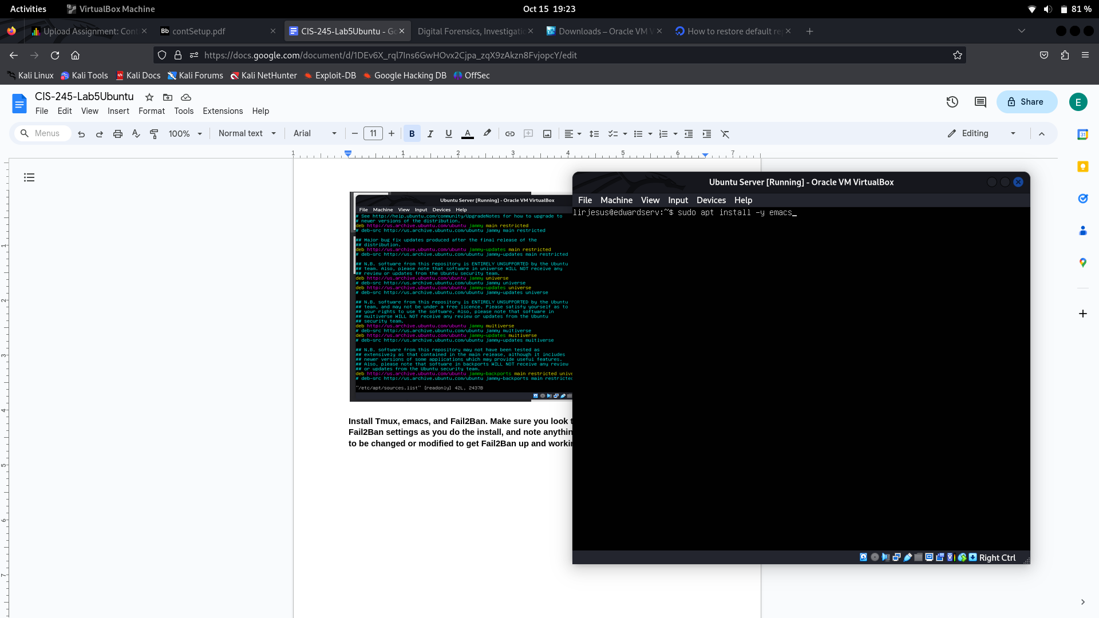

To install Fail2Ban run, **sudo apt install -y fail2ban.** This tool works an intrusion prevention software used to monitor log files and malicious activity and then blocking those IP’s.

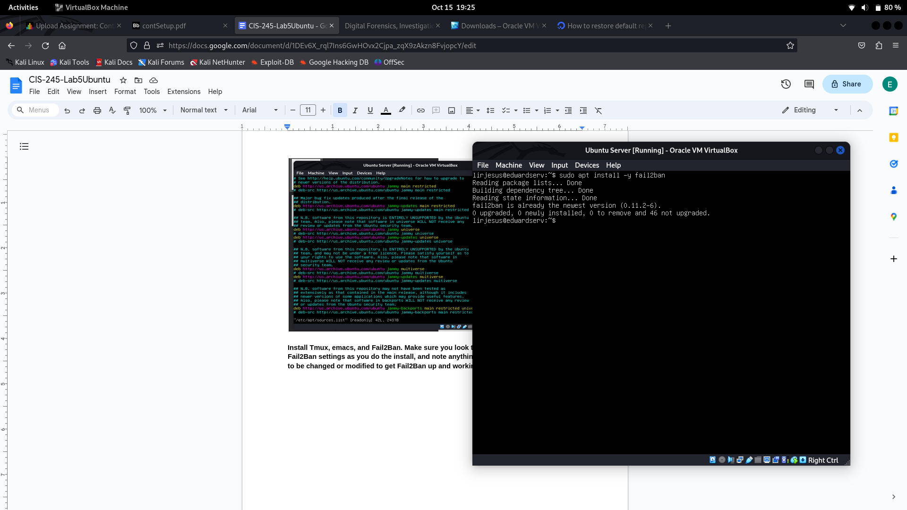

**3. Just for fun, install cowsay and lolcat. (Yes I know these are silly, the**

**point is that i know they aren’t there already.)**

To install cowsay run, **sudo apt install -y cowsay.** Cowsay is just a fun add on that just draws out a cow next to any text after the command. Example **cowsay, Hello World!**

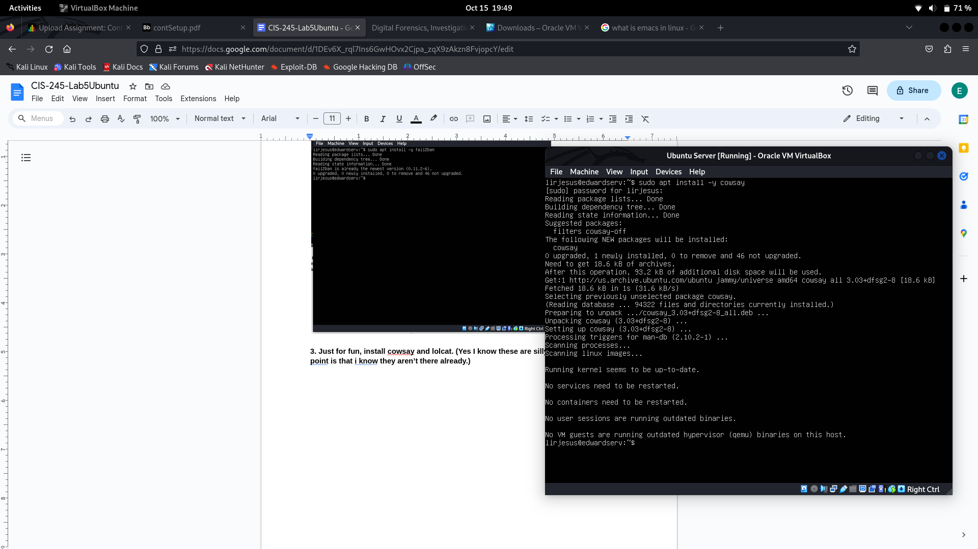

To install lolcat run, **sudo apt install -y lolcat.** Lolcat is another fun add on that displays the text next to the command in rainbow colored text. Example **echo Hello World! | lolcat**

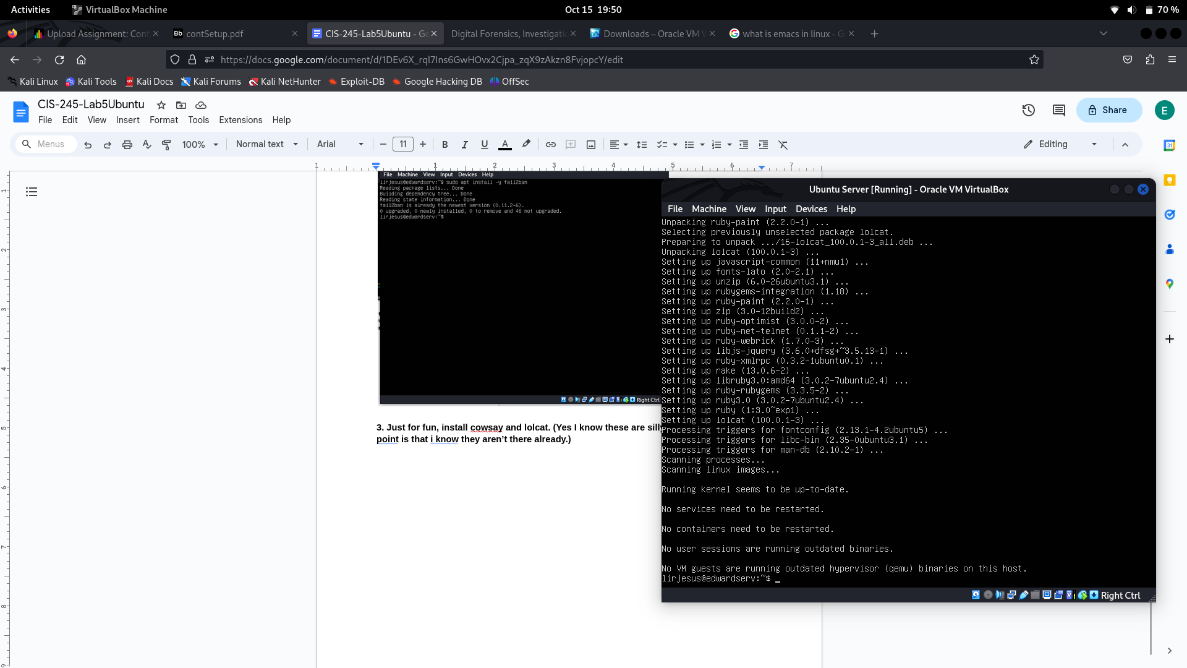

**4. Update VI to vim, update your servers if it’s needed.**

To install vim run**, sudo apt install -y vim. I**n summary vim is just and improved and more powerful vi, the text editor that comes out the box with most linux systems. It offers more tools and customization that many users would choose over the normal text editor.

**To open: vim filename.txt**

**To close without saving: esc, q!**

**To close with saving: esc, wq!**

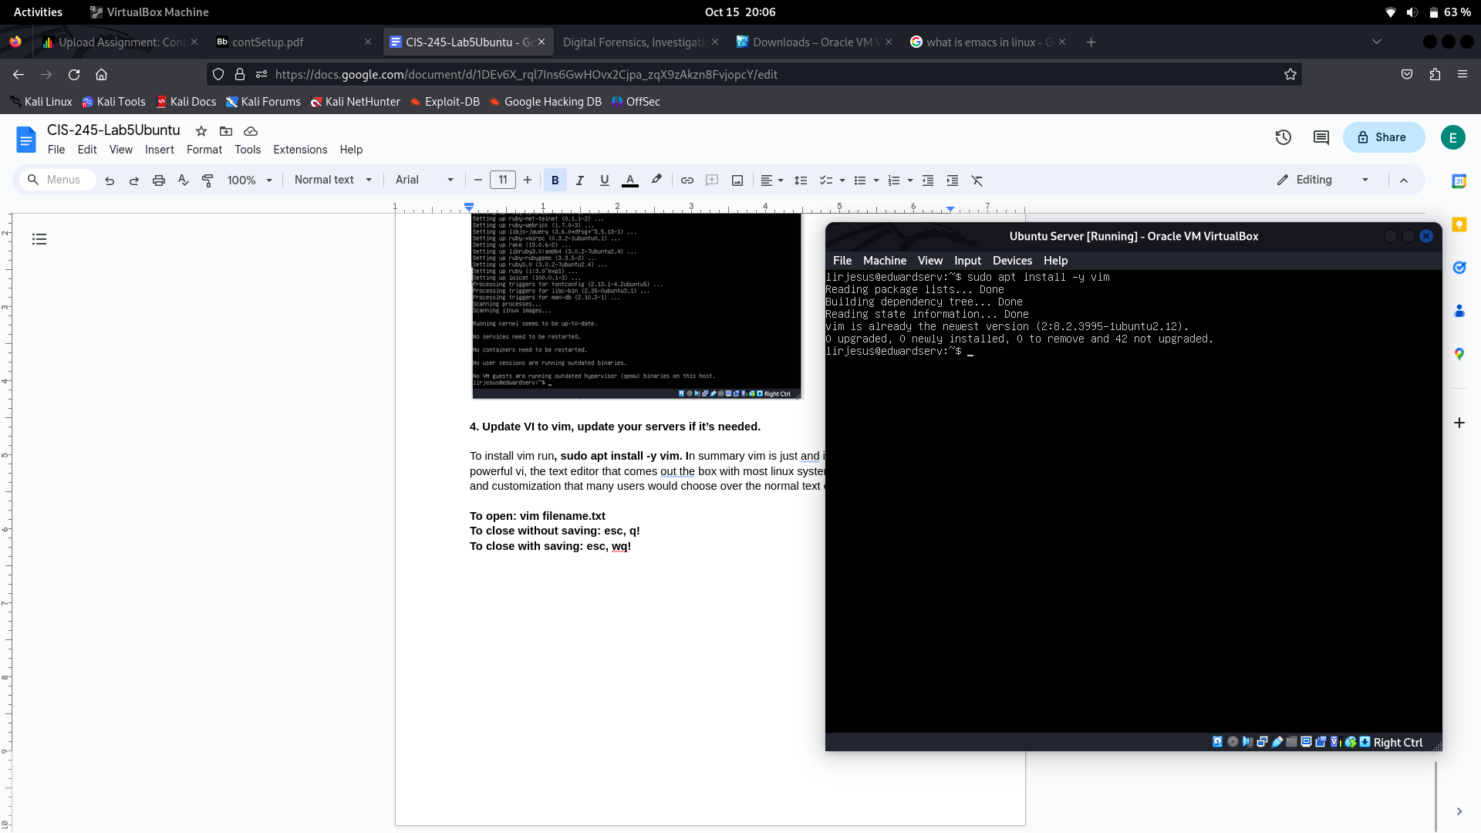

**5. Documentation should include locations of any files you’ve created or**

**need to reference. You should include any programs you’ve installed**

**or updated as well, with dates of when you’ve done those things. You also need to make sure to show how to open each program, what they**

**look like when open, how to use them, and how to close each program**

Here I used **apt-file list** to search some of our programs that we just installed

