The Impact of Corporate Green Bonds on Stock Returns

**Abstract**

I replicate with a different and bigger dataset the analysis of Flammer (2020) on financial markets’ response to the issuance of corporate green bonds, which are debt securities whose proceeds are used for projects with a positive impact on the environment and/or climate. As these bonds are getting more traction on the financial markets, it is interesting to analyse their impact on the stock price of traded companies.

Like Flammer, I find a positive response for the issuance of green bonds in the period from 5 days prior to the first announcement until 10 days following it. However, when analysing first-time issuers separately from seasoned-time issuers, I find a bigger response for the latter ones, while Flammer finds no significant response for them. Moreover, for first-time issuers, I find a significant impact on a different time window, in the period from 20 to 11 days prior to the announcement.

I propose possible explanations for the difference in results.

# Introduction

After the first climate-focused bond by the European Investment Bank in 2007, the World Bank issued the first “green” bond in 2008[1]. Worth SKr 3.35 billion (USD 440 million), this security was meant to:

* Meet the Scandinavian pension funds’ interest for a simple fixed-income product supporting climate-focused projects;
* Attract investors willing to invest sustainably and responsibly;
* Innovate green finance;
* Show financial markets that developing countries can start tackling climate change before it will affect them.

In 2010, another member of the World Bank, the International Finance Corporation, and other public entities such as municipalities, governments and agencies issued USD 4 billion of green bonds. Only three years later, in 2013, private corporations started issuing this kind of debt securities too, resulting in USD 10 billion of green bonds issued worldwide during that year alone.

After starting this new trend across financial markets, the World Bank is now a small player in a sector that is expected to raise USD 250 billion in 2020[2], notwithstanding the impact of the pandemic on the bond market and without considering other USD 70 billion of social and sustainability bonds in the same year.

In January 2014, the International Capital Markets Association introduced some principles that “recommend transparency, disclosure and reporting” for the issuance of green bonds in order to provide markets with the information and transparency that are required for these financial products. According to the Green Bond guidelines provided by the International Capital Markets Association, the four components of a green bond are:

* Use of Proceeds: definition and description of the eligible project categories
* Project evaluation and selection: description of the decision-making processes
* Management of Proceeds: guaranteeing that no projects or assets that do not comply with the stated use of proceeds will be financed nor refinanced
* Reporting: description of reporting intentions, including impact reporting

The International Capital Markets Association clarifies that projects financed through the issue of green bonds should provide “clear environmental benefits” that must be quantified by the issuer whenever feasible.

In order to give a clearer picture of the possible categories under which the use of green bonds’ proceeds can fall, the International Capital Markets Association specifies that green projects include:

* renewable energy;
* energy efficiency;
* pollution prevention and control;
* environmentally sustainable management of living natural resources and land use;
* terrestrial and aquatic biodiversity conservation;
* clean transportation;
* sustainable water and wastewater management;
* climate change adaptation;
* eco-efficient and/or circular economy adapted products, production technologies and processes;
* green buildings which meet regional, national or internationally recognised standards or certifications.

From this list of green projects categories, we can confirm that companies choosing to issue green bonds are supposedly constrained in regard to the projects they choose to finance.

Flammer identifies two possible rationales for the increased administrative and compliance costs due to issuing a certified or uncertified green bond:

* communicating the (sincere or disingenuous) issuer’s interest for the environment;
* obtaining cheaper financing.

As a matter of fact, if green bonds brought no benefit, companies would refrain from issuing this kind of security, as it entails a greater level of transparency and costs together with a binding restriction on the use of proceeds. Flammer even argues that if this were the case, companies would be better off by investing in green projects without labelling their bonds as ‘green’. By doing so, they would face an unconstrained optimization problem rather than a constrained one, which yields to a weakly inferior optimum.

Given the need of transparency and in order to ensure investors that the criteria for a green bond are met, corporations can obtain a certification from a third party that ensures the proceeds finance only green projects.

The Climate Bonds Initiative (CBI), the leading organization for green bonds, is an international not-for-profit organization that issues rigorous scientific criteria that corporations can meet in order to certify and label their securities as “Certified Climate Bonds”. In order to receive the Climate Bonds Initiative’s certification, public and private entities must appoint a third party that has been recognized by the CBI as an Approved Verifier for both their geographical area and sector criteria. This third party will ensure that the bond conforms with the Climate Bonds Standard, which are aligned with the Paris Agreement and its efforts not to exceed a global average warming of 2 degrees Celsius. Approved Verifiers include audit and legal services company, with the notable inclusion of globally recognized firms such as Deloitte, Ernst & Young, KPMG and PricewaterhouseCoopers. After verification of the requirements by the Approved Verifier, the bond will be subject to final confirmation by the Climate Bonds Standard Board, that is composed by the representatives of several not-for-profit organizations that manage USD 51 trillion of assets in total[3].

The certification can be completed prior to the security’s issuance, giving to the issuer the opportunity of using the Climate Bonds Certification Mark when presenting the bond to prospect investors.

After incurring the cost of the verification process, which may vary depending on the agreement between verifier and issuer, the latter must pay 1/10th of a basis point of the bond principal in order to get the final certification. This means that for a USD 250 million bond, the fee would be USD 2,500.

In case the bond fails to respect the Climate Bonds Standard after receiving the certification, the bond incurs in what is defined as ‘green default’. In case the issuer learns that the security does not adhere to the guidelines anymore, it must communicate the event to the Climate Bonds Initiative Board within one month. The latter might suggest a strategy for making the bond compliant again but, in case the conformance will not be restored in a timely manner, the Climate Bonds Initiative Board might even revoke the the Climate Bonds Certification Mark. In this case, the issuer will need to remove the bond from the Climate Bond listing, stop using the Climate Bond Certification Mark and inform both financial markets and bond holders about the loss of certification.

Corke and Myers (2019) find this process “discretionary and uncertain” and underline the fact that it entails no fine, but the mere loss of certification. Moreover, investors are not protected in case of a green default, as the usual market practice consist of stating that “a loss of certification does not constitute an event of default and bondholders cannot exercise redemption rights or take any other action”[4] .

Additionally, Ehlers and Packer (2017) notice that green bond certifications usually lack assessments after the issuance of the certification. For instance, they find that neither CICERO nor Standard & Poor's Green Evaluations do not verify “green compliance” after the initial assessment, while for Moody’s Green Bond Assessments “regular review is anticipated”[5].

The lack of review after certification and processes solely based on self-reports are the main reason why literature[6] identifies “greenwashing” as a possible rationale for the issuance of green bonds. Companies can issue a green bond and even get a third-party certification without receiving high scrutiny in the following years.

In order to better understand why companies would decide to issue green bonds, I replicate with a different and bigger dataset the analysis of Flammer (2020) on financial markets’ response to the issuance of corporate green bonds.

Like Flammer, I find a positive response for the issuance of green bonds in the period from 5 days prior to the first announcement until 10 days following it. However, when analysing first-time issuers separately from seasoned-time issuers, Flammer finds no significant response for the latter ones, while I find a bigger response for them. Moreover, for first-time issuers, I find a significant impact on a different time window from 20 to 11 days prior to the announcement and not in the same one of first-time issuers.

This analysis brings a contribution to the green bond market literature, showing that more data and more studies are required before reaching clear conclusions.

# The dataset

While Flammer (2020) uses Bloomberg as data source, I download the entirety of corporate green bonds available on Refinitiv’s database from 2013 to 2019, in order to have the biggest possible data set from the beginning of the issuance of green bonds by non-statal corporations until the last complete financial year. I do not consider bonds issued in 2020 also in order to avoid polluting the results due to the impacts of the COVID-19 pandemic on financial markets. I then exclude bonds with 'Issuer Type' labelled as 'Non-US Munis' because they are formed by government entities like municipalities and regional governments, which are not corporations.

While Flammer (2020) declares that her dataset likely maps closely the market for corporate green bonds, following the analysis by Ehlers and Packer (2017) on the differences between The Climate Bond Initiative and Bloomberg’s datasets for green bonds, I expect there is no comprehensive dataset on green bonds. In particular, Ehlers and Packer (2017) find that only 624 bonds raising USD 169 billion are on both the CBI and Bloomberg’s databases. While the CBI contains 1,092 bonds for USD 234 billion, Bloomberg lists 779 bonds worth USD 216 billion for the examined period[7].

I therefore expect Refinitiv not to contain the entirety of corporate green bonds, but to rather be a representative sample for those emitted by corporations.

Table 1 reports the increase in market size for green bonds according to Refinitiv’s database in the examined period. Like Flammer (2020), I find an explosive growth from 2013 to 2019. From the mere 20 bonds of 2013, Refinitiv lists 630 green bonds in 2019, totalling USD 195 billion. The market is expected to raise other USD 250 billion in 2020[8].

**Table 1. Corporate Green Bonds Over Time**.

|  |  |  |
| --- | --- | --- |
| **Year** | **# Bonds** | **$ Amount (billion)** |
| **2013** | 20 | 4.45 |
| **2014** | 85 | 19.78 |
| **2015** | 225 | 37.10 |
| **2016** | 156 | 59.48 |
| **2017** | 312 | 86.89 |
| **2018** | 377 | 106.30 |
| **2019** | 630 | 195.05 |

Figure 1 and Figure 2 plot the results showed by Table 1. Figure 2 clearly shows the spike in the number of green bonds issued in 2015. While Flammer (2020) finds 131 bonds issued by Tesla as the cause of the spike in that year, Refinitiv’s database only lists 125 bonds by Tesla’s subsidiary Tesla Energy Operations Inc for the same year, highlighting the small difference between the 2 datasets.

**Figure 1. Issuance of Corporate Green Bonds in USD Billion.**

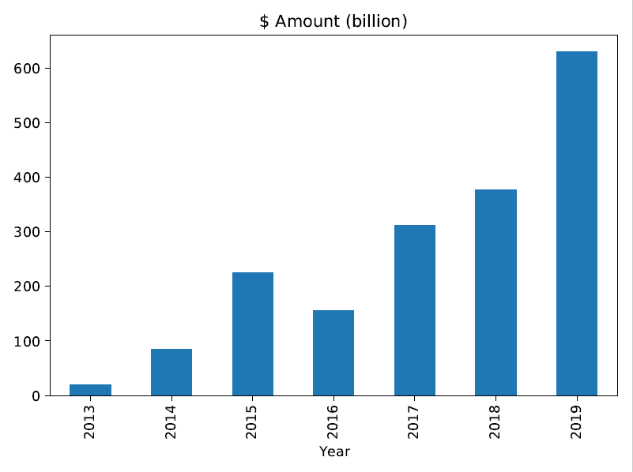

**Figure 2. Number of Corporate Green Bonds.**

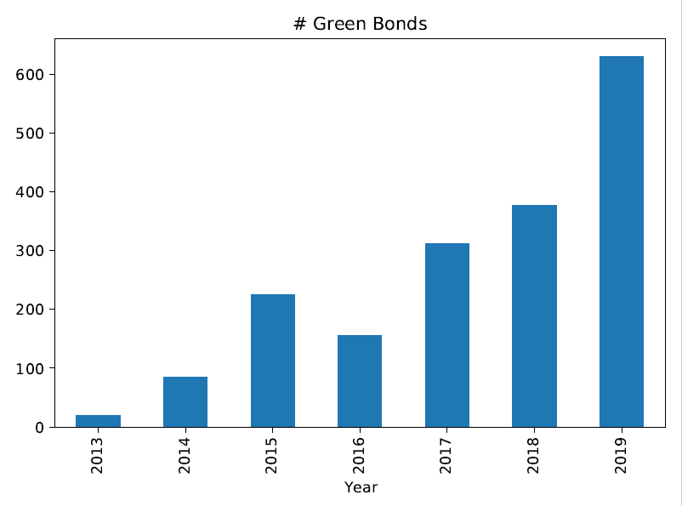Table 2 shows both the number and the amount in USD billion issued by sector for corporate green bonds listed on Refinitiv’s database from 2013 to 2019 after excluding ‘Non-US Munis’. Sectors are defined using Refinitiv’s Sector classification. The table is sorted by number of bonds; sectors with less than 4 bonds are grouped under ‘Other’.

**Table 2. Corporate Green Bonds by Sector.**

|  |  |  |
| --- | --- | --- |
| **Sector** | **# Bonds** | **$ Amount (billion)** |
| **Utility - Other** | 420 | 60.24 |
| **Banking** | 378 | 139.11 |
| **Financial - Other** | 326 | 99.76 |
| **Agency** | 223 | 122.82 |
| **Home Builders** | 157 | 11.16 |
| **Service - Other** | 61 | 12.94 |
| **Real Estate Investment Trust** | 35 | 6.43 |
| **Transportation - Other** | 24 | 5.07 |
| **Oil and Gas** | 19 | 11.59 |
| **Building Products** | 18 | 1.51 |
| **Railroads** | 17 | 1.64 |
| **Gas Utility - Pipelines** | 17 | 0.05 |
| **Electronics** | 15 | 6.18 |
| **Leasing** | 14 | 2.08 |
| **Mortgage Banking** | 13 | 7.66 |
| **Machinery** | 7 | 1.67 |
| **Retail Stores - Other** | 7 | 1.30 |
| **Conglomerate/Diversified Mfg** | 7 | 1.17 |
| **Chemicals** | 7 | 3.17 |
| **Life Insurance** | 7 | 3.15 |
| **Industrials - Other** | 7 | 2.74 |
| **Gas Utility - Local Distrib** | 4 | 1.38 |
| **Other** | 22 | 6.21 |
| **Total** | 1805 | 509.04 |

As it could be anticipated, sectors where the environment plays a big role (like Utilities, Home Builders, and Real Estate Investment) represent almost half of the total green bonds.

Moreover, it can be interesting to notice that Agency companies (that are state-owned companies) are the fourth most represented sector. This shows that government businesses enterprises still play a very important role in the green bond market, as on average they are more interested in environmental-friendly operations than privately owned firms[9].

Table 3 shows the breakdown of corporate green bonds by country, sorted by amount issued. China is the biggest market for green bonds, followed by France, Germany and United States. As a matter of fact, China is on the forefront of the green bonds trend, also thanks to the 13th Five Years Plan’s outlines to solve China’s worrying environmental situation and develop Chinese clean energy, green manufacturing, and environmental services sectors[10].

For the US, the number of bonds is inflated because of the large number of green bonds issued by Tesla in 2014.

Europe as a whole is the biggest market for green bonds.

**Table 3. Corporate Green Bonds by Country.**

|  |  |  |
| --- | --- | --- |
| **Country of Incorporation** | **# Bonds** | **$ Amount (billion)** |
| **China** | 165 | 67.52 |
| **France** | 180 | 60.54 |
| **Germany** | 73 | 49.52 |
| **United States** | 233 | 49.48 |
| **Netherlands** | 70 | 47.92 |
| **Sweden** | 248 | 27.15 |
| **United Kingdom** | 36 | 15.12 |
| **Spain** | 33 | 14.73 |
| **Japan** | 96 | 14.36 |
| **Norway** | 50 | 13.56 |
| **Denmark** | 19 | 13.00 |
| **Australia** | 23 | 12.29 |
| **Canada** | 25 | 10.93 |
| **South Korea** | 28 | 10.39 |
| **Italy** | 26 | 10.37 |
| **Hong Kong** | 26 | 10.16 |
| **Luxembourg** | 17 | 9.44 |
| **Cayman Islands** | 26 | 8.38 |
| **India** | 37 | 6.95 |
| **Mauritius** | 12 | 5.72 |
| **Finland** | 15 | 5.55 |
| **Austria** | 13 | 5.40 |
| **British Virgin Islands** | 14 | 4.38 |
| **Brazil** | 28 | 4.24 |
| **Others** | 312 | 31.94 |

Table 4 shows a summary of the main data regarding green bonds in the dataset, while providing also a distinction between the ones issued by public and private companies. The main issue with this kind of analysis is that public companies often issue their securities through their subsidiaries. In order to solve this conundrum, I get the Ultimate Parent Id for each bond’s issuer and then I verify whether Refinitiv lists the ultimate parent as public. I then replicate the analysis distinguishing 4 categories:

* Issuers labelled as private companies;
* Issuers labelled as public companies;
* Issuers whose ultimate parent is labelled as a private company;
* Issuers whose ultimate parent Is labelled as a public company.

Following Flammer (2020), I define issuer-days as the unique combinations between a single firm and the day in which it issues a bond, without repetitions.

Issuer-years is the number of unique combinations between a single firm and the year in which it issues a bond, without repetitions.

Fixed-rate bond is a dummy variable equal to 1 if the bond has a fixed coupon, 0 otherwise.

As the table shows, public companies experience lower standard deviation in duration and in coupon rate, more fixed-rate and borrow slightly higher amounts. It is interesting to notice that while public companies experience a longer maturity for the bonds they issue, the opposite is true when considering all companies whose ultimate parent is public.

**Table 4. Green Bonds Statistics.**

|  |  |  |  |  |  |
| --- | --- | --- | --- | --- | --- |
| **Index** | **All** | **Parent Private** | **Parent Public** | **Private** | **Public** |
| # Green bonds | 1805 | 1038 | 766 | 1348 | 456 |
| # Green bond issuer-days | 1303 | 786 | 516 | 917 | 385 |
| # Green bond issuer-years | 929 | 523 | 406 | 614 | 315 |
| # Green bond issuers | 643 | 333 | 310 | 413 | 230 |
| Amount (in $M) | 282.17 | 275.12 | 292.03 | 252.24 | 371.35 |
| **Amount (in $M) SD** | **0.44** | **0.42** | **0.46** | **0.40** | **0.53** |
| Maturity (years) | 8.62 | 9.39 | 7.59 | 7.76 | 11.22 |
| **Maturity (years) SD** | **33.87** | **44.27** | **6.76** | **6.61** | **66.47** |
| Fixed-rate bond | 0.79 | 0.77 | 0.81 | 0.8 | 0.76 |
| **Fixed-rate bond SD** | **2.35** | **2.49** | **2.14** | **2.3** | **2.37** |
| Coupon (for fixed-rate bonds) | 3.26 | 3.39 | 3.09 | 3.48 | 2.57 |
| **Coupon (for fixed-rate bonds) SD** | **2.35** | **2.49** | **2.14** | **2.3** | **2.37** |

# The analysis

For the analysis, I replicate the event study by Flammer about the stock price returns for different time windows around the issuance of a green bond. Like Bloomberg, Refinitiv allows to obtain the first announcement date of a bond, that is the exact day on which the company declared its intentions to issue the bond. This piece of information is fundamental as it indicates exactly when the market publicly received the information for the first time. Following Flammer (2020), I:

* use as a baseline time window [-5, 10] from 5 days prior until 10 days following the announcement in order to see if the market has obtained some information in the 5 days before the announcement and if there is an impact in the following 10 days.
* analyse also the time windows [-20, -11], [-10, -6] and [11, 20], [21, 60] to see if there are any impacts before or after the announcement.

For every firm with a public ultimate parent, I formalize a market model using an Ordinary Least Square that uses a constant α and a coefficient β trained over the 200 trading days prior to the first time window. This means that the period for estimating the model corresponds to the time window [-220, -21].

Therefore, the market model simply analyses the relationship between the market returns and the stock returns. The equation is:

$$R_{i}= α_{i} + β_{i} × R_{m_{t}} + ϵ_{i_{t}}$$

For each bond issuer’s country of incorporation, I identify the corresponding market index. The relationship country-to-index is listed on table 5. For Bermuda, British Virgin Islands and Cayman Islands’ stock markets, I could not identify any specific market index. Since these three are very international stock markets, I use as market index the S&P500 (.SPX), given that it is one of the most commonly followed equity indexes.

**Table 5. Specific Market Indexes.**

|  |  |
| --- | --- |
| **Country of Incorporation** | **Market Index** |
| Australia | .AXJO |
| Austria | .ATX |
| Belgium | .BFX |
| Bermuda | .SPX |
| Brazil | .BVSP |
| British Virgin Islands | .SPX |
| Canada | .SPTSE |
| Cayman Islands | .SPX |
| Chile | .SPIPSA |
| China (Mainland) | .SSEC |
| Colombia | .COLCAP |
| Denmark | .OMXC20 |
| Finland | .OMXH25 |
| France | .FCHI |
| Germany | .GDAXI |
| Greece | .ATFMI |
| Hong Kong | .HSI |
| India | .BSESN |
| Italy | .FTMIB |
| Japan | .N225E |
| Lithuania | .OMXVGI |
| Luxembourg | .LUXX |
| Malaysia | .KLSE |
| Mexico | .MXX |
| Morocco | .MASI |
| Namibia | .FTN098 |
| Netherlands | .AEX |
| New Zealand | .NZ50 |
| Nigeria | .NGSEINDEX |
| Norway | .OBX |
| Peru | .SPBLPGPT |
| Philippines | .PSI |
| Poland | .WIG |
| Portugal | .PSI20 |
| Singapore | .STI |
| South Africa | .JTOPI |
| South Korea | .KS11 |
| Spain | .IBEX |
| Sweden | .OMXS30 |
| Switzerland | .SSMI |
| Taiwan | .TWII |
| Thailand | .SETI |
| Turkey | .XU100 |
| United Arab Emirates | .ADI |
| United Kingdom | .FTSE |
| United States | .SPX |

Therefore, the estimated returns on the stock of firm are:

$$\hat{R_{i}}= \hat{α_{i}} + \hat{β_{i}} ×\hat{R_{mt}}$$

And the abnormal daily returns on the day t of the time window are instead:

$$AR_{it} = R_{it}- \hat{R_{it}}$$

By summing all the abnormal return, I obtain the cumulative abnormal returns (CAR) for each time window among the already listed [–20, –11], [–10, –6], [–5, 10], [11, 20], and [21, 60].

Table 6 shows the results of the event study over the 519 unique combinations between issuers with public parent and the day of announcement. Over these 519 issuer-days, I exclude 25 due to the lack of sufficient stock data on Refinitiv, as the companies entered the stock market less than 220 trading days prior to the green bond announcement date.

Table 6 shows the results for the remaining 494 issuer-days. *, **, and *** respectively denote significance at the 10%, 5%, and 1% level.

**Table 6. Cumulated Abnormal Returns for different time windows around green bond announcement (N=494).**

|  |  |  |
| --- | --- | --- |
| **Event time** | **CAR** | **Std. Err.** |
| **[-20, -11]** | 0.305 | 0.2 |
| **[-10, -6]** | 0.045 | 0.136 |
| **[-5, 10]** | 0.529** | 0.247 |
| **[11, 20]** | 0.127 | 0.178 |
| **[21, 60]** | 0.018 | 0.501 |

Like Flammer, I find cumulative abnormal returns for the [-5, 10] time window significant at the 5% level, although for a bigger sample size.

Nevertheless, when differentiating between first-time and seasoned green bond issuers, Flammer (2020) finds a stronger statistically significant response for the former ones. As shown by Table 7, I instead find no statistically significant response for the [-5, 10] time window. I do find a stronger response in the [-20, -11] time window instead. This result is still significant at the 5% value.

**Table 7. Cumulated Abnormal Returns different time windows around first green bond announcement (N=242).**

|  |  |  |
| --- | --- | --- |
| **Event time** | **CAR** | **Std. Err.** |
| **[-20, -11]** | 0.701** | 0.287 |
| **[-10, -6]** | -0.077 | 0.172 |
| **[-5, 10]** | 0.065 | 0.37 |
| **[11, 20]** | 0.162 | 0.252 |
| **[21, 60]** | 0.081 | 0.814 |

For seasoned green bond issuers, Flammer (2020) finds no statistically significant response from financial markets. I do instead find a much stronger response for the [-5, 10] time window that is significant to the 1% value.

**Table 8. Cumulated Abnormal Returns different time windows around non-first green bond announcement (N=252).**

|  |  |  |
| --- | --- | --- |
| **Event time** | **CAR** | **Std. Err.** |
| **[-20, -11]** | -0.075 | 0.275 |
| **[-10, -6]** | 0.162 | 0.21 |
| **[-5, 10]** | 0.974*** | 0.328 |
| **[11, 20]** | 0.093 | 0.252 |
| **[21, 60]** | -0.042 | 0.602 |

# Conclusions

These statistically significant positive cumulated abnormal returns sustain Flammer’s thesis that the stock market has a positive reaction towards the issuance of green bonds.

Given that literature shows that the stock market does not react to bond issues[11], it is likely that the positive cumulative abnormal returns must be caused by the company’s signalling of its commitment towards the environment.

While Flammer (2020) arguments that her finding of small and insignificant abnormal returns for seasoned issuers is consistent with her signalling theory, I would argue that my finding is more consistent with the latter hypothesis. As a matter of fact, one green bond issuance is not sufficient to show a constant effort towards the environment. The commitment, especially for a grey area such the one for green bonds, must be renovated periodically to show:

* that the first green bond issuance was not a mere greenwashing attempt;
* that the company is still interested in eco-friendly investments;
* that for the company the transparency and compliance requirements for green bonds represent neither big administrative nor opportunity costs, because the corporation has already the interest and the administrative structure to issue such bonds.

It is more difficult to explain the difference in findings for the time window where abnormal returns materialize for first-time issuers. I would argue that it is possible that the market obtains information much sooner about the first issuance of a green bond than for the issuance of a second or third one. Due to the novelty of the project for the business, information might indeed leak sooner and more easily. For successive issuances, the company would experience the project more as a routine one. Additionally, operations like contacting an appointed verifier that can provide a green bond certification would not represent a big signal of a possible green bond issuance, but a mere contact regarding the previous issuances. Nevertheless, it is clear that the impact of green bonds on stock returns requires further analysis.

This research only provides both a confirmation and a small rejection of Flammer’s event study on abnormal returns due to the issuance of green bonds. Nevertheless, the entire code for the analysis is available at <https://github.com/ElLorans/GreenBonds> . Since the biggest problems for this kind of analysis are data cleaning and data collection, having a ready-to-use baseline code might provide useful for further research.

Considering Ehlers and Packer (2017) finding on the differences between the databases for green bonds of Bloomberg and Climate Bond Index, new analysis might focus on combining these 2 data sources to Refinitiv or Thomson Reuters in order to create a dataset that could really closely map the entire global market for green bonds.

# Bibliography

International Bank for Reconstruction and Development, The World Bank (2015). *What are Green Bonds?*, in The World Bank. Available at: <http://documents1.worldbank.org/curated/en/400251468187810398/pdf/99662-REVISED-WB-Green-Bond-Box393208B-PUBLIC.pdf>

Unicredit Bank (2020). *The Green Bond and ESG Chartbook.* Available at: <https://www.research.unicredit.eu/DocsKey/credit_docs_2020_176565.ashx?EXT=pdf&KEY=n03ZZLYZf5m_TjufI0N-SYIayxf3oNc8JOXSk3v6nU0=&T=1>

ICMA Group (2018). *Green Bond Principles: Voluntary Process Guidelines for Issuing Green Bonds.* Available at: <https://www.icmagroup.org/assets/documents/Regulatory/Green-Bonds/Green-Bonds-Principles-June-2018-270520.pdf>

Torsten Ehlers and Frank Packer (2017). *Green bond finance and certification.* Available at: <https://www.bis.org/publ/qtrpdf/r_qt1709h.htm>

Corke and Myers (2019). *When ‘green’ bonds go brown.* Available at: <https://www.lexology.com/library/detail.aspx?g=0a6503d3-d4ff-44fc-ab2b-5166c157f630>

Larcker and Watts (2019), Journal of Accounting and Economics

Volume 69, Issues 2–3, April–May 2020. *Where’s the greenium?* Available at: <https://doi.org/10.1016/j.jacceco.2020.101312>

Chen, Sinha and Dong (2019), Business Strategy and the Environment Volume 29, Issue 1 (2020), *Are firms with state ownership greener? An institutional complexity view.* Available at: <https://onlinelibrary.wiley.com/doi/abs/10.1002/bse.2358>

Koleski (2017), *US-China Economic and Security Review Commission Staff Research Report*. Available at: <https://www.uscc.gov/sites/default/files/Research/The%2013th%20Five-Year%20Plan_Final_2.14.17_Updated%20(002).pdf>

Eckbo, Masulis and Norli (2007), HANDBOOK OF CORPORATE FINANCE: EMPIRICAL CORPORATE FINANCE, Vol. 1, Chapter 6, pp. 233-373, Elsevier/North-Holland Handbook of Finance Series, *Security Offerings.* Available at: https://papers.ssrn.com/sol3/papers.cfm?abstract_id=863664

1. International Bank for Reconstruction and Development, The World Bank (2015)
2. Unicredit Bank (2020).
3. The Climate Bonds Initiative (2020)
4. Corke and Myers (2019)
5. Ehlers and Packer (2017)
6. See Larcker and Watts (2019) and Flammer (2020) among others.
7. Ehlers and Packer (2017)
8. Unicredit Bank (2020)
9. Chen, Sinha and Dong (2019)
10. Koleski (2017)
11. Eckbo, Masulis, and Norli (2007)