***Transshipment Out Audit Tool:***

***Developers Guide for non-programmers***

**Step 1:**

**Get administrator rights** (download “Amazon Admin Right Tool” from Software Center).

**Step 2:**

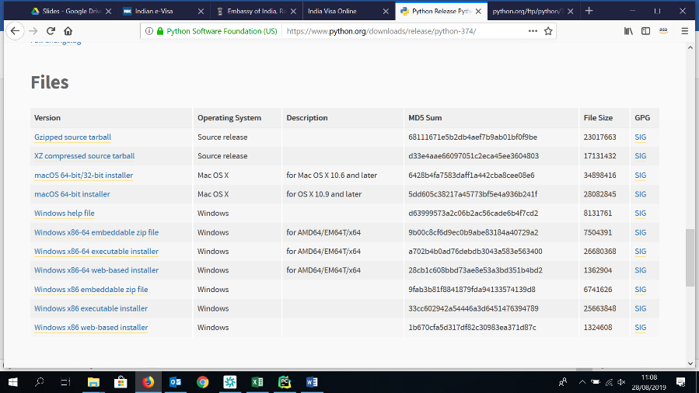[Install Python 3.7.4](https://www.python.org/downloads/release/python-374/) . Scroll down the linked page and download Windows x86-64 executable installer (but any Windows x86 should work).

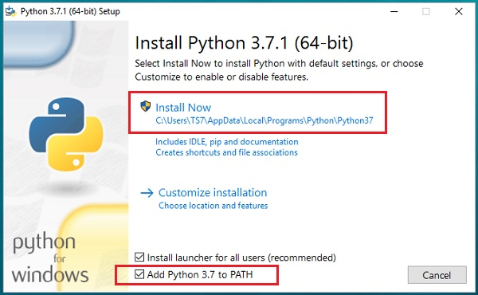

**WARNING:** it is FUNDAMENTAL to add Python Environment Variables during installation.

**Step 3:**

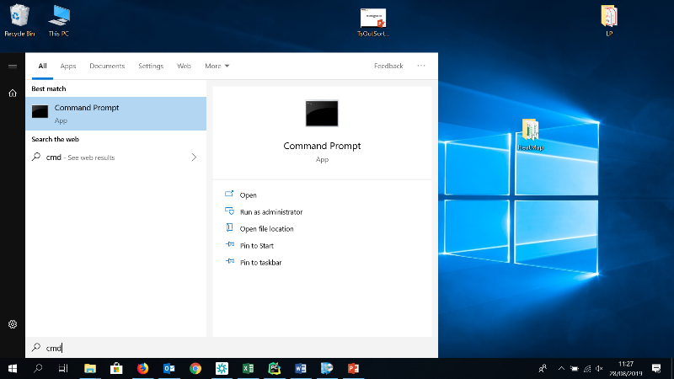Check that python is installed and added to Environment Variables:

1. Open the start menu, digit “cmd” and **open the Command Prompt**;
2. 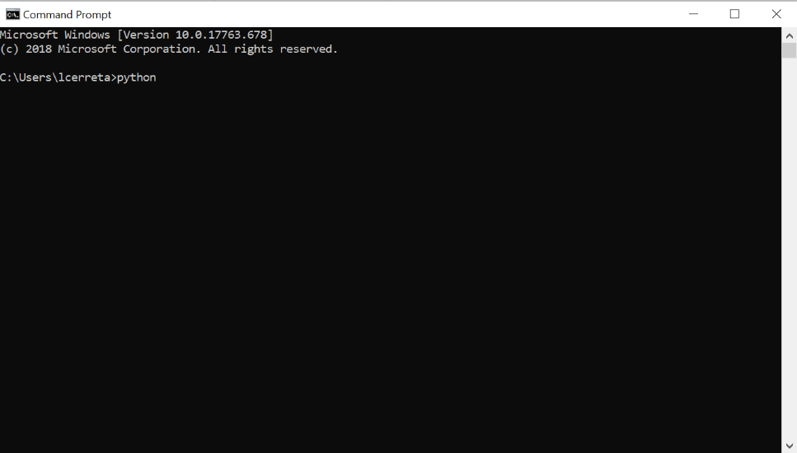In the Command Prompt, **insert python**.

If after pressing enter you get an **error message** stating “python is not recognized as an…” please **uninstall python and reinstall** it again following Step 2 or [add Python to environment variables](https://www.youtube.com/watch?v=Y2q_b4ugPWk).

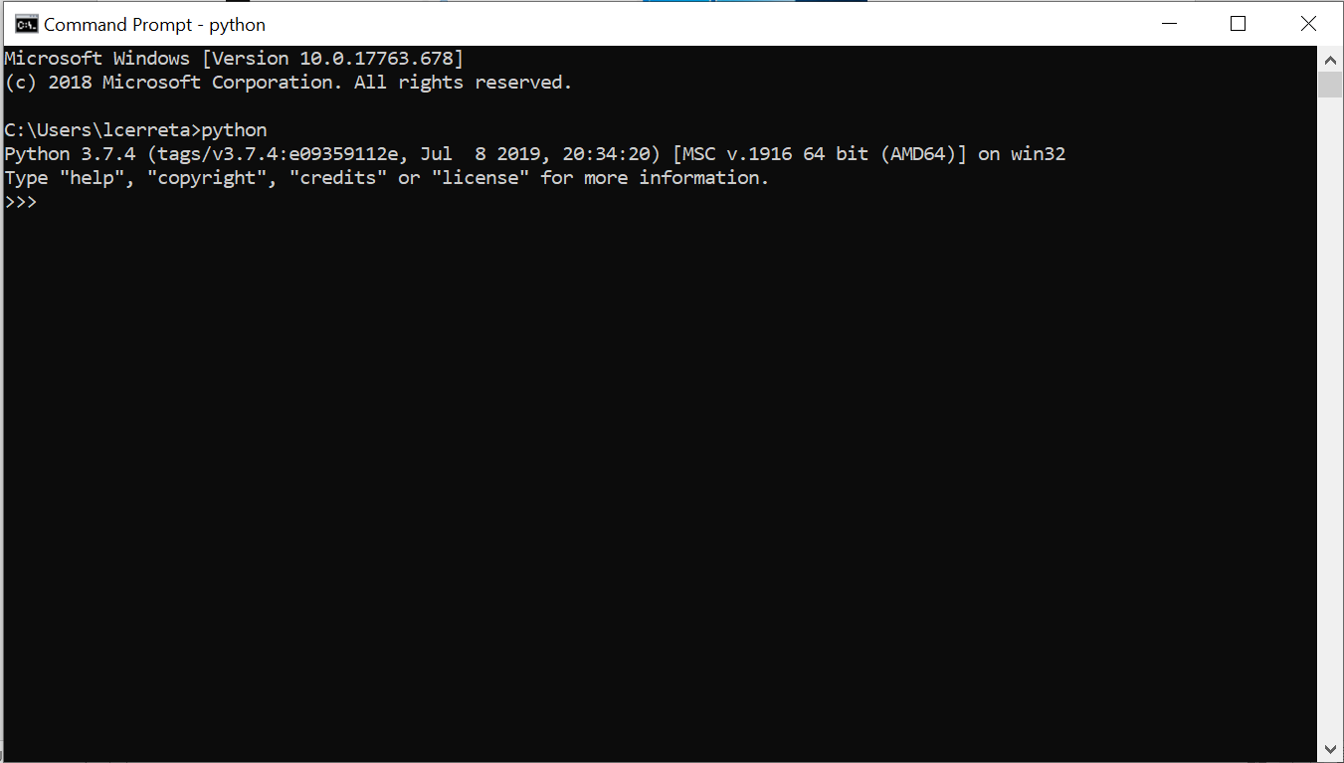If instead after inserting “python” you see a message very similar to the one in the picture on the right (Python 3.7.4 (tags/v3.7.4 …), you installed Python and you added it to the environment variables. Close the Command Prompt and **go to step 4**.

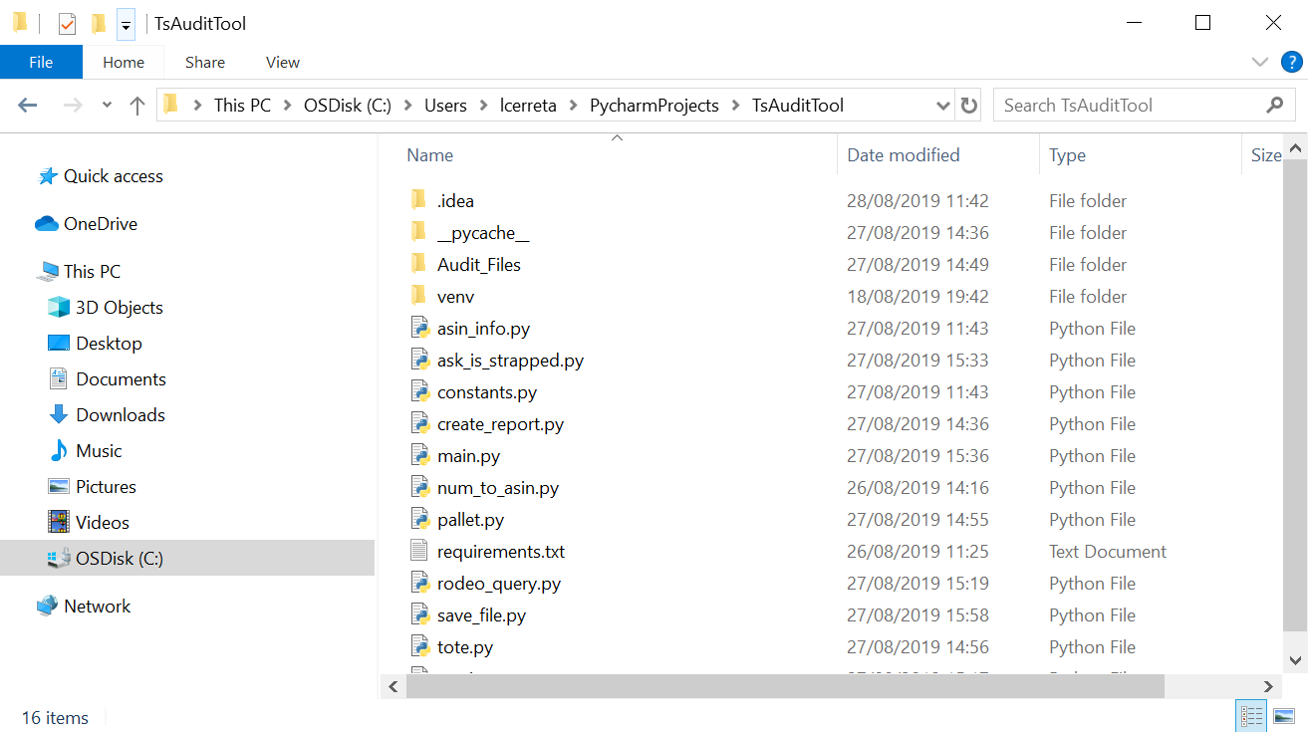**Step 4:**

**Open the folder** containing the source code of TsOutAuditTool. You should see some .py files and a requirements.txt file.

**Step 5:**

Now you need to install the libraries listed in requirements.txt

In the folder with the source code, **hold shift and right click**. On the menu, select “**Open PowerShell window here**”. The PowerShell is very similar to the Command Prompt.

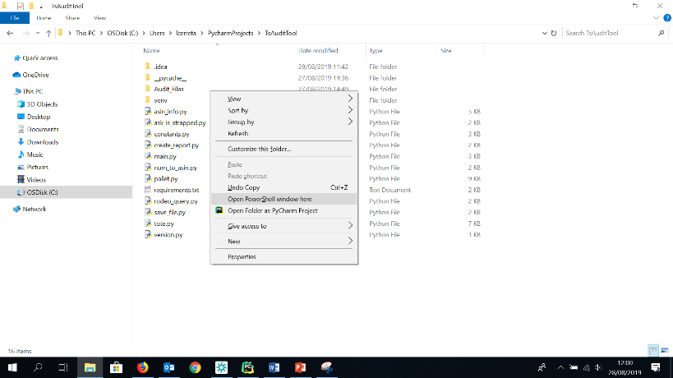

**Step 6:**

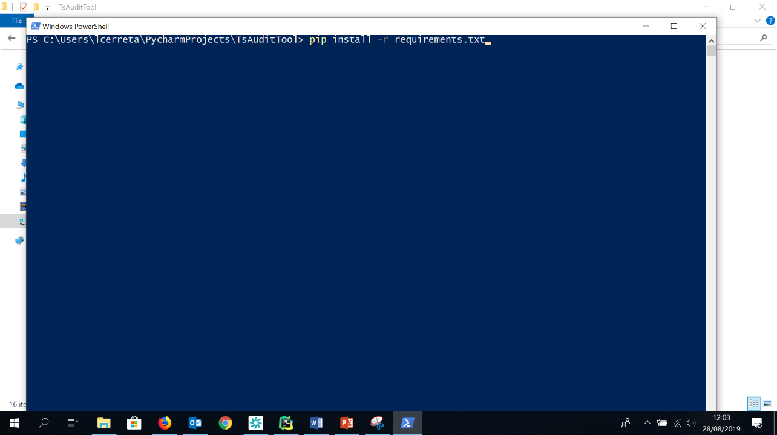In the PowerShell, insert “**pip install -r requirements.txt**”. Click enter and wait that the installation process is complete. If asked for confirmation, insert ‘y’ very time.

**Step 7:**

As soon as the installation process, the PowerShell will write something similar to “PS C:\Users\...” and will allow you to write again. You can **close the PowerShell**.

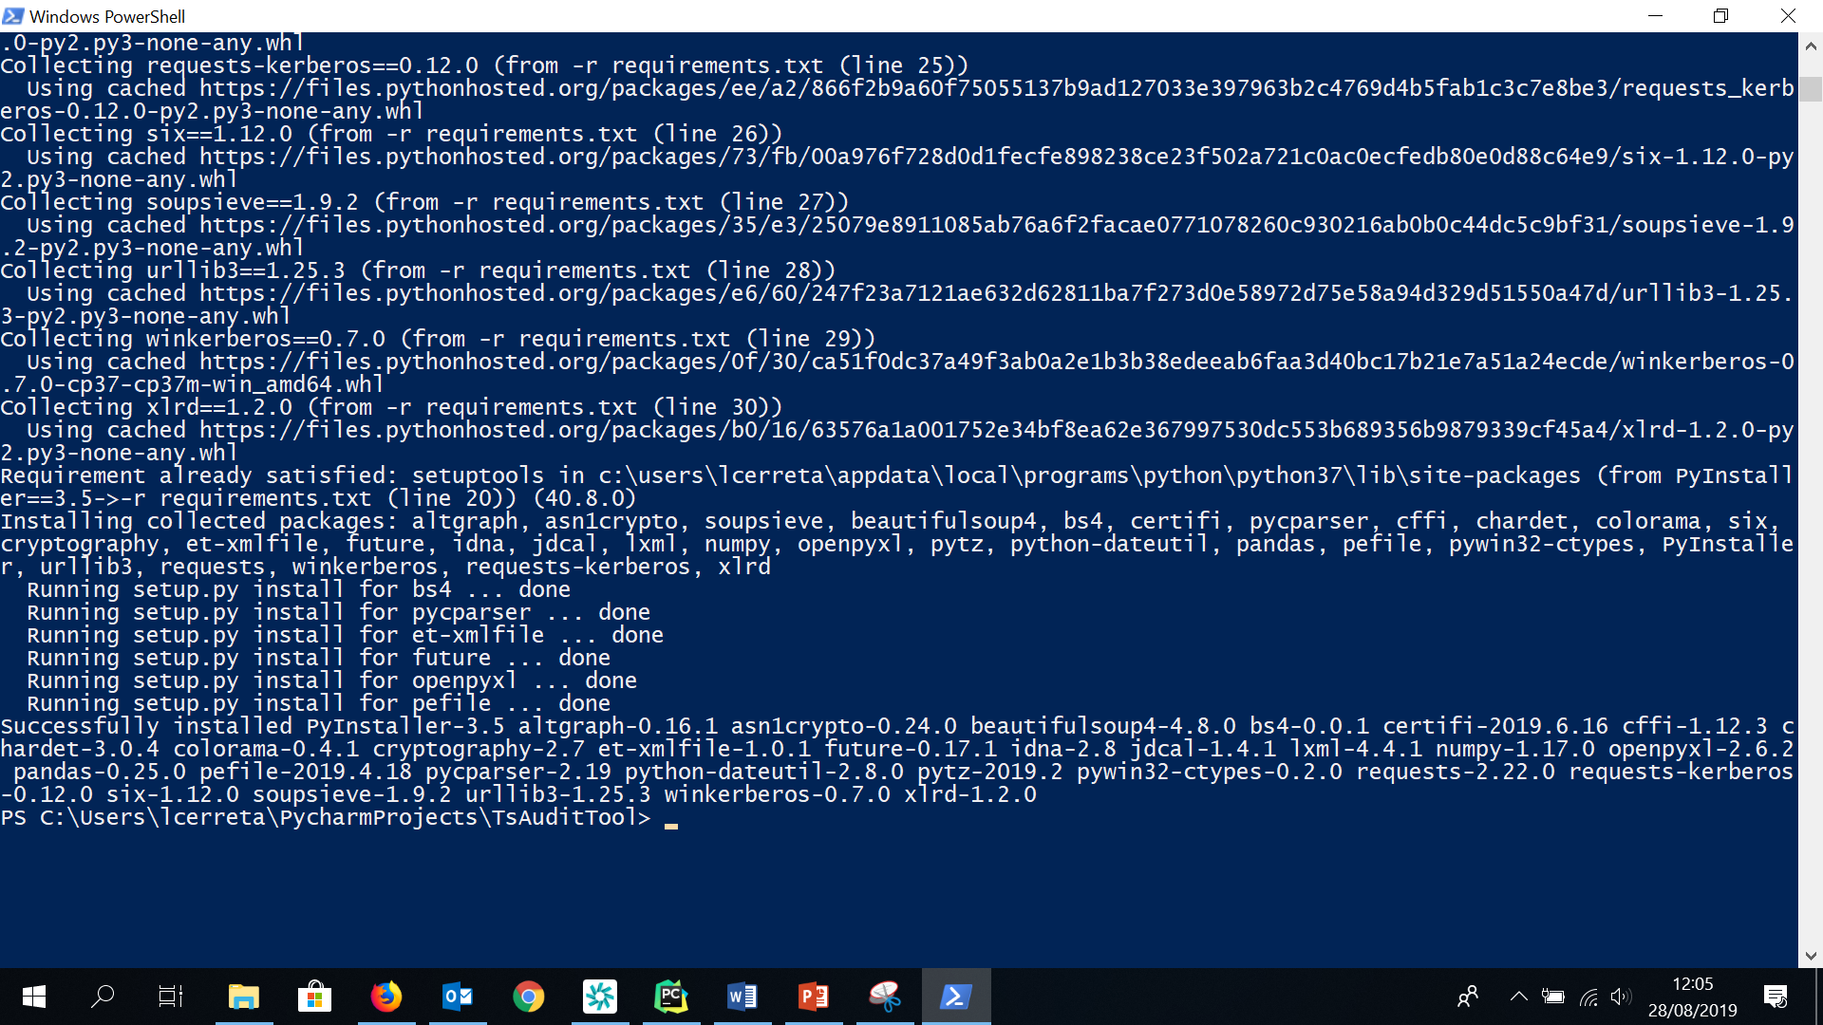

**Step 8:**

Now you have installed python and all the necessaries libraries to run the source code of Ts Out Audit Tool. You can **double click on main.py** and it will work like TsOutAuditV_0.4.exe . The only differences will be the icon and the name on top of the window.

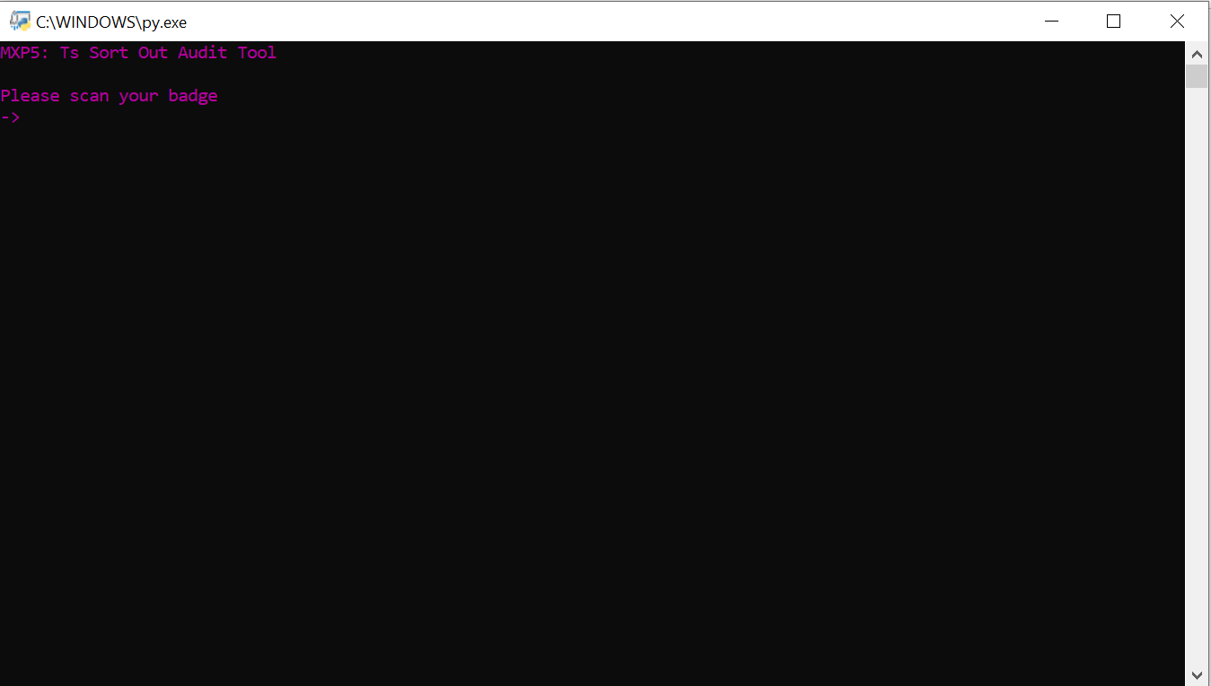

**Step 9 (Modifying the Source Code):**

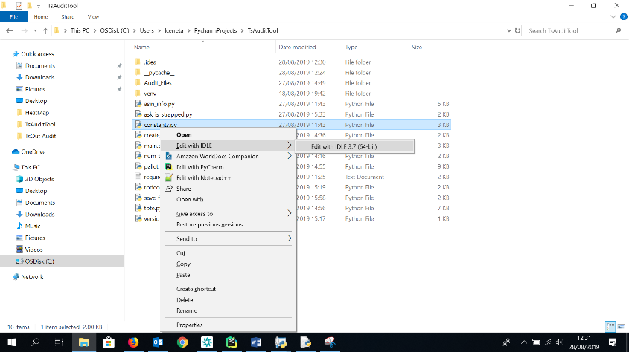You can now modify the code as you wish to. For example, suppose you need to modify the FC and the country code. Right click on constants.py and select “**Edit with IDLE**”.

**WATCH OUT:** save a copy of the source code before modifying it, so that the original code can be retrieved in case of errors.

Now you can see the source code and modify it. Scroll down the page until you see “FC”.

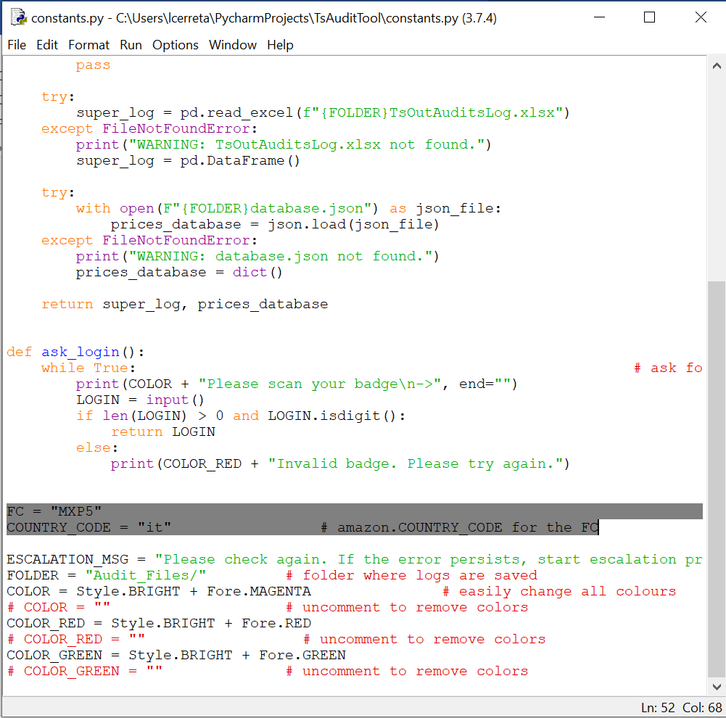

**Replace “MXP5” with another FC code**, like “ORY1”. **Modify the COUNTRY_CODE accordingly**, in this case “it” will be replaced by “fr”, because the relevant prices for ORY1 should be downloaded from <https://www.amazon.fr/> .

**Step 10 (Converting the source code to a .exe):**

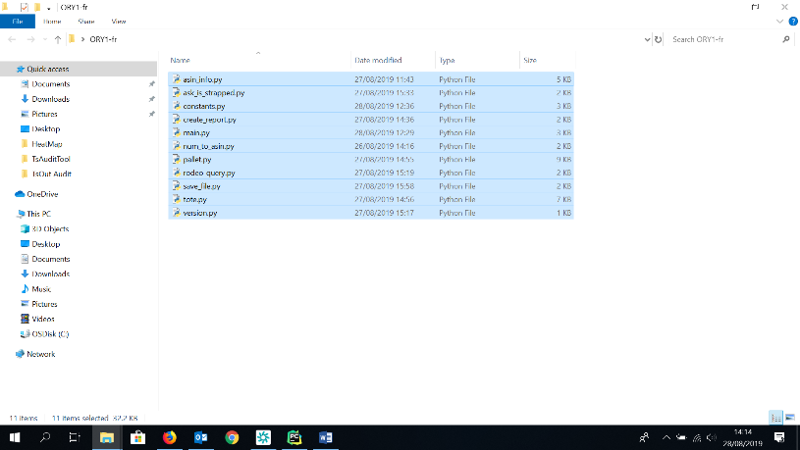In order to run the TS Out Audit Tool on PCs without Python installed, we need to convert the source code to a .exe file. Usually you want your distribution folder to be separate from you development one, so **create a new folder and copy there all the .py files**.

In the new folder with all the .py files, hold shift and right click. In the menu, select “**Open PowerShell window here**”.

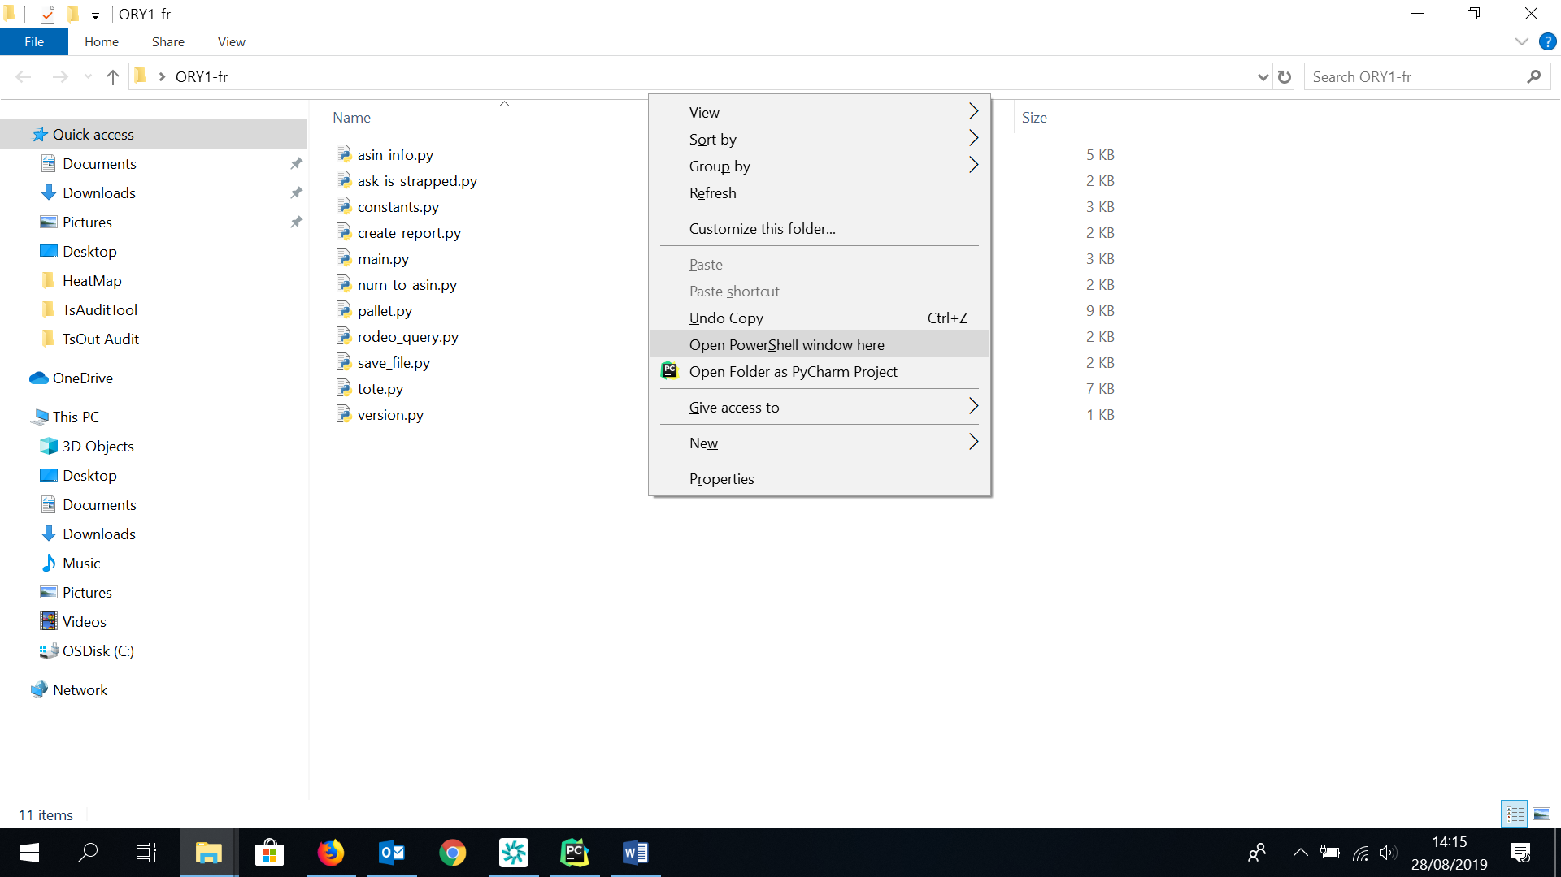

In the PowerShell, insert “**pyinstaller -F main.py --clean**”. This command will create a single .exe file (thanks to the –F command) with a clean cache (thanks to the –clean command, which is important if we already created a first .exe but we need to create a slightly different second one).

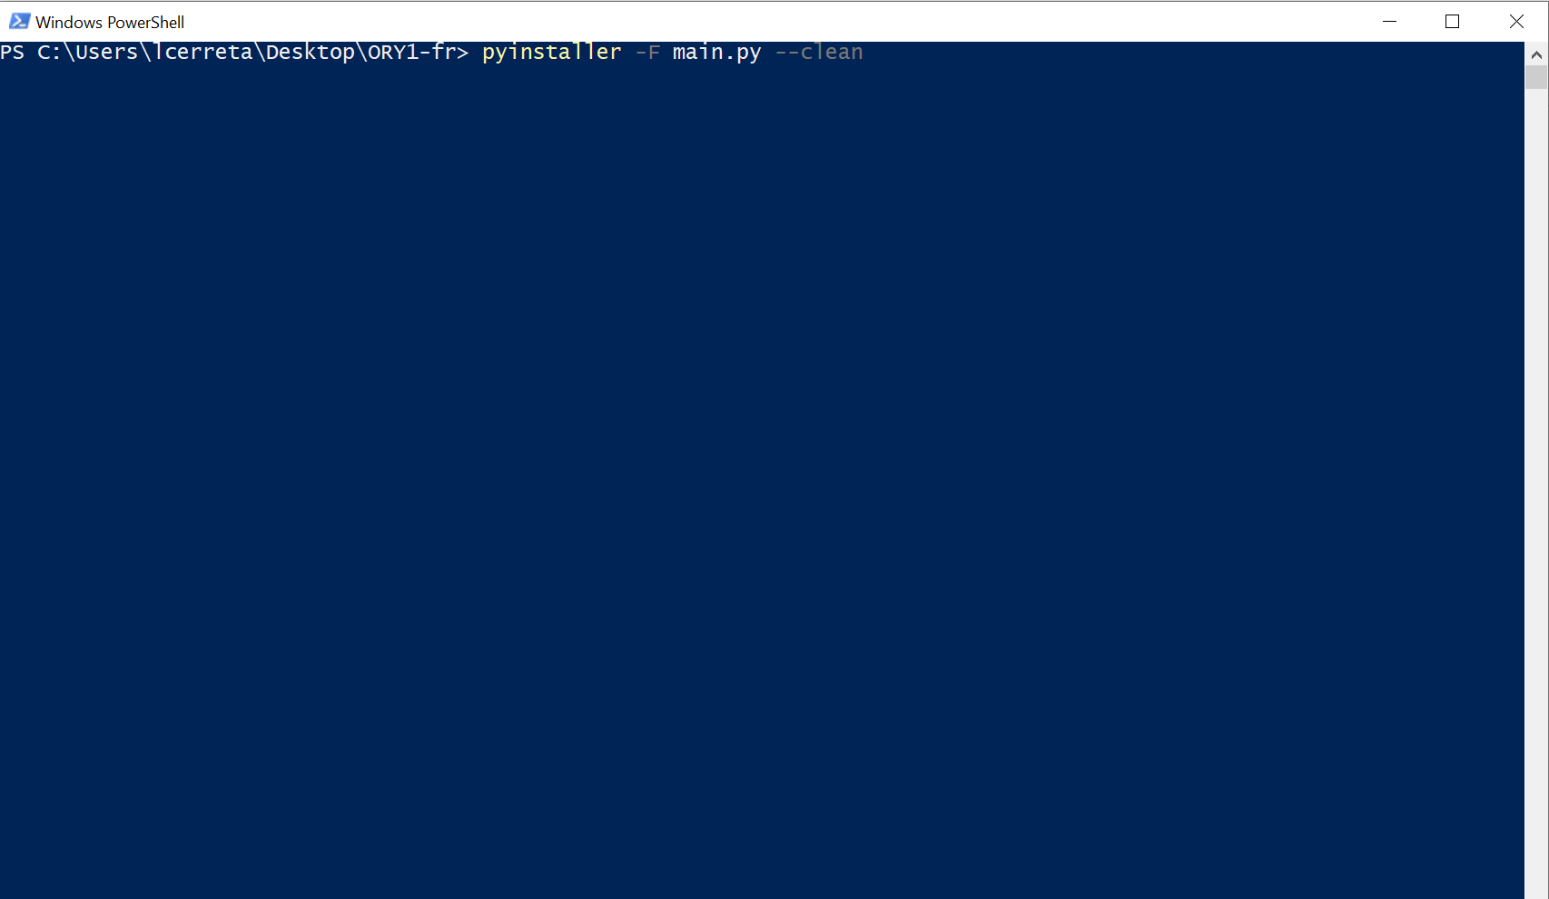

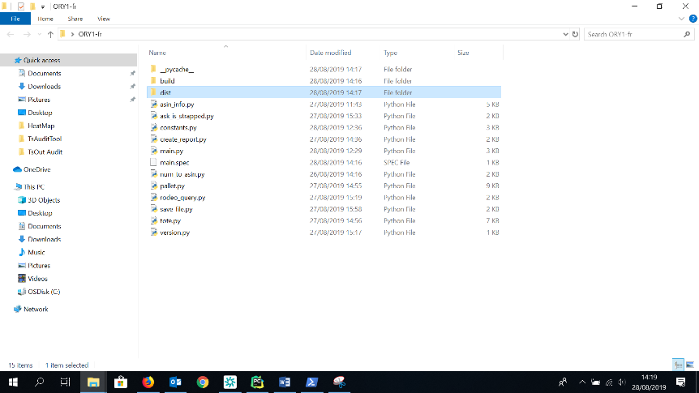When the PowerShell finishes, open the newly created dist folder to find your new “main.exe” file.

**HINT**: you might need to refresh the folder to see the “dist” folder.