*Gurobi optimizer*

More than 2,500 companies around the world and across over 40 different industries rely on the Gurobi Optimizer. The Gurobi Optimizer is capable of solving all major problem types (convex and non-convex):

* Linear programming (LP)
* Mixed-integer linear programming (MILP)
* Quadratic programming (QP)
* Mixed-integer quadratic programming (MIQP)
* Quadratically-constrained programming (QCP)
* Mixed-integer quadratically-constrained programming (MIQCP)

All of our object and matrix-oriented interfaces are implemented as lightweight, modern APIs. These include:

* Object-oriented interfaces for Python, C++, Java, and .NET
* Matrix-oriented interfaces for C, MATLAB®, and R
* Links to standard modeling languages including AIMMS, AMPL, GAMS, and MPL
* Links to Excel through Frontline Solvers

The Gurobi Optimizer provides advanced implementations of the latest algorithms including:

* LP algorithms – simplex, parallel barrier with crossover, concurrent and sifting.
* QP algorithms – simplex and parallel barrier QCP algorithms – parallel barrier (SOCP).
* MIP algorithms – deterministic parallel, non-traditional search, heuristics, solution improvement, cutting planes, and symmetry breaking.

With the Gurobi Optimizer, you can deploy your mathematical optimization model where and how you want. One user can solve a single model on one machine or many users can solve multiple models using many machines. Models can also be solved locally or on an internal or public cloud. Licenses may be used for both development and deployment. It is offered a wide variety of license types to meet your specific business requirements. In the following is shown a graph on how much Gurobi is getting better and better in terms of performances over the different developed versions.

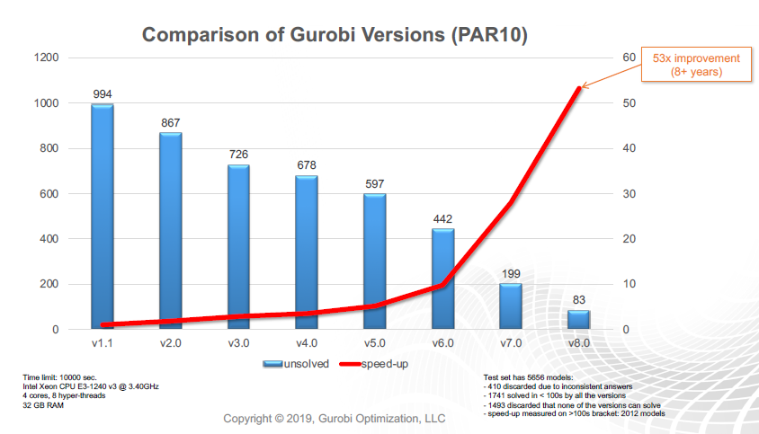

Consistent with prior releases, the Gurobi Optimizer v8.0 delivers performance improvements over v7.0 across a broad range of model types:

* **MIP – 57%** faster overall, 109% faster on models that take >100 seconds to solve
* **LP**
  + Concurrent – **15%** faster overall, 46% faster on models that take >100 seconds to solve
  + Primal Simplex – **24%** faster overall, 49% faster on models that take >100 seconds to solve
  + Dual Simplex – **32%** faster overall, 82% faster on models that take >100s to solve
  + Barrier – **13%** faster overall, 44% faster on models that take >100s to solve
* **MIQP – 2.76x** faster overall
* **MIQCP – 20%** faster overall
* **SOCP – 19%** faster overall

Gurobi Optimizer v8.1 improves performance significantly over v8.0 on integer quadratic programs:

* **MIQP – 2.8x** faster overall
* **MIQCP – 38%** faster overall
* **LP –** both dual simplex and barrier are **10%** faster on models that take > 100 seconds to solve

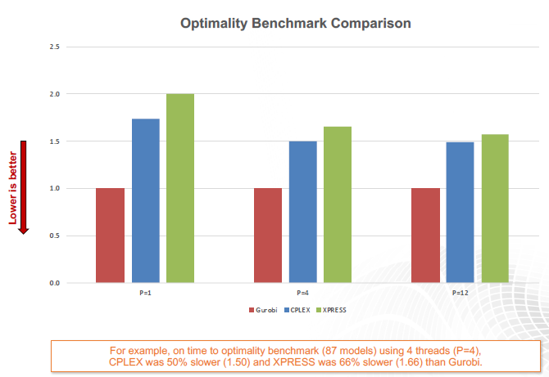

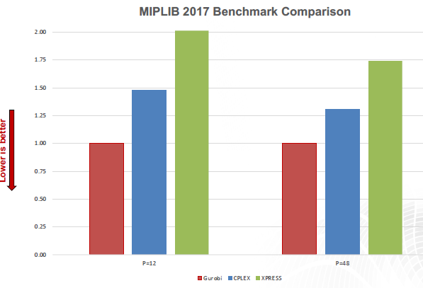

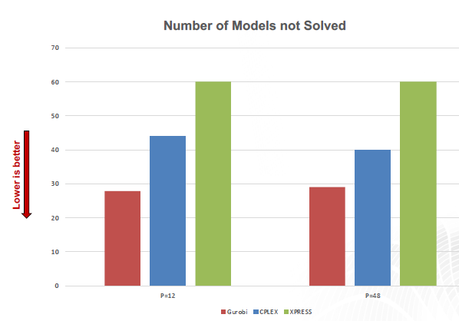

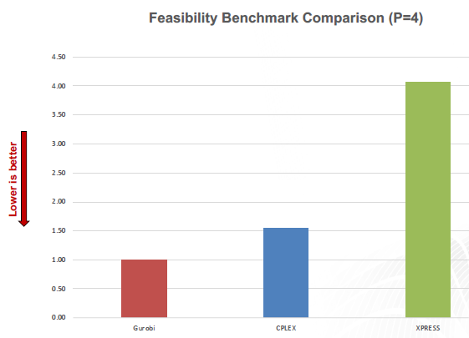

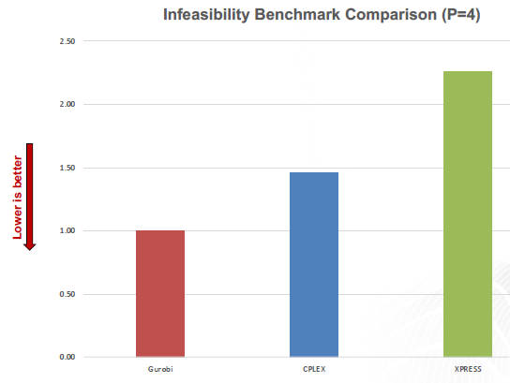

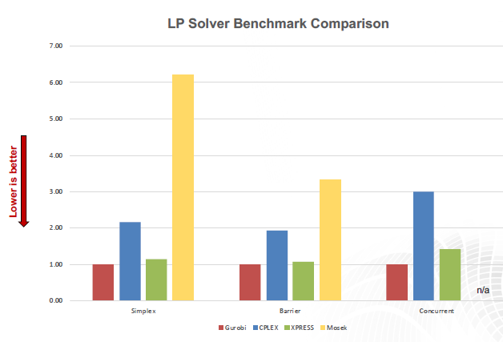

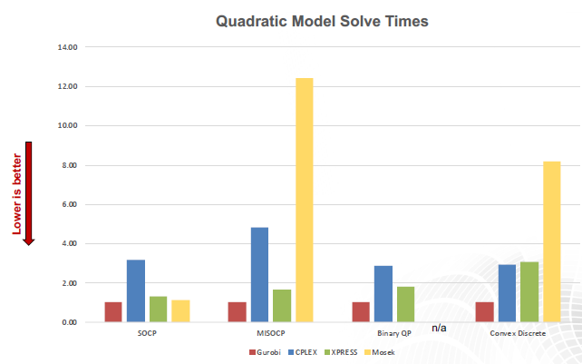

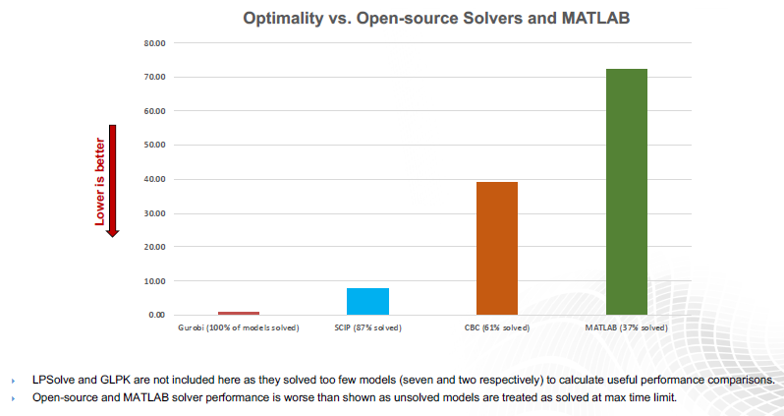

Basing on all these graphs, it is possible to write the following conclusions:

1. Gurobi is the fastest on MIPLIB 2010 Benchmark
2. Gurobi is the fastest on the New MIPLIB 2017 Benchmark
3. Gurobi solves more models in MIPLIB 2017 Benchmark
4. Gurobi is the fastest to feasibility
5. Gurobi is the fastest to detect infeasibility
6. Gurobi is the fastest across all LP Benchmarks

From point 1) to 5) the comparison has been done in between: Gurobi 8.1.0, CPLEX 12.8.0 and XPRESS 8.5.1. Point 6) includes Gurobi 8.1.0, CPLEX 12.8.0 and XPRESS 8.5.1 and Mosek 8.1.0. Last graph makes a comparison with SCIP, CBC and Matlab.

Evaluation License for Commercial Users:

Get a free, full-featured license of the Gurobi Optimizer to experience the performance, support, benchmarking and tuning services we provide as part of our product offering. To **New Users** Gurobi allows to try a free, full-featured, commercial evaluation license for 30 days. During that time, the user will also get:

* Free benchmarking services
* Free model tuning services
* Access to Gurobi’s world-class technical support
* Two free hours of one-on-one consulting services

Free License for Academic Users

Gurobi supports the teaching and use of optimization within academic institutions. It is offered free, full-featured copies of Gurobi for use in class, and for research. **Named-user academic license:**this license can be set up on a single physical machine. Users may install and license Gurobi for their own use on more than one machine. **Web License Service academic license:**the [Gurobi Web License Service (WLS)](https://www.gurobi.com/web-license-service/" \t "_blank) is a new licensing services for containerized environments (Docker, Kubernetes,…). As an academic user, Gurobi allows you to create a free WLS Academic License for 90 days that can be extended as long as you maintain your eligibility. **Multi-user academic site license:** this license of Gurobi can be setup on a university’s local-area network. The “Take Gurobi With You” program allows students to “take” one named user commercial license with them to their professional role for a period of one year.

These are the standard prices for AMPL and for the sold solvers.

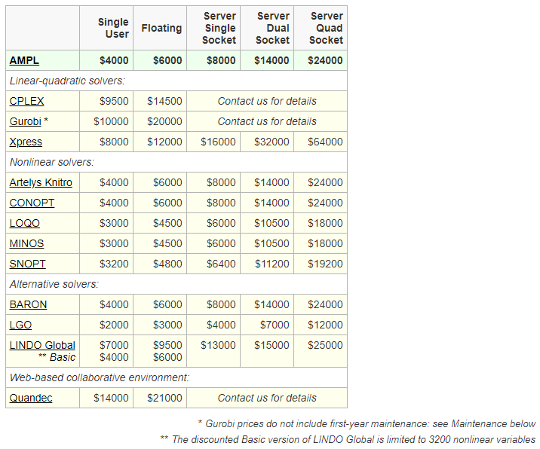

The following are the academic prices for AMPL and for the sold solvers. These prices apply to purchases by degree-awarding institutions for use in noncommercial teaching and research activities. Products covered by academic prices are full-featured and have no arbitrary limits on problem size.

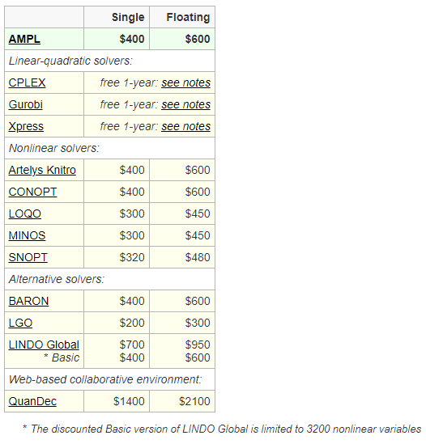

*References:*

https://www.gurobi.com/wp-content/uploads/2021/02/Gurobi-Optimization\_Product-Brochure-2021.pdf

https://www.gurobi.com/pdfs/benchmarks.pdf

https://www.gurobi.com/academia/academic-program-and-licenses/

https://ampl.com/products/standard-price-list/