Cell-wise average log-probability of the chain for [fish, krill, bubble]

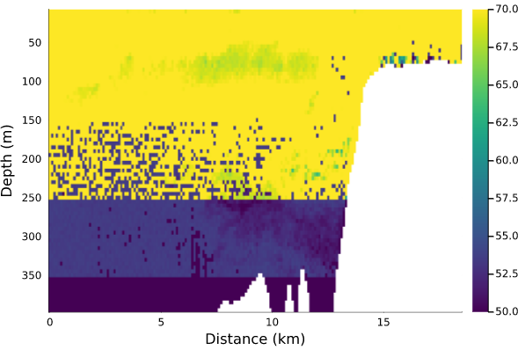

And 3-spp model:

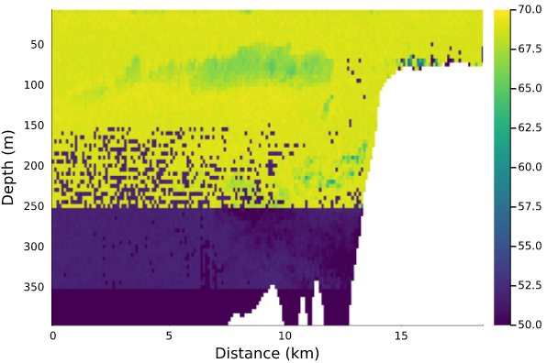

Cell-wise CV for 3-spp model:

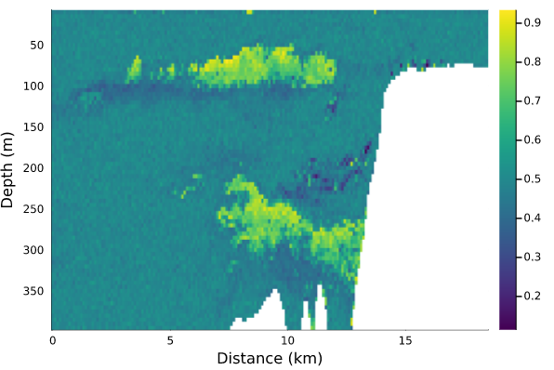

And 4-spp model:

