Figures
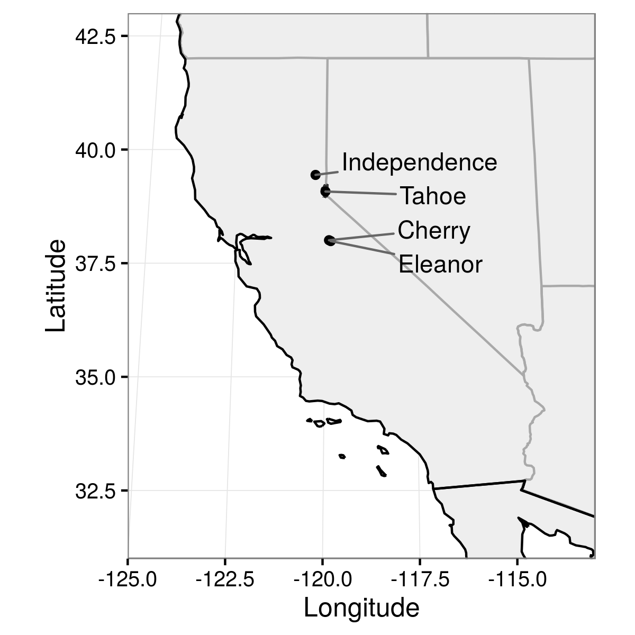
Figure 1. Map of California in the western United States, showing locations of the four study lakes.
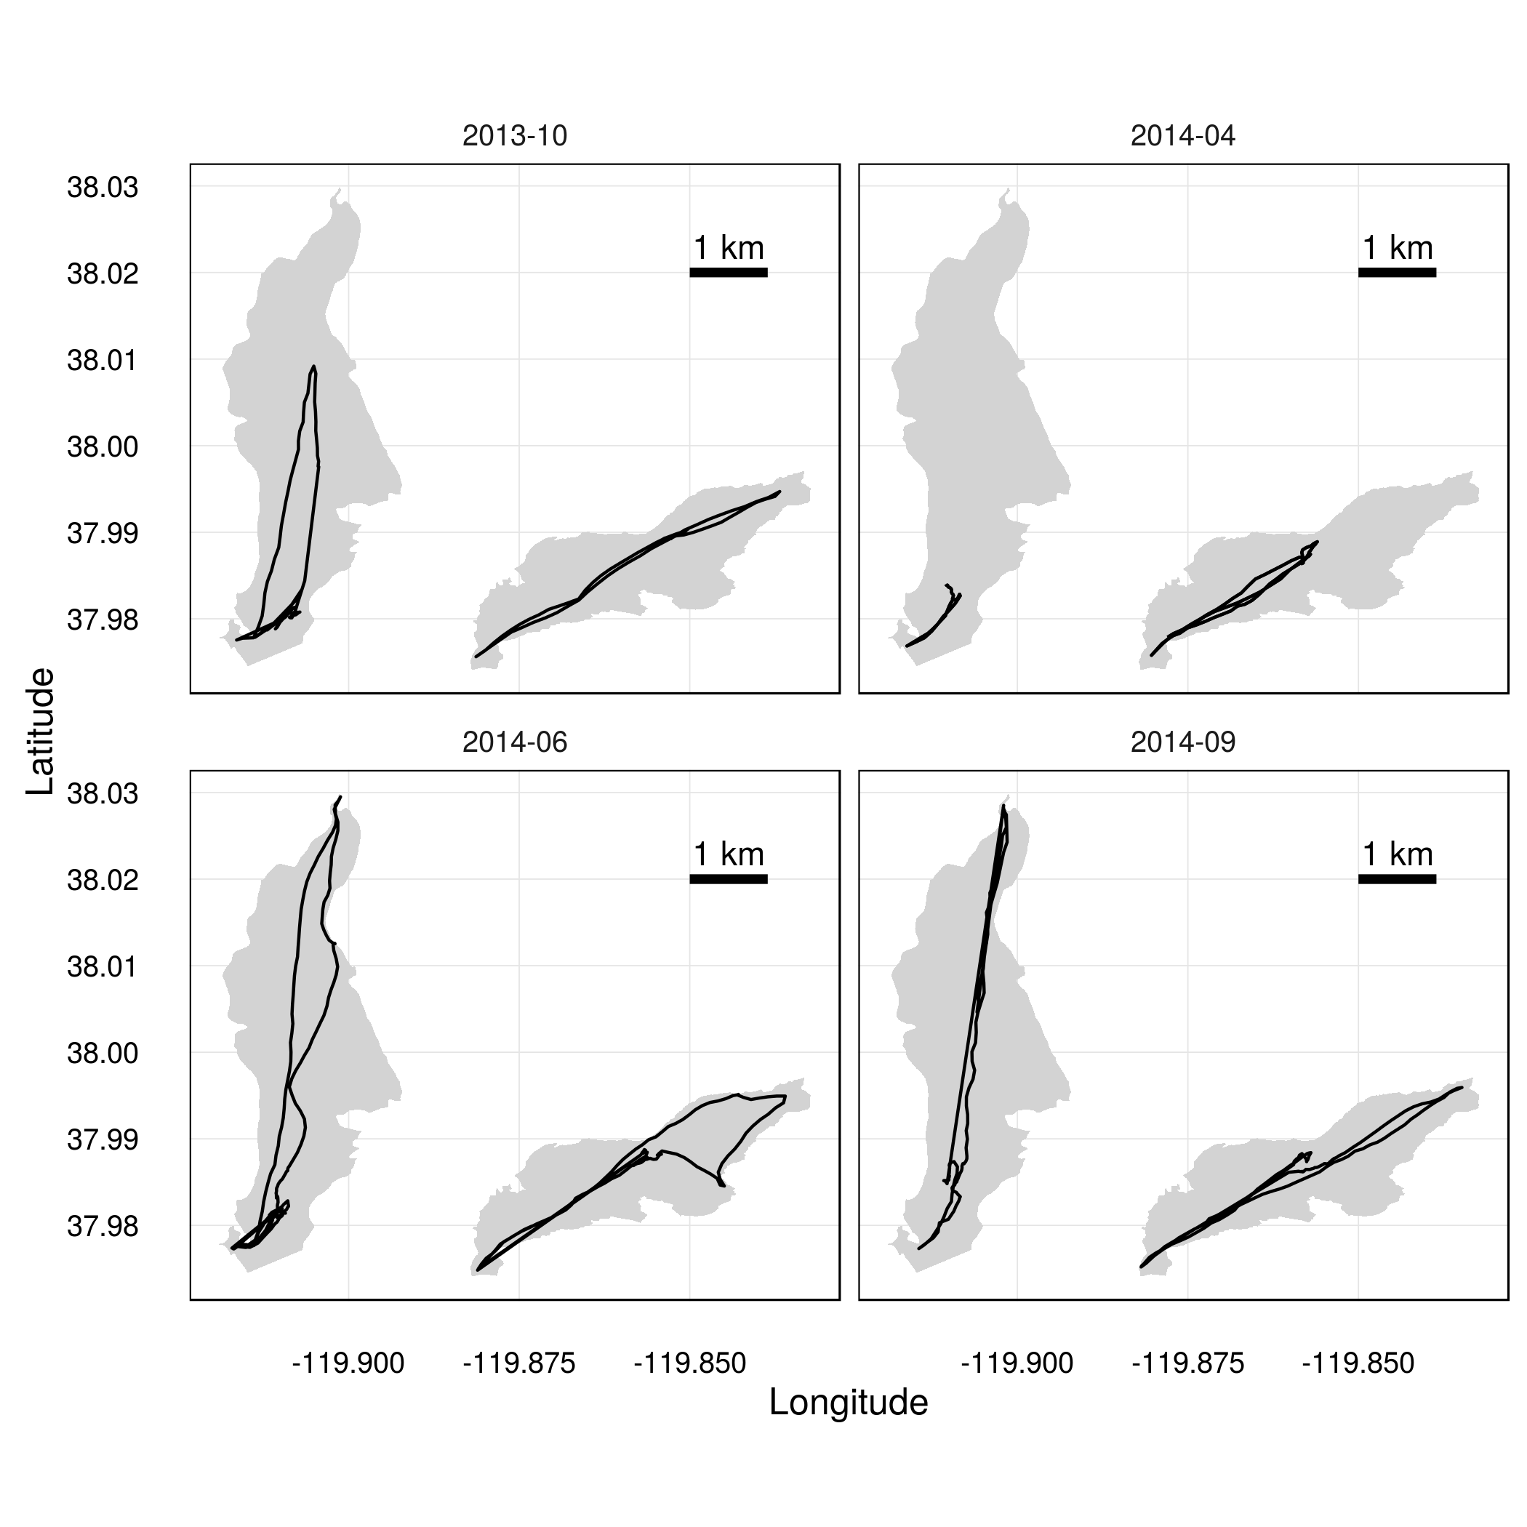
Figure 2. Tracklines of repeated acoustic surveys in Cherry Lake (left) and Lake Eleanor (right) in October 2013, April 2014, June 2014, and September 2014.
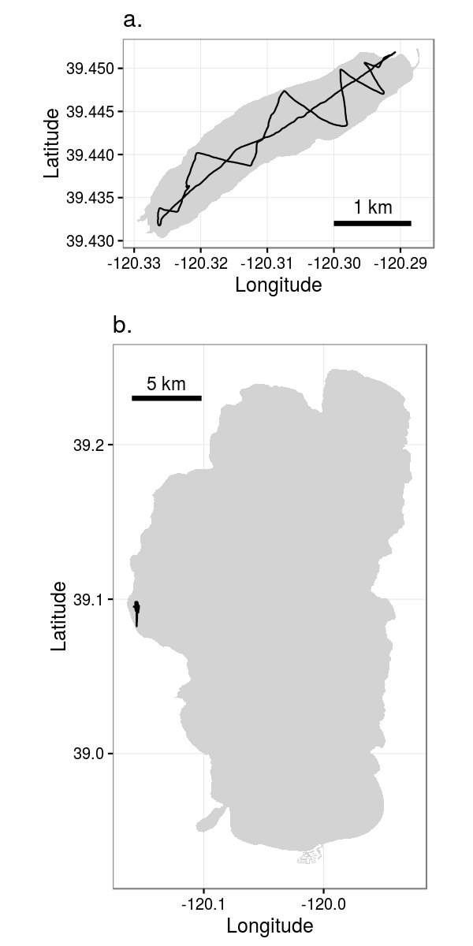
Figure 3. Acoustic survey tracks in a) Independence Lake on 21 October 2013, and b) Lake Tahoe on 20 October 2013.
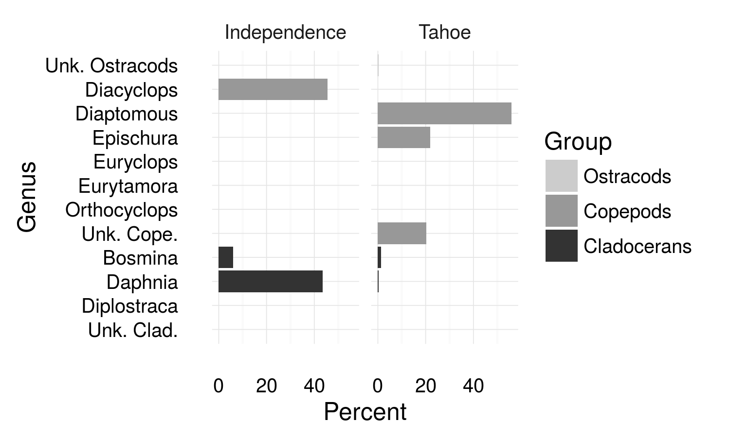
Figure 4. Composition of crustacean zooplankton community in Independence Lake and Lake Tahoe in October 2013.
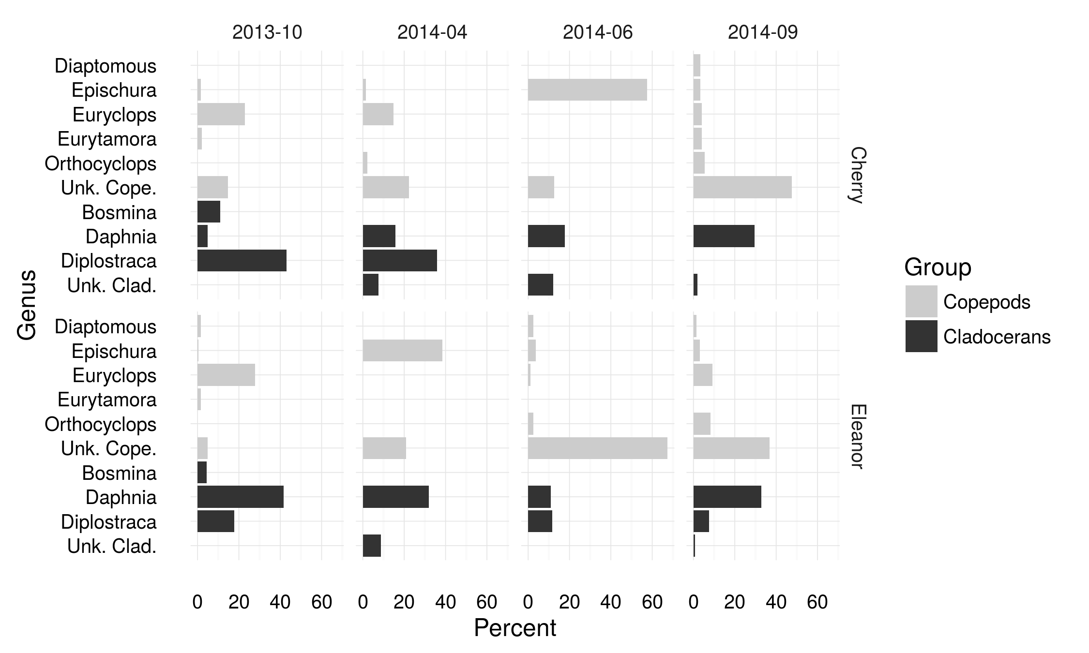
Figure 5. Composition of crustacean zooplankton community in Cherry Lake and Lake Eleanor in four seasonal surveys.
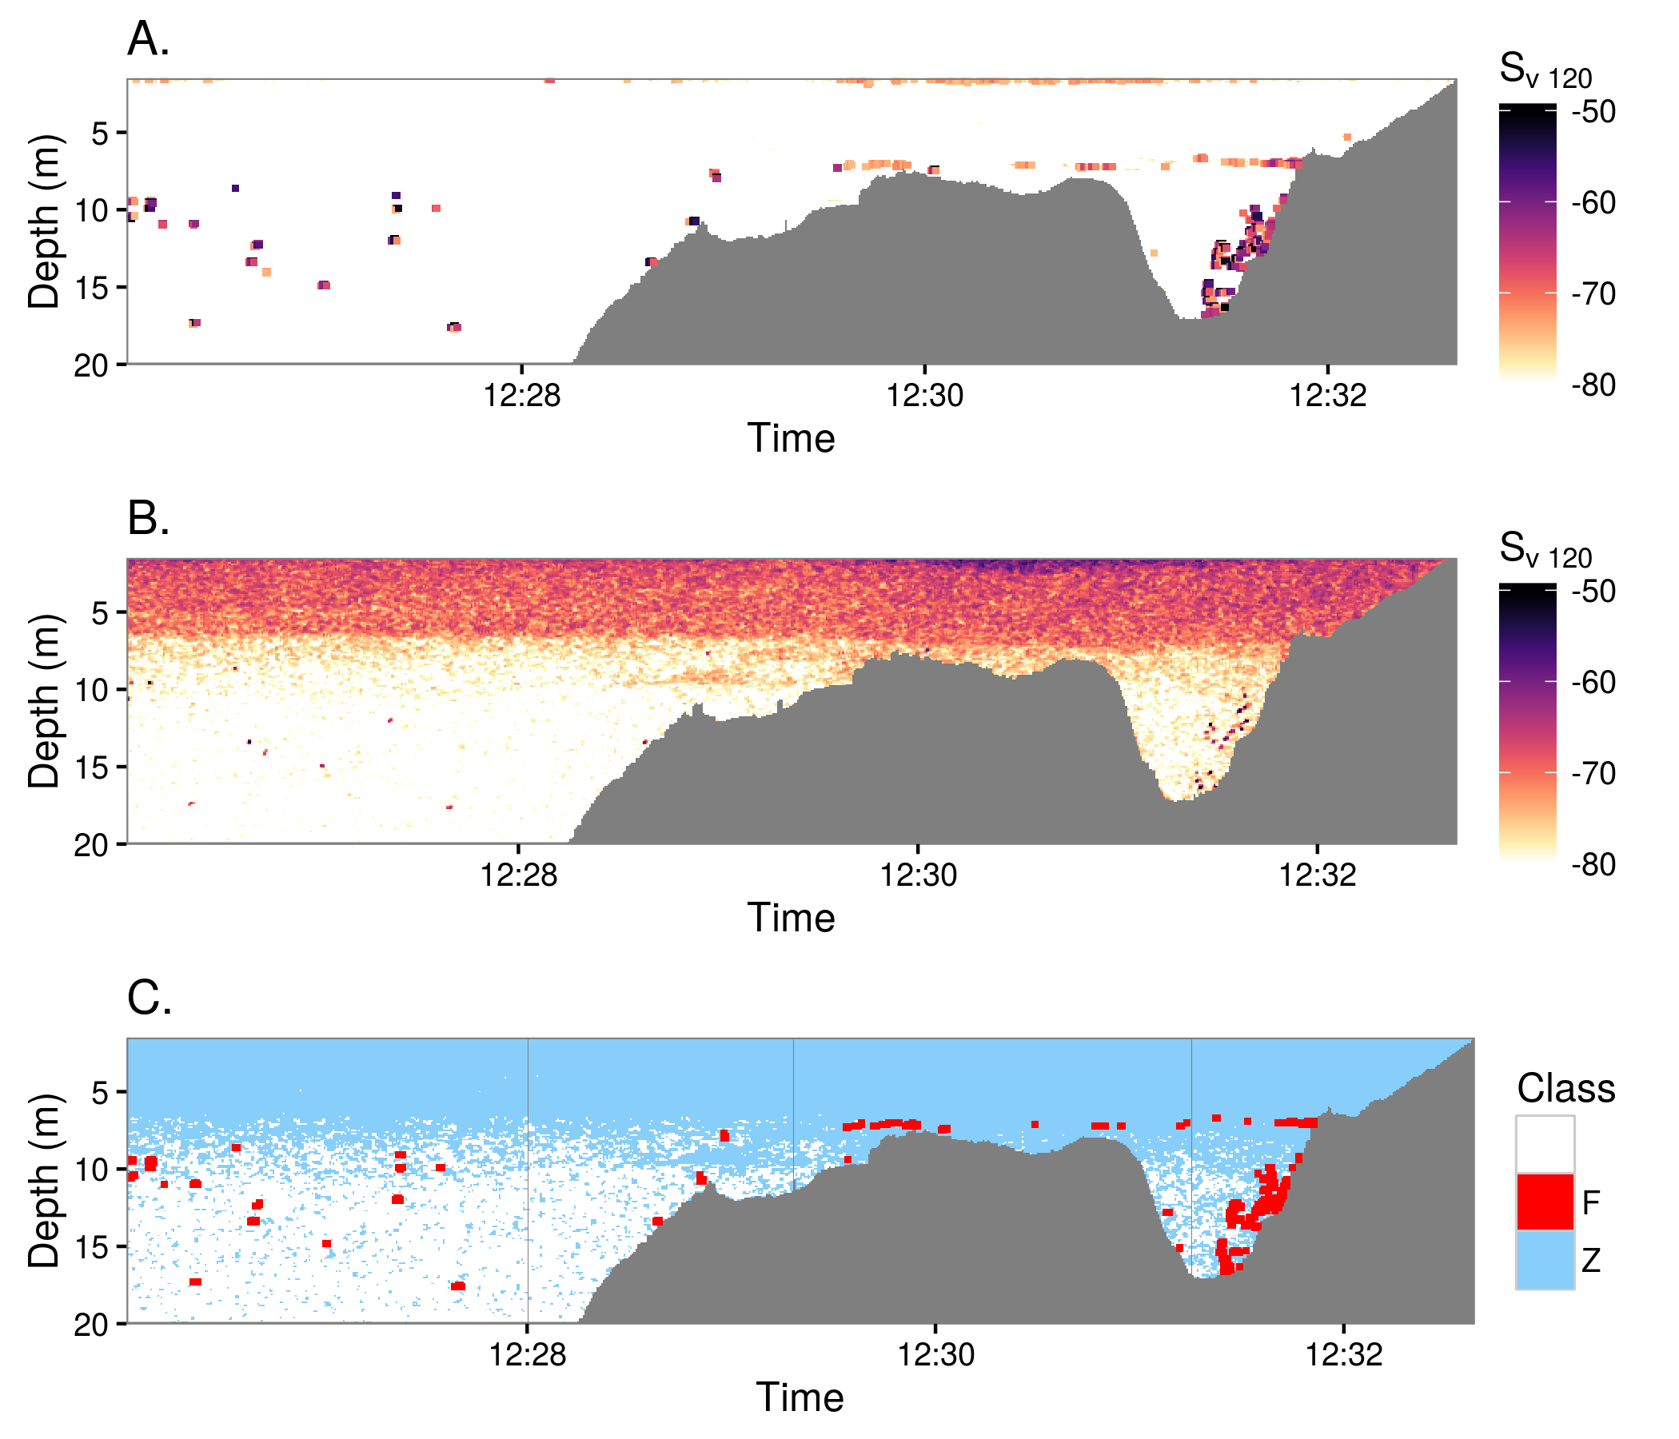
Figure 6. Acoustic profile through part of Cherry Lake on 24 June 2014, showing acoustic backscatter at A) 120 kHz and B) 710 kHz. Isolated dots are echoes from individual fish, while the layer of scattering between ~7 m and the surface represents echoes from zooplankton, which are only visible at 710 kHz. C) Classification of backscatter as fish or zooplankton based on frequency differencing. Red areas are fish, scattering more strongly at 120 kHz, while blue area are zooplankton, scattering more strongly at 710 kHz. Pixels classified as fish have been dilated slightly in A) and C) for better visibility. White shows areas of empty water (volume backscatter < -80 dB at 710 kHz). The horizontal length of this section is approximately 700 m.
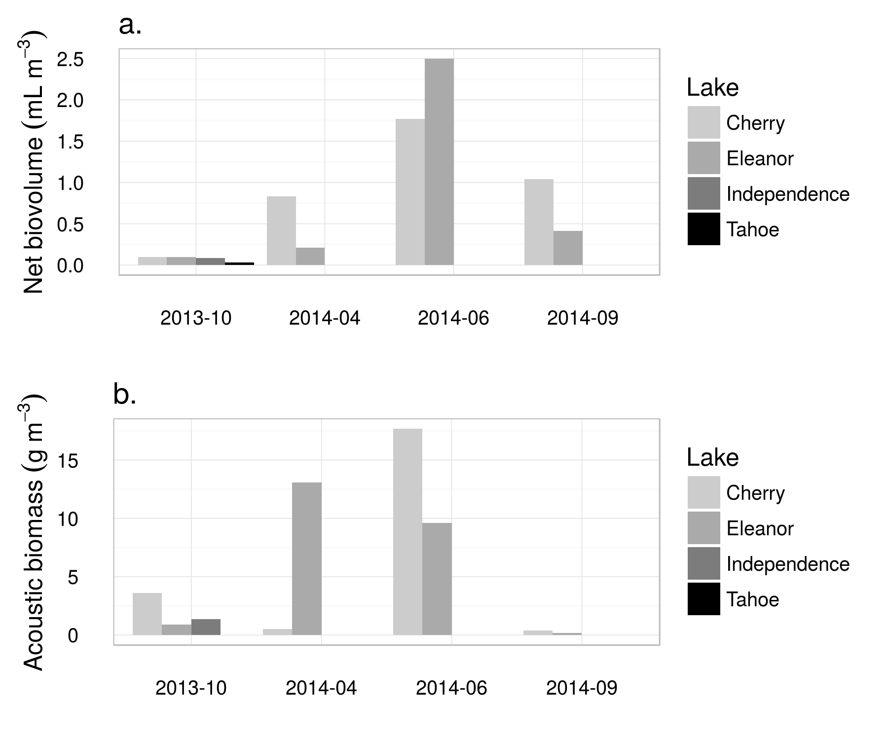
Figure 7. Measures of zooplankton abundance measured by nets and acoustics in each of four seasonal surveys. The color of each bar indicates the lake; note that Independence and Tahoe were only sampled in October 2013. A) Biovolume of zooplankton caught in vertical net tows. These values are normalized by the volume of water filtered, giving units of mL biovolume per cubic meter of lake water. B) Dry biomass of zooplankton per cubic meter, estimated from acoustic surveys, using measured zooplankton lengths identities to parameterize target strengths and length-weight relationships.
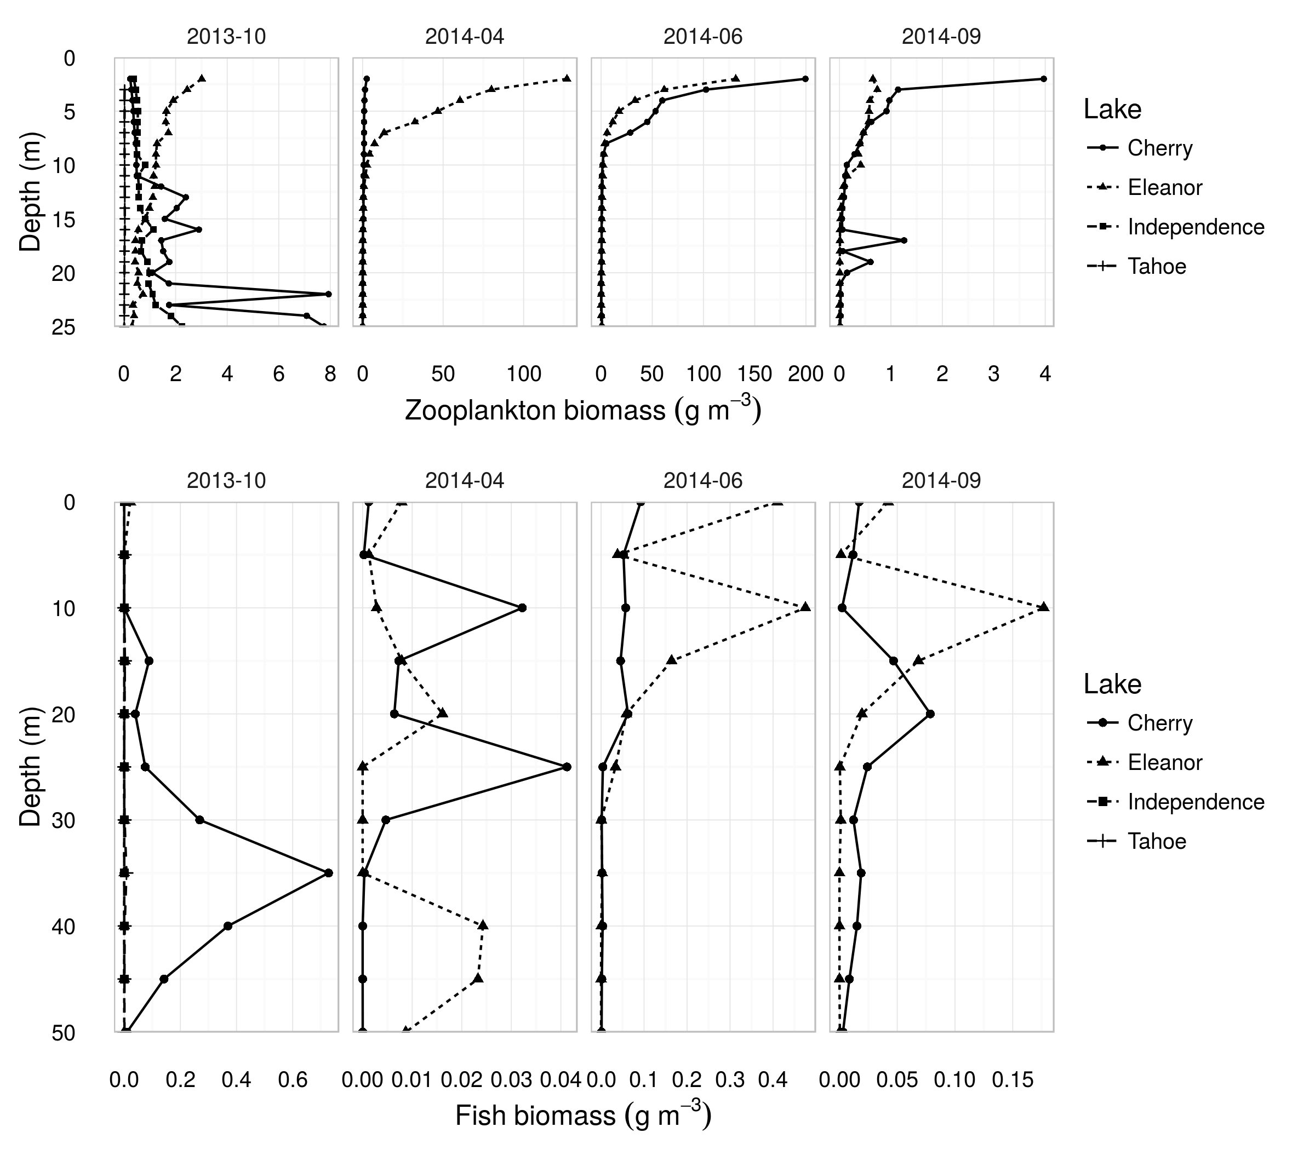
Figure 8. Depth profiles of zooplankton (top row) and fish (bottom row) biomass density measured acoustically in the lakes sampled during each of four seasonal surveys. (Lake Tahoe and Independence Lake were only sampled in October 2013). Lines show approximate biomass density of all zooplankton as a function of depth,. The target strengths used to calculated numerical densities from acoustic backscatter target strengthestimate average anusing were estimated using the distorted-wave Born approximations for the zooplankton communities, and measured in-situ for fish using a split-beam echosounder. Note differing x-axis scales in each plot.
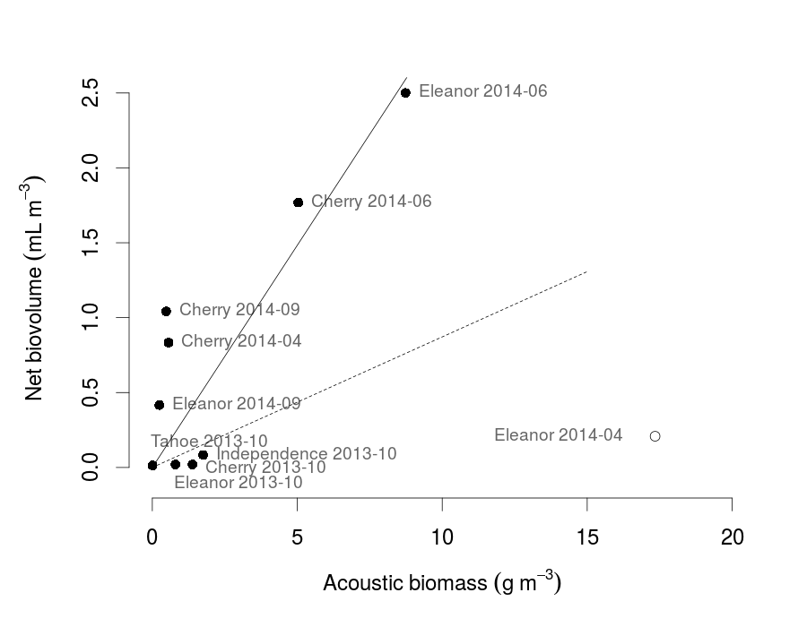
Figure 9. Regression of biovolumes estimated from vertical net tows with acoustic estimates of biomass density. Data points are labeled with their lake and date. Two best-fit lines are plotted: the dashed line was fit to all data points, while the solid line excluded Lake Eleanor in April 2014, plotted as an empty point.

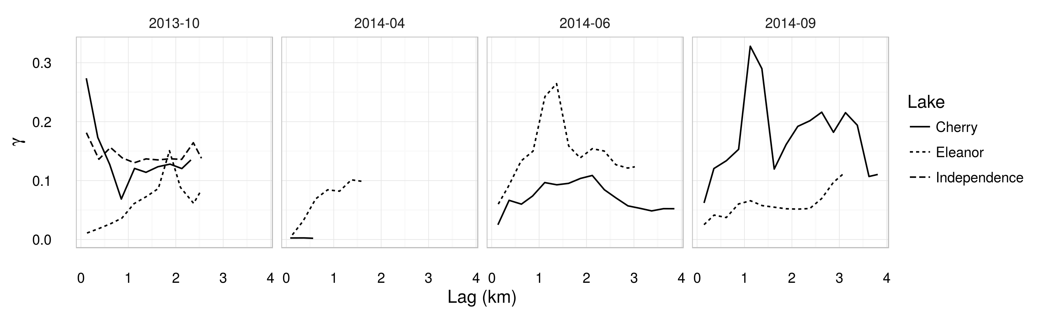
Figure 10. Empirical variograms of log-transformed zooplankton areal biomass density (i.e., mass of zooplankton per m² of lake surface) for each lake and survey.

