Spatial distribution and seasonal changes of fish and zooplankton density in four alpine lakes in the Sierra Nevada, California

Authors: Urmy and Warren

Target journal: L&O, Hydrobiologia, CJFAS,

Abstract

Introduction

Zooplankton play a number of important roles in lake ecosystems. They exert influence on water clarity and nutrient cycling through grazing on primary production. They are also the conduit through which primary production reaches larger predators such as fish, which are often of commercial, recreational, and cultural importance for humans. For the sake of conceptual clarity or computational tractibility, most models of aquatic food webs assume, explicitly or implicitly, that the spatial distributions of their component species can be ignored (Grünbaum 2012)⁠. However, this may not always be a valid assumption, since patchiness is common in nature, and large fractions of total predation can occur in very local patches over short timespans (Temming et al. 2007)⁠.
Despite the potential importance of inhomogenous zooplankton distributions, they have rarely been quantified in lakes. This is largely a consequence of sampling techniques. The most common methods for sampling zooplankton are net tows and traps. Even when closing nets are used for vertically stratified tows, spatial resolution is limited, and all nets and traps involve a degree of spatial or temporal blurring. Automated optical techniques (e.g., ***citations***) have better spatial resolution than traps or nets, though observations are still limited to the instrument's towed path through the water, and they lose taxonomic resolution relative to direct samples.
In contrast, active acoustics (i.e., sonar) can measure the density of animals through the water column quickly and at high (sub-meter) resolution. Acoustics are regularly used to survey fish in lakes, but have rarely been used for zooplankton. This is mostly due to the fact that most lake zooplankton scatter sound very weakly at the acoustic frequencies used for fish surveys, with the notable example of some larger genera such as Mysis (Rudstam et al. 2008)⁠ and Macrohectopus (Melnik et al. 1993)⁠, and gas-bearing larvae of midges in the genus Chaoborus (***Northcote 1964, Teraguchi and Northcote 1966***). Only a few studies have used high-frequency (i.e. > 200 kHz) acoustics to measure the vertical or horizontal distribution of small (< 2 mm) zooplankton (Roman et al. 2001, Hembre and Megard 2003, Parks et al. 2012)⁠. Likewise, few studies in lakes have examined the joint distribution of zooplankton with their fish predators at the same fine spatial scale (Pinel-Alloul et al. 1999, Masson et al. 2001)⁠. Acoustic methods are uniquely suited to address these questions, though they do have limitations. Most importantly, echoes return only limited information on the size and identity of scattering organisms, so that direct sampling is still necessary to identify them and as ground-truth for acoustic density estimates. Acoustics is a powerful tool for measuring the distribution of zooplankton, especially when higher frequencies enable their sensitive detection (Warren et al. 2016)⁠.
If the fine-scale distribution and patchiness of zooplankton has been rarely measured in lakes in general, it has almost never been measured in lakes at high elevations. Alpine and sub-alpine lakes differ in several important ways from low-elevation lakes. They typically have lower inputs of sediment and nutrients than lowland lakes, and are clearer and more oligotrophic. As a consequence, different environmental factors, such as ultraviolet radiation, may be more important in structuring their pelagic ecosystems (Williamson et al. 2011, 2016)⁠. Alpine and sub-alpine lakes may also be more sensitive to human disturbance, including damming, eutrophication, deforestation, and introductions of non-native plant and animal species (***citations***).
We surveyed the zooplankton and fish in three lakes in the Sierra Nevada mountains of California, USA, between autumn 2013 and autumn 2014. Our primary tool was a two-frequency acoustic system which allowed us to measure the vertical and horizontal distribution of these animals at high (meter-scale) resolution. Acoustic observations were augmented with net samples to identify the zooplankton scatterers and parameterize scattering models that allow us to convert acoustic backscatter to estimates of biomass. Differences in the vertical profiles of zooplankton and fish density were compared between lakes. We also investigated horizontal trends in zooplankton and fish density at the scale of the lake basins, and quantified their spatial patchiness using standard geostatistical models. Changes in the distributions of zooplankton and fish from one season to another were also examined. Finally, we speculate on possible dynamics generating the observed patterns.

Methods
Study lakes
Surveys were conducted in three lakes in the Sierra Nevada, namely Cherry Lake, Lake Eleanor, Independence Lake, and Lake Tahoe (Figure 1). Our main focus was on Cherry Lake and Lake Eleanor, located at the border of Yosemite National Park near 38° 0' N, 119° 52.6' W (Figure 3). Both are reservoirs of the San Francisco Public Utilities Commision. Cherry Lake is artificial, created by the damming of Cherry Creek in 1956 (Eckart 1940)⁠. Lake Eleanor was formed naturally, but enlarged and deepened by the construction of a dam in 1918 (Eckart 1940)⁠. Both lakes are approximately 1,420 m above sea level, and have areas of 6.3 km² (Cherry) and 3.9 km² (Eleanor). Cherry and Eleanor were surveyed on successive days in October 2013, April 2014, June 2014, and September 2013. In addition to our repeated surveys of Cherry and Eleanor, we surveyed Independence Lake, located at 39° 26.4' N, 120° 18.6' W, and Lake Tahoe, at 39° 10' N, 120° 0' W once each in October 2013. Independence is a natural lake 2,127 m above sea level, and 2.6 km² in area. It has never been stocked with fish, and is one of only two lakes in the world with a self-sustaining population of Lahontan cutthroat trout, Oncorhyncus clarkii henshawi. Lake Tahoe, at 1,897 m elevation, is much larger and deeper than the other three lakes, with a surface area of 490 km² and maximum depth of 501 m. It is also eutrophic and does not freeze in winter, in contrast to the three smaller lakes, which are mesotrophic and do freeze. The watersheds of the three smaller lakes are undeveloped, although portions of the Cherry and Eleanor Creek watersheds were burned during the 2013 Rim Fire (***cite***). Tahoe is bordered by several towns, with a total permanent population of approximately 50,000. All four watersheds are on granitic substrate.

Acoustic data collection
Surveys were run from outboard-powered boats trailered to each lake, and took place during daytime. Acoustic data were collected at two frequencies, 120 and 710 kHz. The 120 kHz echosounder was a Simrad ES60 with a split-beam transducer (7° beam width), which can accurately measure the target strength of individual fish in situ. The 710 kHz echosounder was a Simrad EK60 with a single-beam (2.8° beam width) transducer. This high-frequency system could detect small (<1 mm) zooplankton (Holliday and Pieper 1995, Warren et al. 2016)⁠, but its effective range was limited to approximately 30 m due to attenuation in water. Both transducers were deployed on a pole mount off the side of the survey boat at depths of approximately 30-50 cm depending on wave conditions. Details of the operating parameters are given in Table ***. Both systems were calibrated on [***date***] with a tungsten carbide standard target sphere (Foote et al. 1987)⁠.

Zooplankton sampling and target strength models
Zooplankton were collected on each sampling day with a vertical tow from 50 m to the surface using a 0.75 m diameter net with 80 μm mesh and preserved for later analysis in 10% buffered formalin. A subsample of 200-300 animals was split from each original sample and counted under a compound microscope. Animals were identified to the lowest possible taxonomic level. In addition, the lengths of first 30 animals counted were measured to the nearest 0.1 mm.
To convert acoustic backscatter to animal densities it is necessary to know the backscattering cross-section, σ_{BS}, of the scattering organisms. The backscattering cross-section is also expressed in its logarithmic form, the target strength, TS = 10 log₁₀(σ_{BS}) (MacLennan et al. 2002)⁠. We calculated these values using the stochastic distorted-wave born approximation (DWBA, Stanton et al. 1998, McGehee et al. 1998)⁠. We used generic models for the body shapes of cladocerans and calanoid copepods (Warren et al. 2016)⁠, and assumed density and sound-speed contrasts of 1.04 (Stanton and Chu 2000)⁠. For each lake, sampling date, and taxonomic group (i.e., cladocerans and copepods), we calculated the mean body length and its standard deviation (s.d). We then drew 1000 random lengths from a normal distribution with these parameters, scaling the generic body shape each one and calculating its backscattering cross-section. Assuming that the mean of these values, 〈σ_{BS}〉, is representative for the taxonomic group in question, then the density of animals ρ (number m⁻³) is given by

(1)

where s_{v} is the acoustic volume backscattering coefficient (MacLennan et al. 2002)⁠.

Acoustic data processing and analysis
Acoustic data were preprocessed using Echoview Software version 7.0 (Myriax Pty Ltd 2016)⁠. Background noise was estimated and subtracted following (De Robertis and Higginbottom 2007)⁠. Data were manually scrutinized to correct bottom lines, exclude echoes from instrument casts, and eliminate intermittent interference, such as multipath and sidelobe echoes from the steep rocky sides of the lake. Acoustic data were integrated in bins 1 m deep and 10 m wide along-track and exported for further analysis. Single fish targets were detected in the 120 kHz data using Echoview's individual target detection operator (***citation for algorithm***), with [***single-target-detection parameters***]. The in-situ TS values of these targets were also exported.
After exporting, fish echoes were eliminated from the 710 kHz data by excluding cells where backscatter was higher at 120 kHz. Backscatter at 710 kHz in each lake on each sampling date was apportioned to copepods and cladocerans based on the proportional abundances and target strengths using the following two relations:

where N₁ and N₂ are the counts of copepods and cladocerans in the corresponding net sample. Numerical densities were converted to biomassses based on the measured lengths of the zooplankton in the net samples, using published regressions for calanoid nauplii, the calanoid Diaptomus oregonenis, and Daphnia galeatea (Culver et al. 1985)⁠. Fish densities were calculated from the integrated 120 kHz backscatter. Integration cells were classified as fish if their backscatter was higher at 120 kHz than at 710 kHz. The empirical mean TS of the individual fish targets was used to convert backscatter to fish densities.

Distribution of zooplankton and fish
Vertical profiles of fish and zooplankton density were constructed for each lake and date by averaging values horizontally within each depth bin. We also investigated horizontal spatial trends and patchiness of fish and zooplankton by averaging their densities vertically through the water column. The (log-transformed) densities in this horizontal dataset were modeled as a function of distance from each lake's main stream inlet. Spatial structure in the residuals was assessed by calculating empirical variograms for the residuals of each regression.

Results
The zooplankton communities of the four lakes differed, both between lakes and, in the case of the repeated samples at Cherry and Eleanor, over time. Lake Tahoe’s zooplankton were numerically dominated by the calanoid copepods Leptodiaptomus tyrelli (56%) and Epischura nevadensis (22%), with another 20% made up by unidentified copepods and copepodites (Figure 4). The zooplankton in Independence Lake were split evenly between the cyclopoid copepod Diacyclops thomasi (46%) and the cladoceran Daphnia middendorffiana (44%), with the remainder composed of Bosmina longirostris (6%) and unidentified rotifers (4%).
The zooplankton communities in Cherry Lake and Lake Eleanor were more diverse than those in Independence and Tahoe, with 4-10 species present in each sample (Figure 5). In October 2013, both the community in both lakes was approximately 60% cladocerans in the genera Daphnia and Diplostraca. The following April, the community in Cherry Lake remained similar, but in Lake Eleanor it had shifted to 59% Copepods, mostly Epischura nevadensis. During the final two surveys, in June and September 2014, the communities in both lakes were between 59 and 77% copepods, a large proportion of which were copepodites of unknown calanoid species. The 22-41% of the communities composed of cladocerans in June and September were again a mix of Daphnia and Diplostraca (Figure 5).
Target strengths for the different classes of zooplankton scatterers, as calculated using the DWBA, varied widely (Table ***). The strongest scatterers were copepods in Cherry Lake in April 2014, with an average TS of -111 dB. The weakest were nauplius larvae in Cherry Lake in October 2013, with a mean TS of -148 dB. Cladoceran target strengths fell between -112 and -127 dB. Adult copepod target strengths fell in the same broad range, from -104 to -128 dB. Nauplii, due to their much smaller size, were predicted to scatter sound more weakly, with their mean TS falling between -120 and -148 dB (Table ***). There were no systematic trends in TS between the lakes, or through time.
Zooplankton biomass densities were low (< 1 g m⁻³) in all lakes, but varied seasonally (Figure 6). In October 2013, the zooplankton density in all four lakes was low, with less than 10 mg of zooplankton biomass m⁻³. Lake Eleanor had a weak sound-scattering layer extending from the surface to 15 m, corresponding to an estimated peak zooplankton density of just over 6 mg m⁻³. In April 2014, Cherry Lake again contained zooplankton at similarly low densities, though Lake Eleanor had a zooplankton layer near the surface, increasing from near-zero density at 10 m depth to a maximum of 750 mg m⁻³ at 2 m depth, the bottom of the echosounder’s blind zone (Figure 6). Two months later, this layer was still present, though only about 20% as dense (maximum 130 mg m⁻³) as in April. During this time, a similar layer had also appeared in Cherry Lake, with a maximum density, at 2 m depth, of 371 mg m⁻³. By September, the surface zooplankton layer in Cherry Lake had mostly disappeared. The layer in Lake Eleanor was much less dense (maximum 91 mg m⁻³) and slightly deeper, with its lower limit at approximately 11 m depth (Figure 6).
When integrated from 2 m to 25 m depth and scaled by their respective lake areas, these densities yielded a wide range of estimates for the total zooplankton biomass in the different lakes. In October 2013, Lake Tahoe contained an estimated 8 t of small zooplankton. Zooplankton in the three smaller lakes was 40-70 times denser than in Tahoe, but their much smaller areas led to total biomass estimates smaller by a factor of two (Table 2). In April 2014, the zooplankton density in Lake Eleanor had increased to 13 mg m⁻³, raising its total biomass estimate to over 50 t, higher than that of Lake Tahoe in October 2013. Total zooplankton biomass in Cherry Lake in April was slightly less than in the October survey. By June, however, it had increased dramatically, to 113 t, while the zooplankton biomass in Eleanor dropped to 40 t. During the September 2014 survey, zooplankton populations in both lakes had dropped back to levels similar to those measured the previous autumn (Table 2).
With the exception of Cherry Lake in the first survey and Lake Eleanor in the last, zooplankton biomass density consistently increased closer to each lake’s inlet (Figure 8). This trend was most pronounced in Cherry Lake in June 2014, where zooplankton biomass density was an order of magnitude higher near the lake’s inlet than near the dam at the other end. The residuals from these regressions were spatially autocorrelated in some, but not all, lakes and surveys. In September 2013, when biomass densities in all lakes were low, none showed strong evidence for spatial structure: all three empirical variograms were relatively flat, and in Cherry and Independence Lake, were even higher at shorter lags, suggesting short-range anticorrelation. In April, when biomass in Lake Eleanor was higher, spatial structure was in evidence, with the variogram showing a sill of around 0.05 at a range of 0.5 km. Back-transformed to linear units, this implies an expected difference in biomass on the order of 12% across distances of 500 m or greater. In June, the sill of the variogram in Lake Eleanor had increased to 0.15 at a range of 1.2 km (Figure 9), implying an expected difference in biomass on the order of 40% when transformed back to linear units. In Cherry Lake, the variogram was similar to the variogram in Eleanor from the previous survey (Figure 9). The variogram for Lake Eleanor did not change greatly between June and August 2014. However, the variogram for Cherry Lake in the final survey showed higher overall variability, which increased through the maximum lag of 2 km with no clear sign of a sill. This is trend is indicative of nested scales of patchiness.

Discussion
- Looks like more fish/less zooplankton in Cherry Lake
  - Different food web due to stocking?
  - Discuss differences (if any) in zooplankton communities between lakes
- Seasonal cycle
  - Looks like spring bloom present in both lakes
  - Stratification increases over summer, zoops concentrate near surface?
  - Zoop populations decline by end of the summer
  - With just four time points, may have missed short-scale effects or changes (e.g., runoff after individual rainstorms)
- Acoustic methods: advantages and uncertainties
  - Standard acoustic disclaimers (though we have good data, with direct ground truth)
  - TS modeling: not a ton known about these species’ material and scattering properties
  - Advantages:
    - Vertical distribution at high resolution
    - Better coverage of lake area: can see trends, e.g. more zooplankton closer to inlets in some surveys, and spatial patchiness
    - Hopefully, more reliable estimates of population/biomass in lakes than single-point net sample
- Summarize and wrap up
  - Even in relatively small lakes, can have trends, gradients, and patchiness in zooplankton
  - There’s value in high-resolution measurements
Table 1. Acoustic properties of crustacean zooplankton. For each class of scatterers (Cladocerans, Copepods, and Nauplius larvae), the mean acoustic target strength (dB re m²) and individual weight (μg) are displayed, along with the percentage of the net catch made up of that class of scatterers.

Table 2. Estimated total biomass of zooplankton (in kg) in each lake, by date.
 | 2013-10 | 2014-04 | 2014-06 | 2014-09
Cherry | 170 | 223 | 5,790 | 62
Eleanor | 218 | 8,160 | 1,070 | 1,110
Independence | 75 | — | — | —
Tahoe | 8,040 | — | — | —

Figures
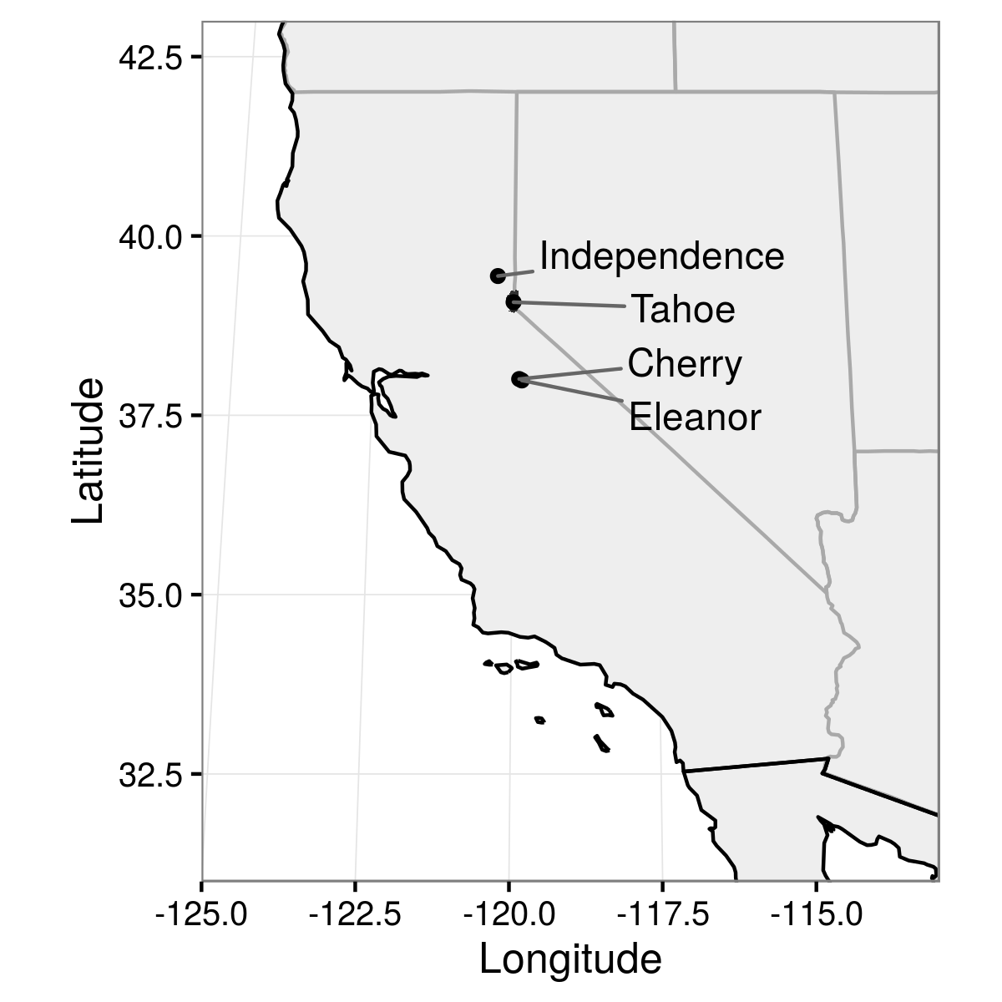
Figure 1. Map of California in the western United States, showing locations of the four study lakes.
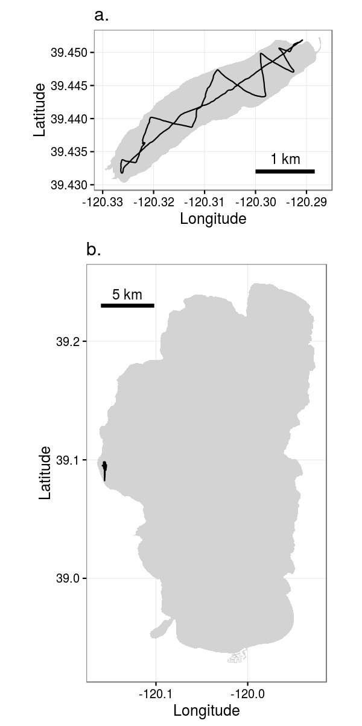
Figure 2. Acoustic survey tracks in a) Independence Lake on 21 October 2013, and b) Lake Tahoe on 20 October 2013.
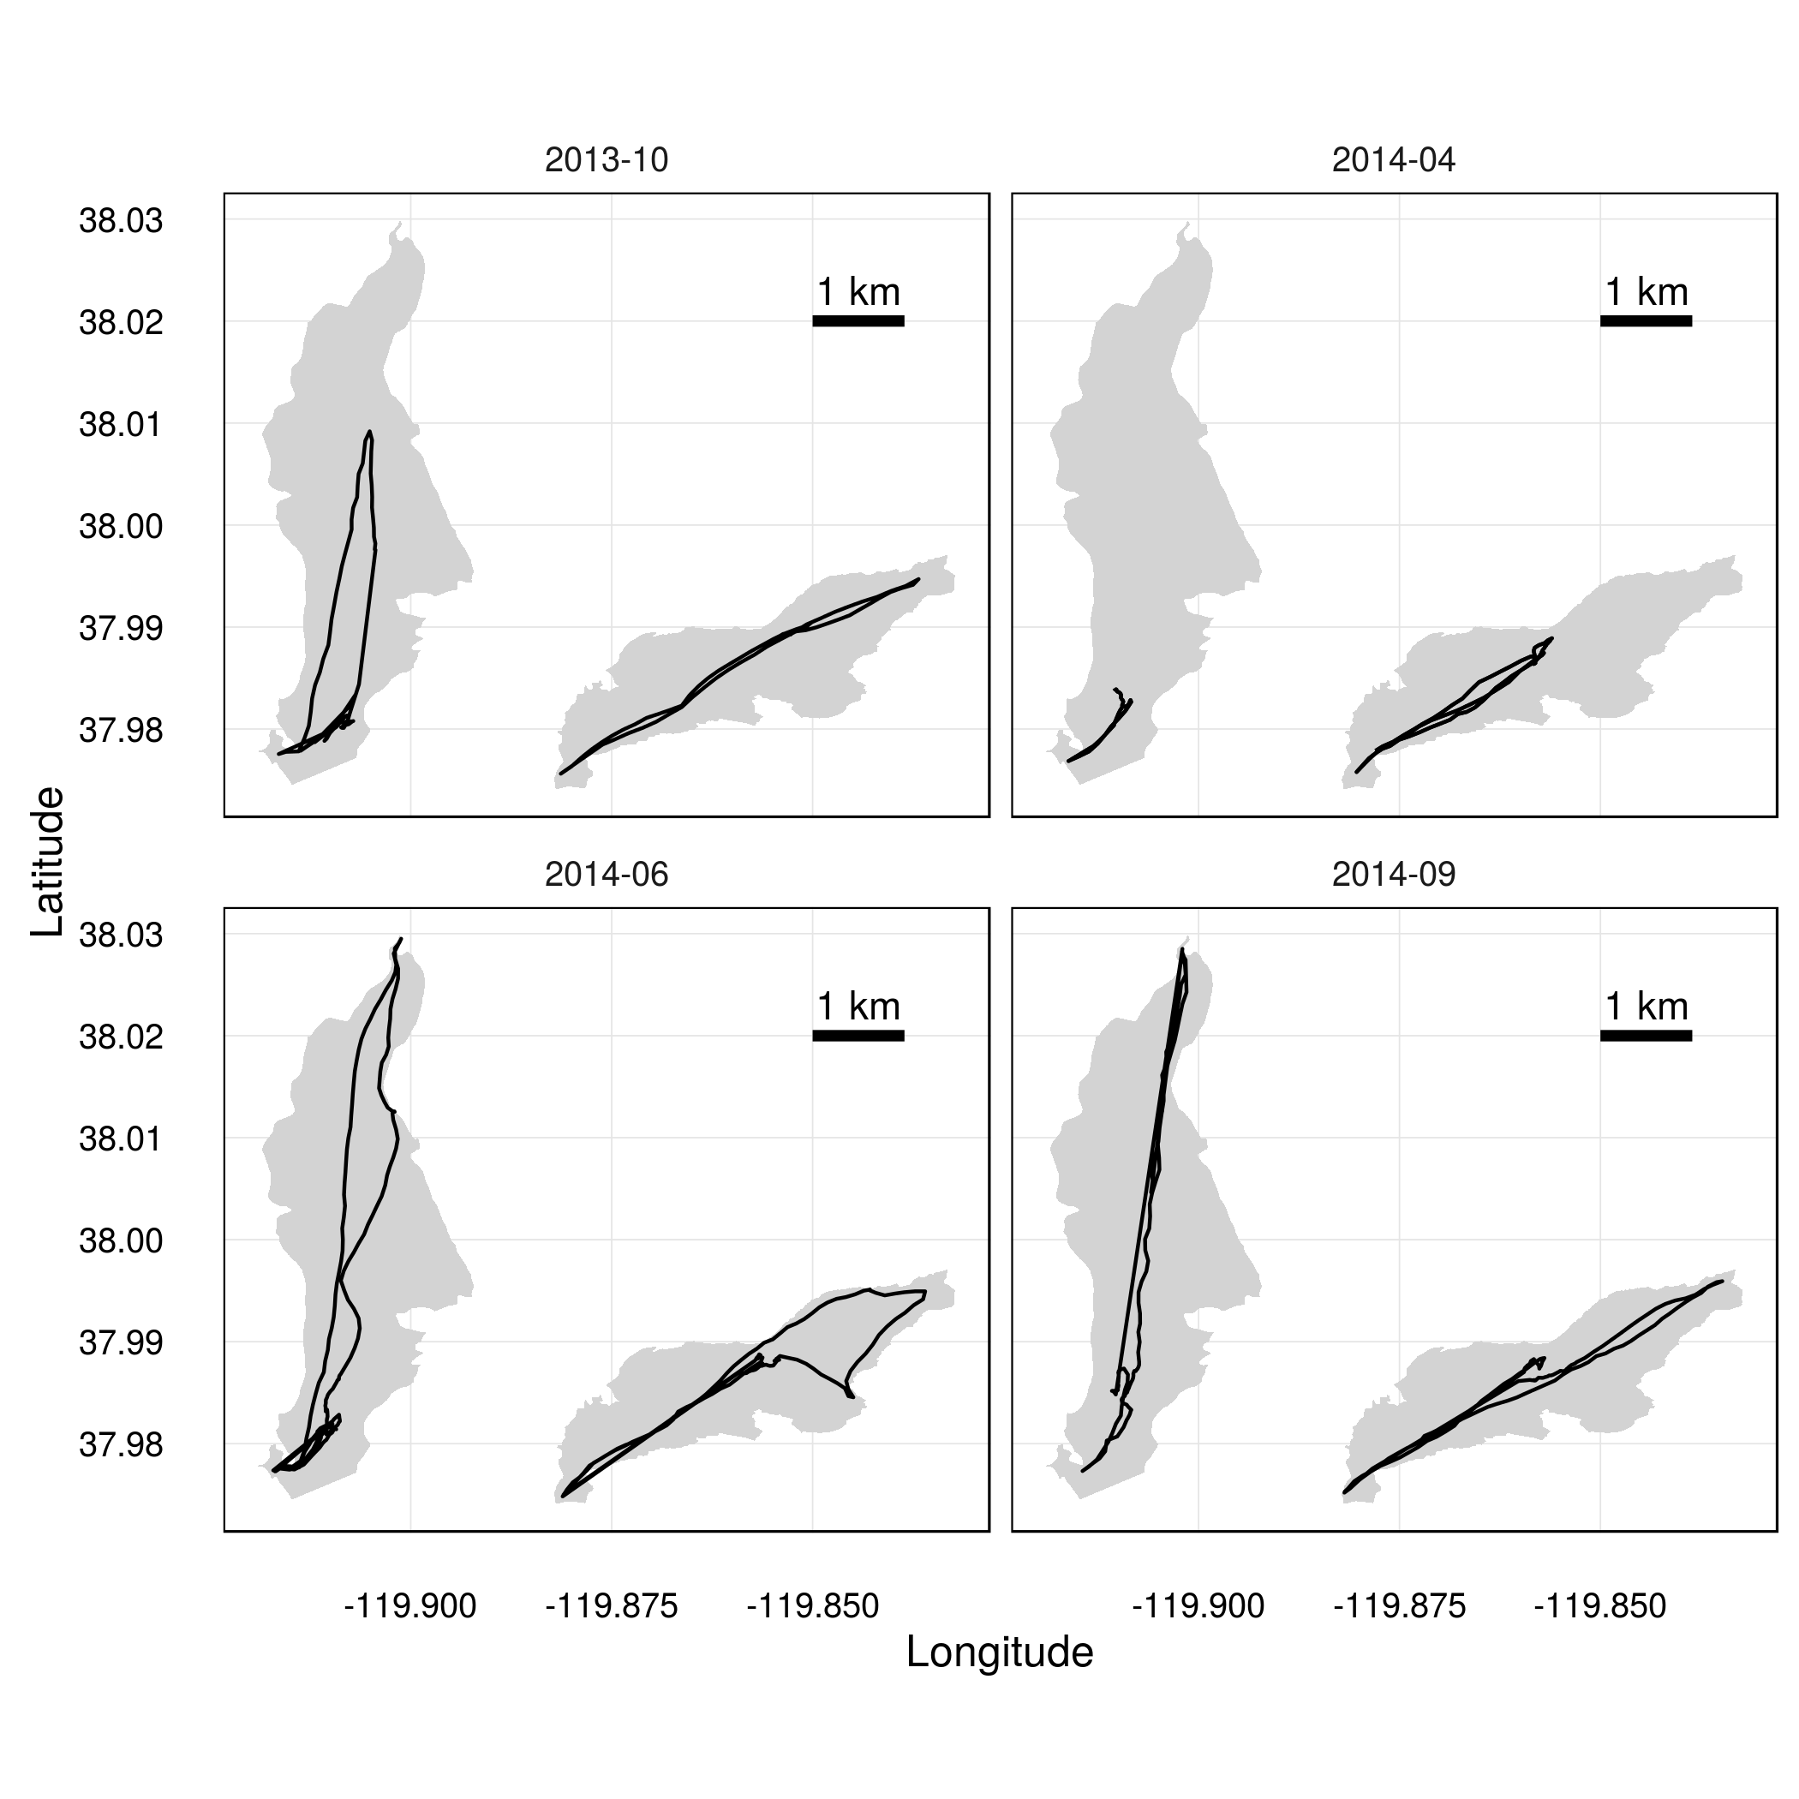
Figure 3. Tracklines of repeated acoustic surveys in Cherry Lake (left) and Lake Eleanor (right) in October 2013, April 2014, June 2014, and September 2014.
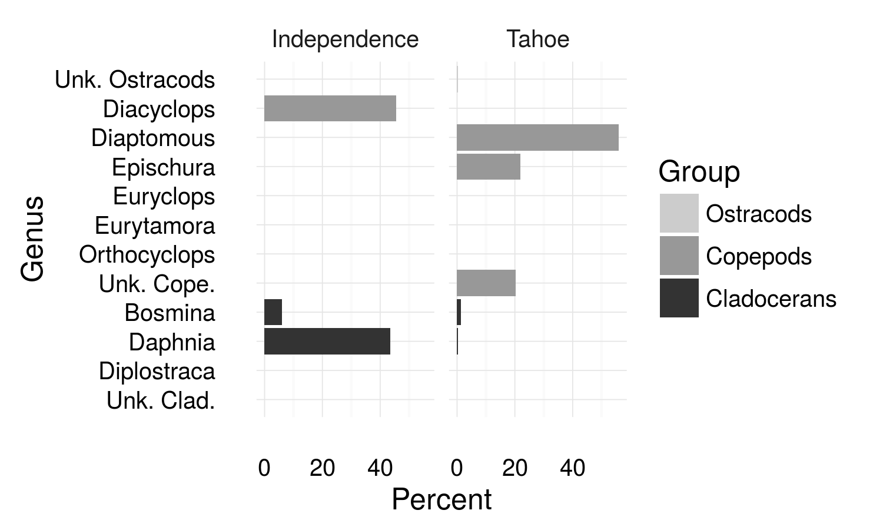
Figure 4. Composition of crustacean zooplankton community in Independence Lake and Lake Tahoe in October 2013.
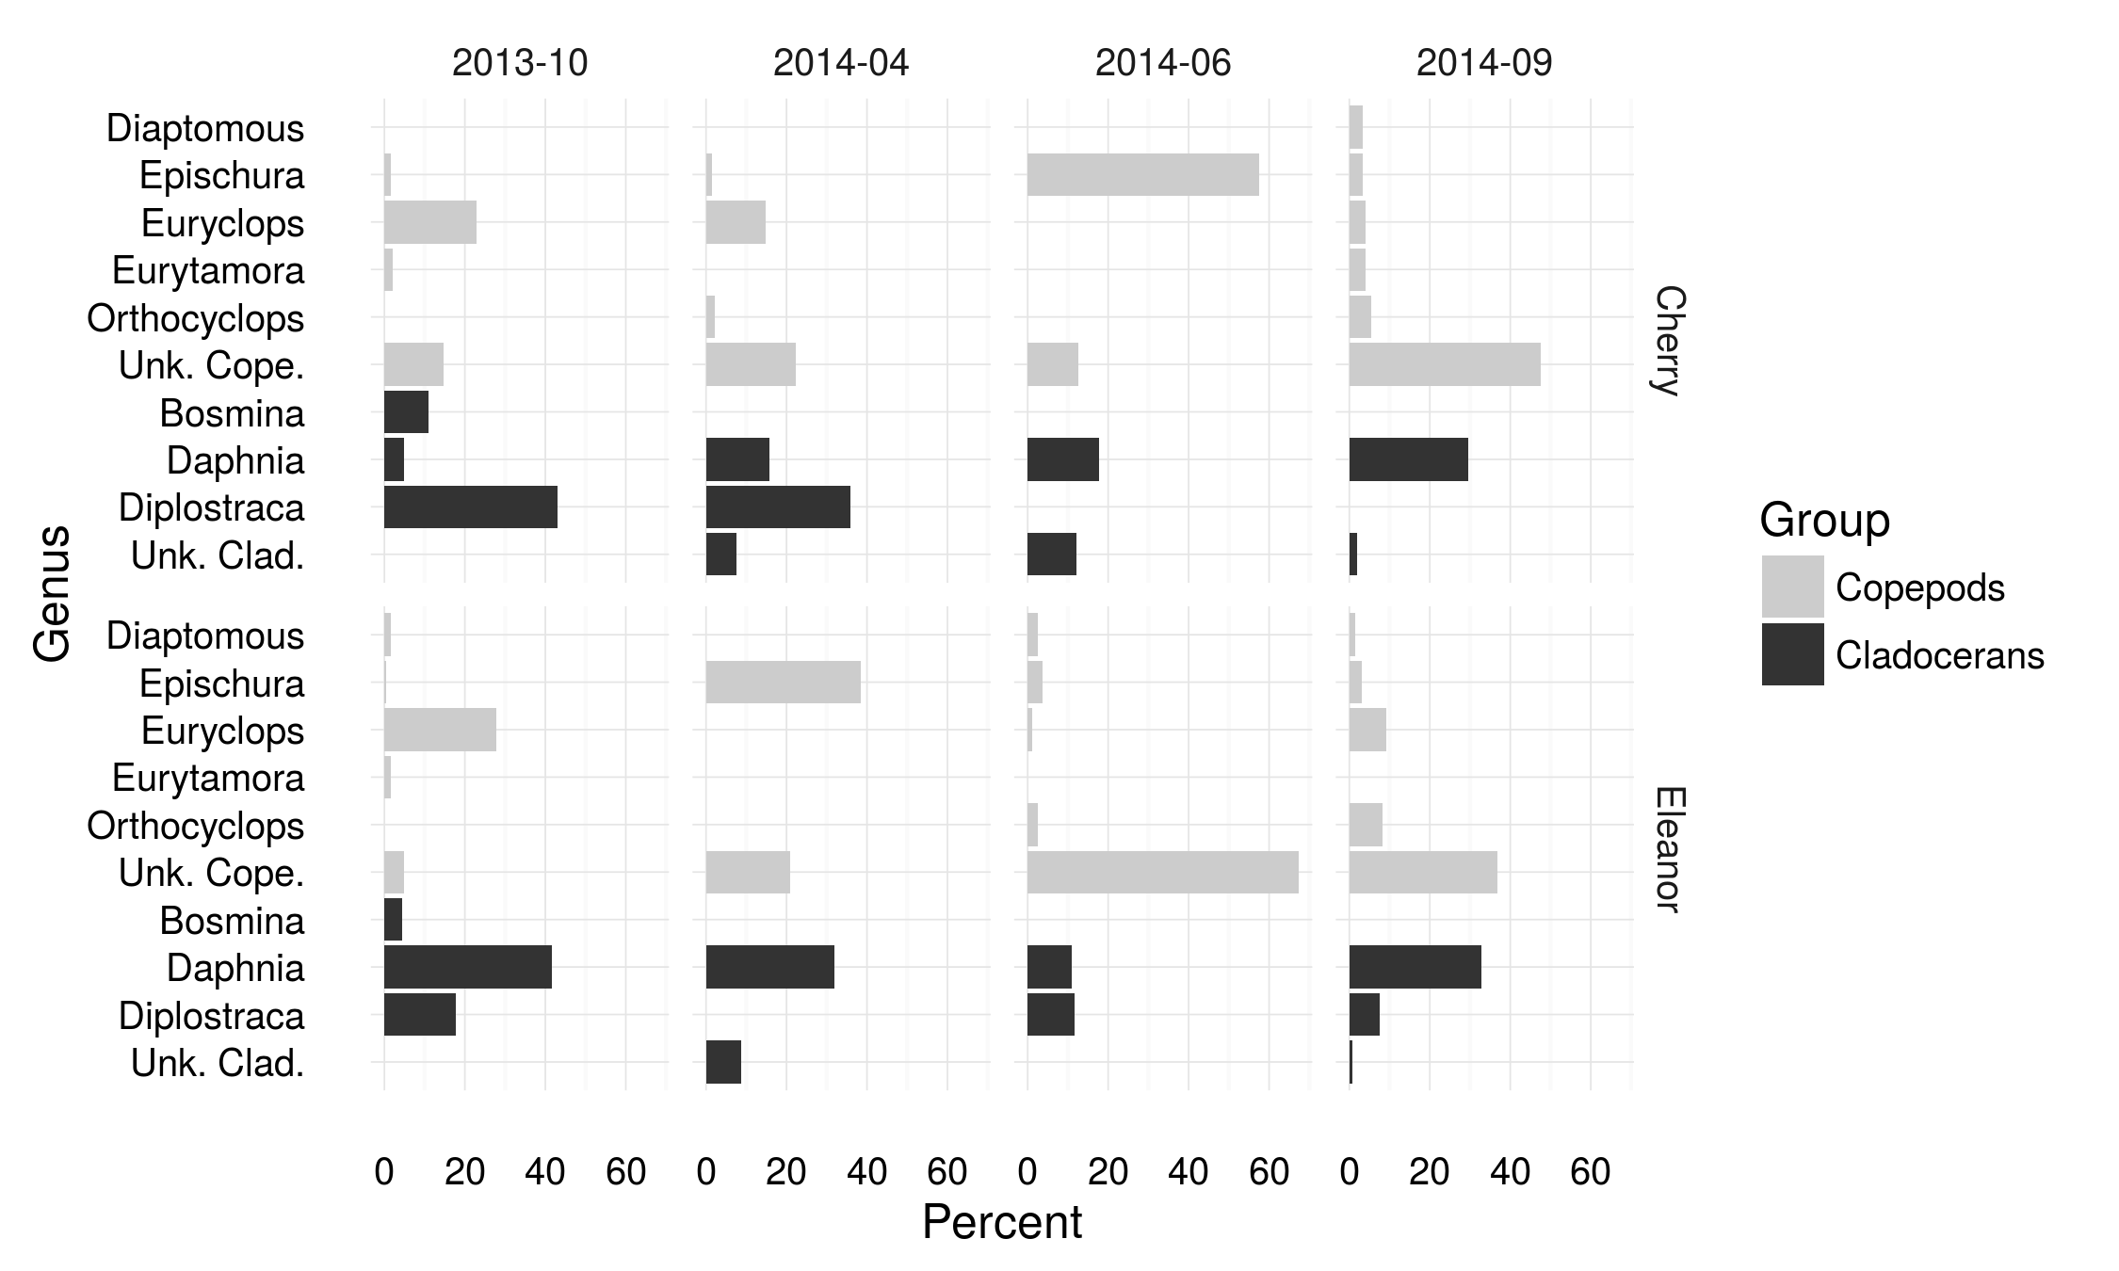
Figure 5. Composition of crustacean zooplankton community in Cherry Lake and Lake Eleanor in four seasonal surveys.
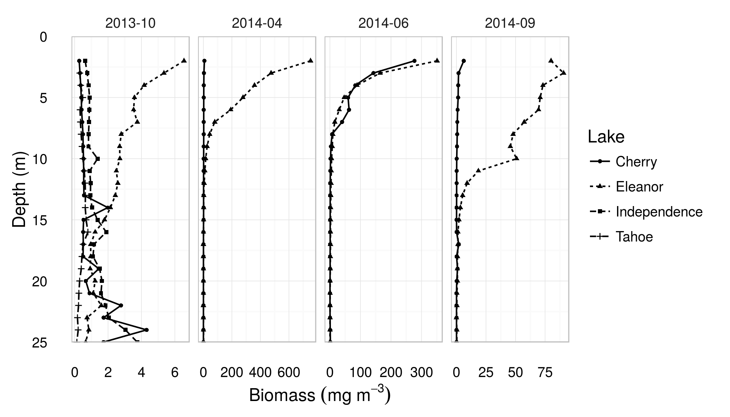
Figure 6. Depth profiles of zooplankton density in the lakes sampled during each of four seasonal surveys (Lake Tahoe and Independence Lake were only sampled in October 2013). Lines show approximate biomass density of all zooplankton as a function of depth, calculated from acoustic backscatter using an estimate average target strength for the zooplankton communities. Note differing x-axis scales in each plot.
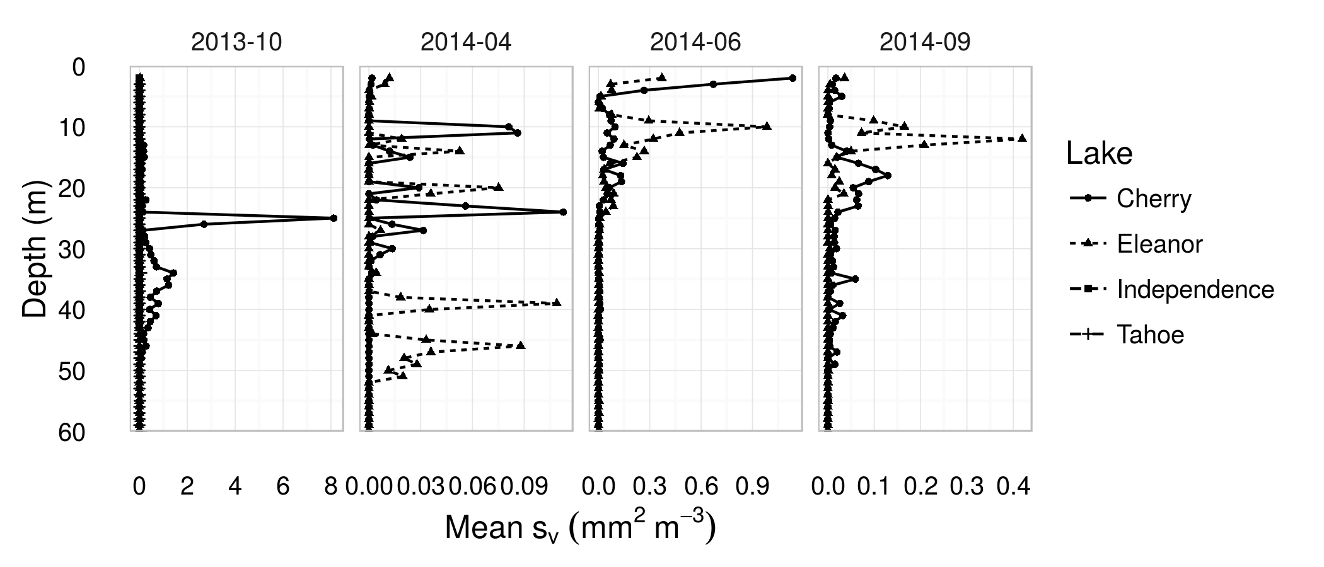
Figure 7. Depth profiles of acoustic fish density in the lakes sampled during each of four seasonal surveys. Lines show mean volume backscattering coefficients as a function of depth. Note that Lake Tahoe and Independence Lake were only sampled in October 2013.
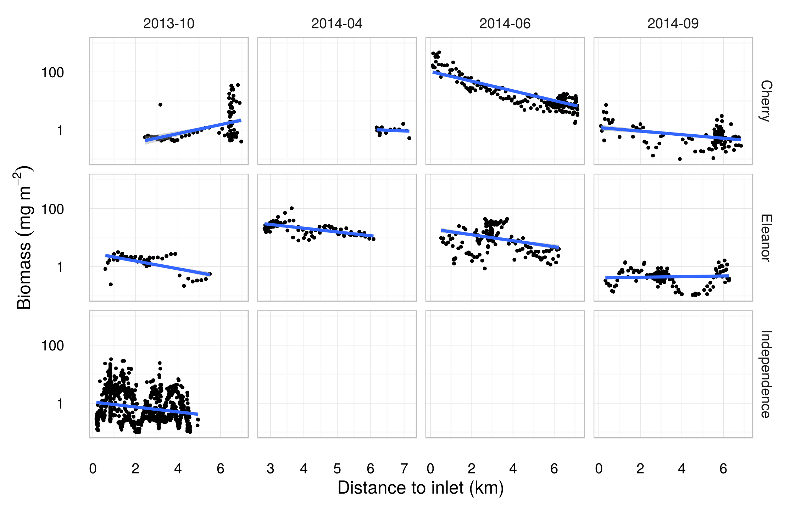
Figure 8. Regressions of log-transformed biomass density on distance to stream inlet, by lake and survey.
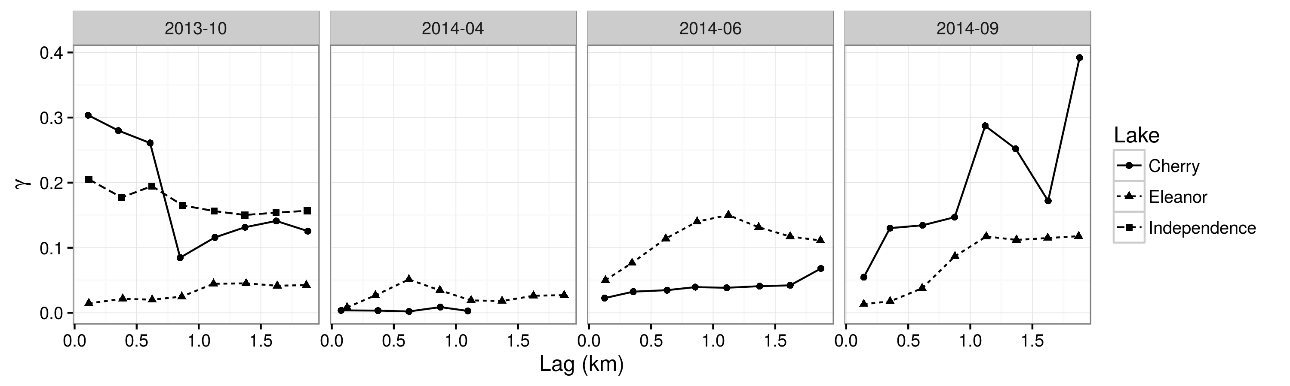
Figure 9. Empirical variograms of log-transformed zooplankton areal biomass density (i.e., mass of zooplankton per m² of lake surface) for each lake and survey.
References
Culver, D. a., M. M. Boucherle, D. J. Bean, and J. W. Fletcher. 1985. Biomass of Freshwater Crustacean Zooplankton from Length–Weight Regressions. Canadian Journal of Fisheries and Aquatic Sciences 42:1380–1390.
Eckart, N. A. 1940. The Water Supply System of San Francisco. Journal (American Water Works Association) 32:751–794.
Foote, K. G., H. P. Knudsen, G. Vestnes, D. N. MacLennan, and E. J. Simmonds. 1987. Calibration of acoustic instruments for fish density estimation: a practical guide. techreport.
Grünbaum, D. 2012. The logic of ecological patchiness. Interface Focus 2:150–155.
Hembre, L. K., and R. O. Megard. 2003. Seasonal and diel patchiness of a Daphnia population: An acoustic analysis. Limnology and Oceanography 48:2221–2233.
Holliday, D. Van, and R. E. Pieper. 1995. Bioacoustical oceanography at high frequencies. ICES Journal of Marine Science 52:279–296.
MacLennan, D. N., P. G. Fernandes, and J. Dalen. 2002. A consistent approach to definitions and symbols in fisheries acoustics. ICES Journal of Marine Science 59:365–369.
Masson, S., N. Angeli, J. Guillard, and B. Pinel-Alloul. 2001. Diel vertical and horizontal distribution of crustacean zooplankton and young of the year fish in a sub-alpine lake: an approach based on high frequency sampling. Journal of Plankton Research 23:1041–1060.
McGehee, D. E., R. L. O’Driscoll, and L. V. M. Traykovski. 1998. Effects of orientation on acoustic scattering from Antarctic krill at 120 kHz. Deep-Sea Research II 45:1273–1294.
Melnik, N. G., O. A. Timoshkin, V. G. Sidleva, S. V. Pushkin, and V. S. Mamylov. 1993. Hydroacoustic measurement of the density of the Baikal macrozooplankter Macrohectopus branickii. Limnology and Oceanography 38:425–434.
Myriax Pty Ltd. 2016. Echoview. Hobart, Tasmania.
Parks, S. E., J. D. Warren, K. Stamieszkin, C. a Mayo, and D. Wiley. 2012. Dangerous dining: surface foraging of North Atlantic right whales increases risk of vessel collisions. Biology letters 8:57–60.
Pinel-Alloul, B., C. Guay, N. Angeli, P. Legendre, P. Dutilleul, G. Balvay, D. Gerdeaux, and J. Guillard. 1999. Large-scale spatial heterogeneity of macrozooplankton in Lake of Geneva. Canadian Journal of Fisheries and Aquatic Sciences 56:1437–1451.
De Robertis, A., and I. Higginbottom. 2007. A post-processing technique to estimate the signal-to-noise ratio and remove echosounder background noise. ICES Journal of Marine Science 64:1282–1291.
Roman, M. R., D. V. Holliday, and L. P. Sanford. 2001. Temporal and spatial patterns of zooplankton in the Chesapeake Bay turbidity maximum. Marine Ecology Progress Series 213:215–227.
Rudstam, L. G., F. R. Knudsen, H. Balk, G. Gal, B. T. Boscarino, and T. Axenrot. 2008. Acoustic characterization of Mysis relicta at multiple frequencies. Canadian Journal of Fisheries and Aquatic Sciences 65:2769–2779.
Stanton, T. K., and D. Chu. 2000. Review and recommendations for the modelling of acoustic scattering by fluid-like elongated zooplankton: euphausiids and copepods. ICES Journal of Marine Science 57:793–807.
Stanton, T. K., D. Chu, and P. H. Wiebe. 1998. Sound scattering by several zooplankton groups. II. Scattering models. The Journal of the Acoustical Society of America 103:236–253.
Temming, A., J. Floeter, and S. Ehrich. 2007. Predation Hot Spots: Large Scale Impact of Local Aggregations. Ecosystems 10:865–876.
Warren, J. D., T. H. Leach, and C. E. Williamson. 2016. Measuring the distribution, abundance, and biovolume of zooplankton in an oligotrophic freshwater lake with a 710 kHz scientific echosounder. Limnology and Oceanography: Methods.
Williamson, C. E., J. M. Fischer, S. M. Bollens, E. P. Overholt, and J. K. Breckenridge. 2011. Towards a more comprehensive theory of zooplankton diel vertical migration: Integrating ultraviolet radiation and water transparency into the biotic paradigm. Limnology and Oceanography 56:1603–1623.
Williamson, C. E., E. P. Overholt, J. A. Brentrup, R. M. Pilla, T. H. Leach, S. G. Schladow, J. D. Warren, S. S. Urmy, S. Sadro, S. Chandra, and P. J. Neale. 2016. Sentinel responses to droughts, wildfires, and floods: Ultraviolet radiation and the consequences for lakes and their ecosystem services. Frontiers in Ecology and the Environment 14:102–109.

