Seasonal changes in the abundance, distribution, and patchiness of zooplankton and fish in four peri-alpine lakes in the Sierra Nevada, California

Samuel S. Urmy and Joseph D. Warren*
School of Marine and Atmospheric Sciences
Stony Brook University
239 Montauk Hwy
Southampton, NY 11901, USA

* Corresponding author: joe.warren@stonybrook.edu

Running head: Zooplankton and fish in Sierra Nevada Lakes

Keywords: acoustics, biomass estimation, fish, patchiness, target strength, variograms, zooplankton.

Abstract
Zooplankton are recognized as a critical component of lake ecosystems. While it is well-known that their spatial distribution is often patchy, this aspect of their ecology has rarely been thoroughly quantified in most lakes, let alone those in remote, high-altitude locations. We used a portable, dual-frequency scientific echosounder deployed from small boats to map acoustic backscatter from zooplankton and fish in four peri-alpine lakes in the Sierra Nevada Mountains of California, USA: Independence Lake, Lake Tahoe, Cherry Lake, and Lake Eleanor. We conducted net sampling to confirm the identities of the scattering organisms and to parameterize physics-based models to estimate the sound-scattering properties of these organisms. This allowed us to convert acoustic backscatter measurements into estimates of total zooplankton and fish biomass. In two of the lakes, Cherry and Eleanor, we repeated the surveys four times at seasonal intervals between fall 2013 and fall 2014. Zooplankton abundances were highest in these lakes in the spring and summer of 2014, with peak wet-weight biomasses estimated at 51 t in Lake Eleanor in April and 110 t in Cherry Lake in June. The estimated density of fish also varied in time and in its vertical distribution, increasing and moving shallower in the water column in June in both Cherry Lake and Lake Eleanor. Zooplankton density displayed spatial trends at the lake-wide scale, and the residuals from these trends were spatially autocorrelated to distances over 1 km. These results illustrate how acoustic sampling can be used to rapidly measure the biomass and distribution of multiple trophic levels in small lakes, and to describe spatial trends and patterns of these organisms. They also highlight the presence of gradients and patchiness in the distribution of freshwater zooplankton, even in small lakes, and provide a method to study the processes generating and maintaining those spatial distributions and their importance for trophic interactions, overlap between predator and prey, zoops and their resources (or something similar?).

Introduction
Zooplankton play a number of important roles in lake ecosystems. They influence water clarity and nutrient cycling through grazing on primary production. They are also the conduit through which primary production reaches larger predators such as fish, which often have commercial, recreational, and cultural importance for humans. For the sake of conceptual clarity or computational tractability, most models of aquatic food webs assume, explicitly or implicitly, that the spatial distributions of their component species can be ignored (Grünbaum 2012)⁠. However, this may not always be a valid assumption, since patchiness is common in nature, and large fractions of total predation can occur in small patches over short timespans (Temming et al. 2007)⁠. In aquatic environments, sharp vertical gradients are common, and the distributions of predators and prey often overlap to varying degrees, for instance due to diel vertical migration (DVM). Horizontal gradients and patchiness may also be important, though these are measured less often.
Despite the potential importance of inhomogenous zooplankton distributions, they have rarely been quantified with any substantial degree of temporal and spatial resolution in lakes. This is largely a consequence of sampling techniques. The most common methods for sampling zooplankton are net tows and traps. Even when closing nets are used for vertically stratified tows, spatial resolution is limited, and all nets and traps involve a degree of spatial or temporal blurring. Automated optical techniques (Finlay et al. 2007)⁠ have better spatial resolution than traps or nets, though observations are still limited to the instrument's towed path through the water, and they lose taxonomic resolution relative to direct samples.
In contrast, active acoustics (i.e., scientific echosounders) can measure the density of animals through the water column quickly and at high (sub-meter) resolution. Acoustics are regularly used to survey fish in lakes (e.g. Brandt et al. 1991, Rudstam et al. 2009, Simonin et al. 2012)⁠, but have rarely been used for zooplankton. This is mostly due to the fact that most lake zooplankton scatter sound very weakly at the acoustic frequencies used for fish surveys, with the notable example of some larger genera such as Mysis (Rudstam et al. 2008)⁠ and Macrohectopus (Melnik et al. 1993)⁠, and gas-bearing larvae of midges in the genus Chaoborus (Northcote 1964; Teraguchi and Northcote 1966)⁠. Only a few studies have used high-frequency (i.e. > 200 kHz) acoustics to measure the vertical or horizontal distribution of small (< 2 mm) zooplankton (Holliday and Pieper 1995, Roman et al. 2001, Hembre and Megard 2003, Parks et al. 2012)⁠. Likewise, few studies in lakes have examined the joint distribution of zooplankton with their fish predators at the same fine spatial scale (Pinel-Alloul et al. 1999; Masson et al. 2001)⁠. Acoustic methods are uniquely suited to address these questions, though they do have limitations. Most importantly, echoes return limited information on the size and identity of scattering organisms, so that direct sampling is still necessary to identify them and as ground-truth for acoustic density estimates. Acoustics is a powerful tool for measuring the distribution of zooplankton, especially when higher frequencies enable the detection of small size classes or abundances of organisms (Warren et al. 2016)⁠.
The fine-scale distribution and patchiness of zooplankton has been rarely measured in lakes in general, and it has almost never been measured in lakes at high elevations. Alpine and sub-alpine lakes differ in several important ways from low-elevation lakes. They typically have lower inputs of sediment and nutrients than lowland lakes, and are clearer and more oligotrophic. As a consequence, different environmental factors, such as ultraviolet radiation, may be more important in structuring their pelagic ecosystems (Williamson et al. 2011, 2016)⁠. Alpine and sub-alpine lakes may also be more sensitive to human disturbance, including eutrophication, pH changes, deforestation, and introductions of non-native plant and animal species (Bradford et al. 1998; Knapp et al. 2001; Schabetsberger et al. 2009)⁠.
We surveyed the zooplankton and fish in four lakes in the Sierra Nevada mountains of California, USA, between autumn 2013 and autumn 2014. Our primary tool was a two-frequency acoustic system which allowed us to measure the vertical and horizontal distribution of these animals at high (meter-scale) resolution. Acoustic observations were augmented with net samples to size and identify the zooplankton scatterers and parameterize scattering models that allow us to convert acoustic backscatter to estimates of biomass. Differences in the vertical profiles of zooplankton and fish numerical density were compared between lakes. We also investigated horizontal trends in zooplankton and fish numerical density at the scale of the lake basins, and quantified their spatial patchiness using standard geostatistical models. Changes in the distributions of zooplankton and fish from one season to another were also examined. Finally, we speculate on possible dynamics generating the observed patterns.

Methods
Study lakes
Surveys were conducted in four lakes in the Sierra Nevada: Cherry Lake, Lake Eleanor, Independence Lake, and Lake Tahoe (Figure 1). Cherry Lake and Lake Eleanor, located at the border of Yosemite National Park near 38° 0' N, 119° 52.6' W (Figure 1), are reservoirs of the San Francisco Public Utilities Commission. Cherry Lake is artificial, created by the damming of Cherry Creek in 1956 (Eckart 1940)⁠. Lake Eleanor was formed naturally, but enlarged and deepened by the construction of a dam in 1918 (Eckart 1940)⁠. Both lakes are approximately 1,420 m above sea level, and have areas of 6.3 km² (Cherry) and 3.9 km² (Eleanor). Both lakes have been stocked with fish, including rainbow trout (Onchoryncus mykiss), brown trout (Salmo trutta), and, in Cherry Lake, eastern brook trout (Salvelinus fontinalis) (Bingaman 1961; United States Forest Service 2016)⁠. Cherry and Eleanor were surveyed in October 2013, April 2014, June 2014, and September 2013 (Figure 1). In addition to our repeated surveys of Cherry and Eleanor, we surveyed Independence Lake, located at 39° 26.4' N, 120° 18.6' W, and Lake Tahoe, at 39° 10' N, 120° 0' W once each in October 2013 (Figure 1). Independence is a natural lake 2,127 m above sea level, and 2.6 km² in area. It has never been stocked with fish, and is one of only two lakes in the world with a self-sustaining population of Lahontan cutthroat trout, Oncorhyncus clarkii henshawi (Nielsen and Sage 2002)⁠. Lake Tahoe, at 1,897 m elevation, is much larger and deeper than the other three lakes, with a surface area of 490 km² and maximum depth of 501 m. It is also oligotrophic, in contrast to the three smaller lakes, which are mesotrophic. The watersheds of the three smaller lakes are undeveloped, although portions of the Cherry and Eleanor Creek watersheds were burned during the 2013 Rim Fire (National Wildfire Coordinating Group 2013)⁠. Lake Tahoe is bordered by several towns, with a total permanent population of approximately 50,000. All four watersheds are on granitic substrate.

Acoustic data collection
Surveys were run from outboard-powered boats trailered to each lake, and took place during daytime. Acoustic volume backscatter was recorded at two frequencies, 120 and 710 kHz. Volume backscatter can be expressed either in logarithmic form as “mean volume backscattering strength,” S_{V}, or a linear form as “volume backscattering coefficient,” s_{V} (MacLennan et al. 2002)⁠. The latter quantity is proportional to the density of sound-scattering objects in the water. The 120 kHz echosounder was a Simrad ES60 with a split-beam transducer (7° beam width), which can accurately measure the target strength of individual scatterers in situ. The 710 kHz echosounder was a Simrad EK60 with a single-beam (5° beam width) transducer. This high-frequency system could detect small (<1 mm) zooplankton (Warren et al. 2016)⁠, but its effective range was limited to approximately 30 m due to attenuation in water. Both transducers were deployed on a pole mount off the side of the survey boat at depths of approximately 30-50 cm depending on wave conditions.
Both systems were calibrated in Lake Tahoe on 21 October 2013 with a 38.1 mm tungsten carbide standard target sphere (Foote et al. 1987)⁠. Because of the 710 kHz transducer’s narrow beam width, we were unable to center the sphere in the beam in the field, and so performed an additional, ex-situ calibration for this instrument in a tank on land. A 166 L aquarium, 80 cm deep and 50 cm across (Rubbermaid, Atlanta GA), was filled with fresh water and the transducer mounted at the vessel’s center just below the surface. The calibration sphere could then be suspended beyond the transducer’s 40 cm near field and placed on the beam’s axis.
Independence Lake was sampled on 20 October 2013, and Lake Tahoe was sampled on 21 October. Cherry Lake and Lake Eleanor were each sampled four times. Cherry was sampled on 29 October 2013, and on 2 April, 24 June, and 10 September 2014. Eleanor was sampled one day later, on 30 October 2013, and 3 April, 25 June, and 11 September 2014. In the three smaller lakes, we attempted to perform a lengthwise transect from one end of the lake to the other. In Independence Lake, we were also able to add a series of zig-zag transects across the main axis of the lake. The April 2014 transects in Cherry and Eleanor were shorter due to snowfall, which required slow travel on the mountain roads and reduced the time available for sampling.

Zooplankton sampling and target strength models
Zooplankton were collected on each sampling day near the center of the lake with a vertical tow from 50 m to the surface using a ring net with 0.3 or 0.73 m diameter and 153 μm mesh. Due to an equipment problem with the ring net during the October 2013 trip to Cherry and Eleanor, we instead used a Van Dorn bottle (10 cm diameter) with an elastic nylon mesh (~100 μm) over one end. Samples were preserved for later analysis in 10% buffered formalin. In the lab, the total biovolume of each sample was measured after allowing it to settle in a graduated cylinder. Because of the small diameter of the Van Dorn sampler, the biovolumes in the samples from Cherry and Eleanor in October 2013 were smaller than the finest graduation on our cylinder, preventing a precise measurement. We estimated them at 0.1 mL; our analyses did not appear sensitive to these estimates when they were in the range of 0-1 mL. A subsample of 200-300 animals was split from each original sample and counted under a compound microscope. Animals were identified to the lowest possible taxonomic level. In addition, the lengths of the first 30 animals counted were measured to the nearest 0.1 mm.
To convert acoustic backscatter to animal densities it is necessary to know the backscattering cross-section, σ_{BS}, of the scattering organisms. The backscattering cross-section is also expressed in its logarithmic form, the target strength, TS = 10 log₁₀(σ_{BS}) (MacLennan et al. 2002)⁠. We calculated these values using the stochastic distorted-wave born approximation (DWBA, Stanton et al. 1998, McGehee et al. 1998)⁠, implemented as a package, SDWBA.jl (Urmy 2016)⁠ in the Julia language (Bezanson et al. 2012)⁠. This package uses models for the body shapes of cladocerans and calanoid copepods from Warren et al. (2016)⁠, and we assumed density and sound-speed contrasts of 1.04 (Stanton and Chu 2000)⁠. For each lake, sampling date, and taxonomic group (i.e., cladocerans and copepods), we calculated the mean body length and its standard deviation (s.d). We then drew 1000 random lengths from a normal distribution with these parameters (i.e., a parametric bootstrapping procedure, Efron and Tibshirani 1993⁠). The generic body shape was scaled to each length and its backscattering cross-section (σ_{BS}) calculated using the DWBA. We also calculated its dry weight, W_{d} using a published regression for calanoid nauplii, the calanoid Diaptomus oregonenis, or Daphnia galeatea (Culver et al. 1985)⁠, and converted the dry weight to a wet weight, W_{w} using a relationship from Wiebe et al. (1975)⁠.
The backscattering cross-sections and wet weights were averaged to get representative values for each survey date, lake, and taxonomic group. We also calculated the mean backscattering cross-section and wet weight across all three classes of scatterers using the weighted sums,
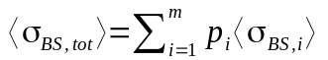
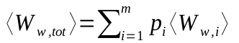
where p_{i} is the proportional numerical abundance of scattering class i in the net sample. The total numerical density of all zooplankton (number m⁻³) is then given by n_{tot} = s_{V} /〈σ_{BS, tot}〉, and the overall wet weight biomass density (g m⁻³) is given by b_{tot} = n_{tot} 〈W_{w, tot}〉.

Acoustic data processing and analysis
Acoustic data were preprocessed using Echoview Software version 7.0 (Myriax Pty Ltd 2016)⁠. Background noise was estimated and subtracted following De Robertis and Higginbottom (2007)⁠. Data were manually scrutinized to correct bottom detection lines, exclude echoes from net and other instrument casts, and eliminate intermittent interference, such as multipath and sidelobe echoes from the steep rocky sides of the lake when close to shore. Acoustic data were integrated in bins 1 m deep and 10 m wide along-track and exported for further analysis.
Single fish targets were detected from the 120 kHz data using Echoview's individual target detection operator (split-beam method 2), using an uncompensated TS threshold of -70 dB, pulse length determination level of -6 dB, and minimum and maximum normalized pulse lengths of 0.5 and 2.0. Targets were rejected if their beam-pattern compensation was greater than 6 dB or if their angular standard deviation was greater than 0.5°. In Independence Lake, only the 710 kHz single-beam echosounder was operated, so we did not measure fish TS in this lake. Fish target strengths were averaged (in the linear domain) by lake and survey.
Acoustic integration cells were classified as fish if their backscatter was higher at 120 kHz than at 710 kHz, since resonant scattering from fishes’ swim bladders makes them stronger targets at the lower frequency. Zooplankton backscatter at 710 kHz in each lake on each sampling date was apportioned to copepods, cladocerans, and nauplius larvae using the proportional abundances in the net samples and converted to numerical and biomass densities based on the representative values for the overall zooplankton community, as described above (Culver et al. 1985). Zooplankton biomasses were then converted to wet weight using another published scaling relationship (Wiebe et al. 1975).
Fish densities were calculated from the integrated 120 kHz backscatter, using the empirical mean TS of the individual fish targets to convert backscatter to fish densities. To obtain approximate estimates of fish biomass, we first converted each fish target’s TS to a length (in cm) by solving the relationship TS = 20log₁₀(L) – 67.4 for physoclist fishes (Foote 1987)⁠. These lengths were then converted to approximate wet weights using published scaling relationships. Length-weight relationships for fish are usually assumed to follow a power law of the form 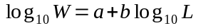, where a and b are fitted empirically for a particular species or population. Because we could not identify fish targets to species, we averaged the parameters for rainbow trout (a = -4.898, b = 2.99, Simpkins and Hubert 1996), brook trout (a = -5.186, b = 3.103, Hyatt and Hubert 2001), and brown trout (a = -4.867, b = 2.96, Milewski and Brown 1994) to get a single length-weight equation with a = -4.98 and b = 3.02. These lengths and weights were averaged into mean values for each lake and survey.
Zooplankton and fish biomass densities were averaged across the survey track to give depth profiles of zooplankton and fish density. They were also integrated through the water column from and multiplied by each lake’s area to give estimates of the total biomass of fish and zooplankton in each lake and survey. We also calculated the ratio of zooplankton to fish biomass for each lake survey.

Comparison of net and acoustic biomass
To test the agreement between acoustic estimates of zooplankton biomass and the direct net sampling, we regressed the acoustic estimate of biomass density for each lake on the biovolume from the corresponding net sample. Net biovolumes were normalized by the total volume of water filtered to give a biovolume density, in mL m⁻³. The intercept in the linear regression was fixed at the origin, since a preliminary model showed it was not significantly different from zero (at the p=0.05 level), and because it is physically reasonable. Fitting the model without an intercept also added a degree of freedom, increasing power and precision for the slope estimate, which was advantageous given the small sample size (n=10). When examining preliminary results, one data point (from Lake Eleanor in April 2014) appeared to be an outlier exerting undue influence on the slope, so we also fit the model without this point for comparison. The significance of the slopes was assessed at the 0.05 level. These analyses were run using R (R Development Core Team 2016)⁠.

Distribution of zooplankton and fish
Vertical profiles of fish and zooplankton density were constructed for each lake and date by averaging values horizontally within each depth bin. We also investigated horizontal spatial trends and patchiness of zooplankton by averaging their densities vertically through the water column. The densities in this horizontal dataset were log₁₀-transformed and regressed on their distance from the shoreline and from each lake's main stream inlet. This was done to test whether there was any spatial trend in the density of zooplankton, that is a response to a supply of food or nutrients via runoff. Spatial autocorrelation was assessed by calculating empirical variograms for the residuals of each regression. Two key features of a variogram are its maximum value or sill, indicating the expected absolute differences between biomass densities at widely separated locations. The spatial lag at which the variogram reaches its sill is called the range, and characterizes the decorrelation distance. Because we calculated the variograms for log₁₀-transformed units, they imply multiplicative differences (×/÷) in zooplankton density in the linear domain. Variograms were calculated at spatial lags from zero to half the distance spanned by the transect in each lake, in bins 0.25 km wide. Lake Tahoe was omitted from these spatial analyses, because it is much larger and fed by many small streams at inlets around its perimeter, and, because the sampling schedule did not permit extended transects, precluding the calculation of variograms.

Results
The zooplankton communities of the four lakes differed, both among lakes and, in the case of the repeated samples at Cherry and Eleanor, over time. Lake Tahoe’s zooplankton were numerically dominated by the calanoid copepods Leptodiaptomus tyrelli (56%) and Epischura nevadensis (22%), with another 20% made up by unidentified copepods and copepodids (Figure 2). The zooplankton in Independence Lake were split more evenly between the cyclopoid copepod Diacyclops thomasi (46%) and the cladoceran Daphnia middendorffiana (44%), with the remainder composed of Bosmina longirostris (6%) and unidentified rotifers (4%).
The zooplankton communities in Cherry Lake and Lake Eleanor were more diverse than those in Independence and Tahoe, with four to ten species present in each sample (Figure 3). In October 2013, the communities in both lakes were approximately 60% cladocerans in the genera Daphnia and Diplostraca, with the remainder mostly composed of cyclopoid copepods in the genus Eurycyclops,. The following April, the community in Cherry Lake remained similar, but in Lake Eleanor it had shifted to 59% Copepods, mostly Epischura nevadensis. During the final two surveys, in June and September 2014, the communities in both lakes were between 59 and 77% copepods, a large proportion of which were copepodids of unknown calanoid species. The cladocerans which composed 22-41% of the communities in June and September were again a mix of Daphnia and Diplostraca (Figure 3). Biovolumes of zooplankton estimated from the nets ranged from 0.1 mL m⁻³ in Lake Tahoe to 2.5 mL m⁻³ in Lake Eleanor in April 2014 (Figure 4). Biovolumes in both Cherry Lake and Lake Eleanor were highest in June 2014 and lower in the other months.
Target strengths for the different classes of zooplankton scatterers, as calculated using the DWBA, varied widely (Table 1). The strongest scatterers were copepods in Cherry Lake in April 2014, with an average TS of -111 dB. The weakest were nauplius larvae in Cherry Lake in October 2013, with a mean TS of -148 dB. Cladoceran target strengths fell between -111 and -127 dB. Adult copepod target strengths fell in the same broad range, from -104 to -128 dB. Nauplii, due to their much smaller size, were predicted to scatter much less sound, with their mean TS falling between -120 and -148 dB (Table 1). After averaging across all scattering classes, overall mean TS ranged from -125 dB, in Cherry Lake in September 2014, to -105 dB, in Lake Tahoe in October 2013 (Table 1). There were no systematic trends in modeled TS between the lakes, or through time.
Mean fish target strengths, measured in situ, ranged between -39 and -36 dB re m², corresponding to mean lengths from 21 to 31 cm, and mean weights from 198 to 719 g (Table 2). In October 2013, the mean TS (and the mean lengths and weights derived from them) were roughly equal in Lake Eleanor and Lake Tahoe and slightly higher in Cherry Lake. In the following three surveys, however, mean TS was 1-3 dB higher in Lake Eleanor, with corresponding length and weight differences of 2-8 cm and 140-380 g.
The 710 kHz echosounder was able to detect the small zooplankton in the lakes, and the frequency-differencing procedure could clearly separate them from fish echoes (Figure 5), Mean zooplankton wet-weight biomass densities measured acoustically were relatively low (< 20 g m⁻³) in all lakes, and varied seasonally (Figure 4). In October 2013, the mean zooplankton density in all four lakes was low, with less than 5 g of zooplankton wet-weight biomass m⁻³ (Figure 4). Lake Eleanor had a weak sound-scattering layer extending from the surface to 15 m, corresponding to an estimated peak zooplankton biomass density of just over 4 g m⁻³ (Figure 6). In April 2014, Cherry Lake again contained zooplankton at similarly low densities, though Lake Eleanor had a zooplankton layer near the surface, increasing from near-zero density at 10 m depth to a maximum of 125 g m⁻³ at 2 m depth, the bottom of the echosounder’s blind zone (Figure 6). Two months later, this layer was still present, though not quite as deep as in April. During this time, a similar layer had also appeared in Cherry Lake, with a maximum density, at 2 m depth, of 200g m⁻³ (Figure 6). By September, the surface zooplankton layer in Lake Eleanor had mostly disappeared. The layer in Cherry Lake was much less dense (maximum 4 g m⁻³) and slightly deeper, with its lower limit at approximately 11 m depth (Figure 6).
Peak fish densities in the lakes ranged between 0.007 and 1.6 fish per 1000 m⁻³, corresponding to biomass densities of 0.04 to 0.7 g m⁻³ (Figure 6). These fish were mostly found below the zooplankton layers (Figure 6). In the first surveys in October 2013, fish in Cherry Lake were concentrated in a layer centered at 35 m depth, with much higher densities than the other three lakes (Figure 6). The overall mean fish density in October in Cherry Lake was 1.6 per 1000 m⁻³, compared to 0.007 in Lake Eleanor. The next April, the fish in both lakes were grouped in two layers. These layers were shallower in Cherry Lake, at depths of 10 and 25 m, than in Lake Eleanor, where they were at depths of 20 and 40 m (Figure 6). In June, fish in both lakes were concentrated in the upper 10-15 m and were more abundant overall than in April, with mean densities of 0.3 (Cherry) and 0.5 (Eleanor) fish per 1000 m⁻³. In September, the fish in each lake were in one broad layer, between 5 to 20 m depth in Lake Eleanor and from 10 to 30 m in Cherry Lake. Overall densities were lower than in June, at 0.2 fish per 1000 m⁻³ in Cherry Lake and 0.1 fish per 1000 m⁻³ in Lake Eleanor.
When depth-integrated and scaled by their respective lake areas, these densities yielded a wide range of estimates for the total biomasses in the different lakes. In October 2013, Lake Tahoe contained an estimated 2,200 kg of small zooplankton. Zooplankton biomasses in the three smaller lakes were 60-240 times denser than in Tahoe, but their much smaller areas led to similar or smaller total biomass estimates (Table 3). In April 2014, the zooplankton wet-weight biomass density in Lake Eleanor had increased to 13 g m⁻³, raising its total biomass estimate to over 51,000 kg, higher than that of Lake Tahoe in October 2013. Total zooplankton biomass in Cherry Lake in April was 14% of its level in the October survey. By June, however, it had increased to 110,000 kg, while the zooplankton biomass in Eleanor dropped to 31,000 kg. During the September 2014 survey, zooplankton populations in both lakes had dropped back to low levels, similar to the previous autumn (Table 3). Estimates for total fish biomass were much lower than those for zooplankton. The highest estimate was 2,200 kg in Lake Tahoe, followed by 1,700 kg in Cherry Lake, both in October 2013. Fish biomass was lowest the following April, increasing somewhat in the following two surveys. Fish biomass did not vary as widely as zooplankton biomass, and in all surveys, zooplankton outweighed fish by a factor between 3.4 and 850.
Net and acoustic estimates of zooplankton density were positively related (Figure 7). The regression of net-caught zooplankton biovolume on acoustically estimated biomass was not statistically significant when all data points were included (p=0.1, R²=0.19), though fitted slope was positive. When the outlying measurement from Lake Eleanor in April 2014 was excluded, the fitted slope was significantly different from zero, with a fitted value of 0.29 mL mg⁻¹, with a 95% confidence interval from 0.1 to 0.4 mL mg⁻¹. This model fit the data fairly well, with an adjusted R² of 0.82.
Zooplankton biomass density displayed significant trends with respect to distance from the inlet and shore in most surveys, though the directions of these trends were variable (Table 4). The most pronounced trend was in Cherry Lake in June 2014, where zooplankton biomass density was an order of magnitude higher near the lake’s inlet than near the dam at the other end. In eight out of the nine surveys, the coefficients for distance from shore and distance from the inlet were the same; Independence Lake was the exception. In three of the four surveys in Cherry Lake, zooplankton density increased towards the shore and inlet. In Lake Eleanor, the reverse was true: three out of four surveys showed zooplankton density higher away from shore and the inlet (Table 4). These spatial regressions explained a low-to-moderate amount of the variability in the data, with R² values ranging from approximately zero in Lake Eleanor in October 2013, to 0.63 in Cherry Lake in June 2014 (Table 4).
The residuals from these regressions were spatially autocorrelated in some, but not all, lakes and surveys. In September 2013, when biomass densities in all lakes were low, Lake Eleanor’s variogram reached its sill of 0.1 at a range of about 2 km. Cherry Lake’s variogram was flat, showing little evidence for spatial autocorrelation, and in Independence Lake, the variogram was higher at shorter lags, suggesting short-range anticorrelation (Figure 8). In April, Lake Eleanor’s variogram was similar, with a sill of around 0.1 at a range of 1.5 km. Back-transformed to linear units, this implies an expected difference in biomass on the order of 25% across distances of 500 m or greater. The short transect in Cherry Lake limited the spatial information available for that variogram.
In June, the sill of the variogram in Lake Eleanor had increased to 0.15 at a range of 2 km (Figure 8), implying an expected difference in biomass on the order of 50% when transformed back to linear units. In Cherry Lake, the variogram was relatively flat, showing little evidence for spatial structure other than the lakewide trends descibed above (Figure 8). Spatial variability in Lake Eleanor decreased somewhat between June and August 2014. However, the variogram for Cherry Lake in the final survey showed higher overall variability, peaking at 0.37 at a lag of 1 km and a sill near 0.2 beyond 1.5 km. Overall, the variogram sill values ranged from approximately 0.1 to 0.2 . These values, in log₁₀-transformed units, imply multiplicative differences (×/÷) in zooplankton density from 0.25 to 1.6 at long ranges, where “long ranges,” as defined by the variograms, are between 1 and 2 km.

Discussion
A spring bloom of zooplankton occurred in both Cherry Lake and Lake Eleanor, with peak biomass densities of 4-6 g m⁻³. In spring and summer, the zooplankton were concentrated in the upper 5-10 m of the water column, probably associated with a stratified surface layer. In 2014, the bloom appeared to begin earlier in Lake Eleanor than in Cherry Lake, since a near-surface zooplankton layer was present in Eleanor, but not Cherry, during the early April survey. By June, both lakes had similar zooplankton densities, and by September, zooplankton populations in both lakes had declined by an order of magnitude. At this point there were still more zooplankton in Cherry Lake, however, suggesting that the bloom there, which started later, also took longer to collapse in the fall. This pattern, of a spring and summer increase in zooplankton as they respond to blooming phytoplankton, is consistent with standard models of seasonal cycles in lake ecosystems (Sommer et al. 1986)⁠. However, it should be noted that our seasonal sampling interval may have caused us to miss shorter-scale variability in zooplankton populations, due either to sub-seasonal population dynamics, or responses to environmental forcings such as runoff from rainstorms or overturning due to wind. This study also only covers one year, leaving longer-term trends unknown.
Two longer-term environmental changes were under way during this study which deserve particular mention. The first was the Rim Wildfire, which started approximately 20 km southwest of Cherry Lake and Lake Eleanor on 17 August 2013. The fire spread rapidly, becoming the third-largest wildfire on record in California, and burned portions of both lakes’ watersheds. The fire was not fully contained until several days after the first surveys in October 2013 (National Wildfire Coordinating Group 2013)⁠. Fires may have a number of effects on lakes and the animals in them, for instance by increasing runoff from burned watersheds, depositing ash from the air, or altering the characteristics of incident solar radiation via drifting smoke plumes (Urmy et al. 2016; Williamson et al. 2016)⁠.
The second major environmental trend was an ongoing drought affecting the western United States. One consequence of the drought was a decline in the water levels of Cherry Lake and Lake Eleanor, which were nearly 8 m lower in the final survey in September 2014 than they were in the first survey, in October 2013. (Both lakes are reservoirs supplying water and electricity to the San Francisco, and their levels are managed by that city’s Public Utilities Commission). The drought probably played a role in the spread of the Rim Fire: most of California’s largest wildfires, inlcuding the Rim Fire, have occurred during droughts (Williamson et al. 2016)⁠. However, the drought may also have mitigated some of the fire’s effects on Cherry and Eleanor: precipitation during the winter of 2013-2014 was well below normal, meaning that runoff and erosion in the burned areas were much less than they might have been in a more normal year. Both the drought and fire are likely to have affected the lakes in some way, but the limited sampling schedule makes it impossible to separate these effects from the expected seasonal cycle for a temperate lake.
Fish target strengths, and the corresponding estimated lengths, were in the expected range for lake salmonids. The vertical distribution of fish in Cherry Lake and Lake Eleanor was qualitatively similar in every survey but the first, suggesting similar dynamics in the fish community of both lakes. These drivers cannot be determined from the limited information available in this study, but the similar vertical patterns of fish density, offset in some cases by up to 10 m, suggest that Cherry Lake and Lake Eleanor could be an interesting setting for further comparative studies of fish behavior. The vertical distributions of fish and zooplankton did not coincide except in June 2014, though this is not particularly surprising, since our surveys were only run in the daytime and many fish migrate vertically.
There was fair agreement between the acoustic and net-based estimates of zooplankton biomass. However, the data from Lake Eleanor in April 2014 formed a notable outlier, with the net-based biovolume much lower relative to the acoustic biomass than expected, based on the other samples. A relatively strong scattering layer was visible near the surface along the entire survey track. This layer, along with weaker-than-average zooplankton TS (Table 1), accounted for the high acoustic biomass. The small biovolume estimate is accurate, at least based on the net sample (0.5 mL of zooplankton from a total filtered volume of 15 m³). The discrepancy between these two measures is probably due to some combination of random variability in the net sample and uncertainty in our TS estimates. Regardless, regressions with and without this outlier produced positive slopes. Without it, the slope was significantly different from zero, and its value, 0.29 mL mg⁻¹, is a physically reasonable number. Though not measured in the same units, we can express them in roughly equivalent terms using a published scaling relationship between zooplankton wet weight and displacement volume (Wiebe et al. 1975)⁠. Across the range of biomasses estimated from the acoustics, this equation predicts biovolumes 4-5 times higher than our fitted regression. This multi-step conversion process from acoustic backscatter to biovolume introduces a number of uncertainties, and should be interpreted with caution. However, it does produce reasonable values, especially given that acoustic estimates of biomass are often several times higher than corresponding net-based estimates. Such discrepancies are usually attributed to net avoidance by the animals (Warren and Wiebe 2008; Wiebe et al. 2013)⁠.

The variable spatial trends in zooplankton density in the three small lakes defy a single explanation, given the short surveys and limited set of spatial covariates available. The clearest trend was increasing zooplankton density close to the Cherry Lake’s main stream inlet in June 2014. One reasonable explanation for this trend is that the stream transports nutrients, detritus, or other exogenous resources into the lake near its inlet, supporting higher primary production, and maintaining a higher rate of zooplankton growth at the upstream end of the lake. Alternatively, the higher biomass estimates near the inlets could be an artifact due to acoustic scattering from sediments introduced by the streams (Thorne and Hanes 2002)⁠. This explanation is consistent with the fact that the steepest gradient was observed in June, near the peak of the seasonal snow melt and runoff. While sediments might remain suspended near the stream mouth, they would settle out rapidly farther into the lake basin, and we do not expect the effect on our lakewide biomass estimates to be large.
Even after subtracting the lake-scale trend in zooplankton density, spatial autocorrelation was evident in the residuals, as illustrated by the empirical variograms (Figure 8). These should be interpreted with caution, since they were based in most cases on single reciprocal transects down the main axis of each lake which may not have captured any spatial anisotropy present. In particular, the restricted time available to survey Cherry Lake on 2 April 2013 meant that the transect was only about 1 km long, limiting our ability to draw conclusions about the spatial distribution of zooplankton. Regardless, most of the variograms did show evidence of spatial patchiness in the distribution of zooplankton, with approximate spatial scales, based on the variogram ranges, between 500 and 2000 km. It is unknown what processes generate and maintain patchiness in these lakes. In the ocean, patchiness in zooplankton appears to be driven mostly by bottom-up processes, with scales of biological variability mirroring scales of physical variability (Denman et al. 1977; Mackas et al. 1985; Urmy et al. 2012)⁠. It seems unlikely that these lakes (with the possible exception of Tahoe) are large enough to support much horizontal physical variability, so the patchiness in the zooplankton is probably due to other processes, such as aggregation (Byron et al. 1983)⁠ or predation by schooling fish.
The acoustic methods used here offer a number of advantages over traditional direct sampling methods, though they also come with their own uncertainties and caveats. Identification of scatterers is often a challenge with acoustics. However, using a two (or more) frequency system, as in this study, reliably separates areas of backscatter from zooplankton and fish. Furthermore, direct net sampling of the zooplankton community, especially in relatively small lakes such as Independence, Cherry, and Eleanor, lets us confidently identify the main classes (i.e. size and species) of zooplankton scatterers. The main source of uncertainty when interpreting acoustic backscatter as an estimate of biomass density is in the target strengths assumed for the scattering organisms. The DWBA is an accurate and widely used method to calculate zooplankton target strengths, but it in turn is highly dependent on accurate values for the scatterers’ material properties—namely the density- and sound-speed-contrasts g and h. To our knowledge, these values have never been measured for any freshwater zooplankton. In their absence, we used generic values from the literature, based on marine zooplankton (Stanton and Chu 2000)⁠. These values are reasonable defaults, but they may not be accurate for the species considered here, introducing a degree of unknown error into the TS and hence biomass estimates. Measurements of the material properties of freshwater zooplankton would be a worthwhile objective for future research.
Despite these uncertainties, acoustic methods for surveying zooplankton have several compelling advantages. Acoustic methods provide high-resolution vertical profiles of fish and zooplankton densities, offering insights into the biotic and abiotic processes structuring lake ecosystems (Beauchamp et al. 1999; Urmy et al. 2016)⁠ Acoustics are also an excellent method for recording the diel vertical migration of lake zooplankton (Warren et al. 2016)⁠. Although DVM was not part of this study, it would be a worthwhile topic for further investigation in these lakes. Acoustics can also reveal trends in the distribution of zooplankton that would be missed by traditional sampling methods (Pinel-Alloul et al. 1999; Hembre and Megard 2003)⁠. In this case, these findings included trends in zooplankton biomass density with distance from shore or from the stream inlet. Accounting for spatial trends and patchiness in turn reduces uncertainty in the biomass estimates.
Perhaps most notably, multi-frequency echosounders allow the biomass of multiple trophic levels to be measured efficiently and at the same spatial resolution, providing valuable data for ecosystem based management decisions (Slocombe 1993, Allan and Johnson 1997, Link 2002). In a relatively small lake such as Cherry, Eleanor, or Independence, the ability to survey large volumes of water quickly means that a virtual census of the lake’s fauna is feasible. The time available for our acoustic surveys was somewhat constrained by the need to collect a variety of other optical, chemical, and biological data not reported in this study, as well as the time required to trailer the boat to each lake. However, we were still able to run full-length transects of the lakes in most of the surveys, and with just a few more hours it would be possible to survey the lakes quite thoroughly, producing detailed three-dimensional maps of the distribution of fish and zooplankton as well as accurate estimates of their numbers and biomass. As this study demonstrates, such a goal is realizable and offers an exciting prospect for studies of predator-prey interactions and lake food webs.

References

Beauchamp, D. a, C. M. Baldwin, J. L. Vogel, and C. P. Gubala. 1999. Estimating diel, depth-specific foraging opportunities with a visual encounter rate model for pelagic piscivores. Can. J. Fish. Aquat. Sci. 56: 128–139. doi:10.1139/f99-217
Bezanson, J., S. Karpinski, V. B. Shah, and A. Edelman. 2012. Julia: a fast, dynamic language for technical computing. arXiv Prepr. arXiv:1209. doi:10.1109/APS.2015.7305314
Bingaman, J. W. 1961. Guardians of the Yosemite: A Story of the First Rangers, 1st ed. Desert Printers.
Bradford, D. F., S. D. Cooper, T. M. Jenkins, Jr., and others. 1998. Influences of natural acidity and introduced fish on faunal assemblages in California alpine lakes. Can. J. Fish. Aquat. Sci. 55: 2478–2491. doi:10.1139/f98-128
Brandt, S. B., D. M. Mason, E. V Patrick, R. L. Argyle, L. Wells, P. A. Unger, and D. J. Stewart. 1991. Acoustic measures of the abundance and size of pelagic planktivores in Lake Michigan. Can. J. Fish. Aquat. Sci. 48: 894–908. doi:10.1139/f91-106
Byron, E. R., P. T. Whitman, and C. R. Goldman. 1983. Observation of copepod swarms in Lake Tahoe. Limnol. Oceanogr. 28: 378–382. doi:10.4319/lo.1983.28.2.0378
Culver, D. A., M. M. Boucherle, D. J. Bean, and J. W. Fletcher. 1985. Biomass of Freshwater Crustacean Zooplankton from Length–Weight Regressions. Can. J. Fish. Aquat. Sci. 42: 1380–1390. doi:10.1139/f85-173
Denman, K., A. Okubo, and T. Platt. 1977. The chlorophyll function spectrum in the sea. Limnol. Oceanogr. 22: 1033–1038. doi:10.4319/lo.1977.22.6.1033
Eckart, N. A. 1940. The Water Supply System of San Francisco. J. Am. Water Works Assoc. 32: 751–794.
Efron, B., and R. J. Tibshirani. 1993. An Introuction to the Bootstrap, Chapman & Hall.
Finlay, K., B. E. Beisner, and a J. D. Barnett. 2007. The use of the Laser Optical Plankton Counter to measure zooplankton size, abundance, and biomass in small freshwater lakes. Limnol. Oceanogr. 5: 41–49. doi:10.4319/lom.2007.5.41
Foote, K. G. 1987. Fish target strengths for use in echo integrator surveys. J. Acoust. Soc. Am. 82: 981. doi:10.1121/1.395298
Foote, K. G., H. P. Knudsen, G. Vestnes, D. N. MacLennan, and E. J. Simmonds. 1987. Calibration of acoustic instruments for fish density estimation: a practical guide.
Grünbaum, D. 2012. The logic of ecological patchiness. Interface Focus 2: 150–155. doi:10.1098/rsfs.2011.0084
Hembre, L. K., and R. O. Megard. 2003. Seasonal and diel patchiness of a Daphnia population: An acoustic analysis. Limnol. Oceanogr. 48: 2221–2233. doi:10.4319/lo.2003.48.6.2221
Holliday, D. V., and R. E. Pieper. 1995. Bioacoustical oceanography at high frequencies. ICES J. Mar. Sci. 52: 279–296. doi:10.1016/1054-3139(95)80044-1
Hyatt, M. W., and W. a Hubert. 2001. Proposed Standard-Weight Equations for Brook Trout. North Am. J. Fish. Manag. 21: 253–254. doi:10.1577/1548-8675(2001)021<0253:PSWEFB>2.0.CO;2
Knapp, R. A., K. R. Matthews, and O. Sarnelle. 2001. Resistance and resilience of alpine lake fauna to fish introductions. Ecol. Monogr. 71: 401–421. doi:10.1890/0012-9615(2001)071[0401:raroal]2.0.co;2
Mackas, D. L., K. L. Denman, and M. R. Abbott. 1985. Plankton patchiness: biology in the physical vernacular. Bull. Mar. Sci. 37: 653–674.
MacLennan, D. N., P. G. Fernandes, J. D. Maclennan, D. N. Fernandes, D. M. Maclennan, and P. G. Fernandes. 2002. A consistent approach to definitions and symbols in fisheries acoustics. ICES J. Mar. Sci. 59: 365–369. doi:10.1006/jmsc.2001.1158
Masson, S., N. Angeli, J. Guillard, and B. Pinel-Alloul. 2001. Diel vertical and horizontal distribution of crustacean zooplankton and young of the year fish in a sub-alpine lake: an approach based on high frequency sampling. J. Plankton Res. 23: 1041–1060. doi:10.1093/plankt/23.10.1041
McGehee, D. E., R. L. O’Driscoll, and L. V. M. Traykovski. 1998. Effects of orientation on acoustic scattering from Antarctic krill at 120 kHz. Deep. Res. Part II Top. Stud. Oceanogr. 45: 1273–1294. doi:10.1016/S0967-0645(98)00036-8
Melnik, N. G., O. A. Timoshkin, V. G. Sidleva, S. V. Pushkin, and V. S. Mamylov. 1993. Hydroacoustic measurement of the density of the Baikal macrozooplankter Macrohectopus branickii. Limnol. Oceanogr. 38: 425–434. doi:10.4319/lo.1993.38.2.0425
Milewski, C. L., and M. L. Brown. 1994. Proposed Standard Weight (Ws) Equation and Length-Categorization Standards for Stream-Dwelling Brown Trout (Salmo trutta). J. Freshw. Ecol. 9: 111–116. doi:10.1080/02705060.1994.9664437
Myriax Pty Ltd. 2016. Echoview.
National Wildfire Coordinating Group. 2013. Rim Fire Final Update.
Nielsen, J. L., and G. K. Sage. 2002. Population Genetic Structure in Lahontan Cutthroat Trout. Trans. Am. Fish. Soc. 131: 376–388. doi:10.1577/1548-8659(2002)131<0376:PGSILC>2.0.CO;2
Northcote, T. G. 1964. Use of a high-frequency echo sounder to record distribution and migration of Chaoborus larvae. Limnol. Oceanogr. 9: 87–91. doi:10.4319/lo.1964.9.1.0087
Parks, S. E., J. D. Warren, K. Stamieszkin, C. A. Mayo, and D. Wiley. 2012. Dangerous dining: surface foraging of North Atlantic right whales increases risk of vessel collisions. Biol Lett 8: 57–60. doi:10.1098/rsbl.2011.0578
Pinel-Alloul, B., C. Guay, N. Angeli, P. Legendre, P. Dutilleul, G. Balvay, D. Gerdeaux, and J. Guillard. 1999. Large-scale spatial heterogeneity of macrozooplankton in Lake of Geneva. Can. J. Fish. Aquat. Sci. 56: 1437–1451. doi:10.1139/cjfas-56-8-1437
R Development Core Team. 2016. R: A Language and Environment for Statistical Computing.
De Robertis, A., and I. Higginbottom. 2007. A post-processing technique to estimate the signal-to-noise ratio and remove echosounder background noise. ICES J. Mar. Sci. 64: 1282–1291. doi:10.1093/icesjms/fsm112
Roman, M. R., D. V. Holliday, and L. P. Sanford. 2001. Temporal and spatial patterns of zooplankton in the Chesapeake Bay turbidity maximum. Mar. Ecol. Prog. Ser. 213: 215–227. doi:10.3354/meps213215
Rudstam, L. G., F. R. Knudsen, H. Balk, G. Gal, B. T. Boscarino, and T. Axenrot. 2008. Acoustic characterization of Mysis relicta at multiple frequencies. Can. J. Fish. Aquat. Sci. 65: 2769–2779. doi:10.1139/F08-179
Rudstam, L. G., S. L. Parker-Stetter, P. J. Sullivan, and D. M. Warner. 2009. Towards a standard operating procedure for fishery acoustic surveys in the Laurentian Great Lakes, North America. ICES J. Mar. Sci.
Schabetsberger, R., M. S. Luger, G. Drozdowski, and A. Jagsch. 2009. Only the small survive: Monitoring long-term changes in the zooplankton community of an Alpine lake after fish introduction. Biol. Invasions 11: 1335–1345. doi:10.1007/s10530-008-9341-z
Simonin, P. W., D. L. Parrish, L. G. Rudstam, P. J. Sullivan, and B. Pientka. 2012. Native rainbow smelt and nonnative alewife distribution related to temperature and light gradients in Lake Champlain. J. Great Lakes Res. 38: 115–122. doi:10.1016/j.jglr.2011.06.002
Simpkins, D. G., and W. A. Hubert. 1996. Proposed revision of the standard-weight equation for rainbow trout. 11: 3–9.
Sommer, U., Z. M. Gliwicz, W. Lampert, and A. Duncan. 1986. The PEG-model of seasonal succession of plantkonic events in fresh waters. Arch. fur Hydrobiol. 106: 433–471. doi:10.1111/j.1469-185X.1969.tb01218.x
Stanton, T. K., and D. Chu. 2000. Review and recommendations for the modelling of acoustic scattering by fluid-like elongated zooplankton: euphausiids and copepods. ICES J. Mar. Sci. 57: 793–807. doi:10.1006/jmsc.1999.0517
Stanton, T. K., D. Chu, and P. H. Wiebe. 1998. Sound scattering by several zooplankton groups. II. Scattering models. J. Acoust. Soc. Am. 103: 236–253. doi:10.1121/1.421110
Temming, A., J. Floeter, and S. Ehrich. 2007. Predation hot spots: Large scale impact of local aggregations. Ecosystems 10: 865–876. doi:10.1007/s10021-007-9066-3
Teraguchi, M., and T. G. Northcote. 1966. Teraguchi_and_Northcote_1966.Pdf. Limnol. Oceanogr. 11: 164–176.
Thorne, P. D., and D. M. Hanes. 2002. A review of acoustic measurement of small-scale sediment processes. Cont. Shelf Res. 22: 603–632. doi:10.1016/S0278-4343(01)00101-7
United States Forest Service. 2016. Stanislaus National Forest - Cherry Lake.
Urmy, S. S. 2016. SDWBA.jl: A Julia package for modeling acoustic backscatter from zooplankton.doi:http://doi.org/10.5281/zenodo.56814
Urmy, S. S., J. K. Horne, and D. H. Barbee. 2012. Measuring the vertical distributional variability of pelagic fauna in Monterey Bay. ICES J. Mar. Sci. 69: 184–196. doi:10.1093/icesjms/fsr205
Urmy, S. S., C. E. Williamson, T. H. Leach, S. G. Schladow, E. P. Overholt, and J. D. Warren. 2016. Vertical redistribution of zooplankton in an oligotrophic lake associated with reduction in ultraviolet radiation by wildfire smoke. Geophys. Res. Lett. 43: 3746–3753. doi:10.1002/2016GL068533
Warren, J. D., T. H. Leach, and C. E. Williamson. 2016. Measuring the distribution, abundance, and biovolume of zooplankton in an oligotrophic freshwater lake with a 710 kHz scientific echosounder. Limnol. Oceanogr. Methods 14: 231–244. doi:10.1002/lom3.10084
Warren, J. D., and P. H. Wiebe. 2008. Accounting for biological and physical sources of acoustic backscatter improves estimates of zooplankton biomass. Can. J. Fish. Aquat. Sci. 65: 1321–1333. doi:10.1139/F08-047
Wiebe, P. H., S. Boyd, and J. L. Cox. 1975. Relationships between zooplankton displacement volume, wet weight, dry weight, and carbon. Fish. Bull. 73: 777–786.
Wiebe, P. H., G. L. Lawson, A. C. Lavery, N. J. Copley, E. Horgan, and A. Bradley. 2013. Improved agreement of net and acoustical methods for surveying euphausiids by mitigating avoidance using a net-based LED strobe light system. ICES J. Mar. Sci. 70: 650–664. doi:10.1093/icesjms/fst005
Williamson, C. E., J. M. Fischer, S. M. Bollens, E. P. Overholt, and J. K. Breckenridge. 2011. Towards a more comprehensive theory of zooplankton diel vertical migration: Integrating ultraviolet radiation and water transparency into the biotic paradigm. Limnol. Oceanogr. 56: 1603–1623. doi:10.4319/lo.2011.56.5.1603
Williamson, C. E., E. P. Overholt, J. A. Brentrup, and others. 2016. Sentinel responses to droughts, wildfires, and floods: Effects of UV radiation on lakes and their ecosystem services. Front. Ecol. Environ. 14: 102–109. doi:10.1002/fee.1228
Acknowledgements
Many of the logistical aspects of this project were planned and executed on short notice, and could not have succeeded without help from a number of people. The staff of the UC Davis Tahoe Environmental Research Center, in particular Raph Townsend, Katie Webb, and Brant Allen, got us in and out of the lakes safely in conditions that were usually difficult and at times dangerous. Taylor Leach and Jennifer Brentrup assisted with field work in Independence Lake and Lake Tahoe and helped process some of the zooplankton samples. Maria Anderson, Kayla Hartigan, Michaela Miller, and Helena Nierer identified, counted and measured the zooplankton. Erin Overholt maintained her good humor while dealing with reimbursements for a dozen cross-country flights, booked on short notice. This project was funded by the National Science Foundation’s Division of Environmental Biology RAPID grant 13-60066, awarded to Craig E. Williamson and S. Geoffrey Schladow.

Table 1. Acoustic properties of crustacean zooplankton. For each class of scatterers (Cladocerans, Copepods, and Nauplius larvae), the mean acoustic target strength (dB re m²) and individual wet weight (μg) are displayed, along with the percentage of the net catch made up of that class of scatterers.
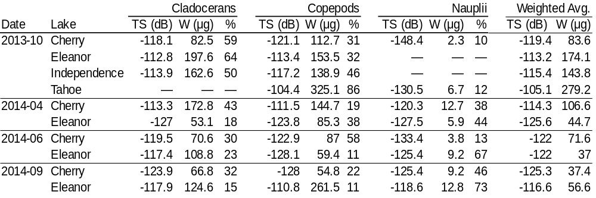

Table 2. Average fish TS, with estimated lengths and wet weights. Standard deviations are given in parentheses. The final column gives the number of fish targets detected in each survey. Target strengths were measured in-situ in each lake with a 120 kHz split-beam echosounder and converted to lengths and weights using published empirical TS-length and length-weight scaling relations (see Methods for details).
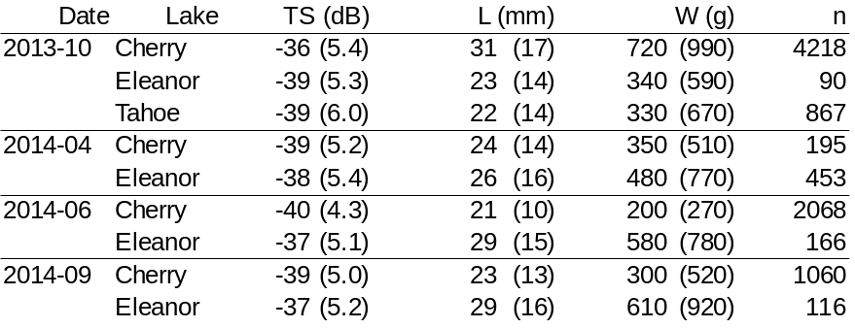
Table 3. Acoustic estimates of total wet-weight biomass of zooplankton and fish in each lake show seasonal changes in different trophic levels as well as interlake differences. These values (as well as the ratio of lower to higher trophic level biomasses) may provide useful data for investigations of various ecosystem-level processes in these habitats.
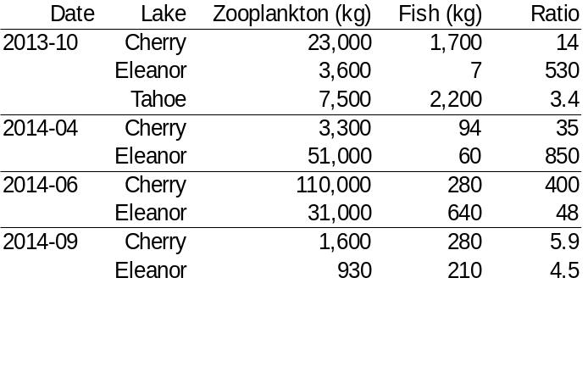
Table 4. Summary of regression models for spatial trends in the density of zooplankton, by lake and survey. The average wet-weight biomass density of zooplankton (in g m⁻³), was averaged through the water column, log₁₀-transformed, and modeled as a linear function of distance (in km) from the lake’s inlet and from the shore. The columns “Intercept”, “Inlet distance”, and “Shore distance” give the regression intercept and coefficients associated with each covariate. Their respective p-values are in the columns to their right.

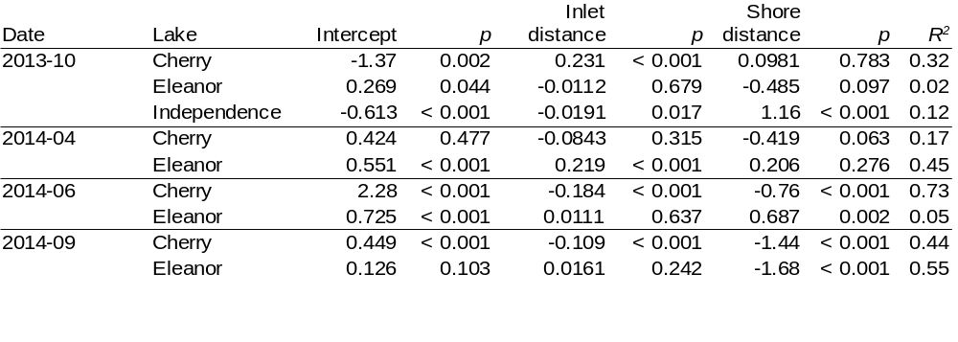

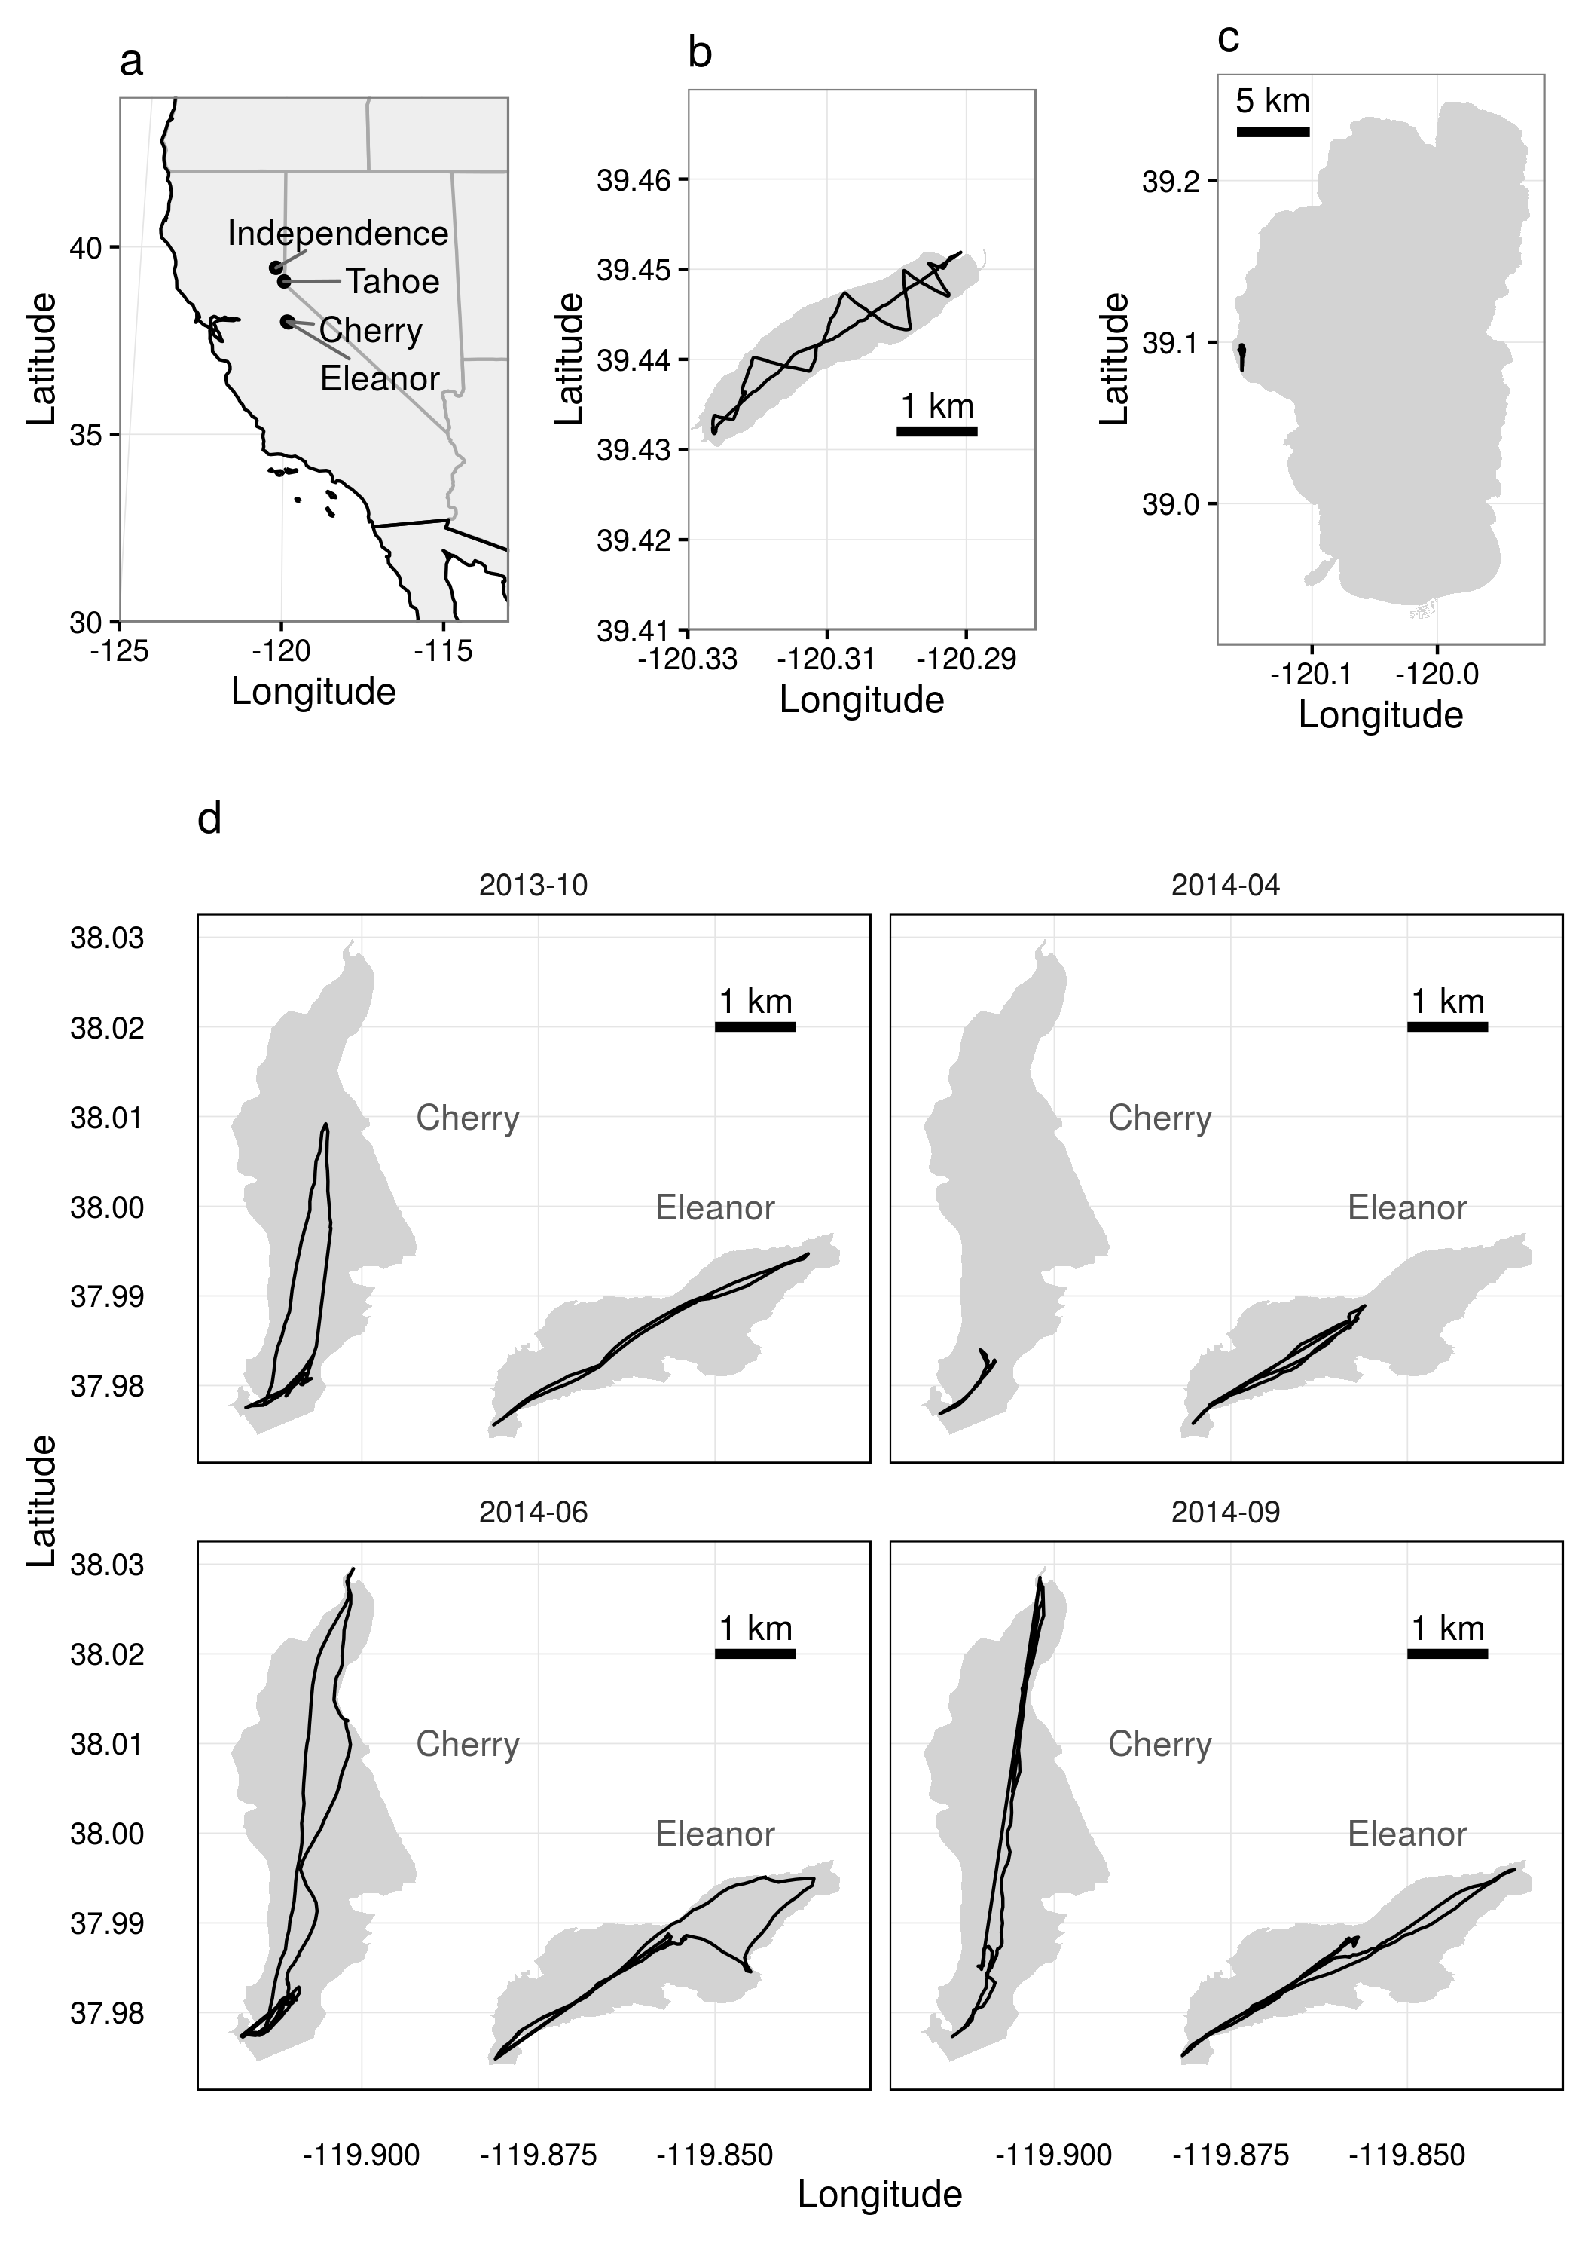
Figure 1. Maps of study lakes, showing (a) location of the four surveyed lakes in California in the western United States, survey tracks in October 2013 in (b) Independence Lake and (c) Lake Tahoe, and (d) repeated surveys in Cherry Lake and Lake Eleanor in October 2013, April 2014, June 2014, and September 2014.
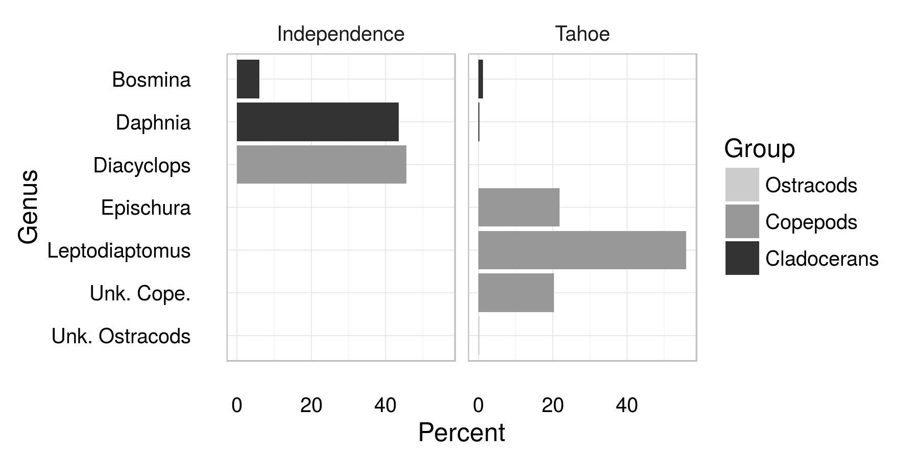
Figure 2. Composition of crustacean zooplankton community in Independence Lake and Lake Tahoe in October 2013 was dominated by a few species.
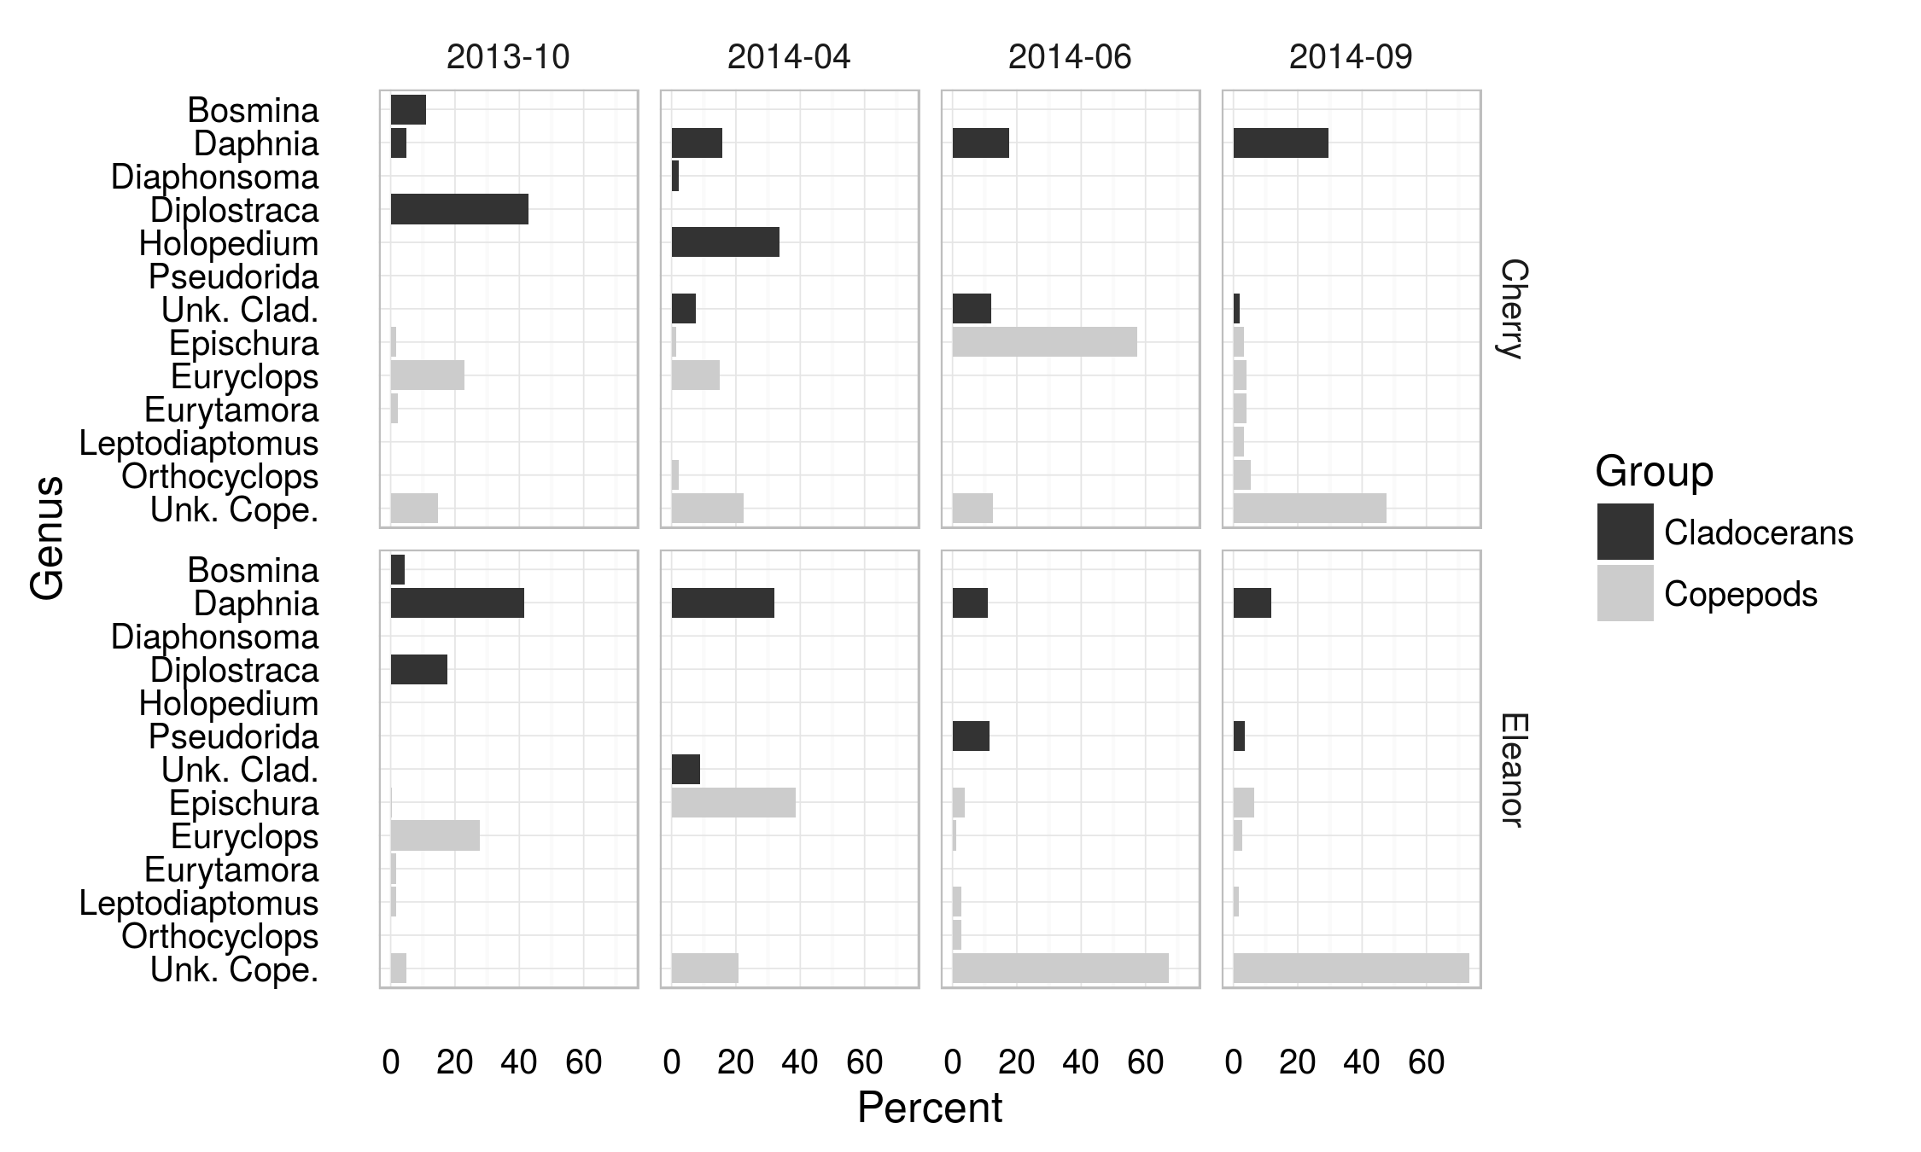
Figure 3. Composition of crustacean zooplankton community in Cherry Lake and Lake Eleanor in four seasonal surveys varied seasonally and between the two sites.
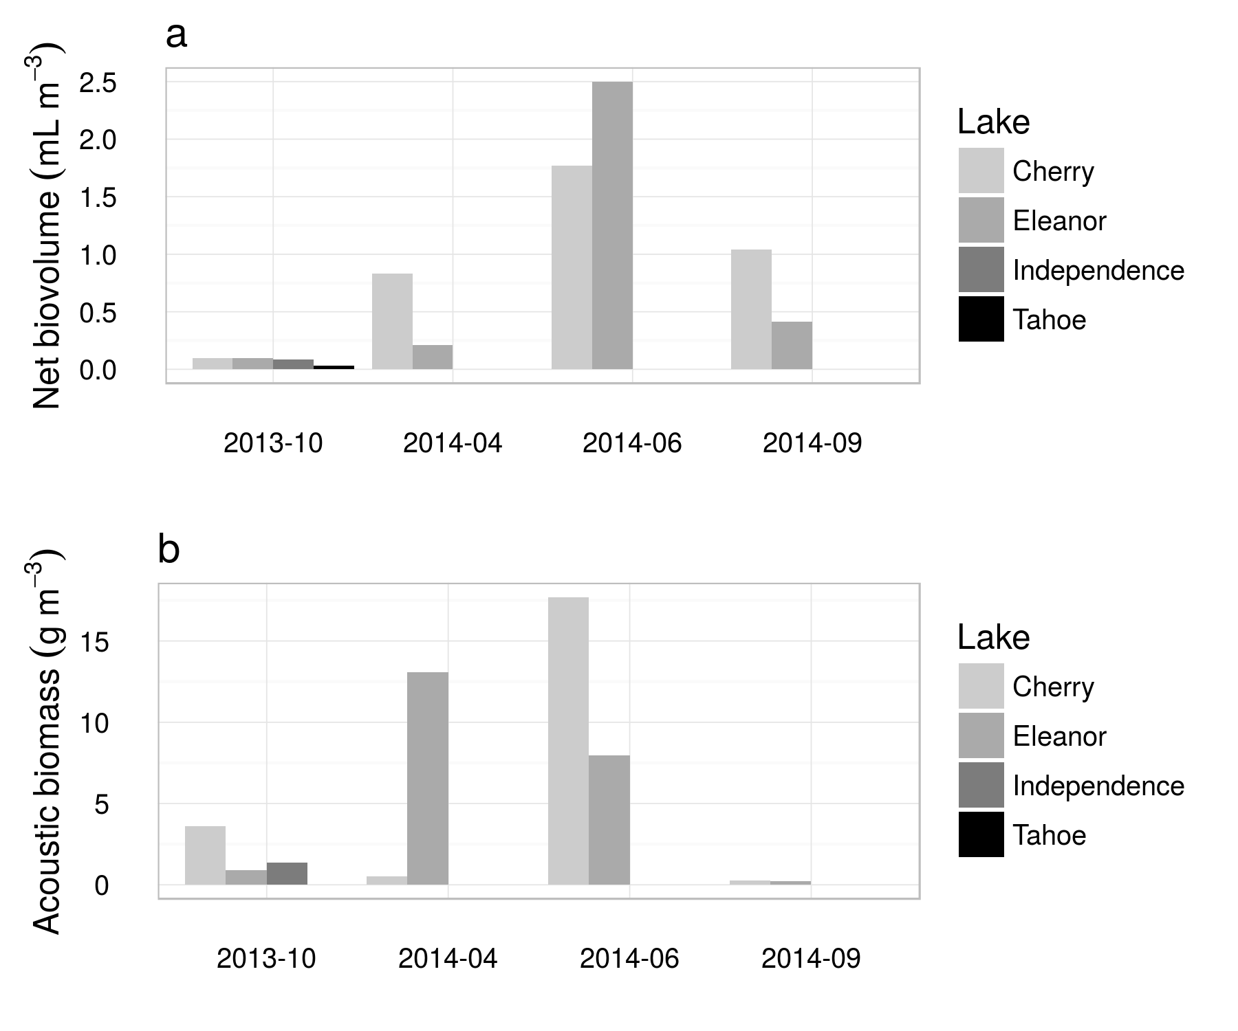
Figure 4. Zooplankton abundance measured by nets and acoustics in each of four seasonal surveys. The color of each bar indicates the lake; note that Independence and Tahoe were only sampled in October 2013. A) Biovolume of zooplankton caught in vertical net tows. These values are normalized by the volume of water filtered, giving units of mL biovolume per cubic meter of lake water. B) Dry biomass of zooplankton per cubic meter, estimated from acoustic surveys, using measured zooplankton lengths identities to parameterize target strengths and length-weight relationships.
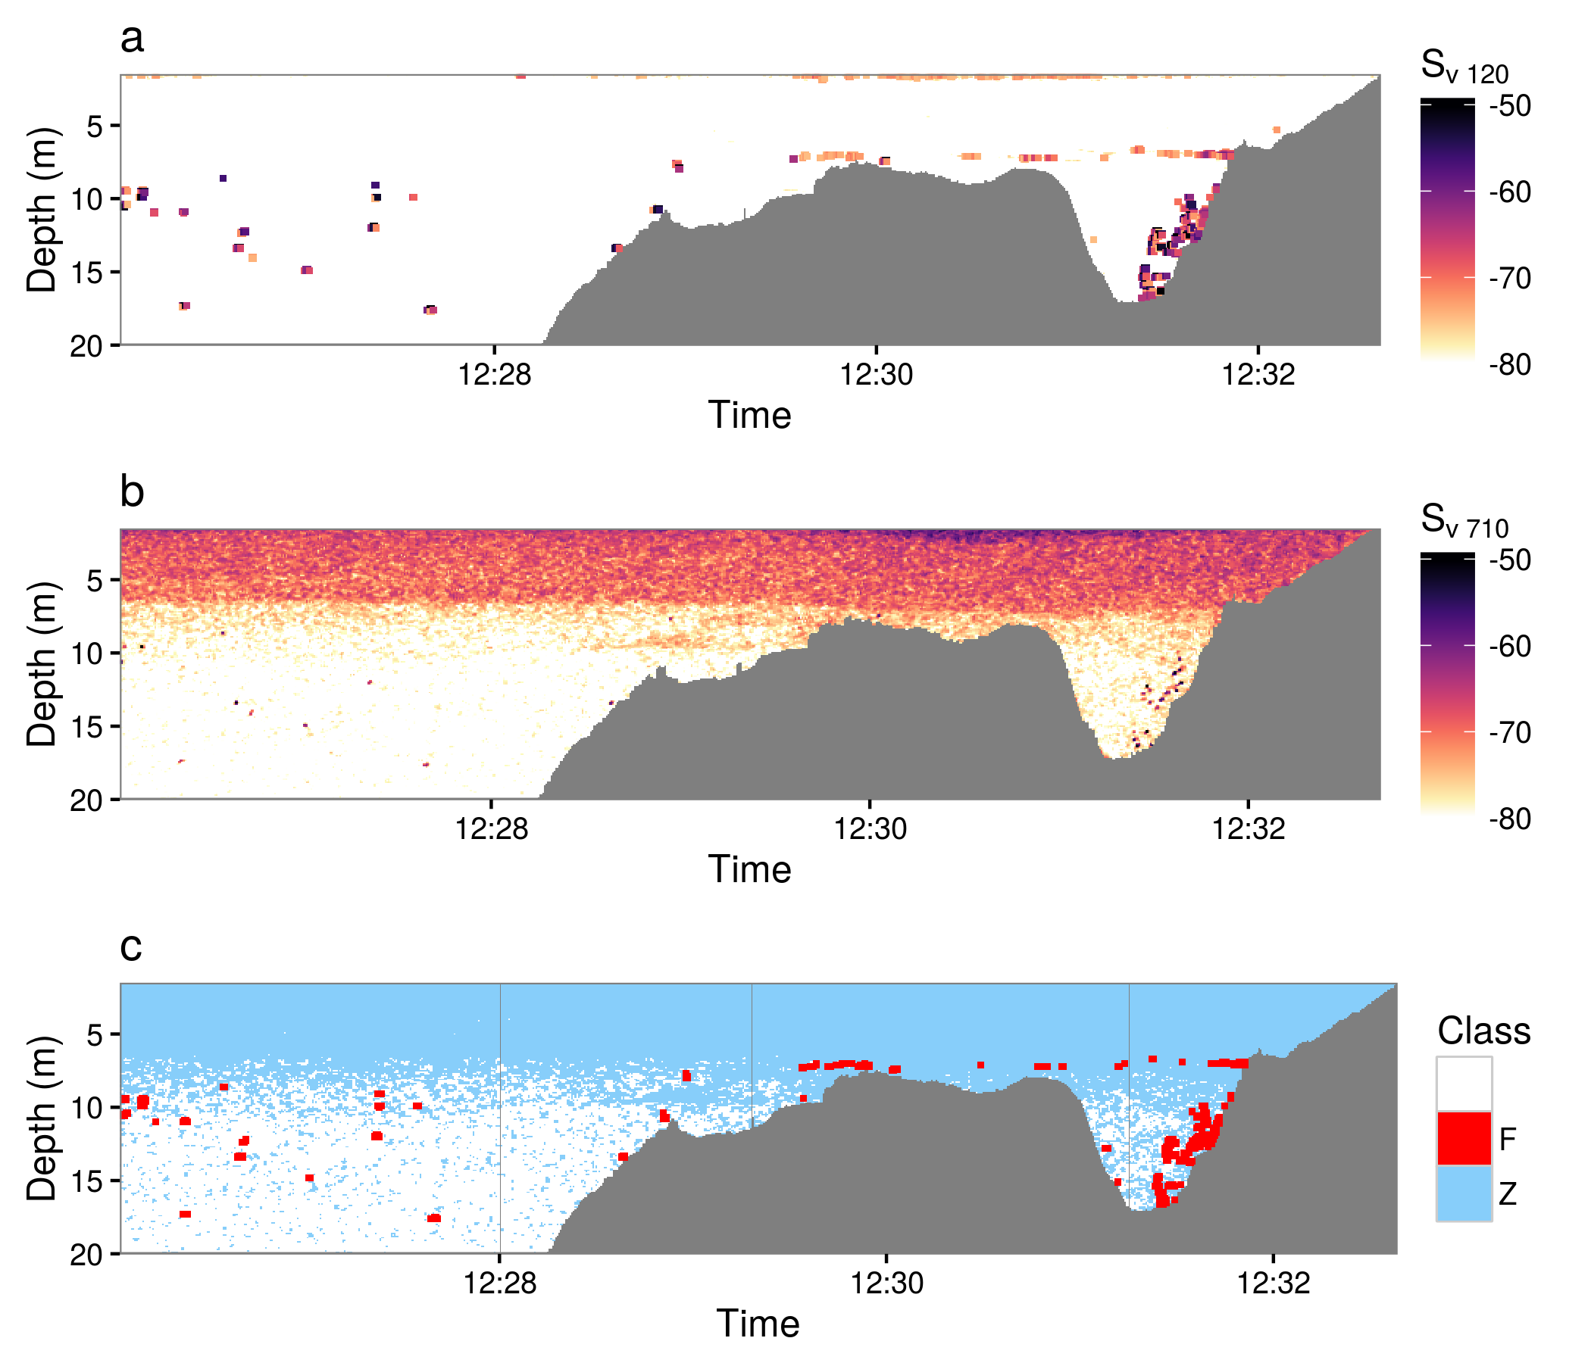
Figure 5. Acoustic profile through part of Cherry Lake on 24 June 2014, showing acoustic backscatter at (a) 120 kHz and (b) 710 kHz. Isolated dots are echoes from individual fish, while the layer of scattering between ~7 m and the surface represents echoes from zooplankton, which are only visible at 710 kHz. (c) Classification of backscatter as fish (“F”) or zooplankton (“Z”) based on frequency differencing. Red areas are fish, scattering more strongly at 120 kHz, while blue area are zooplankton, scattering more strongly at 710 kHz. Pixels classified as fish have been dilated slightly in (a) and (c) for better visibility. White shows areas of empty water (volume backscatter < -80 dB at 710 kHz). The horizontal length of this section is approximately 700 m.
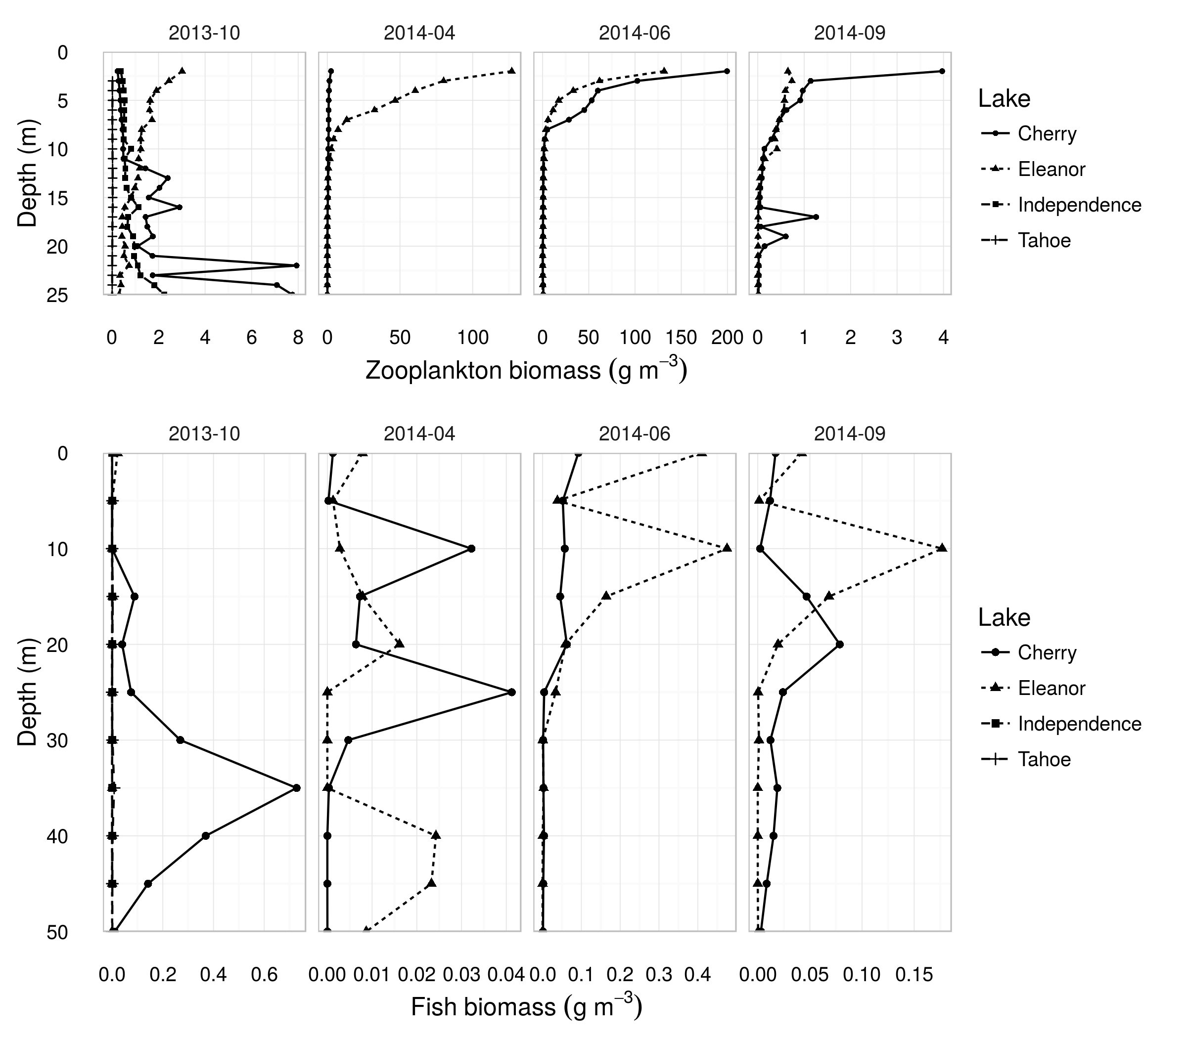
Figure 6. Depth profiles of zooplankton (top row) and fish (bottom row) wet weight biomass density measured acoustically in the lakes sampled during each of four seasonal surveys. (Lake Tahoe and Independence Lake were only sampled in October 2013). Lines show approximate biomass density of all zooplankton as a function of depth,. The target strengths used to calculate numerical densities from acoustic backscatter measurements were estimated using the distorted-wave Born approximations for the zooplankton communities, and measured in-situ for fish using a split-beam echosounder. Note differing x-axis scales in each plot.
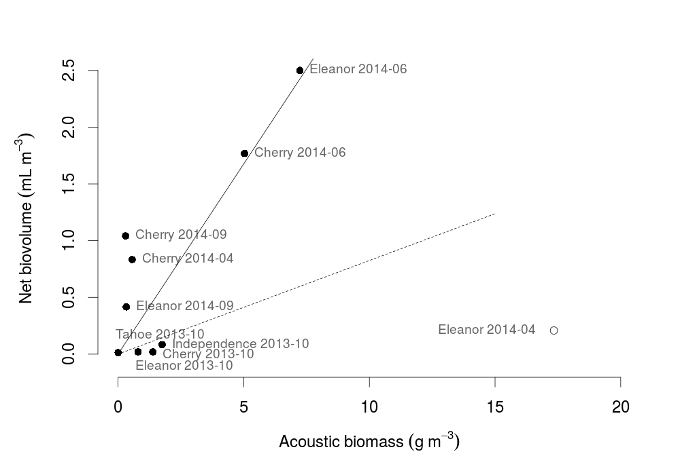
Figure 7. Regression of biovolumes estimated from vertical net tows with acoustic estimates of wet weight biomass density. Data points are labeled with their lake and date. Two best-fit lines are plotted: the dashed line was fit to all data points, while the solid line excluded Lake Eleanor in April 2014, plotted as an empty point.

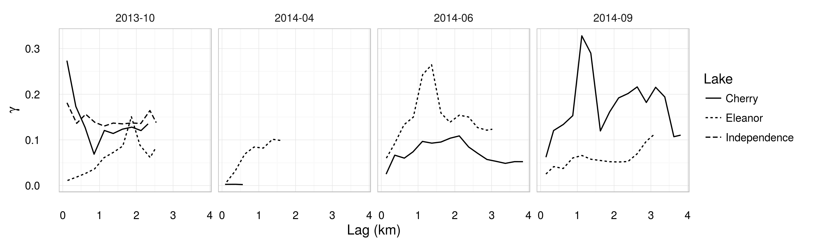
Figure 8. Empirical variograms of log-transformed zooplankton areal biomass density (i.e., mass of zooplankton per m² of lake surface) for each lake and survey.

