PLsi v0

Hardware Manual

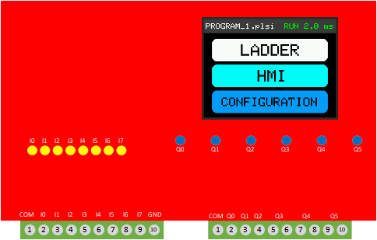


Project page:
https://github.com/ElPercha/PLsi

Purpose of this document
This PLsi manual provides you with information to build a PLsi v0 unit, it comprises the board assembly, firmware download and a series of tests to validate the main functionalities. For wiring, configuration and programming information, refer to “PLsi v0 User Manual”.
Please, create an issue in the PLsi repository if you see that this manual is not clear enough or has opportunities to improve.

Document information
Manual Name: PLsi_v0_Hardware_Manual
Revision: A
Date: February 20, 2022

Revision history
Revision | Date | Description | Latest Firmware
A | February 20, 2022 | First Revision | V0.00.03

License
The complete PLsi Project is under GPL v3.0 license.


This includes Hardware, Software, Documentation and all related contributions:

Copyright (c) 2019 Prieto Lucas. All rights reserved.
This file is part of the PLsi project.
PLsi is free software and hardware: you can redistribute it and/or modify
it under the terms of the GNU General Public License as published by
the Free Software Foundation, either version 3 of the License, or
(at your option) any later version.
PLsi is distributed in the hope that it will be useful,
but WITHOUT ANY WARRANTY; without even the implied warranty of
MERCHANTABILITY or FITNESS FOR A PARTICULAR PURPOSE. See the
GNU General Public License for more details.

You should have received a copy of the GNU General Public License
along with this program. If not, see <https://www.gnu.org/licenses/>.

A full copy of the License is included on the Master branch of the project for reference:
https://github.com/ElPercha/PLsi/blob/master/LICENSE
Original copy with useful FAQ:
https://www.gnu.org/licenses/gpl-3.0.html

Safety Guidelines
All applicable local and national codes that regulate the installation and operation of your equipment shall be followed in order to minimize the risk of potential safety issues.
PLsi is not fault-tolerant and must not be used to control equipment in hazardous environments where the failure of the system could lead to death, people injury, or severe environmental damage. Refers to the Disclaimer notice for more information.
This manual contains 3 levels of hints:

WARNING:
Death, serious harm to health or equipment damage can result
if the stated measures are not followed !


CAUTION:
Harm to health or equipment damage can result if the
stated measures are not followed


TIP:
Important information that requires your special attention

Table of Contents
Purpose of this document 2
Document information 2
Revision history 2
License 3
Safety Guidelines 4
Table of Contents 5
1. Introduction 6
1.1 Project documentation 7
1.2 Minimum system 8
1.3 Drawing 12
1.4 Connections and Isolation 15
1.4.1 Digital version 15
1.4.2 Analog version 17
2. Board Assembly 19
2.2 Digital version 21
2.2.1 Component list 21
2.2.2 Assembly 22
2.3 Analog version 29
2.3.1 Component list 30
2.3.2 Assembly 31
3. Firmware Download 40
3.1 Required files 41
3.2 Espressif download tool 42
3.2 Downloading the Firmware 46
4. Hardware Configuration 53
5. Hardware Validation 57
5.1 Digital Version I/O validation 60
5.2 Analog Version I/O validation 66
6. Housing 73
6.1 3D Printed Parts 75
6.2 List of Materials 79
6.3 Assembly 85

1. Introduction
The objective of the PLsi project is to create a PLC & HMI with the following main characteristics:
- To not require external systems such us Laptops or Cellphones to be programmed
- To be used on Classroom for educational purposes, IoT applications or industrial low risk applications
- Software and Hardware with Industrial performance and features
- Open Source and Open Hardware
- Focus on Low Cost
The hardware version 0 of PLsi system is designed to be cheap and easy to build. It does not have SMD components, what makes the building process easy, fast and feasible using basic tools. The components selection was oriented to use easy to get and cheap elements.
The PLsi v0 is mainly composed by:
- Main board
- ESP32 module
- TFT 2.8” SPI Display module with touchscreen
- Terminal blocks and common electronic components
The PLsi v0 board is designed to support different input output configurations. This manual will cover the 2 main suggested configurations. For that reason, before to start, you have to select which version are you going to build, these are the 2 main options:
- Digital version:
  - 8 digital inputs (5 to 26VDC)
  - 6 relay outputs (10A max per PLsi, external fuse required)
- Analog version:
  - 6 digital inputs (5 to 26VDC)
  - 4 relay outputs (10A max per PLsi, external fuse required)
  - 2 Analog Inputs (0-5V)
  - 2 Analog Outputs (0-5V)
This definition will modify your component list. The details of which component is required on each version is covered on the following chapters.

1.1 Project documentation
The PLsi project is hosted on GitHub:
https://github.com/ElPercha/PLsi
The tree structure is divided in 3 main folders:
- doc: Contains project documentation and auxiliary tools
- firm: Contains the Firmware, it is designed using PlatformIO + Visual Studio
- hard: Contains the Hardware documentation, mainly:
  - Circuit schematic
  - Component list
  - Board fabrication details
  - 3D Printed housing fabrication details
  - 3D Printed Din Rail support fabrication details
The most updated information is located on the master branch (link provided above), but it also might contain nightly builds of the firmware, hardware or any document. For this reason, it is recommended to use the “releases”, they are a more trustworthy information source.
Each release contains a snapshot of the full project site by the moment of his creation, plus the required binaries to flash the ESP32 module.
By the time this document was created, the latest revision available is the “v0.00.03”.
It is recommended to use the latest available release to build your PLsi unit.
https://github.com/ElPercha/PLsi/releases
The details on how to use the binary files to flash your PLsi are going to be covered during the next chapters.

1.2 Minimum system
The easiest way to build a PLsi v0 is using the board designed for it, but for PLsi CPU testing purposes (with no Inputs Outputs) a limited system can be easily built.
It consist of:
- ESP32 WROOM module
  - 38 pins version
  - They typically have yellow pin terminals
  - For test purposes you can use another ESP32 module as long as it has dual core, but the described model is required if you use the PLsi v0 board.
- 2.8” 320x240 SPI TFT Display – LcdWiki info
  - Driver ILI 9341
  - Touchscreen driver XPT2046
  - For test purposes you can use another display, as long as it has the same interface, resolution and drivers, but the described model is required if you use the PLsi v0 board.
- 9 Jumper cables for the ESP32 ← → Display connections.
- Micro USB cable and adapter with 1A capacity (recommended 2A)
  - This fed the ESP32 module and it is the main incoming supply voltage of the PLsi v0

Required ESP32 ← → Display connections for minimal system:

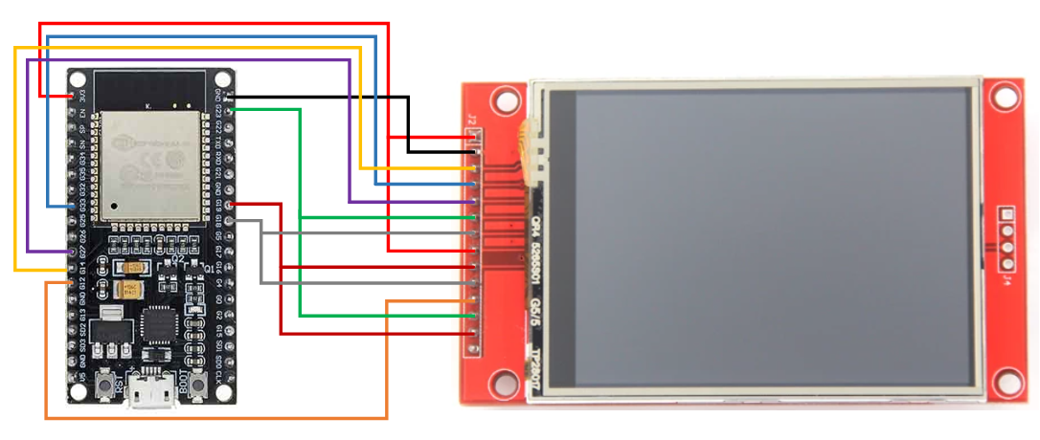

In the above sketch the minimal connections are shown.
The only pending activity to have a functional CPU will be the ESP32 Firmware download. This procedure is detailed in the Firmware Download chapter.
Required ESP32 Module
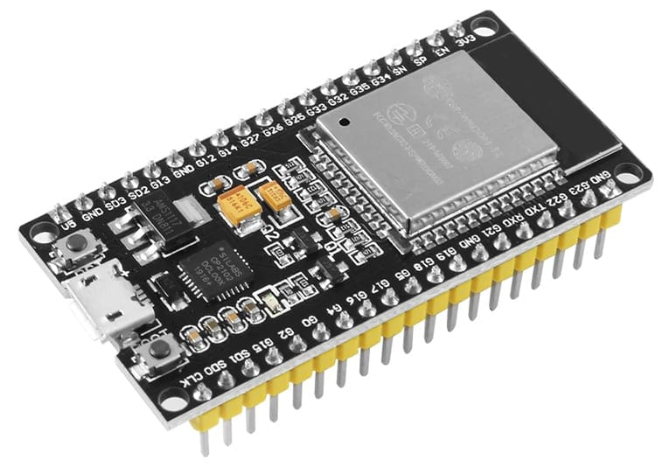
Dimensions:
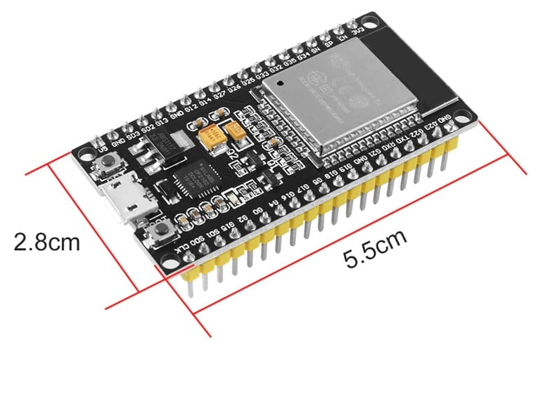

Required display:

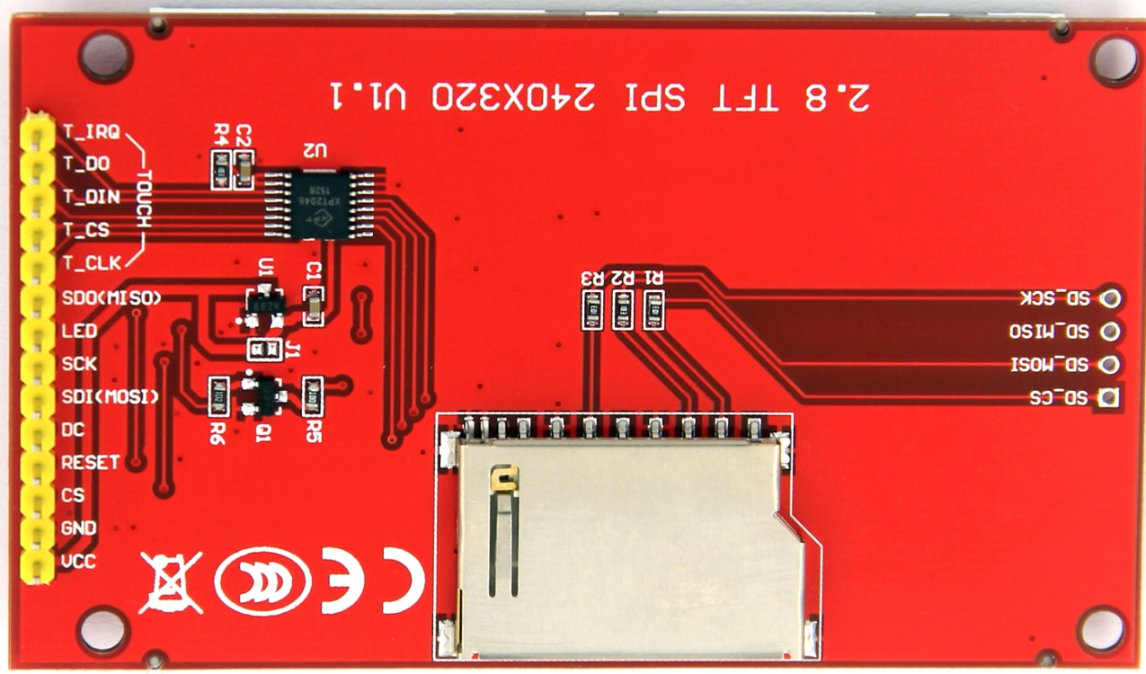
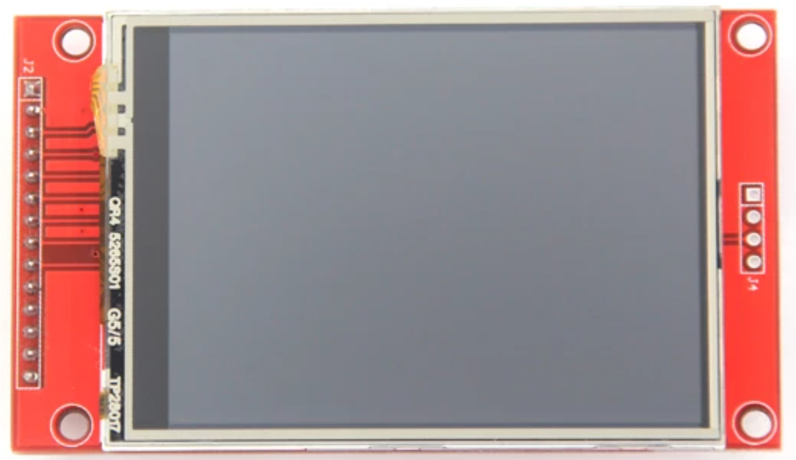

1.3 Drawing
The drawing was created using the free editor EasyEDA.
You can access the project following this link.
The schematic is also stored on GitHub, in the folder hard/CPU/v0/schematic

The drawing is composed by 3 pages:
- CPU & HMI
- Inputs
- Outputs

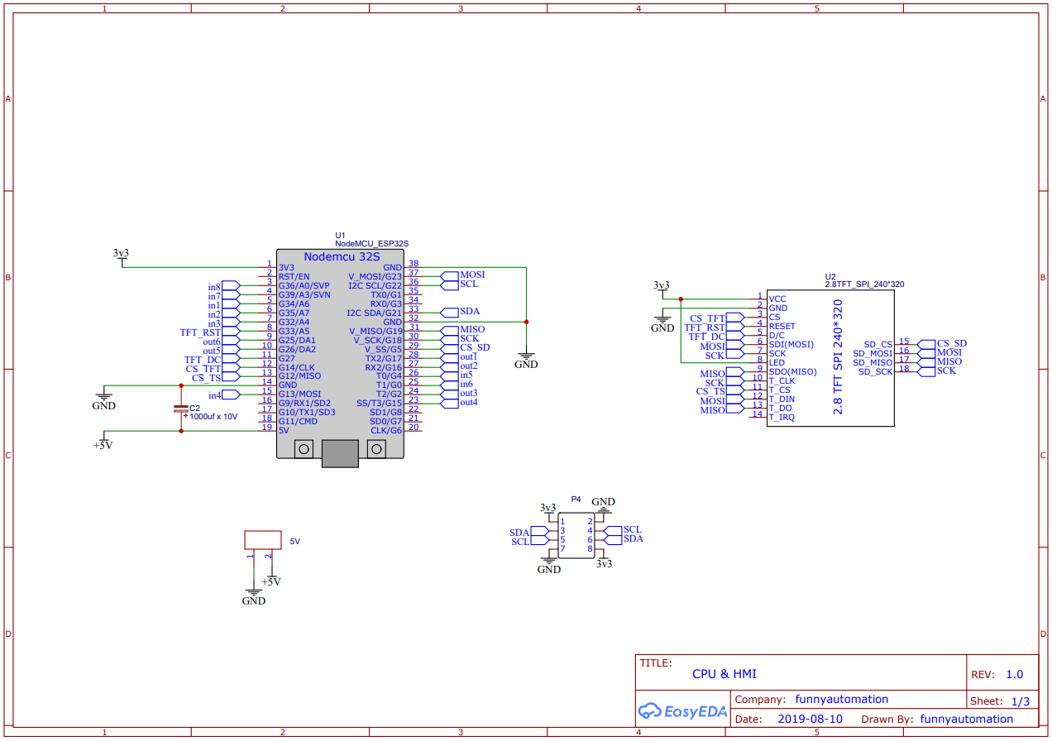
All the components shown in the above schematic are required for any PLsi v0 version, analog or digital.

Digital & Analog inputs schematic:

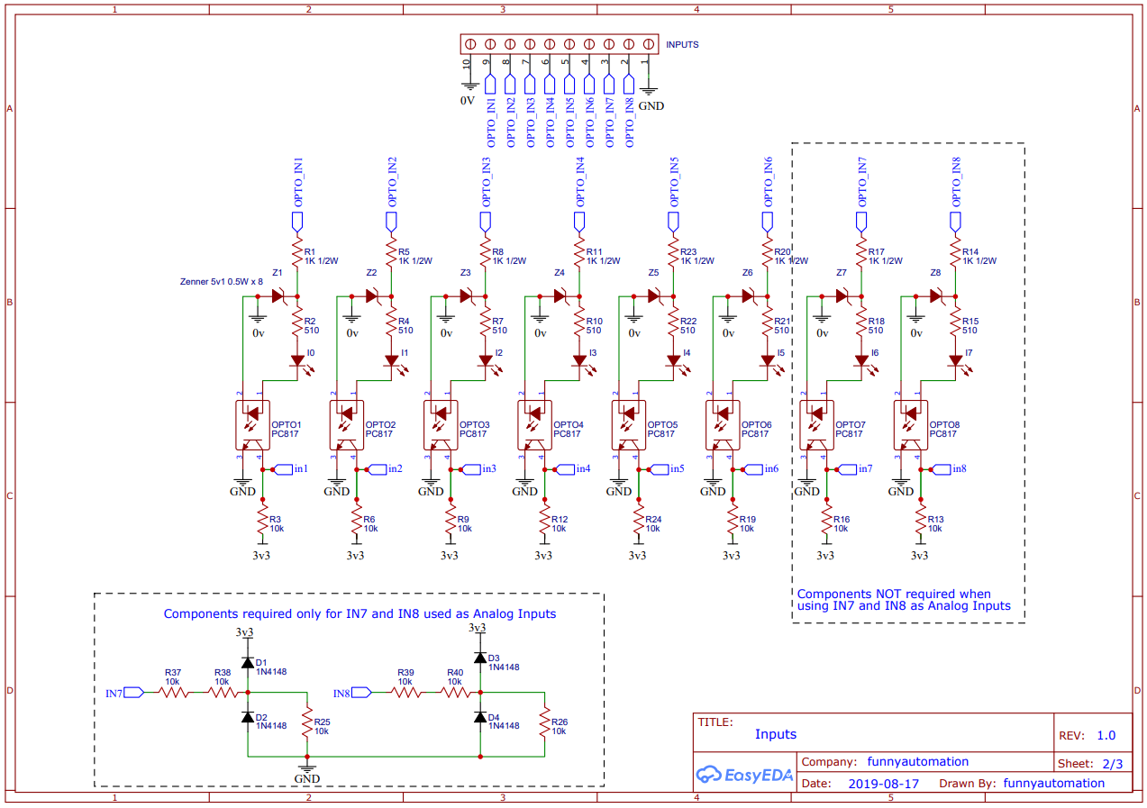

Note that not all components are required.
The components list for Analog or Digital version is detailed over
the next chapters

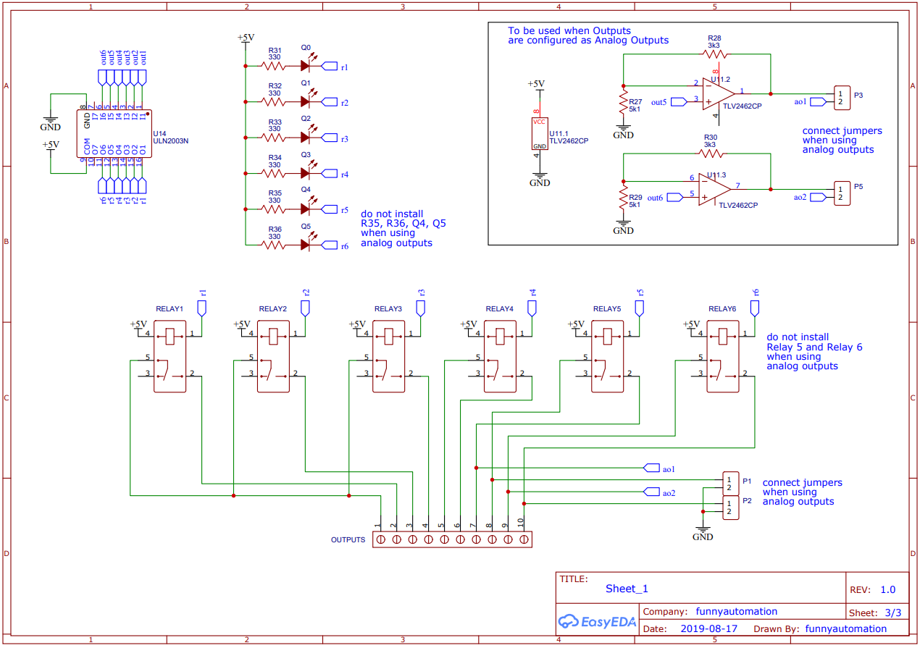
Digital & Analog outputs schematic:

Note that not all components are required.
The components list for Analog or Digital version is detailed over
the next chapters

1.4 Connections and Isolation
The following sections provide in advance information about the connection and PLsi v0 isolation.
For more information about wiring and setup, refer to the “User Manual”

1.4.1 Digital version
The following diagram shows the main connections required for your PLsi v0 Digital version.
USB main feeder, I2C expansion and SD card connectors are shown

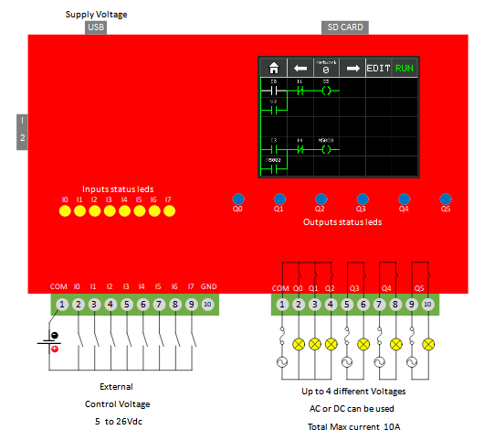

I0 to I7 share the same common connection supporting a voltage range of 5Vdc to 26Vdc.
Q0, Q1 and Q2 share the same common connection at terminal 1
Q3, Q4 and Q5 have their own common connection
Install external Fuses as indicated on the diagram for a total max capacity of 10 Amps
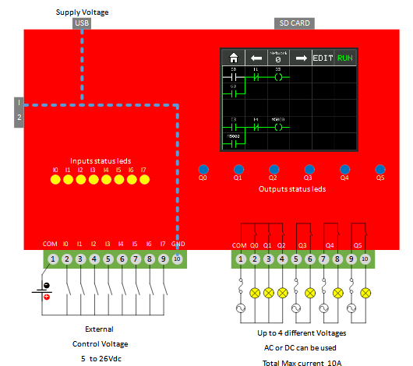
For example 4 fuses of 2 Amps.

The above diagram shows how the 0V reference of the CPU is fully isolated from I/O connections.
Do not connect terminal GND to an external power supply.

1.4.2 Analog version
The following diagram shows the main connections required for your PLsi v0 Analog version.
USB main feeder, I2C expansion and SD card connectors are shown
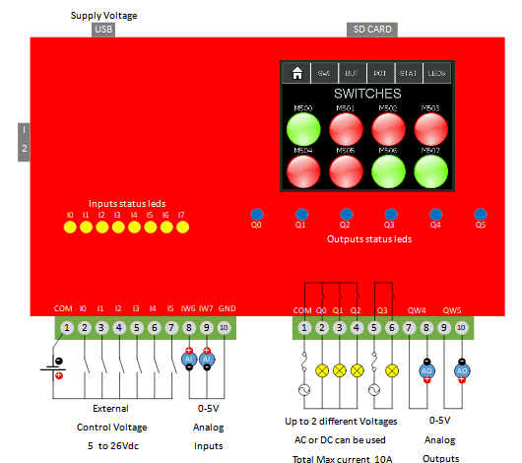

Q0, Q1 and Q2 share the same common connection at terminal 1
Q3 has his own common connection
Install external Fuses as indicated on the diagram for a total max capacity of 6 Amps
For example 2 fuses of 2 Amps.

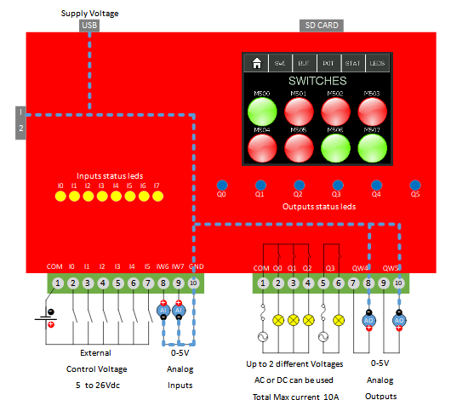

The Analog Inputs and Outputs for PLsi v0 are not isolated, for this reason the 0V reference is now shared between the CPU and the Analog I/O as shown in the above diagram.

2. Board Assembly
The recommended way to build your PLsi is using the board designed for it.
All the required files to build the board are stored on Github. Each PLsi hardware version has his own folder.

PLsi v0 board link.

Folder content:
- Gerber Files
- EasyEDA source
- Altium source (it is a beta export option of the EasyEDA platform, not tested)
- Schematic
- BOM

The EasyEDA project is also public, you can directly clone the project, download or open the files from here.

The Boards used to prototype the PLsi v0 were ordered to:
https://jlcpcb.com/
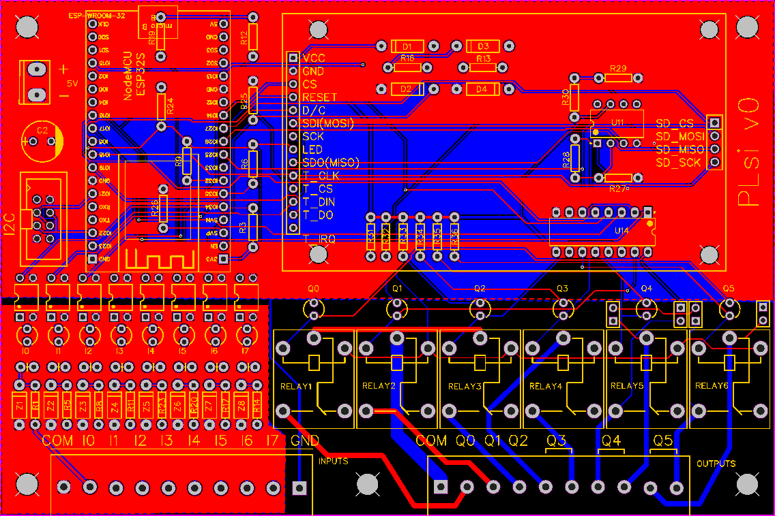

Select the desired PLsi v0 version to build:
- Digital version:
  - 8 digital inputs (5 to 26VDC)
  - 6 relay outputs (10A max per PLsi, external fuse required)
Continue to Chapter 2.2
- Analog version:
  - 6 digital inputs (5 to 26VDC)
  - 4 relay outputs (10A max per PLsi, external fuse required)
  - 2 Analog Inputs (0-5V)
  - 2 Analog Outputs (0-5V)
Continue to Chapter 2.3

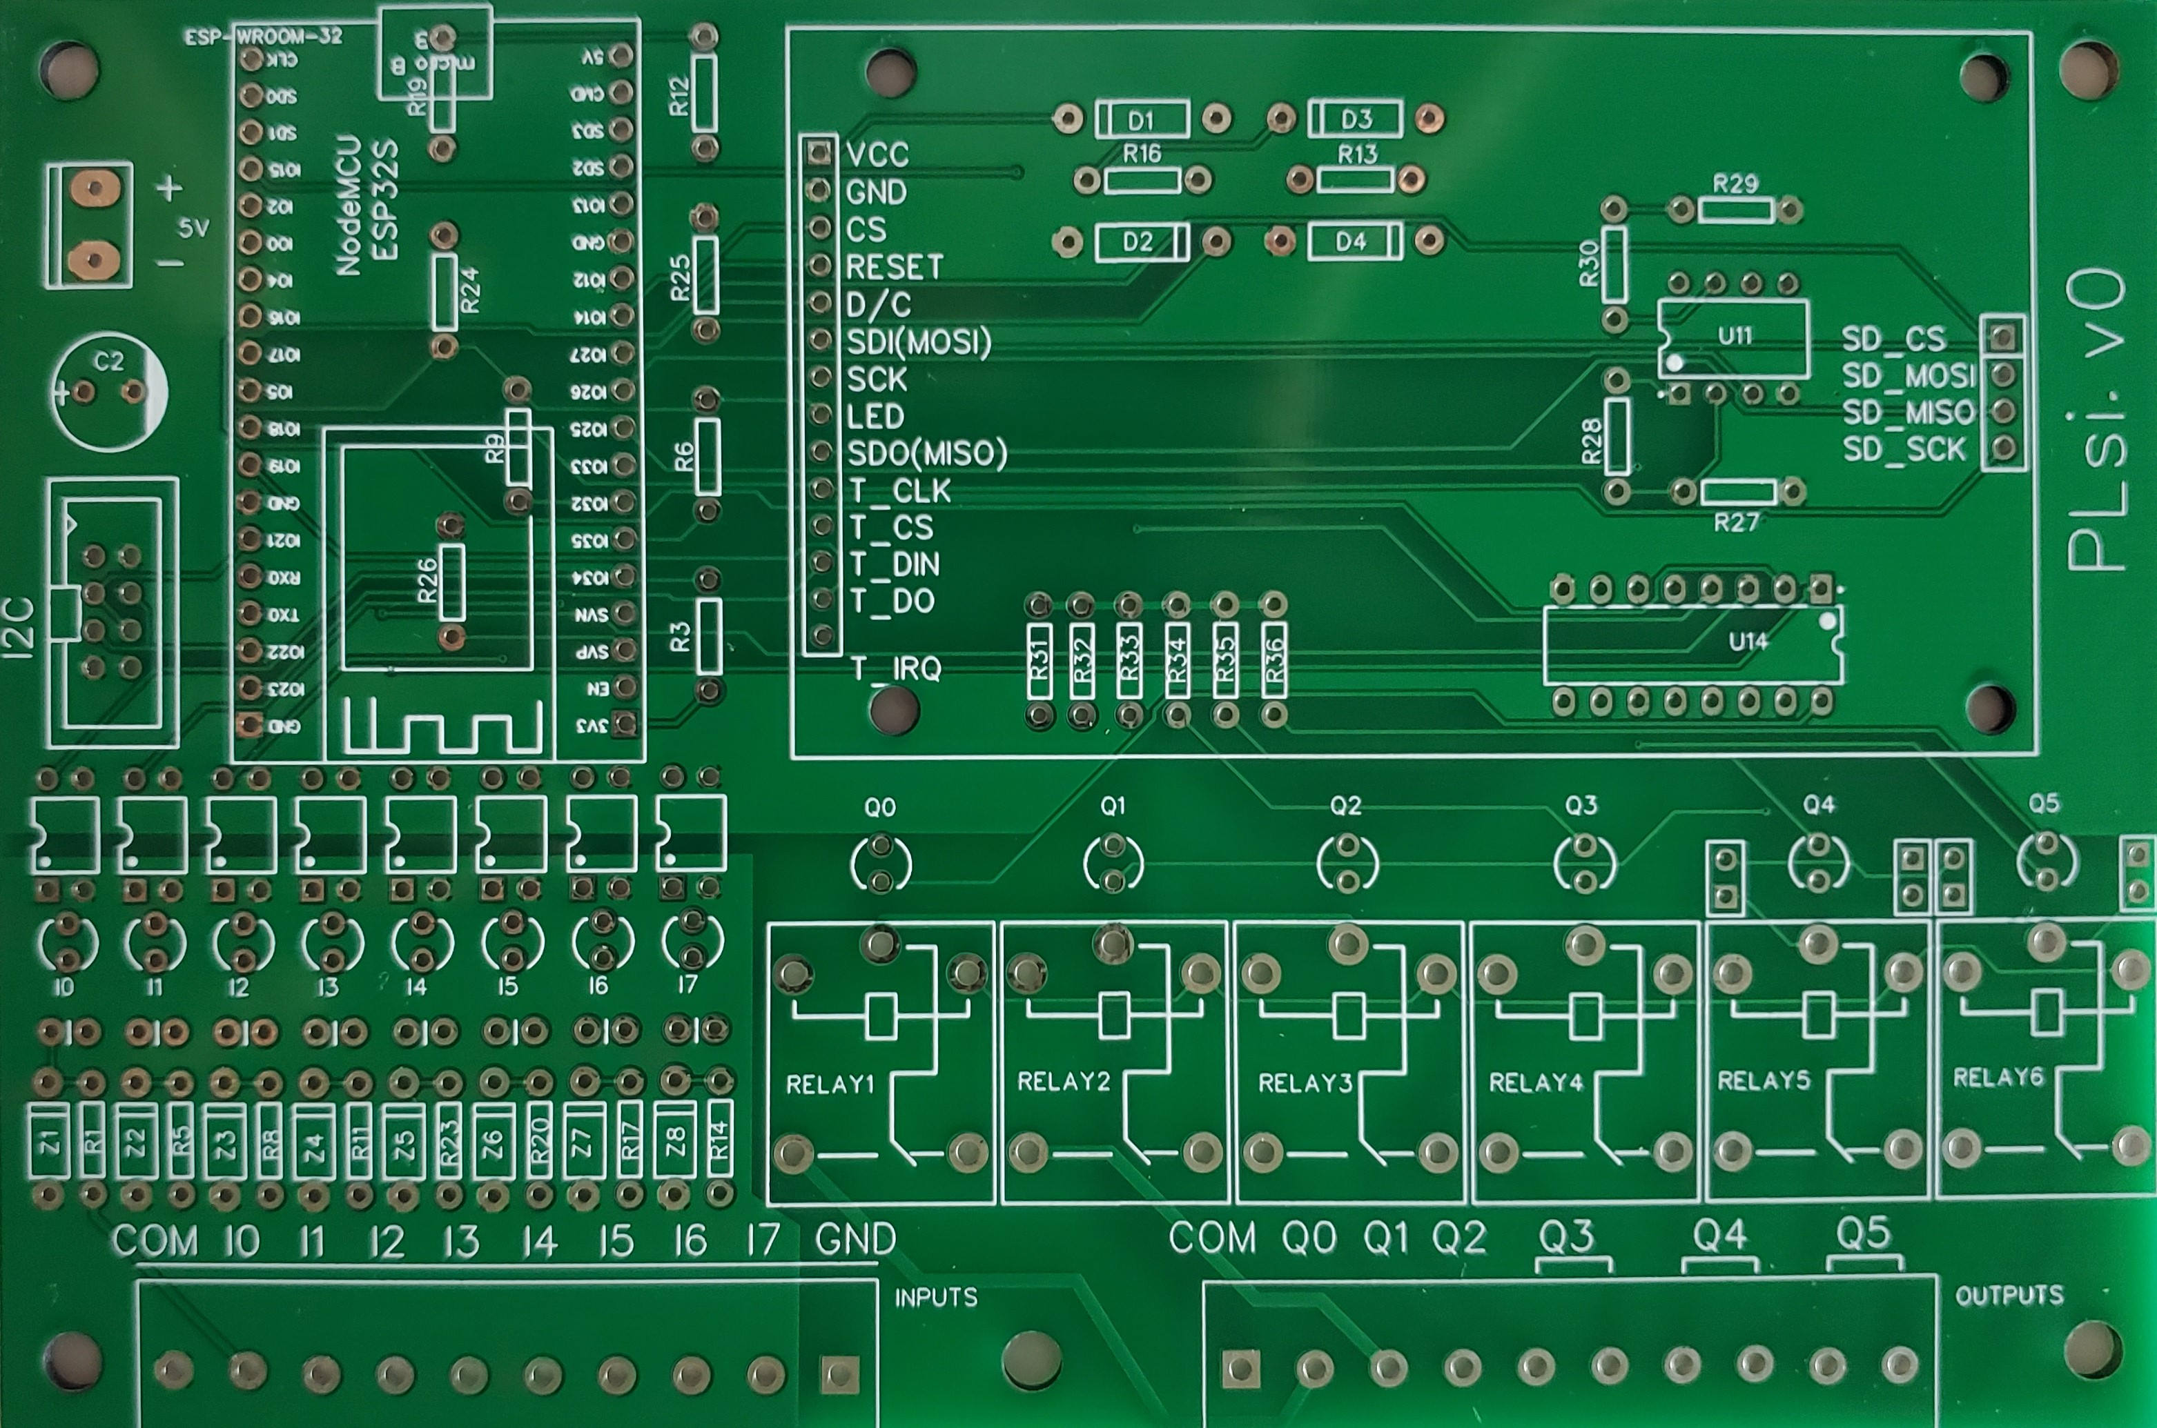

2.2 Digital version
The Digital version of PLsi hardware v0 will have:
- 8 digital inputs (5 to 26VDC)
- 6 relay outputs (10A max per PLsi, external fuse required)

2.2.1 Component list
The following table has the list of components required to build your Digital PLsi v0:

Item | Component TAG | Description | Quantity
1 | U1 | NodeMCU_ESP32S | 1
2 | U2 | Touch Screen Display | 1
3 | U14 | ULN2003N | 1
4 | INPUTS, OUTPUTS | 5.08 x 10 Terminal block | 2
5 | U2 – SD Card connection pins | Dupont 2.54mm Male strip | 4 pins
6 | U1 and U2 - Socket | Dupont 2.54mm Female strip | 2 x 40 pins
7 | 5V (Optional) | Dupont 3 pins male | 3 pins
8 | P4 (Optional) | HDR-IDC-2.54-2X4P | 1
9 | C2 | Capacitor 1000uF 9V | 1
10 | OPTO1, OPTO2, OPTO3, OPTO4, OPTO5, OPTO6, OPTO7, OPTO8 | Optocoupler PC817 | 8
11 | Z1, Z2, Z3, Z4, Z5, Z6, Z7, Z8 | Diode 5v1 – Zenner 1w | 8
12 | I0, I1, I2, I3, I4, I5, I6, I7 | Leds 3mm Color 1 | 8
13 | Q0, Q1, Q2, Q3, Q4, Q5 | Leds 3mm Color 2 | 6
14 | R3, R6, R9, R12, R13, R16, R19, R24 | Resistor 10k | 8
15 | R1, R5, R8, R11, R14, R17, R20, R23 | Resistor 1K x 1/2W | 8
16 | R2, R4, R7, R10, R15, R18, R21, R22 | Resistor 510 ohms | 8
17 | R31, R32, R33, R34, R35, R36 | Resistor 330 ohms | 6
18 | RELAY1, RELAY2, RELAY3, RELAY4, RELAY5, RELAY6 | SRD-05VDC-SL-C | 6

The latest version of the BOM (Bill of Materials) file, is stored in this Folder.

2.2.2 Assembly
This section will recommended a step by step sequence to facilitate the assembly process using the PLsi v0 board. It basically starts with the smaller components and finishes with the bigger ones, adding tips to minimize mistakes.
For each step, the indicated Item number can be found on the previous table (Section 2.2.1) to get more information about the component.
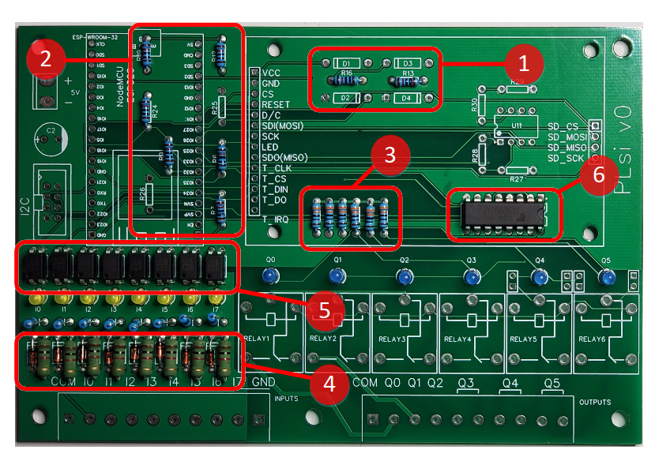
Step 1 - Weld quantity 2 x 10K Resistors – Item 14
Step 2 - Weld quantity 6 x 10K Resistors – Item 14
Step 3 - Weld quantity 6 x 330 ohm Resistors – Item 17
Measure the Resistors value before to weld them

Step 4 - Weld quantity 8 x 1K x 1/2W Resistors – Item 15
Weld the 8 x Zenner Diodes 5.1V x 1W – Item 11
Pay special attention to the Zenner diodes polarity:
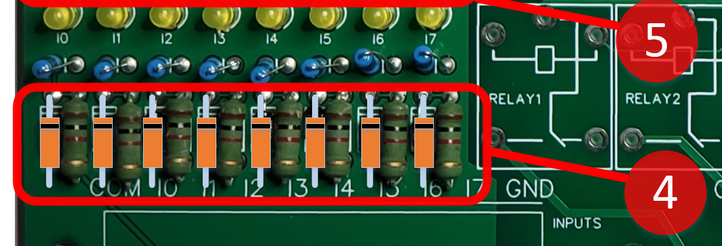

Do not use components with less power of what is suggested.
1/2W for Resistors and 1W for Zenner Diodes

Step 5 - Weld quantity 8 x PC817 Optocouplers – Item 10
Pay special attention to the orientation mark on the Chip
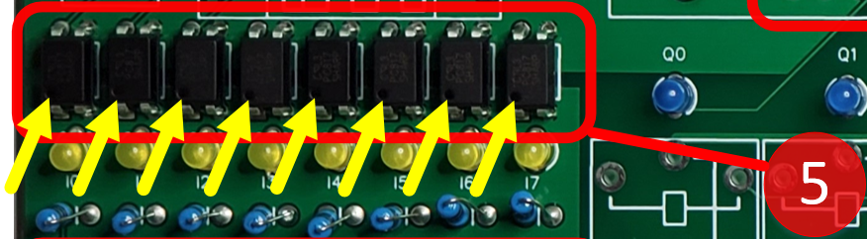

Step 6 - Weld quantity 1 x UNL2003N driver – Item 3
Pay special attention to the orientation mark on the Chip
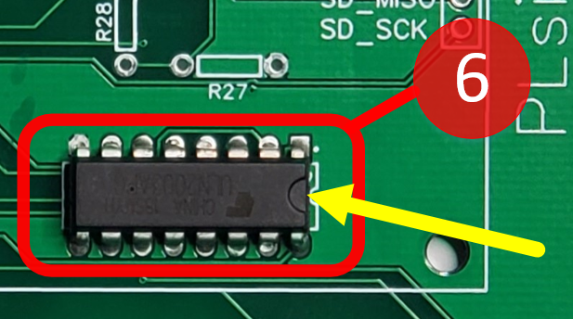

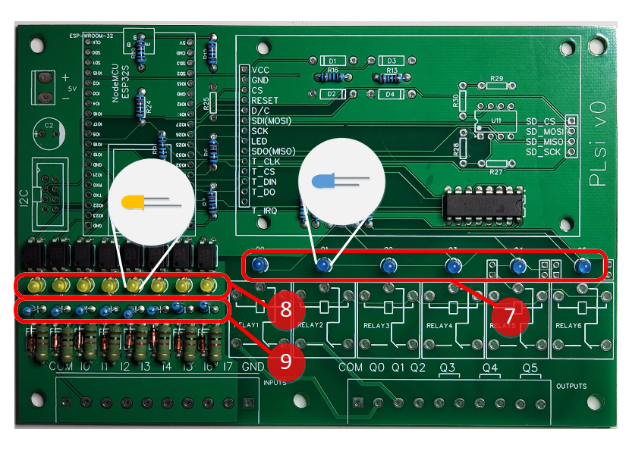
Step 7 - Weld quantity 6 x 3mm Leds of your favorite color – Item 13
It is recommended to avoid using red and green since they are typically used to indicate failures and OK statuses respectively.
Pay special attention to the polarity (Long leg/Short leg)
Recommended color: Blue
Step 8 – Weld quantity 8 x 3mm Leds of your favorite color – Item 12
It is recommended to avoid using red and green since they are typically used to indicate failures and OK statuses respectively.
Pay special attention to the polarity (Long leg/Short leg)
Recommended color: Yellow
Step 9 - Weld vertically quantity 8 x 510 ohms Resistors – Item 16

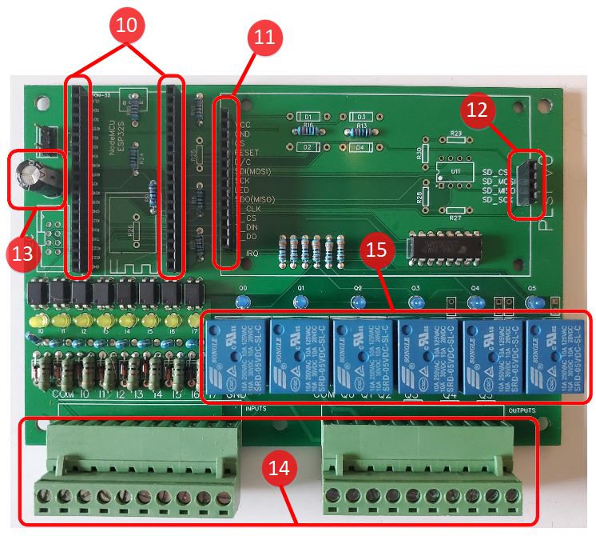
Step 10 – Weld quantity 2 x 18 pins Female Dupont headers (2.54mm) – Item 6
Step 11 - Weld quantity 1 x 14 pins Female Dupont header (2.54mm) – Item 6
Step 12 - Weld quantity 1 x 4 pins Female Dupont header (2.54mm) – Item 6
Cut the Dupont headers to the required dimension using a small cutter
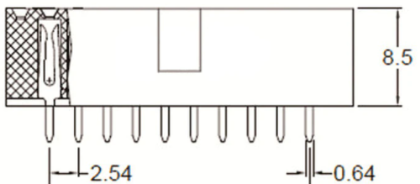
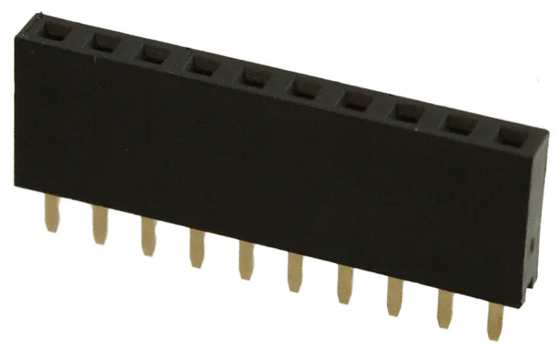
Step 13 - Weld quantity 1 x Capacitor 1000uF 9V – Item 9
Observe the Polarity detail:
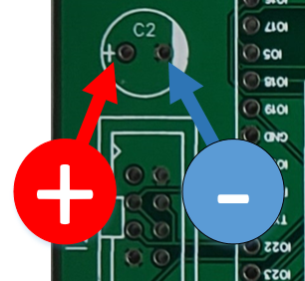

Step 14 - Weld quantity 2 x Header 10 pins 5.08mm – Item 4
Step 15 - Weld quantity 6 x Relay 10Amps Coil 5vdc – Item 18
Step 16 – Optional
Weld the “5V Aux Output Header” – Item 7
Weld the “I2C Expansion Header” – Item 8

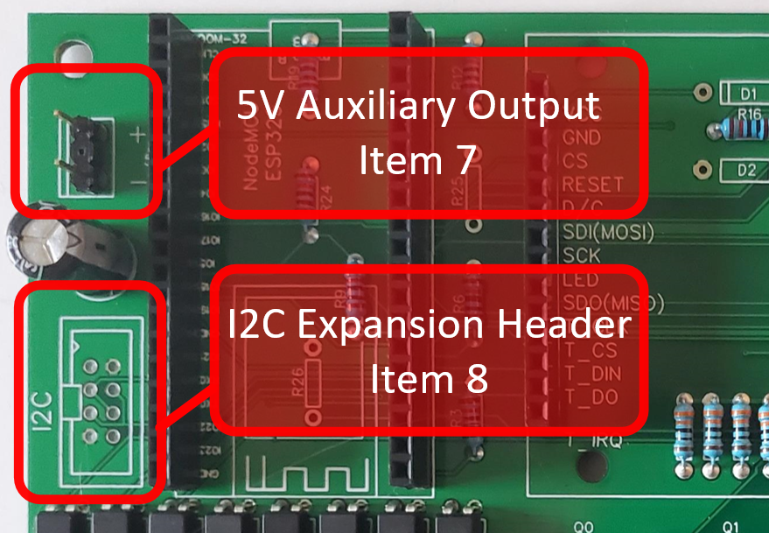

Step 17 – Weld the 4 pin Dupont male header – Item 5 – into the right side of the Display, as indicated in the following picture:

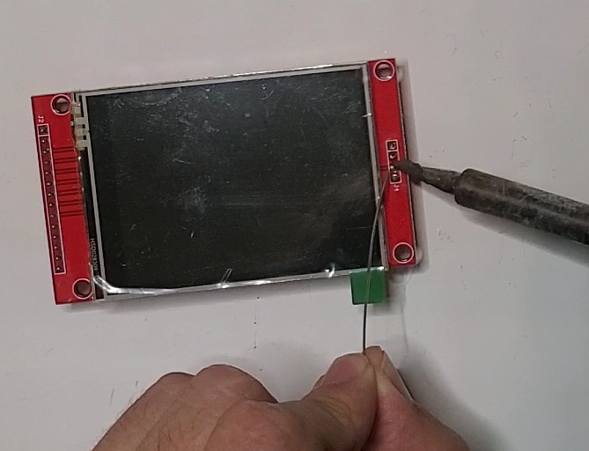

Step 18 – Insert ESP32 Module (Item 1) and Display (Item 2)

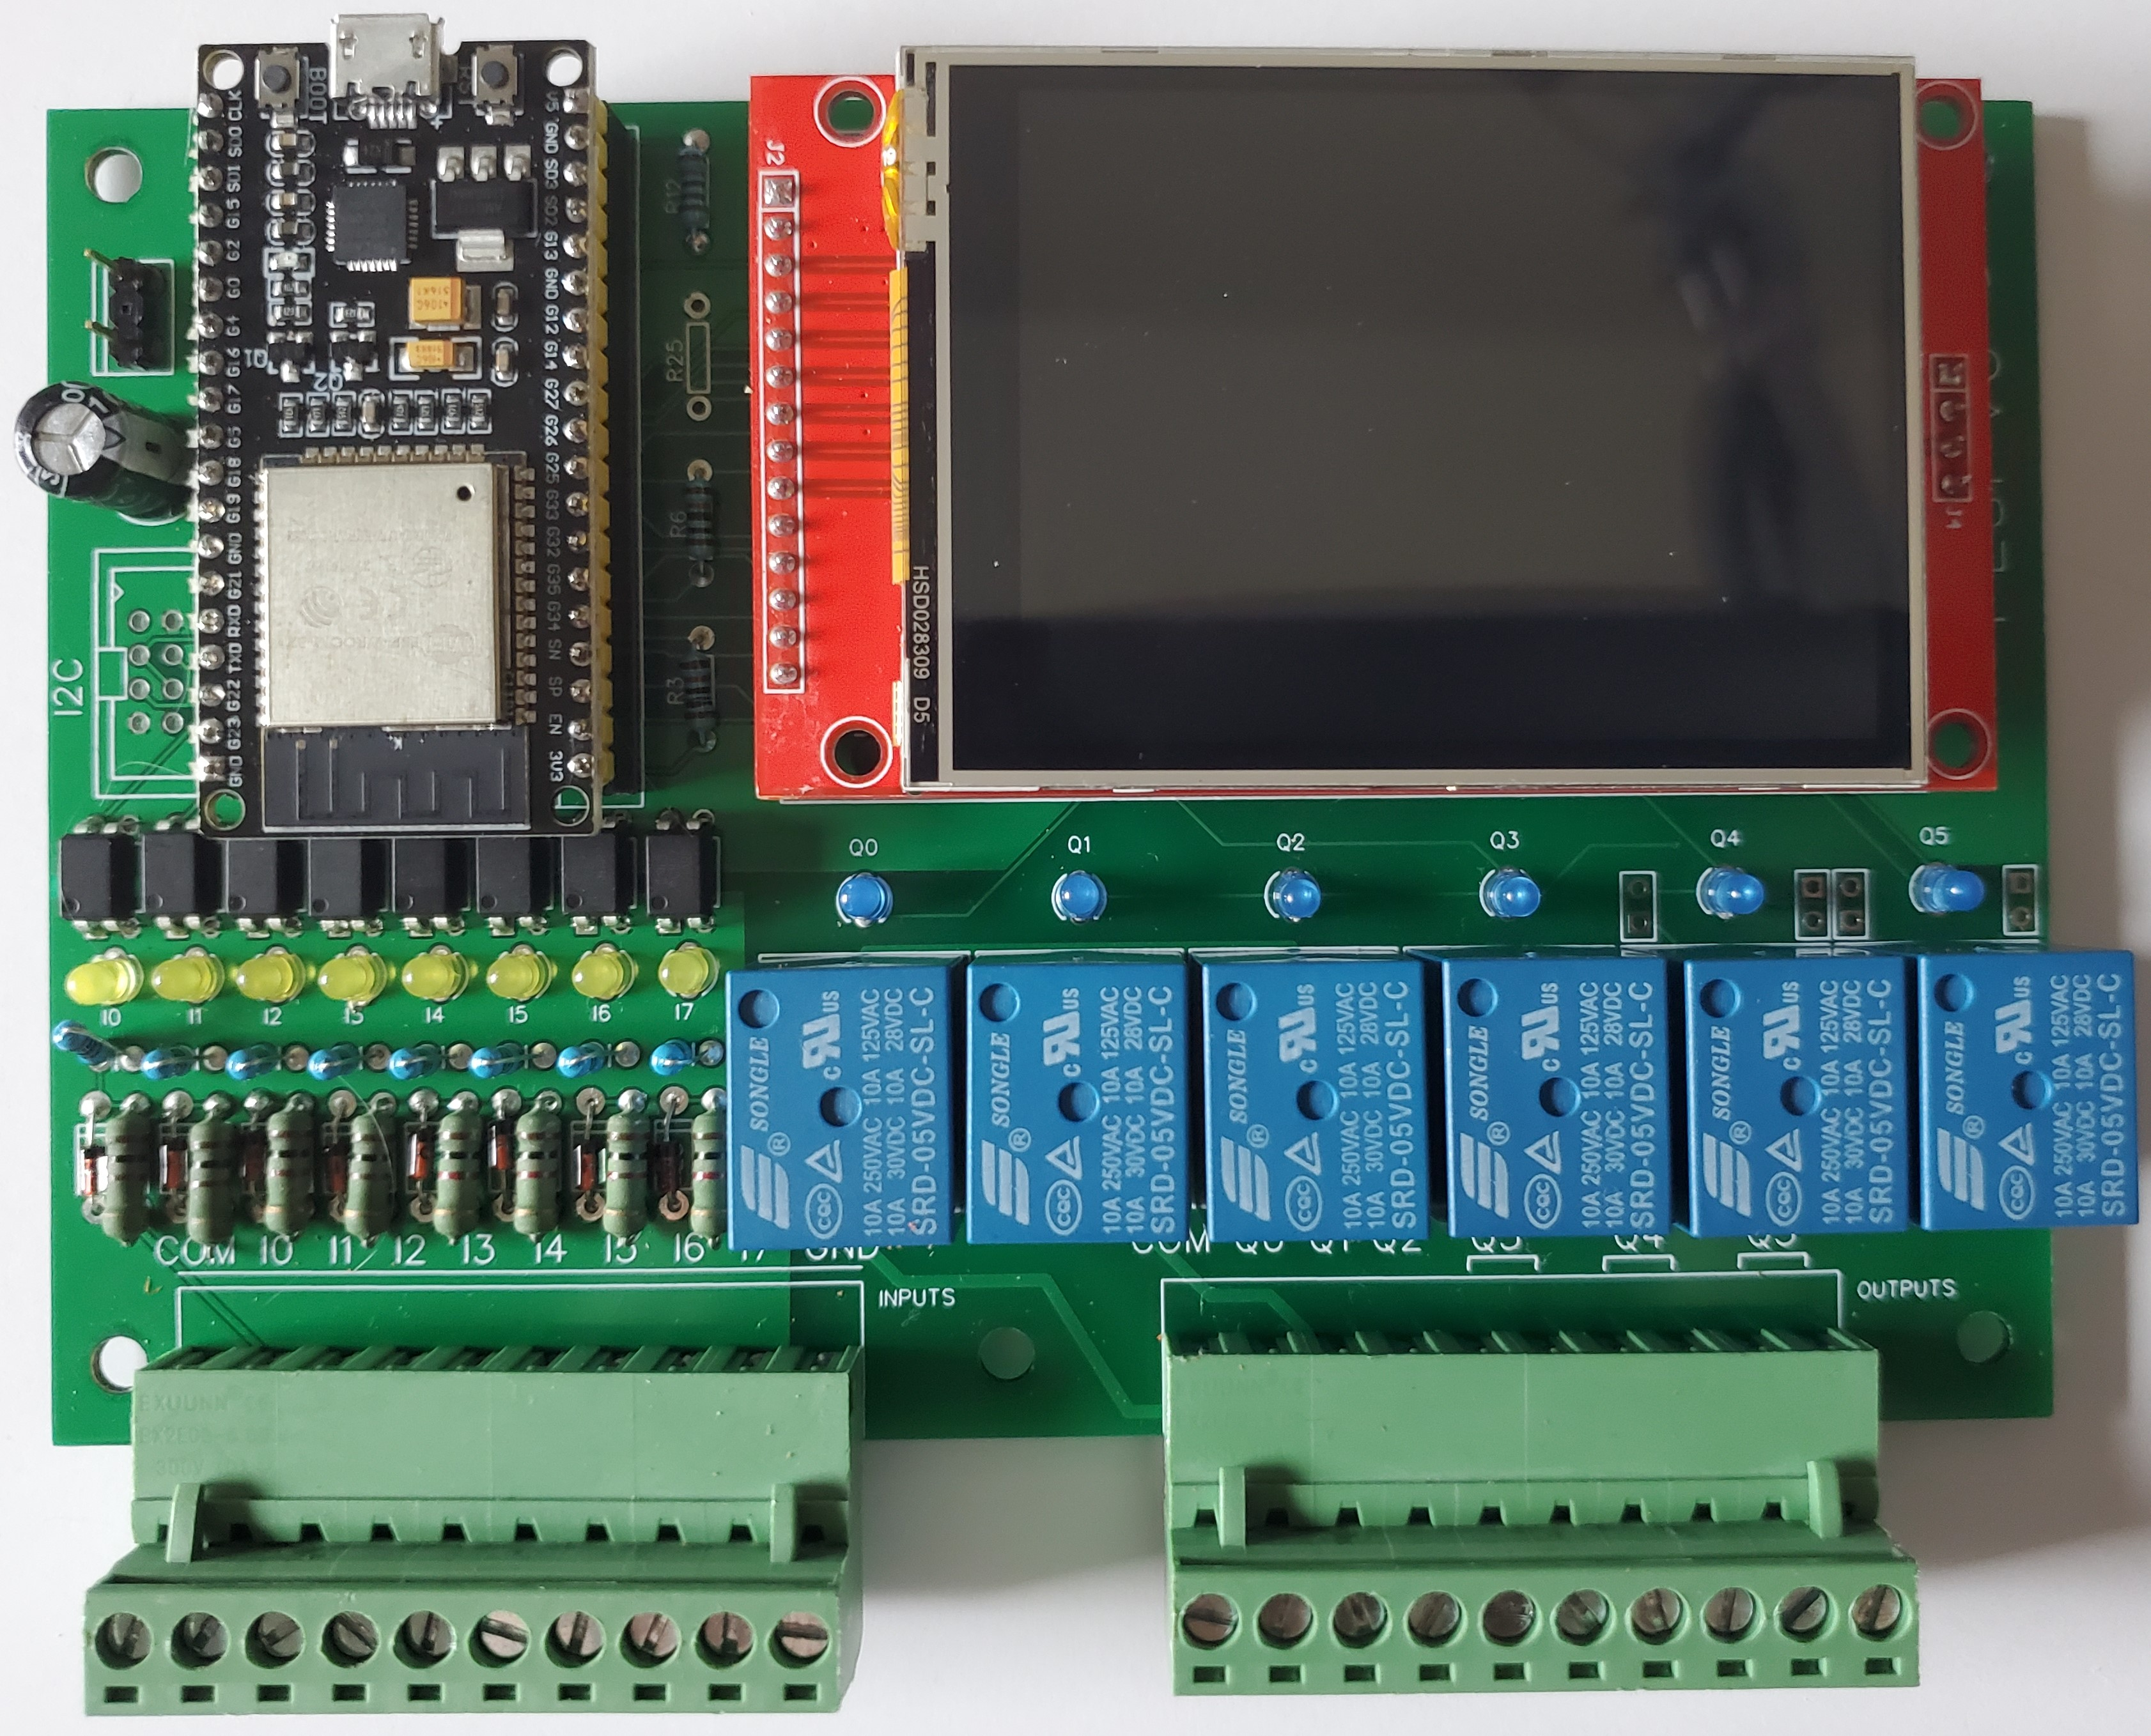

You have now completed the PLsi v0 - Digital Version - hardware assembly.
Jump to Chapter 3 to proceed with the Firmware Download procedure.

2.3 Analog version
The Analog version of PLsi hardware v0 will have:
- 6 digital inputs (5 to 26VDC)
- 4 relay outputs (10A max per PLsi, external fuse required)
- 2 Analog inputs 0-5VDC range (non isolated)
- 2 Analog outputs 0-5VDC range (non isolated)
The analog inputs in the ESP32 doesn't have a good linear response and they have a considerable zero drift. The firmware implement a couple of corrections to improve the linear response of the ADC. The ADC is configured at -6dB:
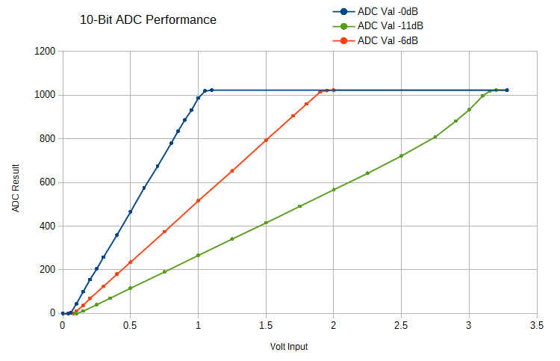
If high precision analog readings are required
an external I2C or Wi-Fi expansion is suggested.

2.3.1 Component list
The following table has the list of components required to build your Analog PLsi v0:
Item | Component TAG | Description | Quantity
1 | U1 | NodeMCU_ESP32S | 1
2 | U2 | Touch Screen Display | 1
3 | U14 | ULN2003N | 1
4 | INPUTS, OUTPUTS | 5.08 x 10 Terminal block | 2
5 | U2 – SD Card connection pins | Dupont 2.54mm Male strip | 4 pins
6 | U1 and U2 - Socket | Dupont 2.54mm Female strip | 2 x 40 pins
7 | 5V (Optional) | Dupont 3 pins male | 3 pins
8 | P4 (Optional) | HDR-IDC-2.54-2X4P | 1
9 | C2 | Capacitor 1000uF 9V | 1
10 | OPTO1, OPTO2, OPTO3, OPTO4, OPTO5, OPTO6 | Optocupler PC817 | 6
11 | Z1, Z2, Z3, Z4, Z5, Z6 | Diode 5v1 – Zenner 1w | 6
12 | I0, I1, I2, I3, I4, I5 | Leds 3mm Color 1 | 6
13 | Q0, Q1, Q2, Q3 | Leds 3mm Color 2 | 4
14 | R3, R6, R9, R12, R19, R24 | Resistor 10k | 6
15 | R1, R5, R8, R11, R20, R23 | Resistor 1K x 1/2W | 6
16 | R2, R4, R7, R10, R21, R22 | Resistor 510 ohms | 6
17 | R31, R32, R33, R34 | Resistor 330 ohms | 4
18 | RELAY1, RELAY2, RELAY3, RELAY4 | SRD-05VDC-SL-C | 4
19 | D1, D2, D3, D4 | Diode 1N4148 | 4
20 | R25, R26, R37, R38, R39, R40 | Resistor 10k 1% | 6
21 | R27,R29 | Resistor 5k1 1% | 2
22 | R28,R30 | Resistor 3k3 1% | 2
23 | U11 | TLV2462CP | 1

The latest version of the BOM (Bill of Materials) file, is stored in this Folder.

2.3.2 Assembly
This section will recommended a step by step sequence to facilitate the assembly process using the PLsi v0 board. It basically starts with the smaller components and finishes with the bigger ones, adding tips to minimize mistakes.
For each step, the indicated Item number can be found on the previous table (Section 2.2.1) to get more information about the component.
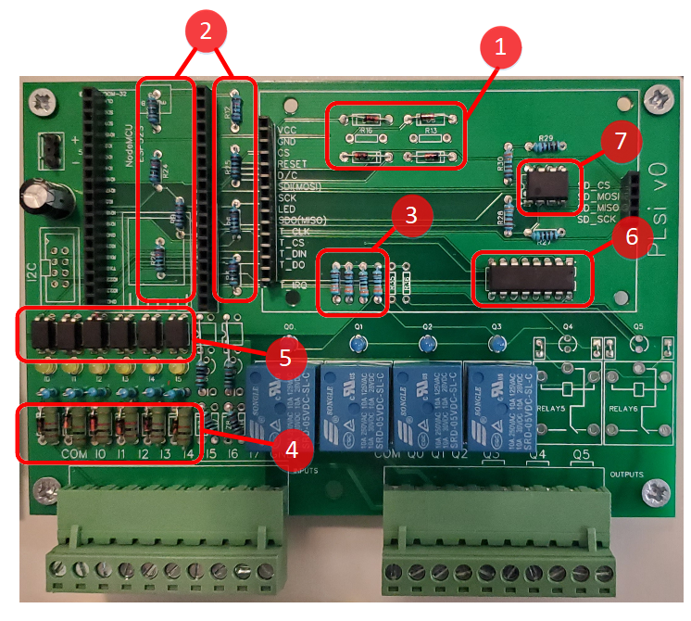
Step 1 - Weld quantity 4 x 1N4148 diodes – Item 19
Pay attention to the diodes polarity:
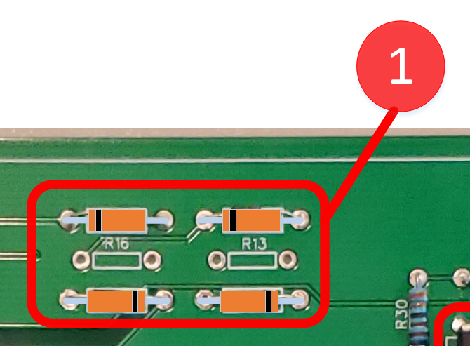

Step 2 - Weld quantity 6 x 10K Resistors – Item 14
Weld quantity 2 x 10K @1% Resistors – Item 20 – Component R25 and R26
Step 3 - Weld quantity 4 x 330 ohm Resistors – Item 17
Measure the Resistors value before to weld them

Step 4 - Weld quantity 6 x 1K x 1/2W Resistors – Item 15
Weld the 6 x Zenner Diodes 5.1V x 1W – Item 11
Pay special attention to the Zenner diodes polarity:

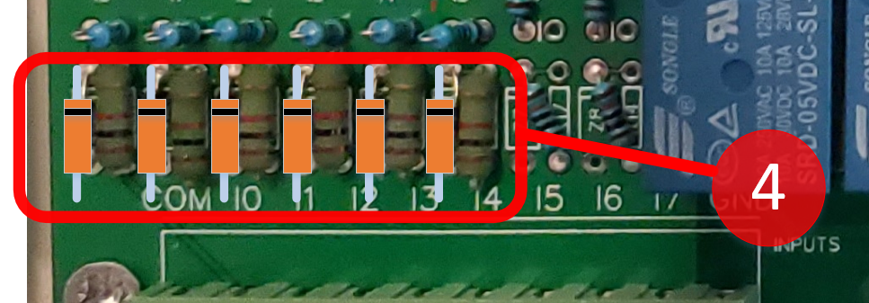

Do not use components with less power of what is suggested.
1/2W for Resistors and 1W for Zenner Diodes

Step 5 - Weld quantity 6 x PC817 Optocouplers – Item 10
Pay special attention to the orientation mark on the Chip

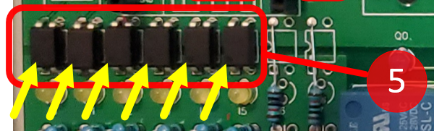

Step 6 - Weld quantity 1 x UNL2003N driver – Item 3
Pay special attention to the orientation mark on the Chip

Step 7 - Weld quantity 1 x TLV2462CP Operation Amplifier – Item 23
Pay special attention to the orientation mark on the Chip

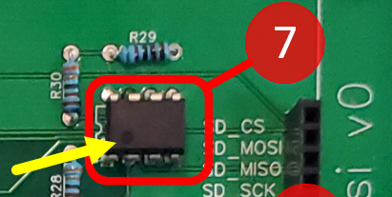

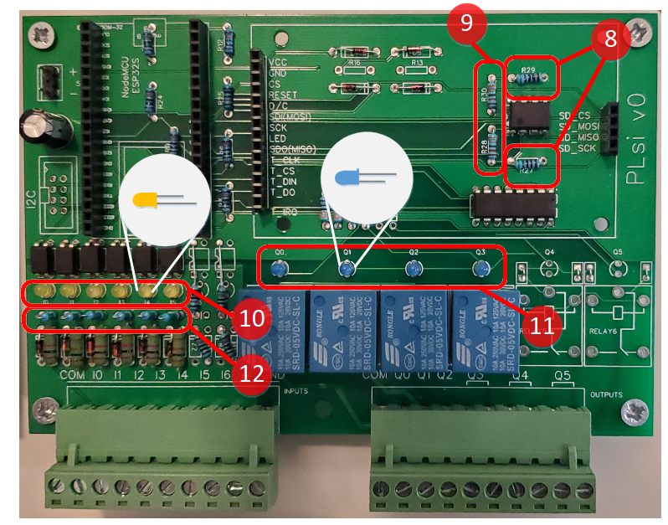
Step 8 - Weld quantity 2 x 5k1 @1% Resistors – Item 21
Step 9 - Weld quantity 2 x 3k3 @1% Resistors – Item 22
Step 10 – Weld quantity 6 x 3mm Leds of your favorite color – Item 12
It is recommended to avoid using red and green since they are typically used to indicate failures and OK statuses respectively.
Pay special attention to the polarity (Long leg/Short leg)
Recommended color: Yellow

Step 11 - Weld quantity 4 x 3mm Leds of your favorite color – Item 13
It is recommended to avoid using red and green since they are typically used to indicate failures and OK statuses respectively.
Pay special attention to the polarity (Long leg/Short leg)
Recommended color: Blue
Step 12 - Weld vertically quantity 6 x 510 ohms Resistors – Item 16

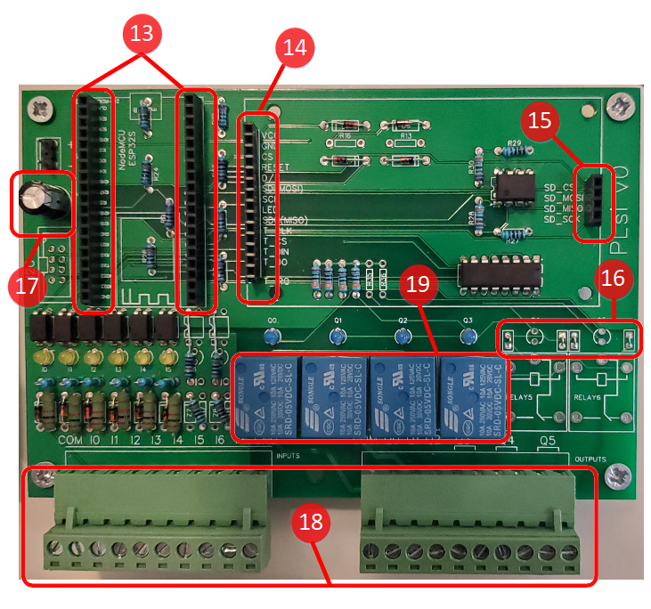
Step 13 – Weld quantity 2 x 18 pins Female Dupont headers (2.54mm) – Item 6
Step 14 - Weld quantity 1 x 14 pins Female Dupont header (2.54mm) – Item 6
Step 15 - Weld quantity 1 x 4 pins Female Dupont header (2.54mm) – Item 6
Cut the Dupont headers to the required dimension using a small cutter

Step 16 - Weld quantity 4 jumpers
Step 17 - Weld quantity 1 x Capacitor 1000uF 9V – Item 9
Observe the Polarity detail:

Step 18 - Weld quantity 2 x Header 10 pins 5.08mm – Item 4
Step 19 - Weld quantity 4 x Relay 10Amps Coil 5vdc – Item 18

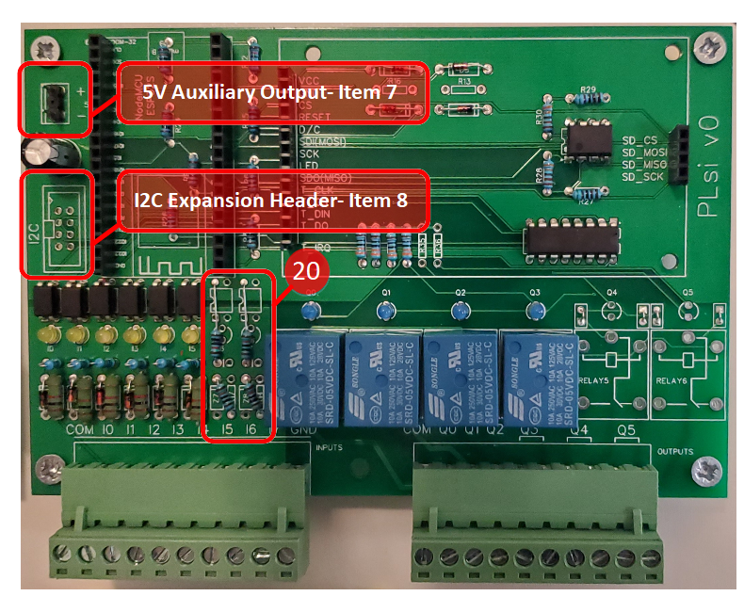
Step 20 – Weld quantity 4 x 10k @1% Resistors – Item 20
Pay special attention since these resistors are located in odd holes
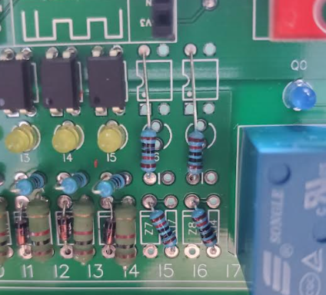

Step 21 – Optional
Weld the “5V Aux Output Header” – Item 7
Weld the “I2C Expansion Header” – Item 8
Step 22 – Weld the 4 pin Dupont male header – Item 5 – into the right side of the Display, as indicated in the following picture:

Step 23 – Insert ESP32 Module (Item 1) and Display (Item 2)

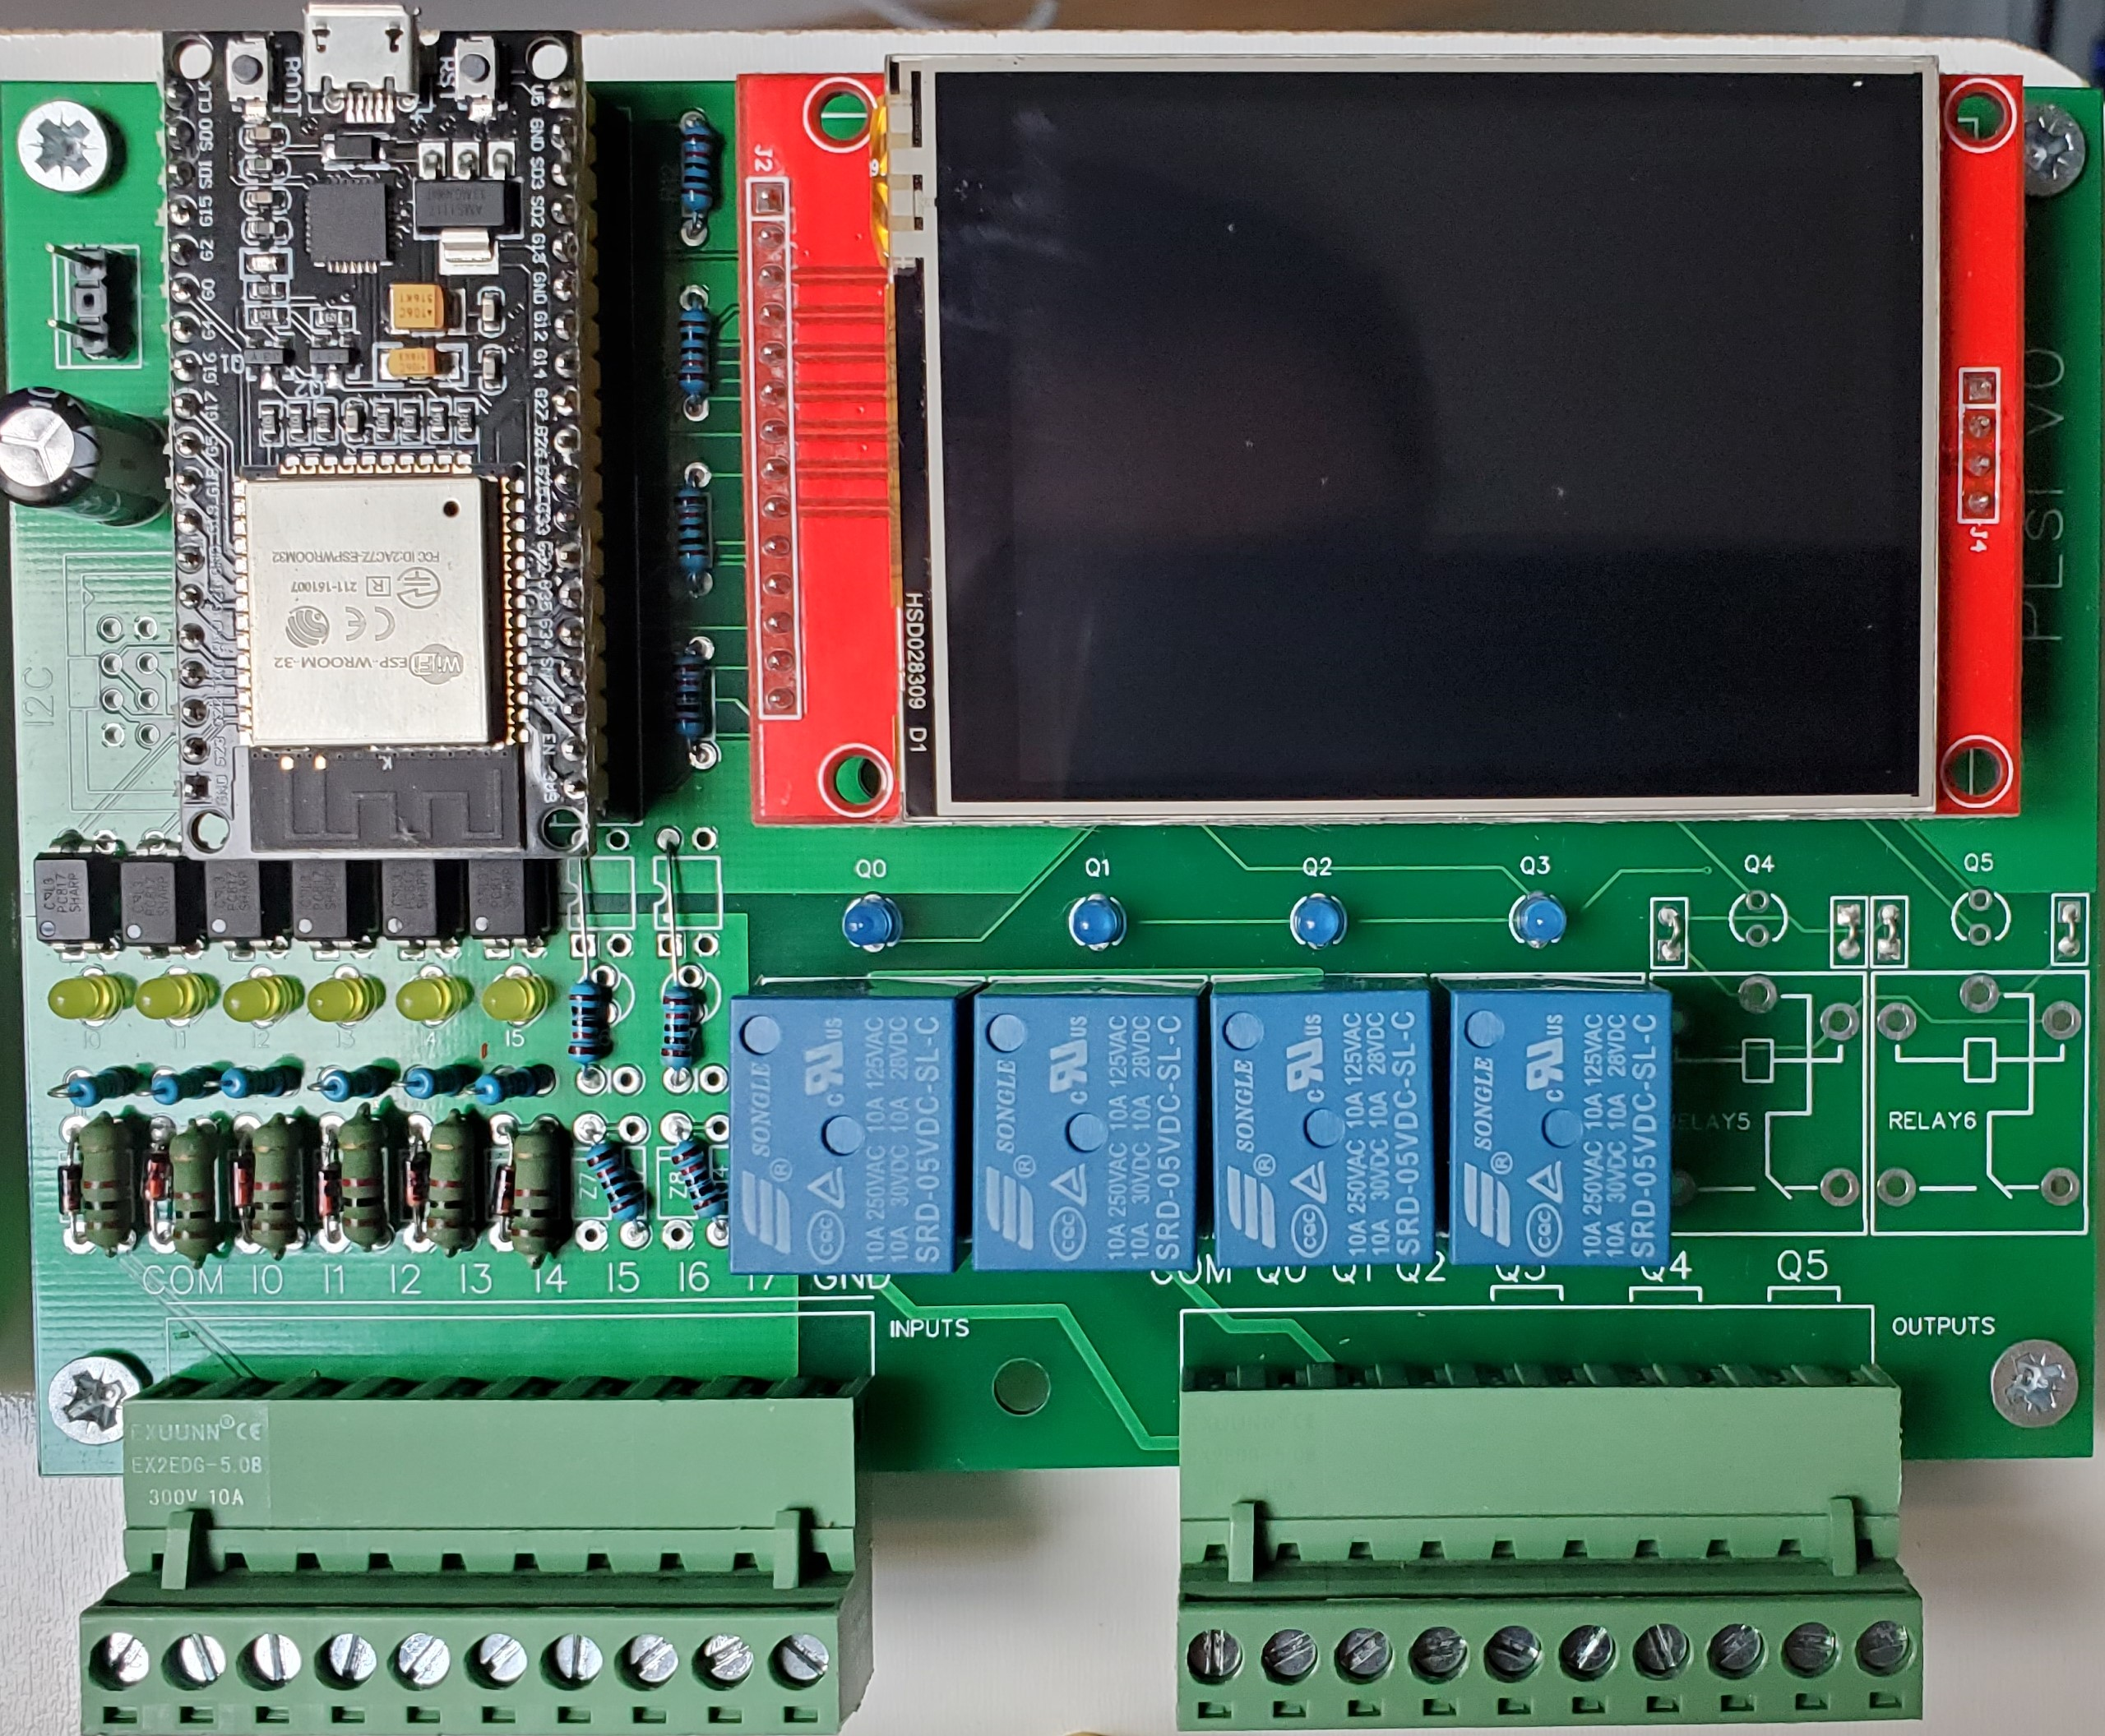

You have now completed the PLsi v0 - Analog Version - hardware assembly.
Jump to Chapter 3 to proceed with the Firmware Download procedure.

3. Firmware Download
This chapter will cover the initial firmware download procedure of your PLsi.
For the initial download the full firmware must be downloaded, it is composed by 4 files:

Number | Filename | Address
1 | 0x01000 - bootloader_dio_40m.bin | 0x01000
2 | 0x08000 - partitions.bin | 0x08000
3 | 0x0E000 - boot_app0.bin | 0x0E000
4 | 0x10000 - PLsi v0.00.03 | 0x10000

The Filename in the table corresponds with Version 0.00.03, further versions may have different Filenames. Be aware that the Filename contains the address, this is to facilitate and avoid errors during the download assignment: File <<>> Address

After this initial procedure, refer to the User Manual to start using the Web Page method to download newer Firmware versions. The web page updater only needs to download file number 4, which is the PLsi firmware itself.
All, the four files are only required to be downloaded during the initial programming discussed on this chapter.

3.1 Required files
The 4 mentioned Firmware files are provided with each release of PLsi.
For example, for the Release v0.00.03, at the bottom of the description you will find the zip named “PLsi.binaries.vX.XX.XX”, containing the 4 required files:
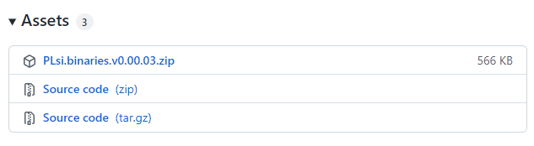

Download the file and decompress it, in this example using release v0.00.03, the following files should be available:

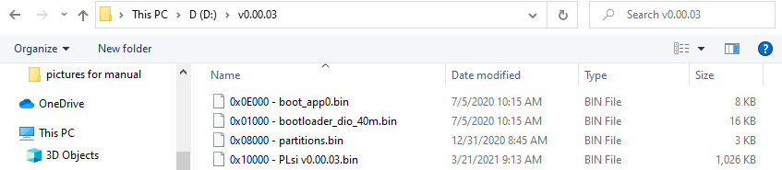

It is recommended to download the latest available Release

3.2 Espressif download tool
The recommended method presented on this chapter, uses the standard tool provided by Espressif “Flash Download Tool” to write the initial Firmware.
Tools Required:
- PC with an USB port available. The software can be installed on Windows, macOS and Linux
- USB micro-B Cable to connect the PC to your PLsi

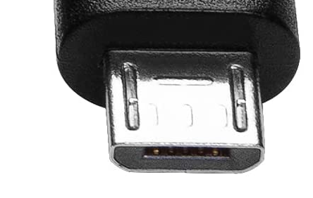

To get the program you can either download the latest version from Espressif web page or download a saved copy from PLsi repository:
1 – Espressif web page: Go to Support → Tools → Flash Download Tool → Download
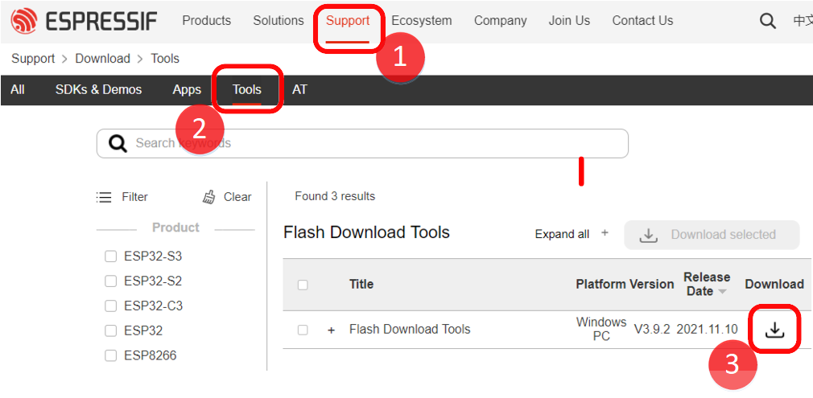
2 – PLsi repository: Go to Folder doc → tools → Right click on File --> Download
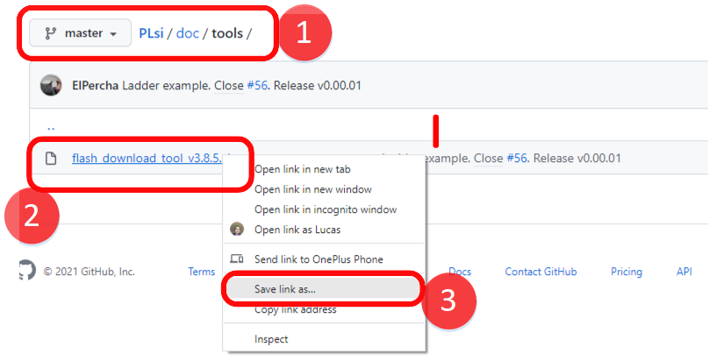
Once you have downloaded the Flash Download Tool zip file, decompress it and execute the exe file in the root directory. In this example: “flash_download_tool_3.8.5.exe”
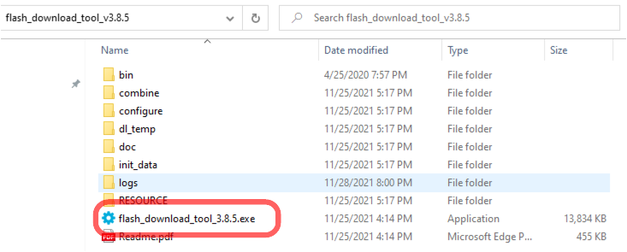

The main Window will appear:
Factory Mode is intended to Flash multiple devices with a single command.
Select “Developer Mode” since we will program a single device:
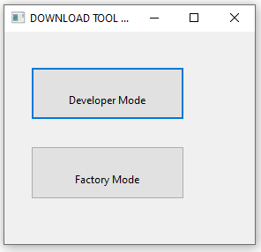

The device selection menu will appear, select “ESP32 DownloadTool” from the menu:
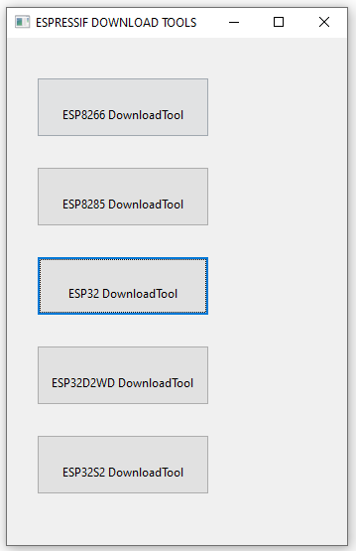

The Download tool will now open.
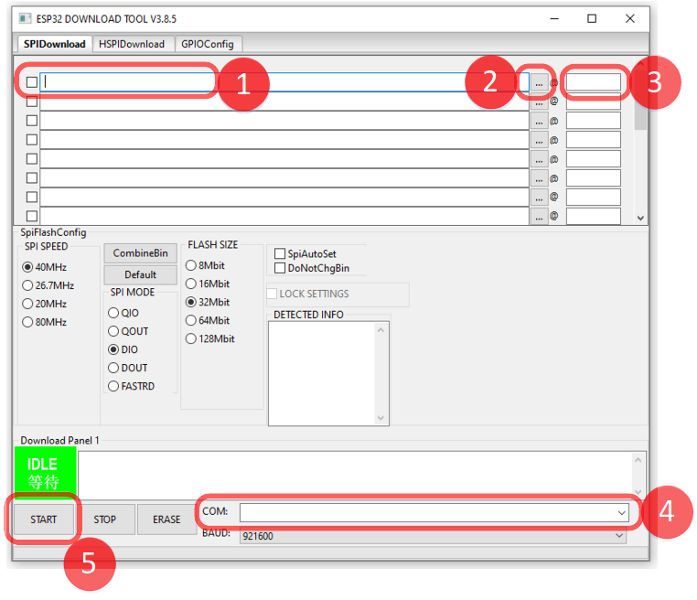
The main components to be used during the process are:
1 – File Name and Location. Insert the File location and name
2 – Opens the File Browser to facilitate the file location
3 – Memory Address of the File
4 – COM port where the ESP32 is connected
5 – START command for the Firmware download process

3.2 Downloading the Firmware
In the main Screen of the Flash Download Tool, select the following settings and configurations:
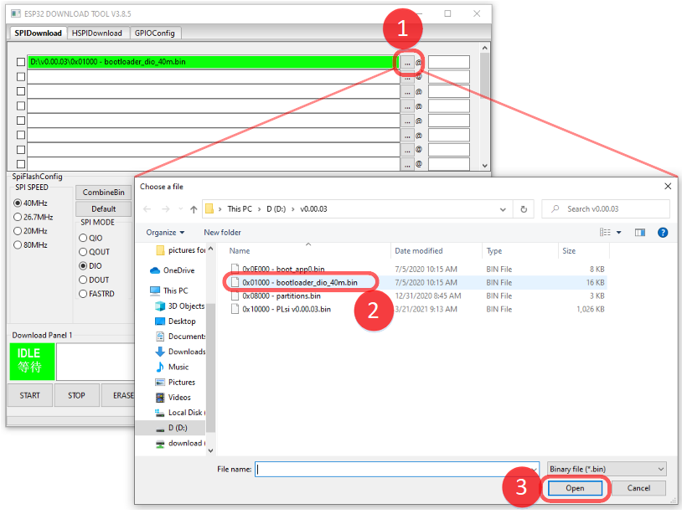
1 – Click on File Browser
2 – Select the First file to be downloaded, they will be organized from the lowest memory address to the highest. Start with the “0x01000 – bootloader_dio_40m.bin”
3 – Click “Open”

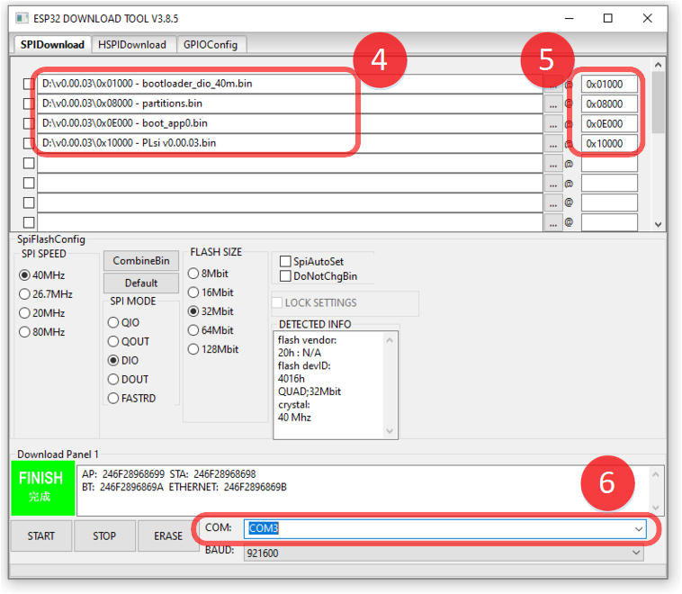
4 – Load the 4 required files
5 – Manually configure the address of each file. Double check that the filename matches with the address you are introducing on the right panel
6 – Select the COM port where the ESP32 PLsi is connected

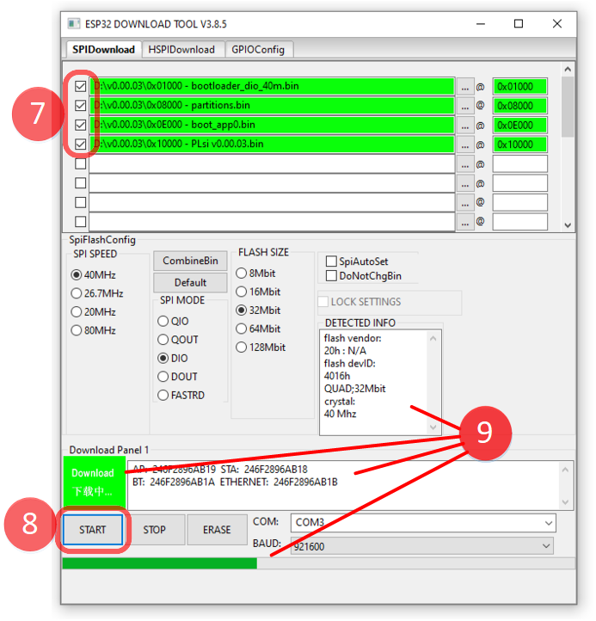
7 – Select all the 4 files, they should become green. Leave the rest of settings by Default.
8 – Click on START button to initiate the Firmware download process

9 – Immediately after the command START is given, it is recommended to push and hold for a couple of seconds the BOOT button of your ESP32 module until the process starts:

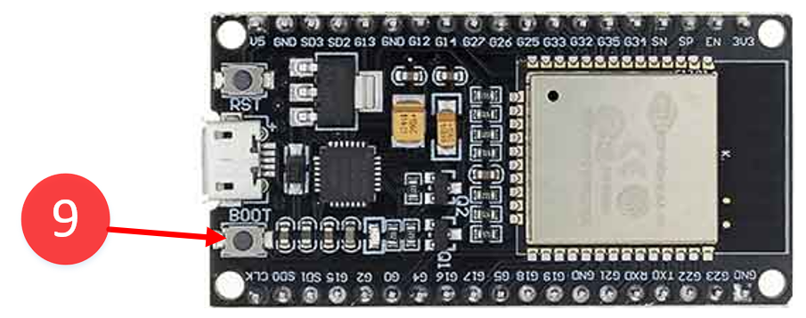
When the download process is started, you will see the green progress bar running as long as the other indications about the ESP32 chip detected.

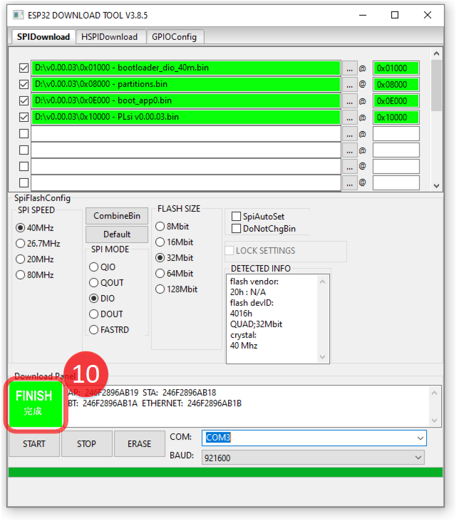

10 – When the procedure finishes with no errors, you will see the FINISH indication in green.
Repeat the operation if the process was not successfully completed.
If problem persists, perform the function ERASE holding the BOOT button on your ESP32 and retry the process.
Replace the ESP32 Module if the problem persist.

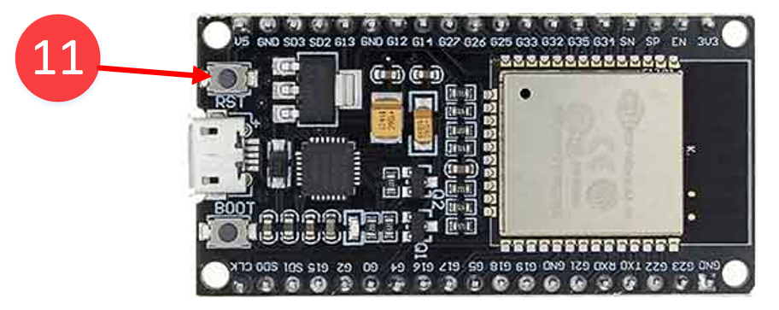
11 - After the firmware is downloaded correctly, press the RST button of the ESP32 module or you can power cycle the PLsi unit by disconnecting and reconnecting the USB cable.

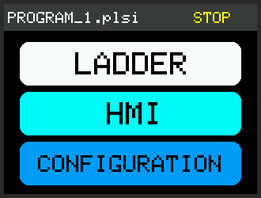

You should see the above Main screen. Your PLsi unit is now ready to be configured and tested, proceed with the Hardware Configuration and Validation chapters

Refer to the User Manual for more information about
Wiring, Configuration and Programming

4. Hardware Configuration
If your PLsi type is Digital, the default firmware setup is enough, no further configurations are required. Jump to Validations Chapter.
If instead, you PLsi is Analog Version you will need to configure the proper Inputs and Outputs as Analog.
The following table shows the memory mapping of the PLsi v0 Input Output Digital and Analog:

Digital Version |  | Analog Version
Digital input 0 | I0 | I0 | Digital input 0
Digital input 1 | I1 | I1 | Digital input 1
Digital input 2 | I2 | I2 | Digital input 2
Digital input 3 | I3 | I3 | Digital input 3
Digital input 4 | I4 | I4 | Digital input 4
Digital input 5 | I5 | I5 | Digital input 5
Digital input 6 | I6 | IW6 | Analog input 6
Digital input 7 | I7 | IW7 | Analog input 7
Digital Output 0 | Q0 | Q0 | Digital Output 0
Digital Output 1 | Q1 | Q1 | Digital Output 1
Digital Output 2 | Q2 | Q2 | Digital Output 2
Digital Output 3 | Q3 | Q3 | Digital Output 3
Digital Output 4 | Q4 | QW4 | Analog Output 4
Digital Output 5 | Q5 | QW5 | Analog Output 5

The I/O to reconfigure on Analog units is:
I6 → IW6
I7→ IW7
Q4 → QW4
Q5→ QW5

Ix represents a Digital Input
Qx represents a Digital Output
IWx represents an Analog Input
QWx represents an Analog Output
For more information about Memory areas refer to the User Manual.

Follow the next step by step guide to change your I/O configurations:

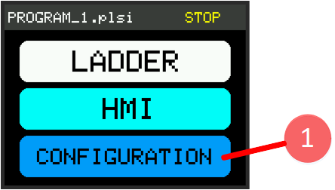

1 – PLC shall be on STOP mode. Click on CONFIGURATION.

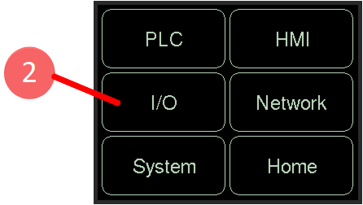

2 – Click on I/O

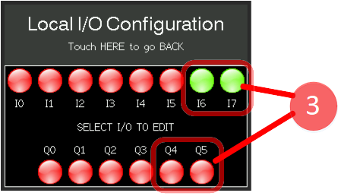

3 – Touch the I/O to be changed, one by one. If you want to go back to the previous mode touch it again

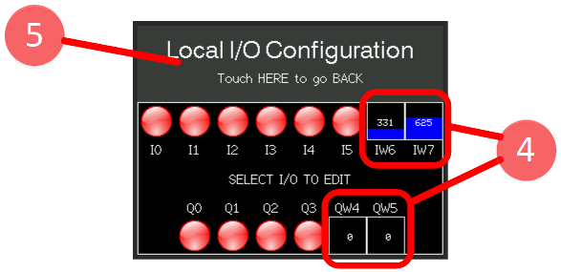

4 – After configuring the 4 Inputs Outputs, you should see the screen as indicated above
5 – Touch on the top bar to go back.

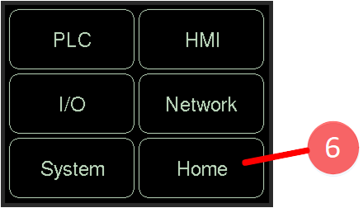

6 – Touch Home to go back to the Main Menu
7 – Your PLsi is now configured as Analog Version.

5. Hardware Validation
This step is optional but recommended. It comprises a step by step guide to perform basic validations of the Inputs and Outputs of your PLsi. You will need:
- USB power supply – To energize your PLsi
- Meter – Capable to measure DC Voltage and Resistance
- Wire jumpers – To make the connections
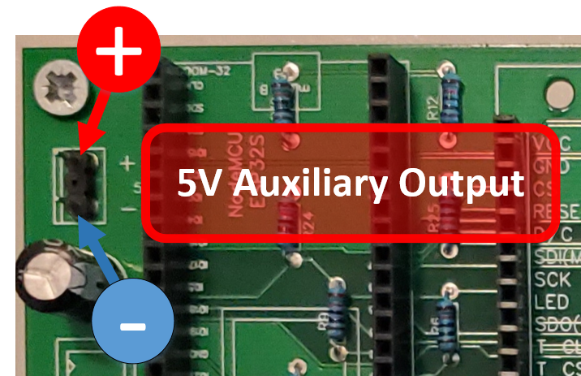
- 24V power supply – Optional – The 5V PLsi auxiliary output can be used instead

- To validate Analog inputs you can use:
  - A Potentiometer in the range of 1K to 100K
  - A 0 to 5V variable power supply

Go to the HMI I/O Status page to proceed with the validation:
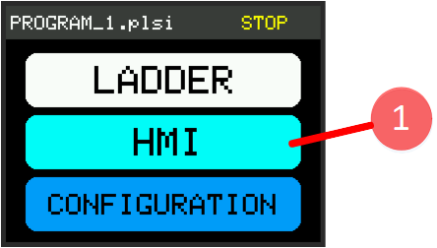

1 - Click on HMI button
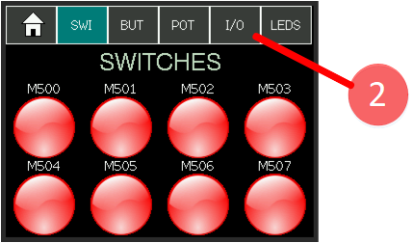

2 - Click on I/O menu button

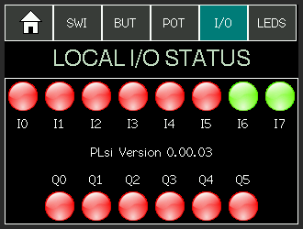

3a - For PLsi Digital versions, the above screen will be shown
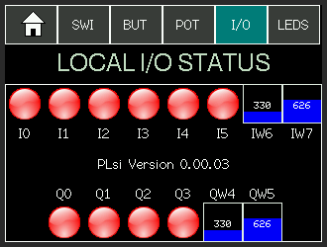

3b - For PLsi Analog versions, the above screen will be shown.

Refer to Chapter 4 – Hardware Configuration
If the I/O type has to be changed

5.1 Digital Version I/O validation
The Digital Version validation will be composed by 2 steps:
1 – Test quantity 8 Digital Inputs
2 – Test quantity 6 Digital Outputs
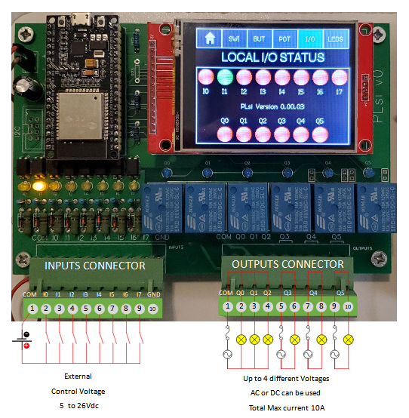

The above diagram shows the connections required to test Digital inputs, Left and Digital Outputs on the Right. The Outputs can be tested with or without load. This manual suggest to test first with no load.

Test quantity 8 Digital Inputs
The Digital Input voltage range goes from 5V to 26V. It is recommended to not exceed 24V.
Proceed to feed each Digital Input with the desired control voltage. For each energized channel you have to see the corresponding indicator light on the Display switching to Green when control voltage is applied.
Proceed to validate I0 to I7.
Digital Input | Voltage to apply | 0v to Pin | + Voltage to Pin
I0 | 5 to 24V | 1 (COM) | 2
I1 | 5 to 24V | 1 (COM) | 3
I2 | 5 to 24V | 1 (COM) | 4
I3 | 5 to 24V | 1 (COM) | 5
I4 | 5 to 24V | 1 (COM) | 6
I5 | 5 to 24V | 1 (COM) | 7
I6 | 5 to 24V | 1 (COM) | 8
I7 | 5 to 24V | 1 (COM) | 9

If after applying the Input voltage to a particular channel, the Light on the touchscreen doesn’t switch to Green and or the physical Led does not work properly, review the following potential root causes:
Case A: The physical Led is not turning On and Off properly:
- Review that all components for the channel are installed
- Review all related welding
- Review resistors and diodes values
- Review zenner mounting polarity
- Review the polarity of the LED
- Review the correct placement of the Optocoupler
- Replace Led
- Replace Optocoupler
- Replace ESP32 CPU module

Case B: The physical Led is turning On and Off properly but the information on the display is not correct:
- Review that all components for the channel are installed
- Review all related welding
- Review resistors and diodes values
- Review zenner mounting polarity
- Review the correct placement of the Optocoupler
- Replace Optocoupler
- Replace ESP32 CPU module

Test quantity 6 Digital Outputs
The Digital Outputs for V0 Hardware are relays dry contacts, for these reason they can be tested with a variety of loads, but for practical reasons, this manual suggests to test the resistance of each contact using a regular Meter.
For an easy I/O validation, after the first PLsi start (boot) a Demo program is loaded on program Slot 1. The ladder demo program loaded after the first PLsi start cycle, connects the HMI Switches with the physical Outputs, for a quick and easy validation.
To perform this test, the PLC MODE shall be changed to RUN state:
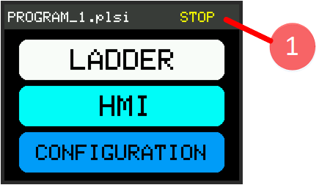

1 – Click on Top Right bar
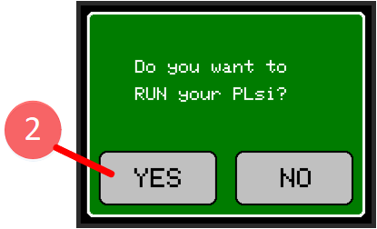

2 – Select YES to switch the PLC mode to RUN
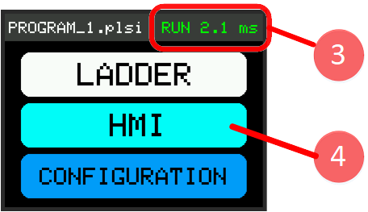

3 – The top Right indicator should now show RUN and the Cycle time is displayed. In this example is 2.1 milliseconds.
4 – Access the HMI Switches (SWI) page

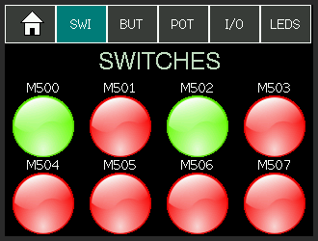

5 – Activate the Relay Outputs one by one using the HMI Switches.
Digital Output | Activate with | Measure Pin A | Measure Pin B
Q0 | M500 | 1 | 2
Q1 | M501 | 1 | 3
Q2 | M502 | 1 | 4
Q3 | M503 | 5 | 6
Q4 | M504 | 7 | 8
Q5 | M505 | 9 | 10

Measure resistance in the indicated terminals of the Outputs Connector to validate each Digital Output
Two values must be measured for each Digital Output
1 – Measure Open Circuit – Infinite Resistance – when Output is Deactivated
Button Red Color – Physical Led is OFF

2 – Measure Short Circuit – Less than 1 Ohm – when the Output is Activated.
Button Green Color – Physical Led is ON

If no verification error is present, the I/O is now Validated.
If any measure fails, verify the following potential root causes.

Case A: The physical Led is not turning On and Off properly:
- Review that all components for the channel are installed
- Review all related welding
- Review Led resistors values
- Review the polarity of the LED
- Review the correct placement of the Driver chip (UNL2003)
- Replace Led
- Replace Driver chip
- Replace ESP32 CPU module

Case B: The physical Led is turning On and Off properly but the Relay is not being activated or no resistance near Zero is measured:
- Review that Relay characteristics (coil must be 5Vdc)
- Review all related welding
- Replace Relay
- Replace Driver chip

Case C: The physical Led is turning On and Off properly but the Relay is not being deactivated or no infinite resistance is measured:
- Review potential short circuits on Relay terminals
- Replace Relay

5.2 Analog Version I/O validation
The Analog Version validation will be composed by 4 steps:
1 – Test quantity 6 Digital Inputs
2 – Test quantity 4 Digital Outputs
3 – Test quantity 2 Analog Inputs
4 – Test quantity 2 Analog Outputs
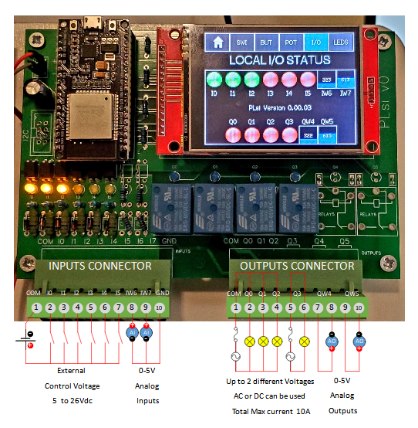
The previous diagram shows the connections required to test Digital inputs, Analog Inputs, Digital Outputs and Analog Outputs

Test quantity 6 Digital Inputs
Follow the procedure described on Chapter 5.1 to perform the validation of Digital Inputs and troubleshooting.
Proceed to validate I0 to I5.
Digital Input | Voltage to apply | 0v to Pin | + Voltage to Pin
I0 | 5 to 24V | 1 (COM) | 2
I1 | 5 to 24V | 1 (COM) | 3
I2 | 5 to 24V | 1 (COM) | 4
I3 | 5 to 24V | 1 (COM) | 5
I4 | 5 to 24V | 1 (COM) | 6
I5 | 5 to 24V | 1 (COM) | 7

Test quantity 4 Digital Outputs
Follow the procedure described on Chapter 5.1 to perform the validation of Digital Outputs and troubleshooting.
Proceed to validate Q0 to Q3
Digital Output | Activate with | Measure Pin A | Measure Pin B
Q0 | M500 | 1 | 2
Q1 | M501 | 1 | 3
Q2 | M502 | 1 | 4
Q3 | M503 | 5 | 6

Test quantity 2 Analog Inputs
Apply variable Voltage to the Inputs Connector Pins 8 (+) and 10 (-) to test IW6
Apply variable Voltage to the Inputs Connector Pins 9 (+) and 10 (-) to test IW7

Embedded Analog Inputs have 10 bits resolution
Providing a 0 to1023 range

Perform the following list of tests to validate Analog Inputs:
Test  Item | Analog Input | Voltage to Apply | Theoretical Scaled Value | Negative Pin to Apply voltage | Positive Pin to Apply voltage
1 | IW6 | 0 V | 0 | 10 | 8
2 | IW6 | 1 V | 205 | 10 | 8
3 | IW6 | 2 V | 410 | 10 | 8
4 | IW6 | 3 V | 614 | 10 | 8
5 | IW6 | 4 V | 819 | 10 | 8
6 | IW6 | 5 V | 1023 | 10 | 8
7 | IW7 | 0 V | 0 | 10 | 9
8 | IW7 | 1 V | 205 | 10 | 9
9 | IW7 | 2 V | 410 | 10 | 9
10 | IW7 | 3 V | 614 | 10 | 9
11 | IW7 | 4 V | 819 | 10 | 9
12 | IW7 | 5 V | 1023 | 10 | 9

For each Test Item apply the suggested Voltage to Apply on the indicated terminals.
Validate that the Analog input is reading the Theoretical Scaled Value +/- 10% in the Display

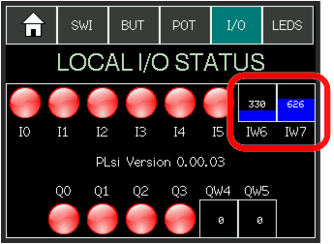

If the analog input channel does not perform between the expected 10% of deviation, proceed to validate the following potential root causes.
Case A: No analog indicator shown for IW6 and or IW7:
- Proceed to Chapter 4 – Hardware Configuration and configure according to your hardware

Case B: The HMI indicator shows wrong values or it is always at zero
- Review that all components for the channel are installed
- Review all related welding
- Review resistors values and tolerances
- Review that all required board jumpers are in place
- Review diodes polarity is according to the drawing
- Replace ESP32 CPU module

Test quantity 2 Analog Outputs
To validate the Analog Outputs the Ladder Demo Program has logic that moves the HMI POT values D500 and D501 to the QW4 and QW5 Analog Outputs, respectively.
Go to POT HMI Page:
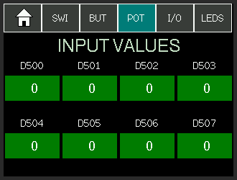

Touching the D500 or the D501 Indicator the Keyboard Page will show up:
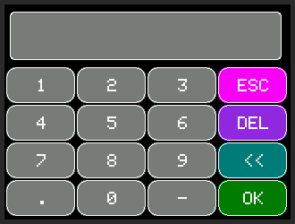

Introduce the Scaled Value to Apply by typing it, then click OK

Perform the following list of tests to validate Analog Outputs:
Test  Item | Analog Output | HMI POT  Field | Scaled Value  to Apply | Negative Pin to Measure voltage | Positive Pin to Measure voltage | Theoretical Voltage to Measure
1 | QW4 | D500 | 0 | 8 | 7 | 0 V
2 | QW4 | D500 | 205 | 8 | 7 | 1 V
3 | QW4 | D500 | 410 | 8 | 7 | 2 V
4 | QW4 | D500 | 614 | 8 | 7 | 3 V
5 | QW4 | D500 | 819 | 8 | 7 | 4 V
6 | QW4 | D500 | 1023 | 8 | 7 | 5 V
7 | QW5 | D501 | 0 | 10 | 9 | 0 V
8 | QW5 | D501 | 205 | 10 | 9 | 1 V
9 | QW5 | D501 | 410 | 10 | 9 | 2 V
10 | QW5 | D501 | 614 | 10 | 9 | 3 V
11 | QW5 | D501 | 819 | 10 | 9 | 4 V
12 | QW5 | D501 | 1023 | 10 | 9 | 5 V

For each Test Item apply the suggested value on the HMI Field
Validate that the Output Voltage, measured in the indicated pins, is in the range of +/- 10%

Embedded Analog Outputs have 8 bits resolution but PLsi Firmware
standardizes it to 10 bits, providing a 0 to1023 range

If no verification error is present, the complete I/O is now Validated.

If any measure fails, or the analog output channel does not perform between the expected 10% of deviation, proceed to validate the following potential root causes.

Case A: No analog indicator shown for QW4 and or QW5:
- Proceed to Chapter 4 – Hardware Configuration and configure your hardware accordingly

Case B: The Measured Values are wrong or measured voltage is always zero
- Review that all components for the channel are installed
- Review all related welding
- Review resistors values and tolerances
- Review that all required board jumpers are in place
- Replace Operational Amplifier chip
- Replace ESP32 CPU module

6. Housing
This chapter will provide information about the PLsi v0 CPU Housing, components list, 3D printed parts and assembly process.
The most common way to mount industrial components to panels is using a 35mm din rail.
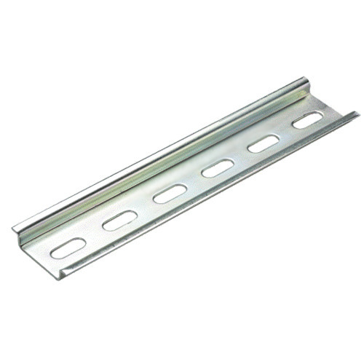

Check the following 2 options and variants for your PLsi v0 CPU housing:
Components Option 1 – Without Din Rail mounting
Item 1 – Quantity 1 x Housing Base 3D printed
Item 2a – Quantity 1 x Housing Cover 3D printed (Revision E)
Item 2b – Quantity 1 x Housing Cover with Touch Pen 3D printed (Revision F)
Item 3 – Quantity 5 x Size #4 x ½” screws

Components Option 2 – With Din Rail mounting
Item 1 – Quantity 1 x Housing Base 3D printed
Item 2a – Quantity 1 x Housing Cover 3D printed (Revision E)
Item 2b – Quantity 1 x Housing Cover with Touch Pen 3D printed (Revision F)
Item 3 – Quantity 2 x housing din rail mounting brackets 3D printed
Item 4 – Quantity 1 x Size #4 x ½” screws
Item 5 – Quantity 4 x Size #4 x ¾” screws

The housing cover (Item 2) has two variants to chose from, the suggested version is the 2b that has a Touch Pen embedded holder. The Touch Pen typically comes with the display.

Optionally, 200mm of 2mm diameter rounded acrylic bar can be used to improve the I/O indication visibility quality and provide a better look.
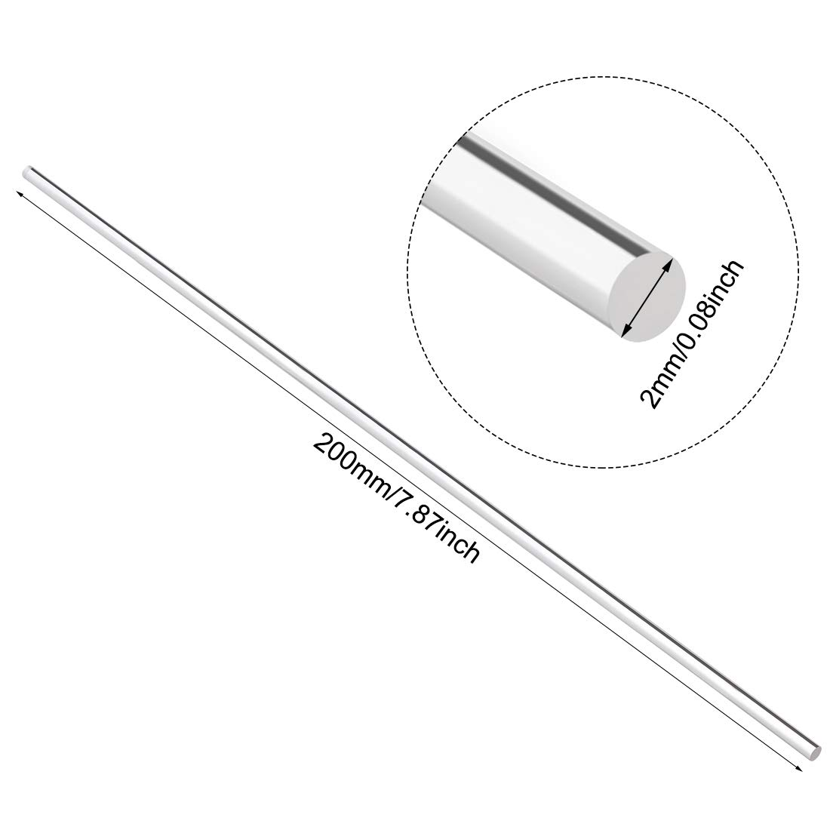

Suggested screws shape:

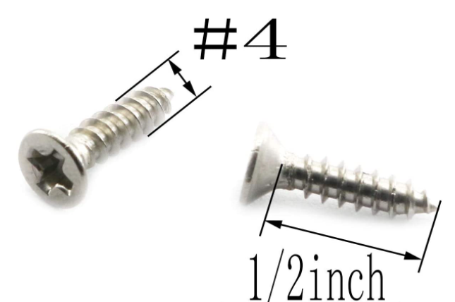

When using Din Rail mounting brackets, 4 screws shall be ¾ inches long

6.1 3D Printed Parts
The required 3D print files to build the PLsi v0 housing are located on the housing folder
Proceed to 3D print the 3 parts corresponding with your selected version
Part 1 – Quantity 1 x Housing Base 3D printed
Part 2a – Quantity 1 x Housing Cover 3D printed (Revision E)
Part 2b – Quantity 1 x Housing Cover with Touch Pen 3D printed (Revision F)
Part 3 – Quantity 2 x housing din rail mounting brackets 3D printed

Only quantity 1 of part 2 is required. Print only your preferred option

The 3D design files are created using Microsoft 3D builder. Its a free Editor.
The respective STL files are also available to be imported on another drawing tool.
Additionally, for each part, the Ultimaker Cura slicer project and gcode files are available.
The gcode files are created to be used on Creality 3D Ender V2 printer with BLTouch

Be aware that both programs
Microsoft 3D Builder and Ultimaker Cura projects
share the same file extension *.3mf
but they have different uses

The temperature inside industrial panels may reach around 50°C (in cases more) for this reason, the suggested material to print the parts is PETG.

Printing the parts with PLA is not recommended
The PLA temperature tolerance is lower than PETG

Take in account the following information to plan and configure your prints:
Estimated Printing Times:
Housing Base: ~5 hours
Housing Cover (both options): ~9.5 hours
Housing Din Rail Brackets: ~10 hours

Suggested printing parameters:
Material: Generic PETG
Nozzle diameter: 0.4mm
Filament diameter: 1.75mm
Speed: 50mm/s
Speed first and last layer: 25mm/s
Infill: 100%
Nozzle Temp First layer: 230C
Nozzle Temp: 225C
Bed Temp: 80C
Layer Height: 0.2mm
Retracting distance: 3mm
Retracting speed: 45mm/s
Generate Support: true
Support placement: Everywhere
Support Overhang Angle: 45
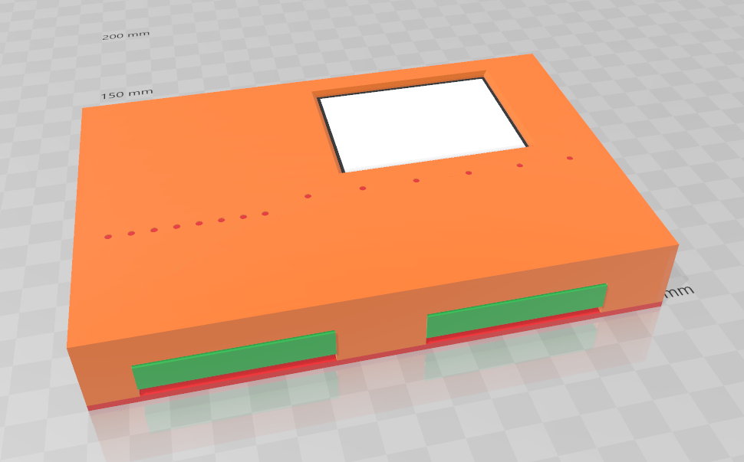

Housing cover with Pen support render:
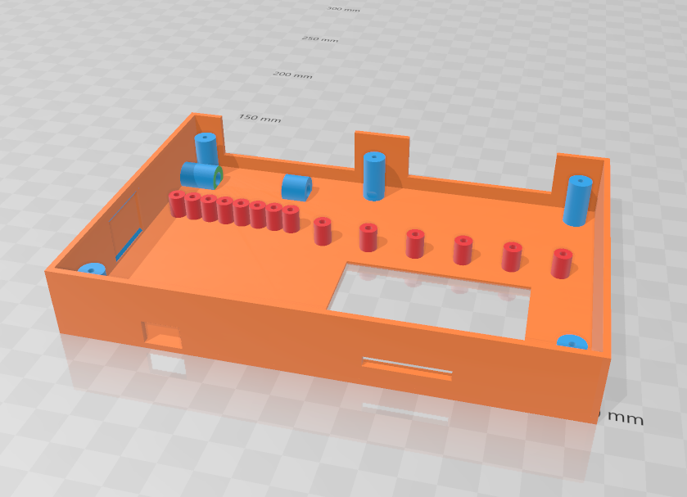

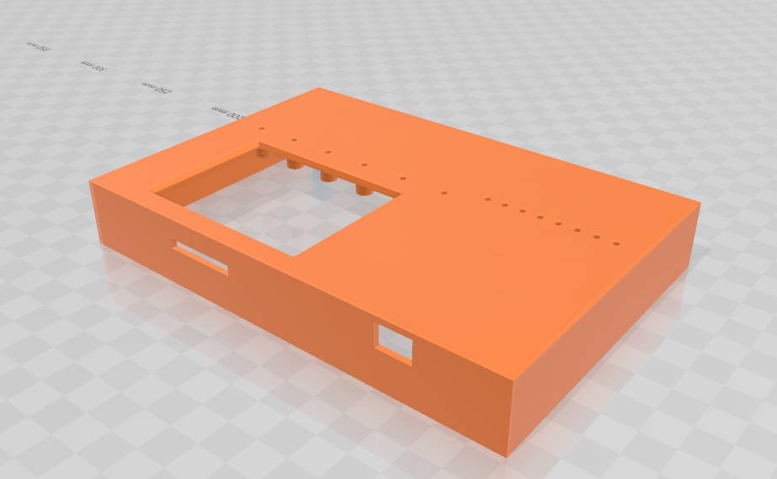

Housing Base render:
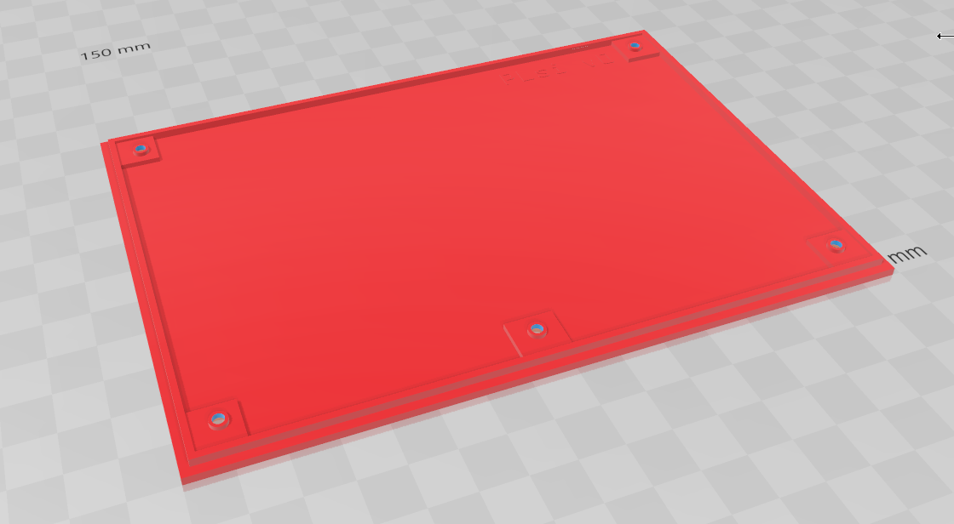

Housing Din Rail brackets render:
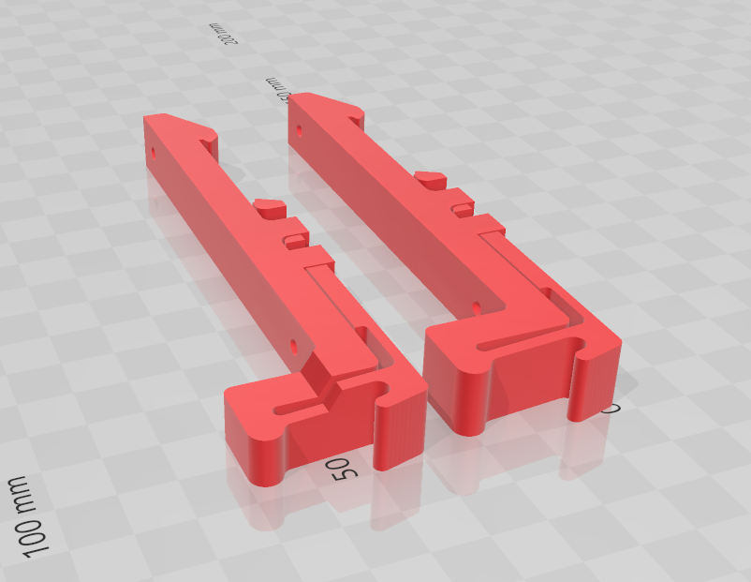

6.2 List of Materials
The following materials are shown as an example, they correspond with the following PLsi Housing configuration:
Housing PLsi CPU v0 + Pen holder + Din rail Brackets.
The Board shown is the Analog Version.

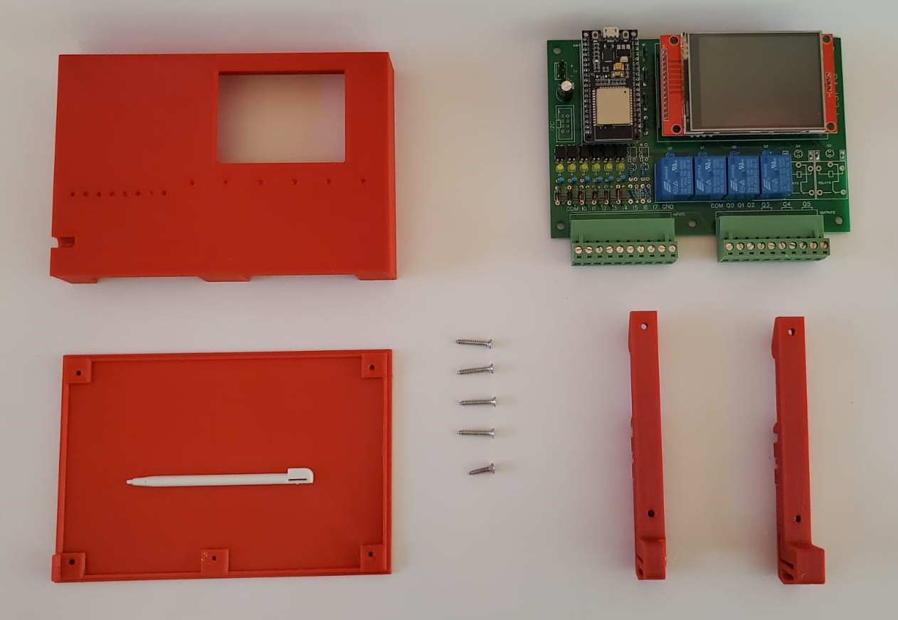

Housing Cover with Pen holder:
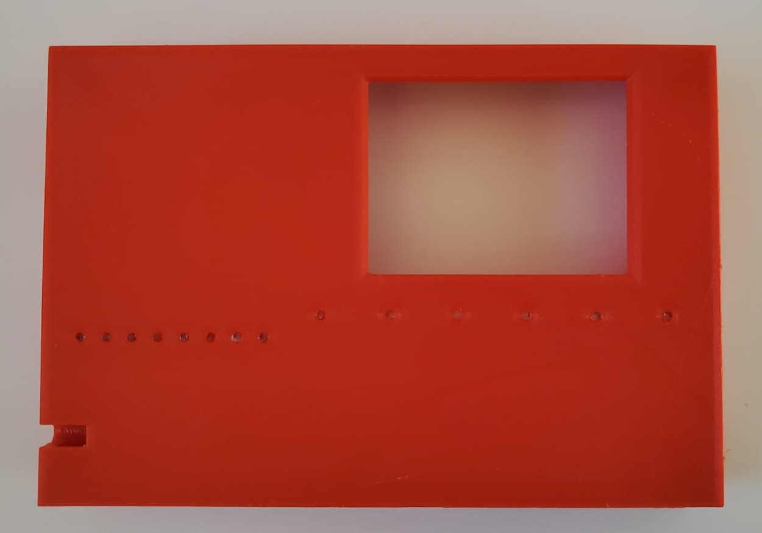

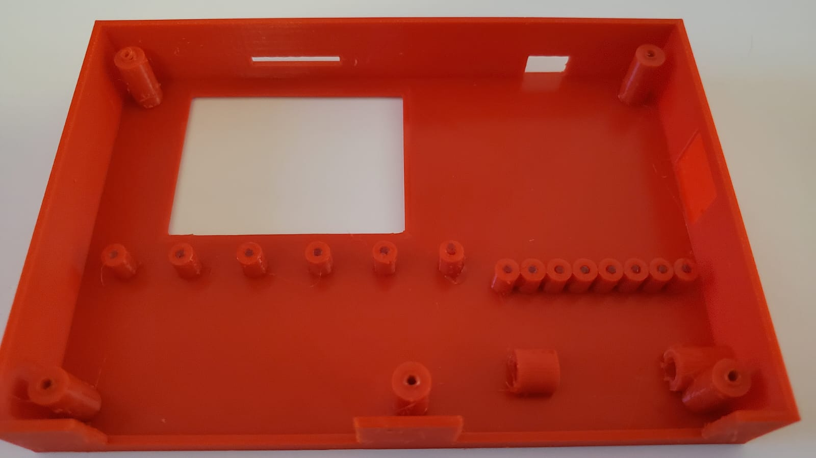

Housing Din rail brackets:
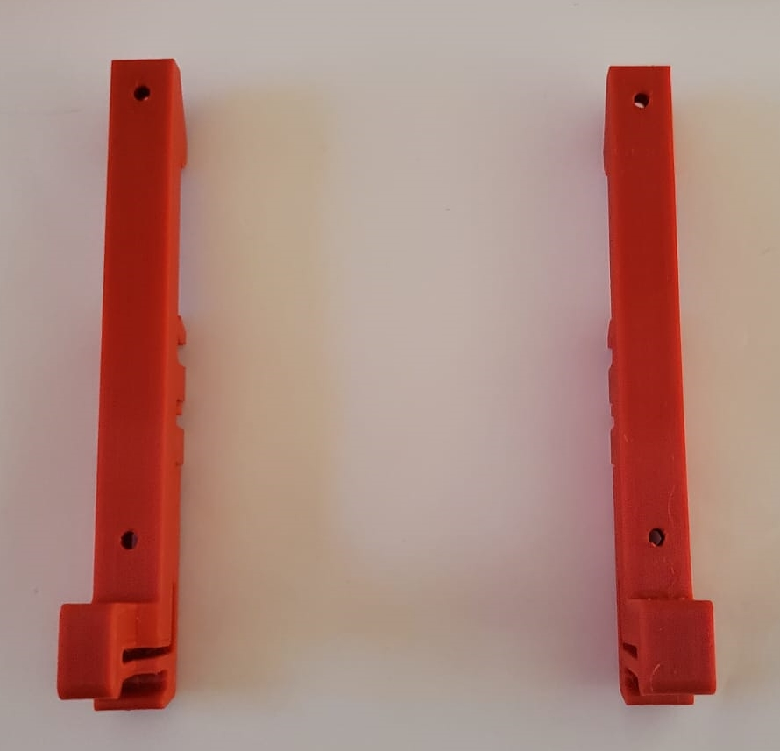

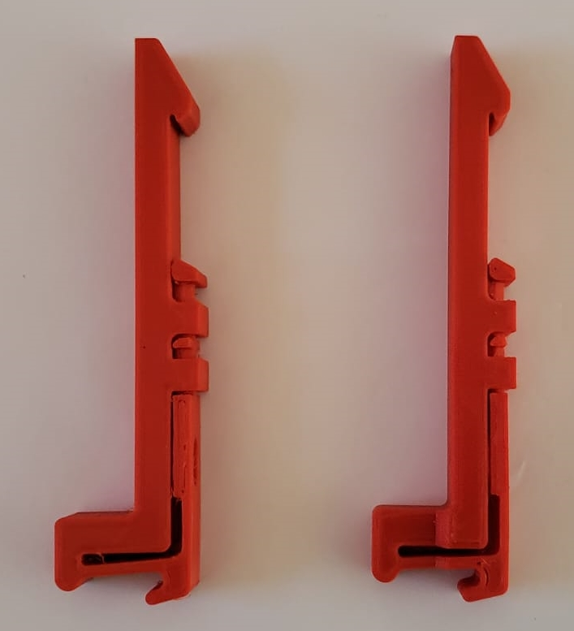

Housing Base:
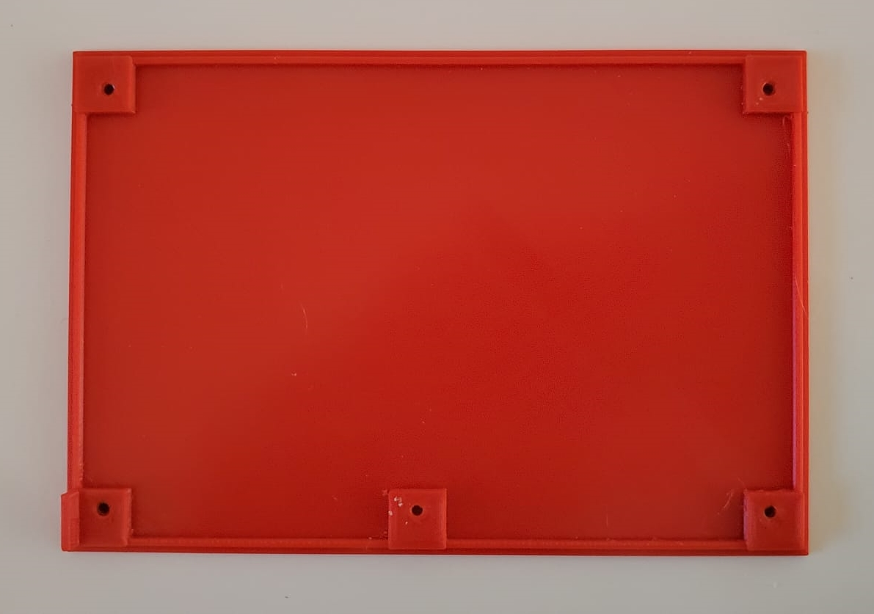

Acrylic bar, 2mm diameter
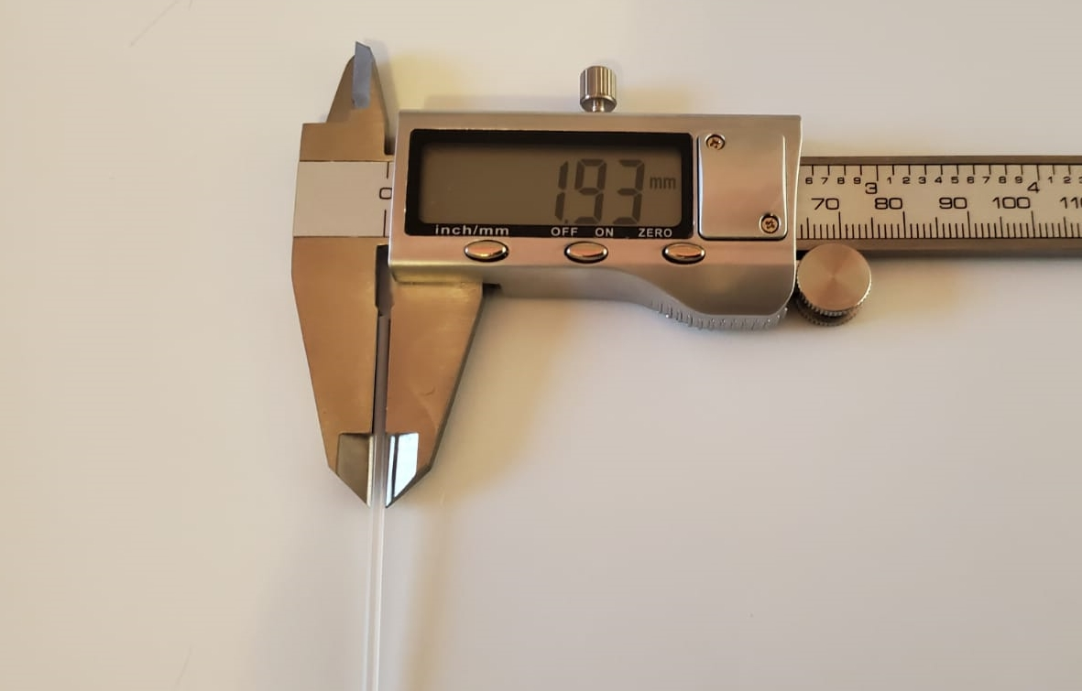

Quantity 1, Size #4 by ~½ Inches long screws
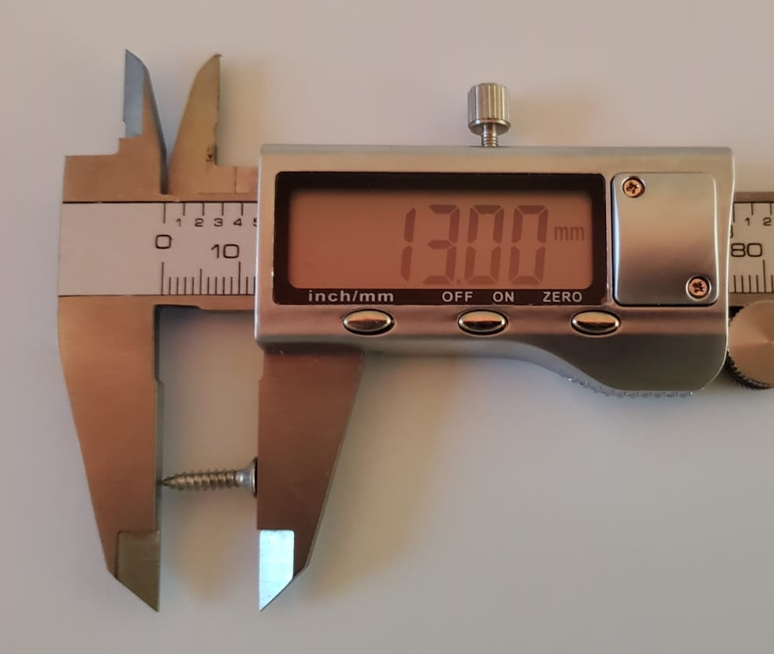

Quantity 4, Size #4 by ~¾ Inches long screws
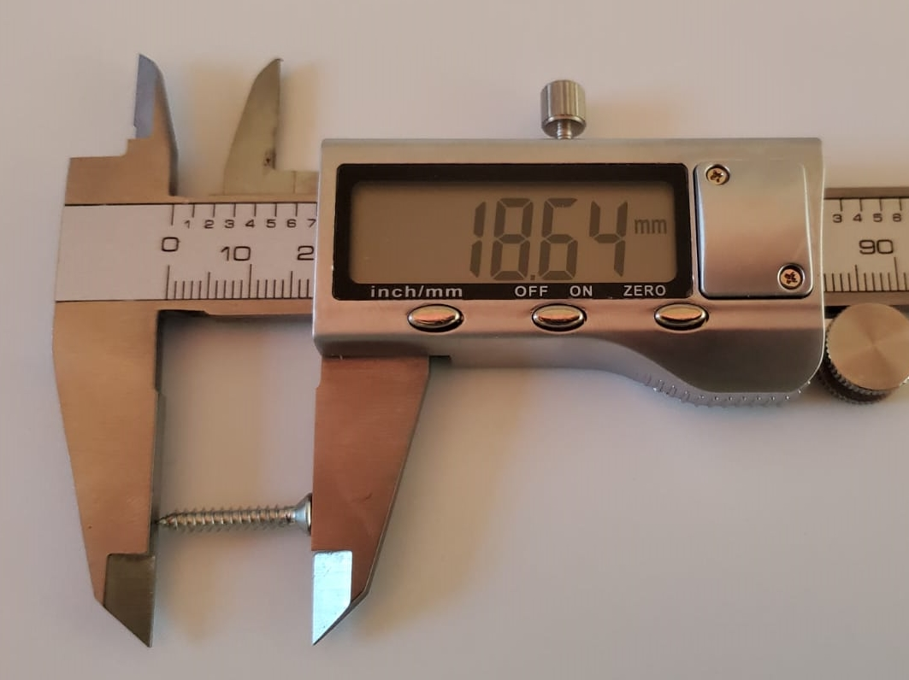

PLsi v0 CPU Board. Analog version.
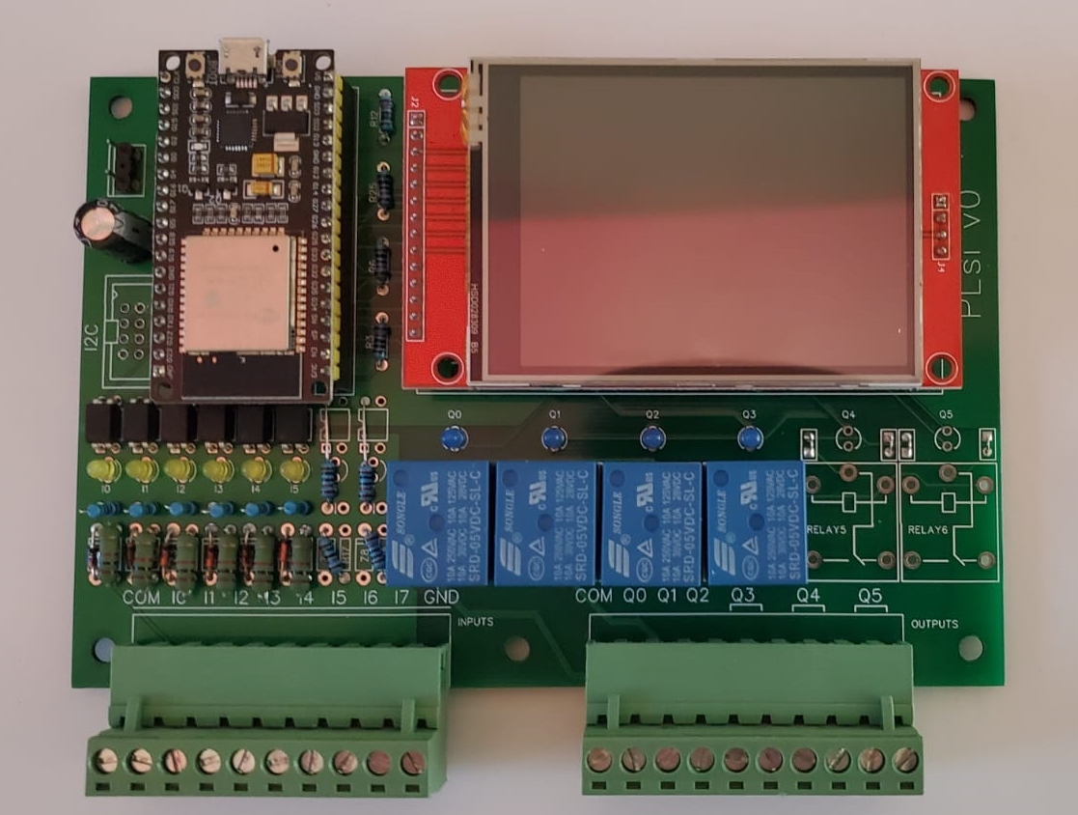

6.3 Assembly

Install the acrylic bars on Housing cover:
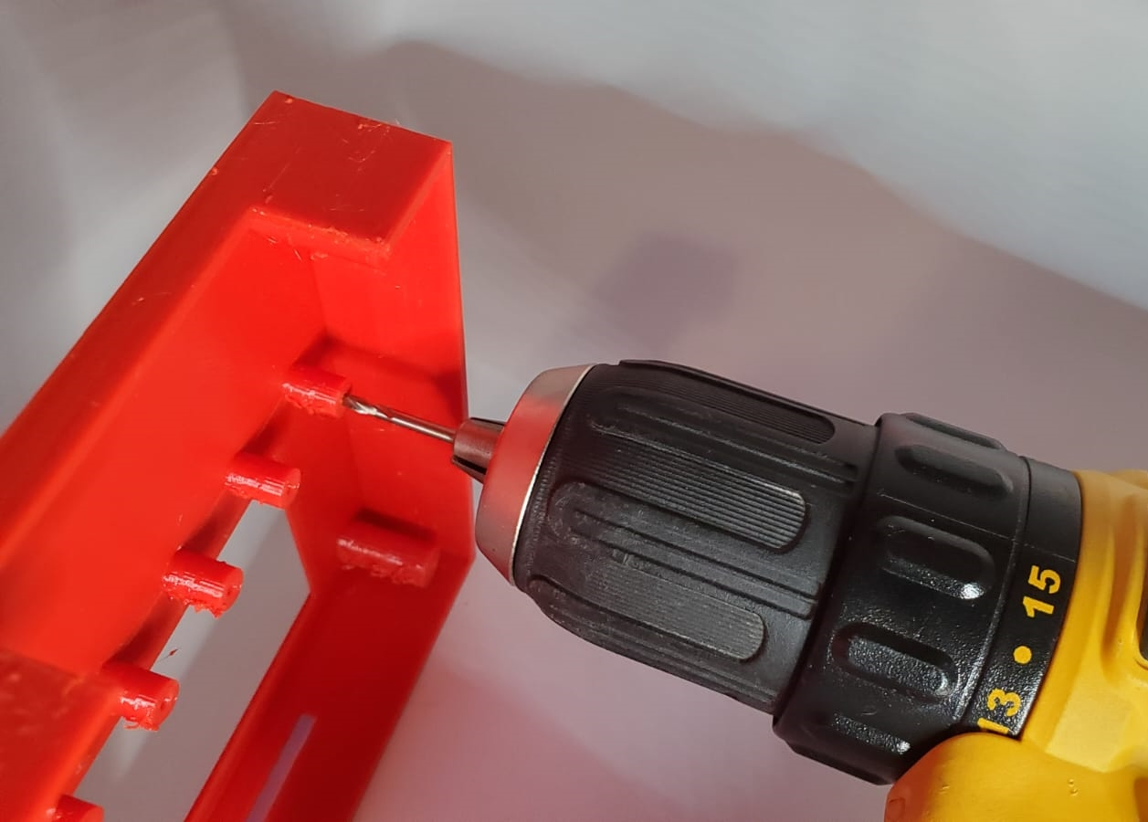
Use a 2mm drill bit to improve the 3D printed hole quality if needed.

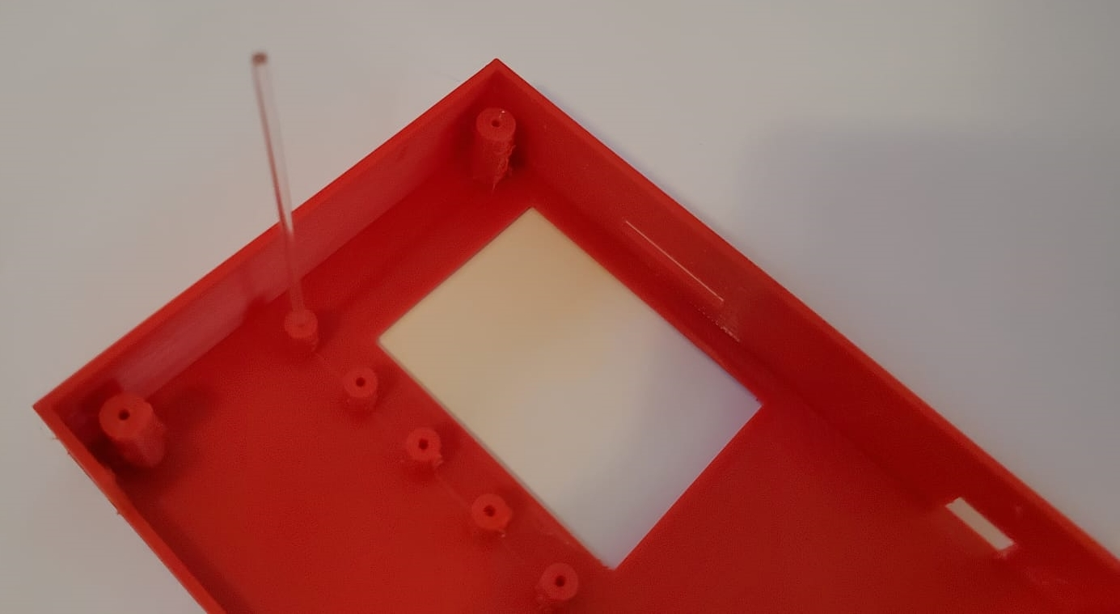

Insert the acrylic bar from the interior of the housing; make it flash with the front of the housing

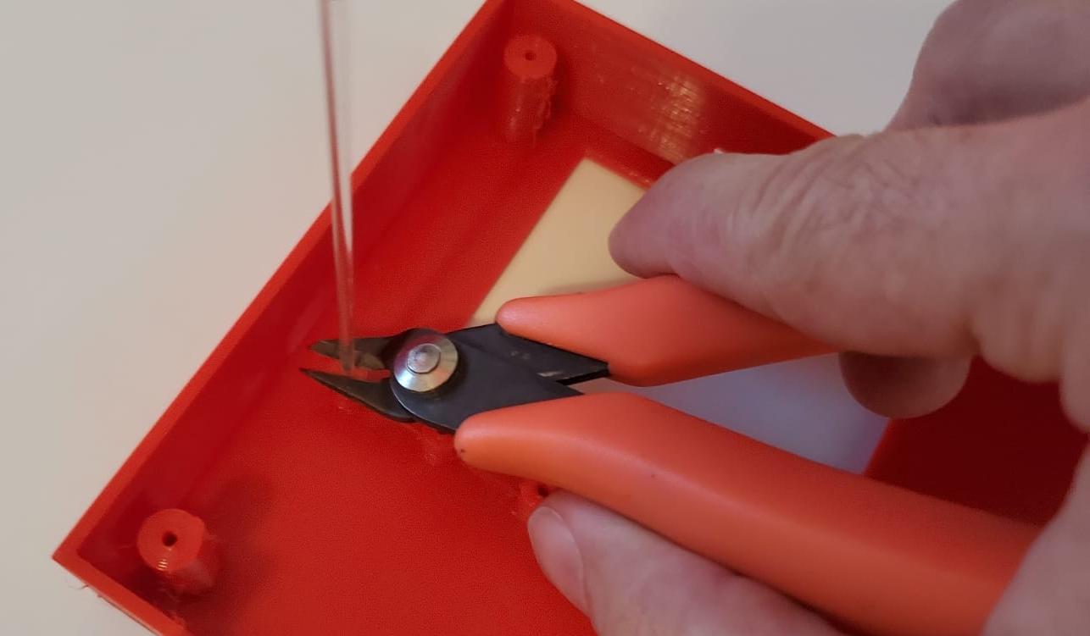

Cut the bar with a small cable cutter

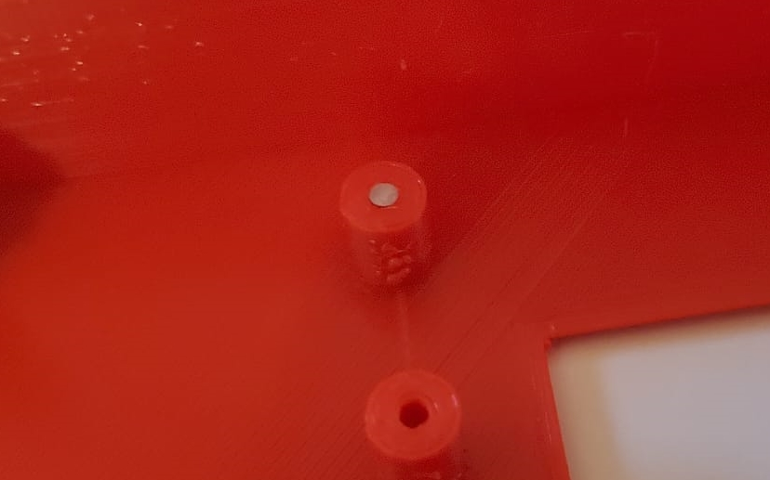

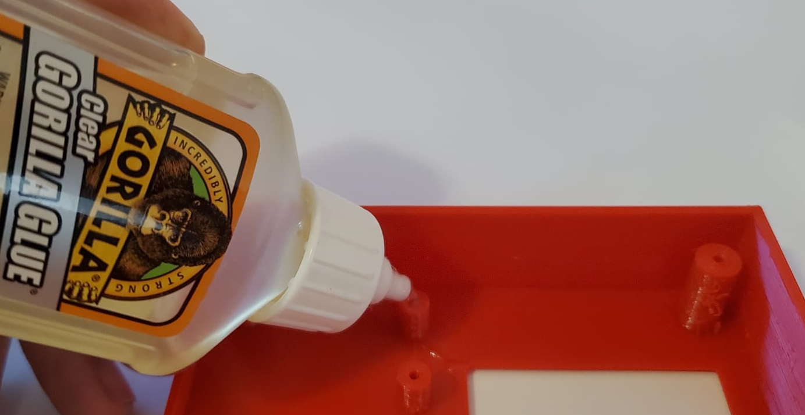

Glue the acrylic bars from the interior of the housing cover using any transparent glue:

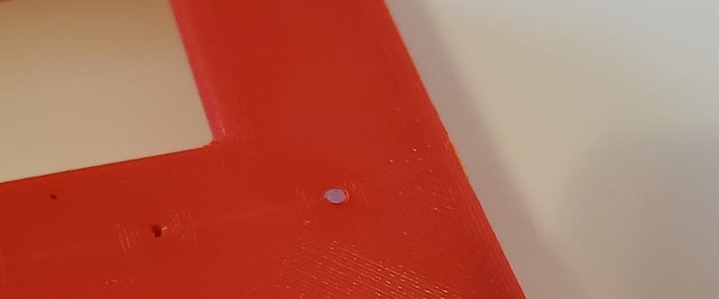

Front view of a finished acrylic bar installation. They improve the Led visibility and provide a better look.

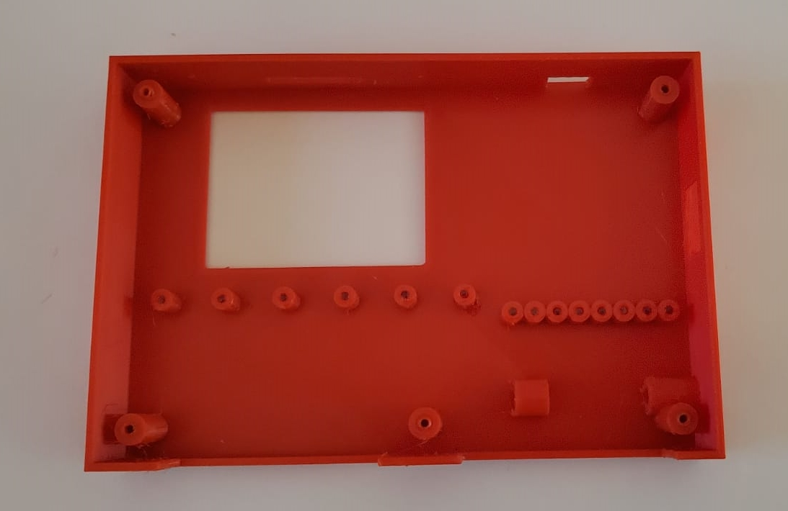

Repeat the Acrylic bar installation process for all Led channels, 8 for inputs and 6 for outputs.
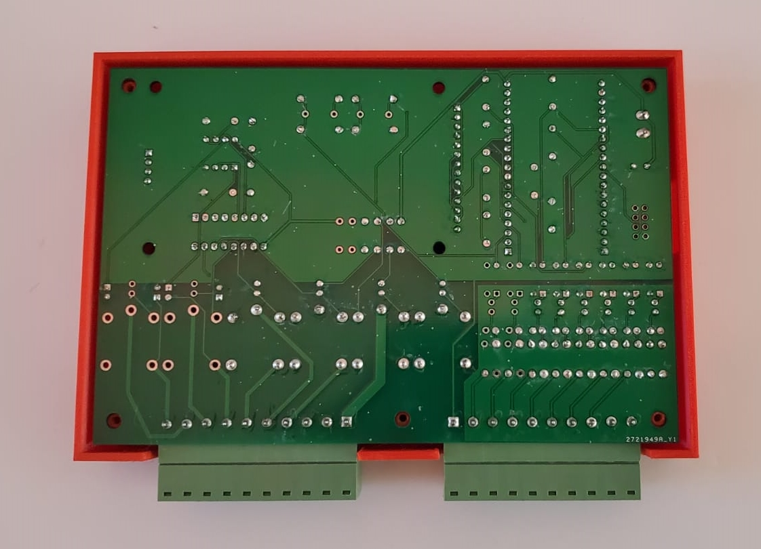

Install the board inside the Housing Cover

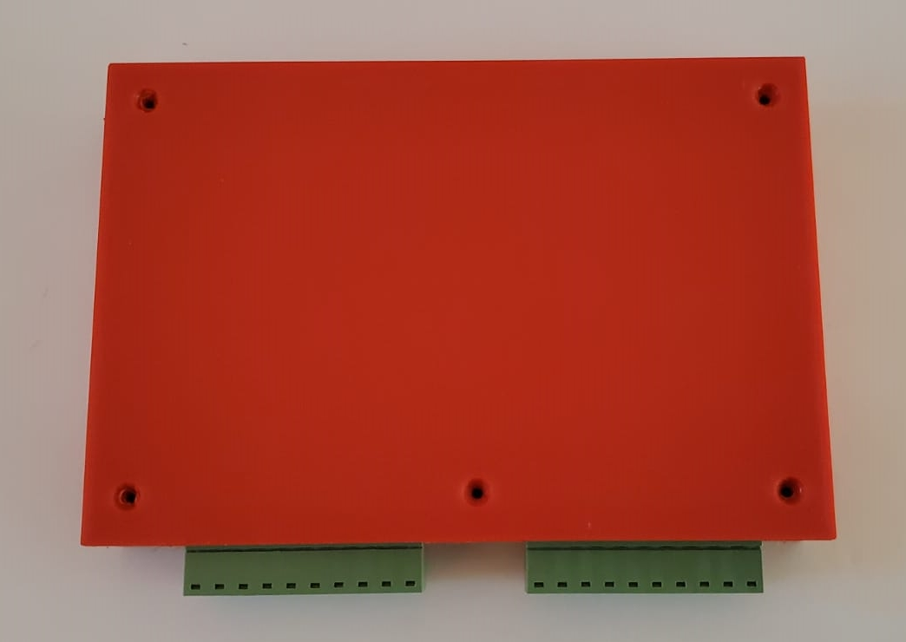

Install Housing base

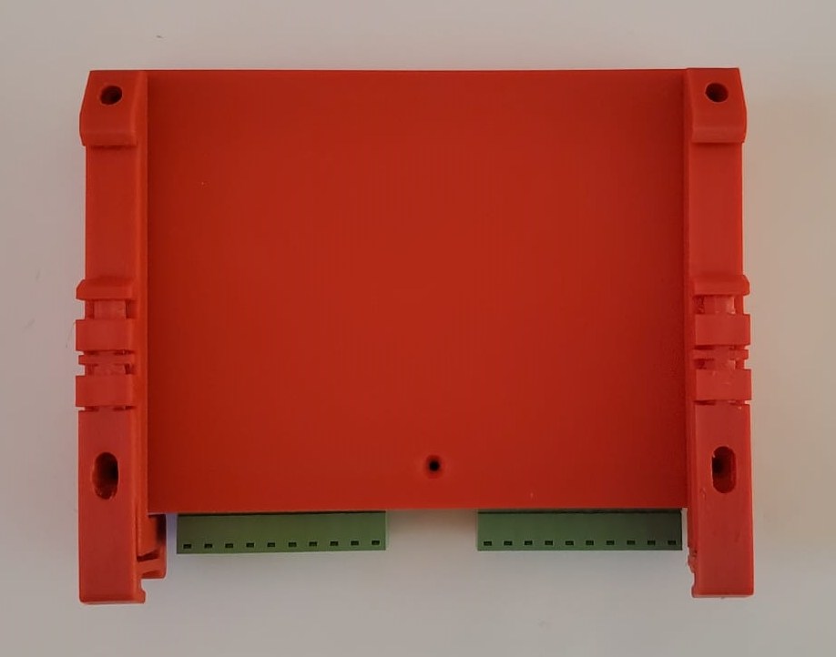

Locate the Din Rail brackets.
Be sure that the removable terminal blocks are installed before this step. The 2 brackets are different, one of them has a width reduction to avoid interference with the removable terminal block.
In the above picture, the bracket with the width reduction goes on the Right.

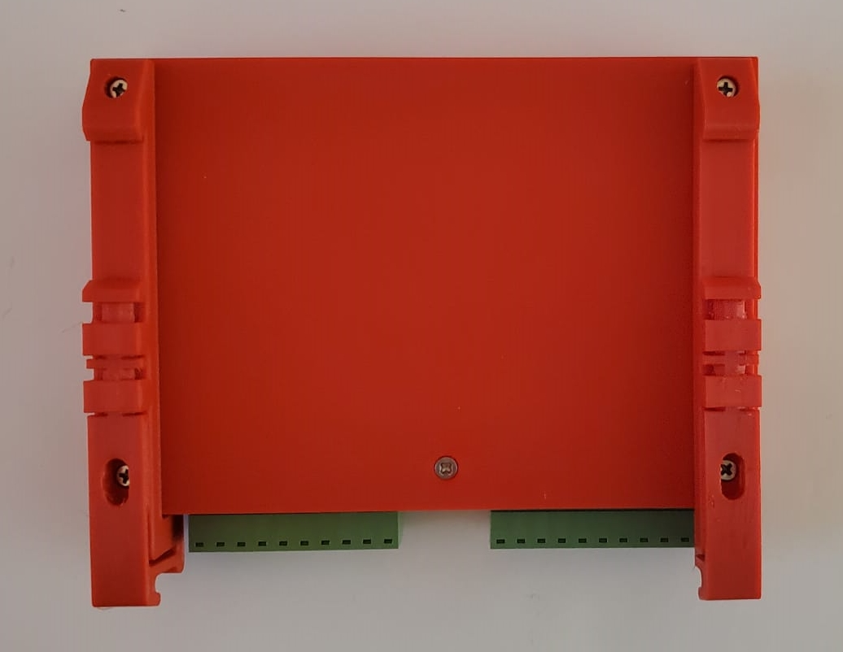
Install quantity 4 - Size #4 x ¾” screws on the corners
Install quantity 1 - Size #4 x ½” screws on the center bottom hole

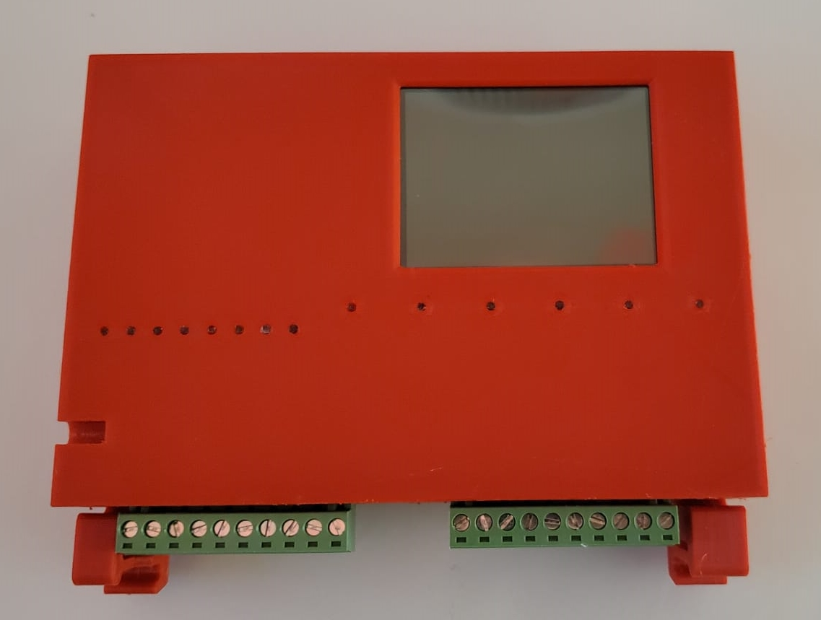
Proceed with the Pen installation

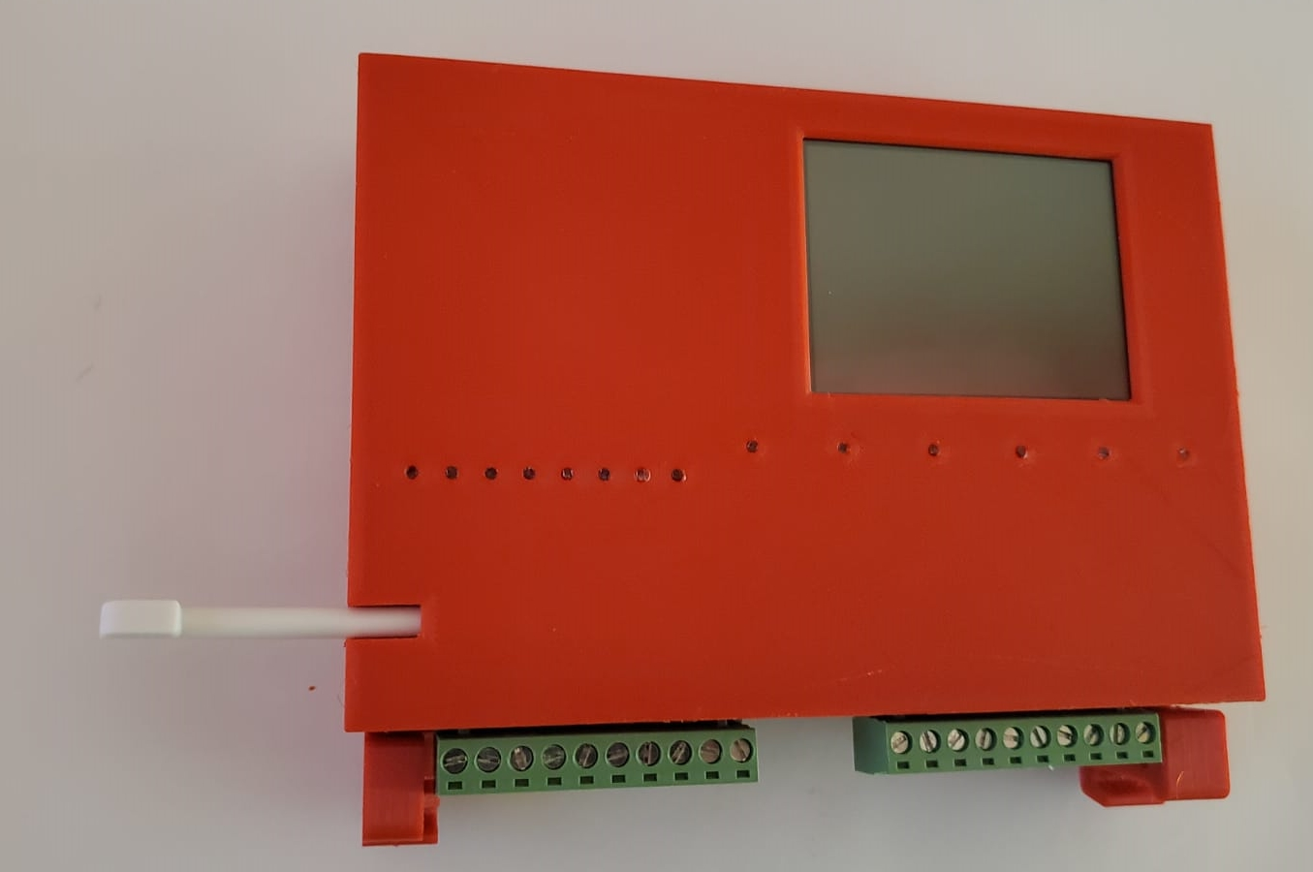

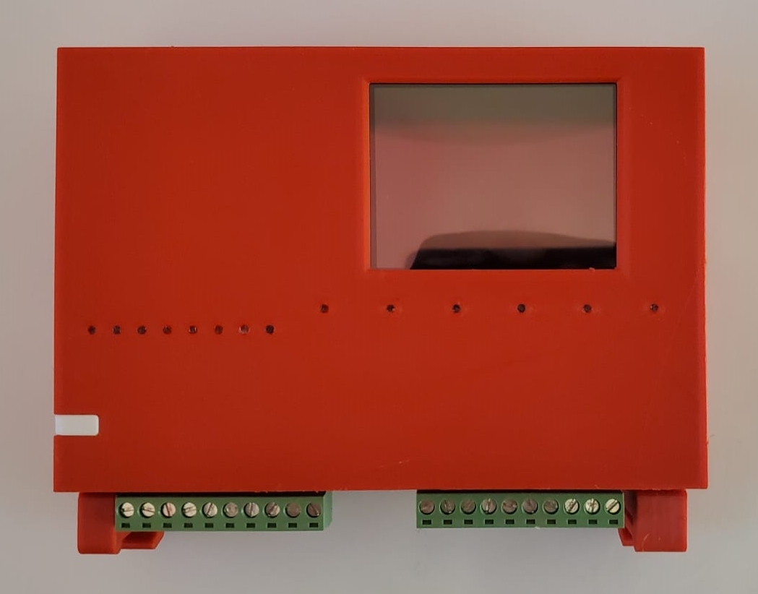

Insert and remove the pen until if feels comfortably soft
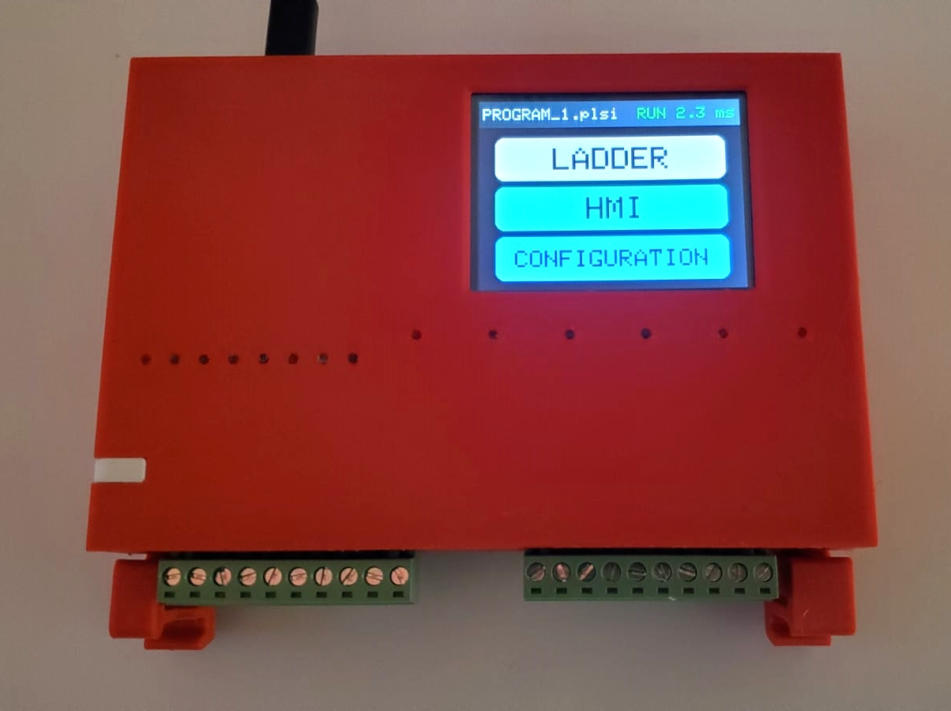

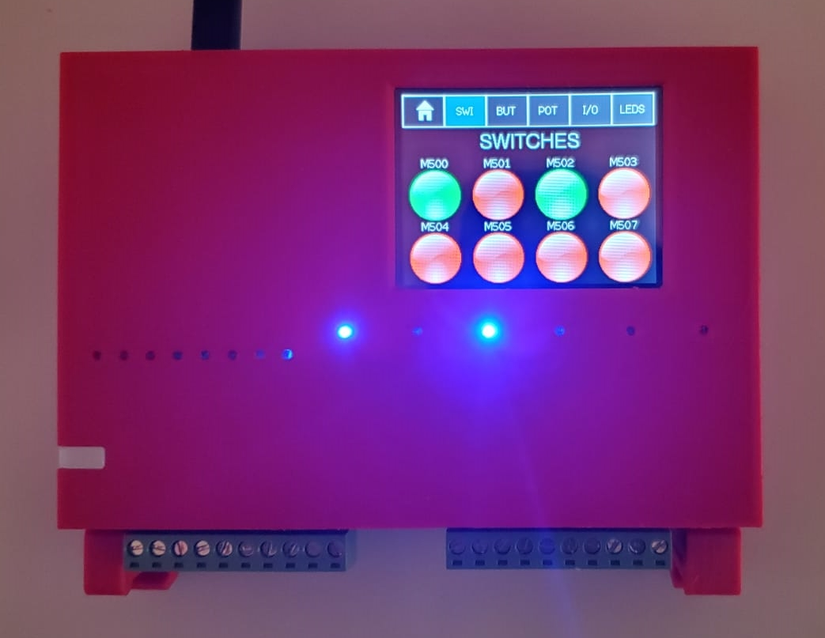

Power On your PLsi unit.
Proceed to the User Manual for Wiring, configuration and Programming information.

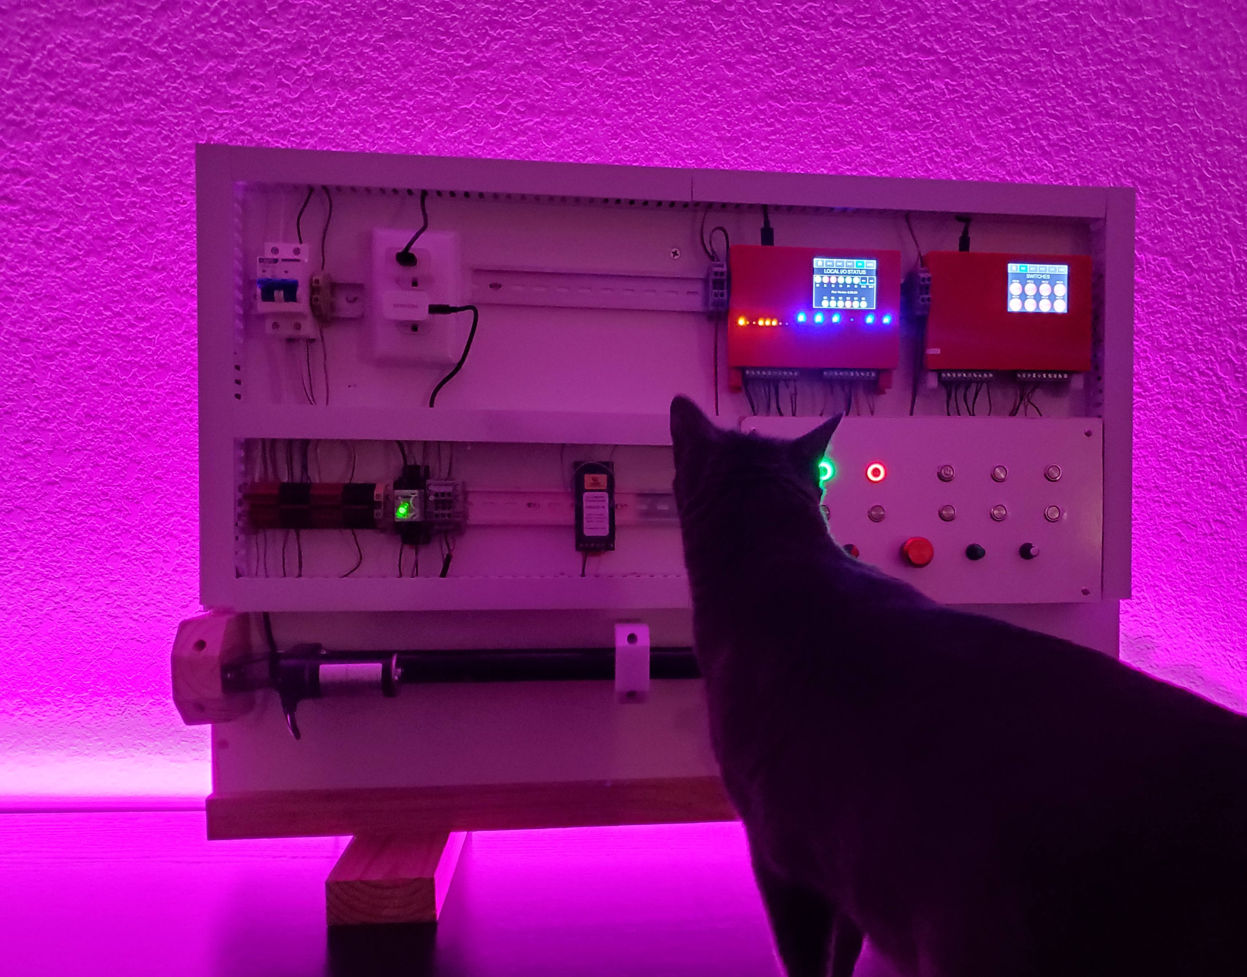

Teach yourself and others how to program a PLC

