PLsi v0

Hardware Manual

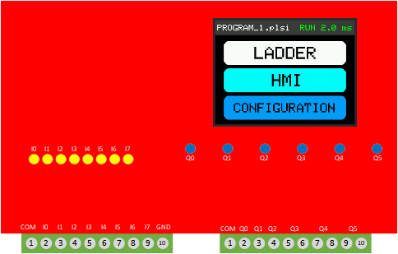


Project page:
https://github.com/ElPercha/PLsi

Purpose of this document
This PLsi manual provides you with information to build a PLsi v0 unit, it comprises the board assembly, firmware download and a series of tests to validate the main functionalities. For wiring, configuration and programming information use the “PLsi v0 User Manual” instead.
Please, create an issue in the PLsi repository if you see that this manual is not clear enough or has opportunities to improve.

Document information
Manual Name: PLsi_v0_Hardware_Manual
Revision: A
Date: January 20, 2021

Revision history
Revision | Date | Description
A | March 20, 2021 | First Revision

License
The complete PLsi Project is under GPL v3.0 license.
This includes Hardware, Software, Documentation and all related contributions:

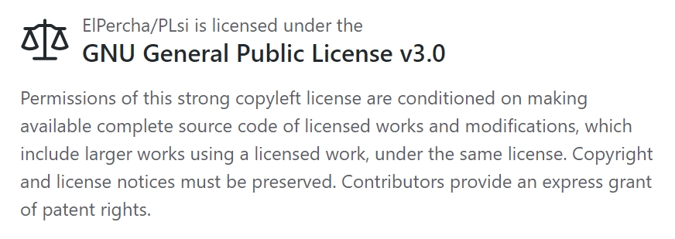

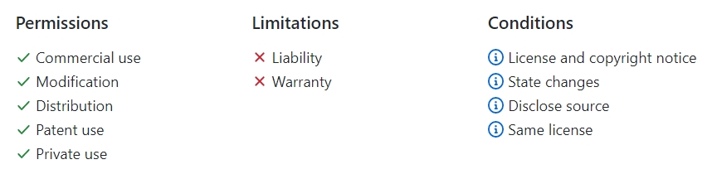

A full copy of the License is included on the Master branch of the project for reference:
https://github.com/ElPercha/PLsi/blob/master/LICENSE
Original copy with useful FAQ:
https://www.gnu.org/licenses/gpl-3.0.html

Disclaimer

Copyright (c) 2019 Prieto Lucas. All rights reserved.
This file is part of the PLsi project.

PLsi is free software and hardware: you can redistribute it and/or modify
it under the terms of the GNU General Public License as published by
the Free Software Foundation, either version 3 of the License, or
(at your option) any later version.
PLsi is distributed in the hope that it will be useful,
but WITHOUT ANY WARRANTY; without even the implied warranty of
MERCHANTABILITY or FITNESS FOR A PARTICULAR PURPOSE. See the
GNU General Public License for more details.

You should have received a copy of the GNU General Public License
along with this program. If not, see <https://www.gnu.org/licenses/>.

Safety Guidelines
All applicable local and national codes that regulate the installation and operation of your equipment shall be followed in order to minimize the risk of potential safety issues.
PLsi is not fault-tolerant and must not be used to control equipment in hazardous environments where the failure of the system could lead to death, people injury, or severe environmental damage. Refers to the Disclaimer notice for more information.
This manual contains 3 levels of hints:

WARNING:
Death, serious harm to health or equipment damage can result
if the stated measures are not followed !


CAUTION:
Harm to health or equipment damage can result if the
stated measures are not followed


TIP:
Important information that requires your special attention

Table of Contents
Purpose of this document 2
Document information 2
Revision history 2
License 3
Disclaimer 4
Safety Guidelines 5
1. Introduction 7
1.1 Project documentation 8
1.2 Minimum system 9
1.3 Drawing 13
2. Board Assembly 13
2.2 Digital version 14
2.2.1 Component list 14
2.2.2 Assembly 15
2.3 Analog version 19
2.3.1 Component list 19
2.3.2 Assembly 20
3. Firmware Download 20
3.1 Required files 20
3.2 Espressif download tool 20
3.3 Compile the source 21
3.3.1 PLsi customization 21
4. Hardware Validation 21
4.1 Digital Inputs validation 21
4.2 Digital Outputs validation 21
4.3 Analog Inputs validation 21
4.4 Analog Outputs validation 22

1. Introduction
The objective of the PLsi project is to create a PLC & HMI with the following main characteristics:
- To not require external systems such us Laptops or Cellphones to be programmed
- To be used on Classroom for educational purposes, IOT applications or industrial low risk applications
- Software and Hardware with Industrial performance and features
- Open Source and Open Hardware
- Focus on Low Cost
The hardware version 0 of PLsi system is designed to be cheap and easy to build. It does not have SMD components, what makes the building process easy, fast and feasible using basic tools. The components selection was oriented to use easy to get and cheap elements.
The PLsi v0 is mainly composed by:
- Main board
- ESP32 module
- TFT 2.8” SPI Display module with touchscreen
- Terminal blocks and common electronic components
The PLsi v0 board is designed to support different input output configurations. This manual will cover the 2 main suggested configurations. For that reason, before to start, you have to select which version are you going to build, these are the 2 main options:
- Digital version:
  - 8 digital inputs (5 to 26VDC)
  - 6 relay outputs (10A max per PLsi, external fuse required)
- Analog version:
  - 6 digital inputs (5 to 26VDC)
  - 4 relay outputs (10A max per PLsi, external fuse required)
  - 2 Analog Inputs (0-5V)
  - 2 Analog Outputs (0-5V)
This definition will modify your component list. The details of which component is required on each version is covered on the following chapters.

1.1 Project documentation
The PLsi project is hosted on GitHub:
https://github.com/ElPercha/PLsi
The tree structure is divided in 3 main folders:
- doc: Contains project documentation and auxiliary tools
- firm: Contains the Firmware, it is designed using PlatformIO + Visual Studio
- hard: Contains the Hardware documentation, mainly:
  - Circuit schematic
  - Component list
  - Board fabrication details
  - 3D Printed housing fabrication details
  - 3D Printed Din Rail support fabrication details
The most updated information is located on the master branch (link provided above), but it also might contain nightly builds of the firmware, hardware or any document. For this reason, it is recommended to use the “releases”, they are a more trustworthy information source.
Each release contains a snapshot of the full project site by the moment of his creation, plus the required binaries to flash the ESP32 module.
By the time this document was created, the latest revision available is the “v0.00.03”.
It is recommended to use the latest available release to build your PLsi unit.
https://github.com/ElPercha/PLsi/releases
The details on how to use the binary files to flash your PLsi are going to be covered during the next chapters.

1.2 Minimum system
The easiest way to build a PLsi v0 is using the board designed for it, but for PLsi CPU testing purposes (with no Inputs Outputs) a limited system can be easily built.
It consist of:
- ESP32 WROOM module
  - 38 pins version
  - They typically have yellow pin terminals
  - For test purposes you can use another ESP32 module as long as it has dual core, but the described model is required if you use the PLsi v0 board.
- 2.8” 320x240 SPI TFT Display – LcdWiki info
  - Driver ILI 9341
  - Touchscreen driver XPT2046
  - For test purposes you can use another display, as long as it has the same interface, resolution and drivers, but the described model is required if you use the PLsi v0 board.
- 9 Jumper cables for the ESP32 ← → Display connections.
- Micro USB cable and adapter with 1A capacity (recommended 2A)
  - This fed the ESP32 module and it is the main incoming supply voltage of the PLsi v0

Required ESP32 ← → Display connections for minimal system:

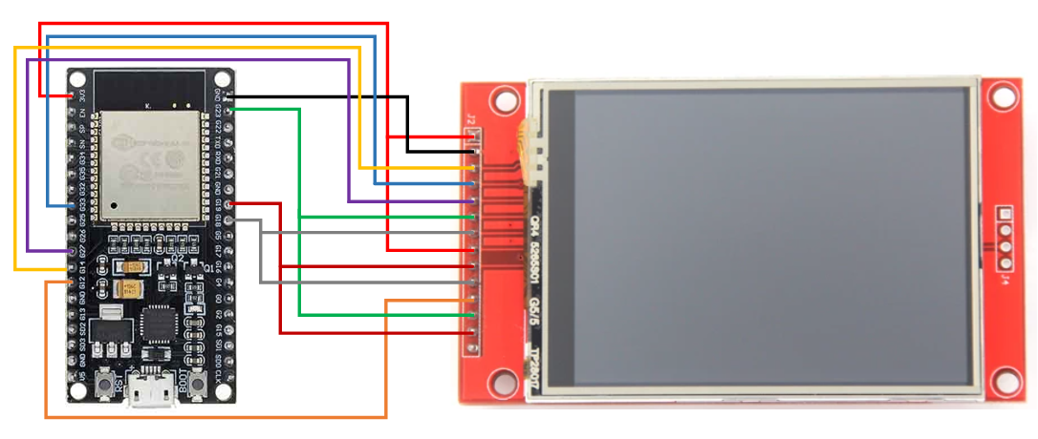

In the above sketch the minimal connections are shown.
The only pending activity to complete the test will be the Firmware download to ESP32.
It is detailed in Firmware Download chapter.
Required ESP32 Module
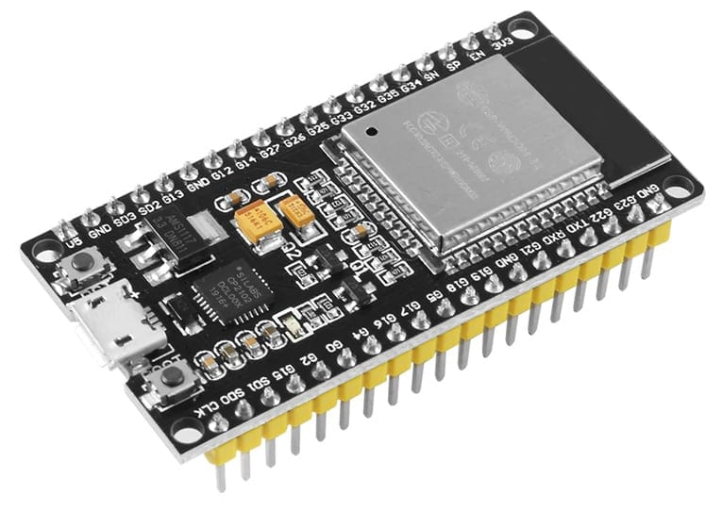
Dimensions:
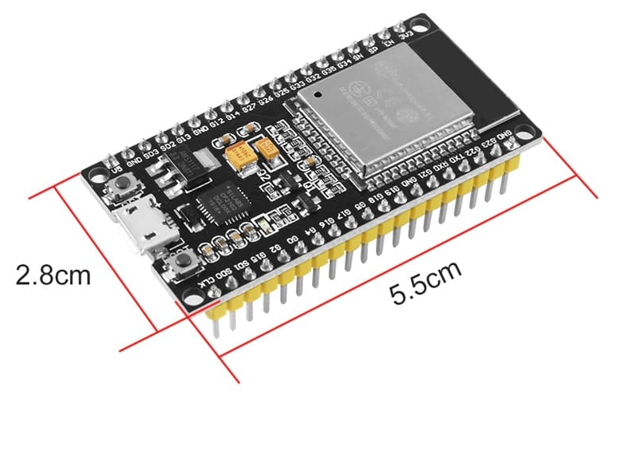

Required display:

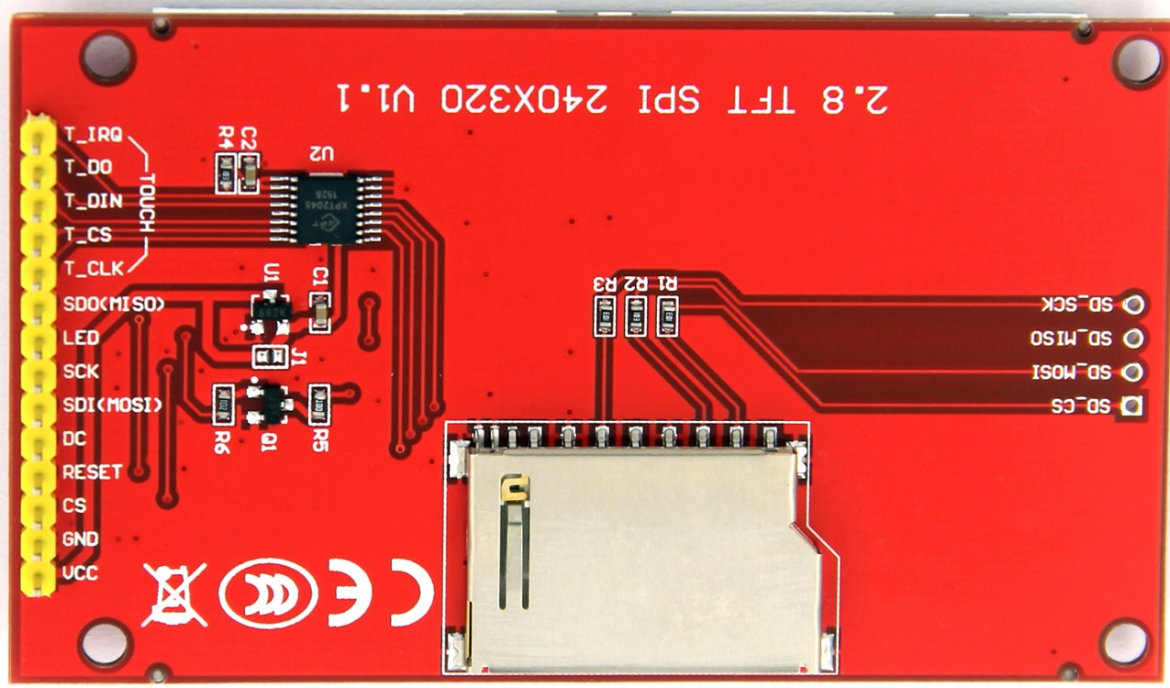
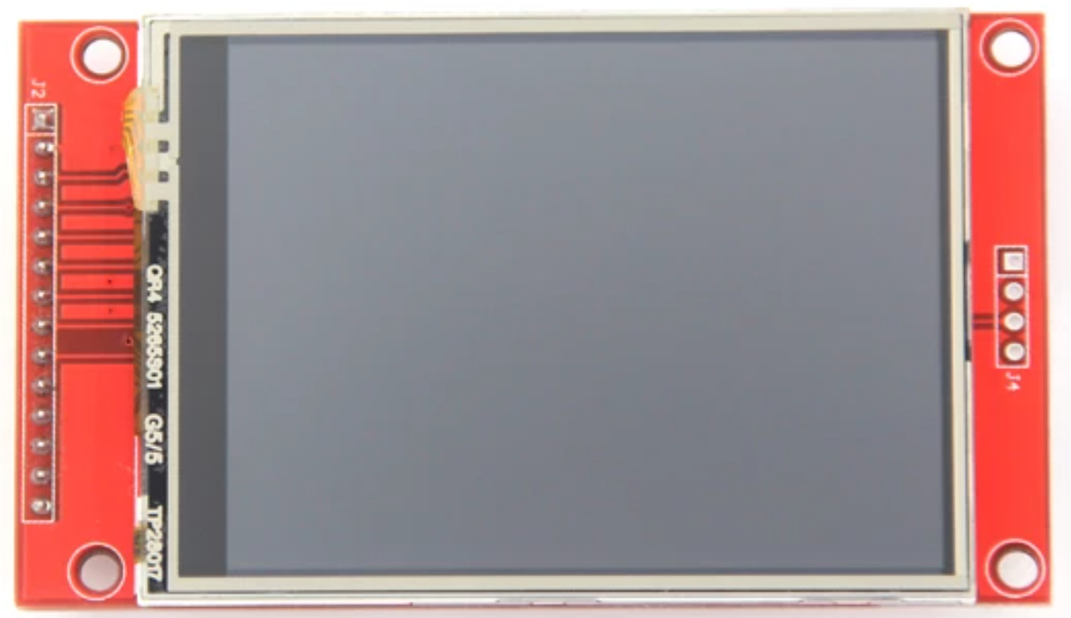

1.3 Drawing

2. Board Assembly
The recommended way to build your PLsi is using the board designed for it.
All the required files to build the board are provided In the hard (hardware) folder. Each PLsi hardware version has his own folder.

PLsi v0 board main folder:
https://github.com/ElPercha/PLsi/tree/master/hard/v0/board

Folder content:
- Gerber Files
- EasyEDA source
- Altium source (it is a beta export option of the EasyEDA platform, not tested)
- Schematic
- BOM

The EasyEDA project is also public and for this reason you can directly clone the project, download or open the files from here:
https://oshwlab.com/funnyautomation/PLsi_0

The Boards used to prototype the PLsi v0 were ordered to:
https://jlcpcb.com/
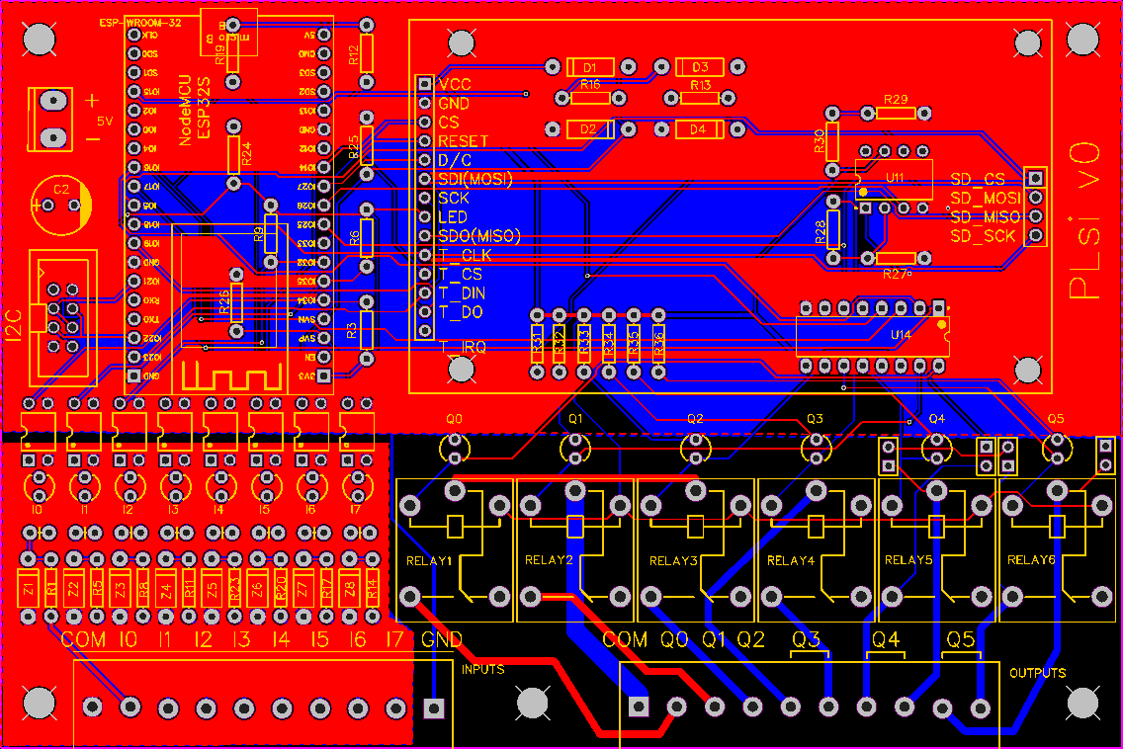

2.2 Digital version
The hardware v0 digital version will have:
- 8 digital inputs (5 to 26VDC)
- 6 relay outputs (10A max per PLsi, external fuse required)
The component list with links to AliExpress options can be found here:
https://github.com/ElPercha/PLsi/tree/master/hard/v0-CPU

2.2.1 Component list
The following table has the list of components required to build your PLsi v0 digital:
Item | Designator | Description | Quantity
1 | U1 | NodeMCU_ESP32S | 1
2 | U2 | Touch Screen Display | 1
3 | U14 | ULN2003N | 1
4 | INPUTS, OUTPUTS | 5.08 x 10 Terminal block | 2
5 | U2 – SD Card conenction pins | Dupont 2.54mm Male strip | 4 pins
6 | U1 and U2 - Optional socket | Dupont 2.54mm Female strip | 2 x 40 pins
7 | 5V | Dupont 3 pins male | 3 pins
8 | P4 | HDR-IDC-2.54-2X4P | 1
9 | C2 | Capacitor 1000uF 9V | 1
10 | OPTO1, OPTO2, OPTO3, OPTO4, OPTO5, OPTO6, OPTO7, OPTO8 | Optocupler PC817 | 8
11 | Z1, Z2, Z3, Z4, Z5, Z6, Z7, Z8 | Diode 5v1 – Zenner 1w | 8
12 | I0, I1, I2, I3, I4, I5, I6, I7 | Leds 3mm Color 1 | 8
13 | Q0, Q1, Q2, Q3, Q4, Q5 | Leds 3mm Color 2 | 6
14 | R3, R6, R9, R12, R13, R16, R19, R24 | Resistor 10k | 8
15 | R1, R5, R8, R11, R14, R17, R20, R23 | Resistor 1K x 1/2W | 8
16 | R2, R4, R7, R10, R15, R18, R21, R22 | Resistor 510 ohms | 8
17 | R31, R32, R33, R34, R35, R36 | Resistor 330 ohms | 6
18 | RELAY1, RELAY2, RELAY3, RELAY4, RELAY5, RELAY6 | SRD-05VDC-SL-C | 6

The latest version of the BOM (Bill of Materials) file, with more information, is available on:
https://github.com/ElPercha/PLsi/tree/master/hard/v0-CPU/board/bom

2.2.2 Assembly
There is no special considerations on the bulding process. This section will recommended a step by step secuence to facilitate the assembly process:

2.3 Analog version
PLsi is not fault-tolerant and must not be used to control equipment in hazardous environments where the failure of the system could lead to death, people injury, or severe environmental damage. Refers to the Disclaimer notice for more information.

ANALOG resolution. Lineatization issue

2.3.1 Component list
PLsi is not fault-tolerant and must not be used to control equipment in hazardous environments

Item | Designator | Description | Quantity
1 | U1 | NodeMCU_ESP32S | 1
2 | U2 | Touch Screen Display | 1
3 | U14 | ULN2003N | 1
4 | INPUTS, OUTPUTS | 5.08 x 10 Terminal block | 2
5 | U2 – SD Card conenction pins | Dupont 2.54mm Male strip | 4 pins
6 | U1 and U2 - Optional socket | Dupont 2.54mm Female strip | 2 x 40 pins
7 | 5V | Dupont 3 pins male | 3 pins
8 | P4 | HDR-IDC-2.54-2X4P | 1
9 | C2 | Capacitor 1000uF 9V | 1
10 | OPTO1, OPTO2, OPTO3, OPTO4, OPTO5, OPTO6 | Optocupler PC817 | 6
11 | Z1, Z2, Z3, Z4, Z5, Z6 | Diode 5v1 – Zenner 1w | 6
12 | I0, I1, I2, I3, I4, I5 | Leds 3mm Color 1 | 6
13 | Q0, Q1, Q2, Q3 | Leds 3mm Color 2 | 4
14 | R3, R6, R9, R12, R19, R24 | Resistor 10k | 6
15 | R1, R5, R8, R11, R20, R23 | Resistor 1K x 1/2W | 6
16 | R2, R4, R7, R10, R21, R22 | Resistor 510 ohms | 6
17 | R31, R32, R33, R34 | Resistor 330 ohms | 4
18 | RELAY1, RELAY2, RELAY3, RELAY4 | SRD-05VDC-SL-C | 4
19 | D1, D2, D3, D4 | Diode 1N4148 | 4
20 | R25, R26, R37, R38, R39, R40 | Resistor 10k 1% | 6
21 | R27,R29 | Resistor 5k1 | 2
22 | R28,R30 | Resistor 3k3 | 2
23 | U11 | TLV2462CP | 1

where the failure of the system could lead to death, people injury, or severe environmental damage. Refers to the Disclaimer notice for more information.

2.3.2 Assembly
PLsi is not fault-tolerant and must not be used to control equipment in hazardous environments where the failure of the system could lead to death, people injury, or severe environmental damage. Refers to the Disclaimer notice for more information.

3. Firmware Download
PLsi is not fault-tolerant and must not be used to control equipment in hazardous environments where the failure of the system could lead to death, people injury, or severe environmental damage. Refers to the Disclaimer notice for more information.

3.1 Required files
PLsi is not fault-tolerant and must not be used to control equipment in hazardous environments where the failure of the system could lead to death, people injury, or severe environmental damage. Refers to the Disclaimer notice for more information.

3.2 Espressif download tool
PLsi is not fault-tolerant and must not be used to control equipment in hazardous environments where the failure of the system could lead to death, people injury, or severe environmental damage. Refers to the Disclaimer notice for more information.

3.3 Compile the source
PLsi is not fault-tolerant and must not be used to control equipment in hazardous environments where the failure of the system could lead to death, people injury, or severe environmental damage. Refers to the Disclaimer notice for more information.

3.3.1 PLsi customization
PLsi is not fault-tolerant and must not be used to control equipment in hazardous environments where the failure of the system could lead to death, people injury, or severe environmental damage. Refers to the Disclaimer notice for more information.

4. Hardware Validation
This step is optional but recommended…………..

4.1 Digital Inputs validation
PLsi is not fault-tolerant and must not be used to control equipment in hazardous environments where the failure of the system could lead to death, people injury, or severe environmental damage. Refers to the Disclaimer notice for more information.

4.2 Digital Outputs validation
PLsi is not fault-tolerant and must not be used to control equipment in hazardous environments where the failure of the system could lead to death, people injury, or severe environmental damage. Refers to the Disclaimer notice for more information.

4.3 Analog Inputs validation
PLsi is not fault-tolerant and must not be used to control equipment in hazardous environments where the failure of the system could lead to death, people injury, or severe environmental damage. Refers to the Disclaimer notice for more information.

4.4 Analog Outputs validation
PLsi is not fault-tolerant and must not be used to control equipment in hazardous environments where the failure of the system could lead to death, people injury, or severe environmental damage. Refers to the Disclaimer notice for more information.

DIY: Como construir:
listado de componentes
minimo para probar esp32 y display
explicacion del circuito
Detalles placa i2c etc
mencionar analogicos
construir placa
montaje paso a paso?
bajar firmware con esp32 tool
0x1000 - bootloader_dio_40m.bin
0x8000 - partitions.bin
0xe000 - boot_app0.bin
0x10000 - firmware.bin
https://www.espressif.com/en/products/socs/esp32/resources
la herramienta esta incluida pero si queres la ultima version proveer link
en la carpeta de la gherramienta esta el manual once you unzip
o compilar con platformio no mucho detalle
si tienen problemas que avisen

