PLsi v0

User Manual

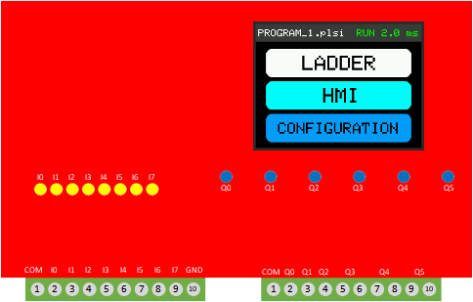


Project page:
https://github.com/ElPercha/PLsi

Purpose of this document
This manual provides information about wiring, configuration and programming of PLsi v0 CPU unit.
For building and assembly instructions, initial firmware download and hardware validation, refer to “PLsi v0 Hardware Manual”.
Please, create an issue in the PLsi repository if you see that this manual is not clear enough or has opportunities to improve.

MANUAL UNDER CONSTRUCTION

Document information
Manual Name: PLsi_v0_User_Manual
Revision: MANUAL UNDER CONSTRUCTION
Date: May 20, 2022

Revision history
Revision | Date | Description | Latest Firmware
A | May 20, 2022 | First Revision | V0.00.03

License
The complete PLsi Project is under GPL v3.0 license.
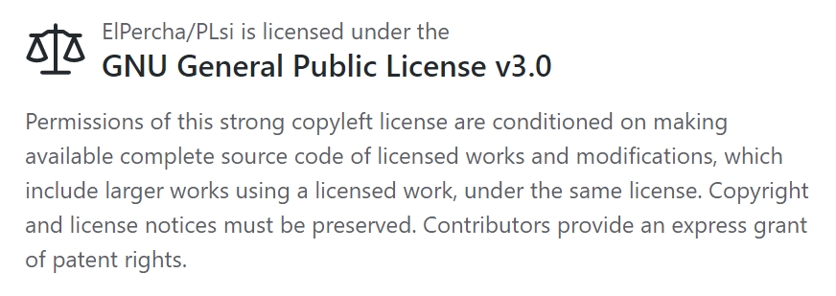

This includes Hardware, Software, Documentation and all related contributions:

Copyright (c) 2019 Prieto Lucas. All rights reserved.
This file is part of the PLsi project.
PLsi is free software and hardware: you can redistribute it and/or modify
it under the terms of the GNU General Public License as published by
the Free Software Foundation, either version 3 of the License, or
(at your option) any later version.
PLsi is distributed in the hope that it will be useful,
but WITHOUT ANY WARRANTY; without even the implied warranty of
MERCHANTABILITY or FITNESS FOR A PARTICULAR PURPOSE. See the
GNU General Public License for more details.

You should have received a copy of the GNU General Public License
along with this program. If not, see <https://www.gnu.org/licenses/>.

A full copy of the License is included on the Master branch of the project for reference:
https://github.com/ElPercha/PLsi/blob/master/LICENSE
Original copy with useful FAQ:
https://www.gnu.org/licenses/gpl-3.0.html

Safety Guidelines
All applicable local and national codes that regulate the installation and operation of your equipment shall be followed in order to minimize the risk of potential safety issues.
PLsi is not fault-tolerant and must not be used to control equipment in hazardous environments where the failure of the system could lead to death, people injury, or severe environmental damage. Refers to the Disclaimer notice for more information.
This manual contains 3 levels of hints:

WARNING:
Death, serious harm to health or equipment damage can result
if the stated measures are not followed !


CAUTION:
Harm to health or equipment damage can result if the
stated measures are not followed


TIP:
Important information that requires your special attention

Table of Contents
Purpose of this document 2
Document information 2
Revision history 2
License 3
Safety Guidelines 4
Table of Contents 5
1. Introduction 6
1.1 Project documentation 7
1.2 Prerequisites 8
1.3 Drawing 9
1.4 Connections and Isolation 10
1.4.1 Digital version 10

1. Introduction
The objective of the PLsi project is to create a PLC & HMI with the following main characteristics:
- To not require external systems such us Laptops or Cellphones to be programmed
- To be used on Classroom for educational purposes, IoT applications or industrial low risk applications
- Software and Hardware with Industrial performance and features
- Open Source and Open Hardware
- Focus on Low Cost
The PLsi v0 Hardware main characteristics:
- ESP32 Processor - Dual Core @240MHZ
- Wi-Fi connectivity
- 2.8" Touchscreen Display
- Removable Terminal blocks
- USB 5Vdc main power supply
- I2C port for hardwired expansions
- SD Card slot
The PLsi v0 board is designed to support different input output configurations. This manual will cover the 2 main suggested configurations:
- Digital version:
  - 8 digital inputs (5 to 26VDC)
  - 6 relay outputs (10A max per PLsi, external fuse required)
- Analog version:
  - 6 digital inputs (5 to 26VDC)
  - 4 relay outputs (10A max per PLsi, external fuse required)
  - 2 Analog Inputs (0-5V)
  - 2 Analog Outputs (0-5V)
This definition will modify the I/O addressing and wiring.
Refer to the “Hardware manual” for more information about the 2 main configuration and electrical details.

Main Software Characteristics:
35 PLC Ladder Logic Instructions
PLC Memory Areas:
2000 Marks (M)
200 Counters ©
300 Timers (T)
10000 Registers 16bits (D)
PLC Program size:
  - Up to 400 networks of 6x5 cells (12K boolean instructions)
  - Up to 4 PLC programs stored on internal memory (max. 400 networks each)
- PLC Program Editor
  - Online Edition (with PLC running)
  - Row, Column and Network Editor
  - Network Navigation
- PLC performance and control
  - Scan time of 2.3ms for 2000 Boolean instructions
  - Processor Core 1 runs Ladder Logic exclusively
  - RUN/STOP with user confirmation
- Display functions:
  - PLC Programming and debugging
  - PLsi Configuration
  - HMI
    - "Fix" version implemented (User cannot edit memory areas nor texts)
    - Screen 1: 8 Switches M500 to M507
    - Screen 2: 8 Buttons M510 to M517
    - Screen 3: 8 User Input Values D500 to D507
    - Screen 4: Local I/O visualization
    - Screen 5: 8 Indicators M520 to M527
- Communications:
  - Wi-Fi configuration. Only DHCP
  - SSID scanning functionality
- Firmware update via Web Page
- Analog Inputs and Outputs
  - Selectable via Configuration page

1.1 Project documentation
The PLsi project is hosted on GitHub:
https://github.com/ElPercha/PLsi
The tree structure is divided in 3 main folders:
- doc: Contains project documentation and auxiliary tools
- firm: Contains the Firmware, it is designed using PlatformIO + Visual Studio
- hard: Contains the Hardware documentation, mainly:
  - Circuit schematic
  - Component list
  - Board fabrication details
  - 3D Printed housing fabrication details
  - 3D Printed Din Rail support fabrication details
The most updated information is located on the master branch (link provided above), but it also might contain nightly builds of the firmware, hardware or any document. For this reason, it is recommended to use the “releases”, they are a more trustworthy information source.
Each release contains a snapshot of the full project site by the moment of his creation, plus the required binaries to flash the ESP32 module.
By the time this document was created, the latest revision available is the “v0.00.03”.

1.2 Prerequisites
There are not special prerequisites to became a PLsi user and programmer.
This manual will introduce and explain the configuration options and programming functions from scratch.

1.3 Drawing
The drawing was created using the free editor EasyEDA.
You can access the project following this link.
The schematic is also stored on GitHub, in the folder hard/CPU/v0/schematic

1.4 Connections and Isolation
The following sections provide in advance information about the connection and PLsi v0 isolation.
For more information about wiring and setup, refer to the “User Manual”

1.4.1 Digital version
The following diagram shows the main connections required for your PLsi v0 Digital version.

