Group I

- The use of hydraulic actuators in mobile robotics is appropriate if:
  - We want an actuator capable of developing high forces, with a high degree of position
  - We want a simple method of control, preferably for linear motion, but the required force is not a critical element.
  - we want a linear actuator, with high positioning precision, easy to integrate in s.. mobile robots
  - we want a simple control method, preferably for rotary movements, where the required force is a critical element.

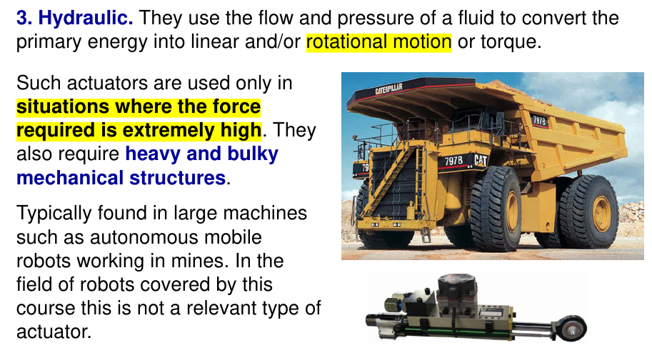

- When we refer to an actuator as being compliant, we are talking about actuators:
  - which include force sensors for the purpose of recording the actuation process and subsequent analysis of the results.
  - which include passive elements that absorb part of the impact energy and transform … another form of dissipated energy.
  - that ensure a result in terms of rotational speed, position or exerted force within limits of certainty in relation to the intended objectives.
  - where part of the primary energy is stored in passive energy storage elements, wh… be influenced by forces outside the system.

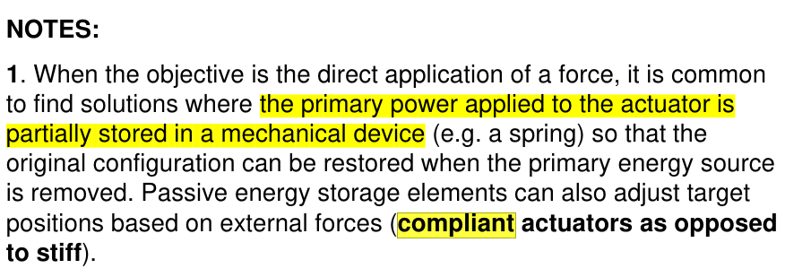

- Electric motors in which the rotor consists of a permanent magnet and the stator, is commonly called:
  - stepper motors.
  - BLDC motors.
  - DC motors
  - AC motors.
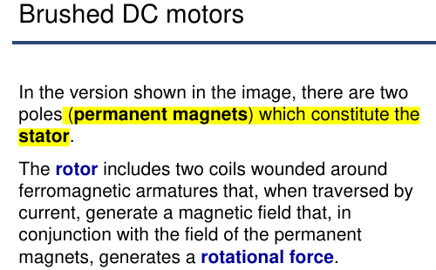

- The main elements that can make up a servo motor are:
  - a stepper motor, a position measurement element and an open loop controller.
  - a DC motor, a gearbox, a position measurement element and a closed loop controller.
  - a DC motor, a gearbox, a speed measuring element and an open loop controller.
  - a BLDC motor, a gearbox, a position measurement element and an open loop.

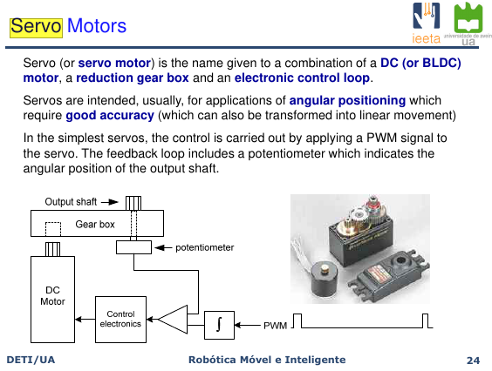

- If you wanted to choose an electric motor for an application where the main requisite … to control and with a wide range of power, you would choose:
  - DC motors.
  - Servo motors.
  - BLDC motors.
  - stenner motors
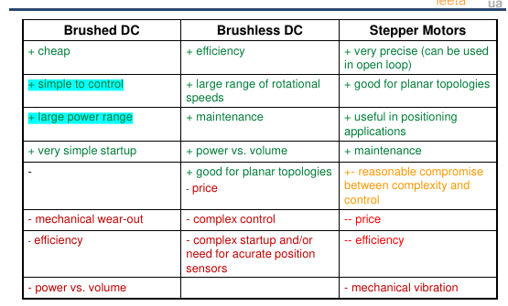

- To detect if a robot has fallen of flipped over(it is not in the upright position), you would use:
  - an encoder.
  - a potentiometer.
  - an accelerometer.
  - a Laser Range Finder
Um acelerometro é um sensor que mede a aceleração linear do robô em diferentes direções. Ao monitorar as mudanças na aceleração, o acelerômetro pode determinar se o robô caiu ou virou, pois esses eventos causam mudanças muito bruscas e repentinas na aceleração registrada.

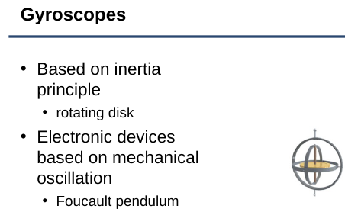
- A gyroscope is a sensor used:
  - to measure how fast a device rotates.
  - to measure linear acceleration.
  - to detect impact
  - to measure changes in orientation of a device

Um gyroscope é um sensor que deteta rotações e movimentos angulares, permitindo medir com precisão as mudanças na orientação de um dispositivo.

- Phase quadrature signals is a method used in optical encoders that allows:
  - to detect the sense of rotation (clockwise/anticlockwise).
  - to increase the encoder resolution.
  - to detect the sense of rotation and increase the encoder resolution.
  - to make the encoder more robust regarding noise.

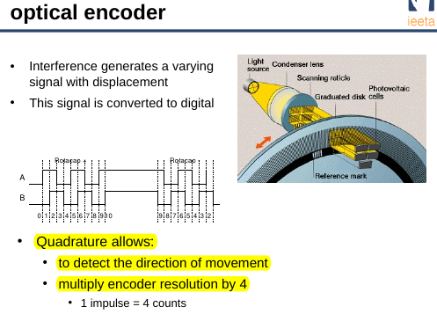

- Consider the block diagram on the right, displaying a system with two blocks. The transfer function corresponding to the aggregate of these two blocks is

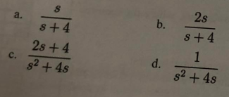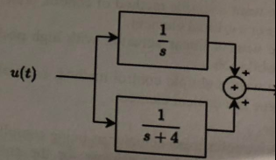

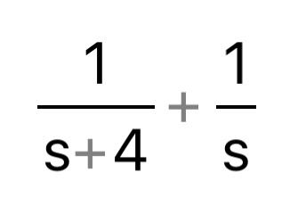
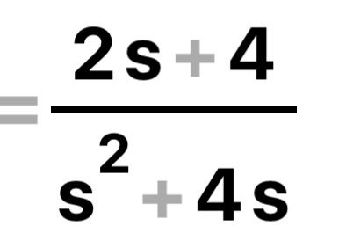

- The transfer function of the system presented in the figure is:

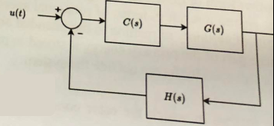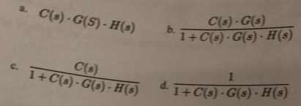

R: Como é retroalimentação negativa é a opção B

- In the figure of the previous question, G(s) is the system to be control…
  - a sensor.
  - the feedback element.
  - the controller.
  - the optimizer.

C(s) é o controller
H(s) é o feedback

- In the A* search algorithm, the cost function is the sum of two terms, the order to find an optimal path, the heuristic:
  - must be the Euclidian distance from the current node to the goal.
  - must not overestimate the remaining cost to reach the goal.
  - can not be zero.
  - must always overestimate the remaining cost to reach the goal

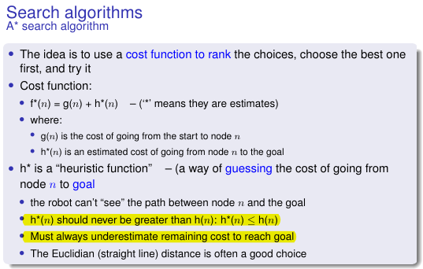
- In mobile robotics, path planning algorithms usually consider some assumptions? → assumo que a pergunta seja para escolher a opção falsa porque b,c,d estão corretas
  - the environment must be represented by a cell grid, where the cell’s size is … robot’s diameter.
  - the robot is symmetric, holonomic and is treated as a point.
  - the exists a good enough representation of the environment
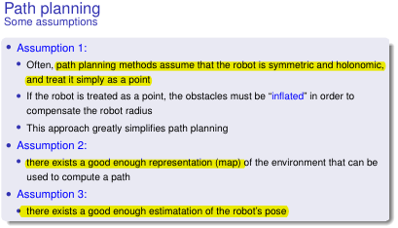
  - there exists a good enough estimation of the robot’s pose.

- Consider the following definition of a certain image parameter: it represents the luminous intensity, per unit area, of light traveling in a given direction. We are talking about:
  - Saturation
  - Luminance
  - Brightness
  - Contrast
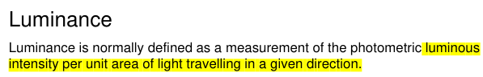

- Consider the following definition of a certain image parameter: it is determined… that is acquired by a pixel and how much this light is distributed across the spectrum. We are talking about:
  - Sharpness of the image.
  - White balance.
  - Chrominance.
  - Saturation of a color.

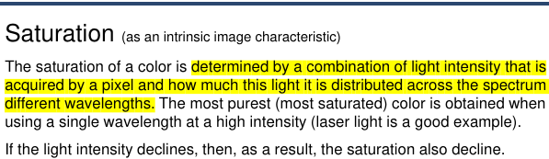
- Consider the following definition of a certain image parameter: it is the global a… colors (typically red, green, and blue primary colors) necessary to render specific… –correctly. We are talking about:
  - White balance.
  - Gamma.
  - Saturation.
  - Sharpness.

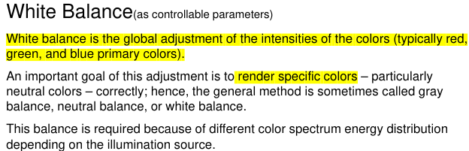

- The image on the right represents one of the characteristics of a pixel. In this o looking at the following color space:
  - CYM(K) space.
  - Chromaticity Diagram.
  - U-V plane.
  - HCL space.

No image :(

- A wheeled robot based on a three-wheel configuration:
  - requires a suspension system to be stable and to compensate for irregularities in the environment.
  - is statically stable if the center of mass is inside the triangle formed by the contact points of the wheels to the ground.
  - must be powered with a single motor.
  - is always stable.

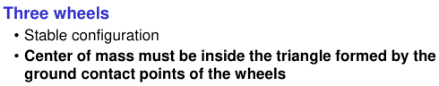
- A wheeled robot based on a four-wheel configuration:
  - must use Ackerman steering drive.
  - can be powered by 4 independent motors and four differential gears.
  - requires a suspension system to compensate for irregularities in the environment where the robot has to move.
  - can be implemented with one active drive wheel and 3 passive castor wheels.
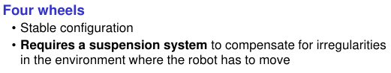
- The differential drive is typically implemented with:
  - two active independent drive wheels and one or two passive castor wheels.
  - one active drive wheel and two passive steering wheels.
  - one active drive wheel and two or more passive castor wheels.
  - two passive normal wheels and one or two active castor wheels.
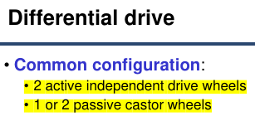

- The Ackerman steering configuration can be implemented with:
  - two rear drive wheels and one front steering wheel.
  - two front drive and steering wheels and two rear castor wheels.
  - two rear drive wheels and one front steering castor wheel.
  - two front steering wheels and two rear drive wheels.

- The aside figure represents a cell decomposition of an environment, where the black boxes are obstacles. In which one of the following cell decomposition approaches does it fit?
  - approximate cell decomposition.
  - exact cell decomposition.
  - fixed-size cell decomposition. 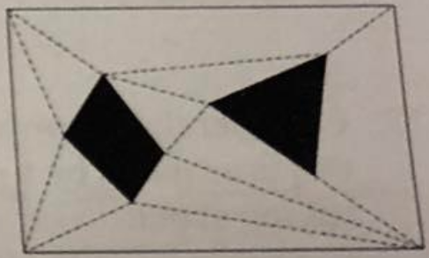
  - triangular cell decomposition.

- In the resampling phase of the Monte Carlo localization algorithm:
  - few of the lightest particles are kept to tackle with the kidnapping problem.
  - lighter particles are discarded.
  - heavier particles are more likely to be selected.
  - the heaviest particles are kept as they best represent the pose.
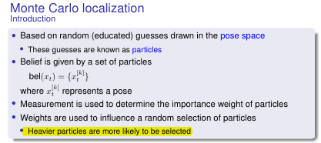
Grupo II
- Consider a robot with tricycle drive with the following characteristics: distance between the rear wheels, 50cm; distance between the rear wheels and the front wheel, 75cm; wheels diameter, 10cm front wheel drive. The robot is turned on moving forward with a steering angle of 0º and, after a given period of time, the front wheel rotated 3.2 laps. Supposing that the initial pose of the robot was(x, y, θ)=(2.3cm, 4.6cm, π/6), at that time instant the new pose of the robot is, approximately:
  - p=(1.8, 3.7, π/6).
  - p=(4.0, 6.5, π/6).
  - p=(2.8, 5.5, π/6).
  - p=(3.2, 5.1, π/6).

Consider that:
cos(π/6)≈ 0.9, cos(π/4)≈0.7, cos(π/3)≈0.5

- Consider an artificial vision system compromising a lens and a CMOS Sensor represented by the simplified pin… model shown above where the(X1,X2) plane represents the lens, the (Y1,Y2) plane represents the Image plane “R” represents the Principal Point of the system. The CMOS sensor has 1920x1080 square pixels with a side of 4μm each. Assume that the intrinsic parameter matrix of this system, K (units in pixels) is the one defined … right side of the picture below.

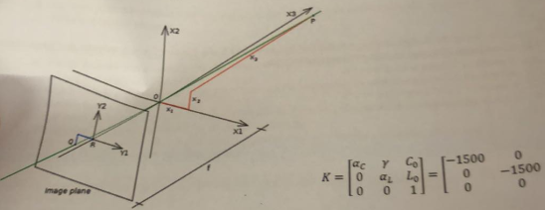

If point(“P”) lies at coordinates P=[x1,x2,x3]=[1,0.8,20] m in the (X1,X2,X3) coordinate system, and… point in the image plane has coordinates (Y1,Y2)=(780,470) the coordinates, expressed in pixels, of the… point “R” are:

- [950, 550].
- [920, 520].
- [930, 530].
- [960, 540].

- A DC motor, attached to the wheel of a robot, has its rotation speed controlled by a PWM controller (picture on the right). This configuration allows the motor (and hence the wheel to rotate in both directions). Considering that, at a certain instant, the 4 outputs of the PWM controller have the time diagram shown in the same picture, we can say that the percentage of the maximum energy applied to the motor and its rotation direction is the following:
  - 60%, counter-clockwise rotation.
  - 60%, clockwise rotation.
  - 20% , clockwise rotation.
  - 20%, counter-clockwise rotation.

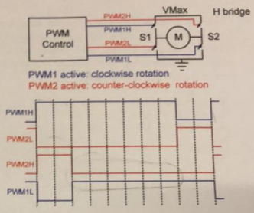

- If you join, using the Kalman Filter, a belief that has a mean of 0 and variance 2 and a measure that has ... of 3 and variance of 4, you should get a new belief with:
  - a mean of 1.5 and a variance of 6.
  - a mean of 1.5 and a variance of 4/3.
  - a mean of 2 and a variance of 2/3.
  - a mean of 1 and a variance of 4/3.

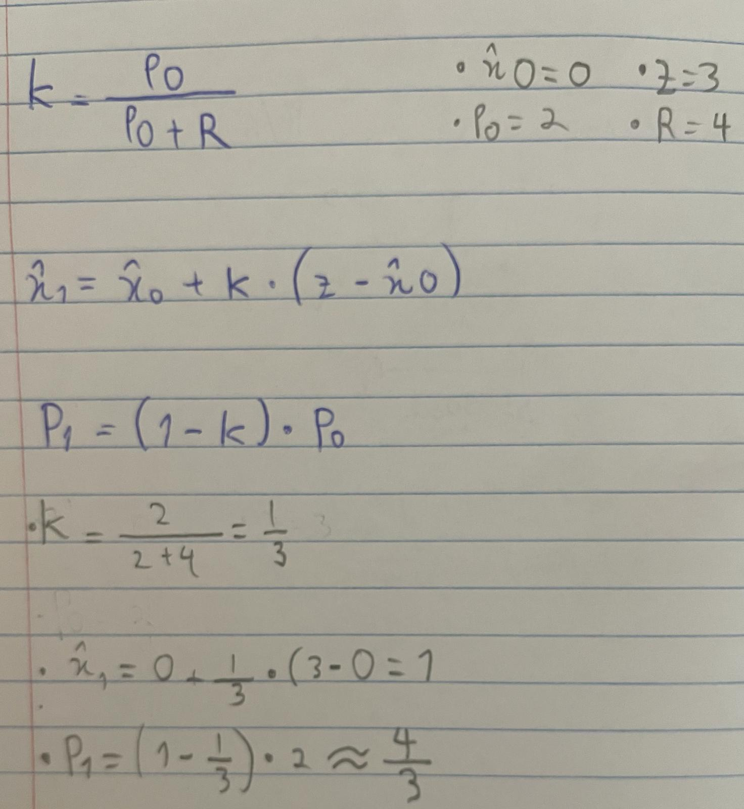

- Suppose that the calculation of a rotation movement in an agent for a differential-drive robot results in a difference of (new_angle - previous_angle)=600°. In this case, in order to minimize the movement performed, the robot should rotate:
  - 120° clockwise.
  - 60° clock wise.
  - 60° counter-clockwise.
  - d. 240º counter-clockwise.

