Hotel Booking Data Analysis
Final Project Report
Group members: Eljona Pacolli, Allan Jakubovits, Denis Anderson, Jekaterina Zasijenko

1. Context and Research Questions
What one row represents: one hotel booking (completed or cancelled).
Population and period: 1,000 sampled bookings from a city hotel (Lisbon) and a resort hotel (Algarve), Portugal, with arrival dates from July 2015 to August 2017. Source: António, de Almeida & Nunes (2019), Hotel booking demand datasets, Data in Brief, 22, 41–49.
Purpose: to describe booking patterns, cancellations, and prices at the two hotels and to give evidence-based suggestions to hotel management. The analysis describes associations only, not causes.
Research questions
- Do cancellation rates differ across market segments? (categorical comparison)
- Is the number of guests in a booking associated with the average daily rate (ADR)? (numerical variable, grouped comparison)
- How does the ADR vary by arrival month in each hotel? (time pattern)

2. Data and Methods
The analysis was done in Python (Pandas and Matplotlib) in a Jupyter Notebook, following the workflow inspect → clean → transform → summarize → visualize → interpret → export. The original DataFrame was kept unchanged and all cleaning was applied to a copy (cleaned_df).

2.1 Data inspection and cleaning
The raw data has 1,000 rows and 20 variables. We checked the eight required data-quality issues; the decisions are summarised below. After cleaning, 974 bookings remain and are used in all results.
Issue checked | Evidence | Decision
Missing values | country: 2 missing values | Filled with "Unknown"
Exact duplicates | 26 duplicate rows | Removed (1,000 → 974 rows)
Invalid dates | All arrival months are valid month names | Kept
Negative values | No negative values in numeric columns | Kept
Zero total guests | 3 bookings | Kept in the data; excluded from the guest analysis
Zero total nights | 5 bookings | Kept (same-day stays are possible)
Unusual lead_time | Maximum 542 days; 24 bookings above 365 days | Kept (long lead times are realistic)
Unusual ADR | Maximum 304; no values above 500; 15 bookings with ADR = 0 | Kept (may be complimentary stays)

2.2 Derived variables
Four variables were created: arrival_date (a proper Pandas date built from year, month and day), total_nights (weekend + weekday nights), total_guests (adults + children + babies) and estimated_booking_value (ADR × total_nights).

2.3 Analysis methods
Single variables were described with counts and percentages (categorical) and with mean, median, standard deviation, minimum and maximum (numerical). Relationships were analysed with a crosstab (market segment × cancellation, percentages of each segment), groupby() aggregation (ADR by number of guests) and a pivot table (ADR by arrival month and hotel). Inferential tests were not used.

3. Description of the Main Variables
The sample contains 618 City Hotel bookings (63.4%) and 356 Resort Hotel bookings (36.6%). This describes our sample, not the real size of the hotels. Online travel agents (Online TA) are the largest market segment (481 bookings, 49.4%); together with Offline TA/TO (20.4%) travel agents make up about 70% of bookings. Groups account for 15.1%, Direct for 10.3%, Corporate for 4.2% and Complementary for 0.6% (6 bookings).
Variable (n = 974) | Mean | Median | Std | Min | Max
Lead time (days) | 102.84 | 68.0 | 104.81 | 0 | 542
Average daily rate (ADR) | 101.45 | 94.5 | 46.14 | 0 | 304

Lead time is strongly right-skewed: many bookings are made shortly before arrival, but some are made up to 542 days ahead. The median (68 days) is much lower than the mean (102.8 days), so the median describes a typical booking better. ADR is moderately right-skewed, with the mean slightly above the median.

4. Results and Visualizations

4.1 Cancellation rates by market segment
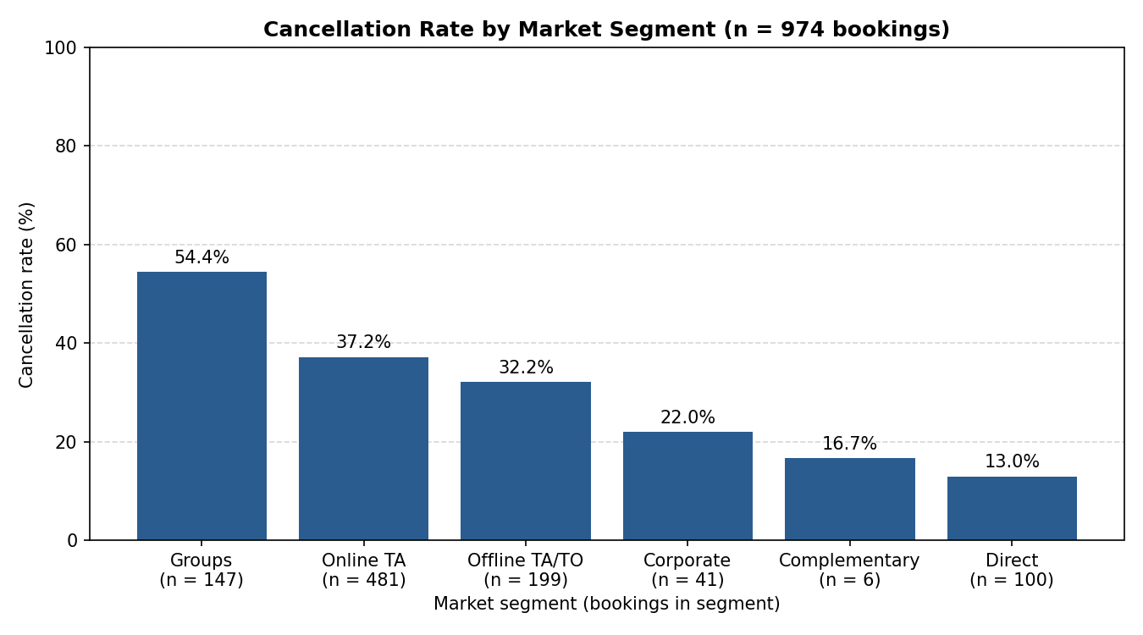
Figure 1. Cancellation rate by market segment (n = 974 bookings).
What can we observe? Overall, 346 of 974 bookings (35.5%) were cancelled. Group bookings have the highest cancellation rate (54.4%, 147 bookings), followed by Online TA (37.2%) and Offline TA/TO (32.2%). Corporate (22.0%) and Direct bookings (13.0%) have the lowest rates among the larger segments. Complementary shows 16.7%, but this is only 1 of 6 bookings and should not be interpreted. The figure shows differences between channels; it does not explain why guests cancel.

4.2 Distribution of the average daily rate
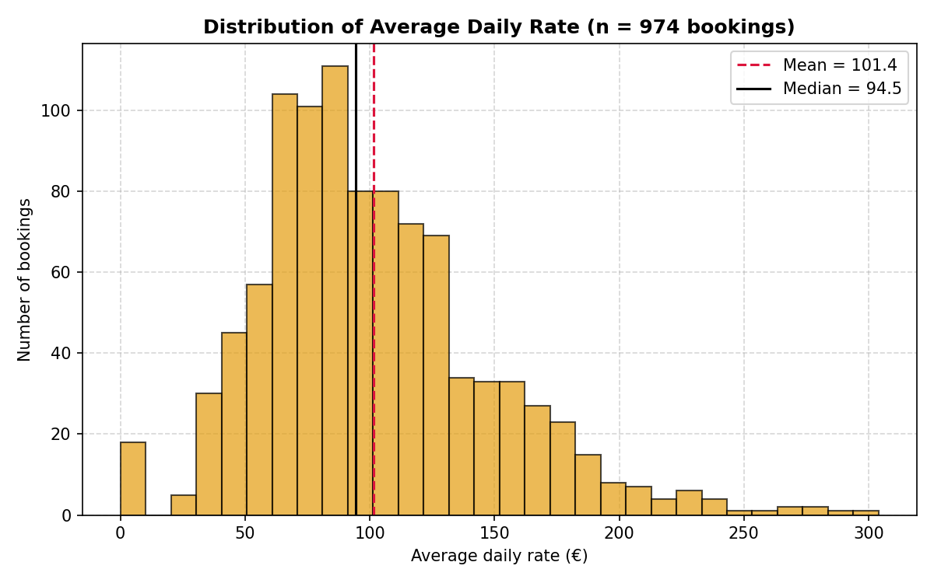
Figure 2. Distribution of average daily rate (n = 974 bookings).
What can we observe? The distribution is not symmetric: most bookings are on the left side and a small tail goes to the right. The middle half of bookings has an ADR between about 69 and 125, the mean is 101.4 and the median 94.5, and the maximum is 304. The long right tail contains rare high-priced bookings. Fifteen bookings (1.5%) have an ADR of 0; some may be complimentary stays, but the data cannot confirm this, so they were kept.

4.3 Guests and average daily rate by hotel
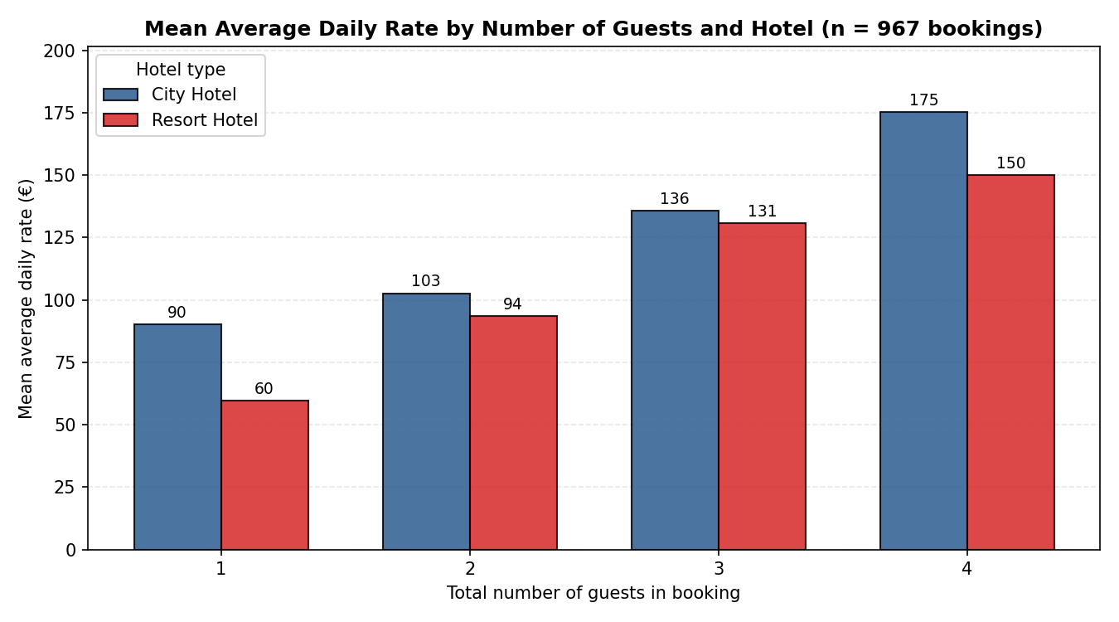
Figure 3. Mean ADR by number of guests and hotel (n = 967 bookings with 1–4 guests).
What can we observe? The mean ADR rises with the number of guests in both hotels. Overall, the mean ADR is about 81 for 1 guest, 99 for 2 guests, 134 for 3 guests and 163 for 4 or more guests (correlation 0.40, a moderate positive association). The City Hotel has a higher mean ADR than the Resort Hotel for every party size shown (for example 90 vs 60 for 1 guest and 175 vs 150 for 4 guests). Parties of 4 are rare (36 bookings), so these values are less reliable. The data show an association, not its reason.

4.4 Average daily rate by arrival month and hotel
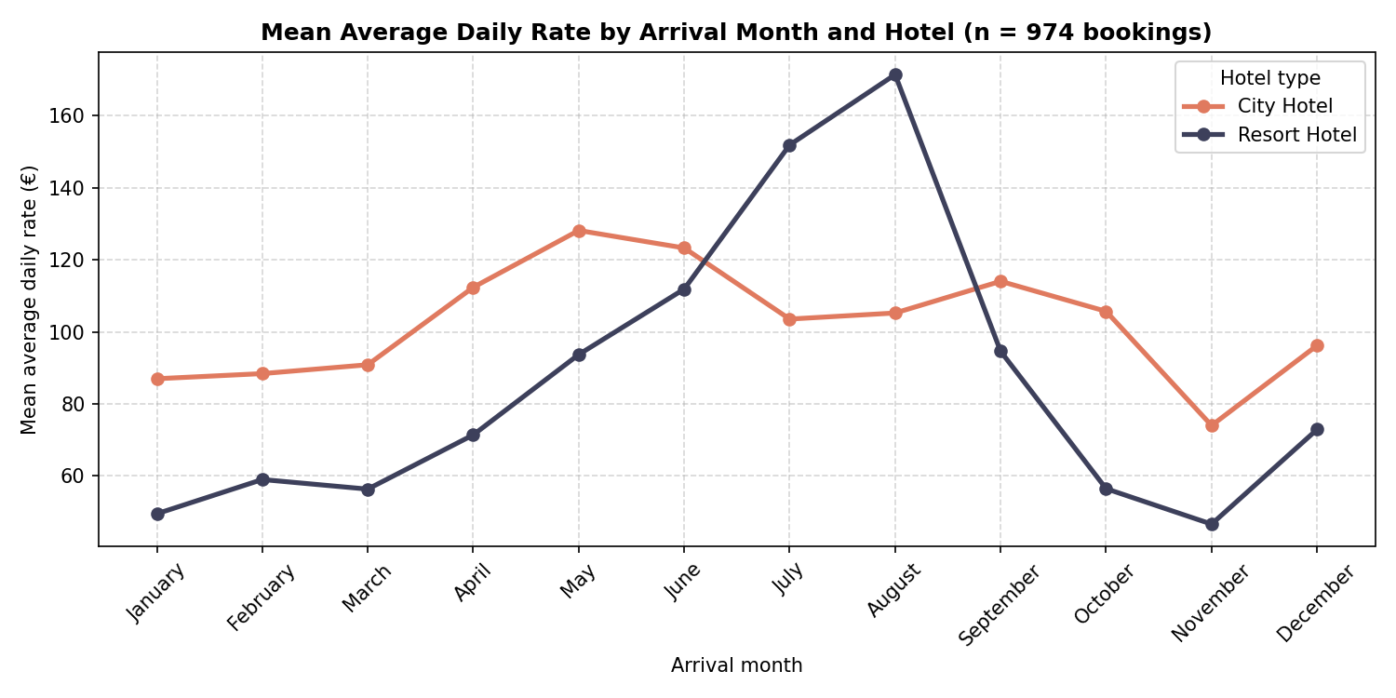
Figure 4. Mean ADR by arrival month and hotel (n = 974 bookings).
What can we observe? The Resort Hotel has a strong seasonal pattern: its mean ADR stays below 75 from October to April, rises from May, and peaks in July (151.9) and August (171.4). It is above the City Hotel only in July and August. The City Hotel varies much less, between 74.0 (November) and 128.2 (May), with its highest values in spring. A possible explanation is seasonal demand, but the data do not show causes. Each month and hotel combination contains only 16 to 77 bookings, and July and August include three arrival years while other months include two, so the monthly means are rough estimates.

5. Conclusions

5.1 Answers to the research questions
- Cancellations by market segment: cancellation rates differ clearly between segments. Group bookings had the highest rate (54.4%), followed by Online TA (37.2%) and Offline TA/TO (32.2%); Direct bookings had the lowest (13.0%).
- Guests and ADR: a larger party is associated with a higher ADR. Single guests averaged about €81 per night, two guests about €99, three guests about €134 and four or more guests about €163. The City Hotel had a higher ADR than the Resort Hotel for every party size.
- ADR by month and hotel: the two hotels behave very differently. The Resort Hotel is strongly seasonal, with €151.9 in July and €171.4 in August and values below €50 in November and January. The City Hotel stays between €74 and €128 all year.

5.2 Key findings
- Channel differences: Online TA, Offline TA/TO and Group bookings make up about 85% of bookings, but their cancellation rates (32% to 54%) are well above the rate for Direct bookings (13%).
- Resort price seasonality: the Resort Hotel's mean ADR in August (€171.4) is about 3.7 times its November value (€46.6).
- Couples dominate: bookings with 2 guests are 65.6% of all bookings (639 of 974).
- Party size and price: mean ADR roughly doubles from 1 guest (about €81) to 4 or more guests (about €163).

5.3 Limitations and cautions
- Small subgroups: the data are a 1,000-record sample, so small groups (Complementary with 6 bookings, parties of 5 or more guests, and single month–hotel combinations with 16 to 77 bookings) are unstable and should be interpreted carefully.
- Observational data only: all findings are associations, not proven causes. Factors such as flight prices, local events or weather were not recorded.

5.4 Recommendation for hotel management
Consider stricter cancellation terms or non-refundable deposits for Group bookings and Online TA bookings, which have the highest cancellation rates (about 37% to 54%). At the same time, encourage direct bookings with incentives such as free breakfast or late check-out, since Direct bookings have the lowest cancellation rate (13.0%). The effect of such measures should be monitored before they are applied widely.

5.5 Next research question
How do lead time, deposit policies and room upgrade types together affect revenue per available room (RevPAR) across seasons? This cannot be answered with the supplied variables because total available rooms, customer IDs and upgrade prices are not included.

5.6 Project files
The group submits the executed notebook (project.ipynb), this report, the recorded video, and the exported files hotel_bookings_cleaned.csv (974 rows) and hotel_booking_summary.csv (24 rows: monthly bookings, cancellation rate, mean ADR and median lead time by hotel).

