#1 (1 point) Describe how formal tools of symbolic logic are used to model real-life situations, including those arising in computing contexts such as program correctness, database queries, and algorithms.

**Symbolic logic can be used for such things like numbers, circuits, computing and logic. This is because these items can be represented by 0 and 1. They can be implemented with transistors and switches. Symbolic logic includes the study of gates, namely AND OR, NOT gates. These can be used to design circuits based of truth tables. This then sets the stage for things like programming and other computing mechanisms**

#2

C= goes to the capital

B= bus stop is there

|  |  |  |  |  |
| --- | --- | --- | --- | --- |
| c | b | c/\~b | ~c/\b | ~c/\~b |
| t | t | f | f | f |
| t | f | t | f | f |
| f | t | f | t | f |
| f | f | f | f | t |
|  |  |  |  |  |

1. How many of the three women are women are truthtellers?

**Since three women all have the same statements, they must be all truth tellers or liars, The statement must be false because on the truth table not one line are exactly two women make true statements.**

1. Does the road go to the capital? Is the bus stop at the location where Ellen spoke to the women?

**In the first line of the truth table the women give false statements. That means g and b are both true statements so the road goes to the capital and a bus stop was there.**

#3 (2 point) Construct truth tables for each of the following:

A)

|  |  |  |
| --- | --- | --- |
| s | t | (s/\t)\/~(s/\t) |
| f | f | t |
| f | t | t |
| t | f | t |
| t | t | t |

B)

|  |  |  |
| --- | --- | --- |
| s | t | (s\/t)->(s/\t) |
| f | f | t |
| f | t | f |
| t | f | f |
| t | t | t |

#4 (1 point) Add 11010 to 1011. Show your work. Convert to decimal and check your work.

**1**

**%11010 = %100101 (1 + 4 +32) = 37**

**+%1011**

#5 (1 point)

P(x): x knows a language

Q(x): x drinks Mountain Dew.

Write a statement is equivalent to “There is a programmer that knows a language and doesn’t drink Mountain Dew.

**∃ P(x) /\ ~ Q(x)**

#6 (1 point) If p = True q = False and r = False what is q^ (¬pV¬r).

**It would be false, F^(~T \/ ~R) t or f = F**

#7 (1 point) Create a truth table to prove that (p -> q) V (q -> p ) is a tautology.

|  |  |  |
| --- | --- | --- |
| P | Q | (p -> q) V (q -> p ) |
| f | f | t |
| f | t | t |
| t | f | t |
| t | t | t |

#8 (2 points) Convert the following

(a) binary to decimal 11101110

**128 64 32 16 8 4 2 1 128 + 64 + 32 +8 + 4 + 2 + 1 = 238**

**1 1 1 0 1 1 1 0**

(b) binary to decimal 10101

**16 8 4 2 1 16 + 8 +1 = 21**

**1 0 1 0 1**

(c) decimal to binary 42

**42 = (2 + 8 + 32)101010**

(d) decimal to binary 143

**143 = (1+ 2 + 4 + 8 + 128) = 10001111**

#9 (1 point) Draw the logic gates for (AB+B’C)



#10 (2 points) Convert the following circuit to its equivalent truth table. What logical operations does this circuit compute?

|  |  |  |  |  |  |  |
| --- | --- | --- | --- | --- | --- | --- |
| D | K | C | S | D/\K | C/\~S | (D/\K)\/(C/\~S) |
| 0 | 0 | 0 | 0 | 0 | 0 | 0 |
| 0 | 0 | 0 | 1 | 0 | 0 | 0 |
| 0 | 0 | 1 | 0 | 0 | 1 | 1 |
| 0 | 0 | 1 | 1 | 0 | 0 | 0 |
| 0 | 1 | 0 | 0 | 0 | 0 | 0 |
| 0 | 1 | 0 | 1 | 0 | 0 | 0 |
| 0 | 1 | 1 | 0 | 0 | 1 | 1 |
| 0 | 1 | 1 | 1 | 0 | 0 | 0 |
| 1 | 0 | 0 | 0 | 0 | 0 | 0 |
| 1 | 0 | 0 | 1 | 0 | 0 | 0 |
| 1 | 0 | 1 | 0 | 0 | 1 | 1 |
| 1 | 0 | 1 | 1 | 0 | 1 | 1 |
| 1 | 1 | 0 | 0 | 1 | 0 | 1 |
| 1 | 1 | 0 | 1 | 1 | 0 | 1 |
| 1 | 1 | 1 | 0 | 1 | 0 | 1 |
| 1 | 1 | 1 | 1 | 1 | 0 | 1 |

#11 (1 point) Use the following Logic Gate and inputs to determine the output.

**The output to the logic gate for 11 is 0**

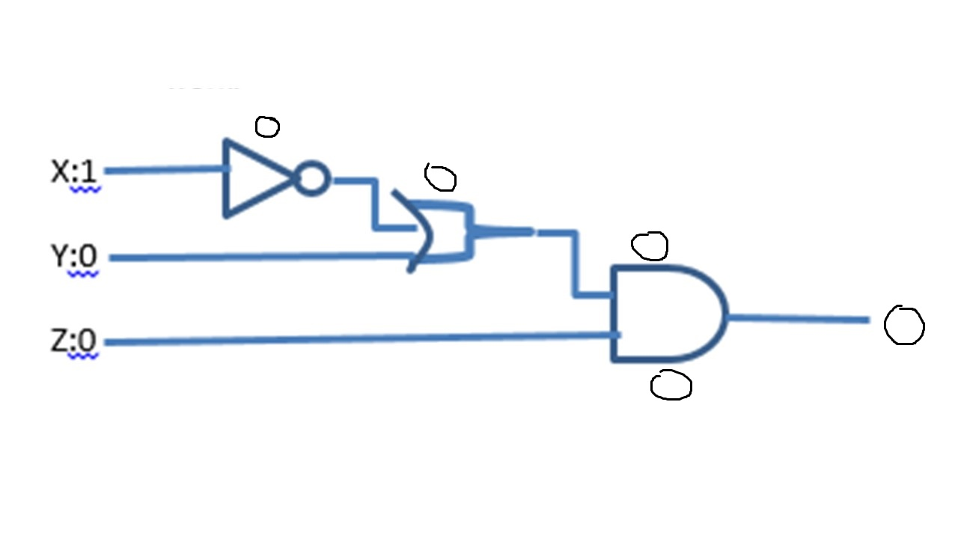

#12 (3 points) Agatha, Bartholomew, Cornelia, Delmer, and Elmira are all the members of a small club. Both Agatha and Bartholomew would like to be the president of the club. Cornelia, Delmer, and Elmira will vote to see who will be the president. Each votes “1” for Agatha, or “0” for Bartholomew. Draw a circuit whose inputs are C, D, E and whose output is 1 if Agatha wins, and 0 if Bartholomew wins.

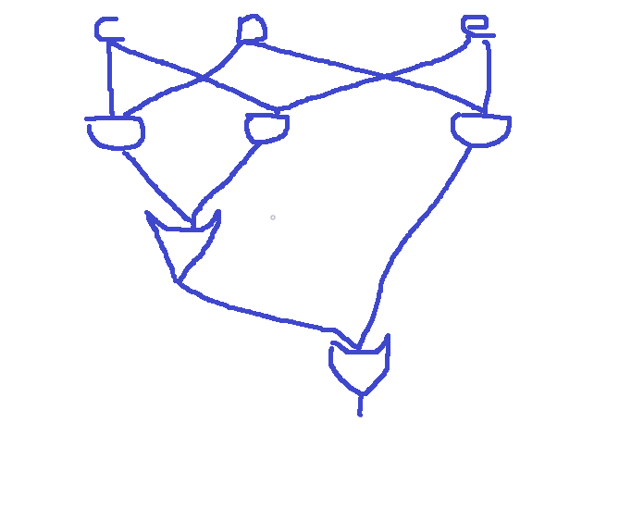

#13 (3 points) Create the equation AND a logic gate circuit for the following

**~A~BC + ~ABC +AB~C**

