#1

**#include <iostream>**

**using namespace std;**

**int main(){**

**cout << "Divisible by 2" << endl;**

**for(int i=1;i<51;i++){**

**if(i % 2 == 0) {**

**cout << i << '\t';**

**}**

**}**

**cout << endl;**

**cout << "Divisible by 3" << endl;**

**for(int k=1;k<51;k++){**

**if(k % 3 == 0){**

**cout << k << '\t';**

**}**

**}**

**cout << endl;**

**cout << "Divisible by 2 and 3" << endl;**

**for(int j=1;j<51;j++){**

**if(j % 3 ==0 || j % 2 ==0){**

**cout << j << '\t';**

**}**

**}**

**cout << endl;**

**cout << "Not divisible by 2 and 3" << endl;**

**for(int a=1;a<51;a++){**

**if(!(a%3 == 0 || a%2 ==0)){**

**cout << a << '\t';**

**}**

**}**

**}**

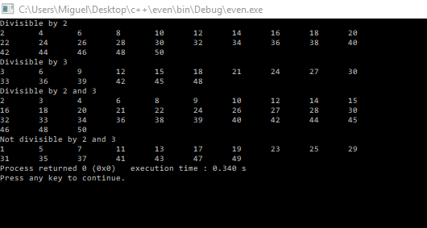

#2 Let A = {1, 2, 6}, B={0, 3}, C= {0, 1, 3, 9} Find the following

1.Power set of B

**{0, {0}, {3},{0,3} }**

2. Determine if any are a subset of another set

***Yes B is a subset of C***

3.A⊂B

**False**

4. A x B

**{(1,0) (1,3) (2,0) (2,3) (6,0 (6,3)}**

5. The cardinality of AxBxC

**3x2x4=24**

#3

1. !(C U D) = **1,5,7**
2. (Bn!C) U! (AnD) = **1,3,5,7,8,9**

#4.

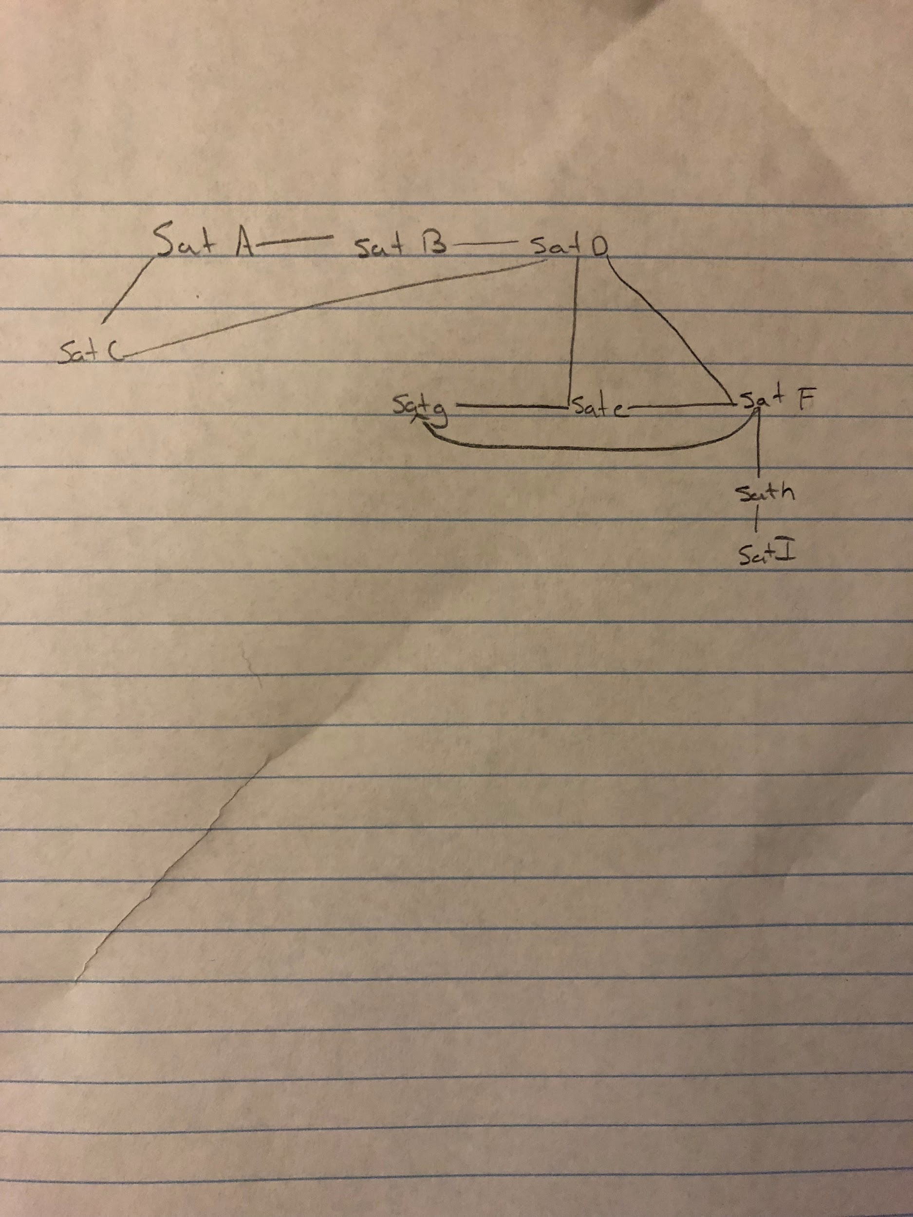

1. If Alice (assigned to SAT-A) wants to call Emily (assigned to SAT-E), how many satellites will her call be routed through?

**It would be routed through two satellites B and D**

2.Which satellite is likely to be the most congested?

**Satellite F and D will be the most congested because it communicates with 4 other satellites each**

3.Is there a satellite whose failure would keep people from communicating, even though neither is assigned to the failing satellite? Which have this property?

**If satellite D was down people assigned to satellite A, B and C would not be able to communicate with people assigned to satellite G, E ,F H and I**

4.Considering the above question, and assuming that all satellites are equally likely to fail temporarily, which satellite would you least want to be assigned to? Which would you most want to be assigned to? Why?

**I would least want to be assigned to satellite I because it is the most remote one and had to travel the longest to reach the other satellites, I would want to be assigned to satellite D because it seems like it's the midpoint and has access to most satellites**

5.What communication-links would you add to make sure that the failure of any single satellite would not cause problems for any phone calls, except those involving somebody assigned to the failing satellite?

**I would add a backup by D and F because those two are really important and have many lines going to them so having a back up to one of those satellites will be really helpful if one of them goes down.**

#5. **A good exam schedule would have edges connecting to two vertices that would not be the same color. This is a good exam schedule because the color represents the time of the exam so having different color vertices means no exam overlaps each other. If he schedules two exams at the same time, the graph would have two vertices of the same color connected by an edge.**

#6. Create a minimal spanning tree for the salesman

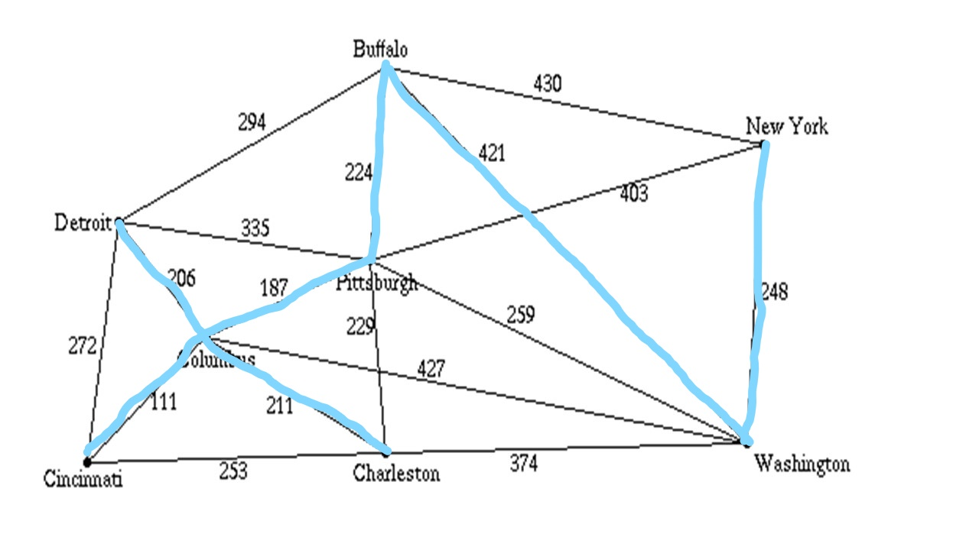#7.

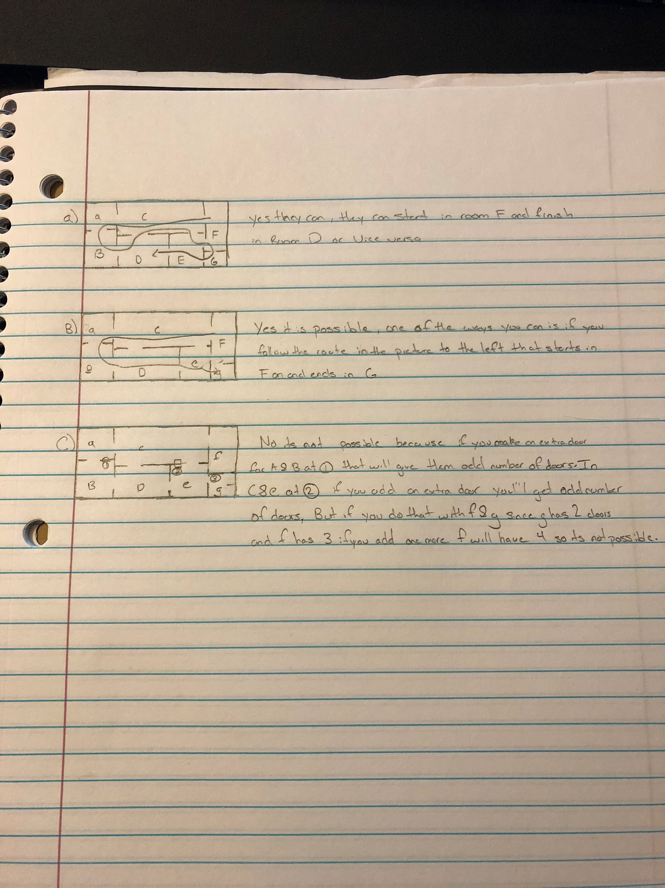

#8. For the following tree, give the order of traversal for each of the following:

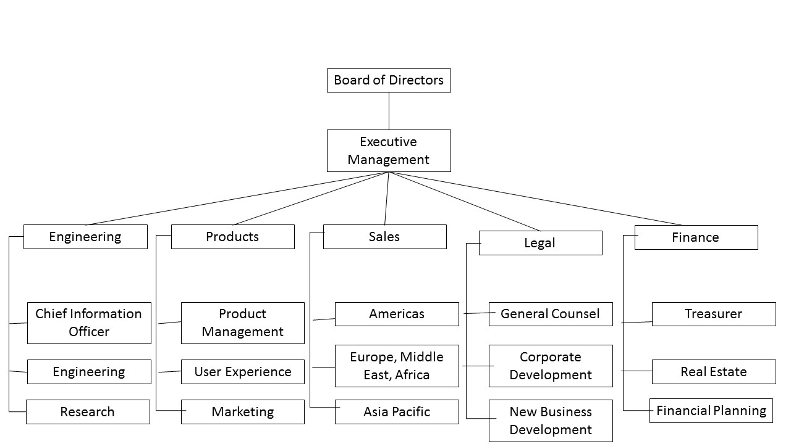

a) Breadth First

Board Of Directors --> Executive management ---> Engineering ---> Products ---> Sales ---> Legal ---> Finance ----> Chief Information Officer --- >Engineering ----> Research ----> Product Management ---> User Experience ---> Marketing ----> Americas ---> Europe,Middle East,Africa ----> Asia Pacific ---> General Counsel ---> Corporate Development ---> New Business Development ---> Treasurer --- > Real Estate ---> Financial Planning

b) Depth first in order

Chief Information Officer ---> Engineering ---> Research ---> Engineering ---> Executive Management ---> Board of Directors ---> Product Management ---> User Experience ---> Marketing ---> Products ---> Americas ---> Europe,Middle East,Africa ----> Asia Pacific ---> Sales --- >General Counsel ---> Corporate Development ----> New Business Development --- Legal ---> Treasurer ---> Real Estate ---> Financial Planning ---> Finance

c) Depth First Post Order

Chief Information Officer ---> Engineering ---> Research ---> Product Management ---> User Experience ---> Marketing ---> Americas ---> Europe,Middle East,Africa --> Asia Pacific ---> General Counsel ---> Corporate Development ---> New Business Development ---> Treasurer ---> Real Estate ---> Financial Planning ---> Finance ---> Engineering ---> Products ---> Sales ---> Legal ---> Finance ---> Executive Management ---> Board of Directors

d) Depth First preOrder

Board Of Directors ---> Executive management ---> Engineering --->Products ---> Sales ---> Legal ---> Finance ----> Chief Information Officer ---> Engineering ---> Research ---> Product Management ---> User Experience ---> Marketing ----> Americas ---> Europe,Middle East,Africa ---> Asia Pacific ---> General Counsel ---> Corporate Development ---> New Business Development ---> Treasurer ----> Real Estate ---> Financial Planning

#9.

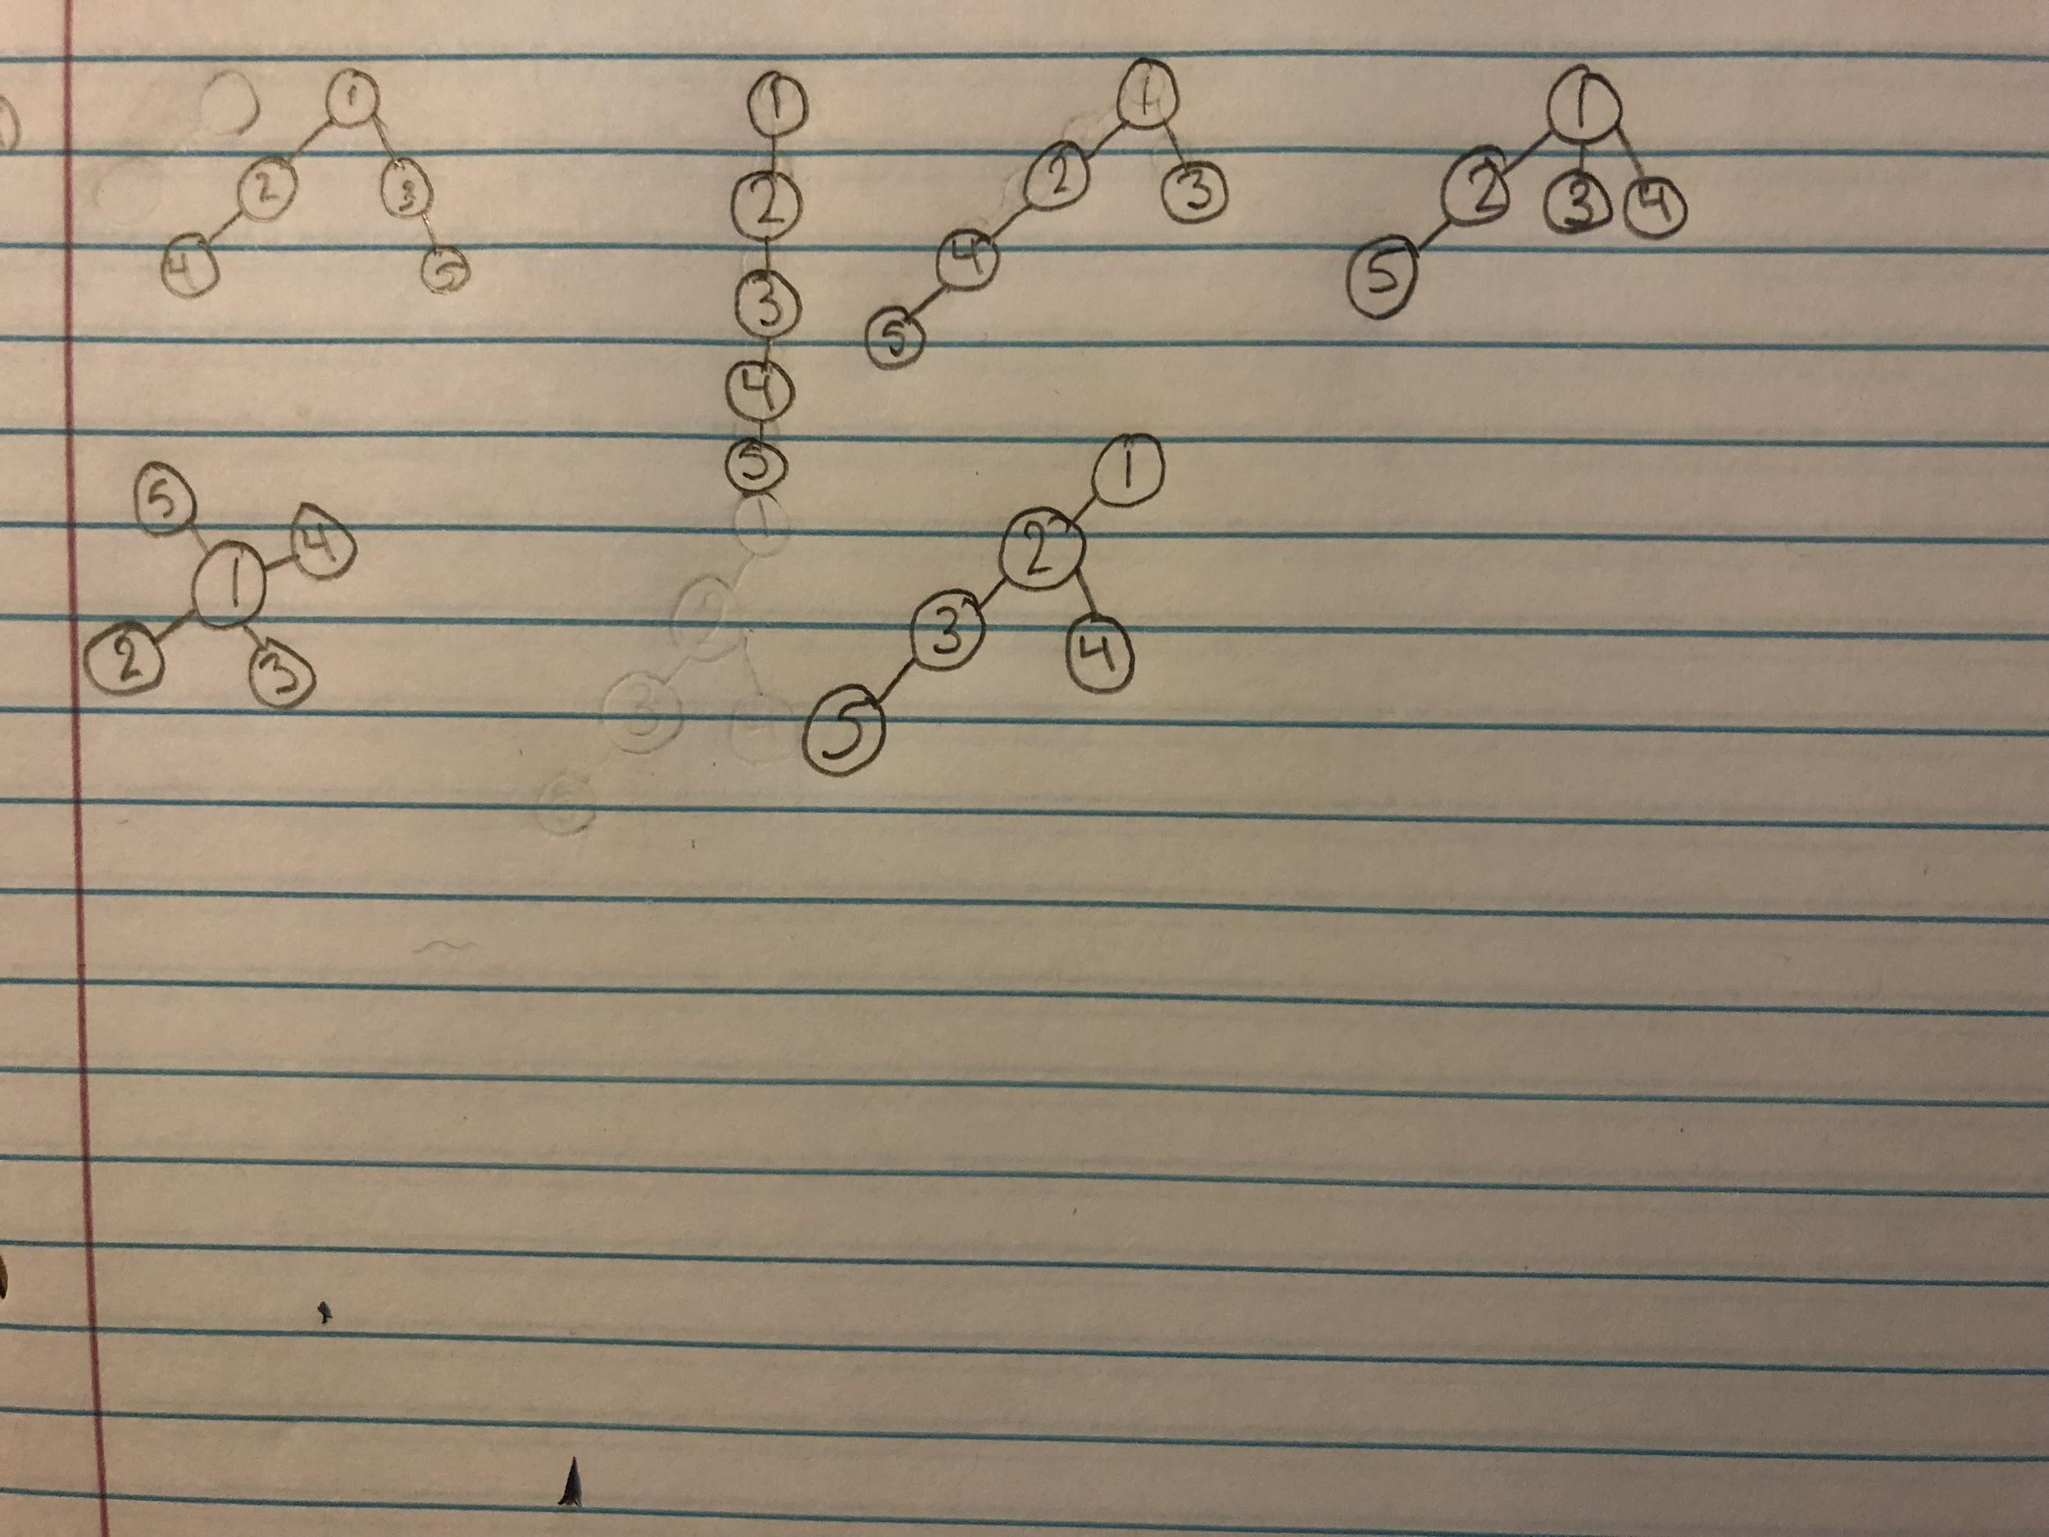

#10.

