#1 (2 points) Create a recursive algorithm that will reverse a string of characters

**A recursive function (reverse) takes in a string pointer (str) as input and calls itself with its next location to passed pointer (str+1) when the pointer reaches ‘\0’ all functions in the stack print char at passed location (str) and return one by one**

2. Come up with a formula that will allow you to pay off $10000 credit card debt. The credit card company charges you a monthly interest rate of 2%. How much do you have to pay per month to pay it off in 3 years? Create an explicit and recursive formula for paying off credit card debt.

**an= an-1 + 0.02 with a0 = 10000 - recursive**

**An = 10000+10000(0.02n) - explicit**

**A36 = 10000+10000(0.02(36)) = 17,200/36**

**478 dollars a month**

3.

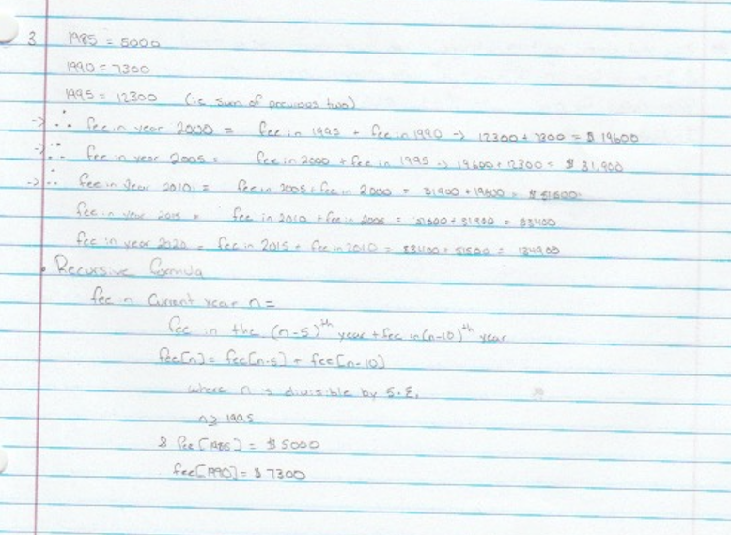

4.

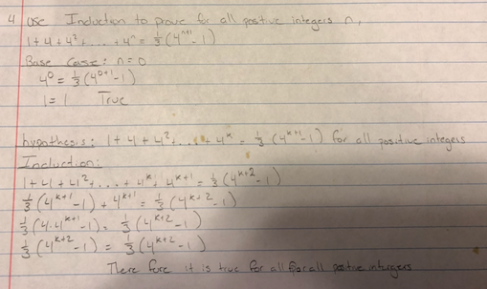

5.

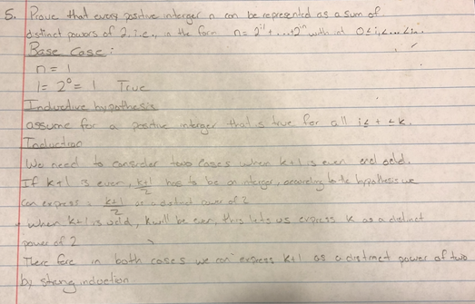

6.

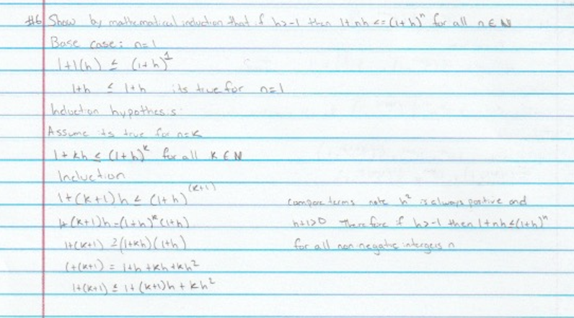

7. **int gcd(int i, int j) {**

**If ((i%j) == 0)**

**return n;**

**Else**

**Return gcd(j,i%j); // recursion happens right here**

**}**

**8.#include<stdio.h>**

**int recursiveSquare(int n){**

**if(n==1){**

**return 1;**

**}else{**

**int m=recursiveSquare(n-1);**

**return m+2*(n-1)+1;**

**}**

**}**

**int main(){**

**printf("Square of 5 is %d",recursiveSquare(5));**

**}**

8b

