The concept for my app was born from the areas that we had covered to date and the fact that there has been a surge in Hikers as of late (my girlfriend being one of them).When out hiking knowing the weather, your location and what direction you are heading is critical.

For this project I used the same UI as for CA2 ( see below). I added 2 buttons to the main activity which were activate using intent from the main activity to either the Compass Activity or Weather Activity. (see below)

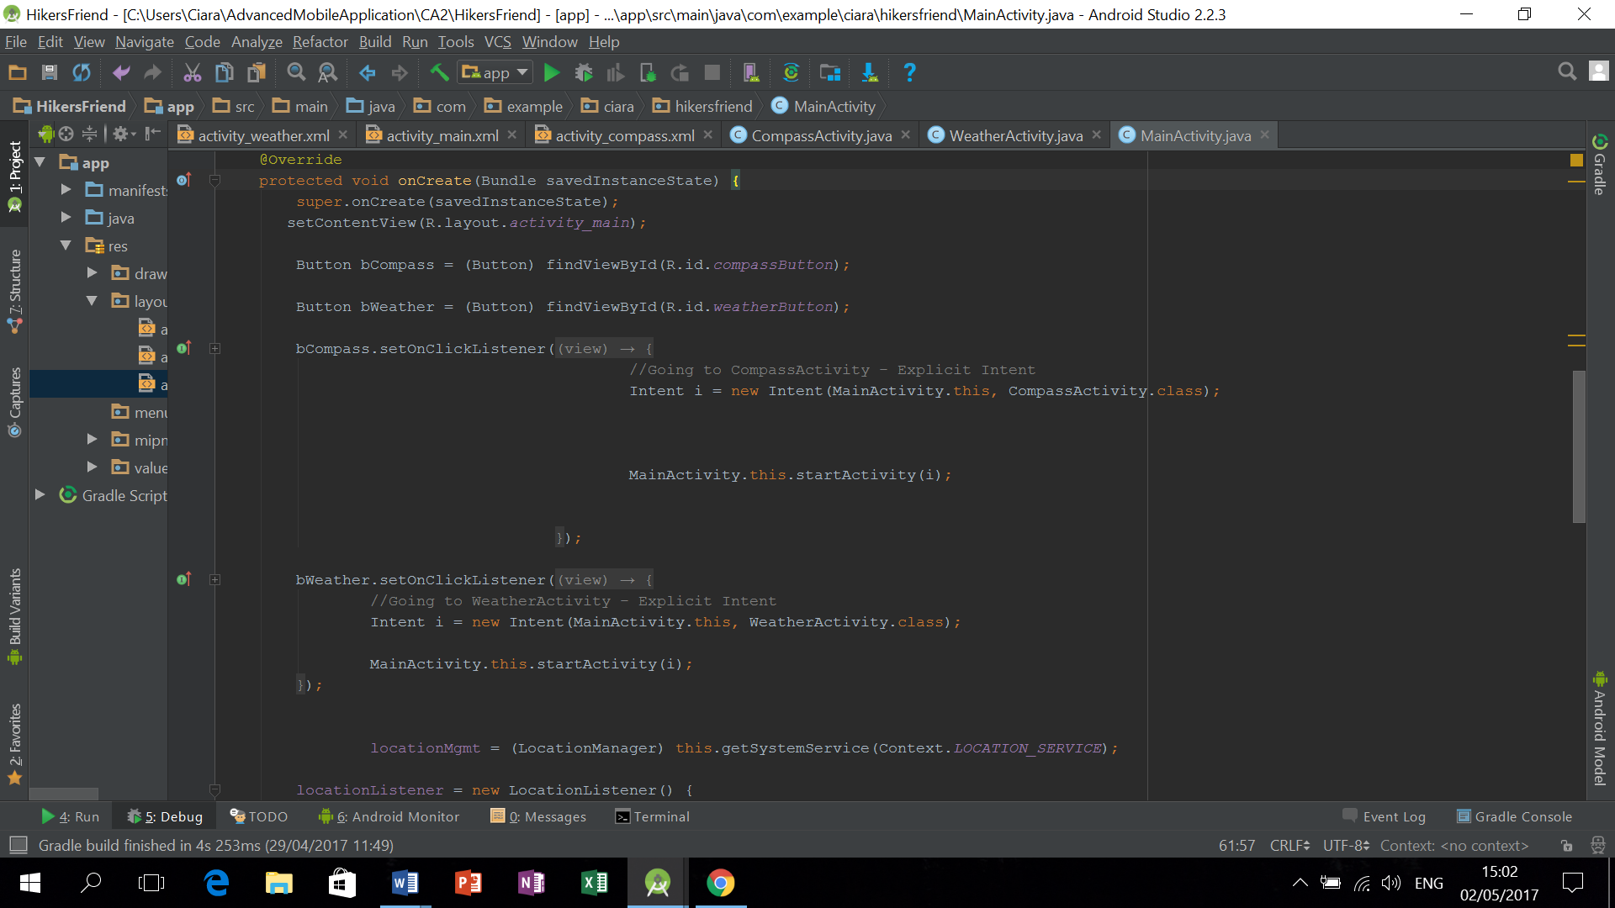

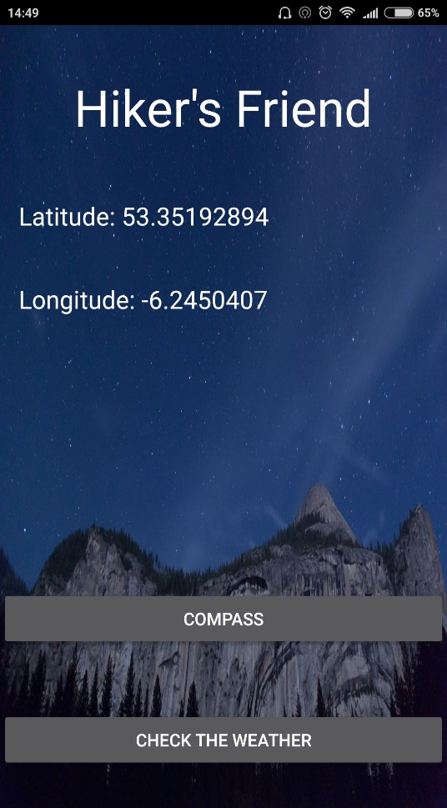

For the weather activity I used a basic UI (same as Main Activity)

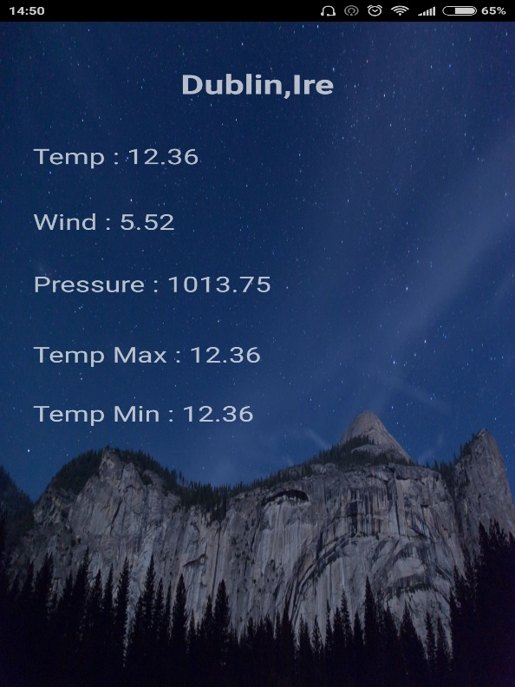

I used the OpenWeatherMap API for this activity. <http://samples.openweathermap.org/data/2.5/weather?lat=35&lon=139&appid=b1b15e88fa797225412429c1c50c122a1>

To simplify matters I used corresponding text fields to match the JSON data that was being parsed from the open weather.

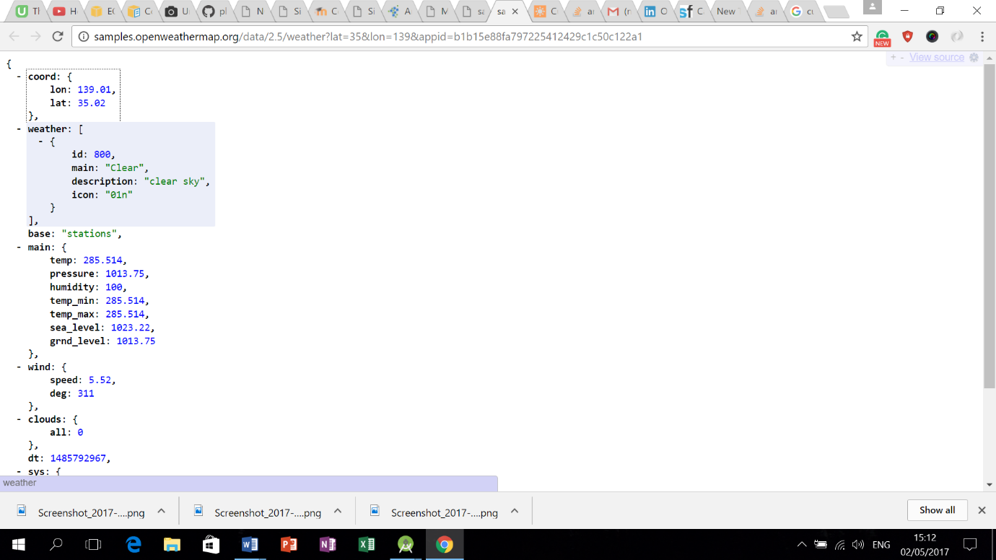

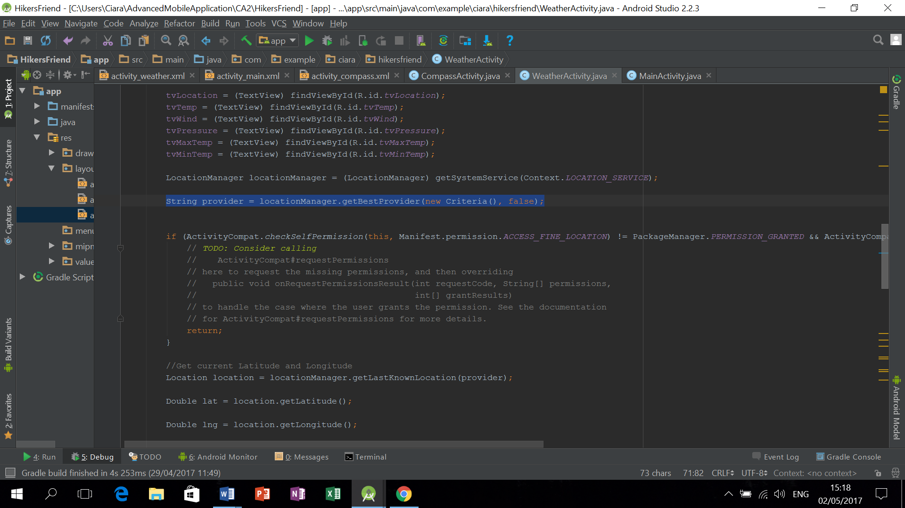

Set up a variable of a type location manager to use Location Service.

Set up provider variable of type string which returns location manager using Criteria Method to access coordinates on phone.

Next, we add permissions to manifest to ACCESS_FINE_LOCATION and to ACCESS INTERNET.

To get location we then use Criteria using the variable “provider” to get “ LastKnownLocation.”

We then use getLatitide and getLongitude methods which return a data type of type double.

We then use Volley to parse the JSON responses from the request queue (see below)

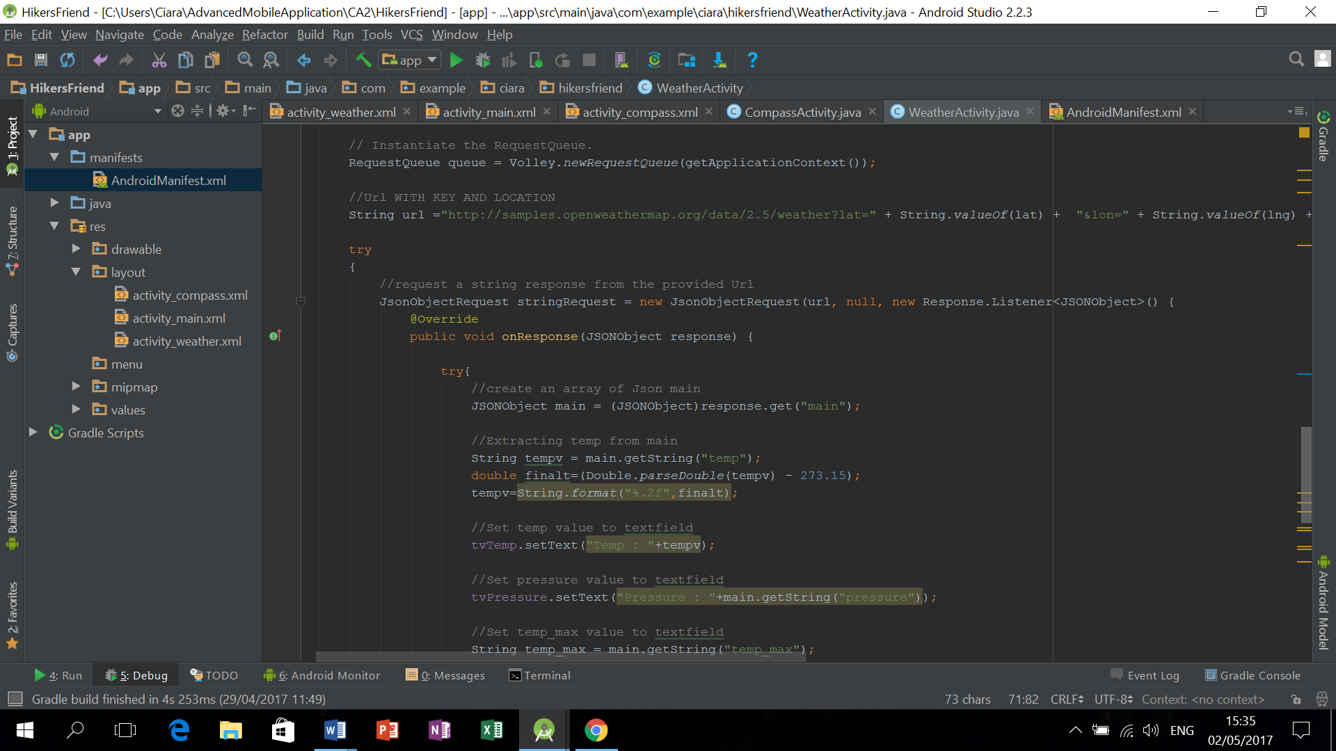

The API I used uses Latitude and Longitude to access the data from API.

I concatenated the value of Latitude and Longitude into the highlighted fields of the API key.

http://samples.openweathermap.org/data/2.5/weather?lat=”35”&lon=”139”&appid=b1b15e88fa797225412429c1c50c122a1

First we create an array of JSON “main:”

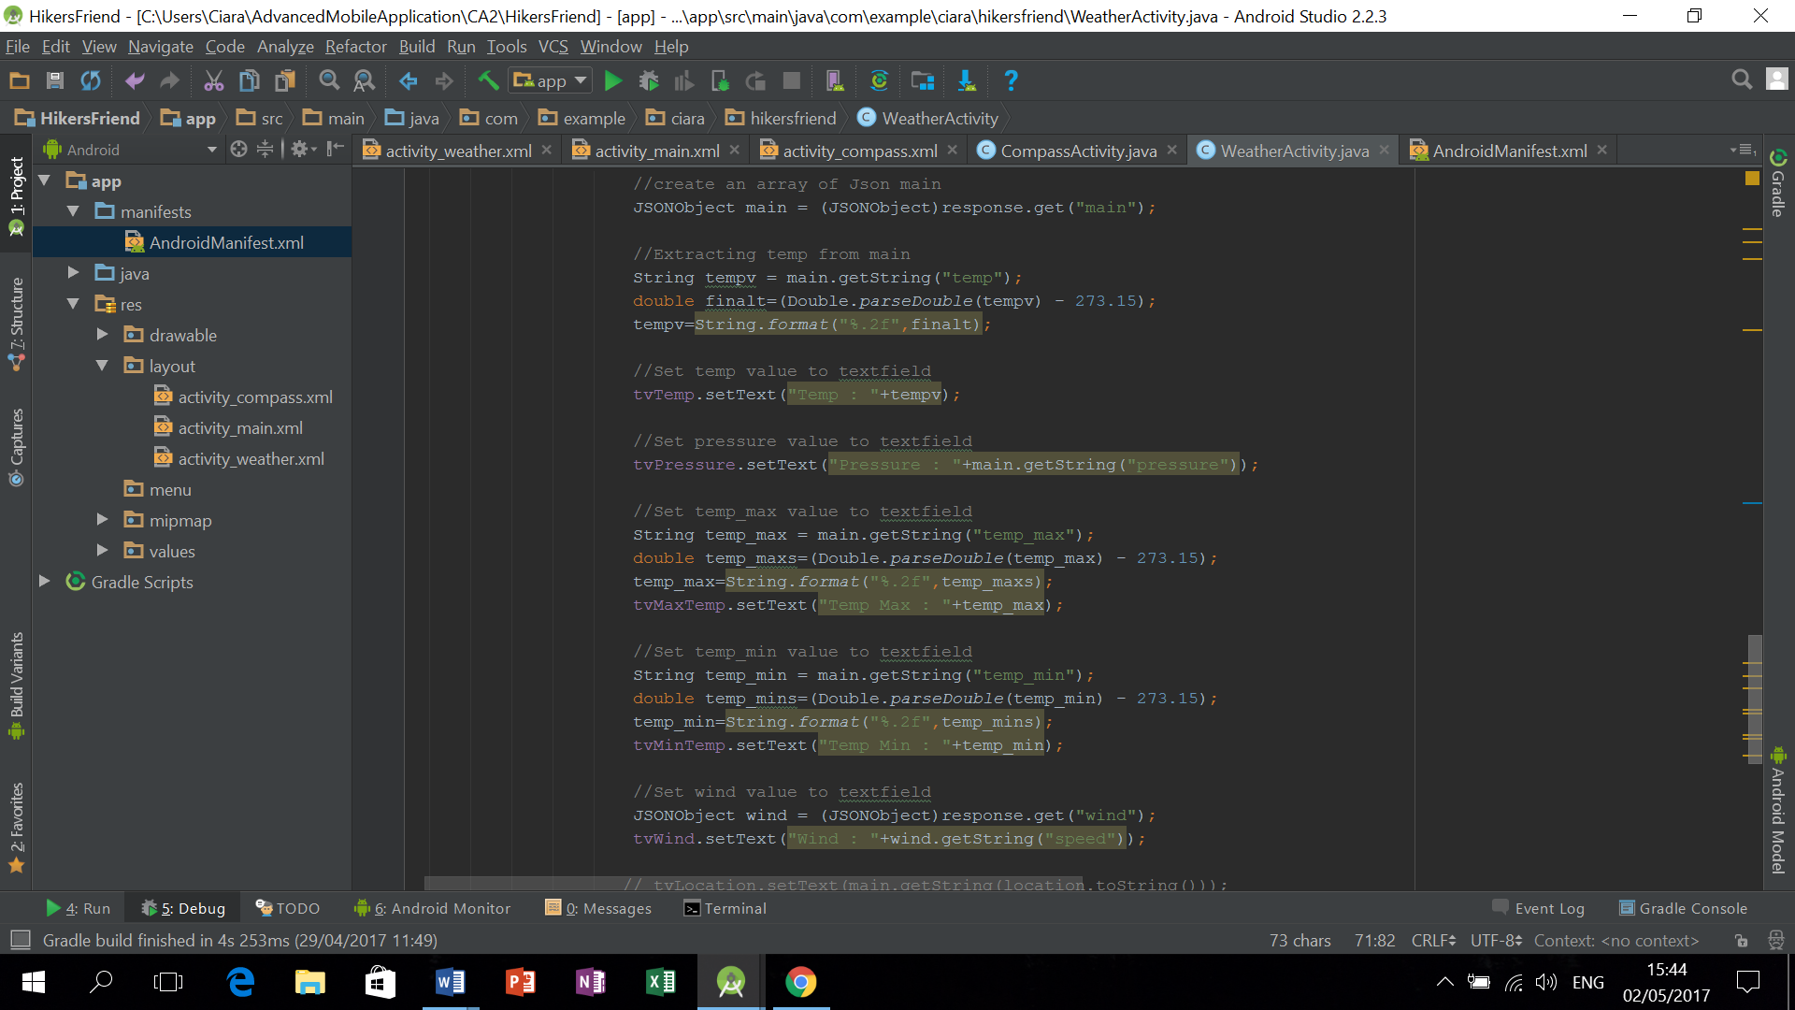

We then want to extract the various data fields from the JSON array into the corresponding text fields.

The temperature data comes in Kelvin so I used a formula to convert it to Celsius and to 2 decimal places.

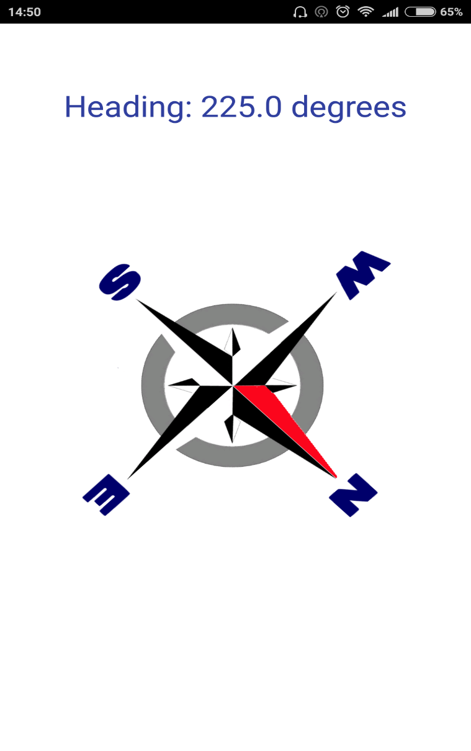

For the Compass Activity I used a transparent compass.png image with a textView to show what Direction you are heading in.

This activity was by far the trickiest and one which I relied heavily upon examples which I found online.

<https://www.javacodegeeks.com/2013/09/android-compass-code-example.html>

First we have to create a SensorEventListener which picks up any movement from the phone.

Next we declare our global variables.

We then initialise that our compass is used whenever the SensorManager is used.

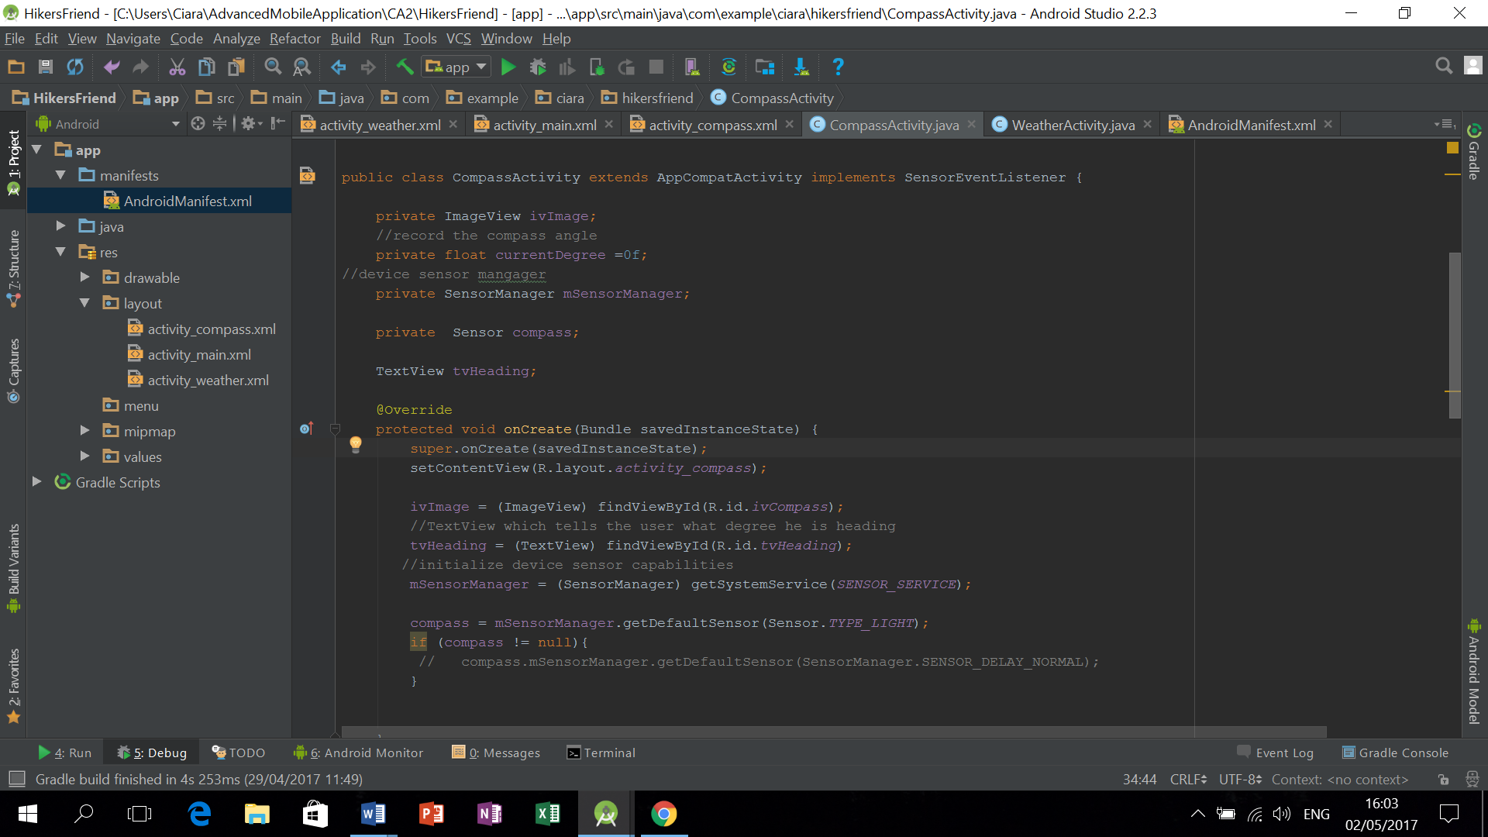

Register our mSensorManager class and our compass class which uses a normal sensor delay.

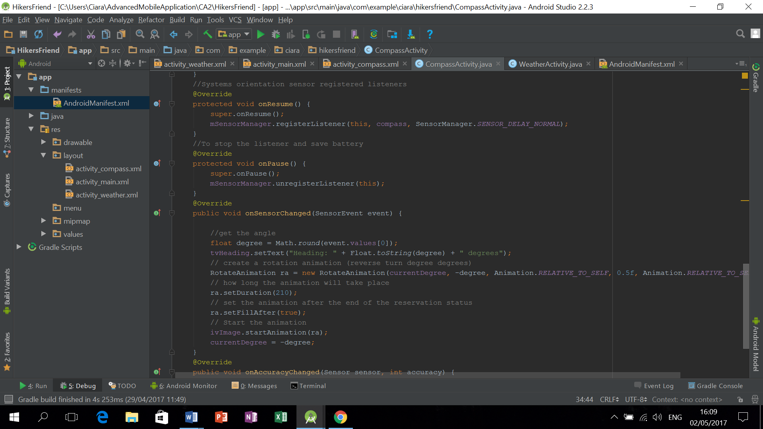

We then unregister the listener whenever we are in the onPause life cycle to save battery.

The onSensorChanged method is the nuts and bolts of how Compass image animation interacts with the sensor to give the user the direction they are going.

To get the direction we use the degree variable which will return 1st “event” from our values array.

We then concatenate this result in our TextView in between “Heading:” and “Degrees:”

We then create RotateAnimation ra class which has a constant of (0.5 f). Couldn’t get Compass class to constantly point north which is the whole point of a compass. I imagine that these our the lines which need to be amended in order for the compass to constantly point north.

Animation is then set for 210 milli seconds.

Start the animation using rotate animation and degree.

NB….I found the compass part of this app quite tricky and requires quite a lot of testing

Resources used;

<https://www.udemy.com/complete-android-n-developer-course/learn/v4/t/lecture/5690104?start=585>

<http://stackoverflow.com/questions/10687409/locationmanagers-getbestprovider-returning-null>

<https://developer.android.com/training/volley/simple.html>

<https://unsplash.com/>

<https://www.javacodegeeks.com/2013/09/android-compass-code-example.html>

<http://samples.openweathermap.org/data/2.5/weather?lat=35&lon=139&appid=b1b15e88fa797225412429c1c50c122a1>

<http://stackoverflow.com/questions/15748323/sensoreventlistener-implementation-do-not-work>