Daniel Olaya Moran
V00855054
CSC225 – Assignment 4

Q1 a)

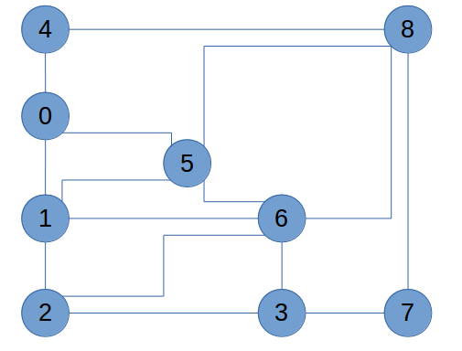

Q1 b)

Q1 c)

Q1 d)

DFS: 0, 1, 2, 3, 6, 5, 8, 4, 7

BFS: 0, 1, 4, 5, 2, 6, 8, 3, 7

Q2

We want to prove m = n – k.

We we will take as proven that m = n -1 for a tree.

Let F be the union of k trees such that F_{k} = U from 1 to k T_{i.}

So let n_{i} be the number of vertices in each tree such that |n| = Sum(n_{i}) from 1 to k = n

Since each component of the forest is a tree, we have k=1

m_{i} = n_{i} – k_{i} –> m_{i} = n_{i} – 1

Therefore, we have proven that m = n-k for an a cyclical graph.

Q3 a)

Input: diagraph G with n vertices
Output: topological ordering of G if the G has unique ordering, else returns string message.

S ← Empty stack
int StackCounter ← 0
for all u in G.vertices() do //counting in-degree of all vertices
incounter (u) ← indeg(u)
if incounter(u) = 0 then
S.push(u) //pushes to the stack all items that can be removed
StackCounter ++
if StackCounter >1 then //checks for unique ordering
return “G does not have unique topological ordering”

i ← 1
while !S.isEmpty() do
u ← S.pop()
StackCounter --
number u as vertex V_{i}
i ++
for all e in G.outIncidentEdges (u) //removing edges from removed node
w ← opposite (u,e)
incounter(w) ← incounter(w) -1
if incounter(w) = 0 then
S.push(w)
if StackCounter >1 then //checks for unique ordering
return “G does not have unique topological ordering”
If i<= n then
return “G has a directed cycle”
return V₁, V₂, … V_{n}

Q3 b i)

By definition,

1. Post order visits the root and the root node first then left sub-tree and finishes with the right sub-tree.
2. In the specified scenario (all children are the source of their parents), all leaves in the tree have an in degree of 0.

Therefore,

Topological sort algorithm says we can remove any of the leafs on our tree, on top of that, post order traversal rules would start visiting leaf nodes on the left sub-tree moving to the right sub-tree (passing through all the in between leaves), which shows the statement is true.

Q3 b ii)

False. By definition, a DAG has a topological sorted order IFF it has no cycles in it.

On the example shown below serves as proof by counter example.

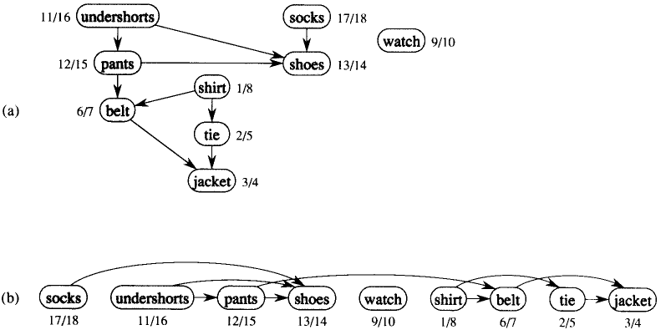
The previous example is a DAG where b) shows its topological ordering. In a), DFS path is shown where back edges have been numbered as part of the path.

Q4)

Consider the universe of people that form part of the network (input). Each person in the network would be represented by nodes and the relation (or lack of) with other people would be represented through edges, people that are friends with each other would have an edge that connect their nodes.

The goal of the problem is to find the largest k or connected component in the graph (output). This problem could be solved by using BFS on the network graph, starting with any random vertex as a starting point. BFS would allow us to start from the selected seed and explore all its neighbor nodes and repeat the process iteratively, until every node graph component has been visited. We would have to repeat the algorithm through all the different vertexes and compare the number of connected nodes on each graph component. The output would be the graph component with the highest number of nodes connected together.

