Developed by: Ben Wolfe (V00205547) and Daniel Olaya (V00855054)
Course: SENG360 - Security Engineering
Date: November, 2017
Assignment 3: Chat program that allows to users to communicate using different security parameters such as encryption, integrity (digital signatures) and mutual authentication.

Required files
The following files are required to run the program:
- Client.java
- Server.java
- AsymmetricCryptography.java
- ClientSignature.java
- ServerSignature.java
- Servercred/credentials.txt
- Servercred/clientRSApublicKey
- Servercred/serverRSAprivateKey
- Servercred/serverRSApublicKey
- Servercred/serverPublicKeySignature
- Clientcred/credentials.txt
- Clientcred/serverRSApublicKey
- Clientcred/clientRSAprivateKey
- Clientcred/clientRSApublicKey
- Clientcred/clientPublicKeySignature

Assumptions

- Client and server have shared their RSA public keys that will be used to encryption, this can be done posting the information online since it does not represent a security risk for the users.

Compiling program

Execute following command
javac -cp *:. ClientSignature.java ServerSignature.java SignatureTesting.java Client.java Server.java AsymmetricCryptography.java

Running the program

Execute following command on a terminal window
java -cp *:. Server

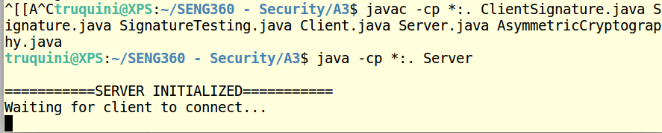
Execute following command on a different terminal window
java -cp *:. Client

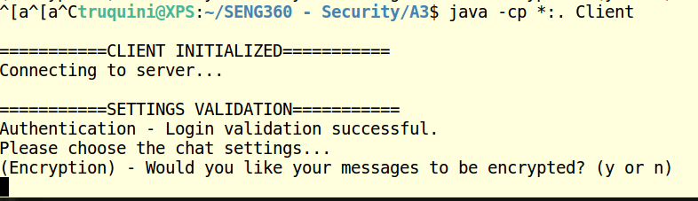

The program will request the client to enter chat settings, use ‘y’ or ‘n’ to select settings. The program will send selected settings and will request the server to enter its desired settings. If both settings are not equal, the connection will restart until both Server and Client have selected the same settings.
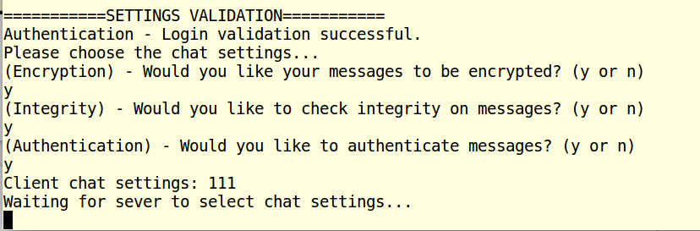

Authentication
If authentication is selected, both the client and server will authenticate to each other. The program hashes the password given by Client and sends it to the server. The server will check the ‘username’ is exists in its login database located in /Servercred/credentials.txt if the login is found, it will proceed to take the salt and hash it with the hash(pass) given. If the result of hash(salt+hash(pass)) matches with the saved entry, the login is valid. If the client login is valid, it will proceed to complete the same process with the server.
WARNING: A list of the plain-text credentials and salt can be found in
/Servercred/credentials-plain.txt this file only exists for assignment grading purposes and should never exist in a production environment.
Proceed to login in Client with username: ‘dan’ and password ‘dan123’.
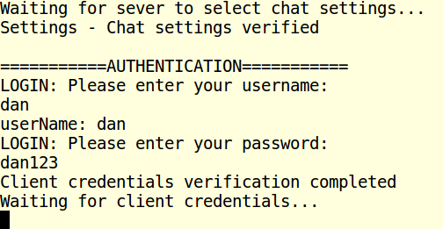

Enter following credentials in Server, username: ‘ben’ and password ‘ben123’.
If wrong password is given by Server or Client, the connection will be restarted for both users.

Integrity
If integrity option is selected, the program will initialize keys that will be used to sign a message (Private key) and validate a message (Public key) using helper class ServerSignature.java and ClientSignature.java

Encryption
If the encryption option is selected, the previously generated keys using the helper class GenerateKeys.java will be initialized using helper class AsymmetricCryptography.java

Encryption
Once all key generation and initialization has been completed, listening and receiving threads will start. Use ‘END’ to finish the conversation. After the conversation is closed, the Server will restart the program and wait for a new connection to be initiated. In the case of the client, it will be able to restart the connection any time by using the command ‘open session’.
