Practical 5 – Hash Functions

Introduction

This site was developed for a Security Principles assignment based upon Hash Functions. This site is best viewed in Mozilla Firefox 7 but it should be fine to view the site in Google Chrome or Safari. If you're using Internet Explorer to view this site then stop immediately and get yourself a proper browser to view it in.
For this research there are several Hash Function exercises that I had to complete. I will explain the different exercises and how they were carried out , also the findings that came from conducting these exercises but firstly lets explain a Hash Function.
Cryptographic Hash Functions are used to provide integrity to messages and it does this by taking some form of data (file, message, etc), it then performs some calculations and produces a hash value repesenting the data. The hash value is basically a figerprint of the data and it is used to check to see if data has been modified in any way. Hash Functions provide the same sized output for each type of inputted file regardless of it size and as such although two completely different message should not give the same hash value, it is possible that this could happen. The image below shows how the Hash function works:

This research will be using the following types of Hash Functions:

- Message Digest Algoritm (MD-5) was designed by Ronald Rivest and first published in 1992. It has descended from the earlier MD-4 and produces a 128 bit hash value.
- Secured Hash Algorithm 1 (SHA-1) which is a revised version the original SHA published in 1995 by U.S National Institute of Technology to help solve weaknesses that were discoverd in SHA. It produces a 160 bit hash value and is slower than MD-5.
- Adler-32 was created by Mark Adler in 1995.

FSUM will be the Hash Functions tool that will be used in througout the research. Developed by SlavaSoft it is a command line tool for generating and verifing hashes for files of any kind of format.

PDF File

In this section I will be testing the following PDF file with the three hash functions to see how differ and how they perform when using PDF files. This is the file that I am using and it is 161kb in size. I also used an edited version of this PDF file in which I just highlighted the text.

MD-5
Firstly I was going to get the MD-5 hash value for the PDF. Below is a screenshot of the command that I ran along with the output. It was able to produce this hash value in under a second and as such I was unable to really test its speed.
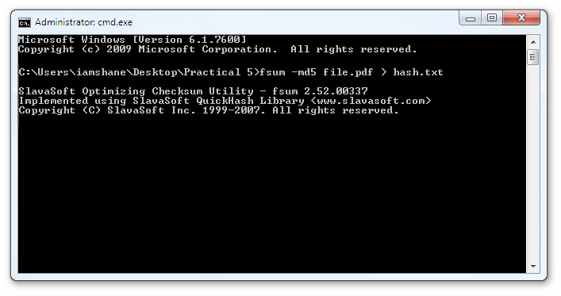
This produces the following 128 bit hash value for the file:

a99f54f76ce8f22b31332d143169ea8d

After I had saved the hash value, I ran the above code again to see if it would produce the same hash value and it did. Next I slightly edited the PDF file and saved it to check if the it would produce a different hash value to the one that is shown above and it did, it produced the hash value below which is complete different to the one that is shown above.

eae4c219db6c5adf7422813b3824fca3

SHA-1
Next I was going to get SHA-1 hash value for the PDF. Below is a screenshot of the command that I ran along with the result. It took roughly the same time as MD-5 to perform the hash function so as of which I was unable to compare the different speeds.
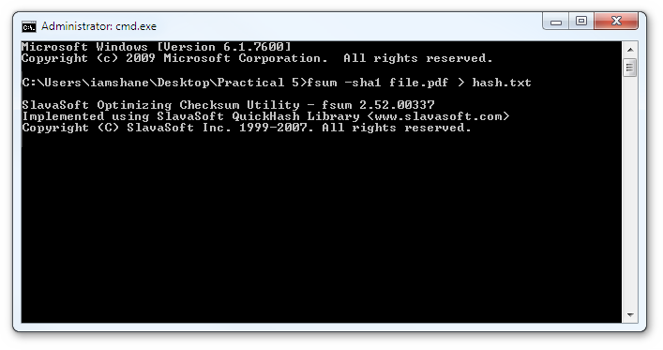
The size of this hash value is slightly larger than the previous. It produced the following 160 bit hash value for the file:

2b6d89dd57270407388a1637fb7af81e39f5528e

Next I ran the code again to see if the hash value would change and it still produced the same hash value. I also ran the above command on the edited PDF version and below is the hash value that it produced which as it should be is completely different to the original hash value.

cc97b51653485571ed2606d82253c8b02f05b824

ADLER-32
Lastly I wanted to get the Adler32 hash value for the pdf. Below is a screenshot of the command that I ran along with the result. The speed that it took to produce the hash value was about the same as two previous hash functions.
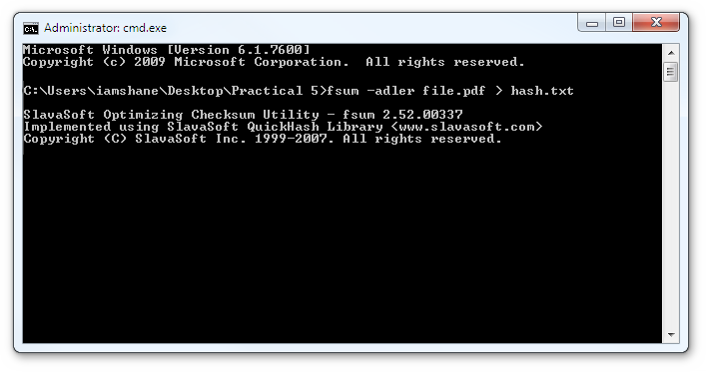
As you will clearly notice the size of this hash value is extremely small when compared to the last two hash values. It produced the following hash value for the file:

20a565e3

Next I ran the code again to see if the hash value would change and it still produced the same hash value. I also ran the above command on the edited PDF version and below is the hash value that it produced which as it should be is completely different to the original hash value.

25392a77

JPG File

Exchange

Conclusion

