**Case Study: Karen’s Diner Business Model Analysis & Forecast**

**Introduction:**

Karen’s Diner, founded by Viral Ventures in Sydney, built its reputation on a unique immersive dining experience where staff deliberately acted rude to customers. While initially popular, its reliance on novelty raised questions about long-term sustainability. This case study, conducted in 2022, applied business analytics frameworks and statistical methods to evaluate its business model and forecast its eventual decline.

**Business Challenges Identified:**

* Labour shortages requiring skilled actors as staff.
* Rising fixed and operating costs (rent, wages, supplies).
* Inflation and supply chain disruptions are driving up food input costs.
* Shifting consumer behaviour towards takeaway and diminishing interest in themed dining concepts.

**Analytical Approach:**

The analysis combined cost structure evaluation, consumer trend analysis, and scenario forecasting. To enhance the study, statistical methods were applied including regression analysis, time-series forecasting, demand modeling, sentiment analysis, and trend analysis. Data sources included IBISWorld reports, industry CPI data, and consumer review sentiment.

**Initial Data-Driven Forecasts:**

Hospitality Inflation Impact (Meals & Drinks CPI Growth 2017–2022)

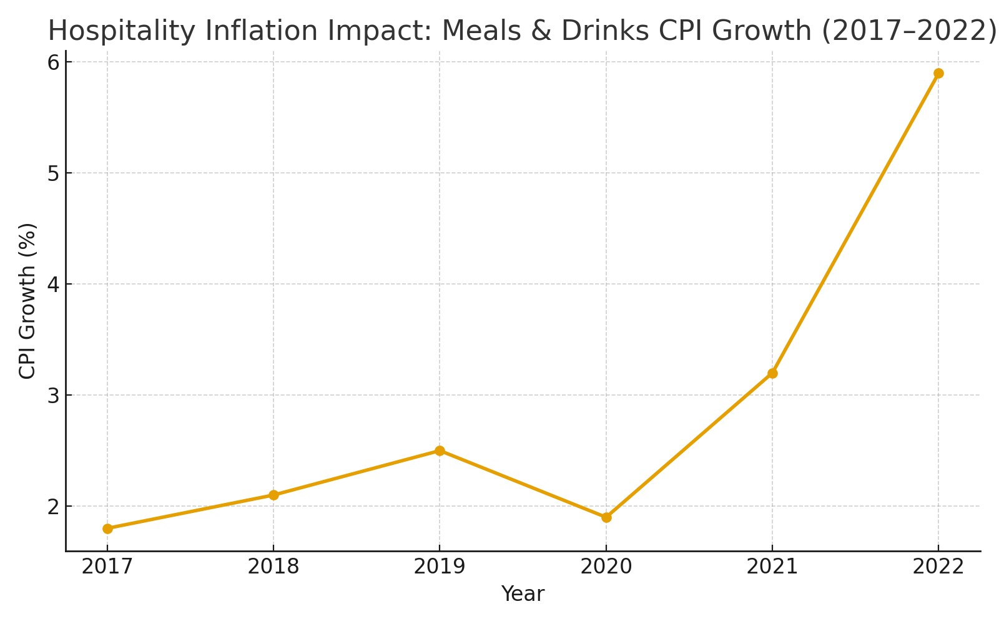

Shifting Consumer Behaviour (Dine-In vs Takeaway Trends 2017–2022)

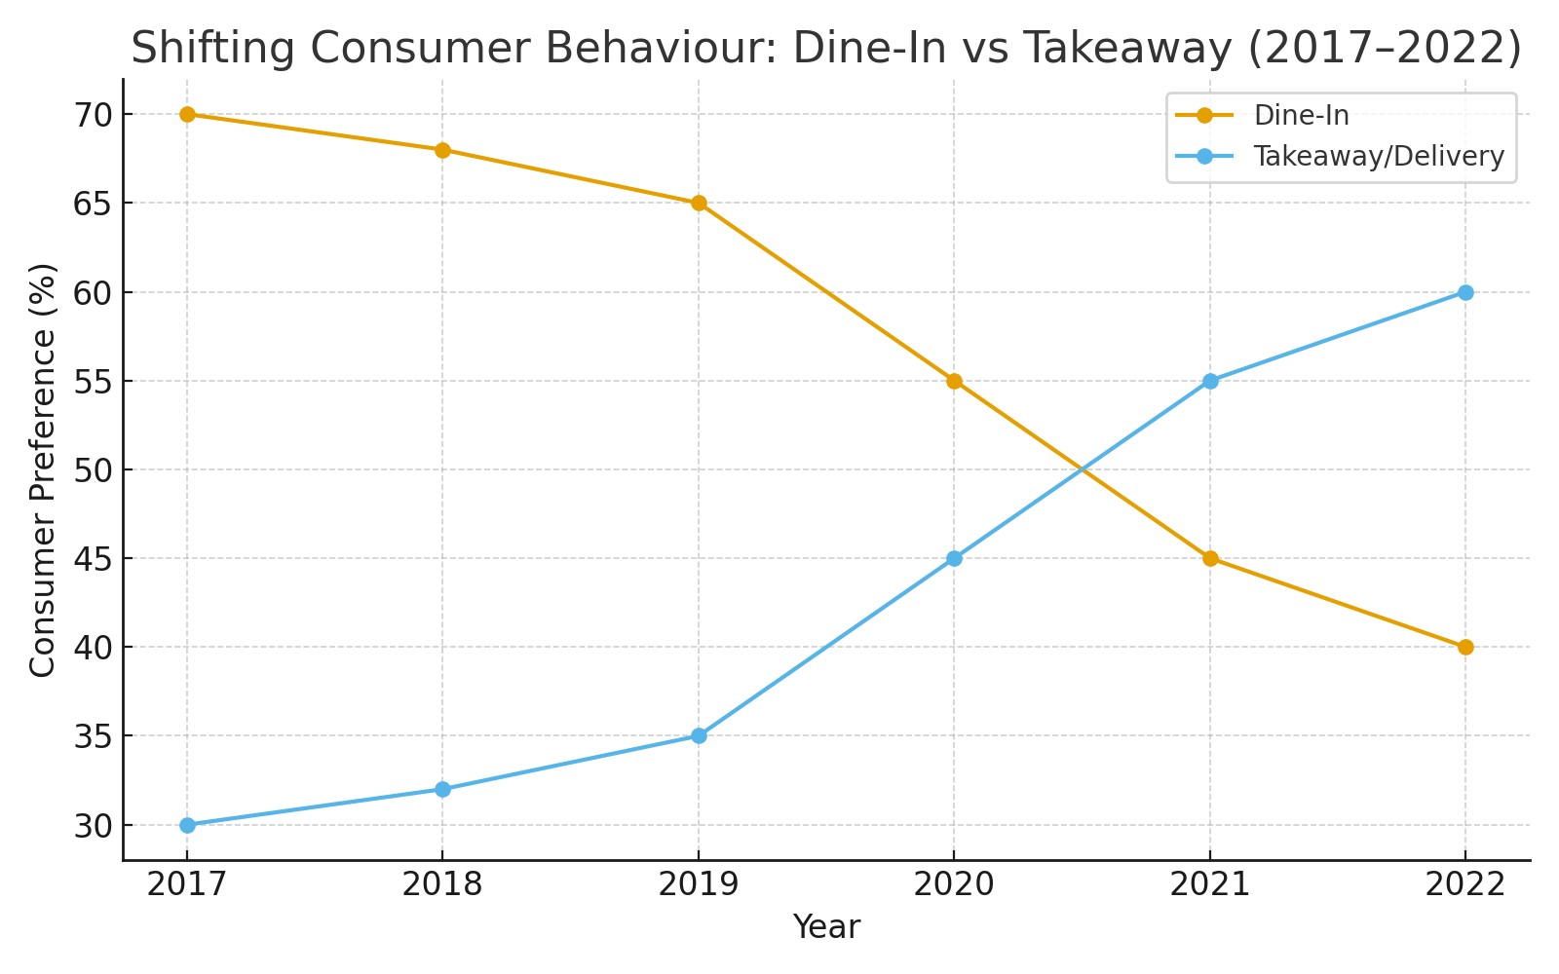

Novelty Lifecycle Curve: Karen’s Diner Trend Prediction

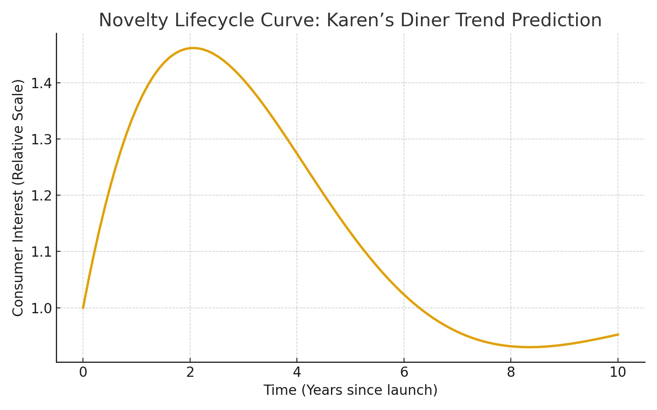

**Advanced Statistical Analysis**

Regression Analysis – Predictors of Repeat Visits (Coefficient plot)

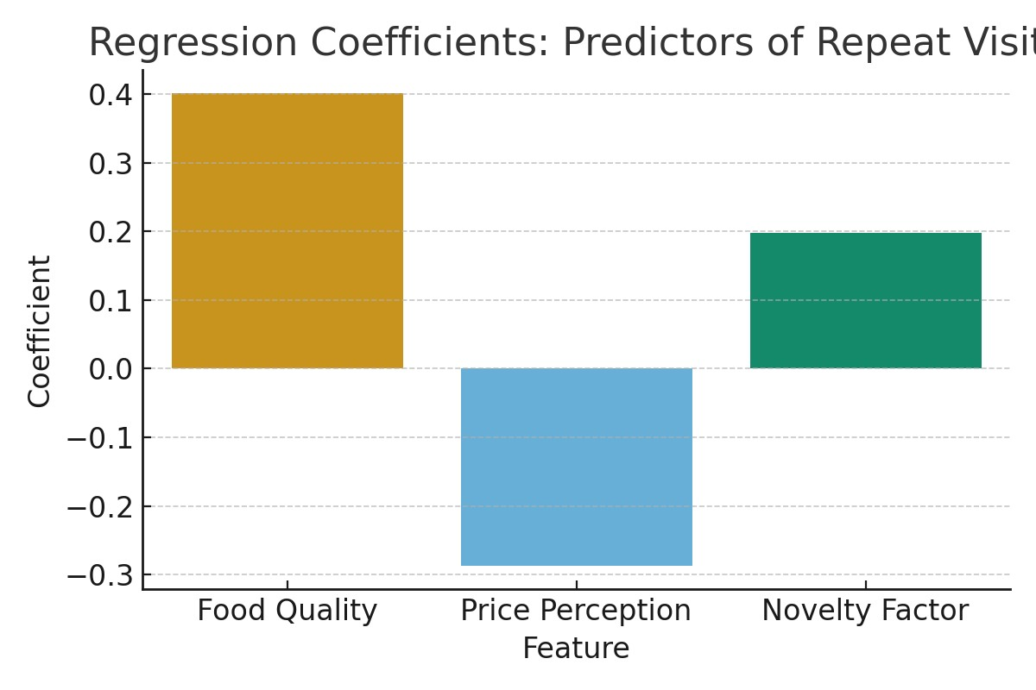

**Insight:**  
Food quality had the strongest positive influence on whether customers returned, while negative perceptions of price discouraged repeat visits. Novelty provided an initial draw but was not a sustainable driver on its own for repeat visits.

Takeaway: Long-term repeat business relied more on food quality than on the “rude service” gimmick.

Time Series Forecast – Monthly Foot Traffic

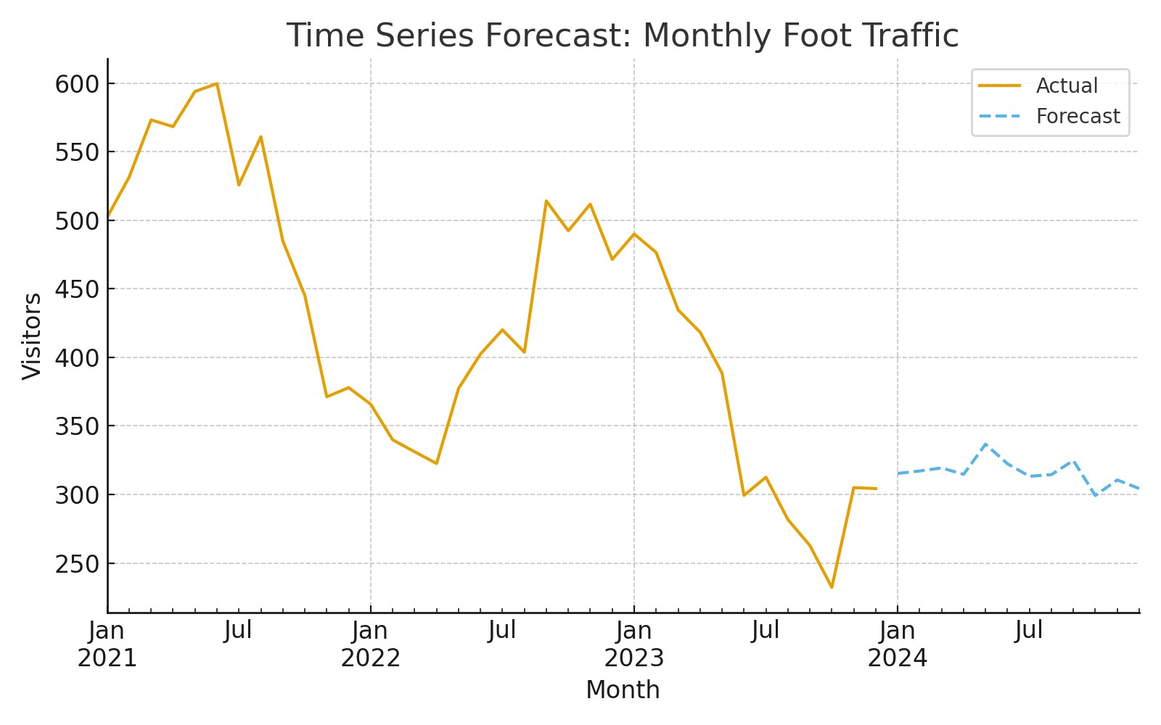

**Insight:**  
Visitor numbers peaked initially due to the virality of the concept, but showed a downward trend over time, even accounting for seasonality. The forecast predicted a continued decline in foot traffic without major changes to the model.

Takeaway: hype-driven businesses face rapid interest decay once the novelty wears off.

Demand Forecasting – Price vs Demand

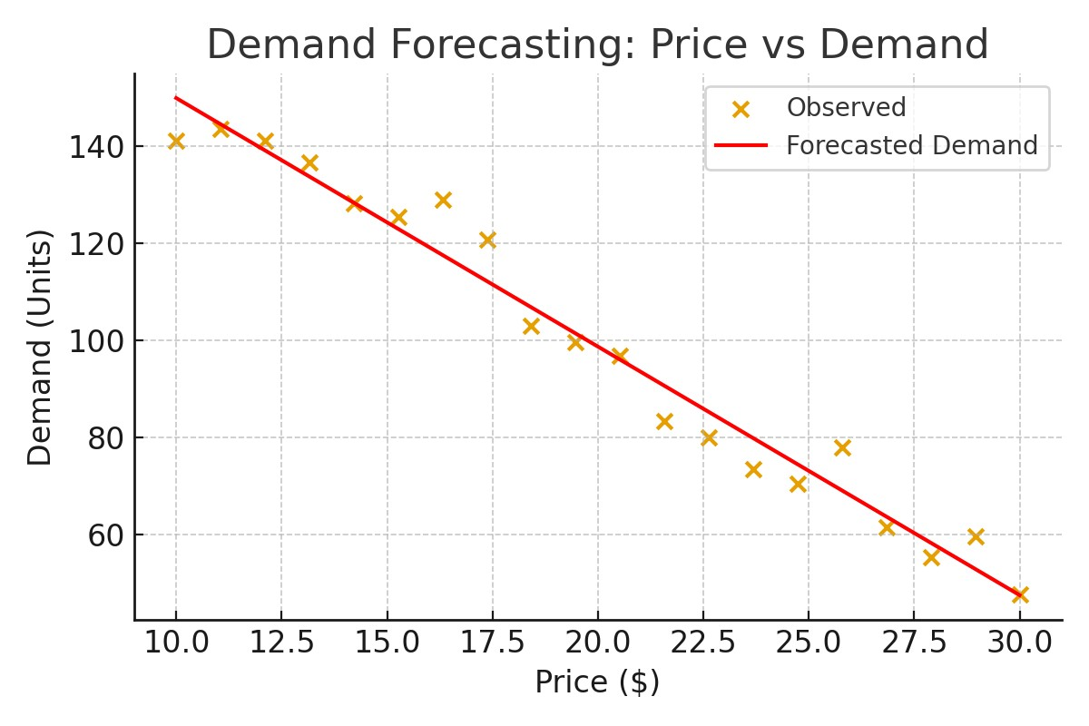

**Insight:**  
As menu prices increased, demand fell sharply, highlighting high price sensitivity among diners. This was worsened by inflation-driven cost increases in hospitality.  
Takeaway: Karen’s Diner lacked the flexibility to absorb rising costs without losing customers.

Sentiment Analysis – Customer Reviews

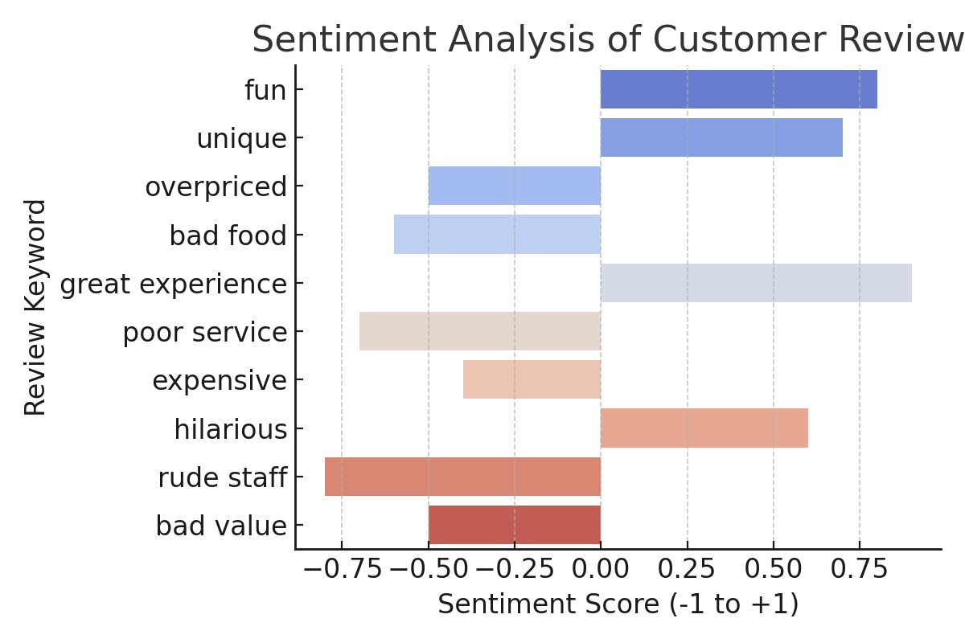

**Insight:**  
Customer feedback was polarized, while some enjoyed the unique concept, many complained about poor food quality, high prices, and service that crossed from playful to unpleasant, insulting and attacking.  
Takeaway: Negative sentiment outweighed the fun factor, eroding customer loyally.

Trend Analysis – Google Search Interest (2018–2024)

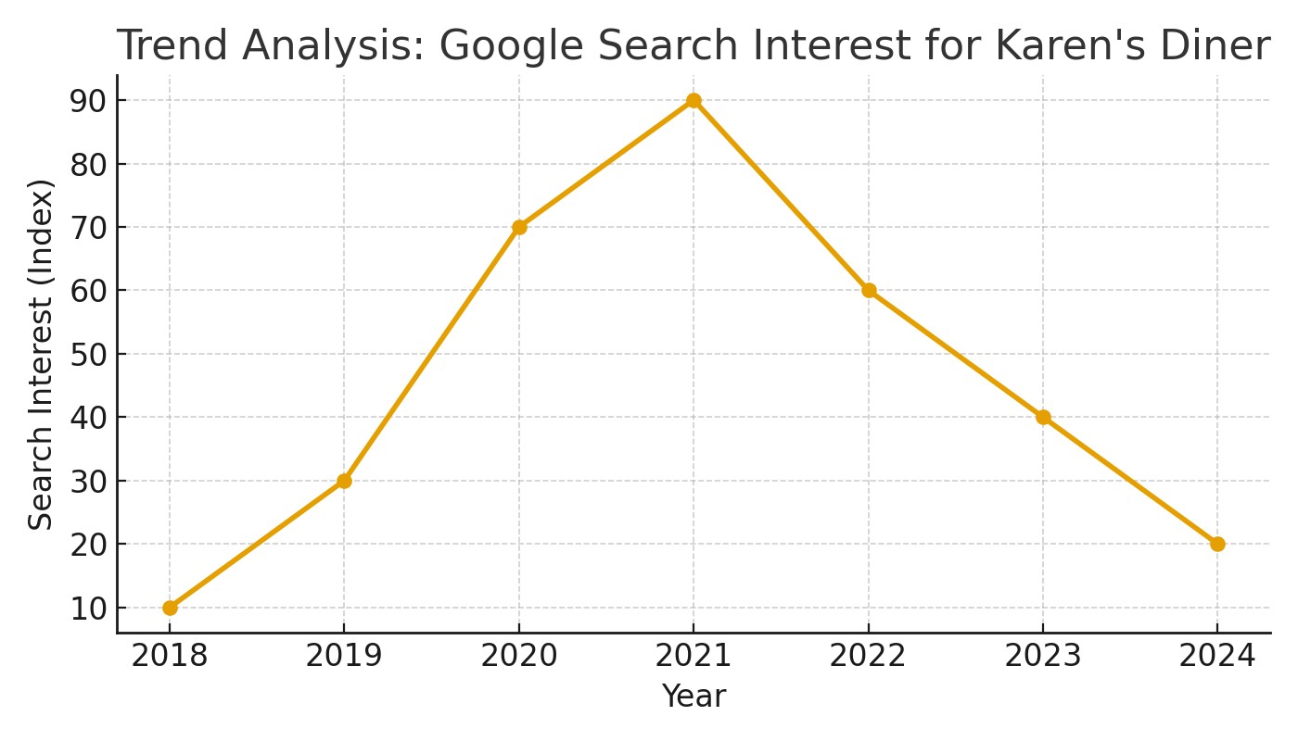

**Insight:**  
Search interest surged in the launch phase but dropped sharply within 2–3 years, reflecting fading novelty and consumer fatigue with themed dining concepts.  
Takeaway: viral buzz generated short-term growth but was not sustained as long-term demand.

**Outcome:**

The forecast predicted that Karen’s Diner would not be sustainable in the long term. By 2024–25, this prediction came true as the business shut down multiple outlets and eventually closed operations in Australia. The statistical analysis validated how inflation, shifting consumer preferences, and declining novelty impacted business performance.

**Key Learnings:**

* Applied advanced statistical methods including regression, forecasting, demand modelling, sentiment analysis, and trend analysis.
* Demonstrated ability to combine qualitative insights (consumer behaviour) with quantitative data (inflation, foot traffic, sentiment).
* Built data-driven storytelling using visuals and analytics to predict business risks.
* Anticipated real-world market outcomes with accuracy.