Carpooling System
Requirements Specification Document

Ali Skeineh, Zein Abed Ali, Reina Nizam, Carl Mazloum

Abstract— This document serves as a requirements specification document for the project that will be submitted for the Software Engineering course. The project will contain a web-based application that connects drivers and passengers traveling along similar routes. Moreover, the system will include features that facilitate the interaction between users, such as trip creation, booking requests, communication, and payment processing. Below is a detailed description of the system requirements.

Index Terms—carpooling, ride-sharing, web application, booking system, transportation
——————————  ——————————

CONTENTS
- Introduction 1
- Overall Description 3
- Specific Requirements 7
References 10

Introduction
T
HIS document serves as a detailed requirements specification document for the carpooling system that is to be developed. Daily transportation and commuting in urban areas are currently associated with high costs, traffic
congestion, and inefficient use of available vehicles. Many individuals rely on private transportation or expensive ride-hailing services, which leads to increased financial burden and road congestion. There is a lack of systems that allow users to efficiently share rides with others traveling along similar routes in a simple and organized manner. In order to solve this problem, our project comes in to provide a web-based system that connects drivers and passengers, enabling ride-sharing and better utilization of available vehicle capacity. This document analyzes and elaborates on the high-level needs and features of that carpooling system.

Purpose
The purpose of the requirements specification document is to provide a complete and comprehensive description of the Carpooling System. This document defines and describes the interfaces, operations, performance, and functional requirements of the software. In addition, it also provides a description of the non-functional requirements and design constraints that are to be considered when the system is to be designed. The SRS also covers other system concerns such as communication dependencies.
The requirements specification document is intended to be proposed to the system customers for checking that the requirements meet their needs and for updating these requirements if necessary. This document is also intended for project managers to plan the system development process and bids for the system. This document serves as a guideline for system development engineers and system test engineers in order to provide a basis for understanding the nature and context of the system to be designed and developing validation tests for that system.

Scope
The aim of this project is to provide an Internet-based website that facilitates ride-sharing between drivers and passengers traveling along similar routes. The project will be specifically designed to be used by drivers, passengers, and administrators. The system will provide functionalities that allow drivers to create and manage trips, and allow passengers to search for available rides, send booking requests, and complete payments. The project will contain a web-based system.
The carpooling system will have a database containing details regarding users, including drivers and passengers, as

Adapted from the IEEE Computer Society template

well as information about trips, bookings, payments, and ratings. The website will be accessible by all users, where each user will log in and access functionalities according to the type of account. Drivers will be able to create trips, manage ride availability, and respond to booking requests, while passengers will be able to view available drivers, select rides, and request bookings. The system will also allow users to communicate, track trip-related information, and maintain records of completed rides.

Definitions, acronyms, and abbreviations

    - Acronyms:
- SQL – Structured Query Language
- LAU – Lebanese American University
- SRS – Software Requirements Specification
- UML – Unified Modeling Language
- GPS – Global Positioning System
- HTTP – Hyper-Text Transfer Protocol
- API – Application Programming Interface
- DB – Database
- PASS – Passenger
- AD – Administrator
- DRIV – Driver
- REL – Reliability
- EOU – Ease of Use
- PRV – Privacy and Data Protection
- DAT – Data Integrity
- SEC – Security and Safety
- PER – Performance
    - Definitions:

Carpooling: The practice of sharing a ride between a driver and one or more passengers who are traveling along the same route.
Driver: A registered user who creates and manages trips and provides available seats to passengers. Passenger: A registered user who searches for available rides and requests to join trips.
Trip: A journey created by a driver that includes a starting point, destination, time, and available seats.
Booking Request: A request sent by a passenger to join a driver’s trip.
Vicinity: A geographical area within a radius of 2 kilometers from the passenger’s current identified location.

Overview
This document contains the software requirements specification of the Carpooling System and is divided into 3 sections. The first section introduces the project with its purpose and objectives. The second section provides an overall general description of the system. The third section contains specific software requirements to a level of detail sufficient to enable designers to design the system, and software testers to test that the system satisfies those requirements.

Overall Description
This section will give an overview of the whole system. The system will be explained in its context to show the interaction of the system with other systems. It will also describe what type of users will use the system and what functionality is available for each type. Finally, the general constraints and assumptions for the system will be presented.

Product Perspective
The Carpooling System is designed to provide a more efficient way of managing daily transportation by enabling users to share rides. The system that will be developed is a web-based system that can be considered as an independent entity, not directly integrated within a larger system.
The website will be accessible by different types of users, mainly drivers and passengers. Drivers will be able to create and manage trips, specify destinations, and respond to booking requests sent by passengers. Passengers, on the other hand, will be able to search for available trips, select rides that match their route, and send booking requests. The system will provide an interface that allows users to perform these actions in a simple and organized manner.
Since the system is data-oriented, it will require a database to store and manage information. The website will communicate with the database in order to store and retrieve data related to users, trips, bookings, and payments. In addition, the system will interact with external services to support functionalities such as location tracking and route visualization. All system interactions will take place through an Internet connection.

    - User Interfaces
The website shall provide a simple and user-friendly interface to drivers, passengers, and administrators in order to perform the different functionalities assigned to each. A login page shall appear first where the user has to enter the credentials. In the case of a first-time user, a sign-up page shall be available in order to create an account. After successful logon, the user will be redirected to a page that contains the list of functionalities that the currently signed-in user can perform according to the type of the account.
The website shall provide a navigation interface that allows the user to switch between the different sections of the system. Drivers will be able to access features related to trip creation and management, while passengers will be able to access features related to searching and booking rides. The interface will also allow users to view relevant trip information and interact with the system in an organized manner.

    - Hardware Interfaces
      - Server side:
The system will be hosted on a server that handles incoming requests from users and processes data related to
the carpooling system. The server will manage the storage and retrieval of data and ensure that the system operates correctly.
      - Client side:
The website can be accessed through a client machine such as a personal computer, smartphone, or any other device that has a web browser. Users will interact with the system through the website interface using these devices.

    - Software Interfaces
2.1.3.1. Server Side:
The system will interact with a database in order to store and manage data related to users, trips, bookings, and payments. The server will handle requests coming from users and process the required operations to ensure correct system functionality.
2.1.3.2 Client Side:
The website will operate through a web browser that allows users to access the system functionalities. The client interface will communicate with the server in order to send user requests and receive the corresponding responses.

    - Communication Interfaces
The system will use HTTP protocols to enable communication between the client and the server.

Product Functions
This section presents the use case diagrams for each of the three primary actors of the Smart Carpooling System. Each subsection introduces the actor's role, lists the use cases associated with that actor, and provides the corresponding use case diagram. The diagrams illustrate direct interactions between actors and system functionalities without modeling relationships between use cases, in order to maintain clarity and simplicity.
A list of all the functions provided by the system will be given in the form of use case diagrams for each type of user: passenger, driver, and administrator.

    - Passenger viewpoint:
The passenger is the primary end-user of the carpooling platform. The first action a passenger performs is signing in to an existing account or registering a new one if accessing the platform for the first time. Once authenticated, the passenger gains access to a set of functionalities that support the complete ride-booking process.
The passenger can view active drivers on a map, select a suitable driver, and submit a booking request by specifying pickup and drop-off locations. After submitting a request, the passenger receives a booking confirmation and can track the driver’s movement in real time. During the trip, the passenger can communicate with the driver through the in-app messaging feature and optionally share their live location for safety purposes.
Upon reaching the destination, the passenger confirms arrival and completes the payment through the system.
Additionally, the passenger can rate the driver, report any issues, and view their trip history for future reference.

The complete set of passenger use cases is listed below, followed by the corresponding use case diagram in Fig. 1.
- Sign In / Register
- View Active Drivers on Map
- Send Booking Request (includes: Specify Pickup & Drop-off)
- Receive Booking Confirmation
- Track Driver in Real Time (includes: Share Live Location)
- Communicate via In-App Messaging
- Confirm Arrival & Complete Payment
- Rate Driver (extended by: Report Driver)
- View Trip History
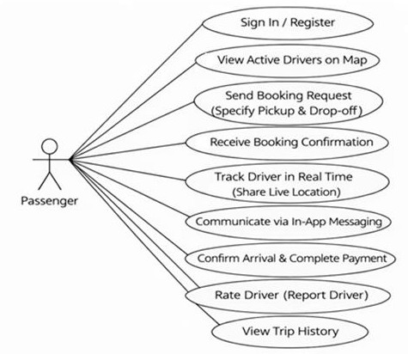
Fig. 1. Passenger use case diagram.

    - Driver viewpoint:
The driver is a verified participant in the carpooling system responsible for providing transportation services. Before using the platform, the driver must register an account and provide necessary personal, vehicle, and license information for verification.
Once registered, the driver can create and activate trips by specifying destinations, routes, and available seats. These trips become visible to passengers on the platform. The driver can view incoming booking requests from passengers and

decide whether to accept or reject them.
After accepting a booking, the driver can view the passenger’s pickup and drop-off locations and communicate with the passenger using the in-app messaging system. During the trip, the driver confirms passenger pickup and drop-off.
Upon completion, the driver receives payment through the system and can review earnings and trip history, and can also rate passengers after completing trips.
The list of driver use cases is presented below, followed by the corresponding diagram in Fig. 2.
- Register & Create Verified Account
- Set Destination & Activate Trip
- View & Respond to Booking Requests (extended by: Accept / Reject Booking Request)
- View Passenger Pickup & Drop-off Locations on Map
- Communicate via In-App Messaging
- Confirm Passenger Pickup & Drop-off
- Receive Payment & View Earnings
- View Trip History
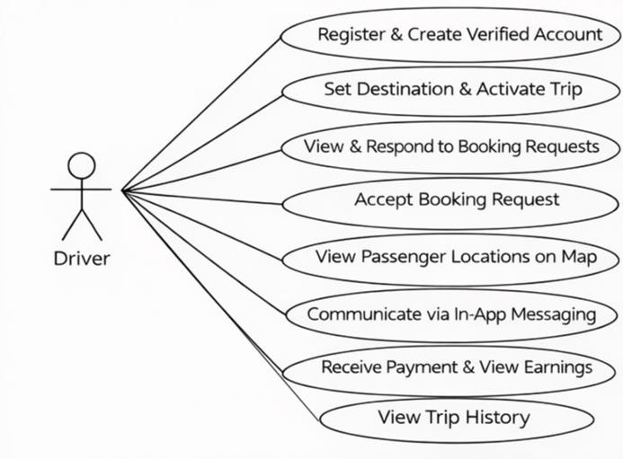
Fig. 2. Driver use case diagram.
    - Administrator viewpoint:
The administrator is a system-level actor responsible for managing and maintaining the carpooling platform. Unlike drivers and passengers, the administrator does not participate in the ride-sharing process but instead oversees system operations and ensures platform reliability, safety, and compliance.
The administrator can log in to a dedicated administrative panel and manage user accounts within the system. This includes creating, modifying, deleting, suspending, and reactivating driver and passenger accounts when necessary.

In addition, the administrator is responsible for verifying driver credentials, including driving licenses, vehicle registration, and identification documents, to ensure that all drivers meet the platform’s requirements.
The administrator also monitors both ongoing and completed trips, with access to trip details such as pickup and drop-off locations and timestamps. Furthermore, the administrator can view payment and transaction records associated with completed trips.
To maintain platform safety, the administrator can review and manage reports submitted by passengers or drivers regarding misconduct, unsafe behavior, or violations of platform policies.
The complete set of administrator use cases is listed below, followed by the corresponding use case diagram in Fig. 3.
- Log In to Admin Panel
- Create Driver / Passenger Account
- Modify/Delete Accounts
- Suspend/Reactivate Accounts
- Verify Driver Credentials
- Monitor Trips (Ongoing & Completed)
- View Payments & Transactions
- Manage Reports & Violations
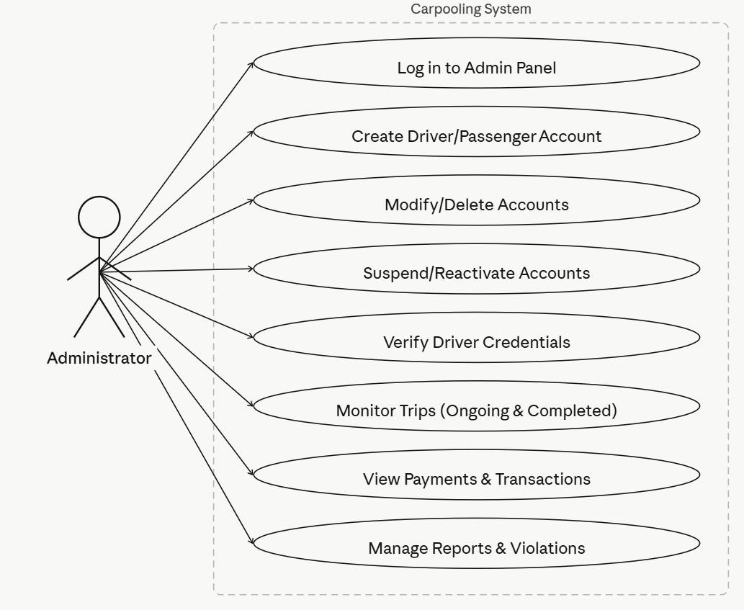
Fig. 3. Administrator use case diagram.

User Characteristics
The users of the system are passengers, drivers, and administrators.
Passengers and drivers are expected to have basic knowledge of Internet browsing and general computer or smartphone usage. With the presence of a user-friendly graphical interface and simple navigation, users with minimal technical expertise will be able to use the system efficiently without requiring formal training.
Administrators are expected to have a higher level of technical proficiency and system understanding. They should be capable of managing user accounts, verifying driver credentials, monitoring trips, reviewing reports, and overseeing system operations to ensure reliability, safety, and proper functionality of the platform.

Constraints
The Online Library System has the following constraints:

- Hardware constraints:
  - The system must be accessible through devices such as personal computers, smartphones, or tablets that
support a web browser.
  - The device used must be capable of connecting to the Internet.
- Software constraints:
  - The system must operate through standard web browser.
  - The system must support user authentication and secure access to functionalities.
- Operational constraints:
  - The system requires a stable Internet connection in order to function properly.
  - The system must handle multiple users accessing the platform at the same time.
  - The system must restrict access to functionalities based on user roles (driver, passenger, administrator).
- Performance constraints:
  - The system performance may be affected by the number of users accessing the system simultaneously.
  - Delays may occur if there is high demand on the system resources.

Assumptions and Dependencies
The system is developed under the assumption that users have access to devices capable of running a web browser and interacting with the website. It is also assumed that users have basic knowledge of using web-based systems.
The system depends on network connectivity to allow communication between users and the
system. In addition, the system relies on external services to support certain functionalities such as location display and route visualization.

Specific Requirement

Database

Data Requirements
The data requirements of the proposed ride-sharing system define the main entities, their relationships, and the constraints needed to support the core functions of the application. These requirements ensure that the system can store and manage information related to drivers, passengers, trips, bookings, messages, and reports in a clear and consistent way. They also provide the basis for representing the system first at a conceptual level and then at a logical level for database design and implementation.

Business Rules and Constraints
- A driver may create zero, one, or many trips.
- Each trip must be created by one and only one driver.
- A passenger may make zero, one, or many bookings.
- Each booking must be made by one and only one passenger.
- A trip may have zero, one, or many bookings.
- Each booking must belong to one and only one trip.
- A booking may include zero, one, or many messages exchanged between the involved users.
- Each message must be associated with one and only one booking.
- A booking may generate zero, one, or many reports.
- Each report must be related to one and only one booking.
- Each report must be submitted by one passenger and must concern one driver.
- A driver may be associated with zero, one, or many reports.
- A passenger may submit zero, one, or many reports regarding bookings or ride experiences

Conceptual Data Model
The conceptual data model presents a high-level view of the proposed ride-sharing system by identifying the main entities involved in the project and illustrating how they interact to support the business process. The system is centered on connecting drivers who offer rides with passengers who search for and reserve available trips. In this project, the main entities are Driver, Passenger, Trip, Booking, Message, and Report. A Driver creates trips, while a Passenger books a selected trip through the Booking entity, which acts as the main connection between passengers and trips. The Message entity is included to support communication between the involved users regarding a booking, while the Report entity allows passengers to submit feedback, complaints, or evaluations concerning a booking or ride experience. Therefore, the conceptual data model explains the overall structure of the project from a business perspective and shows how the main entities cooperate to achieve the core functions of the application.

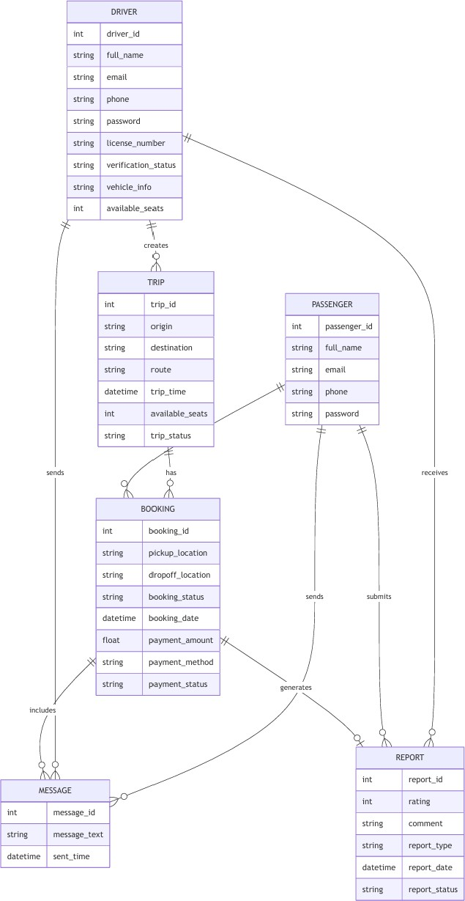
Fig. 4. Conceptual Data Model Diagram.

    - Logical Data Model

The logical data model translates the conceptual view of the ride-sharing project into a structured database design by defining the entities, their attributes, and the keys that connect them together. In the logical model, the Driver entity is linked to the Trip entity through driver_id, since each trip is created by one driver. The Passenger entity is linked to the Booking entity through passenger_id, and the Trip entity is also linked to Booking through trip_id, making Booking the central transactional entity that connects passengers to trips. In addition, the Message entity is connected to Booking through booking_id so that each message is associated with a specific reservation. The Report entity is also logically connected to the related booking and to the users involved through booking_id, passenger_id, and driver_id, allowing the system to track feedback and
complaints in a structured way. As a result, the logical data model does not only describe the data fields of the project, but also clearly shows how all entities are related in the relational database structure.
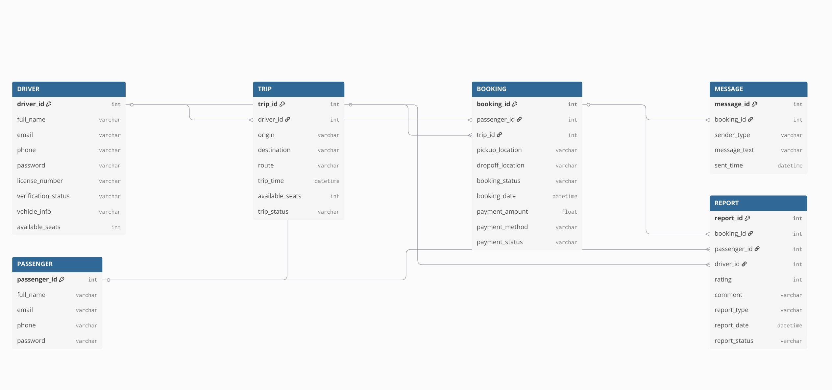
Fig. 5. Logical Data Model Diagram.

Functional Requirements
The functional requirements of the system are that of each type of user (driver user, passenger, and administrator). The following subsections will state these functional requirements followed by a description of the requirements starting with the login activity of all users.
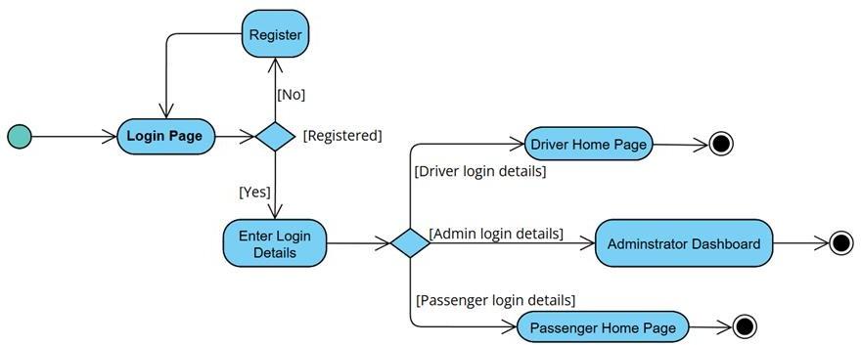

Fig. 6. UML Activity diagram for Login Activity.

Passenger Viewpoint:
The functional requirements within the reader viewpoint are:
FR-PASS-001 The system shall allow passengers, who have existing accounts, to log in using their credentials (See table 1).

Table 1
Structured specification of the passenger functional requirement #1
Purpose | The passenger logs into the system using an existing account.
User | A passenger with an existing profile in the database.
Input | Account username and password.
Output | Redirecting to the corresponding page.
Pre-conditions | The account exists in the database / User password matches pro-file.
Post-Conditions | Page data is appropriate for selected profile
Basic flow | Webpage looks up account data and returns the matching cookie. Afterwards, the webpage is updated to match the new user data.
Alternative flows | Error message is produced because of invalid password, invalid username, or mismatched username and password.

FR-PASS-002 In the case of passengers who do not have an existing account, the system shall allow them to create one following certain account rules and regulations (See description below).
The rules regarding how new passenger are created are the following:
FR-PASS-002.1 Username, password, first name, and last name fields shall not be left empty.
FR-PASS-002.2 The provided username must not be a username currently used by another account in the data- base.
FR-PASS-002.3 Both the username and the password must be between 3 to 15 characters.
FR-PASS-002.4 Both the username and the password must contain numbers, letters, and underscore. FR-PASS-002.5 The two entered passwords must match.
FR-PASS-003 The system shall allow the passenger view all active drivers available in vicinity and their designated routes upon selection.

FR-PASS-004 The system shall allow passengers to check driver’s ratings and verification before booking a trip.
FR-PASS-005 The system shall allow the passenger to select a driver on their map and book a trip based on their identification, rating, and ride.
FR-PASS-006 If the selected driver rejects the passengers’ booking request, the passenger shall be redirected to the home
page where the selection of drivers are viewed.
Table 2
Condition-action rules for passenger functional requirement #2
Condition | Action
Passenger is not registered | User cannot book a trip
Passenger is located far from selected driver’s route | User cannot book a trip
Passenger’s booking request rejected  by driver | User cannot book a trip
(Passenger is registered) ^ (Passenger is on route) ^ (Passenger’s request is accepted) | Trip booked successfully

FR-PASS-007 The system shall enable the passenger to track the driver upon confirmation.
FR-PASS-008 The system shall allow the passenger to communicate with the driver via in-app messaging.
FR-PASS-009 The system shall automatically send a notification to the passenger upon the drivers’ arrival to their pick-up point,
FR-PASS-0010 The system shall enable the passenger to complete payment either through application or via cash on agreement with the driver.
FR-PASS-0011 The system shall enable the passenger to rate and comment on the driver upon drop-off post trip completion.
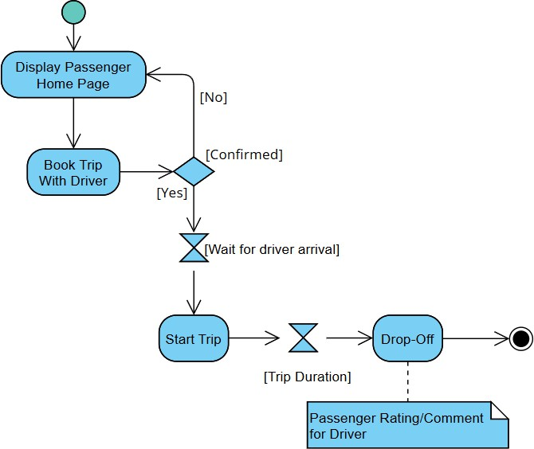
Fig. 7. UML Activity diagram for Passenger Activity.
FR-PASS-0012 The system shall allow the passenger to share their live location via link for safety reasons. FR-PASS-0013 The system shall allow the passenger to view a list of all the trips that have been completed.

Administrator viewpoint:
The functional requirements within the administrator viewpoint are:
FR-AD-001 The system shall enable the administrator to log in with his/her credentials.
FR-AD-002 The system shall allow the administrator to create accounts for drivers and passengers, following the same account rules as the ones mentioned in their respective functional requirement #2.
FR-AD-003 The system shall allow the administrator to delete or modify driver and passenger accounts.
FR-AD-004 The system shall allow the administrator to view payment and transaction records associated with completed trips.
FR-AD-005 The system shall allow the administrator to suspend or reactivate driver and passenger accounts in cases of misconduct, policy violations, or safety concerns.
FR-AD-006 The system shall allow the administrator to review and verify driver credentials, including driving licenses, vehicle registration, and personal identification documents.
FR-AD-007 The system shall allow the administrator to monitor ongoing and completed trips, including access to trip details such as pickup and drop-off locations and timestamps.
FR-AD-008 The system shall allow the administrator to view and manage reports submitted by passengers or drivers regarding unsafe behavior, misconduct, or violations of platform policies.
2.5.2 Driver viewpoint:
The functional requirements within the driver viewpoint are:
FR-DRIV-001 The system shall allow the driver to log in with his/her account credentials.
FR-DRIV-002 In the case of drivers who do not have an existing account, the system shall allow them to create one following certain account rules and regulations (see description below)
The rules regarding how new passenger are created are the following:
FR-DRIV-002.1 Username, password, first name, last name, phone number, vehicle information, vehicle license and registration, and personal identification fields shall not be left empty.
FR-DRIV-002.2 The provided username must not be a username currently used by another account in the data- base.
FR-DRIV-002.3 Both the username and the password must be between 3 to 15 characters.
FR-DRIV-002.4 Both the username and the password must contain numbers, letters, and underscore.
FR-DRIV-002.5 The two entered passwords must match
FR-DRIV-003 The system shall enable the driver to start a ride by enabling their location and setting a destination. FR-DRIV-004 The system shall enable the driver to confirm or reject booking requests received from passengers looking for a trip.
FR-DRIV-005 The system shall send and receive information like GPS tracking to the passenger upon
driver’s consent.
FR-DRIV-006 The system shall enable the driver to receive messages from the passenger and reply back
FR-DRIV-007 The system shall allow the driver to ping the passenger upon arrival to designated pick-up point.
FR-DRIV-008 The system shall allow the driver to confirm passenger pick-up and drop-off actions.
FR-DRIV-009 The system shall allow the driver to receive payment via in-app transaction or cash upon their agreement with the passenger.
FR-DRIV-0010 The system shall allow the driver to rate the passengers and provide feedback based on their behavior and adherence to trip guidelines after completing the ride.

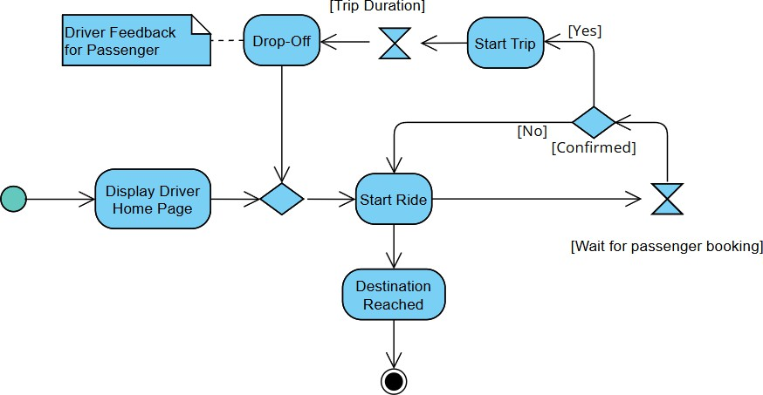

Fig. 8. UML Activity diagram for Driver Activity.

Non-Functional Requirements
    - Reliability:
NFR-REL-001 The system shall provide accurate trip matching and route information up to 98% to ensure correct driver-passenger pairing.
NFR-REL-002 The system shall handle errors gracefully and notify users when operations fail.
    - Ease of use:
NFR-EOU-001 Users shall be able to perform core functionalities such as trip creation, booking requests, and tracking with an error rate of less than 2% per session, without requiring formal training within 30 minutes of self-guided use.
NFR-EOU-002 The interface shall provide consistent navigation structure, instructions, and feedback messages to guide users during interactions within 2 seconds of user’s action.
    - Privacy and Data Protection:
NFR-PRV-001 The system shall protect user personal information (name, contact details, location) and shall not expose it to unauthorized users with TLS encryption.
NFR-PRV-002 Only authorized users (driver, passenger, administrator) shall access functionalities based on their roles. NFR-PRV-003 User authentication shall be required using secure login credentials.
NFR-PRV-004 Sensitive data such as passwords and payment information shall be encrypted, hashed with salting and securely stored.
    - Data Integrity:
NFR-DAT-001 The system shall ensure that all data related to users, trips, bookings, and payments is accurate and consistent by enforcing ACID-compliant database transactions.
NFR-DAT-002 Transactions such as booking confirmations and payments shall be processed without duplication or data loss.
    - Security and Safety:
The log-in communication messages shall be encrypted, so others cannot obtain username and password from these messages. The system shall keep logs and history data sets of IP addresses and associated username logins. The system shall ensure secure communication between users using encrypted protocols.
NFR-SEC-001 The system shall prevent unauthorized access through authentication and access control mechanisms. NFR-SEC-002 The system shall allow users to report unsafe behavior or misconduct.
NFR-SEC-003 The system shall provide basic safety features such as sharing trip details or live location with trusted contacts.

    - Performance:
NFR-PER-001 The system shall process booking requests and return confirmation or rejection within 3 seconds under normal operating conditions.
NFR-PER-002 The system shall support at least 100 users accessing the platform simultaneously without significant delay. NFR-PER-003 Map loading and driver tracking shall be responsive and updated every 5 seconds .

References
- IEEE Software Engineering Standards Committee, “IEEE Std 830-1998, IEEE Recommended Practice for Software Requirements Specifications”, October 20, 1998.
- M. A. Vargas, J. Sefair, J. L. Walteros, A. L. Medaglia, and L. Rivera, “Carpooling optimization: A case study in Strasbourg (France),” 2008 IEEE Systems and Information Engineering Design Symposium, pp. 89–94, Apr. 2008. doi:10.1109/sieds.2008.4559691
- Ian Somerville, Software Engineering, 9th Edition, Pearson, 2011.

