**Introduction**

All images and assets used will be stored here. Images will have the image pasted here with a link to the source.

**Images**

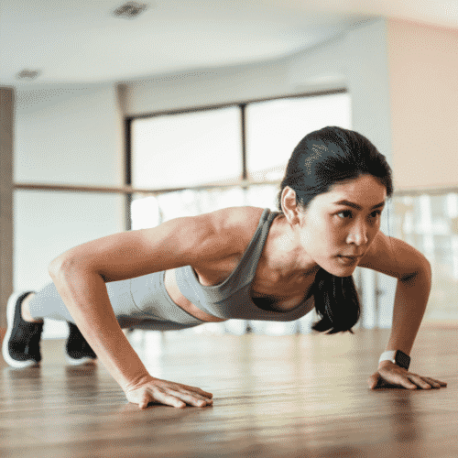https://gethealthyu.com/ultimate-upper-body-hiit-workout/

This image shows the ready workouts with a perfect image.

https://www.istockphoto.com/vector/about-us-blue-and-green-typography-banner-gm1225575961-360783099

Standard for icon. Just to make it look better

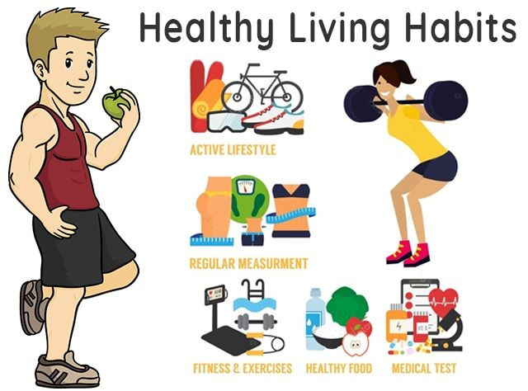 Shows what type of advice it is <https://m.facebook.com/SUHealthyLifestyle/photos/>

 Shows what type of calculator it is <https://mybmicalculator.co.uk/>

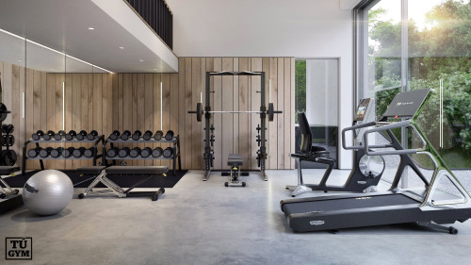

This improves the design <https://tugym.tumblr.com/post/654529463622795264/cozy-private-home-gym>

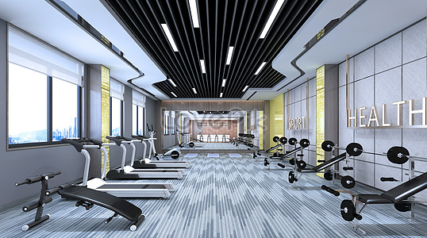 This improves the design <https://lovepik.com/image-401385520/3d-gym-propaganda-scene.html>

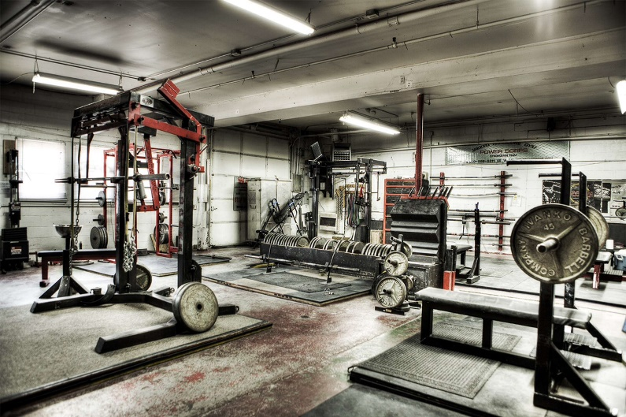 This improves the design <https://www.pxfuel.com/en/desktop-wallpaper-iddaa>

**Advice**

HEALHTY LIVING: <https://fsph.iupui.edu/doc/10-Tips-Healthy-Lifestyle.pdf>

FITNESS TIPS: <https://gethealthyu.com/101-fitness-tips-that-rock/>

TRAINING ADVICE: <https://www.health.harvard.edu/exercise-and-fitness/7-tips-for-a-safe-and-successful-strength-training-program>