Do Language Models Actually Reason?
Mechanistic Evidence from Chain-of-Thought Experiments
Experimental Results Summary · MSc Research Capstone · June 2026
Elad Moshe · IE School of Science and Technology
Models: Gemma-2-2B-IT (Google) · Gemma-3-27B (Google) · Dataset: GSM8K Benchmark · n = 400 problems

Abstract
When a language model is asked to "show its work" before giving an answer — a technique called chain-of-thought (CoT) prompting — its accuracy on math problems often improves dramatically. But does the act of writing reasoning steps genuinely change how the model computes the answer, or does the model already "know" the answer and simply produce post-hoc justifications? This capstone project investigates this question by probing the internal representations of Gemma-2-2B-IT, an open-source language model from Google, on 400 elementary math problems. Across twelve experiments covering linear classification of internal activations, interpretability tools (Sparse Autoencoders and Natural Language Autoencoders), and step-by-step probability tracking, we find that: (1) chain-of-thought prompting triggers a qualitatively distinct computational mode in the model — not just quantitatively more computation; (2) the signal that distinguishes correct from incorrect reasoning is strong (classification accuracy ≈ 80 %) but is diffuse across the model and cannot be captured by current interpretability tools; and (3) the most common failure mode is not that the model commits to a wrong answer early, but that it transiently computes the correct answer and then fails to carry it through to the final output — a "late-stage carry failure." These findings have implications for how we understand reasoning in large language models and for the current state of mechanistic interpretability research.

1. Background and Key Concepts
This section provides a brief, non-technical introduction to the concepts underlying this research. Readers familiar with transformer models and mechanistic interpretability may skip to §2.
1.1 Large Language Models and Chain-of-Thought Prompting
Large language models (LLMs) are neural networks trained on vast amounts of text to predict the next word in a sequence. When prompted appropriately, they can perform arithmetic, write code, and answer questions. However, their reliability varies significantly depending on how they are asked.
Chain-of-thought (CoT) prompting is a technique in which the user asks the model to write out its reasoning step-by-step before giving a final answer (e.g., "Solve this problem. Show all working, then write your final answer inside \boxed{}"). This consistently improves accuracy on reasoning tasks compared to simply asking for the answer directly (NoCoT). On the benchmark used in this project (GSM8K — 400 elementary-school arithmetic word problems), the Gemma-2-2B model goes from 8 % accuracy with direct answers to 51 % with chain-of-thought, and the larger Gemma-3-27B model goes from 31.5 % to 91.5 %.
The key open question is whether this improvement reflects genuine reasoning (the model actually computes the answer by writing intermediate steps) or rationalization (the model already "knows" its answer and the written steps are just plausible-sounding justifications added afterward).
1.2 Mechanistic Interpretability
Mechanistic interpretability is a research discipline that aims to understand how neural networks compute their outputs — not just what they output. Rather than treating a model as a black box and measuring performance, mechanistic interpretability opens the model and examines the internal representations (called activations) produced at each layer.
The central tool used in this project is the residual stream: the sequence of internal activation vectors that flows through the model from input to output. Each transformer layer reads from and writes to this stream. By extracting the residual stream at a specific layer and position, and training a simple linear classifier on it, we can measure how much information about correctness is encoded at that point in the model.
We quantify discriminative power using AUROC (Area Under the Receiver Operating Characteristic Curve). AUROC ranges from 0.5 (the classifier performs no better than random chance) to 1.0 (perfect discrimination). An AUROC of 0.80 means that if we randomly select one correct chain and one incorrect chain, the classifier ranks the correct one higher 80 % of the time.
1.3 Sparse Autoencoders (SAEs) and Natural Language Autoencoders (NLAs)
A Sparse Autoencoder (SAE) is a neural network trained to decompose a model's internal activations into a small number of active "features" from a large dictionary (in this project: 16,384 features). Each feature can be associated with a human-interpretable concept, such as "mathematical formulas" or "numerical data." The SAE produces two components: the reconstructed activation (the interpretable part) and the error term (the part it could not capture). We use the Gemma Scope SAE, a publicly released interpretability tool for the Gemma-2 model family.
A Natural Language Autoencoder (NLA), provided by the Neuronpedia platform, goes one step further: it converts a model's internal activation at a specific position into a short text description of what the model appears to be "thinking about" at that moment. For example, an NLA description might read: "The model is tracking a multiplication problem involving shared quantities between two groups." We used NLA to test whether the signal that distinguishes correct from incorrect reasoning is recoverable in natural language.

2. Research Design
The central research question is: does chain-of-thought reasoning add genuine computational value — changing the model's internal state in a way that predicts whether it will give the correct answer — or is the answer already determined before the first reasoning word is written?
To answer this, we run the same 400 GSM8K problems through Gemma-2-2B-IT under two conditions. In the CoT condition, the model is prompted to show its reasoning before giving an answer. In the NoCoT condition, it is asked to answer directly with no reasoning steps. For each problem and condition, we record whether the model answered correctly and extract its internal activations at two positions:
- Position A (Pos A): the last token generated immediately before the model writes its final answer (i.e., after the full chain of thought). This captures the model's internal state at the moment of answering.
- Position B (Pos B): the last token of the input prompt, before the model generates any output. This tests whether correctness is already encoded before the model writes a single word.
The primary diagnostic is the Δ (delta) between AUROC under CoT and AUROC under NoCoT. A positive Δ means that CoT adds correctness-predictive information beyond what was already present. A Δ near zero means the information was already there before any reasoning was written.
2.1 Experiment Overview
Exp | Name | n | Core question
1 | Residual Stream Regression | 400 | How much correctness-discriminative information exists in raw model activations, and how does it change with layer depth?
2 | SAE Feature Decomposition | 400 | Is the discriminative signal in interpretable (named) features or diffuse geometry the SAE cannot describe?
3 | Log-Probability Baseline | 400 | How well does a simple behavioral signal (model's confidence in its own output) predict correctness?
4 | Flipped-Problems Classifier | 186 | On the same 186 problems where CoT succeeds and direct answers fail: are CoT and NoCoT activations geometrically distinct?
5 | Mode-Switch Control | 236 | Is Exp 1's signal driven by correctness — or just by which prompt format was used?
6 | Shuffled-Label Robustness | 400 | Are the AUROC values above real signal or a regularisation artefact?
7 | Gemma-3-27B Reference | 400 | How does a much larger model (27B parameters) compare on the same task?
8 | NLA Examples (Qualitative) | 10 | What do internal-state text descriptions look like for correct vs. incorrect chains?
9 | NLA Embedding Probe | 58 | Does the text produced by NLA carry enough information to classify correctness?
10 | LLM Judge from NLA | 58 | Can a separate language model (Claude Haiku) predict correctness from NLA descriptions alone?
11 | Token-Type Attribution | 80 | Is the correctness signal concentrated at specific token types (numbers, operators) or spread across the whole chain?
12 | Answer Probability Trajectory | 68 | Does the model's probability of generating the correct answer rise early or late in the reasoning chain?

3. Results
3.1 Correctness Signal in the Residual Stream (Exp 1)
In plain terms: We trained a simple linear classifier on the model's internal state and asked "can we predict whether the model will get this problem right?" We tested this at three depths in the model (Layers 6, 12, 18) and at both positions (after reasoning vs. before any output).
A logistic regression classifier was trained on residual-stream activations at each layer–position combination, independently for the CoT and NoCoT conditions (n = 400 problems). The AUROC measures how accurately the classifier can distinguish correct from incorrect chains using only the internal activation at a single point. The Δ column shows the additional predictive value added by chain-of-thought compared to direct answering at the same position and layer.
Position | Layer | AUROC (CoT) | AUROC (NoCoT) | Δ = CoT − NoCoT
Pos A (last token before answer) | 6 | 0.735 | 0.747 | −0.012
Pos A (last token before answer) | 12 | 0.770 | 0.730 | +0.040
Pos A (last token before answer) | 18 | 0.801 | 0.682 | +0.119 ← largest
Pos B (last prompt token) | 6 | 0.715 | 0.730 | −0.015
Pos B (last prompt token) | 12 | 0.666 | 0.736 | −0.070
Pos B (last prompt token) | 18 | 0.648 | 0.677 | −0.029

Statistical note: SE(AUROC) ≈ ±0.056 at n = 400. The Δ at Layer 18 Pos A (+0.119) is approximately 2.1 standard errors — a meaningful but not definitive effect at this sample size. All CoT and NoCoT AUROCs are well above chance (0.50) with p < 0.001 against shuffled baselines (see Exp 6).
Key finding: Both CoT and NoCoT encode strong correctness-predictive information in the residual stream (all AUROCs > 0.65). The CoT advantage grows steadily with layer depth at Pos A, reaching its peak at Layer 18 (AUROC = 0.801, Δ = +0.119). Crucially, at Pos B — before any reasoning is written — NoCoT is actually slightly more predictive than CoT at the same layer, suggesting that the correctness advantage of CoT builds up during the generation of reasoning steps, not before them.
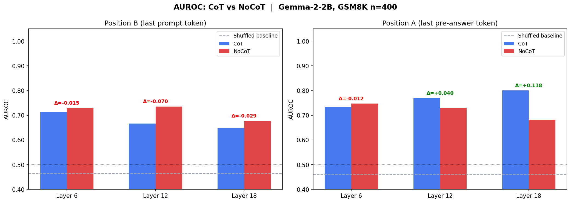
Figure 1: AUROC by layer and position for CoT (blue) and NoCoT (orange). The CoT advantage grows with depth at Pos A (left panels) but is absent or reversed at Pos B (right panels), showing that reasoning steps contribute to the signal. (Exp 1)
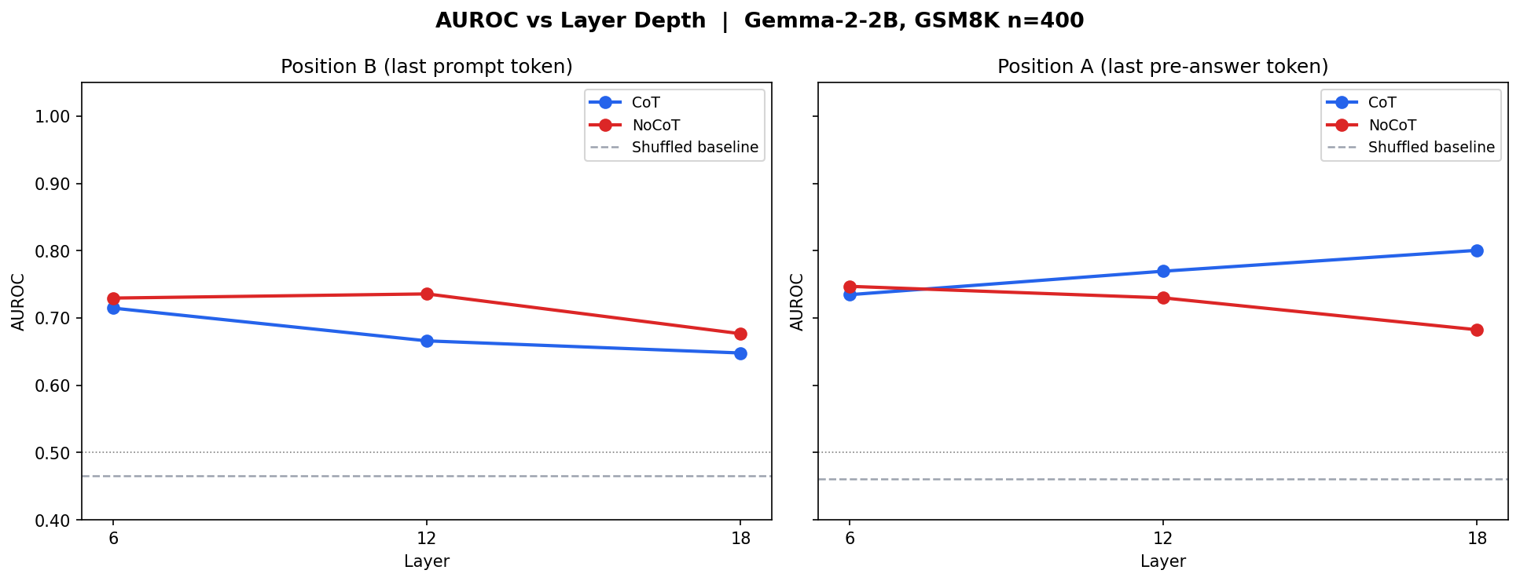
Figure 2: AUROC vs. layer depth at Pos A. The CoT–NoCoT gap (Δ, shaded) increases from Layer 6 to Layer 18, consistent with reasoning information being integrated progressively as the model computes. (Exp 1)
3.2 Is the Signal Interpretable? SAE Decomposition (Exp 2)
In plain terms: We asked whether the part of the model's internal state that predicts correctness can be described using the existing Gemma Scope interpretability dictionary (16,384 named features), or whether it lives in the unnamed, diffuse part of the activation. The answer has direct implications for how legible model reasoning is to human researchers.
The Layer-12, Pos A residual stream was decomposed via the Gemma Scope Sparse Autoencoder (SAE) into two components: the reconstructed component (spanned by 16,384 named features) and the error term (the residual the SAE cannot capture). Separate linear classifiers were trained on each component. SAE quality metrics: R² = 0.014 (the SAE explains only 1.4 % of activation variance), 99.4 % of features are zero for any given token.
Component | AUROC (CoT) | Difference vs. raw residual
Raw residual (full signal, baseline) | 0.770 | —
SAE reconstructed (interpretable part only) | 0.676 | −0.094 (signal lost)
SAE features only (sparse, named) | 0.677 | −0.093 (signal lost)
SAE error term (uninterpretable residual) | 0.770 | 0.000 (all signal preserved)

Top SAE features predictive of CoT correctness at Layer 12: F2785 ("mathematical formulas or expressions," active in 18 % of correct vs. 6 % of incorrect chains), F14938 ("mathematical and logical relationships"), F14669 ("statistical terms and numerical data"). All components are significantly above shuffled baselines (Exp 6).
Key finding: The correctness signal resides almost entirely in the SAE error term — the dense, unnamed geometry that the Gemma Scope dictionary cannot describe. The interpretable SAE features lose ≈9 percentage points of AUROC vs. the raw activation. This means the internal computation that makes chain-of-thought beneficial is not yet nameable using current mechanistic interpretability tools.
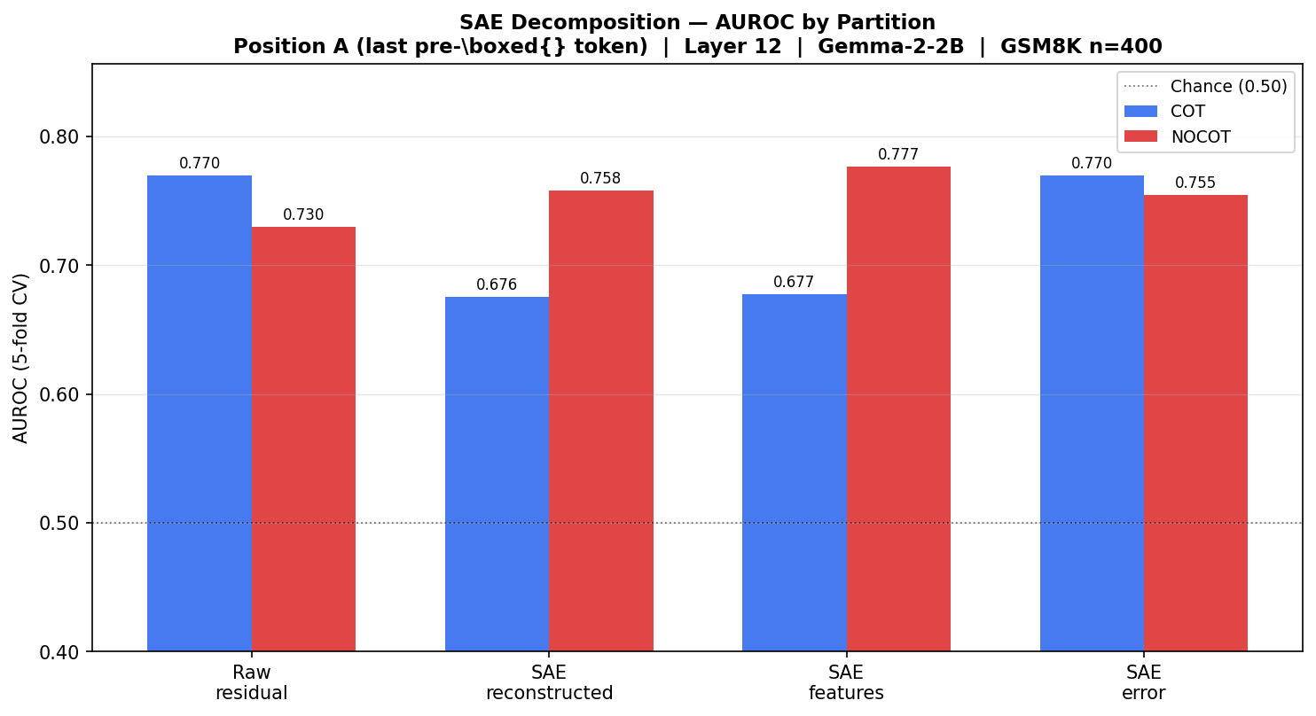
Figure 3: SAE decomposition AUROC at Layer 12 Pos A. The error term (rightmost bar) matches the raw residual; interpretable features (middle bars) lose nearly 10 pp of predictive power. (Exp 2)
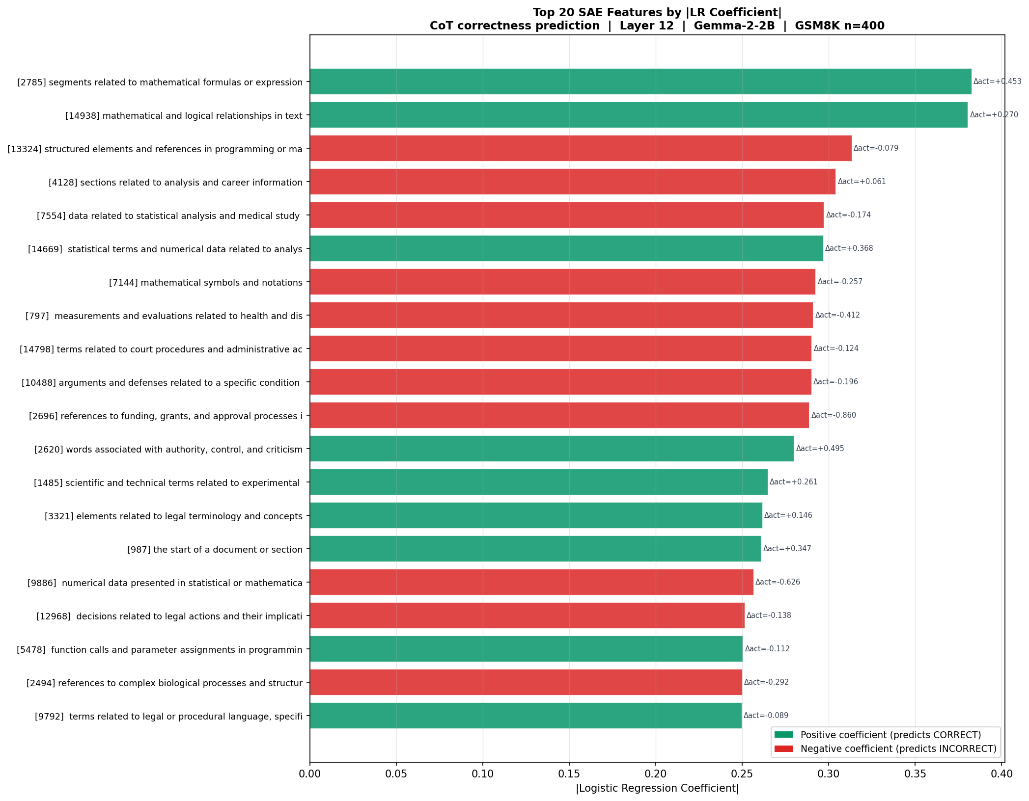
Figure 4: Top Gemma Scope SAE features predictive of CoT correctness at Layer 12. Features describe broad mathematical domains rather than specific reasoning steps, and individually provide only modest predictive power. (Exp 2)
3.3 Behavioral Baseline: Does Confidence Predict Correctness? (Exp 3)
In plain terms: Before probing the model's internals, we tested the simplest possible external signal — does the model's overall "confidence" (measured by the average log-probability it assigns to its own output) predict whether the answer is correct? This establishes a ceiling for purely behavioral prediction.
Mean log-probability (mean logprob) is the average log-likelihood the model assigns to each token it generates. Higher values indicate the model is more "fluent" or "certain" about its output. We test whether this single scalar value can predict answer correctness.
Condition | AUROC | Statistical significance | Gap vs. best mechanistic signal
CoT (chain-of-thought) | 0.692 | p = 1.2 × 10⁻¹¹ *** | −0.109 vs. Exp 1 Layer 18
NoCoT (direct answer) | 0.715 | p = 3.9 × 10⁻⁵ *** | −0.017 vs. Exp 1 Layer 6 NoCoT

Key finding: Mean log-probability is a statistically significant but substantially weaker predictor of correctness (0.69–0.72 AUROC) than the model's internal residual-stream activations (0.77–0.80 AUROC at Layer 12–18). This ≈0.08–0.11 AUROC gap confirms that probing internal representations adds meaningful predictive power beyond simply observing how confidently the model writes its output.
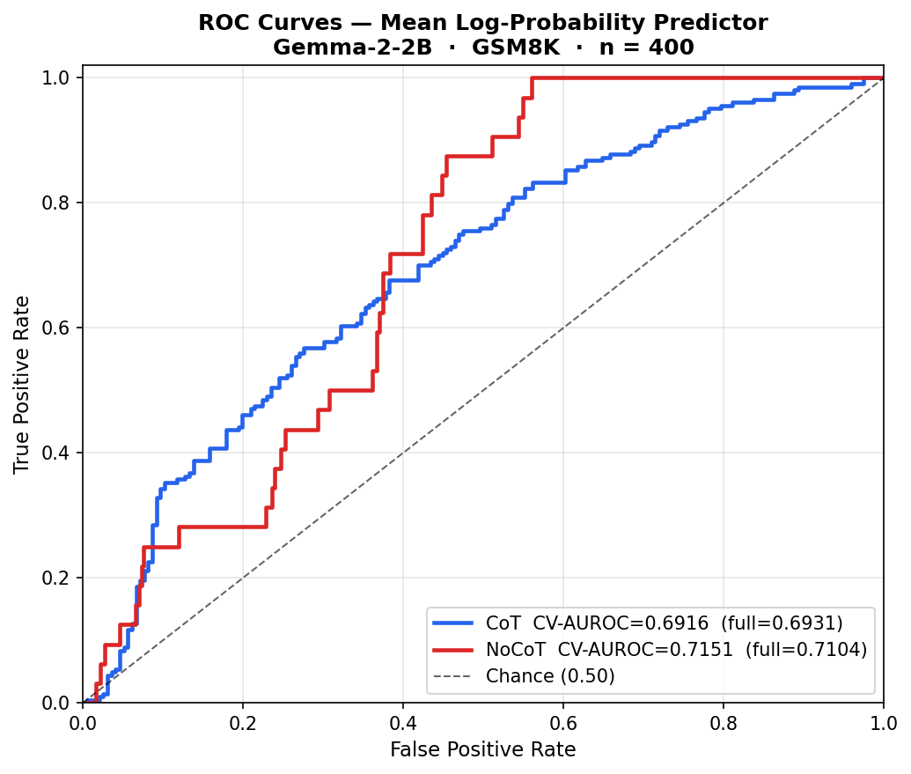
Figure 5: ROC curves for the log-probability-mean classifier under CoT (blue) and NoCoT (orange). Both curves are clearly above the diagonal (chance) but plateau well below the residual-stream ceiling from Exp 1. (Exp 3)
3.4 CoT Triggers a Distinct Computational Mode (Exp 4 & 5)
In plain terms: Exp 4 asks — on the exact same 186 math problems where CoT gives the right answer and direct answering fails, can we tell purely from the model's internal state which condition it was in? Exp 5 asks a separate but related question: even among correct answers only, can the model's internal state reveal whether reasoning was written? This checks whether Exp 1's signal might be a formatting artefact rather than reflecting genuine reasoning.
186 problems (46.5 % of the full sample) had the property that the model answered correctly with CoT but incorrectly without it — these are the "flipped" problems that most clearly demonstrate CoT's causal value. For Exp 5, we selected all correctly answered problems from both conditions and trained a classifier to distinguish CoT-correct from NoCoT-correct activations (holding correctness constant, varying format only).
Experiment | Position | Layer(s) | AUROC | 95 % Confidence Interval
Exp 4 — CoT vs. NoCoT on same 186 flipped problems | A and B | 6, 12, and 18 | 1.000 ± 0.000 | [1.000, 1.000]
Exp 5 — CoT-correct vs. NoCoT-correct (n=236) | Pos A | 12 | 1.000 ± 0.000 | [1.000, 1.000]
Exp 5 — CoT-correct vs. NoCoT-correct (n=236) | Pos B | 12 | 1.000 ± 0.000 | [1.000, 1.000]

Perfect classification (AUROC = 1.000, zero variance) at every layer and position combination tested in Exp 4. The mode switch is detectable at Pos B (before any generation) and on correctly answered problems only (Exp 5) — so it cannot be explained by correctness differences alone. Exp 5 does NOT confound Exp 1: Exp 1 classifiers train within one condition at a time, holding format constant.
Key finding: Chain-of-thought prompting triggers a perfectly separable change in the model's residual-stream geometry — not just a graded shift, but a qualitative change that is detectable at every layer from 6 to 18, at both measurement positions, and even before a single reasoning word is generated. The prompting instruction alone restructures how the model represents the problem internally.
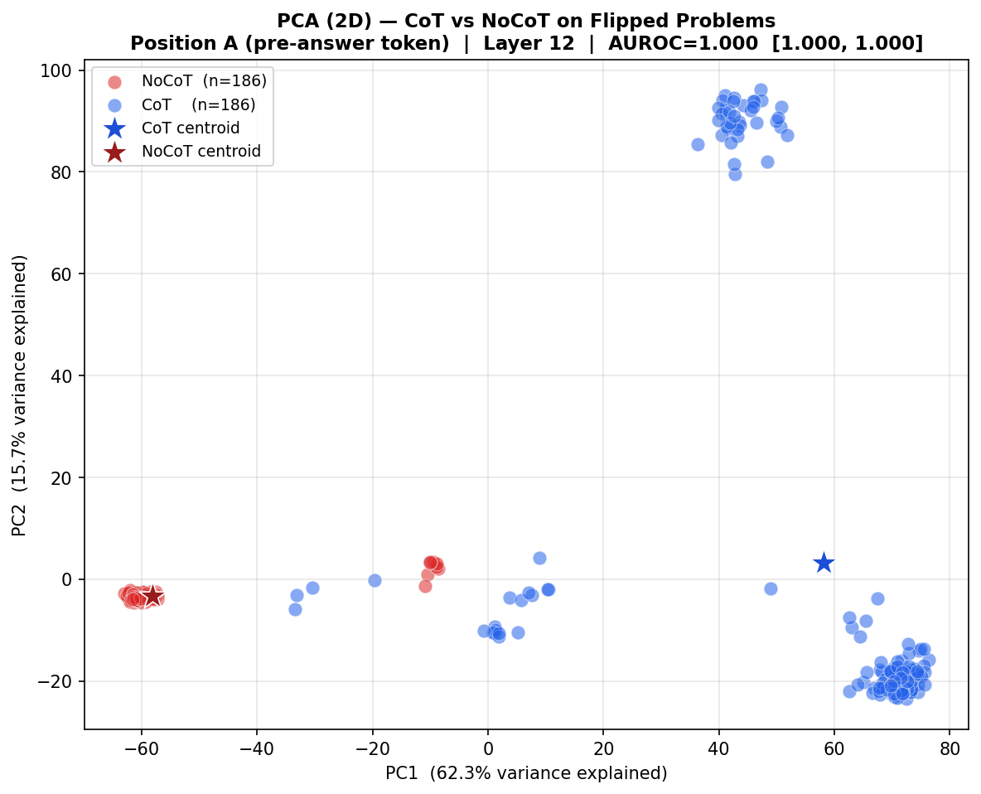
Figure 6: PCA of residual-stream activations on the 186 "flipped" problems. Blue dots = CoT activations; orange dots = NoCoT activations for the same problems. The two groups are fully separated in every layer tested — AUROC = 1.000. (Exp 4)
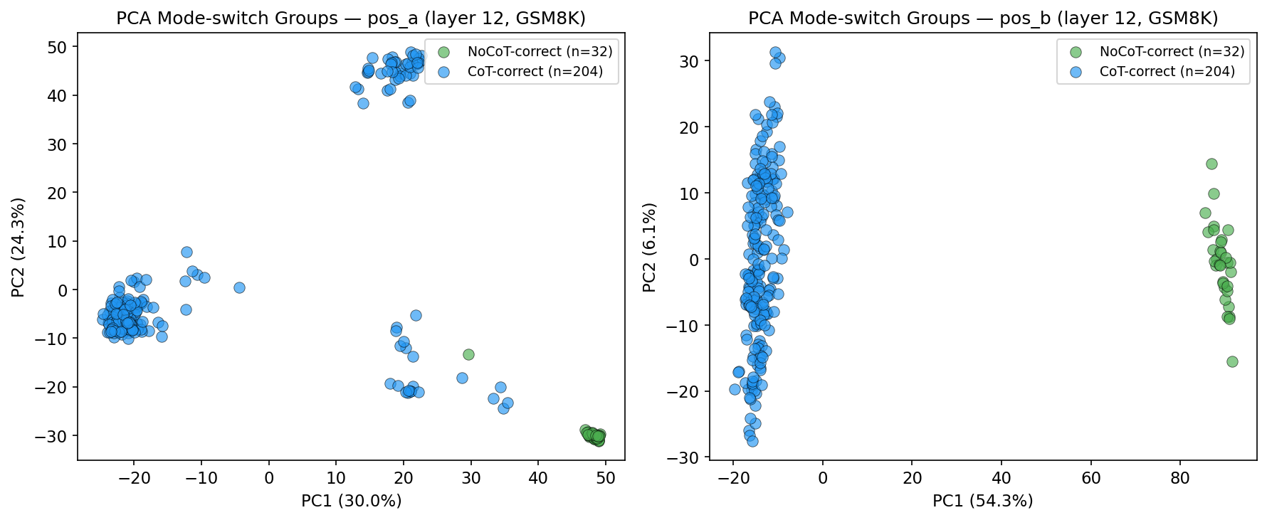
Figure 7: PCA projection showing correctly-answered problems from both conditions. Even when only correct answers are compared, CoT-correct and NoCoT-correct activations form non-overlapping clusters, confirming the mode switch is a formatting effect, not a correctness artefact. (Exp 5)
3.5 Are the Results Real? Shuffled-Label Robustness Check (Exp 6)
In plain terms: Could the high AUROC values in Exp 1–2 simply be a statistical fluke caused by a regularised classifier overfitting to 400 data points? We rule this out by repeating every classification with randomly shuffled labels (correct/incorrect assigned at random) and comparing the real AUROC against the distribution of shuffled AUROCs.
Classifier | Real AUROC | Shuffled mean | Shuffled max | Signal above baseline
Exp 1 CoT, Layer 12, Pos A (raw) | 0.770 | 0.449 | — | +0.270
Exp 2 CoT, Pos A (SAE error term) | 0.770 | 0.501 | 0.581 | +0.270
Exp 2 CoT, Pos A (SAE features) | 0.677 | 0.508 | — | +0.177
Exp 2 NoCoT, Pos A (SAE features) | 0.777 | 0.516 | — | +0.268

A small number of individual shuffle runs exceed 0.55 (due to class imbalance in short cross-validation folds), but all real AUROCs maintain a ≥0.16 advantage over shuffled means. None of the signal is a regularisation artefact.
Key finding: The correctness signal in Experiments 1–2 is robust. Real AUROCs exceed shuffled baselines by 0.17–0.27 AUROC points across every classifier tested. The results reflect genuine structure in the data, not overfitting.
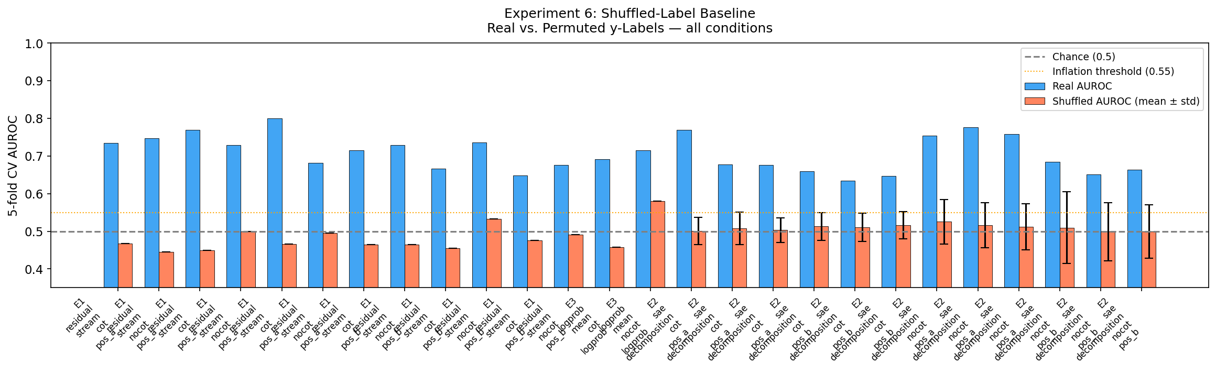
Figure 8: Real AUROC (solid bars) vs. shuffled-label AUROC distribution (box plots) for all classifiers. In every case, the real signal substantially exceeds the shuffled baseline, confirming results are not artefacts. (Exp 6)
3.6 Cross-Model Reference and the NLA Language Bottleneck (Exp 7–10)
In plain terms: We first establish how much better a much larger model (27 billion parameters) performs on the same task (Exp 7). We then ask whether the correctness signal we found in the raw activations can be "read" in natural language by converting those activations into text descriptions (NLA, Exp 8–10). If the signal is legible in plain text, a language model should be able to predict correctness from the description alone.
Exp 7 ran the full 400 GSM8K problems through Gemma-3-27B (13× more parameters than Gemma-2-2B-IT) to establish a stronger-model reference point. Exp 8 qualitatively examined NLA text descriptions of 10 example chains. Exp 9 and 10 quantitatively tested whether those descriptions carry a correctness signal. Note: all Exp 8–10 results are demonstrative only (n = 58, SE(AUROC) ≈ ±0.18) and should be interpreted directionally.
Model | Parameters | CoT accuracy | NoCoT accuracy | CoT benefit
Gemma-2-2B-IT (this project's primary model) | 2 billion | 51.0 % | 8.0 % | +43 pp
Gemma-3-27B (reference) | 27 billion | 91.5 % | 31.5 % | +60 pp

Experiment | Method | Result | Interpretation
Exp 9 — NLA embedding probe (DEMONSTRATIVE) | Embed NLA text → train linear classifier | CV AUROC = 0.363 ± 0.132 | Below chance (0.50); shuffled baseline = 0.563
Exp 10 — LLM judge (DEMONSTRATIVE) | Claude Haiku reads NLA text → predicts correct/incorrect | Accuracy = 48.3 % (28/58) | At chance; predicts "incorrect" for 57 of 58 problems; TP = 0

DEMONSTRATIVE — n = 58. Two independent methods converge on the same null result. Exp 9 CV AUROC is below chance, and Exp 10 LLM judge is no better than always guessing "incorrect." The NLA text bottleneck discards the correctness signal.
Key finding: Despite carrying a strong correctness signal in raw form, the model's internal activations appear to encode that signal in a way that cannot be read in natural language. The NLA compression bottleneck — converting activations to text — loses the discriminative information entirely. This is consistent with the Exp 2 finding that the signal lives in diffuse, non-interpretable geometry.
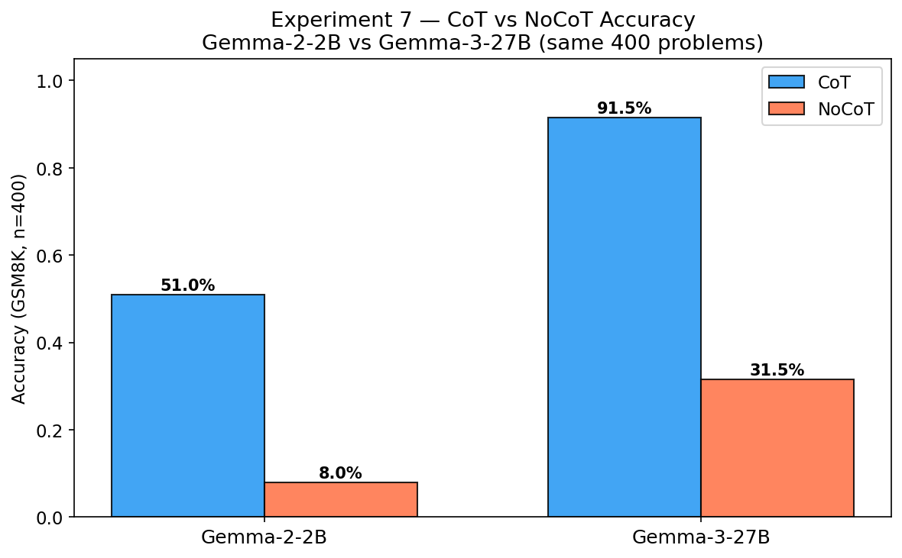
Figure 9: CoT vs. NoCoT accuracy for Gemma-2-2B-IT (left pair) and Gemma-3-27B (right pair) on 400 GSM8K problems. Both models benefit substantially from CoT, and the larger model shows a greater absolute gain. (Exp 7)
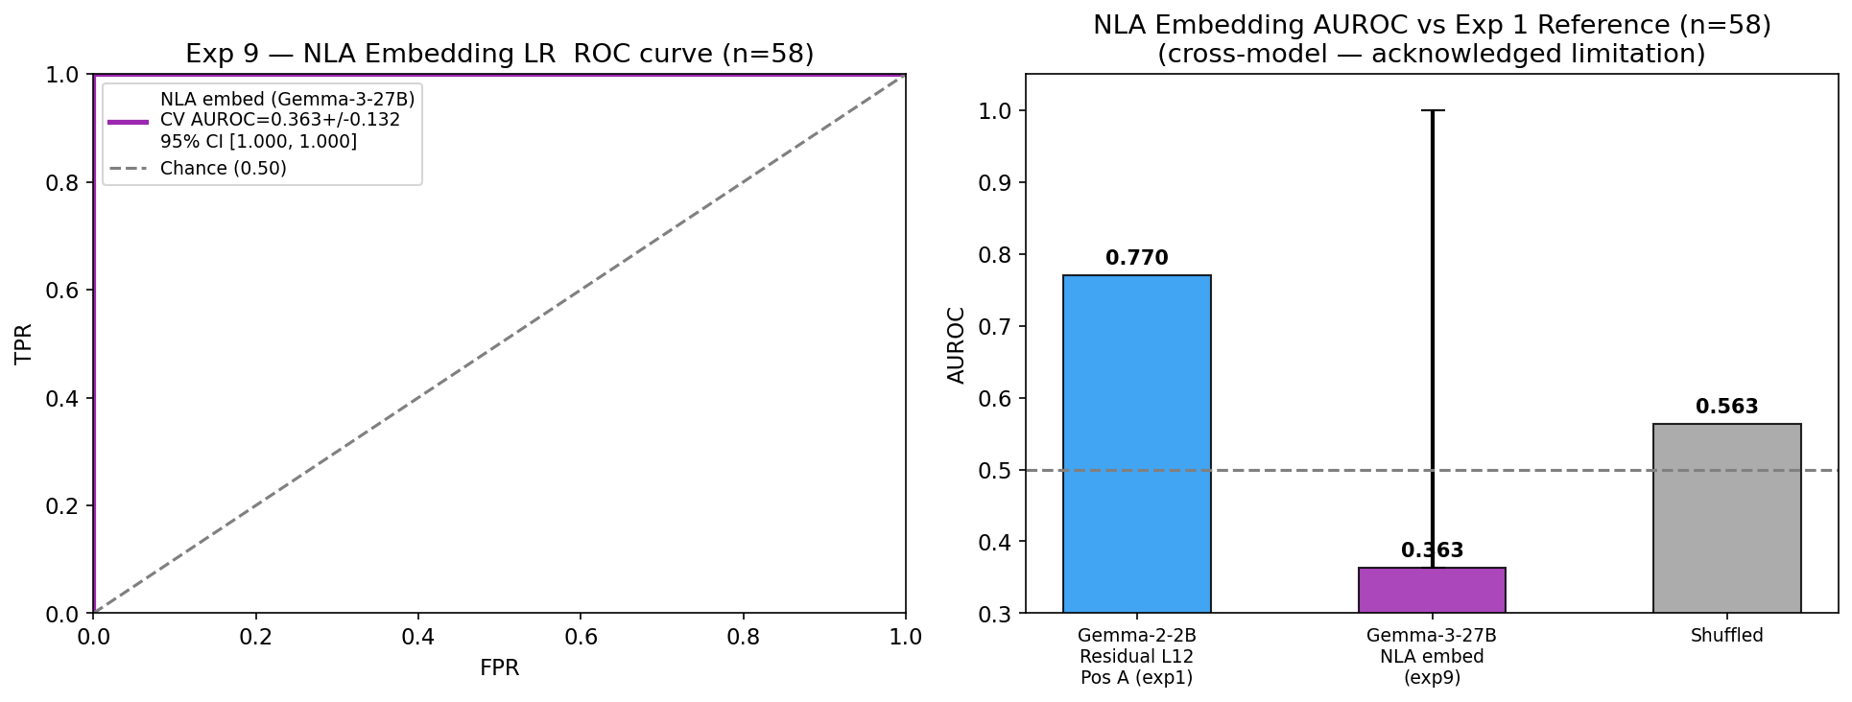
Figure 10: NLA embedding probe: real CV AUROC (0.363, below chance) vs. shuffled baseline (0.563). The text descriptions produced by NLA carry no linearly-separable correctness signal. (Exp 9, DEMONSTRATIVE — n = 58)
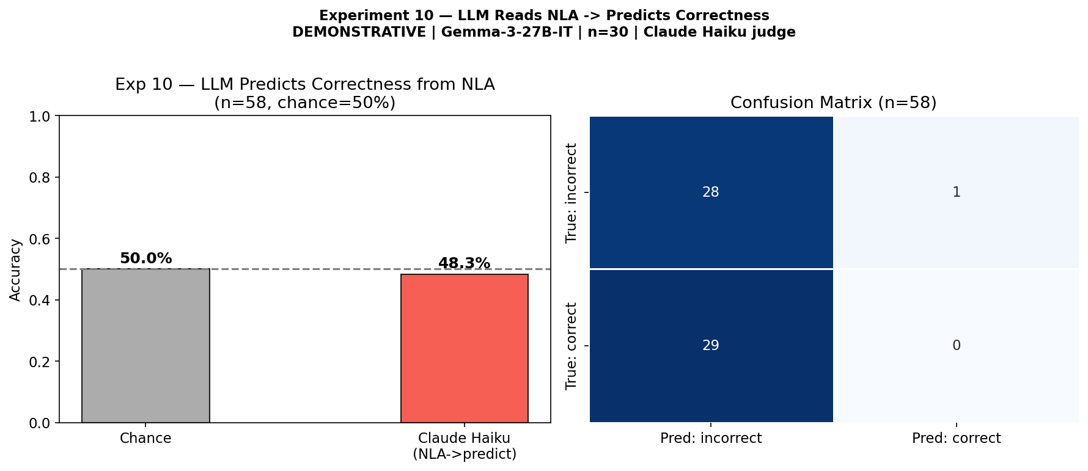
Figure 11: LLM judge (Claude Haiku) accuracy predicting correctness from NLA text descriptions. The model assigns "incorrect" to 57/58 cases, achieving 48.3 % accuracy (below chance). (Exp 10, DEMONSTRATIVE — n = 58)
3.7 Where in the Chain is Correctness Encoded? (Exp 11)
In plain terms: Is the correctness signal concentrated in specific types of tokens — for example, at numbers and operators where actual calculation happens, or at connective words like "therefore" and "thus" where the model transitions between steps? Or is it spread uniformly across the entire chain?
Tokens in the generated CoT were classified into two groups: (1) computation tokens — digits, arithmetic operators (+, −, ×, ÷), equals signs, and \boxed{} delimiters; and (2) reasoning connector tokens — transition phrases such as "therefore," "thus," "so," "step," and similar markers. Average Layer-12 activations were computed separately for each group, and independent linear classifiers were trained on each (n = 80 problems, 40 correct + 40 incorrect).
Token type | Tokens per chain (avg.) | CV AUROC | ± std | Shuffled baseline
Computation tokens (digits, operators) | 78 of 204 (38 %) | 0.750 | 0.057 | 0.494
Reasoning connectors (therefore, thus…) | 7 of 204 (3 %) | 0.750 | 0.072 | 0.303
All tokens together (mean-pool) | 204 total | 0.791 | 0.038 | 0.431
Exp 1 reference (single Pos A token) | 1 token | 0.770 | — | —

All signals are significantly above shuffled baselines (Δ = +0.26 to +0.45 AUROC). The reasoning connector group has 7 tokens per chain on average — very small — but still achieves AUROC = 0.750.
Key finding: Computation tokens (where arithmetic happens) and reasoning connector tokens (transition phrases) carry identical correctness signal — AUROC = 0.750 each. Neither group is more informative than the other. Furthermore, averaging across all tokens in the chain (0.791 AUROC) outperforms any single position — suggesting correctness is a global property of the full reasoning trajectory, distributed uniformly rather than concentrated at any particular token type.
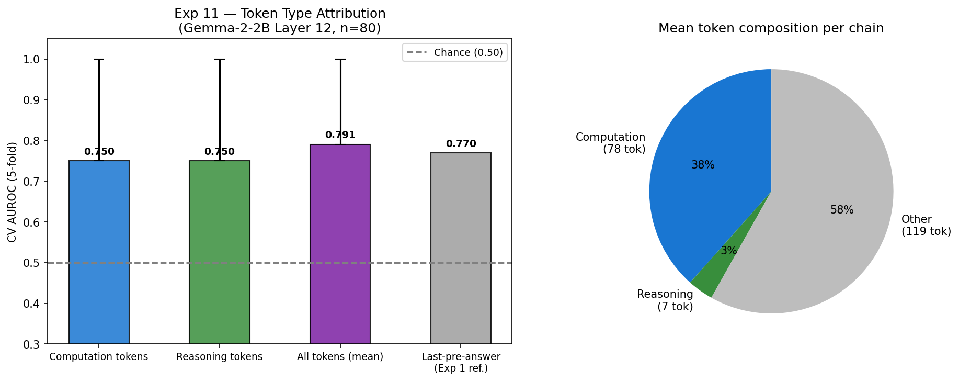
Figure 12: AUROC by token type at Layer 12. Computation and reasoning connector tokens achieve identical performance (0.750), and full-chain mean-pooling (0.791) outperforms any single position. (Exp 11)
3.8 Does the Model "Know" the Answer Early or Late? (Exp 12)
In plain terms: We tracked, token-by-token across the entire reasoning chain, how likely the model was to generate each possible final answer digit (0–9). If the model is genuinely reasoning, we might expect it to commit to the correct answer later (after working it out). If it is rationalizing, it would commit to its answer early and then write justifications. We also ask: in cases where the model gives the wrong answer, does it ever "almost know" the right one?
Only problems with single-digit correct answers (0–9) were used, to ensure each answer maps to exactly one unambiguous token (77 of 400 problems, 68 valid chains after generation: 34 correct, 34 incorrect). 16 of 34 incorrect chains were unusable because the model predicted multi-digit numbers (e.g., predicting 17 when the correct answer is 7), leaving 18 "clean" incorrect chains for analysis. "Commitment" is defined as the first position where P(answer digit) crosses 1 % and stays above it.
Metric | Correct chains (n=34) | Clean incorrect chains (n=18) | Statistical test
Commitment fraction (how far into the chain the model commits) | 55.9 % ± 30.2 % | 51.1 % ± 31.7 % | p = 0.471 n.s.
Peak fraction (when P(answer digit) is highest) | 56.1 % | 54.5 % | p = 0.810 n.s.
Max P(answer digit) reached | 100.0 % | 97.8 % | p = 0.182 n.s.
Max P(correct gold digit) in wrong-answer chains | — | 82.8 % ← | —

14 of 18 clean incorrect chains (78 %) show the correct digit reaching a higher maximum probability than the wrong digit at some point during the chain — the model transiently "knew" the right answer before writing the wrong one. Statistical power is limited by n = 18 clean incorrect chains.
Key finding: There are no statistically significant differences in when correct and incorrect chains commit to their answer (all p > 0.10). The most striking result is that in 78 % of wrong-answer chains, the correct answer digit momentarily reaches high probability (mean maximum P = 82.8 %) during the reasoning chain before the model ultimately writes the wrong answer. This is evidence of a late-stage carry failure: the model computes the correct answer internally but fails to propagate it to the final output. This contrasts with a rationalization story, in which the model would commit to a wrong answer early and never represent the correct one.
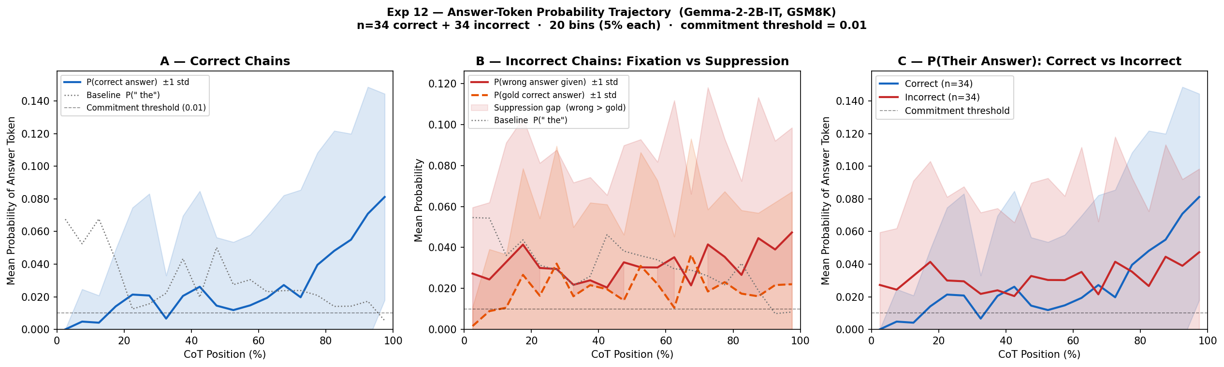
Figure 13: Mean P(answer digit) trajectories across the reasoning chain for correct (blue) vs. incorrect (red) chains. The average trajectories are similar; the key difference is in what happens at the end. (Exp 12)
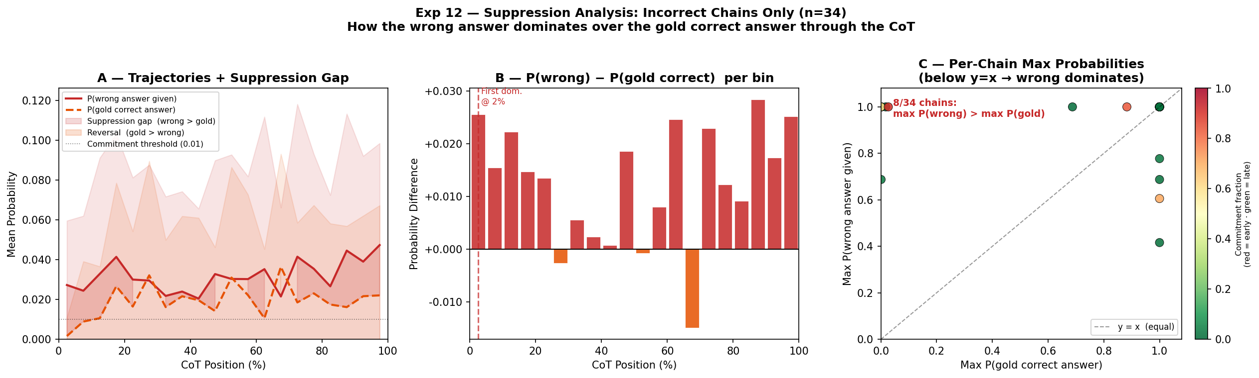
Figure 14: Gold-digit (correct answer) probability in wrong-answer chains. The correct digit frequently peaks above the ultimately-predicted wrong digit mid-chain, then is suppressed before the final answer is written — the carry failure pattern. (Exp 12)
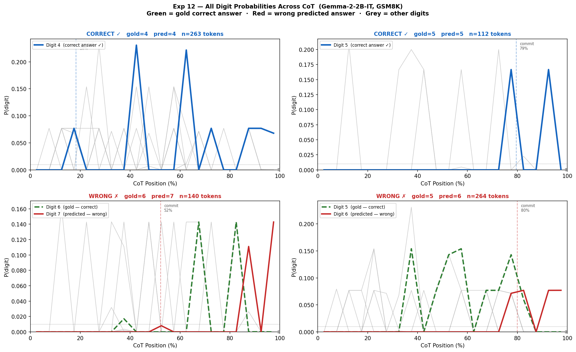
Figure 15: Digit probabilities (0–9) across CoT for four individual example chains (2 correct, top row; 2 incorrect, bottom row). Green dashed line = correct answer digit; red solid = predicted wrong digit; grey lines = all other digits. In both wrong-answer panels, the green dashed line rises to high probability mid-chain before the red line takes over near the end — the late-stage carry failure visible at the individual chain level. (Exp 12)

4. Cross-Experiment Analysis
The twelve experiments form a coherent picture when read together. This section synthesises the main threads.
4.1 CoT as a Mode Switch
The most structurally important result comes from Experiments 4 and 5: chain-of-thought is not simply "more tokens before the answer." The model's internal state is perfectly separable between CoT and NoCoT conditions at every layer, at both measurement positions, and even on problems where both conditions give the correct answer. This separability is detectable at Pos B — before the model has written a single word of its reasoning — meaning that the chat-template instruction alone triggers a qualitatively different processing mode.
This has a practical implication: the improvement from CoT is not just about giving the model more computation time. It engages a different computational strategy from the outset, which partly explains why simply forcing more generation tokens without the CoT framing does not reliably replicate the benefit.
4.2 Where the Signal Lives (and Doesn't)
The correctness signal in the residual stream is strong (up to 0.80 AUROC), builds with layer depth (Exp 1), and is globally distributed across all token types in the chain (Exp 11). But it cannot be located in any interpretable feature (Exp 2) or read in natural language (Exp 9–10).
This creates a coherent picture: the information that distinguishes a correct from an incorrect reasoning chain is encoded in the model's activations, but in a diffuse, non-sparse manner that current interpretability tools cannot name. The Gemma Scope SAE — one of the most powerful interpretability tools available for this model family — captures only 1.4 % of activation variance and loses ≈9 pp of predictive power. The NLA language bottleneck loses the signal entirely. This is not a failure of the particular tools used; it indicates that the correctness-distinguishing computation in the model is fundamentally different from the kinds of discrete, lexicalisable concepts that current feature dictionaries are designed to capture.
4.3 The Failure Mode: Computing Right, Writing Wrong
Experiment 12 adds a new dimension to this picture. The standard framing of "rationalization" implies the model commits to a wrong answer early and writes justifications for it. But the data show something different: in 78 % of incorrect chains, the correct answer digit transiently reaches high probability (mean max P = 82.8 %) during the reasoning chain, higher than the ultimately-predicted wrong digit at that moment. The model is, in some sense, "passing through" the correct answer without capturing it.
This late-stage carry failure is a specific, testable mechanism. It implies that interventions targeting the transition from internal computation to output generation — rather than the reasoning steps themselves — may be the most effective way to improve reliability. Patching the activation at the last pre-answer position to reflect the peak-probability correct answer is a natural next experiment.

5. What These Results Tell Us About Language Models
Beyond the specific experiments, the findings suggest five broader conclusions about how large language models reason.
1. Chain-of-thought is a cognitive mode, not just extra text. The perfect geometric separation between CoT and NoCoT conditions (Exp 4–5), active before any reasoning word is written, implies that the model has learned distinct processing modes corresponding to different prompting strategies. When asked to "show its work," the model does not simply produce longer output — it switches to a fundamentally different internal configuration. This may explain why CoT benefits are sensitive to prompt phrasing and why forcing longer outputs without CoT framing does not reliably help.
2. Correctness is a property of the whole chain, not any individual step. Computation tokens and reasoning connector tokens carry identical correctness signal (Exp 11), and averaging across the full chain outperforms any single position. There is no "eureka moment" token where the model commits to the right answer — the quality of the reasoning is encoded across the entire activation trajectory. This has implications for approaches that try to verify individual reasoning steps: step-level checks may miss the distributed nature of correctness encoding.
3. The mechanistic basis of good reasoning is not yet interpretable. The most advanced interpretability tools available for this model (Gemma Scope SAE, NLA natural language descriptions) cannot capture what makes a reasoning chain correct. The discriminative signal lives in diffuse, non-sparse geometry. This is not a failure specific to Gemma or to math problems — it reflects a fundamental gap in the current state of mechanistic interpretability: we can detect that information is present, but we cannot yet name the computations that carry it.
4. Models can compute the right answer and still write the wrong one. The late-stage carry failure finding (Exp 12) is perhaps the most practically important result. It challenges the idea that wrong answers reflect a failure to compute the correct solution. Instead, in 78 % of incorrect chains, the model appears to internally represent the correct answer at high probability before overwriting it with the wrong output. The failure is in the final "write-out" step, not in the underlying calculation. This suggests that error-correction mechanisms targeting the last step of generation might be more effective than those targeting intermediate reasoning steps.
5. Larger models leverage chain-of-thought more effectively. Gemma-3-27B (27B parameters) gains +60 percentage points from CoT vs. +43 pp for Gemma-2-2B-IT (Exp 7). This is consistent with the hypothesis that larger models have stronger carry mechanisms — better coupling between their internal computation and their generated output — and can therefore make better use of the mode-switch that CoT triggers.

6. Research Limitations
The following limitations should be considered when interpreting the findings.
1. Single model (Exp 1–6, 11–12). All mechanistic experiments use Gemma-2-2B-IT. Findings about residual-stream geometry, SAE decomposition, and carry failure may not generalise to other architectures (e.g., GPT-style, Llama, Mistral) or other model scales. The mode-switch finding in particular needs replication on at least one other model before strong architectural claims can be made.
2. Single domain (arithmetic word problems). All 400 problems are from GSM8K, a benchmark of elementary-school arithmetic. The correctness signal, mode-switch, and carry-failure patterns may be specific to numerical reasoning and may differ in commonsense reasoning, coding, multi-hop question answering, or other domains where "correctness" has a different cognitive structure.
3. Limited statistical power in Exp 12. The single-digit answer filter leaves only 77/400 problems, and contamination (the model predicting multi-digit answers) reduces usable incorrect chains to 18. No metric reached statistical significance, but the study is underpowered (estimated power 0.3–0.5 for a medium effect size at n = 18). The null results should be read as inconclusive rather than as disconfirmation.
4. Demonstrative status of NLA experiments (Exp 8–10). The NLA analyses used n = 58 problems (SE(AUROC) ≈ ±0.18) on Gemma-3-27B — a different model than the mechanistic experiments. The below-chance AUROC in Exp 9 and the at-chance accuracy in Exp 10 are suggestive and converge, but cannot support definitive inference at this sample size. Replication at n ≥ 200 is required for statistical confidence.
5. SAE coverage is very low. The Gemma Scope SAE at Layer 12 explains only 1.4 % of residual-stream variance (R² = 0.014). The "signal in the error term" finding may therefore partly reflect the SAE's own limited coverage rather than a fundamental property of the correctness signal. A better-trained SAE, or one targeting a different layer, might recover more interpretable signal.
6. Probing studies are correlational (Exp 1–3, 11). A high AUROC means correctness information is linearly decodable from activations — not that the model uses this information causally. Only Experiment 4 provides quasi-causal evidence (same problem, different condition, perfect separation). The probing results establish opportunity for causation but do not confirm it.
7. Selection bias in the flipped-problem set (Exp 4). The 186 "flipped" problems are precisely those where CoT helps and NoCoT fails. This group may have specific properties — longer required reasoning, more calculation steps, less direct retrieval — that exaggerate geometric separation. The AUROC = 1.000 may be an upper bound rather than a representative estimate of the CoT effect on an arbitrary problem.
8. The NLA tool has unvalidated fidelity. NLA descriptions are generated by the Neuronpedia platform. Their accuracy, completeness, and consistency have not been independently validated for this task and this model. Conclusions about what the model is "thinking" carry uncertainty about the NLA tool itself in addition to the model.

7. Conclusion
Does chain-of-thought prompting represent genuine computation or post-hoc rationalization? The honest answer from this project is: neither story is fully correct.
Chain-of-thought is not mere rationalization. It triggers a distinct computational mode before the first reasoning word is written, builds correctness-predictive representations progressively through deeper layers, and — most importantly — incorrect chains show evidence that the model computed the right answer and lost it, rather than never computing it at all.
But chain-of-thought is also not fully transparent computation. The signal that distinguishes correct from incorrect reasoning is real and strong, but it cannot be located in any human-interpretable feature or read in natural language. The computations that make CoT beneficial are currently invisible to mechanistic interpretability.
The six most robust findings are:
- CoT triggers a perfectly separable, qualitatively distinct representational regime — detectable at every layer and position, even before any reasoning is written (Exp 4–5, AUROC = 1.000 at all tested settings).
- Within the CoT regime, correctness information builds with layer depth, peaking at Layer 18, Pos A (AUROC = 0.801 CoT vs. 0.682 NoCoT, Δ = +0.119). This is substantially above the behavioral log-probability baseline (0.692, Exp 3).
- The correctness signal lives in diffuse, uninterpretable residual geometry, not in Gemma Scope's named feature dictionary (−0.09 AUROC vs. raw, Exp 2).
- The signal is globally distributed: computation tokens and reasoning connectors carry identical correctness information, and full-chain averaging outperforms any single position (Exp 11).
- The signal does not survive language compression: two independent NLA-based methods find no detectable correctness signal in natural-language descriptions (Exp 9–10).
- In 78 % of incorrect chains, the correct answer digit reaches high probability (mean max P = 82.8 %) during reasoning before being overwritten — late-stage carry failure rather than early wrong fixation (Exp 12).
The central practical implication is that improving model reliability may require interventions at the output generation stage — the "carry" from internal computation to written answer — rather than at intermediate reasoning steps. Current interpretability tools are not yet able to support such targeted interventions, which defines the most important direction for future work.

8. Further Work
1. Expand Exp 12 to multi-digit answers. The single-digit restriction (77/400 problems) leaves only 18 clean incorrect chains — insufficient statistical power. Extending to two- and three-digit answers with per-digit trajectory tracking would provide ≥ 5× more data and allow definitive testing of the carry-failure hypothesis.
2. Causal intervention on the carry mechanism. The most direct follow-up: patch or steer activations at the last pre-answer position to reflect the peak-probability correct answer observed mid-chain. If this improves output accuracy, it would confirm the carry-failure mechanism causally and suggest a practical route to improving model reliability.
3. Localise where carry failure occurs. Tracking the residual stream token-by-token from the peak of P(gold digit) to the \boxed{} position would identify which specific generation steps or attention heads are responsible for overwriting the correct value.
4. Cross-model replication. Repeating the key mechanistic experiments (mode-switch, SAE decomposition, carry failure) on Gemma-3-27B, Llama-3.1, or Mistral would establish how general these findings are and whether carry fidelity scales with model size.
5. Better interpretability tools for diffuse signals. Gemma Scope SAE is insufficient to capture the correctness signal. Transcoders (which model how MLPs transform, not just what activations look like), cross-layer features, or improved SAE training may access the diffuse geometry where the signal lives.
6. Richer NLA representations. Exp 9–10 used single-position activation snapshots. Comparing NLA descriptions between positions (e.g., the difference between early- and late-chain descriptions), or building chain-level summaries from multiple positions, might recover signal that a single snapshot cannot.
7. Extension to other reasoning domains. Testing whether the mode-switch, global-encoding, and carry-failure patterns appear in commonsense reasoning, coding tasks, or multi-hop factual retrieval would determine whether these are properties of CoT in general or specific to arithmetic computation.

