**Assignment 2**

**Due on Mon Oct 26th at 10:00 pm**

|  |
| --- |
| **Name:** Elaf Yousef Aloufi |
| **ID:** 1911265 |
| **Section:** VAR |

Design a counter Using T ff's. This counter should count down from 7 to 0 to 7. The circuit counts downward with sequence **111,110,101,100,011,010,001,000** and then the count repeats.

You will need to:

* Derive the state diagram and state table

From 7 to 0 **State diagram**

From 0 to 7

**111**

**000**

**110**

**001**

**101**

**100**

**010**

**011**

**State table**

|  |  |  |
| --- | --- | --- |
| Present state  A2 ,A1 ,A0 | Next state  A2+ A1+ A0+ | Flip- Flops input  TA2, TA1, TA0 |
| 0 0 0 | 1 1 1 | 1 1 1 |
| 0 0 1 | 0 0 0 | 0 0 1 |
| 0 1 0 | 0 0 1 | 0 1 1 |
| 0 1 1 | 0 1 0 | 0 0 1 |
| 1 0 0 | 0 1 1 | 1 1 1 |
| 1 0 1 | 1 0 0 | 0 0 1 |
| 1 1 0 | 1 0 1 | 0 1 1 |
| 1 1 1 | 1 1 0 | 0 0 1 |

|  |  |  |
| --- | --- | --- |
| Present state  A2 ,A1 ,A0 | Next state  A2+ A1+ A0+ | Flip- Flops input  TA2, TA1, TA0 |
| 0 0 0 | 0 0 1 | 0 0 1 |
| 0 0 1 | 0 1 0 | 0 1 1 |
| 0 1 0 | 0 1 1 | 0 0 1 |
| 0 1 1 | 1 0 0 | 1 1 1 |
| 1 0 0 | 1 0 1 | 0 0 1 |
| 1 0 1 | 1 1 0 | 0 1 1 |
| 1 1 0 | 1 1 1 | 0 0 1 |
| 1 1 1 | 0 0 0 | 1 1 1 |

* Draw the k-maps and derive the logical expressions

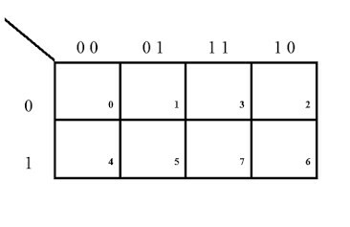**K** **map**

TA0= 1

TA2= A1’ . A0’

TA1= A0’

1 0 0 0

1 0 0 0

1 1 1 1

1 1 1 1

1 0 0 1

1 0 0 1

C



TA0= 1

TA1= A0

TA2= A1 . A0

1 1 1 1

1 1 1 1

0 0 1 0

0 1 1 0

C

0 1 1 0

0 1 1 0

C

* Design and implement the circuit using Logisim.

Show your work below, include a picture of the final design from the simulator and submit the Logisim file as well.

